

Executive Summary
Chow Tai Fook Jewellery Group Limited “CTFJ, a well-known jewellery retailer, has a proven robust revenue with a strong balance sheet since listed on HKEx in 2011. The company also keep on developing its business in Hong Kong, Macau, and China, furthermore, it continuously establishing new product lines and new point of sales to cater to the different market sectors.

CTFJ is the market leader based on our findings from this financial assessment. In this report, we used a peer comparison with another two well-known brands in Hong Kong - Luk Fook “LF” and Tse Sui Luen “TSL”. By studying these three companies’ annual reports between 2017 and 2019, we confirmed that CTFJ is financially healthy and performing far beyond LF and TSL in most of the financial matrix.

In chapter 3, we noticed that the stakeholders at CTFJ has a well-organized corporate governance that compliance with HKEx regulations; the overall structure will help the company to overcome different challenges and risks ahead, as well as to its shareholders for transparency, fair and accountable.

CTFJ has an on-going development strategy and sustained competitive advantage, in chapter 4, we tapped into one of the company’s investment plan that announced recently, with a recommendation to invest 5% of its China revenue in 2019 for a 10-year investment proposal. Under the section of investment appraisal, we used four different matrices to evaluate this project, and it is proven that this is a valuable investment supported by all the positive evaluations. We suggested CTFJ to raise funds for this project as well as working capital financing in chapter 5.

In the last chapter, we reviewed the possible challenges and risks that may impact CTFJ, followed by strategies and project schedules to pursue.

Table of Contents

Executive Summary 1
Table of Contents 2
List of Figures 3
List of Tables 3
1. Introduction 4
1.1 Company Background 4
1.2 Organization Structure 5
1.3 IPO History and Market Capitalization: 5
1.4 Operating Business Overview 6
1.5 Current & Historical Performance 6
1.6 Market position against competitors 7
1.7 Major development and challenges ahead 9
2. Financial Analysis 10
2.1 Profitability Analysis and Growth Capacity 10
2.2 Financial Positions (Liquidity and Solvency Analysis) 12
2.2.1 Current Ratio 13
2.2.2 Gearing Ratio 14
2.2.3 Cash Cycle 15
2.2.4 Leverage Ratio 16
2.2.5 Share Performance 17
2.2.6 The Du Pont Identity 18
2.2.7 Bankruptcy Index 23
3. Corporate Governance – Internal control and risk management 24
3.1 Corporate Governance System 24
3.2 Transparency and board diversity within a traditional family business 26
3.3 Compliance with Corporate Governance Code 27
3.4 Emerging Risks and Challenges 27
4. Investment Project Appraisal 28
4.1 Cost breakdown of the investment project 29
4.2 Profit and Cash Flow 29
4.2.1 Profit in 10 years 30
4.2.2 Cash Flow in 10 years 31
4.3 Four Types of Investment Appraisal 31
4.3.1 ARR 32
4.3.2 NPV 32
4.3.3 PBP 33
4.3.4 IRR 33
4.4 Assessment of the investment project 34
5. Fund-raising and working capital management 35
5.1 Financing options 35
5.2 Financing alternatives analysis 36
5.3 Financing recommendation 37
6. Conclusion and recommendation 38
6.1 Suggestions to CTFJ 38

Appendix 1: Financing calculation for long-term project 42
Appendix 2: Working Capital Financing 42
Appendix 3: Projected Cashflows 43
Appendix 4: Projected Balance Sheet 43
Appendix 5: Academic Reference 44
Appendix 6: Bibliography 45

List of Figures
Figure 1-1 Revenue by Products in FYE31Mar-19 4
Figure 1-2 Organization Structure 5
Figure 1-3 Revenue and Segment Profit by Regions 6
Figure 1-4 Revenue Contribution by Region 7
Figure 1-5 Inbound Arrivals to Hong Kong between 2017 and 2019 9
Figure 2-1 Self-sustainable growth ratio 11
Figure 2-2 Current Ratio between FYE17-19 13
Figure 2-3 Gearing ratio between 2017 and 2019 14
Figure 2-4 Cash Cycle between 2017 and 2019 15
Figure 2-5 Leverage Ratio between FYE17-19 16
Figure 2-6 Dividend per share (HK$) 17
Figure 2-7 Du Pont Identity for CTFJ as of FYE31Mar-19 18
Figure 2-8 Equity Multiplier 19
Figure 2-9 Total Asset Turnover 20
Figure 2-10 Net Profit Margin 21
Figure 2-11 Return on Equity 22
Figure 2-12 CTFJ’s Stock Value between FYEMar-17 and Mar-19 23
Figure 3-1 Corporate Governance System 24
Figure 4-1 CTFJ’s average expense in development between 2017 and 2019 28
Figure 4-2 NPV breakeven point 30
Figure 4-3 NPV Profile 32
Figure 4-4 Payback Period 33
Figure 5-1 HIBOR 37
Figure 6-1 Gantt Project Chart 38
Figure 6-2 CTFJ’s retail outlets in Central Hong Kong 39

List of Tables
Table 1-1 Market cap and other relevant data on share performance 5
Table 1-2 CTFJ’s historical performance between 2011 and 2019 6
Table 1-3 Revenue by Region 8
Table 1-4 Non-Current Assets Breakdown by Region 8
Table 2-1 Profitability Analysis 10
Table 2-2 Liquidity and Solvency Analysis 12
Table 2-3 Share Performance 17
Table 2-4 Data used for Du Pont Model 18
Table 2-5 Data for Z-Score analysis 23
Table 2-6 The Z-Score Analysis 23
Table 3-1 Executive directors from the Cheng family 26
Table 4-1 Cost breakdown of the investment project 29
Table 4-2 Average financial data between 2017 and 2019 for projection 29
Table 4-3 Depreciation rate and other data for the investment project 29
Table 4-4 Profit in 10 years 30
Table 4-5 Cash Flow in 10 years 31
Table 4-6 Data for Investment Appraisals 31
Table 5-1 Financing for long-term project 35
Table 5-2 Projected gearing and leverage ratio in 10 years 36
Table 5-3 Interest rate 37
Table 5-4 Long-term financing 80% of project cost 37
Table 6-1 CTFJ’s General and distribution costs 40
Table 6-2 CTFJ’s dividend payouts 41

Introduction

1.1 Company Background
Chow Tai Fook Jewellery Group Limited “CTFJ” is Chinese’s top-ranked jewellery retailer (Yiu, 2015), and the 2nd largest jewellery retailer in the globe (Magramo, 2020).

With an extensive retail network of ~3100 retail outlets in China, Hong Kong, Malaysia, Singapore, Malaysia, and the United States; under “Chow Tai Fook”, “Hearts on Fire”, and various brands, coupled with a fast-growing e-retail network through its owned and various other online platforms. More than 95% of the retail outlets are based in China, and the remaining outlets are largely in Hong Kong & Macau. The total number of employees employed is 30,400 (Chow Tai Fook, 2019, p. 15).

CTFJ’s major products include gold & platinum products, which is at 70% of its revenue; gem-set jewellery and watches produced 23% and 7% of the revenue, respectively (Chow Tai Fook, 2019, p. 231)
Figure 1-1 Revenue by Products in FYE31Mar-19
Source: Constructed by the author.
CTFJ is a well-known jewellery brand in the Chinese-speaking community, i.e., solid branding and reputation. It has 90 years of track record that covers high-end to mass luxury jewellery. It owns a vertically integrated business model, from raw materials procurement, design, production, to marketing & sales, which provides practical and tight control on quality and costs allowing CTFJ to better adapt to the market trends (Chow Tai Fook, 2019, p. 111).

1.2 Organization Structure
CTFJ is one of the key subsidiaries of ‘Chow Tai Fook (Holding) Ltd.’, owned by the family of late Cheng Yu Tung (Chow Tai Fook, 2019, p. 162), one of the wealthiest families in Asia, and part of the top four conglomerates in Hong Kong (Chung and Karmali, 2020).

Figure 1-2 Organization Structure
Source: Constructed by the author.

1.3 IPO History and Market Capitalization:
Listed since 15 Dec-11 on HKEx under stock code 1929, which raised HK$15.26 billion to back its growth in China (Reuters, 2011), CTFJ has a strong market capitalization of HK$79.4 billion in FYEMar-19 (Chow Tai Fook, 2019, p. 121). Comparatively, the two other competitors’ annual reports, Luk Fook “LF” and Tse Sui Luen “TSL”, have lower market capitalization of HK$15.5 billion (Luk Fook, 2019) and HK$434 million (Tse Sui Luen, 2019), respectively (Table 1-1).
Table 1-1 Market cap and other relevant data on share performance
Source: Constructed by the author.

1.4 Operating Business Overview
As of FYE31Mar-19, CTFJ generated 64% of the revenue from China and 36% from Hong Kong, Macau & Others. Segment profit-wise, China produced 72% compared to markets outside China at 28% (Chow Tai Fook, 2019, p. 228).

Figure 1-3 Revenue and Segment Profit by Regions
Source: Constructed by the author.

1.5 Current & Historical Performance
CTFJ has a profitable track record (Chow Tai Fook, 2011-2019) even during slower years in the retail sector in FYEMar-16 and 17 (Table 1-2), reflecting its resilience during down cycles. Its fast expansion to China provides revenue diversification to its traditional Hong Kong & Macau markets. The balance sheet is strong, with a sizeable asset of HK$62.2 billion and equity of HK$31.4 billion (Chow Tai Fook, 2019, p. 191).

Table 1-2 CTFJ’s historical performance between 2011 and 2019
Source: Constructed by the author.

1.6 Market position against competitors
Under the peer comparison, we will focus on their performance and assets.

By performance: CTFJ being the largest Asia jewellery retailer, generates robust revenue at 66.9 billion (Chow Tai Fook, 2019, p. 190), leading its peers by 4.2X from LF (Luk Fook, 2019), and 16.4X from TSL (Tse Sui Luen, 2019). Market share is not publicly available.

Figure 1-4 Revenue Contribution by Region
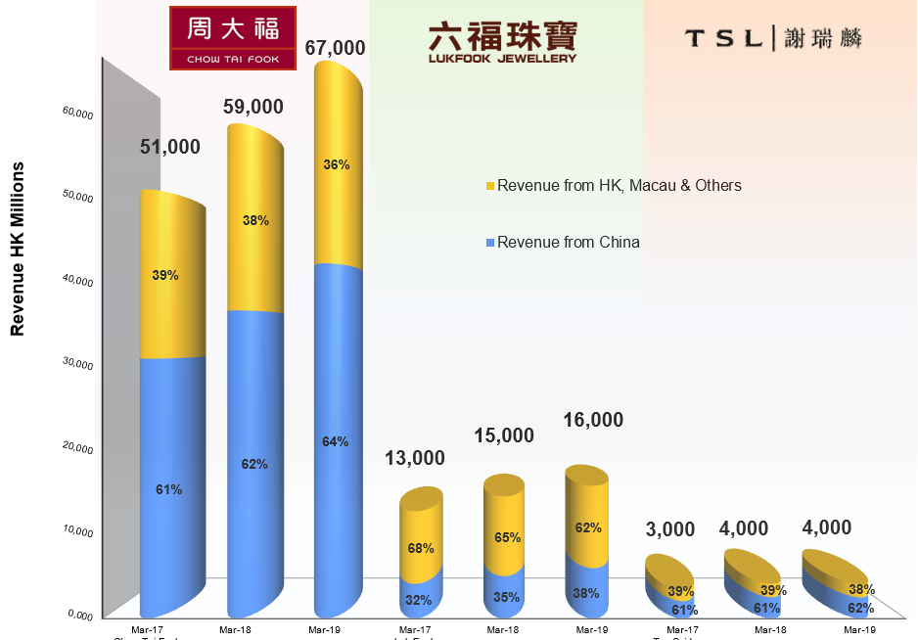
Source: Constructed by the author.

Its strong foothold in China attributes CTFJ’s strong performance, represents 63.7% of its total revenue in FYE31Mar-19 (Chow Tai Fook, 2019, p. 228). Compared to LF and TSL, who are gradually growing in China. In contrast, the revenue in the Hong Kong market is overall declining within the industry in the last three years (Table 1-3).

Table 1-3 Revenue by Region
Source: Constructed by the author.

By non-current assets: To achieve cost optimization, CTFJ is also the first amongst its peers to invest its production facilities to China. 68.69% of its non-current assets as of 31 Mar-19 (Table 1-4), primarily its production facilities & equipment, are based in China (Chow Tai Fook, 2019, p. 230).

Table 1-4 Non-Current Assets Breakdown by Region
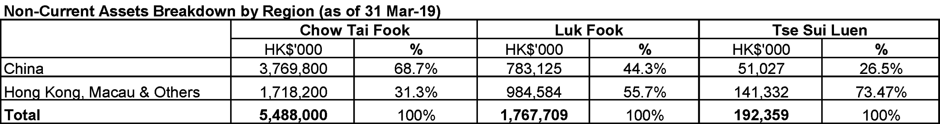
Source: Constructed by the author.

1.7 Major development and challenges ahead
Ever since the global economic crisis in 2009, CTFJ expanded its business operations globally by enlarging the Chinese markets by increasing outlets in China. According to its IPO prospectus, points of sales increased from 1,506 as of 30 Sep-11 (Chow Tai Fook, 2011, p. 68) to 3,100 as of 31 Mar-19 (Chow Tai Fook, 2019, p. 15).

CTFJ faces intense competition from local and major Chinese jewellery retailers such as Laofengxiang and Laomiao (HKTDC Research, 2019). The above risk can be mitigated through its longstanding track record and experience of over 90 years, various brands under CTFJ to meet different age groups and its cost efficiencies through its Chinese production facilities (Chow Tai Fook, 2019, p. 22).

Protests in Hong Kong had impacted its Hong Kong operations since Jun-19, which affected tourist arrivals in the 2nd half of 2019, albeit the revenue affected can be cushioned by its continued expansion in China. The growth of inbound arrivals to Hong Kong in 2019 was -14.2% (Figure 1-5).

Figure 1-5 Inbound Arrivals to Hong Kong between 2017 and 2019
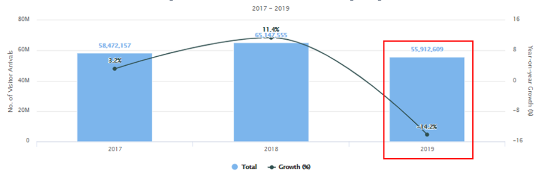
Source: (Hong Kong Tourism Board, 2019)

Weak retail segments are arising from temporary lock-downs and the absence of tourist arrivals amid the COVID-19 outbreak. China has undergone a lock-down in Feb/Mar-20, which saw the temporary closures of its retail stores in China, albeit, they have resumed businesses since early Apr-20 (Brown, 2020). However, its 101 number of Hong Kong and Macau retail outlets (Chow Tai Fook, 2019, p. 15) continued to be affected by the virus pandemic (Kothari, 2020).

Financial Analysis

Typical of the nature of the business, which requires the jewellery retailers to maintain a high inventory level, thus quick ratio and cash ratio may not be a relevant measurement. Essentially, inventory by 2019 was 39 billion (Chow Tai Fook, 2019, p. 191) represents 73% of CTFJ’s current liabilities and 63% of its total liabilities (Table 2-2). In this chapter, a peer comparison method will be used to review the company’s profitability, efficiency, liquidity, solvency, and bankruptcy index.

2.1 Profitability Analysis and Growth Capacity

Table 2-1 Profitability Analysis
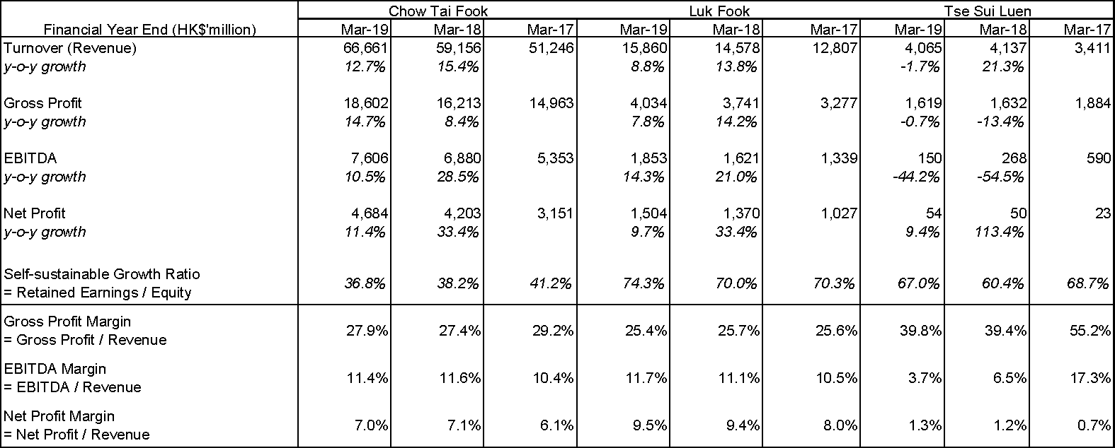
Source: Constructed by the author.

Table 2-1 shows that CTFJ has been a very profitable company over the three years of comparison. CTFJ registered 12.7% and 15.4% revenue growth in FYE31Mar-19 and FYE31Mar-18, higher than its peers due to the continued expansion in China, which has a more substantial exposure compared to the other two peers. EBITDA margin of CTFJ is comparable to LF and stronger than TSL. The net profit margin of CTFJ, however, is lower than LF because of LF’s smaller portion of interest expense, due to its lower proportion of debt (Table 2-2).

Sustainable growth rate illustrates the company’s ability to grow by keeping the wealth composition without selling new equity (Platt, Platt and Chen, 1995). In FYEMar-19, CTFJ recorded retained profit at 11,547.3 million (Chow Tai Fook, 2019, p. 193) and equity at 31,403 million (Chow Tai Fook, 2019, p. 74), thus sustainable growth rate was at 37%, a decreasing trend since 2017. In contrast to the peers, they were almost double in terms of the growth ratio (Figure 2-1). CTFJ may build up its retained earnings to maintain a higher rate for future developments.

Figure 2-1 Self-sustainable growth ratio
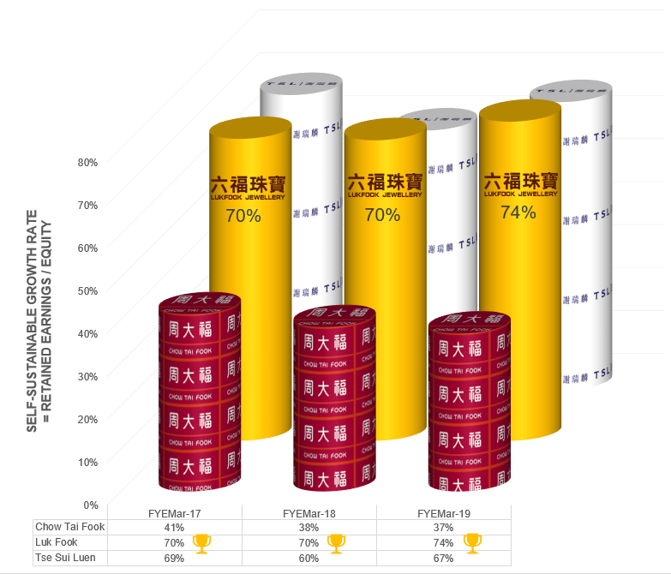
Source: Constructed by the author

2.2 Financial Positions (Liquidity and Solvency Analysis)
In the sections below, we will compare CTFJ with its peers through some key financial figures and ratios with the data according to annual reports from Chow Tai Fook (2017-2019), Luk Fook (2017-2019), and Tse Sui Luen (2017-2019).

Table 2-2 Liquidity and Solvency Analysis
Source: Constructed by the author.

2.2.1 Current Ratio
A company is vigorous with a high current ratio; it is an indication of a company’s capability for using its existing assets to repay its interim debt (Kliestik et al. 2020). CTFJ’s current ratio dropped from 2.38X in FYE31Mar-18 to 1.96X in FYE31Mar-19, mainly due to the higher current liabilities in FYE31Mar-19. Whilst its current ratio of 1.96X is lower than LF’s of 3.34X (Figure 2-2), the ratio can still be considered healthy. It implies CTFJ has 1.96X more current assets than liabilities to covers its debts in FYEMar-19.

Figure 2-2 Current Ratio between FYE17-19
Source: Constructed by the author.

2.2.2 Gearing Ratio

It is an indicator of the financial risk associated with a company. If a company has too much debt, it cannot generate revenue or income because it is unable to meet or cannot pay its financial obligations (Muradoglu, Bakke and Kvernes, 2005). In FYE31Mar-19, CTFJ’s gearing increased from 0.39X to 0.58X, mainly due to higher total debt incurred. CTFJ’s gearing is higher than LF’s gearing of 0.22X, considering that CTFJ has been using debt to fund its China’s expansion (Chow Tai Fook, 2019).

Figure 2-3 Gearing ratio between 2017 and 2019
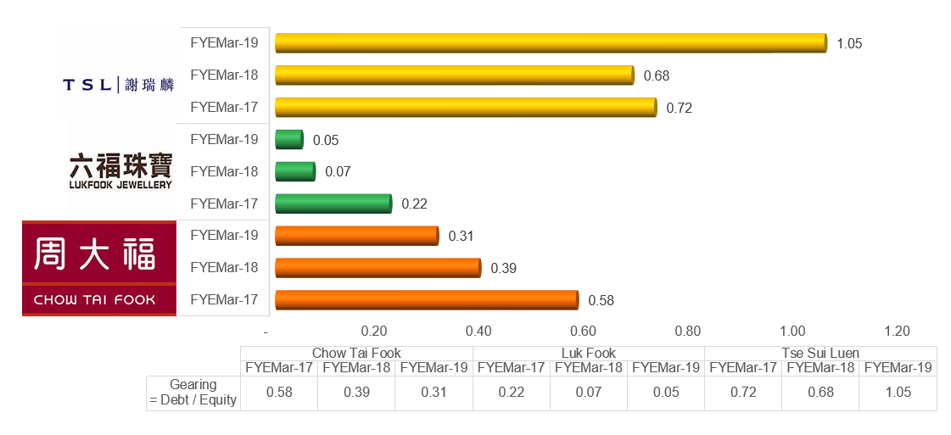
Source: Constructed by the author.

Overall, LF and TSL did not take up long-term debt. If we consider CTFJ’s cash at HK$7.64 billion, net gearing is at a low and comfortable 0.33X (Table 2-2).

2.2.3 Cash Cycle

A research confirmed that the duration of the cash cycle impact to the company’s lucrativeness (Yazdanfar and Öhman, 2014). CTFJ’s cash cycle reduced from 273 days in Mar-17 to 255 days in Mar-19 (Table 2-2), mainly due to a higher creditor payment period, which may be an indicator of CTFJ’s negotiation power as an industry leader. Like LF, jewellery retailers in general maintain relatively high cash cycles.

Figure 2-4 Cash Cycle between 2017 and 2019
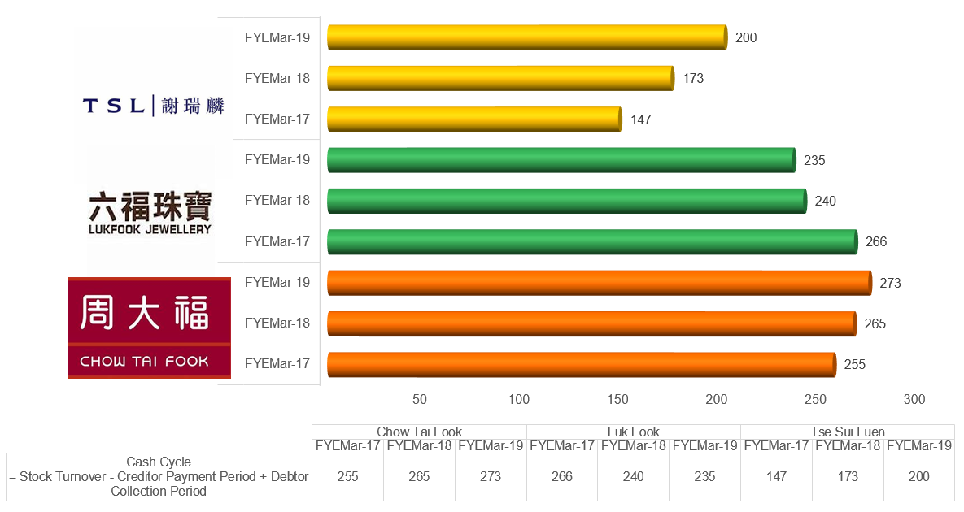
Source: Constructed by the author.

2.2.4 Leverage Ratio

It reveals how long for a company to repay its debt with a constant rate of debt and EBITDA. In FYE31Mar-19, CTFJ’s leverage increased from 1.93X to 2.38X (Figure 2-3), due to higher total debt incurred. CTFJ’s leverage is higher than LF but lower than TSL, considering that the latter had a declining EBITDA margin between FYE31Mar-18 & FYE31Mar-19. If we consider CTFJ’s cash at HK$7.64 billion, its net leverage is indeed a healthy ratio at 1.37X (Table 2-2).

Figure 2-5 Leverage Ratio between FYE17-19
Source: Constructed by the author

2.2.5 Share Performance
CTFJ’s P/E ratio at 17X appeared to be highest among the peers. Notwithstanding the above, its dividend yield 6.75% to 8.19% appears to be the highest as well (Table 2-3). It implies that investors are delighted to pay $17 for $1 current earning from CTFJ, investors are expecting a higher earnings progress in future comparing to its peer group.
Table 2-3 Share Performance
Source: Constructed by the author.

The dividend per share in Table 2-3 is referring to the total of special and normal dividend (Figure 2-3) of the FYE.
Figure 2-6 Dividend per share (HK$)
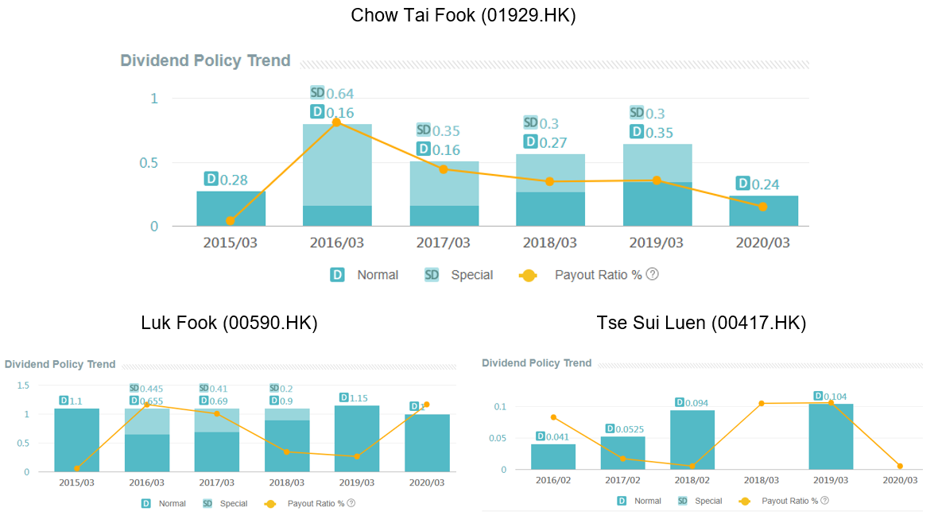Source: (AASTOCKS, 2020)

2.2.6 The Du Pont Identity

Figure 2-7 Du Pont Identity for CTFJ as of FYE31Mar-19

Source: Constructed by the author

It is a methodology to analyze what changes in operation may affect the company’s return on equity (Little, Little and Coffee, 2009). By using this model, we may look more in-depth to the company’s liability management, asset management, and sales management. Table 2-4 below is using the data from the annual reports of Chow Tai Fook (2017-2019), Luk Fook (2017-2019), and Tse Sui Luen (2017-2019).

Table 2-4 Data used for Du Pont Model
Source: Constructed by the author.

Liability Management: CTFJ’s EM in FYEMar-19 was slightly lower than LF but performing stronger than TSL (Figure 2-8). Therefore, TSL has more financial leverage in this comparison. Given the risks mentioned in Chapter 1.7 that may affect the cash flow of the industry, CTFJ may reduce its debt financing so to lower the obligation in debt service costs.

Figure 2-8 Equity Multiplier
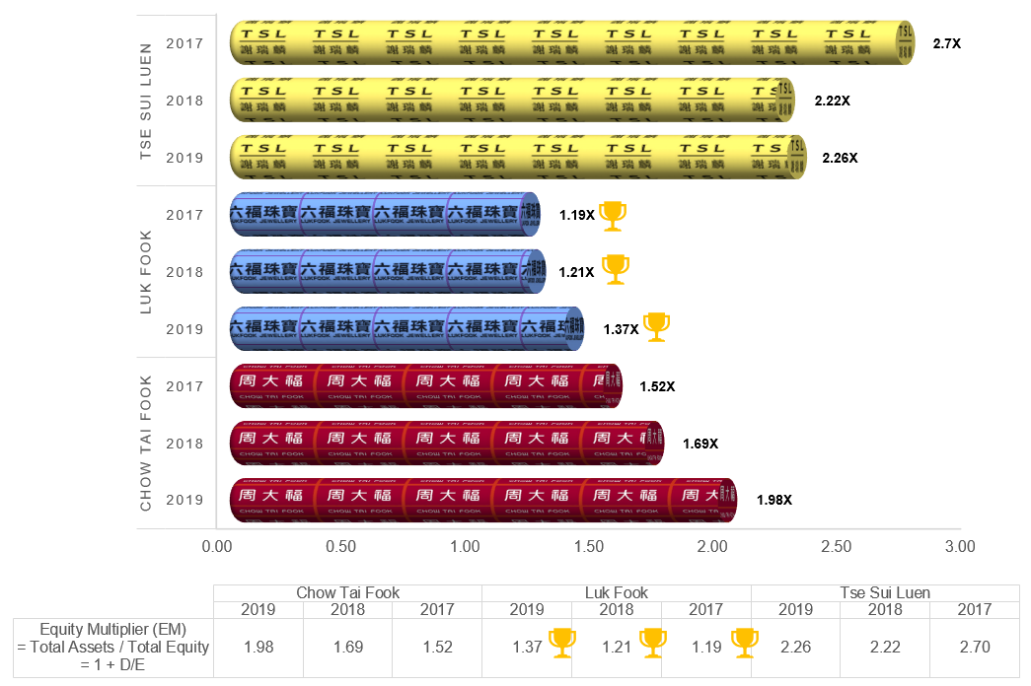
Source: Constructed by the author.

Asset Management: CTFJ’s Total Asset Turnover is in line with its peer in FYEMar-19, although TSL is slightly better in this aspect (Figure 2-9). In general, it reflects that CTFJ is generating slightly more than 1 dollar of sales for every dollar invested in assets.

Figure 2-9 Total Asset Turnover
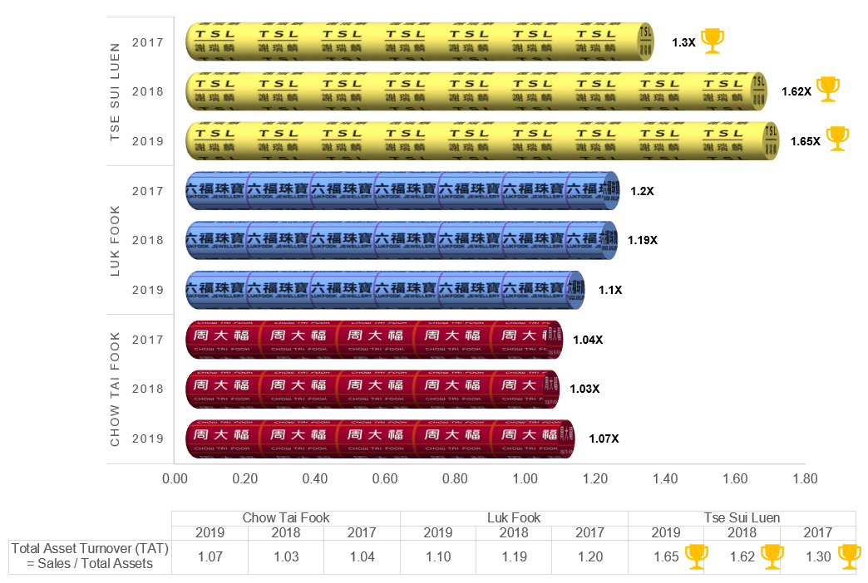
Source: Constructed by the author.

Sales Management: Although CTFJ has the highest sales revenue, its net profit margin at 7.03% is not as healthy as LF at 9.48% in FYEMar-19 (Figure 2-10). It is due to the higher cost of goods sold.

Figure 2-10 Net Profit Margin
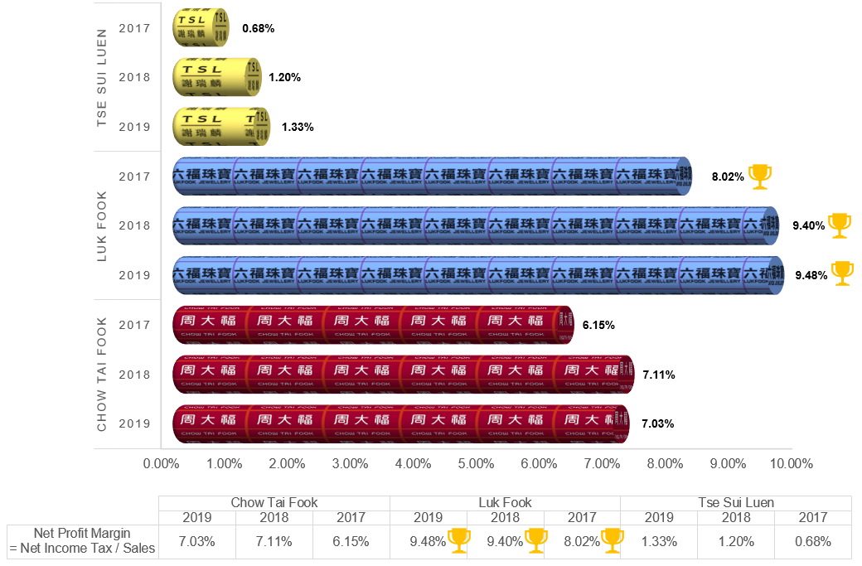
Source: Constructed by the author.

Overall, CTFJ captured its ROE at 14.92% in FYE31Mar-19, higher than its peer group (Figure 2-11). It indicates that CTFJ managed efficiently in using the company’s assets to create profits.

Figure 2-11 Return on Equity
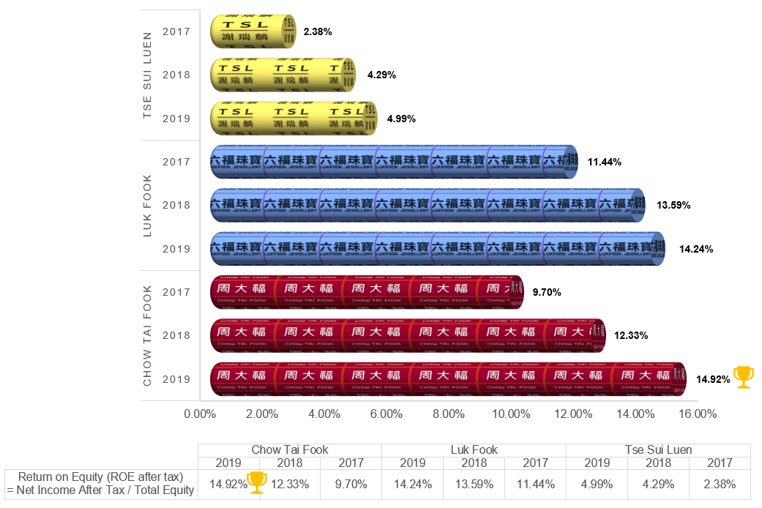
Source: Constructed by the author.

2.2.7 Bankruptcy Index
Altman Z-Score is an equation that reveals a company’s possibility of going bankrupt (Batchelor, 2018). Data from Table 2-5 is retrieved from the companies’ annual reports (Chow Tai Fook, 2017-2019), (Luk Fook, 2017-2019) and (Tse Sui Lune, 2017-2019).
Table 2-5 Data for Z-Score analysis
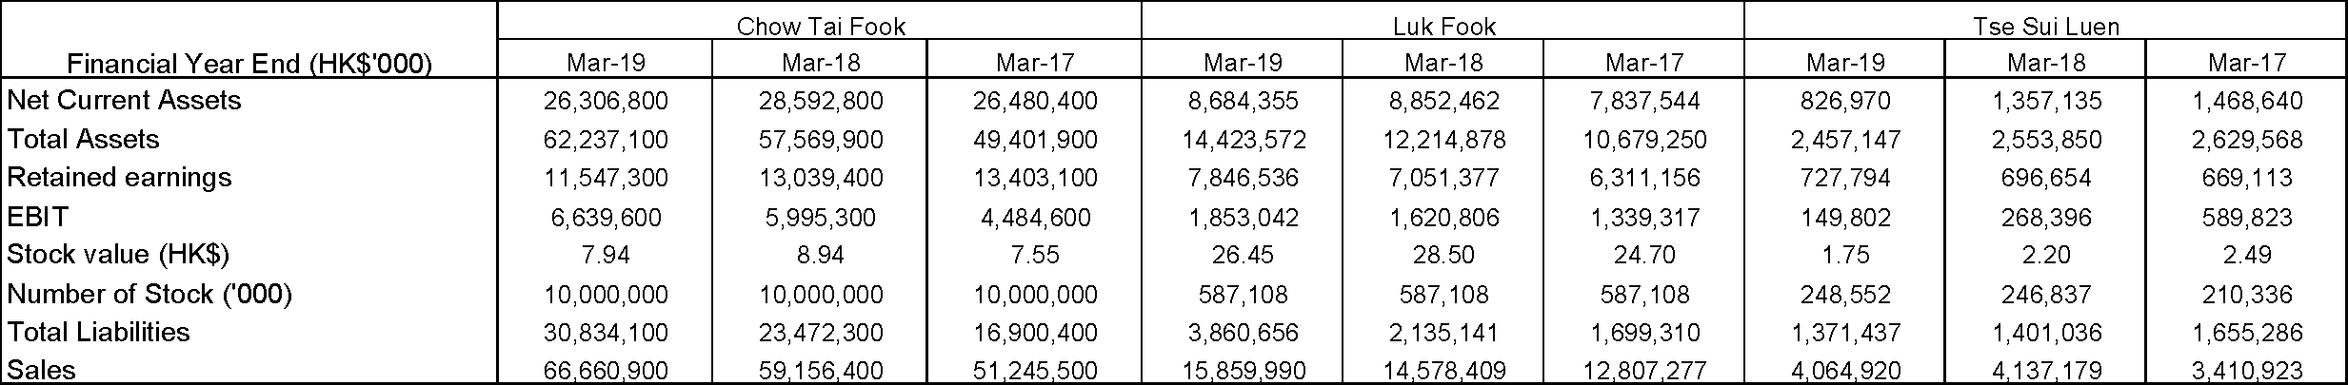 Source: Constructed by the author.
The stock value in Table 2-5 refers to the nearest closing stock value of the FYE.

Figure 2-12 CTFJ’s Stock Value between FYEMar-17 and Mar-19
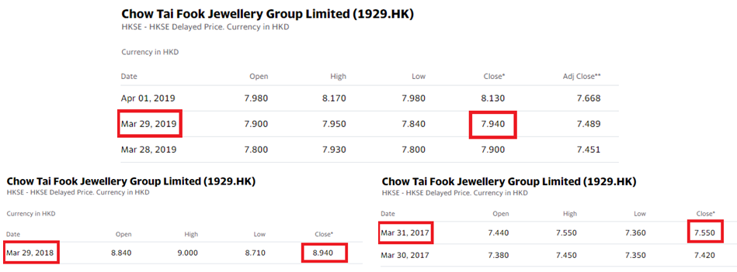
Source: (Yahoo Finance, 2020)

Although CTFJ’s Z-score 3.73 in FYE31Mar-19 was lower than LF at 5.42 (Table 2-6), in view that the latter has lower bank borrowings against total assets (Table 2-5), CTFJ is still financially healthy with a remote probability of bankruptcy.

Table 2-6 The Z-Score Analysis
Source: Constructed by the author.

Corporate Governance – Internal control and risk management
Corporate Governance is crucial for a company as a responsibility to the business’s interest of the shareholders for transparency, fair and accountable (Arjoon, 2005). In this chapter, we will study CTFJ’s governance system and its risk management, followed by recommendations to enhance efficiency.

3.1 Corporate Governance System
CTFJ has a transparent and well-defined governance system, as reflected in its annual report (Chow Tai Fook, 2019, pp. 105-189).

Figure 3-1 Corporate Governance System
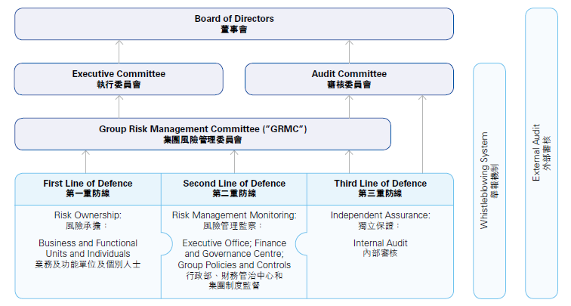
Source: (Chow Tai Fook, 2019, p. 166)

Its risk governance system is articulated between:

- The Board Oversight helmed by the Board of Directors that appoints the Executive Committee and an independent Audit Committee that oversees the risk management and internal control systems on behalf of the board. The board is accountable for scrutinizing and assessing the CTFJ’s policies are under legal and regulatory obligations, primarily the Listing Rules, the Companies Ordinance and the Securities & Futures Ordinance (Chow Tai Fook, 2019, p. 131).

- Management Oversight through a Group Risk Management Committee comprises of Managing Director and executive directors from significant business and divisions, maintaining the risk management and internal control structure, and reviews principal risks quarterly (Chow Tai Fook, 2019, p. 167).

- Three Lines of Defense (Chow Tai Fook, 2019, pp. 167-168) that comprises
First Line of Defense: Mainly is the business and function units.

Second Line of Defense: Made up of Executive Office, Finance and Governance Centre, and Group Policies. The above offices determine guidelines, processes, and benchmarks to underpin risk management and internal control systems. They also examine the prosecution of critical group guidelines such as anti-fraud policy, code of conduct, and crisis management policy.

Third Line of Defense: It is the independent audit department that reports to both the Group Risk Management Committee and the Audit Committee. Internal auditing independently assesses the suitability and efficacy of the risk management and internal control systems.

- External audit offers opinions and measurements of the procedures. It conveys with board committees and management on any risk araised (Chow Tai Fook, 2019, p. 168).

- A separate whistleblowing system gives a private network to persuade staff to bring up matters on fraudsters, and misbehavior whilst assuring confidentiality and job protection (Chow Tai Fook, 2019, p. 168).

3.2 Transparency and board diversity within a traditional family business
CTFJ grew from a traditional family business, with 89% of shareholdings from the founding family (Chow Tai Fook, 2019, p. 162). To date, 4 out of 9 executive members are from the Cheng family helmed by Dr. Henry Cheng (Table 3-1). The rest of the board is from third parties, which forms more than 50% of the executive board, including the Managing Director, Mr. Wong Siu-Kee Kent.

The team of independent non-executive directors are all non-family members, which serves as chairmen or members of the independent nomination committee, remuneration committee, and audit committee, i.e., there is transparency and independence in the business.

Table 3-1 Executive directors from the Cheng family
Source: Constructed by the author.

Segregation of duties: The roles of Chairman Dr. Henry Cheng and Managing Director, Mr. Keng Wong, are well-defined. Dr. Cheng is providing leadership for the board and ensures the board delivers effectively. On the other hand, Mr. Wong is responsible for CTFJ’s day-to-day operations and business developments.

Internal policies, controls, and practices: CTFJ has in place policies, controls and practices approved by the management led by Mr. Wong, including insider trading and business ethics, with an escalation process to the board for non-compliance. A review of internal controls is closely linked to its risk management framework, as defined above. The internal controls are subject to internal audits.

3.3 Compliance with Corporate Governance Code
Since its listing in 2011, there has been no adverse news on non-compliance with the Exchange. CTFJ compliance with all relevant listing rules and obligations outlined in Appendix 14 (HKEx, 2020a) of the Corporate Governance Code (Chow Tai Fook, 2019, p. 131). In terms of code of conduct covering insider trading (HKEx, 2020b), annual checks on directors and relevant employees have been conducted, and the above is in compliance (Chow Tai Fook, 2019, p. 171).

3.4 Emerging Risks and Challenges

Regulatory Risks: Other regulatory risks include environmental risk, local cyber-security risk, and Personal Data Privacy Ordinance (Hong Kong e-Legislation, 1996). CTFJ’s production facilities are primarily based in China, and it must observe the local environmental regulations, such as carbon emissions. An annual sustainability report (Chow Tai Fook, 2019b) is published on both CTFJ & HKEx website. Separately, with an extensive online store, CTFJ has to ensure that there is sufficient protection on its customer information, including the General Data Protection Regulation in the European Union and Cybersecurity Law in China, are abided (Chow Tai Fook, 2019, p. 178).

Anti-Money Laundering: Jewellery and its products are at higher peril of being used for money laundering due to its size, weight, and value. Considering that anti-money laundering regulations do not bound the industry, jewellery retailers may not be equipped with the essential skills and competence to distinguish dubious trades. CTFJ employed third party consultants to assess and examine its internal controls, competency of staff in identifying fraudulent transactions, and executing adequate regulations (Chow Tai Fook, 2019, p. 171).

COVID-19 Risk: COVID-19 risk is unprecedented. There may not be adequate risk controls to meet the unprecedented disruptions in supply chains, temporary closure of outlets, re-deployment of staff, management of high inventories during lock-down periods, and implementing of other cost-cutting measures without compromising risk controls.

Investment Project Appraisal
In the past three years, CTFJ’s development mainly on its new POS, involved 29% of its investment in building constructions, and 64% to new furniture, fixtures, and leasehold improvements; only 7% of the investment was to its plant and machinery (Figure 4-1). Lately, CTFJ announced to expand the China market further, to open approximately 450 POS by Q1 2021 (Reuters, 2020). The expansion to China is the right choice here, and it may help to lower the risk level mentioned in the previous section (Chapter 3.4).

Figure 4-1 CTFJ’s average expense in development between 2017 and 2019
Source: Constructed by the author.

In 2019, CTFJ’s China revenue was 42,432 million (Figure 1-4), we will delve into a 10-year investment project by tapping into 5% of the revenue, i.e., HKD 2,121.6 million. The plan shall use the fund to expand the 450 POS. Furthermore, to support the growth and boost production, CTFJ shall also consider modernizing and replacing its plants and machinery at the Chow Tai Fook Jewellery Culture Industrial Park by using the residual fund, which those were not upgraded in the recent years.

4.1 Cost breakdown of the investment project
The project shall employ total HKD 2,121.6 million, and the breakdown is according to the average expenditure between 2017 and 2019 (Table 4-1), except we are suggesting a bigger portion in replacing plant and machinery.

Table 4-1 Cost breakdown of the investment project
Source: Constructed by the author

The forecasting will also take into the consideration of CTFJ’s sales growth rate in China, EBITDA margin, and the major selling & distribution costs & general & administrative “SG&A” expenses, by the average between 2017 and 2019 (Table 4-2).

Table 4-2 Average financial data between 2017 and 2019 for projection
Source: Constructed by the.

4.2 Profit and Cash Flow
In this section, we will examine the profit and cash flow of this investment project, with the depreciation rate outlined in Table 4-3, followed by an investment appraisal.

Table 4-3 Depreciation rate and other data for the investment project
Source: Constructed by the author with CTFJ’s Annual Reports (Chow Tai Fook, 2017; 2018; 2019).

4.2.1 Profit in 10 years
In 2019, CTFJ’s China revenue was 42,432 million (Figure 1-4). If we launch the new project, assuming in Year 1, the project itself is expecting 40% from 2019’s revenue. NPV breakeven point to the 2019 revenue is between 33% to 34% (Figure 4-2), since this project will establish extra POS, new plant and machinery, that will increase its production resulted in higher cash flows. Thus, we are expecting 40% from last year as a conservative approach, i.e., this project itself will bring in revenue of 42,432 x 40% = 16,972.8 million for the first year.

Figure 4-2 NPV breakeven point
Source: Constructed by the author

Assuming y-to-y growth rate is 6.81% for the first five years, then followed by 3.2% from the 6th years onward (Table 4-3).

Table 4-4 Profit in 10 years
Source: Constructed by the author

4.2.2 Cash Flow in 10 years

Cash flow from operations = EBITDA – Tax – SG&A

Table 4-5 Cash Flow in 10 years
Source: Constructed by the author

4.3 Four Types of Investment Appraisal
In this chapter, we will use four types of investment appraisal to evaluate and support the decision of this investment project: i) Accounting Rate of Return “ARR”, ii) Net Present Value “NPV”, iii) Payback Period “PBP”, iv) Internal Rate of Return “IRR”.

Table 4-6 Data for Investment Appraisals
Source: Constructed by the author

4.3.1 ARR
ARR is a methodology to show a project’s accounting yield, if the result is higher than the enterprise’s expectation, e.g., return on asset “ROA”, then it is worth proceeding. Although the accounting yield did not take the cash flow and time value into consideration, this is a proper way to gauge an investment (Zhao and Zhang, 2019). According to Table 4-6, the ARR is 8%, higher than CTFJ’s ROA in 2019 at 7.53%; this is a project with a promising return.

4.3.2 NPV
NPV illustrates the accumulated prosperity increase throughout an investment period; however, it does not appraise the actual profitability of the capital (Lajos, 2011). The NPV of this project is 341.94 (Table 4-6). If the RRR is smaller than 10.8%, then this project is worth to invest (Figure 4-2).

Figure 4-3 NPV Profile
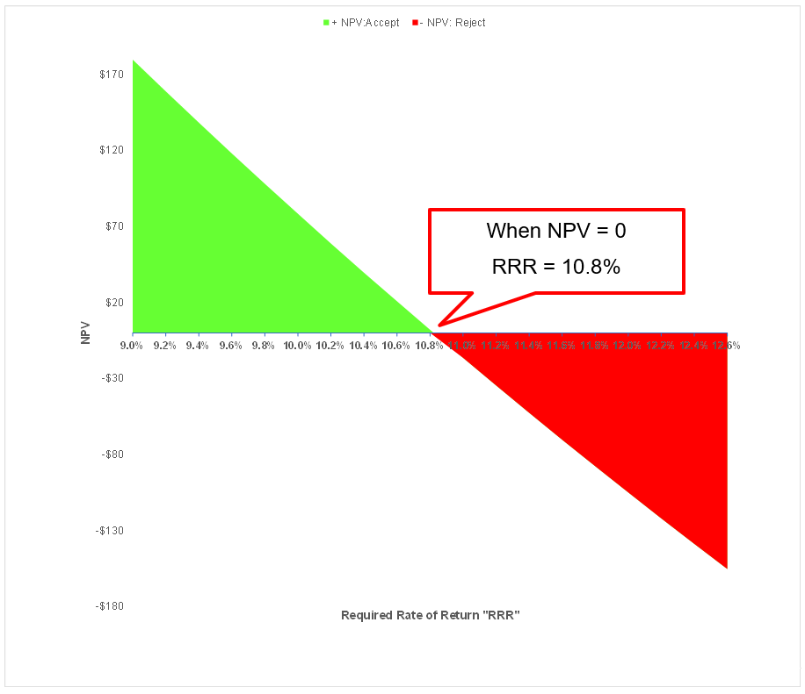
Source: Constructed by the author

4.3.3 PBP
The term is self-explanatory; it shows the timeframe that a project will be able to produce ample funds to offset the initial cost (Lajos, 2011). Our project revealed that it would need 6 years and 1 month to payback (Figure 4-4).

Figure 4-4 Payback Period
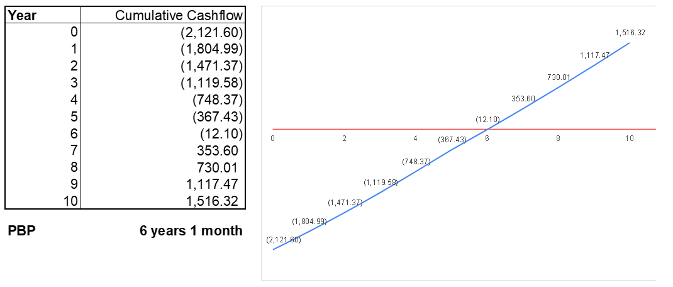
Source: Constructed by the author

4.3.4 IRR
IRR is a way to evaluate a project if its rate of return is higher than the company’s gauge, and the company shall only invest if the IRR is beyond the yardstick (Ryland, 2009, p. 140). As per the calculation from Table 4-6, and when NPV=0 (Figure 4-3), the IRR of this project is 10.8%. IRR is higher than CTFJ’s ROA in 2019 as a benchmark.

4.4 Assessment of the investment project

In reviewing the above investment appraisals, all of those have a positive value and higher than CTFJ’s benchmark on investment return: ARR is higher than the ROA, NPV is positive value, PBP is 6 years and 1 month, IRR is greater than the ROA. Therefore, all index support that this investment is at low risk and is valuable.

CTFJ may proceed to this project, and may consider entering a long term debt to raise the fund; Besides that, since the project will install new plant and machinery, CTFJ will need more raw materials to increase its production, where the cost of goods sold will also be increased. CTFJ may proceed to another working-capital financing, so the company will have sufficient funds to purchase gold materials for its production lines.

Fund-raising and working capital management
The project is expecting to cost HK2,121.6 million, which is 3.4% of CTFJ’s total assets in 2019 (Table 5-1). In this chapter, we will evaluate what financing options are available for CTFJ and its pros and cons.

Table 5-1 Financing for long-term project
Source: Constructed by the author

5.1 Financing options
There are numerous ways of financing, and we will analyze between the equity and debt financing:

i) Equity financing – it refers to a listed firm issuing new shares for the fund-raising, thus, through investors (Huang and Zhang, 2017). The advantage is that the firm does not need to pay back the money and not to involve in any monthly re-payment, then the company will have more liquid cash for other operational expenses. However, this is indeed giving up some portions of the ownership to the investor’s stake. There are other cheaper options in financing.

ii) Debt financing – A research explained that although debt might be risky, it is still better than equity financing (Narayanan, 1988). Once a company repays its loan, then the relationship with the lender is ended, and the lender has no right to control over the firm. Moreover, the interest that occurs from debt financing is taxable as a business expense. However, for small or new startup firms, they might have difficulties to get a bank loan approval without loan history, but CTFJ is a well-established company which this problem does not apply.

5.2 Financing alternatives analysis
As explained, debt is cheaper than equity. Given the strong balance sheet and part of the top 4 conglomerates in Hong Kong, Chow Tai Fook/ New World Development, Sun Hung Kai, Cheung Kong and Henderson Land (Chung & Karmali, 2020), CTFJ is well supported by both international and local banks, and will be able to obtain cheaper debt financings compared to small-medium enterprises. Furthermore, raising capital from third parties may dilute the shareholdings of the existing Cheng family.

In terms of financing, CTFJ should review its financing for the:
(i) new production project (Appendix 1)
(ii) working capital financing for projected incremental production (Appendix 2)

Working capital financing for raw materials should be financed by short term financing, which can be either a revolving credit facility or trade financing facility.

While new production project is a long-term investment and should be funded by long term borrowings or equity. In considering whether to use long-term borrowings or equity, we assess the gearing ratio (net debt/equity) and leverage ratio (net debt/EBITDA), on a before and after the drawdown of a new loan, to determine whether there will be an over-gearing or over-leverage situation.

Based on our projected cashflows (Appendix 3) and projected balance sheet (Appendix 4), the financing ratio summary as follows:
Table 5-2 Projected gearing and leverage ratio in 10 years
Source: Constructed by the author

Net gearing will increase from 0.33X to 0.67X in Year 1, before gradually reducing over the next 10 years. Net leverage will increase from 1.37X to 2.58X in Year 1, before gradually reducing over the next 10 years (Table 5-2). Given the above, CTFJ need not consider raising equity for its new funding needs.

5.3 Financing recommendation
For the long-term project, CTFJ shall take a long term loan, while the 3-month HIBOR is 0.45% (Figure 5-1), and existing bank borrowings ranged from 0.6%-0.9% over HIBOR (Chow Tai Fook, 2019, p. 250).

Figure 5-1 HIBOR
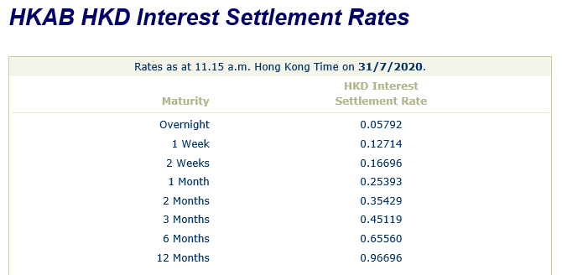
Source: (The Hong Kong Association of Banks, 2020)

Assuming the margin is 1.25% then the total interest rate is only at 1.7%

Table 5-3 Interest rate
Source: Constructed by the author

With the low-interest rate, CTFJ may consider financing 80% of the project cost and the rest to pay by current equity (Table 5-4).

Table 5-4 Long-term financing 80% of project cost
Source: Constructed by the author

Conclusion and recommendation

CTFJ is financially healthy and has a growing potential compared to its peer in Hong Kong. The company is compliant with the corporate governance code, and it is transparent to its shareholders. An investment project is suggested to CTFJ and showing a good return in revenue.

6.1 Suggestions to CTFJ

Apart from the investment project proposed in Chapter 4, below are other prioritized suggestions that CTFJ may proceed in the coming quarters, that may improve the overall performance.

Figure 6-1 Gantt Project Chart

Source: Constructed by the author

Q4 2020 - Rationalization of retail outlets, including regular review of its leases during down cycles. CTFJ has experienced steady growth in its China market, and there is growth potential and higher yields in 3rd and 4th tier cities in China compared to mature markets in Hong Kong and Macau with escalating rental costs uptill Dec-2019. CTFJ should constantly review the lease contracts vis-a-vis the shop’s monthly performance. For instance, there are three retail outlets in sky-high rental Central Hong Kong, where these shops are located within proximity of 100 meters (Figure 6-1). CTFJ can leverage on its strong market position to negotiate for better lease terms such that it has more flexibility in managing its retail outlets in the same region during down cycles.

Figure 6-2 CTFJ’s retail outlets in Central Hong Kong
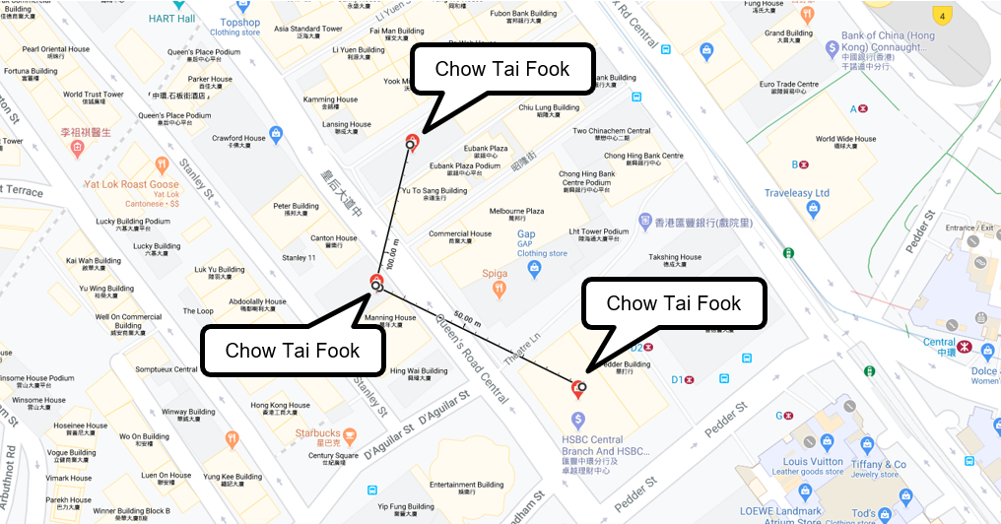
Source: (Google Maps, 2020)

Separately, CTFJ can expand on its online network where rental of premises is not required. Online networks can increase their coverage to internet-savvy clients and to cater to customers when travel is inaccessible. Alternatively, it can strengthen its franchise model where the franchisees cover rentals.

Q1 2021 - Maintaining effective employee costs controls. General and distribution costs represent 13.6% and 13.9% of total revenue in 2019 and 2018, respectively (Chow Tai Fook, 2019, p. 190).

Table 6-1 CTFJ’s General and distribution costs
Source: Constructed by the author

Apart from leases that contributed 2.3% (Chow Tai Fook, 2019, p. 68) of the 13.6% mentioned above, employee costs contributed to a higher 6.9% (Chow Tai Fook, 2019, p. 68). Hence, CTFJ must maintain a robust employee cost structure. Whilst relocating certain stores from Hong Kong & Macau to 3rd & 4th tier Chinese cities will indirectly cut down on its staff costs per store, it is crucial for the CTFJ to adopt flexibility in staff management such as incorporating a percentage of salaries for downward adjustments during down-cycles or contracts on a renewal basis.

Q2 2021 - Improving its supply chain and inventories control. Jewellery retailers typically have high cash cycles, mainly due to high inventories-days on hand hovering between 294 to 300 days from 2017 and 2019 (Table 2-2). The above figures may increase during retail down cycles. CTFJ should continuously review its supply chain to maintain its inventories level, and if need beholds global/region-specific events to move sales.

Q3 2021 - Lowering its dividend payouts for higher retained earnings. Over the last 3 years, dividend payouts (Chow Tai Fook, 2019, p. 77) has been higher than its net profits (Chow Tai Fook, 2019, p. 195), which led to stagnated equity levels despite strong profitability. Strong dividend payouts may improve the share price; however, it will lead to slower equity growth. Indirectly, the CTFJ will have to rely more on debt or equity financing for future expansions instead of relying on its equity.

Table 6-2 CTFJ’s dividend payouts
Source: Constructed by the author.

On-going Q4 2020 to Q4 2021 - Maintain a robust Business Continuity Plan and Crisis Management Plan. To ensure efficient operations during unforeseeable situations, e.g., massive earthquakes and flooding in China that have impacted to 27 provinces in 2019 (Lee, 2020), or prolonged protests and health crisis in Hong Kong which have worried Paul Chan, Financial Secretary of HK, and forewarned for an economy’s burden (Choy, 2020).

Appendix 1: Financing calculation for long-term project

Appendix 2: Working Capital Financing

Appendix 3: Projected Cashflows

Appendix 4: Projected Balance Sheet

Appendix 5: Academic Reference

Arjoon, S. (2005) ‘Corporate Governance: An Ethical Perspective’, Journal of Business Ethics, 61(4), pp. 343-352. DOI: 10.1007/s10551-005-7888-5

Batchelor, T. (2018) ‘Corporate Bankruptcy: Testing the Efficacy of the Altman Z-Score’, International Research Journal of Applied Finance, 9(9), pp. 404-414. Available at: https://nebula.wsimg.com/65384c67d85fb86c885b3b2e9ebf7e87?AccessKeyId=A83663472B839ECDD54B&disposition=0&alloworigin=1 (Accessed: 17 July 2020).

Huang, Y. and Zhang, M. (2017) ‘Research on Evaluation of Equity Financing Efficiency of Listed Companies in Strategic Emerging Industries’ Journal of risk analysis and crisis response, 7(4), pp. 189-213. DOI: 10.2991/jrarc.2017.7.4.2

Kliestik, T. et al. (2020) ‘Remaining Financially Healthy and Competitive: The Role of Financial Predictors’ Journal of Competitiveness, 12(1), pp. 74-92. DOI: 10.7441/joc.2020.01.05

Lajos, J. (2011) ‘Net present value versus internal rate of return’ Economics & sociology, 4(1), pp. 46-53. DOI: 10.14254/2071-789X.2011/4-1/5

Little, P. L., Little, B. L. and Coffee, D. (2009) ‘The Du Pont model: evaluating alternative strategies in the retail industry’ Academy of Strategic Management Journal, Volume 8, pp. 71-80.

Muradoglu, G., Bakke, M. and Kvernes, G. (2005) ‘An investment strategy based on gearing ratio’ Applied Economics Letters, 12(13), pp. 801-804. DOI: 10.1080/13504850500365780

Narayanan, M.P. (1988). ‘Debt versus Equity under Asymmetric Information’ Journal of Financial & Quantitative Analysis, 23(1), pp. 39-52. DOI: 10.2307/2331023

Platt, H.D., Platt, M.B. and Chen, G. (1995) ‘Sustainable growth rate of firms in financial distress’ Journal of Economics and Finance, 19(2), pp. 147-151. DOI: 10.1007/BF02920515

Ryland, P. (2009) Investment an A-Z guide. London: Profile Books Ltd.

Yazdanfar, D. and Öhman, P. (2014) ‘The impact of cash conversion cycle on firm profitability’ International Journal of Managerial Finance, 10(4), pp. 442-452. DOI: 10.1108/IJMF-12-2013-0137

Zhao, R. & Zhang, X. (2019) ‘Analysis of Investment Decisions of SMEs’ Advances in Economics, Business and Management Research, Volume 82. DOI: 10.2991/icmete-19.2019.102

Appendix 6: Bibliography
AASTOCKS (2020) Dividend Policy Trend. Available at: http://www.aastocks.com/en/stocks/analysis/dividend.aspx?symbol=01929 (Accessed: 17 July 2020).

Brown, T. (2020). China after COVID-19: how are consumers returning to shopping venues?. Available at: https://retailinasia.com/in-telligence/china-after-covid-19-how-are-consumers-returning-to-shopping-venues/ (Accessed: 19 July 2020).

Chow Tai Fook (2011) Chow Tai Fook IPO Prospectus. Available at: https://www1.hkexnews.hk/listedco/listconews/sehk/2011/1205/ltn20111205046.pdf (Accessed: 18 July 2020).

Chow Tai Fook (2017) Annual Report 2017, Available at: https://ir.ctfjewellerygroup.com/ar2017_en.pdf (Accessed: 18 July 2020).

Chow Tai Fook (2018) Annual Report 2018, Available at: https://ir.ctfjewellerygroup.com/ar2018_en.pdf (Accessed: 18 July 2020).

Chow Tai Fook (2019) Annual Report 2019, Available at: https://ir.ctfjewellerygroup.com/ar2019_en.pdf (Accessed: 18 July 2020).

Chow Tai Fook (2019b) Substainability Report. Available at: https://www.ctfjewellerygroup.com/file/Sustainability/reports/csr2019.pdf (Accessed: 19 July 2020).

Choy, G. (2020) ‘Hong Kong third wave: Financial Secretary Paul Chan warns government handouts won’t last, even as Covid-19 piles more pressure on economy’ South China Morning Post, 2nd August. Available at: https://www.scmp.com/news/hong-kong/hong-kong-economy/article/3095700/hong-kong-third-wave-financial-secretary-paul-chan (Accessed: 2 August 2020).

Google Maps (2020) Chow Tai Fook [Map]. Available at: https://www.google.com/maps/search/chow+tai+fook/@22.2821906,114.156007,19z/data=!4m8!2m7!3m6!1schow+tai+fook!2sCentral!3s0x34040064a31dd1bd:0x5007a73bdeccb552!4m2!1d114.1587983!2d22.2799907 (Accessed: 1 August 2020).

Chung, G. and Karmali, N. (2020) ‘Hong Kong’s Richest 2020’ Forbes, 6th February. Available at: https://www.forbes.com/hong-kong-billionaires/#153ae2c13e46 (Accessed: 12 July 2020).

HKEx (2020a) Appendix 14 Corporate Governance Code and Corporate Governance Report. Available at: https://en-rules.hkex.com.hk/sites/default/files/net_file_store/new_rulebooks/h/k/HKEX4476_3828_VER10.pdf (Accessed: 19 July 2020).

HKEx (2020b) Appendix 10 Model Code for Securities Transactions by Directors of Listed Issuers. Available at: https://en-rules.hkex.com.hk/sites/default/files/net_file_store/new_rulebooks/h/k/HKEX4476_3785_VER10.pdf (Accessed: 19 July 2020).

HKTDC Research (2019) China’s Jewellery Market. Available at: https://hkmb.hktdc.com/en/1X002MMK/hktdc-research/China%E2%80%99s-Jewellery-Market (Accessed: 18 July 2020).

Hong Kong e-Legislation (1996) Cap. 486 Personal Data (Privacy) Ordinance. Available at: https://www.elegislation.gov.hk/hk/cap486 (Accessed: 19 July 2020).

Hong Kong Tourism Board (2019) Total Visitor Arrivals, Hong Kong. Available at: https://securepartnernet.hktb.com/en/research_statistics/tourism_statistics_database/index.html (Accessed: 18 July 2020).

Kothari, S. (2020) ‘The impact of COVID-19 on the gems and jewellery industry’, SMB Story, 6th June 2020. Available at: https://yourstory.com/smbstory/covid-19-impact-gems-jewellery-industry (Accessed: 19 July 2020).

Lee, A. (2020). ‘China’s economic recovery under threat from fresh coronavirus outbreaks and floods, analysts say’, South China Morning Post, 2nd August. Available at: https://www.scmp.com/economy/china-economy/article/3095458/chinas-economic-recovery-under-threat-fresh-coronavirus (Accessed: 2 August 2020).

Luk Fook (2017) Annual Report 2017. Available at: https://www.lukfook.com/wp-content/uploads/2017/07/ew_00590ar-29062017.pdf (Accessed: 1 July 2020).

Luk Fook (2019) Annual Report 2018. Available at: https://www.lukfook.com/wp-content/uploads/2018/07/ew_00590ar-27062018.pdf (Accessed: 1 July 2020).

Luk Fook (2019) Annual Report 2019. Available at: https://www.lukfook.com/wp-content/uploads/2019/07/cw_00590ar-27062019.pdf (Accessed: 1 July 2020).

Magramo, K. (2020) ‘Hong Kong’s Chow Tai Fook, world’s second-largest jewellery retailer, kicks off mainland China expansion with acquisition of gems maker Enzo’ South China Morning Post, 18th Janurary. Available at: https://www.scmp.com/business/article/3046618/hong-kongs-chow-tai-fook-worlds-second-largest-jewellery-retailer-kicks (Accessed: 1 July 2020).

National Bureau of Statistics of China (2020) Preliminary Accounting Results of GDP for the Second Quarter and the First Half Year of 2020. Available at: http://www.stats.gov.cn/english/PressRelease/202007/t20200717_1776596.html
(Accessed: 1 August 2020).

Reuters (2011) Chow Tai Fook says prices HK IPO at HK$15/share. Available at: https://www.reuters.com/article/chowtaifook-ipo-idUSL3E7ND4G020111213
(Accessed: 12 July 2020).

Reuters (2020) UPDATE 1-HK jeweller Chow Tai Fook posts 36.6% drop in profit, eyes expansion in China. Available at: https://www.reuters.com/article/ctf-group-results/update-1-hk-jeweller-chow-tai-fook-posts-36-6-drop-in-profit-eyes-expansion-in-china-idUSL4N2DO23M (Accessed: 28 July 2020).

The Hong Kong Association of Banks (2020) HKAB HKD Interest Settlement Rates. Available at: https://www.hkab.org.hk/DisplayInterestSettlementRatesAction.do?lang=en
(Accessed: 31 July 2020).

Tse Sui Luen (2017) Annual Report 2017. Available at: http://doc.irasia.com//listco/hk/tsesuiluen/annual/ar176531-e00417_annualreport2016_17.pdf
(Accessed: 1 July 2020).

Tse Sui Luen (2018) Annual Report 2018. Available at: https://doc.irasia.com/listco/hk/tsesuiluen/annual/ar197701-e00417_annualreport2018.pdf
(Accessed: 1 July 2020).

Tse Sui Luen (2019) Annual Report 2019. Available at: https://doc.irasia.com/listco/hk/tsesuiluen/annual/ar215560-e00417_annualreport2018_19.pdf
(Accessed: 1 July 2020).

Yiu, E. (2015) ‘When it comes to jewellery, Chinese believe local companies are best’ South China Morning Post, 2nd June. Available at: https://www.scmp.com/business/companies/article/1814717/when-it-comes-jewellery-chinese-believe-local-companies-are-best (Accessed: 1 July 2020).

