Module title-Introduction to Health and Social care

Module code-LHCS4003

Assignment title- Portfolio

Student name- Aisha Hussain

Student number- 2431992

Lecturer name- Mumtaz Goolam

Task 1: Poster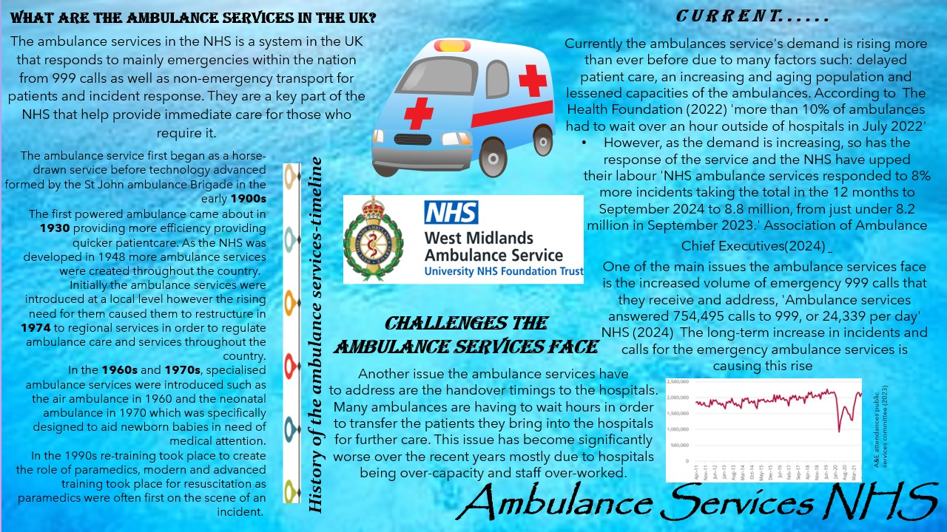
Task 2: Essay

Introduction:
The NHS is the National Health service that was created in 1948 by the National Health Service act 1946 that provides free healthcare available to everyone disregarding external factors such as age, wealth and race etc. The NHS was ‘the first western county to offer free at the point of use medical care to the whole population’ Clement (2023) The NHS is publicly funded through taxes providing the nation with services such as GP visits, mental health care and others such as dentists and opticians that require additional payment.

One of the influences in the creation of the NHS’ creation was the Beveridge report 1942, that called for care ‘from cradle to grave’ that implied the care provided to individuals should be from the moment they’re born up until their deathbed. This sparked the idea to create a service that is available to everyone. As effect of all this the National Health Service act 1948 came about which established the NHS. The first minister of health was Aneurin Bevan MP and stated that there should be an ‘improvement in the physical and mental health of people and the prevention, diagnosis and treatment of illness’ UK Parliament (2025)
World War 2 was another big impact for the formation of the service because it was made aware that free health is easily provided to all civilians when the public was treated and cared for in the war free of charge. Many new hospitals were also already created due to the world war therefore it made sense to come up with the service as the facilities were readily available. Before the war, hospitals, institutions and private care were all separate operating organisations. However, when the NHS was created, they all joined forces as one to create our healthcare system today.

The NHS is a network made up of multiple bodies and connected systems that provide the free, high-quality healthcare to the public. These bodies include The Department of Health and Social care, NHS England, primary care providers like the GP and dentists, and regulatory bodies such as The Care Quality commission. All these bodies work together creating the NHS’s connected system for example the NHS England will look to see the funding that is provided and where the money is spent, where the Department of Health and social care provides this money and funding.
However, despite these interlinking bodies there are many issues that the NHS currently must face. ‘The NHS will continue to evolve based on the challenges it faces at any one time.’ NHS (2024) Some of these issues are; the increased demand from the ageing and growing population, longer waiting lists for treatments and staff shortages. Additionally, the NHS is significantly underfunded which add to the many problems they face. Many changes and decisions have been made to try and improve these issues and to try and create efficiency in the service but there are still many struggles which threaten to affect the long-term stability of the system.

Reference list:

(2024) NHS choices. Available at: https://www.england.nhs.uk/long-read/monthly-operational-statistics-september-2024/
(Accessed: 18 October 2025).

(No date) House of Lords - Emergency Healthcare: A national emergency - public services committee. Available at: https://publications.parliament.uk/pa/ld5803/ldselect/pubserv/130/13005.htm
(Accessed: 18 October 2025).

Clement, D.M. (2023) The founding of the NHS: 75 Years on, History of government. Available at: https://history.blog.gov.uk/2023/07/13/the-founding-of-the-nhs-75-years-on/
(Accessed: 18 October 2025).

1946 National Health Service Act - UK parliament (no date b) 1946 National Health Service Act. Available at: https://www.parliament.uk/about/living-heritage/transformingsociety/livinglearning/coll-9-health1/health-01/ (Accessed: 18 October 2025).

Home (2024) aaceorguk. Available at: https://aace.org.uk/news/nhs-ambulance-services-achieve-performance-improvements-despite-significant-growth-in-demand-and-handover-delays-equating-to-183-years-of-lost-ambulance-capacity/
(Accessed: 18 October 2025).

Stafford, M. and Anne Alarilla, Mai Stafford, Ellen Coughlan, Josh Keith, A. (2022) Why have ambulance waiting times been getting worse? The Health Foundation. Available at: https://www.health.org.uk/reports-and-analysis/analysis/why-have-ambulance-waiting-times-been-getting-worse (Accessed: 18 October 2025).

Structure of the NHS (2022) NHS choices. Available at: https://www.england.nhs.uk/long-read/structure-of-the-nhs/ (Accessed: 18 October 2025).

