Numicon: closing the gaps and striving for mastery in mathematics at secondary school



Georgia Anne Hall
Submitted to the University of Wales in partial fulfilment of the requirements for the degree of Master of Arts (MA) Education (Teach First)
University of Wales Trinity Saint David
2019
Abstract

Numicon has a significant positive impact on the understanding of basic mathematical concepts in primary schools, however students continue to arrive at secondary schools in the United Kingdom with gaps in their knowledge of these basic concepts. The basis of Numicon is a system of coloured shapes that represent the numbers one to ten. The aim is to use Numicon as a multi-sensory approach to aid the learning of basic mathematics in line with the mathematics mastery approach to teaching.

The research was part of a self-evaluation procedure, after implementation of the Numicon programme. This report analyses the impact that Numicon can have at secondary school level, with a focus at key stage 3, and how it can inform the school’s sustained improvement plan for future practice.

It was found that all students involved in the research benefited from the Numicon intervention programme and disadvantaged learners benefited most substantially. The research gathers interpretations from different viewpoints to avoid bias in conclusions. On average; progress scores improved, teachers noticed a shift in confidence levels and students felt like they could access the mathematics mastery scheme of work in their core lessons more easily than prior to having the intervention.

It is recommended that Numicon should not be aimed at a specific age range or key stage at school, but at learners who have gaps in their knowledge of basic mathematical concepts as it is a powerful tool in closing those gaps.

Further research in this field is necessary to confirm findings on a larger scale and explore the impact that using Numicon in key stage 3 has on mathematics attainment in key stage 4.

Declarations and Statements

This work has not previously been accepted in substance for any degree and is not being concurrently submitted in candidature for any degree.

Signed:

Date:

This school improvement report is being submitted in partial fulfilment of the requirements for the degree of Master of Arts (MA) Education (Teach First).

Signed:

Date:

This School Improvement Report is the result of my own independent work/investigation, except where otherwise stated.

Other sources are acknowledged by footnotes giving explicit references. A reference list is appended.

Signed:

Date:

I hereby give consent for my School Improvement Report, if accepted, to be available for photocopying and for inter-library loan, and for the title and summary to be made available to outside organisations.

Signed:

Date:

Contents

List of Tables/Appendices 5
Acknowledgements 6
Main Text 7
Chapter 1: Introduction 7
What is Numicon? 7
Personal Disclosure 9
Aims of the Research 10
Rationale for Terminology 10
Chapter 2: Contextual Background 10
School Context 10
10
Purpose of the Research 10
Rationale within the Schools Sustained Improvement Plan 10
Chapter 3: Critical Analysis of Theoretical and Professional Literature 10
School Improvement 10
Raising Standards in Relation to Mathematics and Numeracy 10
Numicon Intervention 10
Chapter 4: Planning and Undertaking Research 10
Methodology 10
Ethics 10
Data collection procedures (validity and reliability) 10
Chapter 5: Data Analysis 10
Findings 10
Analysis of methods used: 10
Critical evaluation of the investigation – strengths and weaknesses 10
Chapter 6: Case for school priority implementation and Recommendations 10
Summary - Research Questions 10
School Improvement Recommendations 10
Further Research 10
References 10
Appendices 10

List of Tables/Appendices
Figure 1: The Numicon number shapes

Figure 2: A graph to show the progress of disadvantaged and non-disadvantaged students.

Figure 3: A graph to show the percentage of students achieving the basics at 4+ level over the past three years.

Table 1: Research Questions.

Table 2: Student participant demographics.

Table 3: Predicted Attainment definitions.

Table 4: Numicon analysis grid colour chart key.

Figure 4: A graph to compare progress scores and mathematics contribution to progress before and after the intervention.

Figure 5: A graph to compare the progress of Special Education Needs students against student who do not have special educational needs.

Figure 6: A line graph to compare progress of boys and that of girls, following the intervention.

Acknowledgements

To Teach First for the partial funding of this masters degree, as well as my current school and multi-academy trust for allowing me to undertake the research and accepting my recommendations for improvement so eagerly.


Main Text

Chapter 1: Introduction

What is Numicon?
Numicon is the market-leading primary school mathematics programme developed by the education publisher Oxford University Press (Oxford University Press, 2019). It is used to support the teaching of mathematics in Early Years and Key Stage 1 through a concrete-pictorial-abstract approach. Numicon was derived from a teacher development agency research project that investigated how primary teachers taught mathematics. It was quickly realised that teachers had been underestimating the difﬁculties children had understanding abstract ideas without using pictures to help them, so through using structured images, like those above, it was found that pedagogy improved, and children made remarkable progress. In 2014 research undertaken by Oxford University Press and presented in their 5-year impact report found that where Numicon was used at primary schools, results in the end of key stage 2 tests (SATs) increased significantly. The case studies concluded that on average there was a 47% increase at level 3, 155% increase at level 4 and 72% increase at level 5 compared to the previous year (Oxford University Press, 2014; Churches, 2016). The high percentage improvements and significant progress as a result of learning with Numicon were also found in The National College for Teaching and Leadership’s Closing the gap: test and learn programme which used large scale randomised controlled trials as well as in some small scale impact reports at primary schools with different contexts (Churches, 2016; St Helens Primary Alveston, 2014; Nye, et al., 2005).
Figure 1: The Numicon number shapes 1-10
The main component of Numicon is a set of flat plastic shapes, each representing a number from 1 to 10, each number with its own colour, as shown in figure 1. The structured imagery and apparatus which can be associated with mathematical language, encourages students to explore mathematical concepts and supports them in their understanding and explanations (Nye, et al., 2005; Churches, 2016; Oxford University Press, 2019). Sets of number shapes can be purchased as well as other resources such as coloured pegs, number lines and numeral cards alongside the testing and assessment resources, all at a reasonable cost. Schools and organisations can choose the resources they wish to purchase dependent on their aims and context. The Numicon Intervention Programme includes a Diagnostic Assessment which has been created in line with the National Curriculum and age-related expectations for pupils in year two. It identifies a baseline of strengths and gaps in knowledge that need to be closed through intervention. The areas assessed are:
- Oral counting.
- Counting objects.
- Recognising and naming numerals.
- Recognising and devising sequences.
- Ordering Structured Apparatus and Number.
- Writing Numerals.
- Number Patterns - Place Value.
- Recognising and naming arithmetic symbols.
- Adding.
- Subtracting.
- Recall of Adding and Inverse Facts
- Adding and Subtracting Calculations
- Multiplying and Dividing.
- Fractions.
Alongside the Numicon manipulatives, there is an intervention booklet with detailed plans of multiple activities for each area that is assessed. The activities are research and evidenced based, all using a concrete-pictorial-abstract approach. In addition to improved attainment, many research reports have shown that Numicon is proven to have a positive impact on students’ enjoyment of mathematics and their confidence to demonstrate reasoning skills (Wilson, 2014; Churches, 2016; Oxford University Press, 2019; Nye, et al., 2005). Local authority studies found that students’ mathematical self-confidence greatly improved along with their ability in a range of mathematical activities. Furthermore, 98.9% of their customers who had attended Numicon professional development courses said that the training was either effective or very effective in giving teachers confidence to use multi-sensory approaches when teaching mathematics to aid learning (Oxford University Press, 2019).

The intention post Numicon intervention is that when students have understood the concept using imagery and apparatus, they should be able to move away from that, hence becoming fluent in the skill and enabling them to move towards a mastery approach in the classroom. The mastery approach is discussed later in the section Raising Standards in Relation to Mathematics and Numeracy.

Personal Disclosure
The researcher is a Teach First 2015 ambassador working at their second school and currently in the role of Associate Assistant Principal leading on Key Stage 3 interventions and monitoring progress of students in receipt of the Pupil Premium grant. The research is part of a School Improvement Report to be submitted to the University of Wales Trinity Saint David and shared with the Principal and other senior Leaders at the school, with the aims of contributing to the school’s self-evaluation procedure and improvement plans. The researcher is passionate about making education in the UK fair and ensuring parental income does not define how well children do at school. This is in line with the vision of Teach First and hence the decision to study a master’s degree in overcoming socio-economic disadvantage in education. The researcher is the main member of staff carrying out the Numicon intervention programme with the students and, as recommended by research, has attended a full day course and catch up sessions for training to deliver the programme to maximise its effectiveness (Webster, 2017).

The highest levels of professionalism will be adhered to at all stages of the research, in line with the British Education Research Association (BERA) (2011) and University of Wales Trinity Saint David (2016) guidance. The researcher is a teacher and member of the senior leadership team at the school where the research took place and will therefore follow the academy’s data protection and confidentiality policies. Teachers have a professional obligation to develop and maintain professional relationships with a diverse range of people through acting ethically, promoting positive values and maintaining and raising professional standards.

Aims of the Research

The focus for this inquiry is to understand better how a personalised mathematics intervention for low ability year seven and eight students can contribute towards targets in the school’s three-year sustained improvement plan. As part of the researcher’s role as teacher of mathematics and Associate Assistant Principal the Numicon intervention programme was started in October 2018. The short, medium- and long-term aims of the intervention as discussed with the Principal and head of the mathematics department were as follows:
Short term aim: use school and national data to identify a small number of students who are below the government’s age-related expectation in mathematics and create a cohort for intervention based on gaps brought forward from primary school.
Medium term aim: conduct a pilot programme using data gathered from the Numicon diagnostic assessment to implement Numicon interventions and close gaps in knowledge of basic mathematical concepts.
Long term aim: use research and evidence produced from the pilot of Numicon to embed the programme as a consistent approach to remove barriers in mathematics lessons.

The programme is on-going, therefore the research conducted critically analyses the implementation and impact at a midway point, without full completion of the intervention, however the conclusions will provide evidence for continuation of the programme and suggest improvements and recommendations for future interventions within parts of the school improvement plan.

Rationale for Terminology
‘Progress 8’ is an accountability measure which is now the main headline indicator for a school’s academic performance. It was implemented in 2016 with the intention of ensuring that the attainment of all students is prioritised at GCSE, rather than a small number of students on the C/D borderline (Department for Education, 2016). It represents a shift from raw grades towards progress over time, from arriving in year seven to leaving in year 11 allowing lower performing schools to show their impact. This research will use a measure calculated from year 6 SATs exams and data inputted throughout years 7 and 8 regarding predictions against age related expectations which produces a progress score. It is useful to use this measure throughout the research since it is now the main measure used for academic performance and comparisons. Continually the ‘Progress 8’ measure is being reviewed in line with the changes to KS2 (year 6) data reporting and changes to GCSE grading and testing. The measure uses students’ performance across 8 qualifications and represents the progress that is made from the end of primary school to the end of secondary school. Despite this, schools can calculate progress contribution scores for each subject which will significantly help with the evaluation in this investigation. Individual Progress 8 scores are calculated solely in order to determine a school’s Progress 8 score. The scores are usually between -1 and 1, centred around 0. A Progress 8 score of 0 means that students do as well as those with similar prior attainment nationally, a positive score means they do better and a negative score means they do worse (Department for Education, 2016).

In order to calculate a progress score, a baseline is needed. For secondary schools the baseline is the scaled score produced from the national curriculum assessments in year 6, at the end of Key Stage 2 (primary school). Pupils take three tests: in reading, mathematics and grammar, punctuation and spelling. A scaled score of 100 or more indicates that the pupil has met the expected standard. The score ranges from 80 to 120 and if a student scores less than 3 out of 110 (raw score) they will get an N. Additionally, some students are not entered for the tests if it is believed that they will not be able to access the content at all, this results in them not having any comparable standardised data from Key Stage 2 for use in Key Stages 3 and 4. Groups of students at the extremes of the scaled score range are often those targeted in the School Improvement Plan (SIP). The Department for Education uses these scaled scores to make accurate comparisons over time. In 2018 76% of pupils met the expected standard in the mathematics test which is 1% higher than last year (Department for Education and Standards and Testing Agency, 2018). Nevertheless, worryingly 24% of students start secondary school with a disadvantage and must persevere with the help of targeted support to catch up (Department for Education and Standards and Testing Agency, 2018).

School Improvement Plans often contain many numerical goals as these are used by governments for comparison and to judge performance. As well as Progress 8, schools measure the percentage of students in year 11 who achieve 5 GCSEs at grade 4 or above and grade 5 or above including in English and Mathematics. Most employers and education providers use the first measure as the essential criteria for acceptance onto a course or work hence the reason why it is important for schools to strive to help all students reach this measure to improve their life chances. School X has a target within its SIP to achieve 85% grade 4+ this year for five subjects, and 90% grade 4+ in mathematics. This shows that the school has very high expectations and aspirations for success. These are higher than last years results, as seen in Appendix 1, showing the continuous drive for improvement.

The SIP also targets specific groups within pupil premium to raise attainment. Pupil premium is additional funding in England designed to help disadvantaged pupils of all abilities perform better and close the gap between them and their more advantaged peers. The aim is to ensure that disadvantaged pupils make progress in line with their more advantaged peers. This progress is measured in the form of the Progress 8 score. Pupil premium is equivalent to the Pupil Deprivation Grant in Wales. Eligibility for free school meals (eFSM) is the key indicator used by governments to identify levels of deprivation. Unfortunately, this is not a perfect measure as it is dependent on the claiming culture of communities as well as the ability to complete any administration requirements. Schools are made accountable for the impact of this funding on specific students and this impact and level of effectiveness is reported on by Ofsted and Estyn (the education and training inspectorates in England and Wales respectively). Schools are also required to publish their strategy and spending objectives for the pupil premium grant on their websites. The Numicon intervention programme will be used to raise the attainment and boost progress of some eFSM pupils.

Chapter 2: Contextual Background

School Context
The school in which the research has taken place is a small academy and part of a nationally recognised successful academy trust in the north of England. 29% of students at the academy are eligible for the pupil premium grant. This figure is made up of mainly service students, due to its proximity to a range of army and royal air force bases, as well as looked after students and students eligible for free school meals (FSM). 13% of students at the academy are eligible for free school meals. This figure is just above the national average for secondary schools which is 12.4% (Ioannou, 2018). The academy is at the forefront of overcoming socio-economic disadvantage. For the last 3 years students eligible for free school meals have performed, on average, almost a grade higher than expected in eight subjects. Furthermore, in the 2018 and 2016 GCSE examinations, students eligible for free school meals outperformed their peers, in terms of their Progress 8 scores as well as achieving the basics at grade 4+. See figures 1 and 2.

Figure 3: A chart to compare the percentage of students (FSM and non-FSM) who achieve the basics of 5 grade 4+’s including English and Mathematics. (School X, 2019)
Figure 2: A chart to compare the Progress scores of students who receive Free School Meals (FSM) compared to those who do not (non-FSM). (School X, 2019)

In 2017 FSM students did not outperform their more advantaged peers, however still scored an average progress score of 0.8, just 0.08 behind non-FSM students and well above any national averages. Students at the academy make outstanding progress from the time that they enter in year seven to the time they leave in year 11. According to the Fischer Family Trust’s analysis of the 2018 GCSE results, the average Progress 8 score for disadvantaged pupils was -0.40, suggesting that the academy used for this research has a stronger understanding of how to ensure that disadvantaged pupils make significant positive progress in line with their more advantaged peers than most schools in the UK (Thomson, 2018). The school’s self-evaluation report suggests that this is as a result of numerous interventions provided in year 11, such as one-to-one tuition, after-school interventions for all subjects, option Mathematics and English lessons and Vertical Mentoring Group (form time) interventions for Mathematics, Science and English. Fortunately, being part of a large multi-academy trust allows for innovative structures that are evidence-based due to a pool of resources and funding.

The main challenge faced by the academy used in this study is that it is in the same catchment area as a selective grammar school. Due to this, a large proportion of the most able young people in the catchment attend the grammar school, hence creating an inevitable selective environment for the academy.

Purpose of the Research

Educational research improves the sector’s understanding of learning and teaching and therefore informs decision-making about meeting the needs of learners, hence helping schools to improve in relation to performance (Welsh Government, 2015; Hall, 2018). Governments in England, Wales, Scotland and Northern Ireland continually have a clear focus on reviewing and improving the quality of education available for young people. Although these governments are separate organisations, one may be informed by the actions and outcomes of another. The Welsh government’s educational vision 2017-21 specified a priority, amongst others, of enhancing the use of evidence and research at all levels in the system (Welsh Government, 2017). They are willing to invest in strategies that are based on pedagogical research to raise standards and ensure every child is offered a high-quality education. This School Improvement Report reflects upon the impact of an evidence-based strategy, namely Numicon, used to improve the teaching and learning of basic mathematical concepts at a secondary school level. The report, including the findings of the research, will be shared with relevant stakeholders to aid them in improving practice on a wider scale. There is an expanse of evidence from teachers and researchers that show the significant impact that inquiry has on professional learning and the experiences that students have in classrooms (Fictman-Dana & Ydndol-Hoppey, 2008).

Each year there is a high proportion of students who enter secondary schools with significant gaps in their mathematical knowledge and understanding. On average in all types of government funded primary schools the percentage of pupils achieving the expected scaled score of 100 in their end of KS2 SATs Mathematics test is 64.5% (Department for Education and Standards and Testing Agency, 2018). Conversely 35.5% of the population of 11-year olds who progress to secondary school have not got the knowledge and understanding they are expected to have at that age. Not only does this create an obstacle for secondary schools to overcome in preparation for respectable GCSE results but more immediately so that the year seven curriculum is accessible to all students. Considering the wider perspective, research suggests that low levels of numeracy can have a negative impact on employability and the economy as well as maintaining social cohesion therefore giving schools further motivation to intervene (Gross, 2009).

Research from Every Child A Chance Trust, a charity who run programmes for socially disadvantaged children at national and local level, suggests that failing to master basic numeracy skills at primary school level can cost the economy up to £2.4 billion each year, in the form of education, health, employment and social costs (Gross, 2009).

Unfortunately, gaps that are already present on entry to secondary school often widen as students’ progress through years seven to eleven. Numicon is aimed at understanding very basic mathematical concepts, which once understood will help to ensure the foundations for the ability to access and master the mathematical content taught in secondary school. The Numicon Intervention programme has been successful for low ability pupils at primary school level which could imply that if mathematical ability is low, then the Numicon intervention will work for any age student, giving justification for its use at secondary level (Oxford University Press, 2011). The school where the research is taking place has a priority within its Sustained Improvement Plan (SIP) to improve attainment outcomes and progress for low ability pupils. Numicon intervention focusses exactly on this demographic of pupil and although most current research is aimed at understanding at primary school level, the researcher hopes that it will have a similar impact in years seven and eight where the gaps in basic knowledge are still prevalent (Oxford University Press, 2011).

The wide variety and large number of interventions currently offered in year 11 is valuable in the drive for attainment at GCSE level, however there is an obvious lack of support and intervention offered in lower year groups. The current School Improvement Plan proposes more interventions in Key Stage 3 so that less is needed in year 11 and therefore pressure in the final year would be reduced.

The purpose of this action research is to pilot and evaluate Numicon intervention with a group of underachieving pupils in a secondary school, with aspirations that it will increase their understanding of basic mathematical concepts. The report will explore the impact of the action-based research project on closing gaps in knowledge with which students arrive from primary school. The intervention uses research and evidenced-based resources which will help with the analysis and evaluation of its impact in a different context. Since Numicon was initially made for and has been successful in primary level learning, it is an innovative strategy to be tried at secondary school. It is hoped that pupils become more confident in applying their skills in core mathematics lessons due to increased understanding of basic concepts and in turn achieve more throughout their time at secondary school. The report will consider the contribution that Numicon can have to secondary school improvement.

Due to the original intention of Numicon to be for primary school students there is a potential risk that the impact is not as positive as envisioned for students at secondary schools. This is another reason why it is important to investigate its impact through the completion of this research.

Rationale within the Schools Sustained Improvement Plan
As mentioned above the academy has identified a target to achieve over a three-year period to improve the attainment and progress made by low ability students by ensuring they make at least twelve months progress in their Literacy and Numeracy skills during their time in Key Stage 3. Seven strands have been identified from the school’s three-year Sustained Improvement Plan that will be addressed, albeit partly, through the Numicon Intervention Programme in this action research. It is worth noting that this academy’s Sustained Improvement Plan must be considered alongside the multi-academy trust-wide Sustained Improvement Plan which is underpinned by the vision Students first: raising standards and transforming lives (X, 2017). The trust-wide improvement plan identifies a unique transformational model for school improvement which is both systematic and consistent across the trust. Other activities and daily routines within the academy must continue and will also contribute towards these targets however Numicon certainly provides a strong foundation to start addressing them. The following seven strands are targets for improvement, each with specified intended impact. See full sections of the Sustained Improvement Plan in Appendix 1.
- Ensure KS3 experience appropriately prepares students to succeed at KS4
- Support subjects in providing and developing best practice at KS3
- Personalised intervention for each student with Special Educational Needs or Disadvantage so that their needs are met, and barriers are removed for them to achieve the basics
- Target specific groups within Pupil Premium in order to raise achievement
- Target standards of Literacy and Numeracy for all students to ensure access to the curriculum
- Share good practice that exists in school, encouraging staff to learn from others successful strategies
- Enhance engagement in student voice to ensure students are involved in aspects of the school and its decision making. Students involved in the study will be contributing to the self-evaluation of a targeted intervention and will subsequently encourage recommendations for improvement.
The mathematics department have targets with numerical goals in order to measure success on a yearly basis which in turn contribute to achieving the qualitative targets in the academy’s Sustained Improvement Plan as stated above. At each data entry stage throughout the academic year, all classes throughout the school have a target of achieving a progress score higher than zero hence meaning that on average all pupils will have made positive progress in line with expectation (X, 2019) . As a teacher, the aim would be for all pupils to obtain a positive progress score, or one of no less than zero. The mathematics department also have a goal of 85% and 70% for pupils gaining grades 4+ and 5+ respectively in the 2019 GCSE examinations (X, 2017).

Chapter 3: Critical Analysis of Theoretical and Professional Literature

School Improvement
It is inevitable that schools are affected by the contexts and divisions in the society that they are serving. This has been recognised by the Education Endowment Foundation (EEF) who publish data comparing families of similar schools according to pupil characteristics (Education Endowment Foundation, 2016). In recent years the Department for Education in England have reflected on comparisons of similar schools also, which has aided Ofsted’s inspection criteria (Department for Education, 2019).
Consequently, there becomes a responsibility for individual schools and education as a wider movement to challenge any inequalities and overcome the disadvantages that are present. School X performs well at Key Stage 4 compared to similar schools and was given an Outstanding judgement in its last Ofsted inspection, which referred to disadvantaged pupils achieving exceptionally well.

The pattern of educational inequality has been consistent throughout history and across the world government initiatives have been introduced aiming to challenge the inequalities (Darling, 1999; Noltemeyer , et al., 2012). School X’s latest Ofsted inspection report also refers to the highly focussed activities funded by the Pupil Premium grant which enable disadvantaged pupils to achieve outstanding academic success. Numicon was partly funded by the academy’s pupil premium budget since this inspection and therefore this research will enable a critical evaluation of its impact and will be available as evidence for any future inspections. The education sector must be clear however, about the limitations of school-based actions and individual school improvement to tackle the wider consequences of social and economic disadvantage. Good and outstanding schools are always looking for ways to improve, with regard to the daily running of the school through to curriculum and outcomes (Chapman & Sammons, 2013). School X is part of an academy trust whose motto is ‘to constantly raise standards and transform lives’ (X Academy Trust, 2019).

Self-Evaluation
The Department for Education made funding available in 2017 for a range of school improvement activities. The Strategic School Improvement Fund was targeted at schools in England who needed to improve their performance and attainment. There was a preference towards schools who could use the funding to run medium to long term sustainable activities throughout a number of schools and in turn support other schools in their improvement journey as well (Department for Education, 2019). The Welsh Government (2014) also state that identifying strengths and sharing best practice within schools and more widely is a crucial part of system-wide improvement. This collaborative strategy for the most effective school improvement has been recognised and implemented through initiatives such as City Challenge, Excellence in Cities and Education Action Zones (Hutchings, et al., 2012). These initiatives involved interventions in which solutions or ideas were sought locally and problems in specific areas were resolved at an area level using key stakeholders. In line with this, the conclusions and recommendations from this report will be shared with other academies across the North East, within the trust, and hopefully with a wider variety of individuals and schools to wider contribute to teaching practice and school improvement.

Raising standards and improving outcomes is at the heart of education reform. Education has always been a priority in the UK with an ambition to have high-performing education systems characterised by both quality and equity (Welsh Government, 2014; Ofsted, 2019). The Welsh Government suggest that sustainable school improvement can only be supported by effective short- and long-term planning which produces challenging targets commencing from honest and critical self-evaluation (Welsh Government, 2014; Mathews and Sammons, 2004; Chapman and Sammons, 2013). School improvement is a process that should form a continuous cycle; many research documents and case studies mention school development plans or school improvement reports being “live documents” that constantly reflect upon and review practice (Chapman & Sammons, 2013; Welsh Government, 2014; National College for School Leadership and SHA, 2005).

Controversially School Evaluation Forms (SEFs) have been abolished in England however Ofsted maintain a strong focus on promoting self-evaluation as a catalyst to improvement. School self-evaluation is a way of critically analysing data, usually qualitative in the form of case studies, with intentions to improve pupil, professional and organisational learning (Chapman & Sammons, 2013; Welsh Government, 2014). Although not compulsory in England, most schools produce a document like the School Development Plans (SDP) that are required to be produced in Wales and Northern Ireland. Due to the performative culture that is evident in the sector, an SDP or equivalent, allows schools to respond to and manage change by identify priorities and taking action, subsequently improving outcomes.

Importantly the self-evaluation process should be internally driven, involving all stakeholders of the school, whilst being mindful of the current context of the school and the stage of its improvement. Many guidance reports and case studies of best practice published by the Welsh Government, Estyn and Ofsted state that improvement and capacity to improve comes from within, students and teachers being at the core, especially since the knowledge base at school level has increased. The Education Endowment Foundation (2017) have published a toolkit called ‘Do it yourself: evaluation guide’ for schools to encourage this process.

Estyn’s annual report in 2013 suggested that in over 25% of schools that it inspected the self-evaluation process and evidence could be better (Welsh Government, 2014). In relation to the quality of self-evaluation BERA and the Royal Society of Arts (RSA) (2014), a charity devoted to addressing social challenges, found that in schools and classrooms there is a bigger emphasis on data than on research and evidence and stated that this needs to be reversed. Teachers and schools often try new things and gather data with the aim of making education better but fail to analyse rigorously the findings (McShane & Lueken, 2018). Teachers need to be able to examine and translate data into practice that has an impact on teaching and learning. From this it is understandable that the relationship between research and classroom practice continues to evolve (Hall, 2018).

Interventions
Interventions in schools are specific programmes or systems used to help students achieve in an area in which they are underperforming. For interventions to be effective, professional development opportunities should train teachers to identify student needs and match well evidenced strategies to the need, therefore promoting a whole school movement (Ofsted, 2013; Welsh Government, 2014). It is recommended at the Oxford University Press Numicon staff training session as well as in guidance on their website that Numicon interventions should only be conducted by professionals who have attended specific professional development courses run by Numicon specialists (Oxford University Press, 2019). This ensures that the intervention programme is delivered as intended. This view is supported by Webster (2017) who states that deliverers of interventions must be appropriately trained and must have had the appropriate guidance in the delivery of the intervention to ensure it is used as intended to be most effective. Obviously in some cases, and using professional judgement, professionals may feel it acceptable to train another member of staff in the school, especially if they have attended a “train the trainer” type professional development course.

Many interventions, for example individual instruction, which involves different tasks for each learner, or extra revision, during VMG time are low cost and will have high impact as long as the need for the intervention is identified early (X, 2019; Education Endowment Foundation, 2019). Early identification of gaps in knowledge is imperative to significant progress and attainment at GCSE level.

Diagnostic assessments are used prior to an intervention to identify any gaps in knowledge as well as provide a basis when evaluating the impact of any future intervention (Department for Education, 2018). Observations and data from the diagnostic assessment can be used to change the teaching approach so that it is more suited to the pupil’s needs. As mentioned previously the Numicon intervention programme starts with a diagnostic assessment and therefore ensures that the actions of the intervention focus on the unique needs of each student.

From a secondary school leaders’ perspective, ideally primary schools would start to intervene as soon as they recognised that students were not performing to the age-related expectation. When this is not the case however, secondary schools must identify the gaps and provide their own intervention. Systems should be in place whereby information about disadvantaged learners is transferred through transition stages and data is openly available for teachers and leaders to analyse in order to address the disadvantage and provide support that is specific to individual needs (Sharples, et al., 2011; Estyn, 2012). Smooth transition from primary to secondary is key to facilitating continued positive progress. This can be achieved by prioritising induction programmes, ensuring there are clear roles and responsibilities regarding closing knowledge gaps from transition, developing practices for certain groups of students, maintaining collaboration and facilitating effective communication that includes data transfer and consistency (Department for Education, 2018).

Learning outside of the classroom, such as interventions, must be relatable inside the classroom (Webster, 2017). Interventions should not inhibit learning in the standard curriculum, it must compensate for any time spent away from the subject teacher and therefore planned timings and schedules for interventions are very important (Webster, 2017). Coordination and channels of communication between the intervention deliverer and the class teacher are very important, as you should not assume that children can connect learning independently (Webster, et al., 2016). Students should be made aware of what they have learnt in both environments, they will be unable to recall anything if they are not aware that they have done it. Conscious knowledge gives meaning and substance to learning and allows students to make connections (Watanabe-Crockett, 2019; Webster, 2017). Without connections learning does not occur. Connections pave the way for critical thinking, allowing students to develop thinking habits needed to succeed across the school (Watanabe-Crockett, 2019). Making connections between learning that has happened during an intervention session and learning that happens during a core mathematics lesson will help students see relevance in their learning therefore increasing engagement.

In relation to school improvement, it is important to evaluate continuously, to determine whether interventions are having the intended impact. This saves time, money and resources by preventing using methods that are ineffective, as well as guiding the identification of recommendations for improvements, in turn improving results.

Raising Standards in Relation to Mathematics and Numeracy
Unfortunately, gaps in basic conceptual understanding of mathematics are still apparent in students arriving at secondary school. Raising standards in relation to Literacy and Numeracy as well as reducing the impact of poverty on educational attainment are national priorities for England and Wales. At the end of key stage 2 (primary school) boys, FSM pupils, disadvantaged and SEN students are just some of the important groups who have the highest probability of being the lowest attainers in numeracy with just 50%, 35%, 39% and 14% respectively achieving the age related expectation (DfE, 2017).

Catch-up premium is a type of additional funding, additional to pupil premium, available to state-funded schools in England to support students who did not achieve the expected standard in reading or mathematics at the end of key stage 2. It is recommended that schools identify students who need extra support from this funding and only select programmes or resources that they know are effective. Examples given by the DfE are: 121 tuition, small group tuition or external services and resources (Department for Education and Education and Skills Funding Agency, 2019). The EEF toolkit also identify these interventions as cost effective based on moderate evidence (Education Endowment Foundation, 2019). As an accountability measure, schools in England must publish how they spend the catch-up funding on their website; it is also considered by Ofsted, the organisation who are responsible for inspecting in England, when making judgements about the school’s performance. Therefore, it is beneficial to schools if they regularly analyse the impact that their spending on interventions is having on the progress of the catch-up cohort.

A DfE report (2018) suggests that there is very little evidence or research to suggest what resources or interventions are most effective to support low-attaining year seven pupils in Numeracy. In fact, the interventions that they trialled in secondary schools proved to be ineffective, unlike the differing trials conducted in primary schools which were effective. This suggests that some techniques and methods used in primary schools are promising for use with older students and should be transferred and tested in secondary schools. The Education Endowment Foundation, a charity established to improve the educational attainment of disadvantaged students, has written a guidance report about improving mathematics in key stage 2 and 3 (Henderson, et al., 2017). This is important as it covers the bridge in the learning of mathematics from primary to secondary school. There were eight recommendations in the report but the two most relevant to this research were:
- Use assessment to provide information that informs planning and direction for targeted support
- Use manipulatives and representations with a clear rationale to teach specific concepts and help students engage with mathematical ideas

The use of manipulatives for the teaching of mathematics is far more prevalent in primary schools in the current climate due to the culture of secondary school teaching and learning. One teacher from a primary school who uses Numicon as a resource to teach mathematics said that since the manipulatives are consistently available to support all learners in all lessons, it is not seen as a stigma to use resources to assist learning (Royle, 2018). This is the culture and ethos that should be embedded throughout secondary school mathematics lessons and intervention sessions to aid teaching and learning.

Problematically in most schools’ year seven and eight mathematics curriculums pupils are expected to be fluent in their understanding of basic mathematical concepts and therefore the teaching of these fundamentals is ignored. The mastery approach to teaching mathematics is a relatively new phenomenon. Teaching for Mastery is a government funded four-year programme that started in 2016 (NCETM, 2019). It is well developed in primary schools across the UK and work is continuing in secondary schools to investigate the most effective teaching strategies that help students acquire a deep understanding of the subject but also take into account the direction of learning towards GCSEs and post-16 pathways. The NCETM’s definition of mastery is the acquisition of deep, long term, secure, adaptable understanding of the subject (NCETM, 2019).

In secondary school mathematics lessons the teaching for mastery approach hopes to reject the “I can’t do mathematics” attitude and help students view mistakes as opportunities for valuable learning. Teachers have identified the main differences between the mastery approach and conventional mathematics teaching pedagogy to be: the increased amount of time spent on individual topics, whole class learning together which encourages differentiation by depth rather than differentiation by resource or topic, using models, images and diagrams to explain concepts and finally an increased promotion of discussion in the classroom. These all stem from the 5 big ideas of Mastery published by the National Centre for Excellence in Teaching Mathematics (2019): coherence, representation and structure, mathematical thinking, fluency and variation.

Numicon fits in with the mathematics mastery approach due to its carefully sequenced learning journey taught through the use of structured apparatus and manipulatives. It provides a variation in teaching methods and also aids student’s reasoning skills which promotes mathematical thinking.

Numicon Intervention
Currently available research, including case studies and impact reports, for Numicon intervention are based in a primary school context since the intervention was primarily created for KS1 learners. Furthermore, there is a bank of research into Numicon intervention for learners under the age of 11 and those with additional learning needs however these reports do not specify the age of participants in the research. One example is Teaching number skills to children with Down syndrome using the Numicon Foundation Kit which stated some clear conclusions from its study: all schools involved valued Numicon and planned to continue to use it, children who used Numicon made better progress than children who had not used Numicon, children are motivated to engage with the materials and they had developed improved confidence in their mathematical ability (Nye, 2006).

Case studies from primary schools across the country suggest that Numicon has had a huge impact on children, both with confidence and ability. It is clear that the impact is bigger when the Numicon approach to teaching mathematics is embedded from the start of primary school and used consistently until year six.
Because of this concrete understanding, our attainment has increased over the last three years and the children who leave our school, leave as confident mathematicians with a growth mindset. (Royle, 2018)

Numicon does not just improve attainment but also has a positive impact on mathematical confidence. It is unclear if these two variables are correlated or one is the cause of the other. These themes are explored in the analysis of data in later chapters.

Chapter 4: Planning and Undertaking Research
A multi-paradigmatic approach was used throughout the research, which combines positivist, interpretivist and pragmatic approaches. A combination of methods was used within a highly organised methodology that collected and analysed quantitative and qualitative data.

Building on the research findings outlined in the last section, this section describes the methodology used to obtain the qualitative and quantitative data which was used as evidence in the critical analysis of the extent of the impact that Numicon has on student’s progress in core mathematics lessons at secondary school.

Methodology

Research Questions
The research questions in table 1 reflect the aims of this study and have guided the direction of the research methodology.
Main Question:
To what extent does Numicon intervention impact understanding and performance of low ability students in a secondary mathematics curriculum?
Sub Questions:
- Is Numicon needed in secondary schools?
- Does Numicon assist the secondary mathematics mastery curriculum?
- Does closing gaps in basic mathematical concepts help students progress at a higher level in the classroom?
Table 1: Research questions
The proposed study is an enquiry into the impact of Numicon intervention, focussing on the perspectives of teachers and pupils alongside quantitative evidence. This accentuates socially constructed, interactionist knowledge, supporting the interpretivist view that interaction between human beings is critical to understanding meaning and situations (Hall, 2018).

Initially, existing methods for delivering the intervention were identified based on a comprehensive review of current sector practices, academic researches and guidance for the delivery of the programme. These were used to plan questions for the data sources and evaluate the methods and processes used in this context.

Ethics
Prior to any data collection, the chosen participants were provided with verbal and written information about the aims and objectives of the research as well as their rights throughout the process. Adult participants signed and returned a consent form and student participants gave assent with the understanding that they could withdraw at any point. The consent and assent forms were stored under lock and key within the academy, for the sole use of the researcher, and numbered respectively with any data collected to ensure anonymity.

Throughout the research it was made clear to all participants that they could withdraw their consent or assent without explanation as advised in Walliman, (2010) and by the British Education Research Association (2011). The availability and contact details of the researcher were made available to participants in case they wanted to withdraw from the research or ask for additional information. In the case of a participant withdrawing from the research, all data and information stored in connection with the participant would have been destroyed and disregarded from findings (Walliman, 2010).

For pupils who find Mathematics difficult, completing the diagnostic assessment and post-intervention assessment, which are explained later in the report, may have induced emotional responses, for example feelings of anxiety or fear. In order to minimise this risk, the researcher confirmed with the participants that they could leave a question blank or let the researcher know that they were unsure about an answer. The participants were also reminded that they had the right to withdraw at any point in the process. The researcher monitored participants’ emotional states throughout the assessments and interventions and allowed learners to stop if they became distressed. The researcher would respond to any signs of distress according to the school’s safeguarding policy and in line with professional wellbeing practices where necessary.

Methods
The main methodology of the research was mixed methods combining quantitative data from predicted attainment and assessments with qualitative data from observations and questionnaire surveys.

Work plan
Numicon is an individualised programme meeting the specific needs of its participants and therefore the duration for completion can vary depending on the number of gaps identified in the initial assessment data. The diagnostic assessment is extremely thorough and therefore there will be wide variations in identified gaps in knowledge. For the purpose of this report the research for this study was conducted over a 6-month time frame. Two twenty-minute sessions were made available per week for the intervention. This allowed approximately 6 students to have the intervention per week.

The intervention was conducted by a fully qualified teacher of mathematics who has had official Numicon training. The Numicon resources were purchased by the Academy using budgets from the mathematics department and the pupil premium grant at a relatively small cost. The resources consist of the assessment and intervention resource pack, Numicon shapes, pegs, 100 baseboard and number lines. Other resources are needed for some of the intervention activities, but these are general resources normally available in a mathematics classroom or from home. An example would be needing pairs of socks to deliver one of the Odds and Evens intervention activities.

Data Sources
Purposive sampling was used to identify 8 students who experience significantly greater difficulty in learning mathematics than other students their age, as recommended by Cohen et. el (2013) and the Department for Education (2018) if the intervention is targeted at a specific group. These 8 students represent half of the students who attend Numeracy intervention. Triangulation of current attainment data, target grades for GCSE mathematics and scaled scores from national mathematics assessments at KS2 were used to choose the participants from year seven and eight. The three types of data mentioned were obtained from academy records with pupil and senior leadership permission. The 8 students with the lowest combined average were strategically chosen to take part in the research. It is relevant to choose participants based on ability due to the nature of the intervention and therefore makes it relevant to this research project (Bryman, 2012). Other important information to note is that 4 out of the 8 student participants are eFSM, 5 out of 8 qualify for the Pupil Premium grant and 4 out of 8 have Special Educational Needs Support. These factors were not influencing factors in the identification of participants but are important when analysing data to identify any commonalities or differences between groups. This demographic information was obtained from school records with student permission to use in the research.
Participant | Year Group | Gender | Pupil Premium | Free School Meals | Special Education Needs
1 | 7 | M | Y | Y | Y
2 | 7 | F | Y | Y
3 | 7 | M
4 | 8 | M | Y
5 | 8 | F
6 | 8 | M | Y | Y | Y
7 | 8 | M | Y | Y | Y
8 | 8 | M |  |  | Y
Table 2: student participant demographics
With the intention of collecting qualitative data from multiple perspectives regarding the impact of the intervention on student confidence and progress of understanding in core mathematics lessons where the mastery approach is used, 2 adult participants, specifically mathematics teachers, were asked to contribute to the research. The two teachers were the year seven and eight lowest set mathematics teachers who taught the respective student participants. Since the aim of the research is to find out the impact that Numicon can have in secondary mathematics lessons, it is the students and teachers who have the capacity to provide the richest data.

Quantitative data was collected in the form of assessment records and progress scores. All progress scores and attainment records were published by the academy with password protected access to senior leaders and teachers at the academy.

Collection Techniques and instruments
Educational research is on the continuum between positivist and anti-positivist approaches (Bryman, 2012; Opie, 2004)). The researcher used mixed methods to obtain both quantitative and qualitative data to triangulate findings and overcome the weaknesses of any single method.
The Numicon Intervention Programme consists of three stages.

- Initial Diagnostic Assessment
- Evidence and Research-based Interventions
- Repeat of the Diagnostic Assessment Questions

The 3 stages above were followed rigorously. It is a repeated measures design which gives an overview of students’ progress and identifies the gaps in their knowledge at stage 1, the baseline measure, and then tests whether the gaps have been closed in stage 3 following the intervention. This type of repeated measures design gives valuable data that is easy to analyse and evaluate. The questions used in the assessments are written to fit alongside the specific intervention activities that were used (when necessary) following the diagnostic. During the intervention stage a record of progress was kept which was used for the detailed tracking and monitoring of progress of individuals. Stage 3 is the repeat assessment where the same questions are asked as in the Stage 1 diagnostic. A student must be able to correctly answer the question three times on different occasions for it to be signed off as fluently understood. Variation and application of knowledge is checked in the intervention stage and therefore Stage 3 is used only to test if the initial lack of understanding or knowledge has been overcome.

In addition to the three stages of the Numicon intervention programme, extra stages were added to aid the research process to maximise the amount of evidence for conclusions. The seven stages were:
- Pre-intervention Student Questionnaire
- Diagnostic Assessment
- Collect qualitative observational research - during implementation of intervention
- Repeat diagnostic assessment questions to assess knowledge gap closure
- Collect quantitative progress data

- Student Survey
- Teacher Survey

The student and teacher surveys were self-completion questionnaires given prior and post intervention, these are shown in appendices 3 and 4. Questionnaires were given to student participants with the aim of assessing their attitude to mathematics before and after the intervention programme and their opinions towards the impact that the intervention has had on their performance in the classroom. Questionnaires were also given to the main mathematics teachers of the students involved in the study to gather evidence about the impact that the Numicon Intervention programme has had on their performance in lessons. Surveys were the chosen method because they are economical and efficient; they gather standardised data as all participants who complete the survey are asked the same questions. They enable the researcher to observe patterns in responses making data generalisable and allowing the capability of presenting results statistically (Cohen, et al., 2013). The pre intervention questions were asked verbally to the student participants before the diagnostic assessment, and the post intervention questions were asked using an online programme for students to self-complete. This inconsistency in methods could potentially have an effect on reliability and validity of responses and if the research was to be undertaken again, a consistent approach to data gathering would be adopted.

Questionnaires are a particularly versatile and adaptable research tool; there are three basic types: structured, unstructured and semi-structured (Sharp, 2012; Cohen, et al., 2013; Hall, 2018). “Unstructured” is a deceptive term in this case as unless the participant can write about anything there is usually some form of structure, such as a title or topic. Since the sample of participants was small, a semi-structured questionnaire was used with a selection of closed and open questions to allow participants to explain their views and avoid the limitations of pre-set responses. This does make analysis more complicated however it allows for honest and more authentic responses which may not surface from closed questions. All questions were carefully considered, taking into account the low literacy levels of the participants and a conscious effort was made to make sure they related to the aims of the research with data analysis in mind (Cohen, et al., 2013). For the post intervention questionnaire, students were taken to a computer room during scheduled intervention time.

There can be technical issues when administering surveys online, for example reliance on available networks or programme compatibility with different devices. Pilot questionnaires were tested on a variety of devices and models to reduce these risks. There was a small problem with gaining access to the questionnaire through an encrypted link, although this was overcome easily with help from support staff. Regrettably, when using internet questionnaires, you cannot ensure that every participant understands the question as you may not be present when they complete it. To overcome this limitation clear instructions were given in large font, simple language was used, and the researcher as well as support staff were present when the student participants completed their questionnaire.

Questionnaires were numbered in preparation for the potential of participant withdrawal. The numbers corresponded to the list of names stored safely alongside the consent and assent forms. The structure and content of the questions were carefully considered to minimise risks of unnecessary disclosures however secure processes, such as the school safeguarding policy and child protection policy were in place in case of such an event. All participants were reassured that any information given was for the sole understanding of the researcher.

Teacher participants self-administered their responses to the questionnaire via an internet survey that was emailed to them through a link to the appropriate page. Ethically, we cannot assume that emails are completely secure, therefore it was best to use academy email accounts that have maximum security enabled. Internet surveys have a better response rate than paper-based surveys, especially when participants are expected to complete it in their own time, and they also eliminate any associated costs of printing and delivery (Cohen et. el, 2013).

The qualitative and ethnographic parts of the study were based on acquiring knowledge about the influence and impact of Numicon intervention on mathematical understanding and performance in core mathematics lessons at secondary school level. Maxwell (2005, cited in Cohen, 2013) states that qualitative research should have practical goals and intellectual goals, providing theories and results as well as forming an understanding of a situation or process. Context and situations were carefully considered against data, for example: individual needs of student participants, year group and mathematics teacher, consistency of mathematics class teachers and attendance at intervention.

Data from empirical observations was prolonged over a significant period to establish reliability and obtain norms for comparison. Empirical evidence is used in social research through direct or indirect observations to test whether the outcomes of the research are different from that predicted by theory (McShane & Lueken, 2018). It is important when observing though that variables are isolated to give greater confidence that the observed effect is caused by the intervention and not any other factors (McShane & Lueken, 2018). This can be complicated in social studies especially in educational research where there are many factors that effect a student’s performance that can differ on a daily basis.

Records of progress were kept during the intervention stage. This included observational research which allowed the researcher to compare levels of confidence over time and compare student behaviours linked to mathematical understanding during the interventions. Observational research can provide rich qualitative data that helps explore and describe themes in that arise in results analysis. Empirical data was collected through notetaking by the researcher during and after intervention sessions. A review and analysis of this evidence will contribute to triangulation of findings and support any themes arising from questionnaires or assessment and progress data. The data from the empirical evidence and observation notes were used to explain meaning and context of results and therefore ensure the reliability of any conclusions (Welsh Government, 2015). Any notes made from the observations were stored securely throughout the duration of the research and destroyed following the analysis of results.

Progress data and attainment levels are updated on a half termly basis by way of a trust-wide computerised data analytics system, so are already produced and ready to use as evidence. Data from standardised progress and attainment scores were collected to measure progress, as this type of quantitative data was the most reliable measurement available for students in years seven and eight. Data regarding closure of gaps in knowledge will allow comparisons to the ethnographic results from the questionnaire surveys. This very precise, detailed and personalised data allowed the researcher to analyse whether the students had made progress within their own learning rather that judging by the fact that they have achieved the next data point. This is consistent with the new Ofsted framework focussing on progress within a curriculum offered to meet the needs of all students rather than solely focussing on outcomes.

Progress scores are an important measure of how students perform in a broad capacity at school, however there are some things they do not measure. Some qualifications and many activities that do not produce a qualification are not included in the measure. Another disadvantage of Progress 8 is that if schools do not have enough data from student’s Key Stage 2 education, they cannot produce a Progress 8 score. Two of the student participants involved in this research were not entered for the Key Stage 2 national curriculum SATs assessments as they were working at a level below that of the tests, and therefore do not have a progress 8 score. Although mathematics is double-weighted and counts for one quarter of the Progress 8 score, the measure is influenced by 6 other subjects and therefore these other factors must be considered during analysis to avoid confirmation bias. It is for this reason that the progress contribution from mathematics alone is used to provide evidence for impact. This measure is a statistic produced by the academy consistent with government procedures.

For those participants without a progress score, predicted attainment will be used. This will be in the form of a comparison to age-related expectations.

Predicted Attainment | Definition of working | Expected GCSE outcome if this level is sustained
Excelling | Well above age-related expectation | 8-9
Exceeding | Beyond age-related expectation | 6-7
Achieving | At age-related expectation | 4-5
Developing | Towards age-related expectation | 2-3
Emerging | Below age-related expectation | 0-1
Table 3: predicted attainment definitions
It is important to state that the predicted attainment data entered that influences progress scores, was done so by the classroom teachers, rather than the researcher and this data is openly available to all members of the senior leadership team. It is also subjective, considering performance in classroom assessments, work in class books and contributions to class discussions. Some argue against GCSE predictions in years seven and eight, deeming them unreliable due to the time between them and the real GCSE examination (Jadhav, 2017). Research suggests that although teachers are usually very experienced and hold a strong understanding of the proportion of students who will get certain grades, the more precise our predictions, and the further ahead we predict, the less accurate they will be (Jadhav, 2017). This can be due to a variety of factors: changes in grade boundaries, changes in curriculums and assessments, changes in students’ personal circumstances and many more. For this reason, the academy has this year changed its policy for reporting and data collection to qualitative predictions of attainment for students in years seven and eight which are defined by a way of working in respect to their age-related expectation as shown within the methodology section.

Ethnography is the study of people and cultures, it gathers perspectives with the aim to explain specific situations in a specific context. Unfortunately, ethnographic studies are subjective, and value-bound hence the empirical evidence and quantitative data will only be able to distinguish correlation rather than cause from effect. Therefore, optimistically, the assessment and testing data was used to support opinions and themes that arose in the same way that the qualitative data analysed will compliment and augment the quantitative data. Surveys allowed the researcher to gather opinions and generalise themes regarding impact from multiple perspectives. Such measures will give a surface view of the impact of any interventions; however, it was considered in the research that the quantitative data will be shaped by a multitude of other factors and that a single subject specific intervention has a secondary level impact on such data.

Data collection procedures (validity and reliability)
One of the difficulties anticipated was that the less tangible aspects of learning and understanding might be most difficult to analyse. Other anticipated difficulties were that participants may be reluctant to give honest opinions or may find responses hard to construct. In cases of no response, these were recorded and examined. It is understood that there are many other influences on academic performance, attitudes towards learning and specific subjects which were considered throughout the research. Since the researcher was heavily involved in conducting the sampling, intervention and data collection processes, there was a risk that their own opinions would subconsciously affect the reliability and validity of the interpretation of results. To avoid this bias, evidence from data was triangulated to ensure factual conclusions.

A thematic approach will be used in later sections, to generate themes relating to the impact of the intervention. Quantitative data from assessments (stage 1 and 3 of the Numicon intervention programme) will be used to produce comparable graphs and statistics to identify impact, if any, of the intervention. Research from current literature will be used to support this data analysis procedure (Cohen et al, 2013). Risks to validity and reliability of data can come from relationships between the researcher and the participants. These include the “Hawthorne” and the “Halo” effect, where the presence of the researcher influences responses and where the researcher selects only the positive responses, respectively (Cohen, et al., 2013). All responses, therefore, were analysed and considered carefully in relation to the aims of the research, taking awareness of wider limitations and circumstances.

Since some of this research was exploratory, the researcher took care to ensure that all responses and data were analysed to improve reliability of explanations and interpretations. Conclusions drawn from this study may be limited by the characteristics of the participants which have been explored above, and the context of the school in which the study was conducted. These limitations were minimised by systematically triangulating data to draw conclusions that were comparable and transferrable without bias. It is hoped that the findings are transferrable to schools that are less successful than that used in this research, schools not in multi academy trusts and schools in more disadvantaged parts of the UK. Furthermore, it is hoped that this research inspires other professionals to conduct research concerning Numicon in secondary schools, that contributes to school and system improvement.

The methodology was concurrently evaluated alongside the research process in order to provide reflections and self-evaluations that could inform any action necessary to provide more rigorous and robust evidence. Factors that could not be controlled by the researcher were the time constraints in the timetable for the intervention to take place, the submission date for the report, and the school context. The sample was chosen purposely because of the nature and intention of the intervention. The views of the sample represent different groups in the population and therefore the data can be generalised to represent an overall perspective. There are some groups in the population that will not be represented in the sample, including parents and school governors. These groups will not be included because of the time constraints of the study and more importantly because they do not have experience of, or direct interaction with Numicon intervention.

Although there is a relatively small amount of data from a small sample, this research can still have an impact because of the different perspectives that are explored. Time constraints are given to allow for impact so that findings can be implemented as suggested by Opie (2004). Open generalisations used in the analysis of evidence are more useful than closed generalisations as they are more relatable to different settings and circumstances. They give higher confidence when extrapolating the data to predict outcomes in other educational environments.

Chapter 5: Data Analysis

Findings

Summary
The findings for the research here, into the impact of Numicon intervention at secondary school, are similar to that of the findings in the Numicon Impact report and other current research into Numicon at primary schools. It enabled students to make progress, gave them confidence in their ability and closed gaps in their knowledge of basic mathematical concepts. Numicon should not be aimed at a specific age range or key stage at school, but at learners who have gaps in their knowledge of basic mathematical concepts as it is a powerful tool in closing those gaps.

- Progress 8 scores improved by 0.426667 on average.
- Mathematics contributions towards the overall Progress 8 score increased by 0.578334 on average, meaning that students predicted attainment went up by over half a grade.
- All students benefited from the intervention in some capacity, with disadvantaged students benefiting at a higher rate in terms of progress data.
- SEN student’s mathematics contributions to progress scores increased greatly, from 0.095 on average to 1.635 meaning that the SEN students are now predicted to surpass their expected grade in Mathematics by over a grade and a half.
- All students involved in the intervention closed many gaps in their knowledge of basic mathematical concepts.
- Core mathematics teachers saw an impact of the intervention in the classroom in the form of increased confidence, understanding of basic concepts and greater ability to access the mastery scheme of work.
- There was no stigma associated with using manipulatives to help with understanding. Students enjoy using Numicon.

Progress Scores and Attainment
At the end of the research period, half way through the year, 5 out of 6 students made positive progress in terms of Progress 8 and 5 out of 6 students significantly increased their progress contribution in mathematics. Progress 8 scores and progress contributions from mathematics are summarised in the graph below.

Figure 4: Comparison of progress and mathematics contribution before and after the intervention

The average progress contribution from mathematics went up from 0.278 (rounded to three significant figures) to 0.857 (again rounded to three significant figures). Since 0.857 is closer to 1, this suggests that students are predicted to surpass their expected attainment calculated from prior attainment in KS2 by almost a whole grade. This is the figure that would be most directly influenced by the Numicon intervention and therefore the measure that is analysed most critically. Since all figures on the chart above are above zero, on average the students represented here are likely to exceed their expected attainment if they sustain that level of working.

The four students with KS2 data who are eligible for the pupil premium grant have contributed an additional total sum of 2.97 to the mathematics progress scores (0.7425 on average per student). Those three eFSM students with KS2 data have contributed an extra total of 1.82 towards the mathematics progress score which is 0.61 per student compared to an average of 0.55 for those students nFSM. This is an important statistic as it shows that on average all students, no matter the socio-economic background, benefit from the intervention in respect to progress contributions however the students who are disadvantaged benefit at a greater level than their more advantaged peers. This is in line with Estyn’s guidance for best practice in tackling poverty and disadvantage in schools (Estyn, 2012).

The total mathematics contribution for the two SEN students with KS2 data has increased from 0.19 to 3.27, 1.54 average per person, compared to 0.0975 for those non-SEN students. This represents a large gap and suggests that SEN students benefit considerably more so than their non-SEN peers from the intervention. Despite this vast improvement in progress in Mathematics, SEN students have not progressed as much as non-SEN students in terms of overall progress. 0.415 improvement compared to 0.433 respectively. These figures are very similar however and both represent a significant positive movement. It is also important to consider that the overall progress score is influenced by six other subjects in the curriculum which effects the reliability of this judgement as a conclusion. Therefore the individual subject progress contribution is calculated and used as a measure for impact. The figures are displayed graphically for ease of comparison in the chart below.

Figure 5: comparing progress of SEN and non-SEN students after the intervention

Knowledge Gaps – Closer Analysis of Direct Evidence
The two students (participants 7 and 8) who do not have data from KS2 have been given targets of “emerging”. Their predictions have been “emerging” throughout the year and have not changed over the course of the intervention, however due the extent of the barriers they face when learning mathematics, it may take a longer time period to have a noticeable impact on attainment in the form of an increased GCSE prediction. It is therefore important that data gathered from a closer perspective to the intervention is considered for analysis of impact. This is in the form of specific closure of knowledge gaps, in which participant 7 has so far closed 29 gaps in his understanding of basic mathematical concepts such as counting up to thirty objects and identifying odd and even numbers which were just two of those gaps. Participant 8 closed 22 gaps including ordering apparatus and ordering numbers. The record of assessment showing the initial gaps and where they have been closed can be seen in the colour analysis grid in appendix 2.
 | Achieved at diagnostic assessment
 | Incorrect or unable to answer at the diagnostic assessment
Date | Correct three times during intervention with the date of the third time achievement implying that the gap in their knowledge has been closed
 | Student did not reach this question during the diagnostic assessment
Table 4: Numicon analysis grid colour chart key
It is clear from the data in appendix 2 that many gaps in knowledge have been closed for all students in the research. It shows a well sequenced and constructed intervention programme that meets individual needs allowing students to attain and make progress. This is in line with one of the key focusses in the new Ofsted inspection framework (Ofsted, 2019). It states in the same framework that “progress should not be defined as hitting the next data point” which is why it is important here to see progress in the form of closing small scale gaps in student’s knowledge of basic mathematics (Ofsted, 2019).

The diagnostic assessment identified gaps in knowledge for each individual student as seen in the assessment record in appendix 2. It was clear from the diagnostic assessment data that there were certainly some common gaps in knowledge of basic mathematics concepts. Some examples of concepts that were commonly misunderstood are:
- Counting in order between 108 and 1000
- Counting in tens starting at a number that is not a multiple of ten
- Identifying odd and even numbers
- Partitioning 2-digit numbers
- Understanding the word “fewer”
- Making number sentences showing difference

Observations made during the assessments showed that students commonly wrote numbers wrongly, in particular 9s and 5s, portrayed a lack of confidence in recalling information and most worryingly relied on their fingers to do basic calculations and often still got the answer wrong. These commonalities are alarming and pose the questions; ‘do primary schools in the catchment know that these gaps are present?’ and if so, ‘what are they doing to close the gaps before students leave and transition to secondary school?’. Further research and inquiry are needed to explore what primary schools in the catchment are doing to overcome these common gaps in knowledge. It would be extremely beneficial to share the findings from this research with the feeder primary schools and collaborate to eradicate the gaps in knowledge at an earlier stage. This would allow for a smoother transition for students between schools and allow secondary schools to be confident that their year seven curriculum is accessible to a higher proportion of students and consequently having better outcomes.

Gender

Figure 6: a comparison of performance between boys and girls in relation to overall progress and mathematics contribution

The line graph above shows that on average boys made more progress than girls in both their mathematics contribution and their overall Progress 8 score. Girl’s contribution from mathematics decreased to zero due to one of the girl participants having a significant negative progress contribution. This participant did not attend the intervention as much as the other participants due to some issues in other areas of the school. Understandably when students are unhappy, they will not perform to the best of their ability. Within the research period she changed mathematics classes, therefore had a different mathematics teacher at the end of the research compared to when the research began. This reduces consistency and reliability of data.

Year Groups: 7 and 8

Both year seven and eight students generally made positive progress however the year eight students made more progress regarding mathematics contribution, 0.763 compared to 0.393 respectively and year seven made more progress in respect of overall Progress 8, 0.666 compared with 0.186 respectively. These findings are a reliable comparison as there was an equal number of students in years seven and eight who had the progress data available.

Student Feedback

At the start of the intervention and the research process, student participants were asked four questions to assess their attitudes to mathematics. Since the diagnostic assessment process was in a one-to-one environment the questions were asked verbally following a general conversation about school and mathematics.

Within the conversation students were asked what they like doing at school. Not one of the students said mathematics! Common responses were: being with my friends at break and lunch times, doing PE and history lessons. Students were asked how they felt about mathematics lessons and were given the following scale to point at if necessary:

Four of the eight students pointed to OK, one to happy and three to sad. The following questions tried to find a reason for these choices. Generally, students felt they were not good at mathematics as the core mathematics lessons were so hard and therefore, they felt sad about it. Additionally, 87.5% of students did not agree with the statement “my teacher thinks I am good at mathematics” which discernibly would cause negative connotations for the students.

In the survey that student participants completed half way through the academic year, six months into the intervention, 75% stated that they are more confident thanks to Numicon and 62.5% said that the work in lessons is easier now than it was prior to the intervention. Positively, attitudes have changed regarding their belief of what their teachers think, with 87.5% of students stating that their teacher thinks they are good at mathematics, compared with 12.5% prior to the intervention.

From thematic analysis of the responses to the question “What is the best thing about Numicon?”, the most commonly occurring themes were:
- It makes mathematics easier
- It helps me do mathematics
- It’s more fun than “normal” mathematics
These statements suggest that students like Numicon and that they have linked what they have learnt in intervention to the learning in lessons. Moreover, 75% of student participants said that Numicon intervention has helped them understand the work in their core lessons and the other 25% said that it might have. This could be further improved by dialogue between the intervention deliverer and class teachers so that explicit links can be made as it was found in research that we should not assume that children can connect learning independently (Webster, et al., 2016; Watanabe-Crockett, 2019).

Students were also asked what would make Numicon intervention better. The responses are summarised below.
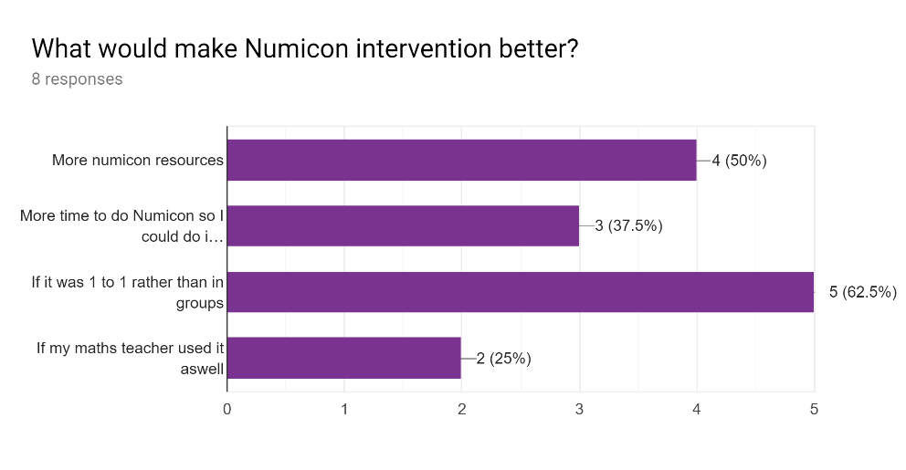
Most commonly students want more Numicon resources so they do not have to share them, and they would prefer if it was 1 to 1 all of the time rather than small groups. Obviously, these recommendations are restrictive due to time and resources such as financial and staffing capacity.

Students were also asked if they feel that any other interventions have influenced their mathematical knowledge and understanding in addition to Numicon. 6 out of 8 students identified Times Tables Rockstars, an engaging and motivational programme used to help boost times table recall speed, 1 identified Hegarty Maths, a programme used on a whole school basis for mathematics homework and 1 did not identify any other interventions as having an impact. Times Tables Rockstars is a ‘gamified’ approach to learning times tables, it can be used competitively against peers or self reflectively to move up the rock star rankings. Case studies from a range of schools across the UK show that Times Tables Rockstars effectively boosts confidence and could have a positive impact when used alongside Numicon intervention as it promotes the recall of essential mathematical facts (Times Tables Rockstars, 2019; Hoxton Garden School, 2019).

Teacher Feedback
Themes arising from the teacher questionnaires were a mix of positive comments and suggestions for improvement. These suggestions were helpful in the formation of recommendations for further research and also in the contribution to the department’s reviewed sustained improvement plan. Positive themes included; confidence, accessibility, understanding and enjoyment. Suggestions for improvement were based around time, availability of resources and communication.

Both teachers strongly agreed that students’ understanding of basic mathematical concepts had improved and that students were more able to access the mastery scheme of work now than at the beginning of the year. Interestingly the year 7 teacher stated that they have not seen an improvement in students’ ability, but they did add that students were now able to explain their reasoning for answers better and hence contribute to class discussions more confidently. The year 8 teacher added that there has been a slight improvement in the quality of work produced in books as well as in achievement on in class formative assessments.

Both teachers strongly agreed with the statement “students are more confident in lessons now than before they attended Numicon intervention” and one said that students are happier in mathematics now than they were at the beginning of the year. Both teachers expressed that some of their lowest ability students enjoy mathematics lessons.

One of the questions asked teachers if they thought that Numicon has made no difference at all to students’ mathematical learning experience at secondary school. This was asked consciously with intent to test reliability of answers given. Both teachers disagreed with the statement which validates the responses they gave to previous questions in which they stated some positive observations and outcomes.

Since the self-evaluation process should be internally driven teaching staff were asked to give feedback on the implementation of the Numicon intervention programme for future practice (Education Endowment Foundation, 2017; Welsh Government, 2014; Chapman & Sammons, 2013). Suggestions given when asked what would make Numicon intervention better from the class teachers’ perspective were:
- Availability of Numicon resources to use in core lessons
- Communication between the deliverer of the intervention and class teachers regarding the concepts being worked on
- More time for Numicon intervention so the gaps were closed in a shorter time period
- Involve the teacher in the delivery of the intervention.

Empirical Evidence
The time taken for the diagnostic assessment was longer than expected and proved to be a drawback in the planning of the intervention. Each diagnostic assessment would have taken at least two hours to complete fully and students were not allowed to be taken out of lessons that were not mathematics. The researcher also had to work around their own timetable, hence why some students did not complete the full diagnostic assessment. Using professional judgement, it was decided that students did not have to complete the assessment if enough gaps were identified to give sufficient scope for impact. Since the intervention is on-going, once the current gaps are closed, the researcher will complete the diagnostic test with each student and then strive to close any further gaps identified.

The diagnostic assessments caused astonishment, revealing gaps in knowledge that would not have been identified in a year 7 mathematics classroom. For example, students struggled to count in order above the number 108. In the year 7 Teaching for Mastery curriculum, this would not be tested as it is assumed that students have that knowledge secured from primary school. They relied greatly on their fingers for almost all questions and even when using their fingers, they often got the answer wrong through miscounting. Some students could double a number but not half, and some squared numbers when asked to double. These notes were written alongside the assessment summary to use during the intervention when challenging misconceptions.

Through observations it was clear that students progressed during every intervention session, they were excited about attending the intervention and enjoyed seeing their progress displayed on the Numicon analysis colour grid. Students became increasingly interested in the gaps that they had and developed a desire to want to close them.

Students worked well with the use of manipulatives, surprisingly there was no stigma assigned to using them. Students reached out for them to help them find an answer. This moved their instant reflex method away from using their fingers to a more concrete method which promoted understanding. Some students were familiar with the sight of Numicon resources from primary school but had never worked with them. Further research is needed to clarify why Numicon is not used consistently in feeder primary schools, but in the short term the academy should provide support, on the back of this project, for those schools.

Unfortunately, during the research process, in December 2018, one of the teachers who taught bottom set year 7, in which three of the participants are in, retired from teaching. This contributes to inconsistencies in teaching styles, and inconsistencies in data, therefore reducing the reliability of predicted attainment entries that effect progress scores and the data from the teacher surveys. This was an external and uncontrollable factor, which hopefully had a minimal effect on the outcomes of the research.

When effective the interventions to close gaps take around twenty minutes. Guidance for the delivery on Numicon suggests that interventions should be on a one-to-one basis, however with just two tutor time slots available for intervention it was decided after the initial three weeks to conduct small group intervention combining students who had the same gaps following the diagnostic assessment (Oxford University Press, 2019). This worked well as students were able to work collaboratively, challenge each other’s misconceptions and discuss their understanding. It was evident that the maximum group size for positive impact was three students, as when there were more than three students the intervention became less personalised and the deliverer could not focus on personal misconceptions.

It is therefore advised for effective delivery of the intervention stage that groups of three or less are used, organised by gaps in knowledge. This is a time-consuming process, although with a clear spreadsheet document like that in appendix 2 it is effortless to see the shared gaps in knowledge between students. As a result, these groups can and will change for each intervention. It would have also been more beneficial if more time was allocated for the intervention either within the timetable or within the mathematics curriculum for low ability year seven and eight students. There should be a teacher who has a significant amount of time dedicated to the delivery of Numicon on their timetable to maximise the impact. If all of the gaps identified were closed in a shorter space of time, rather than over a whole school year, student would be able to make more progress at their actual age-related level.

Analysis of methods used:
Throughout the research it was evident that the research methods used were effective to an extent. The methods were followed as recommended in educational research books and guidance written by Cohen (2013), the Department for Education (2018) and the Welsh Government (2014). To improve the quality of findings that are presented later, including a wider variety of methods, for example interviews and focus groups, on top of the questionnaires, quantitative data and empirical evidence may have been beneficial to a stronger evaluation. From both the student and teacher surveys, convincing recommendations for improvement were obtained, which contribute significantly to the evaluation process and therefore helped when providing recommendations for further improvement within the academy’s sustained improvement plan. Without this data the evaluation may have been biased in the view of the researcher and the impact of further improvements may have been limited.

The quantitative data produced from the diagnostic assessment was powerful with respect to understanding the individual needs of each student and therefore facilitated the successful implementation of the intervention. Data produced from this stage (the diagnostic assessment) was critical to measuring the impact of the intervention and was not overlooked. It was therefore shared with students and referred to by the researcher throughout the intervention programme and the research process. The data was stored safely on an encrypted computer system at the academy and updated throughout the process. The result of the representation of this data is that you can visibly see where students previously had gaps in their knowledge and understanding of basic mathematical concepts and where these gaps have been closed. This proved an especially effective motivational tool as students could see the impact of the intervention and knew specifically where they had improved their knowledge.

Empirical evidence obtained allowed for triangulation of results and assisted the explanation of patterns in data. It also assisted in the development of the research and guided the questions that were asked in the post questionnaires and consequently had an impact on the direction of the study.

Critical evaluation of the investigation – strengths and weaknesses

The investigation was a small-scale action research project and if the researcher was to undertake the project again, they would have included a larger sample of student participants. Unfortunately, two of the student participants did not have data from KS2 because they were working at a low level and not entered for the assessments. This reduced the reliability of the conclusions throughout the analysis of quantitative data however their progress was explained by way of the number of knowledge gaps they had closed. They also contributed to the research project through the questionnaire, surveys and through observations within the empirical evidence.

Time restraints in the curriculum and timetable unfortunately decreased the measurable impact at this stage, however the full impact will be measured at the end of the academic year and reported to the head of the mathematics department and the principal.

Overall the evidence and data that was collected throughout this project within a self-evaluative manner has informed the recommendations for further improvement within the academy’s Sustained Improvement Plan. The conclusions have been informative and positive and have strongly supported the argument for implementing Numicon on a wider scale with more backing within the improvement plan.

Students involved in the project have progressed in their understanding of basic mathematical concepts, increased their confidence. The researcher has learned that Numicon could be implemented within a school improvement plan and now knows how to make it better for future use, thanks to recommendations from participants as well as analysis of observations throughout the research.

This report will contribute to the self-evaluation process within the academy and has given the researcher opportunities to contribute to whole school improvement.

It is hoped that other educational providers will use this evidence to purchase and implement Numicon for students who need it. Primary schools in the catchment area will benefit from this research by knowing what gaps they need to try and fill before students leave them for secondary school. It is hoped that primary schools will use Numicon on a large scale consistently throughout the stages of the school.

Chapter 6: Case for school priority implementation and Recommendations

Summary - Research Questions
Main Question:
To what extent does Numicon intervention impact understanding and performance of low ability students in a secondary mathematics curriculum? | The Numicon intervention has enabled students to close gaps in their knowledge of basic mathematical concepts and for almost all students has resulted in further positive progress above their expectation in mathematics and therefore contributing to increases in overall Progress 8 scores. Consequently, based on the outcomes from the data analysis, there is a strong argument for the continued use of the Numicon intervention programme in future years.
Sub Questions:
- Is Numicon needed in secondary schools?  - Does Numicon assist the secondary mathematics mastery curriculum?  - Does closing gaps in basic mathematical concepts help students progress at a higher level in the classroom? | - If students arrive from primary schools with gaps in their knowledge identified by a scaled score from KS2 SATS assessments below 90, then the Numicon intervention programme can be used to identify the exact gaps and help close them. The identification of gaps is needed in secondary schools until all students arrive with the expected level of numeracy.  - The evidence suggests that students are more able to access the content taught in a secondary mastery scheme of work. Students have made positive progress in the mathematics classroom and are confident to engage with the content of lessons.  - The gaps identified by the Numicon diagnostic would not have been identified by a class teacher as they are at such a basic level that is usually taught in year one or two at primary school. By closing these gaps students were able to progress at a higher level and apply their knowledge to the content taught in the classroom.

Although created for and most commonly aimed at Key Stage 1, evidence from this research concludes that the Numicon intervention programme is suitable for low attaining year 7 and 8 students who have significant gaps in their knowledge and are not showing the understanding that is expected for their age group.

In relation to external validity, it would be beneficial to all secondary schools to use the Numicon diagnostic assessment with year 7 students who do not achieve the age-related expectation in year 6. With this it would be highly likely that the identified gaps in knowledge would be closed through an intervention that follows the diagnostic assessment results. Therefore, the results from this research could be generalised for students at any secondary school who have significant gaps in their knowledge of the basic mathematical concepts. Obviously, grammar schools and other schools with entrance exams where mathematics is tested will not benefit from this research due to not having the cohort of students that Numicon intervention is aimed at. Secondary schools across the United Kingdom face differing challenges and students arrive to them from catchment primary schools at different levels. It is therefore paramount that professional judgement as a human and as a teacher, alongside the school’s context, vision and plans for improvement, are used when deciding whether or not to implement this intervention. If there is a cohort of students who have a scaled score of less than 90 in their KS2 mathematics tests, then this research suggests that the Numicon intervention will have a significant impact in closing the gaps in their mathematical knowledge.

School Improvement Recommendations
Obviously, buying Numicon resources for all teachers will be difficult in some schools due to cuts in department budgets however since the impact of the intervention and resources is proven to be positive leaders may consider using funding from other sources, such as the pupil premium or catch-up funding to supply the resources for teachers to use. Like resources, time in the curriculum and timetable to deliver the intervention is limited, especially in the current teaching climate, where staff retention and recruitment is at a crisis and cuts are being made to funding regularly.

The following recommendations should be part of the academy’s Sustained Improvement Plan and could be adapted for other schools depending on their context. The format can be seen in appendix 1. Most of the recommendations would come under the intervention heading with the Principal, Head of Mathematics, Numeracy lead (or equivalent) or member of staff responsible for transition as the lead. The intended impact would be improved progress throughout KS3, raised achievement at KS4 due to secure core knowledge at KS3, disadvantaged and SEN outcomes match or exceed that of non-disadvantaged or SEN nationally and students enjoy and feel supported in mathematics.

- Implement time in the curriculum model and teaching timetable for year seven and eight to have continuous and consistent Numicon intervention where necessary from a qualified mathematics teacher or Numeracy lead teacher, similar to the one-to-one teacher in year eleven.
- Use Catch-up funding, mathematics budget or pupil premium to invest in more Numicon resources so that teachers of lower ability students can use Numicon to challenge misconceptions and support teaching of concepts, in keeping with the teaching for mastery approach.
- Research and evaluate Times Tables Rockstars, the interactive gaming programme to improve recall of times tables, which could support the effectiveness of the Numicon intervention programme.
- Improve collaboration with primary schools, sharing expertise of the Numicon intervention programme, to try to minimise the number of students arriving at secondary school with gaps in their basic mathematical knowledge.

Further Research
Further research in the field of Numicon use at secondary school level is needed to measure the extent of impact it can have. Current research suggests that Numicon is used in primary schools not just to close gaps in understanding of the basics but to challenge high ability learners and support investigations of more complex mathematics also. Further research would be useful into how this could be transferred to higher level thinking at a secondary school level.

Research into the impact of other initiatives and programmes such as Times Tables Rock Stars to facilitate fluency and pace of recall since times tables are fundamental to success in mathematics at secondary school. Further investigations are required to test the benefits of using Times Tables Rockstar’s alongside the Numicon intervention programme as this was one of the recommendations.

Further research is also needed in three- and four-years’ time to analyse the impact that this programme of Numicon Intervention has had on GCSE outcomes and test whether as many last-minute interventions are necessary in year 11.

References
British Educational Research Association (BERA), 2011. ETHICAL GUIDELINES FOR EDUCATIONAL RESEARCH, 2011: BERA.
Bryman, A., 2012. Social Research Methods. 4th ed. New York: Oxford University Press.
Chapman, C. & Sammons, P., 2013. School self-evaluation for school improvement: what works and why?, Reading: CfBT.
Churches, R., 2016. Closing the gap: test and learn, s.l.: National College for Teaching and Leadership.
Cohen, L., Manion, L. & Morrison, K., 2013. Research Methods in Education. 7th ed. s.l.:Routledge.
Darling, A., 1999. Opportunity for all: Tackling poverty and social exclusion, London: The Stationery Office Limited .
Department for Education and Education and Skills Funding Agency, 2019. Year 7 literacy and numeracy catch-up premium: guide for schools, s.l.: Department for Education.
Department for Education and Standards and Testing Agency, 2018. National curriculum assessments at key stage 2 in England, 2018 (provisional), London: Department for Education.
Department for Education, 2016. Progress 8: How Progress 8 and Attainment 8 measures are calculated, London: Department for Education.
Department for Education, 2018. Literacy and Numeracy Catch Up Strategies, London: s.n.
Department for Education, 2019. School performance: key stage 4 similar schools. [Online]
Available at: https://www.gov.uk/government/publications/school-performance-key-stage-4-similar-schools
[Accessed 7 8 2019].
Department for Education, 2019. Strategic School Improvement Fund, s.l.: Department for Education.
Education and Skills Funding Agency, 2019. Pupil premium 2018 to 2019: conditions of grant. [Online]
Available at: https://www.gov.uk/government/publications/pupil-premium-conditions-of-grant-2018-to-2019/pupil-premium-2018-to-2019-conditions-of-grant
[Accessed 4th April 2019].
Education Endowment Foundation, 2016. Families of Schools Database. [Online]
Available at: https://educationendowmentfoundation.org.uk/tools/families-of-schools-database/
[Accessed 7 8 2019].
Education Endowment Foundation, 2017. DIY Evaluation Guide. [Online]
Available at: https://educationendowmentfoundation.org.uk/tools/diy-guide/getting-started/
[Accessed 7th April 2019].
Education Endowment Foundation, 2019. Teaching and Learning Toolkit. [Online]
Available at: https://educationendowmentfoundation.org.uk/evidence-summaries/teaching-learning-toolkit/
[Accessed 27 08 2019].
Estyn, 2012. Effective practice in tackling poverty and disadvantage in schools, Cardiff: Estyn.
Fictman-Dana, N. & Ydndol-Hoppey, D., 2008. The Reflective Educators Guide to Classroom Research: Learning to teach and teaching to learn through practitioner inquiry. 2nd ed. London: Corwin Press.
Gross, J., 2009. The long term costs of numeracy difficulties, s.l.: Every Child A Chance Trust.
Hall, G., 2018. AN INVESTIGATION INTO “PROACTIVE LEADERSHIP” IN THE FORM OF LEARNING WALKS, s.l.: Unpublished.
Henderson, Hodgen, Foster & Kuchemann, 2017. Improving Maths in KS2 and KS3, London: Education Endowment Foundation.
Hoxton Garden School, 2019. To what extent does technology enhance the acquisition of times table knowledge and the fast and accurate recall of times table facts?, s.l.: Hoxton Garden Primary School.
Hutchings, M. et al., 2012. Evaluation of the City Challenge programme, London: Department for Education.
Ioannou, D. A., 2018. Schools, pupils and their characteristics, Sheffield: Department for Education.
Jadhav, C., 2017. Grade boundaries: the problems with predictions, London: Ofqual.
Mathews, P. & Sammons, P., 2004. Improvement through inspection: An evaluation of the impact of Ofsted’s work , London: Ofsted.
McShane, M. Q. & Lueken, M., 2018. Ed Choice. [Online]
Available at: https://www.edchoice.org/blog/what-is-empirical-evidence/
[Accessed 30th March 2019].
NCETM, 2019. Mastery. [Online]
Available at: https://www.ncetm.org.uk/resources/47230
[Accessed 30th March 2019].
Noltemeyer , A., Mujic, J. & McLoughlin, C., 2012. The History of Inequality in Education. In: C. C, ed. Disproportionality in Education and Special Education. Springfield IL: Thomas Publisher Ltd.
Nye, J., 2006. Teaching number skills to children with Down syndrome using the Numicon Foundation Kit. Hampshire: The Down Syndrome Educational Trust.
Nye, J., Buckley, S. & Bird, G., 2005. Evaluating the Numicon system as a tool for teaching number skills to children with Down syndrome. Down Syndrome News and Update, 1(5), pp. 2-13.
Ofsted, 2013. The Pupil Premium: How schools are spending the funding successfully to maximise achievement, Manchester: Ofsted.
Ofsted, 2019. Draft: Ofsted Inspection Framework, London: Ofsted.
Opie, C., 2004. Doing Educational Research: A Guide to First-Time Researchers. Online ed. London: SAGE Publications Ltd.
Oxford University Press, 2011. Numicon Impact Report, Oxford: Oxford University Press.
Oxford University Press, 2014. Numicon The Impact, s.l.: Oxford University Press.
Oxford University Press, 2019. Numicon. [Online]
Available at: https://global.oup.com/education/content/primary/series/numicon/?region=uk
[Accessed 4th March 2019].
Royle, R., 2018. Numicon and the 2018 SATs. [Online]
Available at: https://educationblog.oup.com/primary/numicon-and-the-2018-sats-barnsbury-primary-school-and-nursery
[Accessed 30th March 2019].
School X, 2019. O Cloud Data Analysis, North Yorkshire: X Academy Trust.
Sharp, J., 2012. Success with your educational research project. 2nd ed. s.l.:Learning Matters.
Sharples, J., Slavin, R. & Chambers, B., 2011. Effective classroom strategies for closing the gap in educational achievement for children and young people living in poverty, including white working-class boys, London: Centre for Excellence and Outcomes in Children and Young People’s Services.
St Helens Primary Alveston, 2014. Cost and Impact review of Numicon , s.l.: St Helens Primary Alveston.
Thomson, D., 2018. Early analysis of 2018 Key Stage 4 results, London: Fischer Family Trust.
Times Tables Rockstars, 2019. ERW Starter. [Online]
Available at: https://ttrockstars.com/page/erwstarter#studies
[Accessed 27 08 2019].
University of Wales Trinity Saint David, 2016. Research and Ethics and Integrity Code of Practice. [Online]
Available at: http://uwtsd.ac.uk/media/uwtsd-website/content-assets/documents/research/Research-Integrity-and-Ethics---Code-of-Practice-(2015-18).pdf
[Accessed 15th October 2018].
Walliman, N., 2010. Research Methods in Education: the basics. In: London: Routledge.
Watanabe-Crockett, L., 2019. This is Why Making Strong Learning Connections Matters Most, s.l.: Global Digital Citezenship Foundation.
Webster, R., 2017. Six steps to ensure effective TA led interventions, s.l.: TES.
Webster, R., Sharples, J. & Blatchford, P., 2016. Making Best Use of Teaching Assistants, London: Education Endowment Foundation.
Welsh Government, 2014. School Development Plans Guidance, Cardiff: Welsh Government.
Welsh Government, 2015. Effective use of data and research evidence, Cardiff: Welsh Government.
Welsh Government, 2017. Learning Wales. [Online]
Available at: earning.gov.wales/docs/learningwales/publications/140224-learning-walks-en.ppt
[Accessed 18 March 2018].
Wilson, J., 2014. Closing the gap with the new primary national curriculum, Nottingham: National College for Teaching and Leadership.
X Academy Trust, 2019. Academy Trust. [Online]
[Accessed 27 August 2019].
X, 2019. Mathematics Sustained Improvement Plan. Yorkshire: School X.
X, A. T., 2017. 2020 Vision: Sustained Improvement Plan 2017-2020. Yorkshire: Academy Trust X.

Appendices
Appendix 1: Academy Sustained Improvement Plan 2017-2020

Sections highlighted were those address or covered within this research. Names have been removed from the “Lead” column to ensure anonymity.

 |  |  | INFORMATION | IDENTIFY | INTERVENTION |  |  |  | IMPACT
 | TARGET |  | Where are we now? | Where do we want to be? | How will we get there? | Time | Funding Int /Ext | Lead | What will be the impact?
1. Raising Standards and Transforming Lives
 |  | 1.1 KNOWLEDGE RICH CURRICULUM: Entitlement to a broad and balanced curriculum where all will secure a solid foundation in knowledge and vocabulary. Provision to enhance literacy and numeracy ensuring all have this core knowledge to enable academic success and access the curriculum. Delivery of rich knowledge will be achieved by a curriculum that is: speciﬁc, cumulative, well-rounded, preparatory and rigorous.
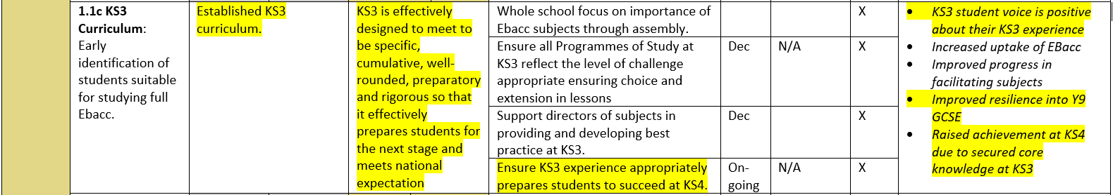
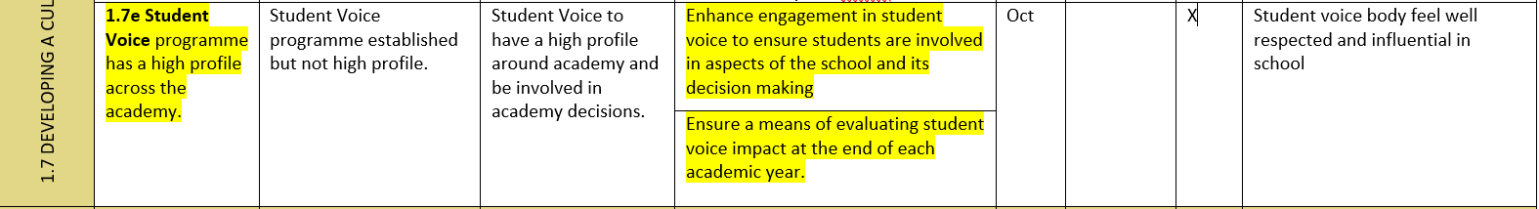
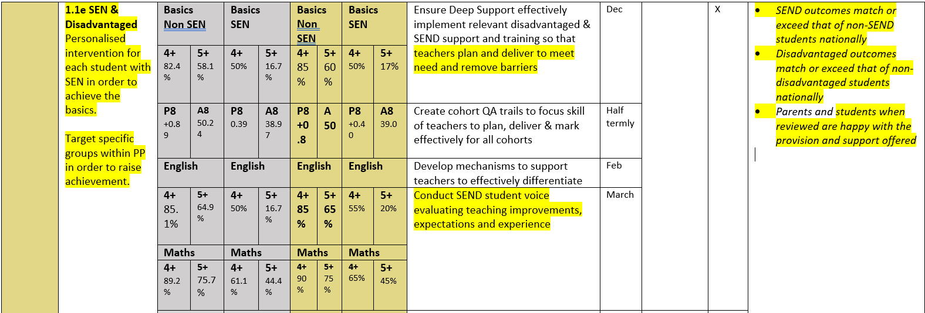
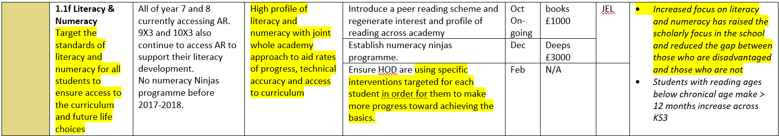

Appendix 2: Numicon Assessment Record.

 |  | PP S |  | PP D SEN | PP D SEN | PP D |  | PP D SEN | SEN
 | NUMICON BASE LINE ASSESSMENT
Oral Counting |  | 4.00 | 5.0 | 6.0 | 1.0 | 2.0 | 3.0 | 7.0 | 8.00
1.1 | 1 to 24
1.2 | 3 to 11 & 15 to 24 |  |  | 12/12/18 |  |  |  |  | 12/12/18
1.3 | 10 to 1 backwards in ones
1.4 | 27 to 34 & 46 to 53 |  |  | 12/12/18 |  |  |  |  | 12/12/18
1.5 | 68 to 75 & 88 to 102 | 1/11/18
1.6 | 108 to 1000 | 13/01/19 | 30/11/18 |  | 28 30 nov | 28/11/18 | 28/11/18 | 28/11/18 | 30/11/18
1.7 | 24 to 10 backwards in ones |  |  |  |  |  |  | 150319
1.8 | 10's forward from 10
1.9 | 10's forward from 26 | 19/11/18 | 19/11/18 | 150119 | 19 28 nov | 28/11/18 | 28/11/18 | 19/11/18 | 9/1/19
1.10 | 10's backwards
1.11 | In 2's forward
1.12 | in 5's forward |  |  |  |  |  |  |  | 150319
Counting Objects
2.1 | In a Line |  |  | 130119 |  | 130119
2.2 | In a group |  |  |  |  |  | 130119
2.3 | Correspondence to 20
2.4 | Counting up to 30 objects |  |  | 130119 |  | 130191 | 130119 | 150119
Recognising & Naming Numerals
3.1 | 1 to 10
3.2 | 11 to 20
3.3 | up to 40
3.4 | Multiples of 10
3.5 | up to 100
3.6 | up to 1000
Recognising & Devising Sequences
4.1 | Simple repeated pattern copies and continue
4.2 | Simple repeated pattern devise
4.3 | Complex repeated pattern devise |  |  |  |  |  |  | 22/02/19
4.4 | Assigning number value |  |  | 220219 |  |  | 22/02/19 | 22/02/19 | 220219
4.5 | Identifying odd & even numbers | 15/01/19 | 15/01/19 |  |  | 150119 | 200219 | 16/01/19 | 16/01/19
Ordering structured apparatus and number
5.1 | Ordering apparatus |  |  |  |  |  |  | 160119 | 160119
5.2 | Identify a missing rod | 160119 |  | 160119 |  |  |  |  | 160119
5.3 | Ordering Numerals 1 to 10
5.4 | Identifying missing numerals 1 to 10
5.5 | Identifying 'in between' numbers 1-10 | 200319 |  |  |  |  |  | 7/11/18 | 7/11/18
5.6 | Ordering Numbers up to 21 |  |  |  |  |  |  | 22/02/19
5.7 | Identifying missing numbers 11-35 |  |  |  |  |  |  | 22/02/19
5.8 | Identifying 'in between' numbers up to 21 |  |  |  |  |  |  | 08/03/19
5.9 | Ordering umbers up to 35 |  |  |  |  |  |  | 08/03/19 | 08/03/19
5.10 | Identifying missing numerals up to 35 |  |  |  |  |  |  | 08/03/19 | 08/03/19
5.11 | Identifying 'in between' numbers to 35 | 200219 |  |  |  |  |  | 20/02.19 | 08/03/19
5.12 | Ordering multiples 10- 100 |  |  |  |  |  |  | 15/03/19 | 15/03/19
5.13 | Identifying missing multiples 10-100 |  |  |  |  |  |  | 15/03/19 | 15/03/19
5.14 | Ordering umbers up to 100 |  |  |  |  |  |  | 15/03/19
5.15 | Identifying missing numbers up to 100 |  |  |  |  |  |  | 15/03/19
Writing Numerals
6.1 | 1 to 10
6.2 | 11 to 20
6.3 | up to 100
6.4 | up to 1000
Number patterns - Place value
7.1 | How many without counting 1 to 5
7.2 | Numicon shapes 1 to 10
7.3 | Nimicon shape patterns 1 to 10
7.4 | Grouping to show how many 1 to 10
7.5 | Grouping to show how many 1 to 20. How many 10's
7.6 | Build numbers with 2 and 3 digits
7.7 | Identify place value 2-digit numbers |  |  |  |  |  | 150319 | 15/02/19 | 15/02/19
7.8 | Partitioning 2-digit numbers | 200219 |  |  |  |  | 200219 | 200219 | 200219
7.9 | Identify place value 3-digit numbers |  |  |  |  |  |  | 27/03/19 | 27/03/19
Number patterns - Place value
8.1 | Say which shows more
8.2 | Say which shows fewer |  | 220319 |  |  |  |  | 13/02/19
8.3 | Showing 1 more |  |  | 220319 |  |  |  |  | 220319
8.4 | Showing 1 fewer |  | 130219 | 130219 |  | 130219 |  | 130219 | 130219
8.5 | Recall 1 more, 1 fewer, of numbers |  | 7/12/18 |  | 7/12/18 | 150219 | 150219 | 150219 | 150219
8.6 | Making groups equal
Recognising and Naming Arithmetic Symbols
9.1 | Adding
9.2 | Subtraction
9.3 | Equals
Adding
10.1 | Combining two groups
10.2 | Making adding number sentence
10.3 | Reading adding number sentence
10.4 | Adding number sentence with apparatus
10.5 | Adding altogether problem
10.6 | Adding more problem
Subtracting
11.1 | Smaller quantity from larger one
11.2 | Making and reading number sentence
11.3 | Subtracting problem
11.4 | Understanding difference |  |  |  |  |  |  | 12/03.18
11.5 | Making number sentence showing difference | 09/03/18 | 09/03/18 | 09/03/18 |  |  | 09/03/18 | 12/03/18 | 13/03/18
11.6 | Difference problem |  | 10/03/18 | 10/03/18 |  |  |  | 13/03/18 | 13/03/18
11.7 | Understanding how many more structure
11.8 | Subtracting how many problem
11.9 | Number sentence using apparatus
Recall of adding and inverse facts
12.1 | Double facts to 5 and 10 |  |  |  |  | 150319
12.2 | All adding facts
12.3 | Adding facts of 10
12.4 | Recalling adding facts |  | 200219 | 200219 |  |  |  | 200219
12.5 | When to use facts of 10
12.6 | When to use other adding facts
12.7 | All subtracting facts
12.8 | Subtracting facts from 10
12.9 | Recalling subtraction facts
12.10 | Understand use of inverse
12.11 | Half numbers up to 20
12.12 | Doubling and halving higher numbers
Adding and subtracting calculations
13.1 | Adding Multiples of 10
13.2 | Add Single to 2 digits without crossing 10
13.3 | Add Single to 2-digit number to reach multiple of 10
13.4 | Subtract Multiples of 10
13.5 | Subtract Single to 2-digit number without crossing 10's
13.6 | Subtract Single digit from a multiple of 10
13.7 | Adding 10's to 2-digit number
13.8 | subtract 10's to 2-digit number
13.9 | Adding and subtract 2 digits not crossing a multiple of 10
13.10 | Adding single- and 2-digit number crossing multiple of 10
13.11 | Subtract single- and 2-digit number crossing multiple of 10 |  |  |  | 13/03/19
13.12 | Adding and Subtraction strategy |  |  |  | 13/03/19
13.13 | Adding and Subtracting within 20 |  |  |  | 13/03/19
Multiplying and Dividing
14.1 | Identifying multiplying built with apparatus
14.2 | Reading Multiplying expression
14.3 | Showing multiplying expression with apparatus
14.4 | Writing a multiplying number sentence
14.5 | Knowing when to multiply
14.6 | Identifying dividing built with apparatus
14.7 | Reading dividing expressions
14.8 | Showing dividing expression with apparatus | 3/4/19 | 3/4/19 | 3/4/19 |  |  | 29/3/19 | 29/3/19
14.9 | Writing a dividing number sentence | 3/4/19 |  | 3/4/19
14.10 | Knowing when to divide
Fractions
15.1 | Finding Half
15.2 | Finding Quarters
 | Equivalence between one half and one quarter
15.3 | Fractions on a number line

Appendix 3: Student Survey
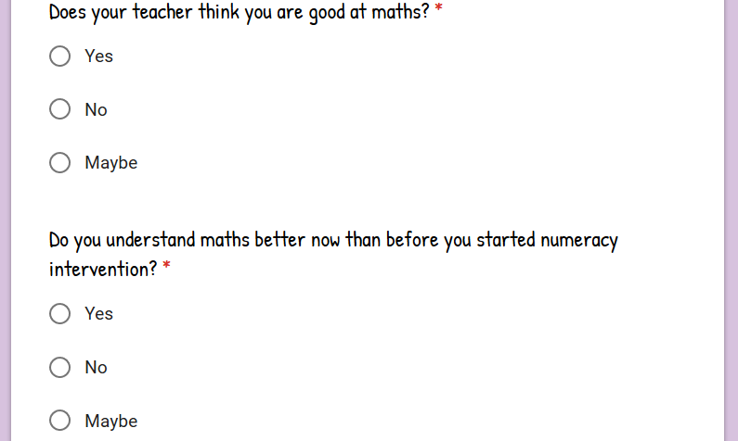
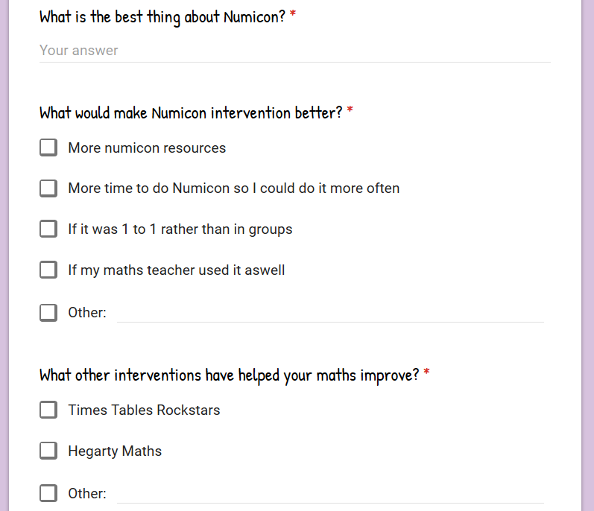
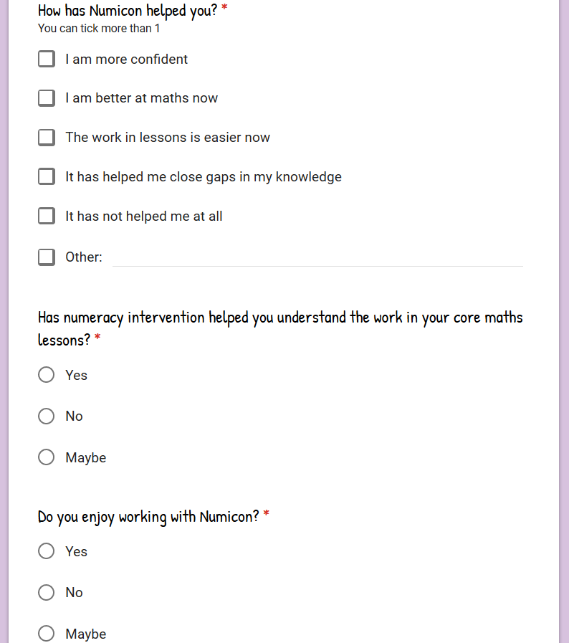
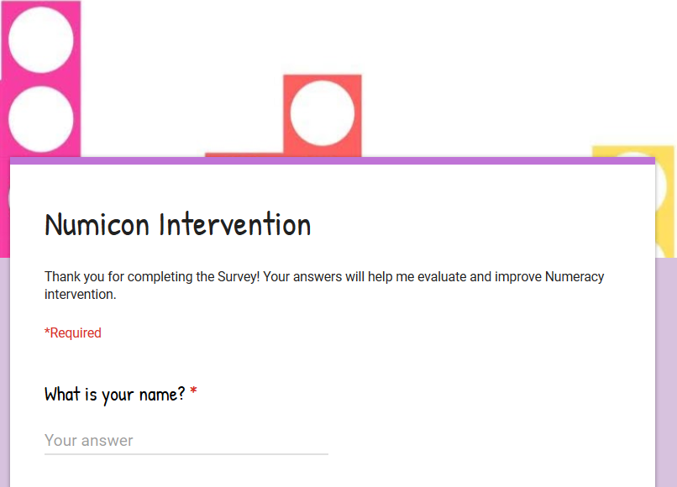

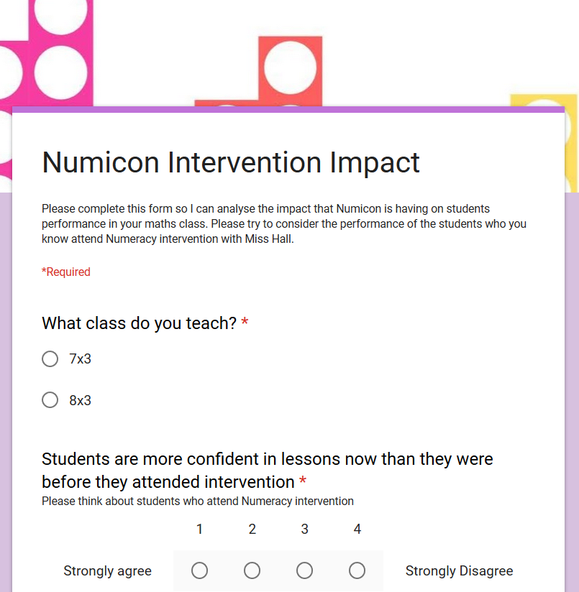
Appendix 4: Teacher Survey


