Carmarthen Business School
Global Business Challenges Assessment One (BMSP4001)
Lecturer: Anthony Burns
Student Number: 2114234

Working from Home During the COVID-19 pandemic and its effect on Global Business.

This article will look at how Working from Home (WFH) has changed from the “Traditional” 9 to 5, how COVID-19 has impacted both UK business and Global business looking at productivity, effects on the mental health of employees and what this change could mean in the future.
On the 31st of January 2020 the World Health Organisation (WHO) declared a global health emergency (Vyas & Butakhieo, 2021). Since then there have been over 246 million cases worldwide resulting in just under 5 million deaths (WHO, 2021). In the UK these figures stand at over 9 million confirmed cases and 140,000 deaths (WHO, 2021), on the 23rd of March 2020 the UK government announced the very first “Stay at home order”. (Vyas & Butakhieo, 2021)
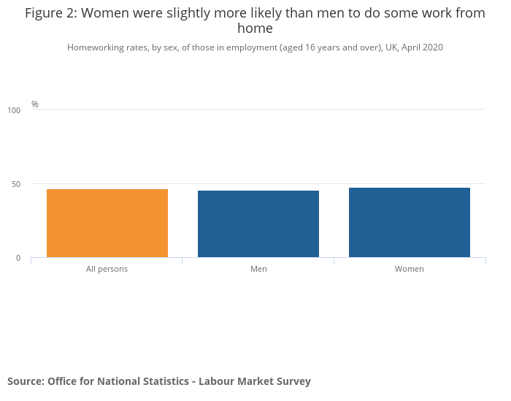
As a direct effect of the pandemic the number of people working from home has increased (Ipsen, van Veldhoven, Kirchner, & Hansen, 2021). According to (Sillars, 2021) the number of people classed as working from home doubled from 12.4% in 2019 to 25.9% in 2020. The Office of National Statistics (ONS) data shows that in March 2020 46.6% of employed people in the United Kingdom (UK) worked from home with 86% of those doing so as a direct link to the COVID-19 pandemic (Cameron, 2020). The statistics show that of that 46.6% there was a slight lean toward female (47.5%) than male (45.7%) this is shown in the table (Cameron, 2020).
Another concept in the world of home working is that of working Asynchronously, this defined by (Griffis, 2020) as “work doesn’t happen at the same time for everyone”. This means that with a more fluid and relaxed approach to working hours that businesses can look at employing staff not just locally, but nationally or even internationally.
According to (Oakman, Kinsman, Stucky, Graham, & Weale, 2020) the concept of WFH or telework has been used since the 1970’s, however with the advancement in technology over the past 50 years this idea has never before been so achievable.

Working 9 to 5 (what a way to make a living)
Traditionally working from 9 to 5 has been the staple of working culture, however due to the COVID-19 pandemic this style of working has shifted. According to (Mousa & Abdelgaffar, 2021) the world is a very different place since the start of the COVID-19 pandemic. Working is no longer restricted by location or time constraints. Previously businesses would use WFH as a privilege that was not given to everybody, however due to the COVID-19 pandemic it has now become a necessity for the masses (Mousa & Abdelgaffar, 2021).
Due to the swift nature of the move to home working, many businesses were not fully equipped for the changes. During the first months of the pandemic there were large increases in online usage of videoconferencing (Kshetri, 2020) for work-related meetings, this led to Zoom becoming increasing popular. During March 2020 Zoom had 200 million users a day, which was up from 10 million users a day in December 2019 (Evans, 2020). By using online conferencing systems such a Zoom, businesses were able to maintain face-to-face links with their staff.
Impact on National and Global Business

Outside factors
- Home schooling
- Carding for others
- Space for others (2 desks)

Impact on Health
It is suggested by (Okuyan & Begen, 2021) that working from home has both positive and negative benefits. The positive benefits include, flexible working, less commuting and a better work-life balance. However, the negatives can be the need to set up a proper workspace (this might not always be possible), the dedication required to be self-motivated and the risk of obesity. This is further backed up by (Oakman, Kinsman, Stucky, Graham, & Weale, 2020) who state that working from home can improve family integration but at the same time blur the lines between work and home in turn having an effect on an individual’s mental health.
(Okuyan & Begen, 2021) states that previous research has shown that there is a direct correlation between a well-ergonomically arranged work environment and productivity and health. According to (RSPH, 2021) 48% of people who have worked from their sofas or bedrooms during the pandemic have reported musculoskeletal problems. (Okuyan & Begen, 2021) states that
An ergonomic working environment and well-arranged physical conditions, such as appropriate temperature and low noise level, increase employee job satisfaction and productivity
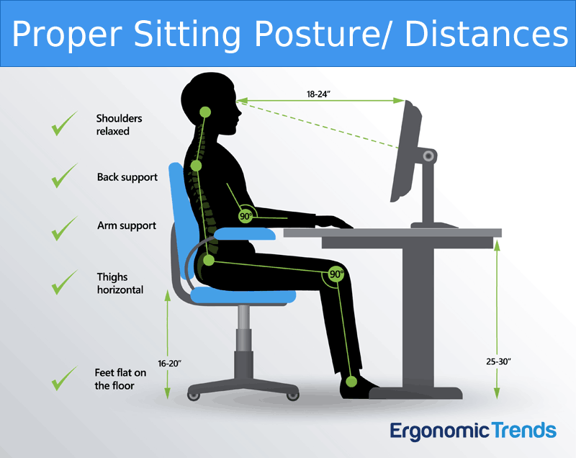
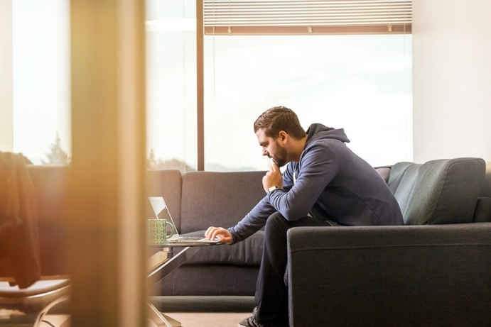
Modern office facilities have been built with these parameters in mind, however at home it can be increasingly difficult to achieve all if any of the above. During the first lockdown in March 2020 many people were asked to work from their own homes without the comforts they have been used to according to (RSPH, 2021) 26% of people surveyed are working from either a sofa or a bedroom during the pandemic. (Creating the Perfect Ergonomic Workspace - The Ultimate Guide, n.d.) show that having the correct sitting position is very important to the working environment.
A survey carried out by the Royal Society for Public Health states that 45% of people surveyed felt that working from home improved their Health and Wellbeing and only 29% felt that it had a detrimental effect (RSPH, 2021).
(Blood, 2020)

Future of Working from Home
Post COVID-19 pandemic 74% of people stated that (Oakman, Kinsman, Stucky, Graham, & Weale, 2020) they didn’t want to go back to the office full time when the pandemic is over (RSPH, 2021). For many workers the idea of a more mixed style of working will become the new normal, through a hybrid working style a more employee driven working balance can be forged (Montgomery, 2021). By having a hybrid system of working from home and attending the office it will allow staff to be more autonomous, be responsible for structuring their own days depending on the tasks ahead and help to improve the work-life balance (Montgomery, 2021).
According to a survey carried out by (Lund, et al., 2021) COVID-19 has intensified the move toward remote working, a survey of 2000 over 800 different occupations showed that 20 to 25 percent of the advanced economies workforces could work from remotely between 3 and 5 days per week. (Lund, et al., 2021) then goes on to states that this is an increase of five times pre COVID-19 levels.
Although permeant working from home or hybrid working can be beneficial to both employee and employer, there is a knock of effect that must be addressed. According to (Osborne, 2021) Pret a Manger felt the effects of the first lockdown even before it had happened, due to their dependence on office trade they had already cut opening hours and closed in-store eating areas up to a week before the official announcement. Pre COVID-19 it is estimated that the British Sandwich and Food market was worth an estimated £8bn, however now it is estimated that the value may be as little as half the original estimate (Osborne, 2021). The story is similar for other sandwich shops that rely heavily on the office trade, although some shops have reported that their trade has returned to pre COVID-19 levels, however this is not the case for all.
Another reason for the slow down in trade is that having worked from home for an extended period of time and with many retailers closed due to the government restrictions consumer spending habits have changed. According to (Osborne, 2021) consumers are now saving between £50 and £150 each month, pre COVID-19 it was habitual to spend that money, however having had months for working from home that money may now have been used for a different purpose. (Boland, De Smet, Palter, & Sanghvi, 2020)
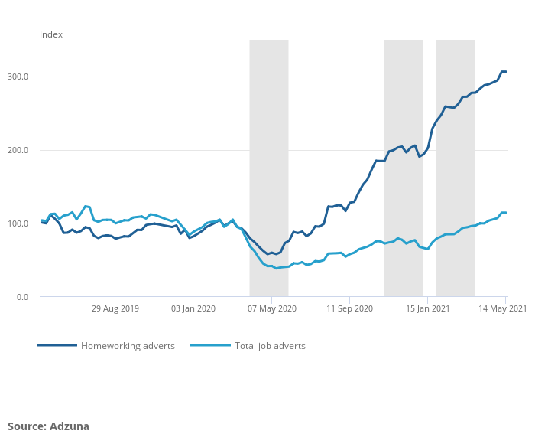
Going forward businesses who adopt a working from home system could well have a larger pool of candidates to choose from, with location and even time zone not being a barrier it will allow companies to expand their work force and attract employees from further afield (Boland, De Smet, Palter, & Sanghvi, 2020). The chart below (Casey, 2021) shows the increase in the number of job adverts that mention home working as a possibility. The table shows that adverts mentioning working from home are up 307%, however only account for 8% of total job adverts posted in May 2021 (Casey, 2021).
(Boland, De Smet, Palter, & Sanghvi, 2020) also suggests that by reducing the number of staff physically in an office at any one time it will also allow for companies to downsize, or even reinvent their offices spaces to be more cost effective. By reducing costs on office spaces companies can then afford to reinvest in other areas.

Conclusion
In conclusion, its clear that that although traditional 9 to 5 office work hasn’t been the norm for everybody in recent years that the COVID-19 pandemic has pushed a large number of office based workers into working from home (Boland, De Smet, Palter, & Sanghvi, 2020). What is also clear is that not all of these workers are ready to go back to full time office based work with 74% of people surveyed by (Oakman, Kinsman, Stucky, Graham, & Weale, 2020) stated that they do not want to go back to full time office work. (Casey, 2021) states that post COVID-19 24% of businesses surveyed intend to increase the amount of staff they have working from home.
One of the main negative aspects to working from home is the wellbeing of staff, during the first lockdown many people were forced to work from make-shift desks, dinning tables or sofas. However, if home working is to become permanent, businesses will need to look at how they can support their employees to set up safe, ergonomic working areas, this is backed up by (Janneck, Jent, Weber, & Nissen, 2018).

