University of Wales Trinity Saint David
Wales Institute of Science and Art

Electric F750 Group Project Overview
George Hall, Daniel Gooch, Alexander Jay, Lily Yallop, Jac Graham-Davis, Tristan Shorts, Tasha Freeman, Ellis Phillips
2404493, 2404008, 2416946, 2400645, 2404810, 2306302, 2419263, 2404558
22/03/26

Contents
Contents 2
1.0 Introduction and Project Organisation 5
1.1 Team Roles 5
2.0 Individual Sections 7
2.1 George Hall – Project Leader 7
2.1.1 – Project Overview 7
2.1.2 – Milestones and Gateways 8
2.1.3 – DVT Software 9
2.1.4 – Wiring Harness 10
2.1.5 – Motor Setup 12
2.1.6 – Motor Testing 13
2.1.7 – Conclusion 13
2.2 Alex Jay – Motor and Drivetrain 15
2.2.1 Introduction 15
2.2.2 Motor Characteristics 16
2.2.3 Differential and driveshafts research 17
2.2.4 Vehicle characteristics 18
2.2.5 Motor output shaft modelling and selection of sprocket, chain 19
2.2.6 Planned implementation 22
2.2.7 Project shortcomings 23
2.2.8 Conclusion 23
2.3 Daniel Gooch – Weight and Suspension 25
2.3.1 Taking Masses and Understanding Sizes 25
2.3.2 Mass Distribution Model 26
2.3.3 Radiator Calculations 27
2.3.4 Battery Box Design 29
2.4 Physical Modifications to Chassis 33
2.4.1 Controller mount 33
2.4.2 Sidepod Mount 34
2.5 Lily Yallop – Cooling Role 34
2.5.1 - Introduction 34
2.5.2 - System Architecture Development 34
2.4.3 - Heat Load and Cooling Requirements 36
2.5.4 - Comparison to Internal Combustion Engine Cooling Requirements 37
2.5.5 - Pipe Sizing and Flow Behaviour 38
2.5.6 - Pressure Loss and System Resistance 39
2.5.7 - Additional Fluid Behaviour Considerations 40
2.5.8 - Evaluation of the Y-Split Configuration 40
2.5.9 - Pump Selection – Davies Craig Electric Pump 40
2.5.10 - Header Tank and Coolant Volume 41
2.5.11 - Component Selection 41
2.5.12 - Packaging and Integration 42
2.5.13 - Engineering Evaluation 43
2.6 Jac Graham-Davies – CAD 43
2.6.1- Role Description and Requirements 43
2.6.2 - Chassis Modelling 43
2.6.3 - Firewalls 46
2.6.4 - Battery Box 47
2.6.5 - CFD and Bodywork 48
2.6.6 - DVT Software 49
2.7 Tristan Short – Packaging and Wire Harness 50
2.7.1 - Introduction 50
2.7.2 - Diagnosed The Wiring Harness 50
2.7.3 - F750 Floor 52
2.7.4 - Motor Mount 53
2.7.5 - Differential Mount 55
2.7.6 - Front Radiator and Nose Mount 55
2.8 Tasha Freeman – Batteries 56
2.9 Ellis Phillips – Driver and Safety 63
2.9.1 Introduction 63
2.9.2 Understanding regulations 63
2.9.3 Firewall design 64
2.9.4 Track Data Analysis 64
2.9.5 Driver Control 65

1.0 Introduction and Project Organisation
The overall goal for this project is the successful adaption of a F750 chassis into an electric car. This means the car must be able to complete the distance of a F750 race in a competitive time, while also following the required regulation for the series (bar any regarding electronics). This project will simulate a team environment to design an electric race car from the ground up and demonstrate the feasibility of adapting a pre-existing race car chassis to electric power, while maintaining performance and reliability.

Team Roles
At the start of the project, each member chose their role within the team based on their own strengths.
Name | Role | Responsibility
George | Group Leader | The team leader oversees the whole project, making sure deadlines are met and that every part of the team is working as it should. Helping and supporting team members when needed and overviewing the whole project making important decisions on the direction of the project.
Dan | Weight + Suspension | The weight + suspension team member is in charge of making sure the suspension is at the right settings to support the car, they are also part in charge of the positioning of heavy internal components of the car so that the car handles right and the centre of gravity is not too high or back so that the car is unstable.
Jac | CAD | The CAD team member is in charge of the computer modelling and development of the car. They get a base of the car that all team members can look at and work and then helps design and test new parts that will go in the car and see where that can be placed.
Alex | Motor + Drivetrain | The motor team member investigates how the motor works and how it connects to the drivetrain and how it gets power to the wheels. They look at the cooling and electrical requirements for the motor. They also are responsible for testing of the motor. They work very closely with the controller as that is what governs the motor.
Lily | Controller + Cooling | The controller team member looks at the software the controller uses and programs it to get the right drive for the car. They also look at the cooling and electrical requirements of the controller. They work closely with the motor team member, so the final drive of the car is correct and work with the driver team member so that the drive is acceptable for the driver.
Ellis | Driver + Safety | The driver and safety team member is responsible for driver health, comfort and safety. They investigate the firewalls, safety regulations/gear and lap details so the driver is safe and in control. They are also responsible for the driveability of the car and adjusting the vehicle to the driver's needs.
Tristan | Packaging + Wiring | The packaging team member oversees the position of components in the car with the direction form the weight + suspension team member, they also investigate the bodywork and wiring harness of the car and how it will all look together.
Tasha | Battery | The battery team member research into the storage of power in the batteries, how much each component needs, the cooling of the battery and the recovery of energy in braking.

2.0 Individual Sections

2.1 George Hall – Project Leader
The role of the group leader is to oversee the completion of the project aims, keep the project on track and understand all parts of the project and have an overall idea of what is happening. This also means helping out in areas that need it and sorting out problems when the arise during the project.

2.1.1 – Project Overview
The group leader must oversee the whole project and team members. They have to make sure deadlines where being made and try to keep things moving smoothly. The group leader came across many difficulties in the project and had to work out ways to overcome them. The project did not reach the original deadlines set due to issues that will be talked about below.
Problem:
The first being team attendance, this was a significant issue with the project as group attendance was very poor. The group leader tried to motivate and push the members all to do their parts but that was ineffective. Therefore, the team never had more than 4 people working on the project at a time which was not optimal, the sections of the people who didn’t turn up were not being completed and hindering the project completion.
Solution:
Therefore, to combat this the group leader handed out the other people’s task to the people who showed up so the project kept moving. This helped the group get back on track, and although now the group leader and a couple of other team members had extra task those group members were all motivated enough to get the project moving again.
Problem:
Another problem to overcome was the lack of access to the batteries, due to lack off PPE and insurance the batteries for the car could not be removed from there original casing. This meant the team had little information on the batteries as the Land Rover hybrid sport battery pack info is not readily available online. This meant the battery box could not be made and instillation of the new wiring harness could not be completed. If the team were to have access to the batteries the battery box could be made and the car would be able to be put together.

Solution:
Based on the limited information, the teams were told to produce everything around the battery box and make assumptions on the batteries so an overall idea on the battery box and BMS could be made. This may not be overall accurate size wise for the battery box, but the box can be edited in CAD as soon as the actual batteries are measured. However the BMS will be corrected as the batteries will be in the assumed ranges from the limited information available.

2.1.2 – Milestones and Gateways
The responsibility of the group leader is to manage and set milestone for the project. This keeps the project moving and means that if a section needs something done before it can be started, it can be scheduled for a time when all previous requirements are met. Below in figure 1 is the Gantt chart from the start of the project.
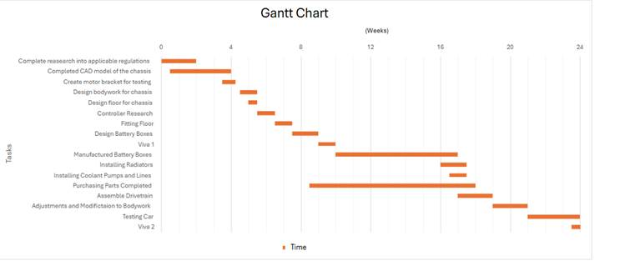
Figure 1 – Gantt Chart
This project was heavily hindered by the lack of access to batteries and the lack of effort from some group member even after efforts to try and engage with said members. This meant that milestones were missed and had to be amended.
After discussions with the overseeing lecturer about ongoing group performance their advice was to give remaining group members who showed high enthusiasm and commitment the remaining tasks which did slow down progress on their sections but meant the gateway objective could be hit although later than originally planned.
This issue has set the project back, so no milestones were hit on time but everything up to viva 1 and all drivetrain testing is completed, mounts have been made and parts mostly purchased. This means the car could be assembled if the team had access to the batteries which as stated earlier severely hindered the project completion as nothing could be done relating to the batteries until towards the end of the project, although the batteries still cannot be accessed.

2.1.3 – DVT Software
BorgWarner DVT is a software used to talk to the controller that will control the motor, getting this software running is pivotal in the success of this project. The DVT software is a useful tool used to setup and optimise the motor control. This controller and DVT allow access to multiple driver modes, which the car will need for being in the pits and then when ready to race.
Due to the delegation of tasks, the group leader took on handling the BorgWarner DVT software which is needed to control the motor. Setting this up was a difficult and long process due to a lack of information available online. Therefore, it had to be taught through practise. Faults that appeared in the software were first identified and their fault codes were looked up using the in-built helper tool to obtain a broader description of the fault.
The first fault that appeared was a battery voltage low fault, using that tree code for battery voltage parameters, the relevant variables could be amended. The Sevcon Gen 6 controller is rated for 80v (BorgWarner, 2026), so all the variables were set around that value, however 48v are being used for testing. As a result, the nominal voltage was set to 48V, the minimum protection voltage set to 42V, and the over-protection voltage set to 52V. After the adjustment were made the fault was cleared.
This process was repeated for all the faults that came up during testing e.g. line contactor fault, throttle fault, sequence fault. Going through all fault codes and changing values or making amends to circuitry eventually lead to zero fault codes from the software. Once this was done it started to give hardware faults which will be talked about in the wiring harness section.
When all faults where cleared, in the DVT software the digital inputs needed to be decided and assigned to a pin in the wiring harness to make sure that all options are selectable to the driver. In the software it was decided that the 5 digital inputs related to driver select 1, driver select 2, handbrake and then forward and reverse although these were wired to a 3 way switch so there is an almost ‘gearstick’ like option for the driver.
Also in the software the torque response graphs had to be amended so that the motor wouldn’t try shut of at low torques as the motor could only run at low torque due to the battery voltage limits. If set up normally the motor would resist the torque trying to be generated at lower torques because the voltage wasn’t high enough and the low voltage cut off would lower power to the motor. However these values for the limits were changed up that the motor would spin even at lower voltages than the controller was originally set up for.

2.1.4 – Wiring Harness
Another task delegated was the wiring of all the electrical parts together for testing and for the actual car. For testing this was done following the DVT Gen 4 Size 6 manual that came with the controller. All main circuit electrical components where pre provided for the project from previous testing. A 50 ohm pre-charge resistor was acquired to go in between the key switch and line contactor (investigated by another team member) which was causing major faults in the software as the software was protecting the controller. Once this was added in the correct position (see figure2) all faults cleared and the system was operational.
The switches for each option where also acquired. These need to be wired to be active low as that is what the controller is expecting to see in this configuration. The foot switch was in the accelerator so doesn’t need to be wired up. Forward and reverse are wired together almost like a gear selector with neutral in the middle, the car needs to start up in neutral. All other switches can just be wired up to be active low like normal.
The CAN and motor encoder wires cam pre-prepared, these were just plugged in to the appropriate parts of the computer and motor respectively. These were tested with a voltmeter at the connection areas to check for appropriate voltage.
Once this was done on the testing rig, the same process can be repeated for the motor and controller that will go in the car, the only thing that changes to get the motor running is the pin out from the controller (see figure3). This was worked out from the Gen 4 Size 10 Manual and the wiring harness made and labelled. The ends of the harness were then prepared for the fitment of the connectors which will be put on once batteries are put into the car, and it is ready to be fitted permanently as minor wire length changes may be needed. The rough position of the wires was setup up in the car chassis to make sure wires reached and is ready to be installed when all components are in the car. The route for the wires was planned so that they are in secure and safe spots if the car where to get into a crash and any wires that go into the driver cockpit carry no more than 12v for the safety of the driver.
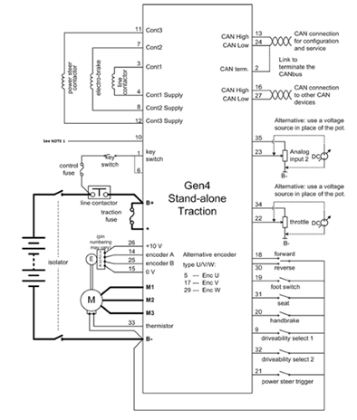
Figure 2 – Gen 4 Size 6 Wiring Diagram (BorgWarner, 2024)
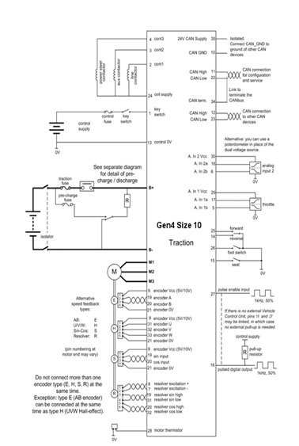
Figure 3 – Gen 4 Size 10 Wiring Diagram (BorgWarner, 2024)

2.1.5 – Motor Setup
Once faults where cleared it was time to setup the motor. This included setting up the motor in a testing rig so that it was safe and would not hurt anyone, this was done by bolting the motor into a metal support which was attached to a work bench. Then to begin setup the software has an in-built tool (motor demand) to run the motor at a target torque or speed. This can be seen below in figure 4. Torque control was chosen as the deciding value. Once the pre-charge button is hit and the drive is enabled, the motor started to spin up too 99Nm of torque (pre-loaded value from software). This preformed as expected and was able to reach the target torque and then would turn off as soon as the ‘disable’ button was hit. This meant the motor and controller were set up correctly. From here ‘throttle’ controlled drive could be attempted.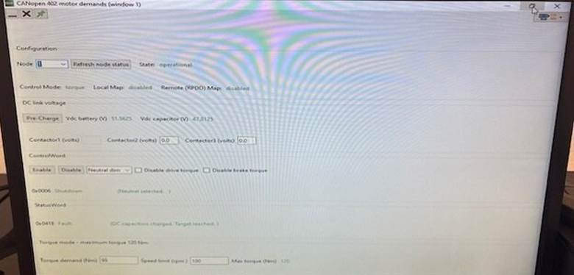
Figure 4 – DVT Software Motor Demand Window
The drive response from the accelerator needed to be adjusted to give a more linear response for the driver after the first test gave inconstant results. For this the ‘throttle setup’ option was used to set max and minimum input voltages from the potentiometer in the accelerator. This meant that when the motor was in its operational state the motor would spin when the accelerator was engaged, however it gave a non-linear and in accurate response. Going into the throttle response tree on the software it was possible to pick the type of feedback curve the throttle had and its limits. Due to the lower supply voltage from the battery setup the motor couldn’t reach full speed, and it had a very small working range due to the software safety measures. Due to this the ‘throttle’ values had to be changed to a lower range around 1/5 of the accelerator’s movement. This gave a linear response from the motor and would max out when that peak was hit and not fault.

2.1.6 – Motor Testing
Using the digital trace option in the software, values can be retrieved while the motor is running. The important values to look at was the torque demand value, torque actual value and the velocity, an example of this page can be seen in figure 5. If demand and actual torque at ‘full throttle’ are equal, then the motor is behaving correctly. This is so low because of the voltage limitations used in the testing rig. As seen in figure 5 which was taken at ‘full throttle’ demand and actual are the same which is as expected and give a final velocity of 1706 RPM.
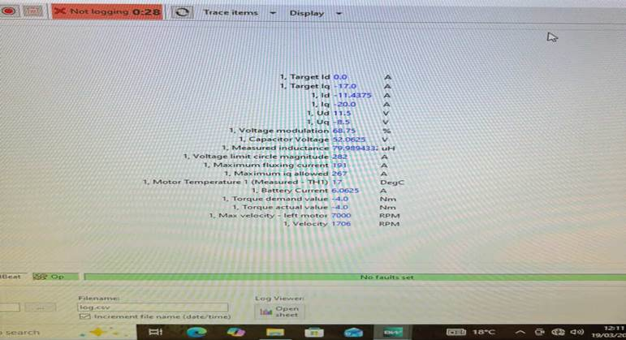
Figure 5 – DVT Digital Trace Testing Image
Due to the lack of voltage, the controller safety is triggered at around 1/5 of the way through the accelerator meaning ‘full throttle’ is very low. In the actual car it would respond normally as the Gen 4 Size 10 controller would be getting the correct amount of voltage for the motor from the hybrid batteries and therefore the safety cut-out would not affect the running of the motor unless there was an unsafe power surge.
With the testing gone relatively well the next stage is to work on the Emrax motor that will be going in the car although without access to the batteries this next step had to stopped and can be completed when batteries are accessible.

2.1.7 – Conclusion
Overall, for the project management side the project has not gone as planned out due to many issues but as a team have tried to minimise the effects of these problem and continue the rest of the project. The car itself is ready to be fully assembled and completed if the cooling parts where brought, mounts manufactured and the batteries where accessible so a battery box can be made.
Furthermore, for the motor and controller side of the project after many setbacks and little help, the testing of motor is complete and is ready for the next stage but is held up by the lack of battery access. The motor runs and responds to the throttle position as best as it can and to all the switches installed. The wiring is ready to be installed into the car once parts are assembled.
The controller software settings are also set up and ready to be copied onto the Gen 4 Size 10 controller that will run the car, with a few amendments to the voltage cut-off values and throttle values the Emrax motor for the car will be ready to drive.

2.2 Alex Jay – Motor and Drivetrain

2.2.1 Introduction
At the conception of this project, this role covered all the motor, differential and driveshaft areas along with their tangential sections. Later along other sections had to be absorbed from team members who were lagging behind, to keep the project from stalling.
The presented work primarily focuses on the selection, modelling and feasibility of integration of the electric powertrain. This includes analysing the motor performance (Emrax 268 medium-voltage) on target characteristics such as acceleration, top speed and power demands. Emphasis has been placed on high speed tracks with performance modelled on Thruxton circuit, where high speed and power demands are at their most critical.
Drivetrain design has been approached through the evaluation of torque and RPM transmission from the motor to the driven rear wheels. This involves selecting appropriate output sprocket size, stress analysis of drivetrain components and chain drive configuration to ensure safe and efficient power delivery. Calculations have been done to determine forces on components such as the chain and output shaft under peak torque event i.e. race starts, alongside considerations of efficiency losses within the drivetrain.
In addition, power consumption has been modelled around Thruxton circuit providing a realistic view of track use. These analyses support battery decisions as well as component selection.
Overall, the work aims to display a drivetrain solution which balances performance, efficiency and reliability, forming a critical part of the vehicle’s successful electrification.

2.2.2 Motor Characteristics
The starting point was to look over the motor specification sheet to find key values such as maximum voltage, RPM and cooling requirements. This was done to assess requirements for other sections such as cooling and batteries.
The peak voltage of an Emrax 268 medium voltage motor is 650V (Manual for Emrax motors, 2020), so to extract the most from the motor, this should be the target voltage produced by the batteries. This 650V produces a sustained peak RPM of 4500 and a maximum (for a few seconds) RPM of 5500. This will be important when sizing the output sprocket for the motor to change the cars top speed.
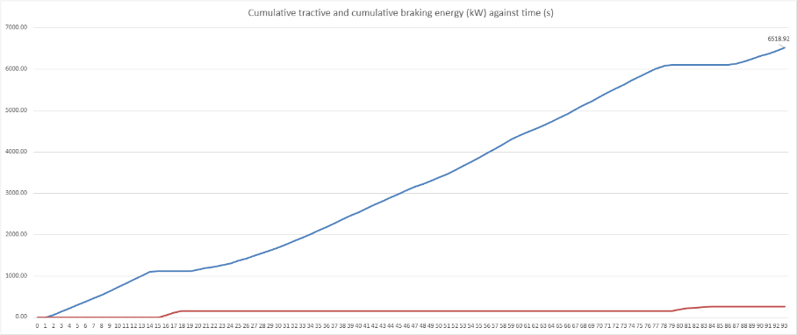
However, this needed to be balanced with other sections like packaging, batteries and mass distribution to create a well-rounded vehicle. 14 batteries were decided upon by the group due balancing the desired voltage with space inside of the chassis, with 14 batteries giving 604.8V however, the motor has an efficiency of 92-98% (Manual for Emrax motors, 2020), so power produced by this voltage will be 0.92-0.98x that to be expected. At Thruxton 16-17kWh was calculated to be the required power for a 15 minute race, using an Excel calculator (Power usage F750, 2026). This calculator was designed by analysing an onboard (RacingAspirations, 2024) and entering the cars velocity at every second over the fastest race lap. However, capacity for 14 batteries is 56.9kWh, this allows for ample safety margin as well as the ability for faster turnarounds between sessions as less recharging is required. Thruxton is a good 'worst-case' power usage example due to its high average speeds and small number of suitable braking moments for kinetic energy recovery.
Figure 6 – Power usage modelled on fastest race lap of ICE F750 around Thruxton circuit
The manual also goes over the cooling requirements for the motor, which are 8L/min of water-glycol mixture at 50°C inlet and 25°C ambient air temperature to maximise the combined cooling setup. Speaking to an experienced engineer from Fortescue Zero, he advised that, as our coolant would also pass through our high-voltage battery box, we likely would be safer using a non-conductive liquid like mineral oil. This possibility would change the flow requirements of the system as mineral oil typically has a lower specific heat capacity than water glycol mixtures leading to a less efficient thermal transfer. Typical values for water glycol mixtures are around 2.36 kJ/kg.K, whereas mineral oils are often around 1.8 kJ/kg.K (The Engineering ToolBox, 2003). If this route were taken, this would necessitate higher flowrates of around 1.5-2x to achieve the same cooling effect inside the motor.

2.2.3 Differential and driveshafts research
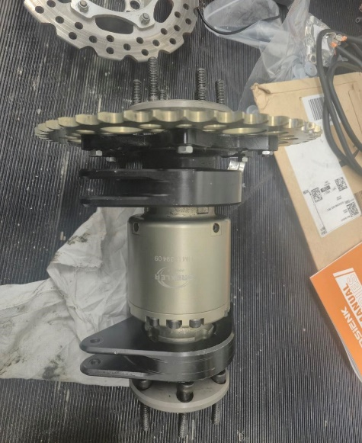
At the beginning of the project, an MX-5 differential was looked at to repurpose into a chain driven version. There are several videos online of people doing this conversion, so these were initially analysed to give an idea of how feasible it was. While not an easy conversion the team had a spare one and at that time no better option, so it was removed from a team members car and stripped to just the gears. Shortly after it was stripped, the team was made aware of a chain driven formula student differential. This was ideal for the project as it also came with driveshafts and a premade driven sprocket. The differential is limited slip, had an internal gear ratio of 1:1 and a sprocket for a 520 pitch chain with 44 teeth.

The hubs on the chassis are for a Fiat Cinquecento and do not fit the Formula student drive shafts. Two Fiat Cinquecento driveshafts were therefore purchased, with the end goal of sending them to an external manufacturer who will cut, splice and balance them with the Formula student ones to the correct length between the hubs and differential.
Figure 7 – Drexler formula student LSD

2.2.4 Vehicle characteristics
As previously stated, the maximum sustained RPM of the motor and peak RPM are 4500 and 5500 respectively. So, the final drive of the car will have to be worked out using this and the top speed of modern ICE F750 cars. Thruxton circuit was chosen as a top speed benchmark due to its long flat straights. Analysing an onboard video (RacingAspirations, 2024), modern F750 cars top out at around 110 mph.

Figure 8 - Velocity modelled on fastest race lap of ICE F750 around Thruxton circuit
Therefore, the top speed of the electric F750 should be around this. An Excel equation was produced using theses RPMs along with the chassis wheel radius of 0.275m (converted into a circumference of 1.73m) to calculate the top speed at different final drives. The final drive was changed around using this calculator until reaching a top speed of 113 mph at a final drive of 3.14, this also allows a high torque at the wheels leading to strong sustained acceleration. Seeing as the differential has a sprocket size of 44 teeth this would require a motor output sprocket with 14 teeth.
Sustained
Torque (Nm) | Sustained motor RPM | Final drive |  | Wheel rpm | Wheel radius (m) | Wheel circumference (m) |  | Velocity (ms^-1) | Velocity (mph) | Torque at wheels (nm)
213 | 4500 | 3.14 |  | 1433 | 0.275 | 1.73 |  | 41.27 | 92.32 | 668.82
Peak (Few seconds)
Torque (Nm) | Peak motor RPM | Final drive |  | Wheel rpm | Wheel radius (m) | Wheel circumference (m) |  | Velocity (ms^-1) | Velocity (mph) | Torque at wheels (nm)
500 | 5500 | 3.14 |  | 1752 | 0.275 | 1.73 |  | 50.44 | 112.84 | 1570
Figure 9 – Sustained motor power characteristics
Figure 10 – Peak motor power characteristics

2.2.5 Motor output shaft modelling and selection of sprocket, chain
The Emrax 268 used in this project did not come with an output shaft, therefore one needed to be designed, which would hold up to the peak torsional forces produced by the motor. With a peak output torque of 500Nm (Manual for Emrax motors, 2020), we want to get as close to this torque figure as possible to produce the fastest 0-60 possible. The design process was done inside SolidWorks and broken down into 3 versions:

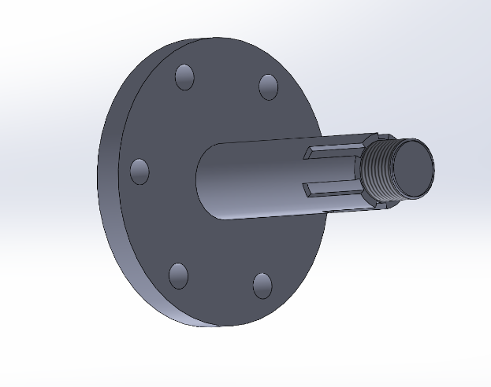
Version 1
This first rendition was mostly created to give a general idea of the output shafts overall design. The splines would attach the sprocket, and thread would allow it to be secured to the shaft. Neither were specific and there was not any research done into CAE stress analysis of the part.

Figure 11 – First output shaft model

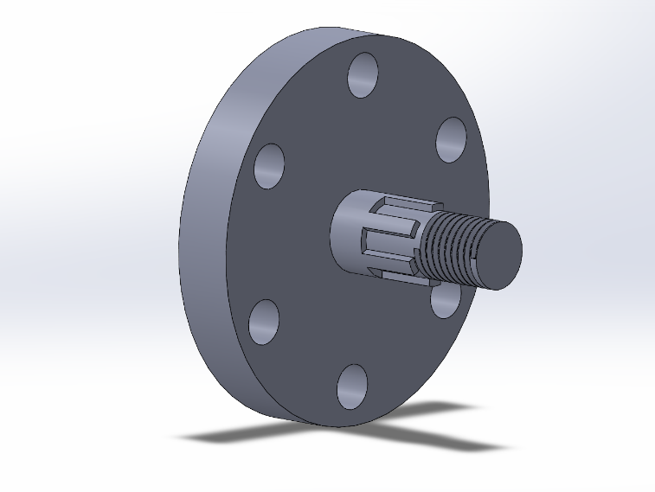
Version 2
This second rendition was shortened to reduce the stress at the joint, as well as this the base was thickened and thread specified to be m16x2.0. The holes in the base are m8 clearance holes which allow the output shaft to directly bolt onto the motor itself.

Figure 12 - Second output shaft model

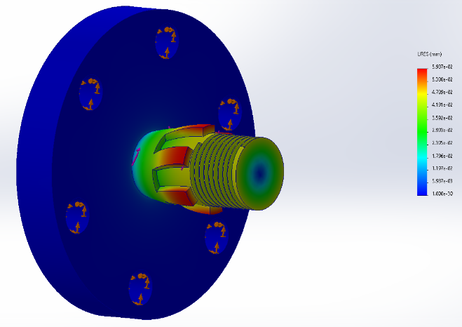
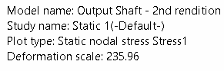
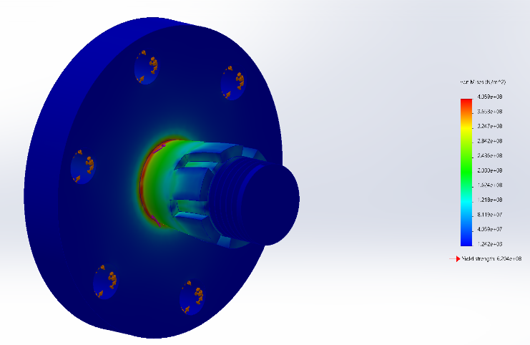

Figure 13- Output shaft stress map at 500Nm torque. Figure 14 - Output shaft deformation at 500Nm torque
Stress analysis was done on this version, using the maximum output torque of 500Nm and alloy steel as the material. At this torque the output shaft deforms by less than 0.06mm and has a yield strength around 1.5x the greatest stress experienced, giving a good safety factor.

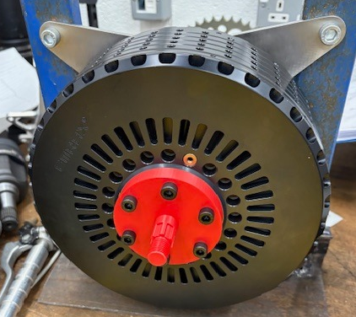
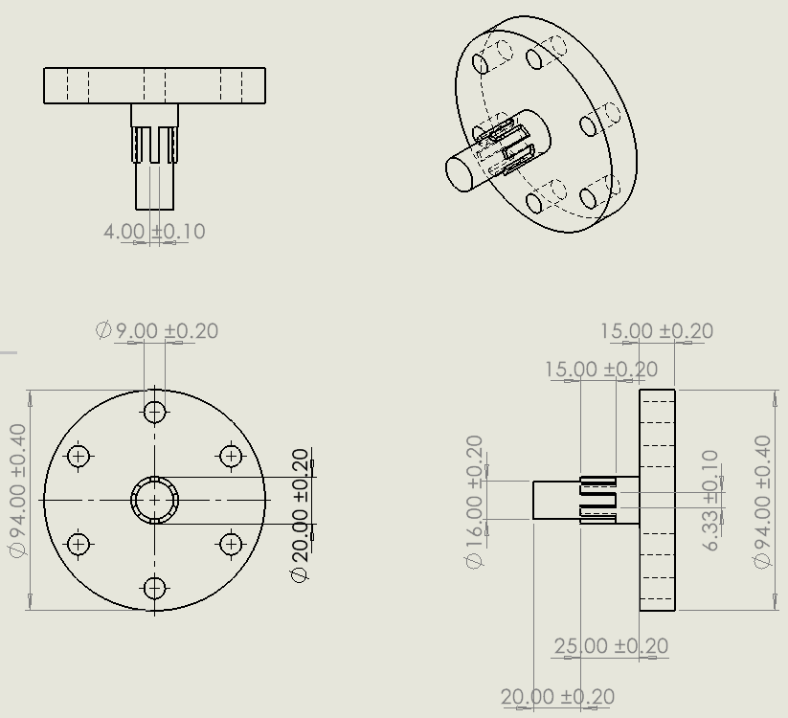
Figure 15- CAD drawing of output shaft Figure 16–3D printed output shaft mounted to motor
This output shaft design was therefore 3D printed as a proof of concept for the project. The 3D printed version was a success and fitted onto the motor well. While being fitted it was discussed with the overseeing lecturer that it may be beneficial to add a shaft at the rear of the base to fit into the motor itself. This would guarantee the output shaft stayed straight and centred.
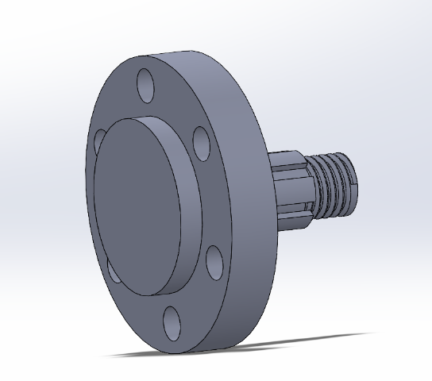
Version 3
This is the final version of the output shaft; it has the same stress tolerances as version 2 but fits snugly into a recess inside the motor. This as previously stated improves the shafts’ ability to resist bending and keep it centred with the motor. It is yet to be 3D printed however once done the file can be sent to an external manufacturer to create the piece.
Figure 17 – Final CAD design of output shaft

Sprocket + Chain
The chosen sprocket had to be a 14 tooth 520 chain pitch to match the differential sprocket as well as give the desired final drive of 3.14. In the end the one by BTS24 was chosen due to fitting both of these requiremnts. It also has an extended spline section which will help spread the load along more surface area, reducing the risk of part failure.
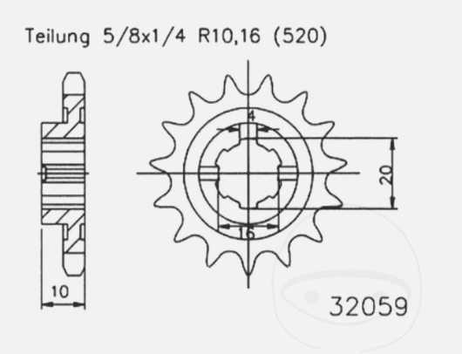

Figure 18 - Front sprocket 14 tooth pitch 520 (BTS24, n.d.)
The chain chosen was manufactured by D.I.D., it was chosen due to being the correct pitch and having a high tensile strength of 36.5 kN. To work out the maximum expected force the chain will experience is calculated by dividing the torque by radius of the sprocket. 500/0.0357500​=14 kN. Therefore, the chain has a safety factor of 2.6x that of the expected maximum tensile force under race start acceleration.


Figure 19 - D.I.D 520VX3 X-ring chain (D.I.D, n.d.)

2.2.6 Planned implementation
The implementation of the electric drivetrain was centred on the integration of the motor with the chain driven differential. The electric motor is intended to be mounted to the chassis itself using a mount designed by the packaging team member, attaching it to the differential will be done by an output shaft and sprocket via a motorbike chain. The limited slip differential then distributes the torque to the rear wheels under varying load and traction conditions.
A key aspect of the drivetrain implementation is the correct alignment of the driving and driven sprockets. Misalignment between these two components can lead to excessive chain wear, high frictional losses and increased chance of chain derailment during use. To mitigate all of these, both sprockets will be aligned in parallel series with one another. This will be done using set squares and CAD model assistance to work out distances between mounting holes.
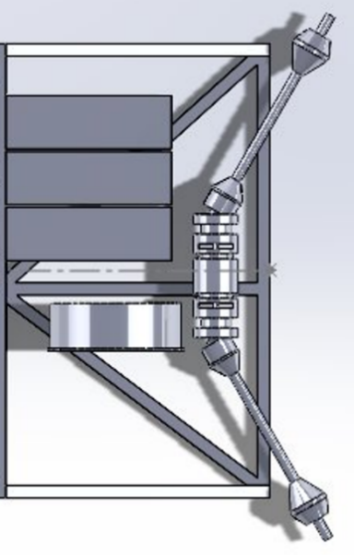
The development of the layout was carried out collaboratively. The differential mount was designed by George, while the motor mount was designed by the packaging team member. Both components were designed in consultation with the author, ensuring decisions regarding layout, sizing, alignment and overall design were consistent with the drivetrain’s overall requirements. This collaborative approach would ensure all subsections integrate seamlessly with the desired characteristics and reliability objectives.

Figure 20 – CAD model of drivetrain layout

2.2.7 Project shortcomings
Progress within the motor and drivetrain developments was limited by issues encountered with the motor control DVT software. The system could not be made fully operational until one to two weeks before the project deadline, this is despite tens of hours being sunk into trying, by several members of the team as well as university staff. This significantly restricted the ability to carry out testing, validation, refinement of the powertrain model and production of a motor tune.
Another limitation was the lack of work done by some members of the team in tangential sections. This led to hours of time which otherwise would have been devoted to this section, being used to research and do the work of other group members to insure the continued progression of this section and the project as a whole.
In addition to this the project was unable to be completed due to institutional constraints. The university did not have appropriate insurance or safety clearance in place to handle the high voltage battery systems required for the vehicle. Once this was discovered it was decided the project would head in a more theoretical approach. As a result, full system integration was not achieved within the scope of this project

2.2.8 Conclusion
The motor and drivetrain development successfully established and justified a solution for the electrification of the F750 vehicle. Through the selection and analysis of the supplied Emrax 268 medium voltage motor, key performance targets such as top speed, acceleration and power demands were all met, with modelling indicating a top speed of 113mph. The drivetrain configuration including the 3.14 final drive ratio and 14 tooth output sprocket were both derived through several iterations of calculations to align motor characteristics with real world lap data around Thruxton.
Component design was also addressed, with the output shaft being developed through 3 different iterations and validated and improved upon using SolidWorks static torque studies, while demonstrating an acceptable safety factor under peak torque conditions. Chain and sprocket selection have also been justified from both a practical sense as well as real world figures, with calculated loads well within component safety limits.
Despite these successes, the lack of practical motor testing due to software and institutional setbacks limited the validation to mostly theoretical models. Assumptions regarding efficiency, thermal performance and real world behaviours therefore remain areas for future refinement. Overall, the work provides a strong foundation for the Formula 750’s electric drivetrain, balancing performance, efficiency and reliability, all while identifying areas for improvement and real world implementation.

2.3 Daniel Gooch – Weight and Suspension

2.3.1 Taking Masses and Understanding Sizes
At the start of the project, finding the weight distribution of the car was a priority job. To achieve this, the car was placed on corner weights to determine the total mass of the vehicle as well as the un-sprung corner weights.
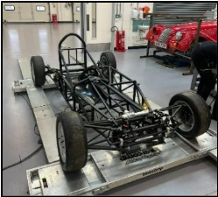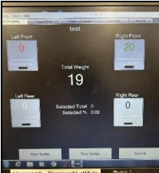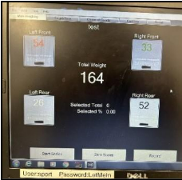
Figure 21 Chassis on scales, Figure 22 Front right weight, Figure 23 Total mass of the car
The front right corner was the only corner that could be measured as the coil over for the front left wasn’t on the car. Post measuring the chassis, the weights for each significant component that needed to be put in the vehicle along with an estimation for driver weight were found. This was done using scales.
Components | Weight (kg) | Additional Info
Un-sprung Mass | 86.0
Sprung Mass Chassis | 79.0
Motor Mass | 20.5
Controller Mass | 10.7
Differential Mass | 6.2
Driveshaft Mass | 9.0 | For both
Battery Mass 1 (Approx) | 100.0 | Casing weight estimated
Battery Mass 2 (Approx) | 75.0
Human Mass | 100.0 | Includes helmet and gear
Total Mass | 486.4
Figure 24 Table of masses
To get an idea for space within the car, cardboard models were made for the batteries, controller and motor. This allowed the group to understand where the batteries would need to go and how many could fit into each space. This is vital as regulations under MSUK (2025) state that any rechargeable energy storage systems can only be comprised of maximum 2 enclosures. From this it was decided that 8 of the batteries could fit alongside the driver, while the remaining 6 required would go in a separate box in the back behind the driver. From this it was also decided that there was adequate room for the controller to fit within the front of the vehicle.
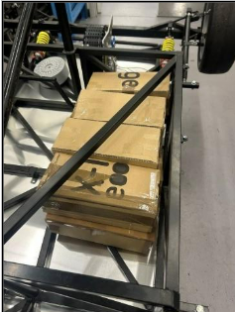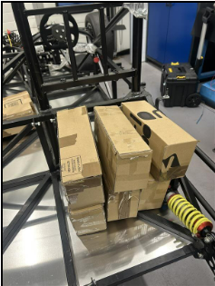
Figure 25 and Figure 26 Boxes made to demonstrate battery size and location

2.3.2 Mass Distribution Model
With these masses known and having understood the space the group is working with, the information was able to be put into a mass distribution model in SolidWorks. For this model, the whole chassis CAD model was used and assigned the sprung mass value to the model. Then separate models and sizing’s were created for each of the components. The model for the driver is a point mass where the estimation for the centre of mass for the driver would be in the car. It is also important to note that, at this point, no values for radiator or fire extinguisher weights have been included in the model. However, these can be assumed to be of minimal effect to the position of the centre of mass. But it will affect the final weight of the vehicle so the values will need to be considered for calculating battery energy requirements.
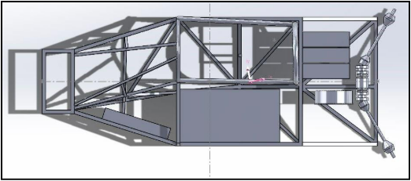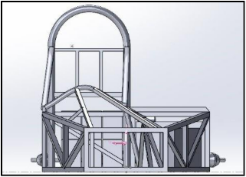
Figure 27 and Figure 28 Top and front view of model
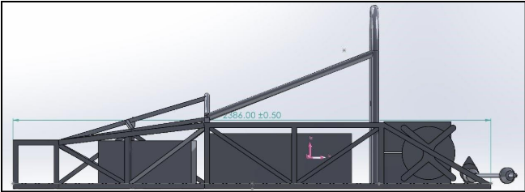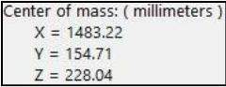Figure 7 and Figure 8 Side view and mass location
The position of the centre of mass for this estimation can be seen in the images from the pink arrow points. The numerical value for this point is in the from the front left. This value is central to the vehicle and isn’t too high above the expected position. The centre of mass is 1483.22mm towards the rear of the vehicle compared to a length of 2386mm. The value for this is a centre of gravity for sprung mass 62.2% rearward.
From this, we can have a reasonable understanding for the car’s behaviour as a heavy rear often indicates that it will naturally oversteer. However, it also means that the car is better during acceleration as it is a rear-wheel-drive car. The extra rear downforce will result in better grip and therefore a better acceleration, which is vital in an electric vehicle that has high torque values.
This 40/60 distribution, we can assume, is typical within the series as a large portion of the cars have a rear mounted engine. This means the car will behave similarly when cornering compared to the other vehicles in the series. Some cars have side mounted engines, which means that may have a slight advantage in the corner.
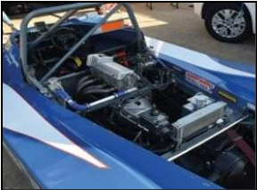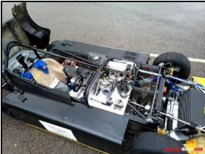
Figure 29 (The Chelsea Magazine Company (2022), Figure 30 (Racecars Direct (2024) )
Images of a rear mounted and side mounted engine arrangement.

Front |  | Rear
Spring Rate | 4.46kg/mm | Spring Rate | 4.29kg/mm
Load (1 side) | 110kg | Load (1 side) | 165kg
Compression | 24.64mm | Compression | 38.5mm
% of length | 19.4 | % of length | 25.3
Figure 31 Standing compression of springs
After calculating the centre of mass, the values for standing compression could be calculated using the spring rates fort the fronts and rears. The values will be useful for understanding the ride height of the car and is easy to adjust as more weight is added.

2.3.3 Radiator Calculations
Due to time constraints, the role of radiator calculations had to be redistributed. To complete this task, an excel sheet was created which allowed the inputting of key values into the sheet and displaying the pipe area required for the radiator in the car.
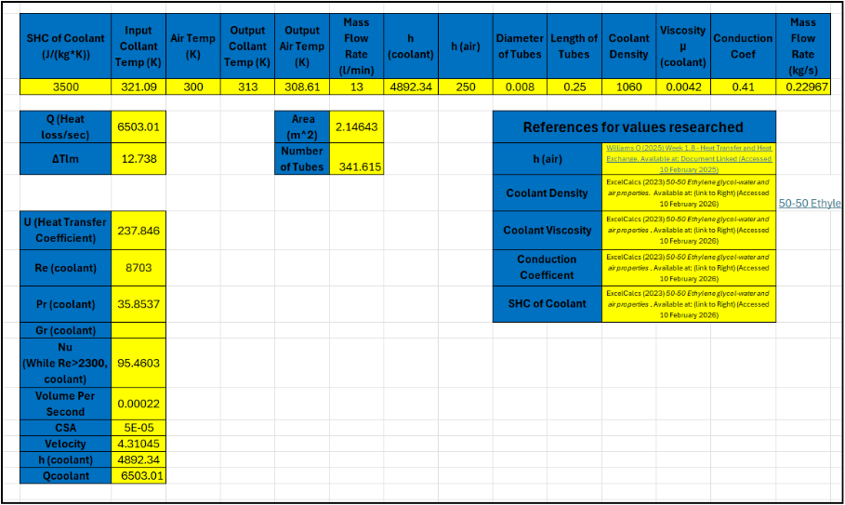
Figure 32 Screenshot of radiator calculation sheet
References from sheet: (Williams, 2026) (ExcelCalcs, 2023) ExcelCalcs values for density, viscosity, conduction coefficient and SHC.
This document allows user input for values along the top, then outputs the required area for a radiator based upon the needs of the system.
To calculate the heat transfer surface area, the values along the top of the worksheet must be found first. Values for SHC, viscosity, density and the conduction coefficient had to be researched based upon the coolant used.
The Input temperature has been assumed to be 27 degrees Celsius and output coolant temp is the lowest temperature required for a component in the system. To find the temperature going into the radiator from cooling the components, the efficiency of each of the components was used and it was assumed that the lost energy was converted to heat. As a strong estimate as to not undercool the components, these values were also assumed to directly affect the coolant temperature.
The equations used for this were: Qc = m*c*ΔT, Qb = 1- η*Wattage, ΔT = Qb/(m*c)
Where m = mass flow and c = specific heat capacity of the coolant.
Component | Equation | Heat Increase (Degrees C)
Batteries | 3000/(0.3533*3500) | 2.43
Controller and Motor | 7000/(0.3533*3500) | 5.66
Figure 33 Temperature change table
Once the change in coolant temperature is calculated, the change in air temperature can also be found by rearranging the equation Q = mcΔT after finding Q.
The length of each tube is assumed to be similar but smaller than the length of the radiator itself, this value came to be roughly 250mm long. The diameter of the piping was researched and found to be around 8mm. This is a modelling estimation which could lead to some inaccuracy as most modern radiators aren’t the same as a heat exchange and have flat tubing instead (Stone, Ball, 2004).
Equations to calculate; U, Nusselt, Reynolds, Prandlt and h formulas were found from lecture notes (Owen, 2026).
The value returned for the area and number of pipes it close to what is expected and is also like formula student radiators, which are often roughly 2m^2 (Danda, Pradecta, Huda, Majid, 2019). This means that we can use the spare formula student radiator as it will have a similar heat transfer surface area. This saves money and means that we do not need to wait on any orders.
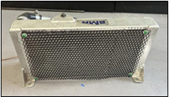
Figure 34 Image of radiator
The radiator is also small enough to be mounted to the front of the vehicle where it can fit under the front body work and have airflow directed into it from the splitter. The splitter will need to be modified to direct the airflow and a joint mount-support for body work will need to be designed and manufactured.

2.3.4 Battery Box Design
From reading the MSUK regulations, it is known that there can only be two containments for the battery boxes for rechargeable batteries. Key details for the boxes themselves include that they must have a: BMS, external kill switch, water-based coolant, plumbed fire extinguishers. The casing must also be in accordance with crash tests (MSUK, 2025).
These design features must be considered when designing the box as they are required to race in any motorsport series in the UK. The location of the cooling matrix and where all the wiring needs to go must also be considered when designing the battery containment.
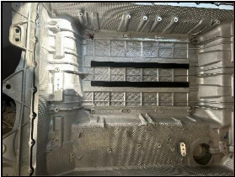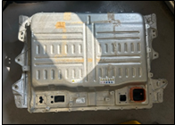
Figure 35 and Figure 36 Images of empty battery box
Due to limited information online, the estimated sizing for each of the batteries was gathered by measuring the existing battery boxes mounting points. This sizing was measured to be 380x170x125mm. This means that, for the box alongside the driver, the batteries must be stood up on the 125mm side to not encroach into the driver cell. Sizing for the kill switch was also measured as well as the room for wiring and the distance between the box lid mounting holes.
Component | Size
Battery | 380x170x125mm
Lid Hole Spacing | 80mm
Kill Switch | 85x85mm, 20mm rad chamfer
Kill Switch Bolt Spacing | 85mm
Figure 37 Table for battery component sizes
The BMS used for this model has a capacity of up to 108 cells, which is well within the necessary 96 cell capability determined by the number of batteries able to be fitted beside the driver. The BMS found for this was an Orion 2 kit (EVShop.eu, 2026) which is commonly used in electric vehicles.
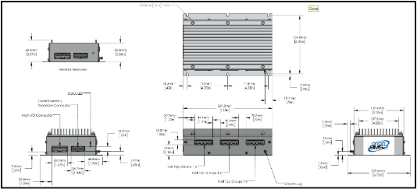
Figure 38 Measurements for BMS box (EVShop.eu, 2026)
Using this, mounting points for the BMS can be determined and modelled on SolidWorks.

Box Lid:
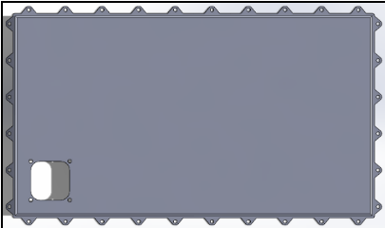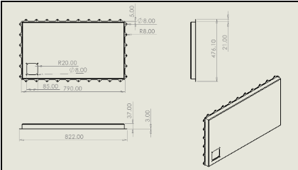
Figure 39 Top view of battery box lid, Figure 40 Dimensions of lid
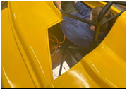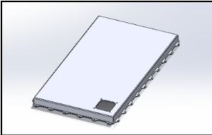
Figure 41 Space in which kill switch will go, Figure 42 angle view of lid
The lid for the container has a simple design with holes for the kill switch and it’s required attachment bolts. This has been placed on the rear, drivers’ side of the box so that it is easily accessed through the bodywork. The lid has depth so that there is enough space for the kill switch, wiring and the BMS height.

Box Body:
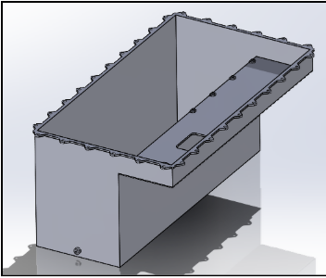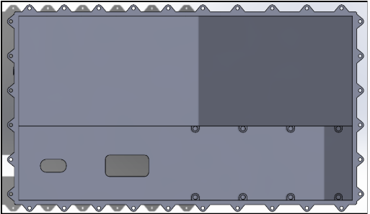
Figure 43 angle view of battery box main body, Figure 44 Top view of main body
The main body for the box includes mounting points for the BMS on the inside. There is one extra set of points so that there is variability for the necessary wiring space for the batteries themselves and the BMS. There are also two access holes on the underside for the wires to go through, one of which for direct access of the kill switch to be wired to the negative from the controller.
Within the box there is enough room for 8 batteries as well as clearance of 10mm for mounting points which will need to be added and silicone gel which will be used to distribute heat evenly within the box. Extra room also accounts for sizing differences that are unknown due to limited online data and no access to the physical batteries.
There is also a threaded hole at the base of the box so that an extinguisher can be plumbed directly into the batteries, as required under the MSUK regulations. The design for this may need to be modified depending on whether a 90-degree end will be needed (dependent on extinguisher location).
The box is also designed with an overhang; this is to leave room for a potential cooling matrix. This hasn’t been designed yet as we have no data on the battery’s behaviour to decide what is needed from the matrix. There is also ample room for any break lines, wires or cooling lines.
Combined and in Chassis:
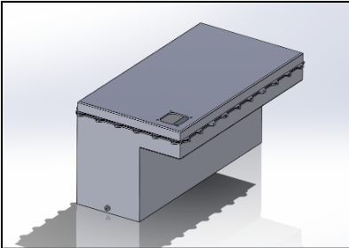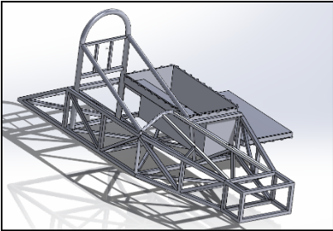
Figure 45 Combined lid and main body, Figure 46 Main body in chassis
The lid and they body line up along the bolt points so that there is only 1 orientation possible for the lid. The hole for the kill switch lines up with the hole underneath for the negative wire.
Once put in the chassis model, the box can be seen to fit within the vertical clearance of the body work and lengthwise within the chassis. The horizontal bar across this section will need to be removed to make enough space for the box, following which a stress analysis will need to be done to understand and fix the effects of its removal.
The space in which the BMS and kill switch is held will also likely need to be reduced so that it doesn’t interfere with the cockpit and roll hoop. This would create an L shape from the top view down; however, it should not affect the cooling matrix or batteries. It does mean that the space for the BMS and kill switch is tighter, making the wiring a more difficult job.
This model gives the group a good idea for what shape and size the battery box beside the driver as well as what is needed from the boxes regarding wiring, fire safety, BMS and the kill switches.

2.4 Physical Modifications to Chassis
Dan Gooch and Alex Jay

2.4.1 Controller mount
The first component to be put in the chassis was the controller. This was done so that we could understand how much room was around the controller for components such as the coolant pump and reservoir.
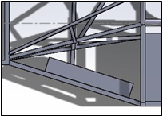
The front of the vehicle was chosen based on the mass distribution measurements as it played a big role in pulling the weight slightly further forward. It also allows for more room in the rear of the vehicle for the drivetrain components and batteries along with their associated mounts.
Figure 47 Controller Location CAD
The decision was made to put an aluminium plate between the controller and the frame. This was so that silicon could be put between the plate and the frame to reduce the harshness of vibrations to the controller.
The aluminium was cut from scrap metal already in the workshop which means no extra money was spent on manufacture. The plates were measured and cut to size using hacksaws, then were de-burred and filed to not cause injury. Holes were then drilled through the frame and the plates at measured points to be bolted through to attach the controller.
The plate on the front end was also made to be taller as to better protected the coolant output pipe. This was not needed at the back as the frame rises to cover it.
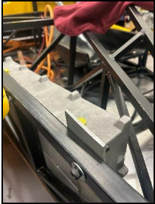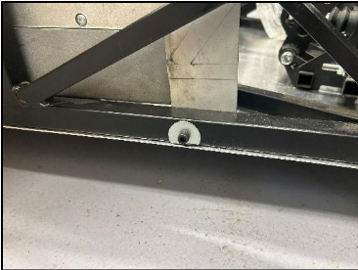
Figure 48 mounting plate shielding coolant pipe, Figure 49 Mounting attachment with cut washer

2.4.2 Sidepod Mount
As a proof of concept, a sidepod mount was created using steel box section. This extends from pre-existing mounting points on the side of the chassis to hold up the sidepods. The mounts are simply held in by a bolt with washers through the extended chassis. This idea was successful at holding up the sidepods and would be more than strong enough to hold under typical race conditions.
However, if any lift is produced over the sidepod, the body work is likely to lift as it is only bolted in at the chassis end. This means that, for future renditions, the body work will need to be secured at the outside of the pods to prevent movement.
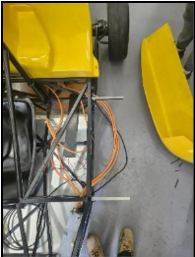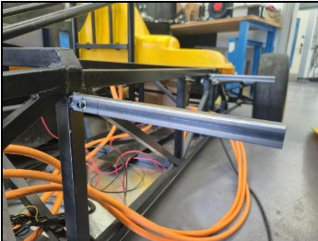
Figure 50 Top view of sidepod mounts, Figure 51 Close up of sidepod mount

2.5 Lily Yallop – Cooling Role

2.5.1 - Introduction
The cooling system was developed to manage the thermal loads generated by the motor, controller and battery packs while considering packaging constraints and system complexity. Multiple configurations were evaluated, including dual loop, parallel (Y-split), and single loop systems. The final design was decided based on fluid behaviour, reliability and practical implementation constraints.
Unlike internal combustion engines, which reject a large proportion of their input energy as heat, electric powertrains operate at significantly higher efficiencies (Bosch, 2018). However, despite this, the high-power levels involved still result in substantial heat generation that must be removed to maintain safe and efficient operation. This makes the design of the cooling system a critical aspect of the vehicle, particularly in high-performance applications where sustained loads can lead to rapid temperature increases.

2.5.2 - System Architecture Development
The cooling system design started with a dual-loop configuration to separate the cooling of the motor and controller from the battery packs due to their differing thermal requirements. While the motor and controller can handle higher temperatures, lithium-ion batteries need tighter temperature control (20–40°C) for efficiency and to prevent degradation.
However, the dual-loop system posed practical challenges, such as limited chassis space for pumps and additional pipes, which increased complexity, weight, and reliability concerns. Additionally, routing two separate cooling systems raised the number of joints and fittings, heightening the risk of leaks and reducing overall robustness.
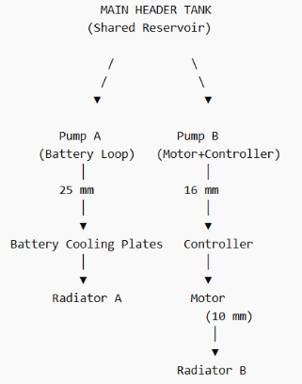
Figure 52 - Dual Loop Diagram
To address the limitations of the system, a parallel cooling configuration with a Y-split was explored. This setup retained a single pump and header tank, dividing coolant flow into two branches: one for the motor and controller, and the other for battery cooling. This design aimed to reduce thermal interaction by providing both subsystems with similar inlet temperatures without needing a second pump. However, analysis revealed a major issue: flow distribution is determined by hydraulic resistance instead of design. The motor branch, with its 10 mm cooling ports, has much higher resistance than the battery branch, leading to uneven flow and more coolant favouring the battery.
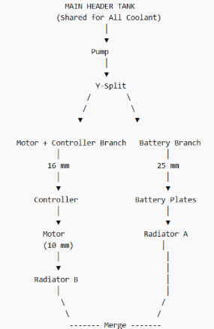
Figure 53 - Y Split Diagram
Because of this behaviour, the Y-split configuration introduced uncertainty in flow distribution and could not guarantee sufficient cooling for the motor under all conditions. While flow balancing devices such as restrictors or valves could be implemented, these would increase system complexity and require experimental validation. As a result, the system was ultimately simplified to a single-loop configuration, prioritising predictable flow behaviour, reduced complexity and improved reliability.
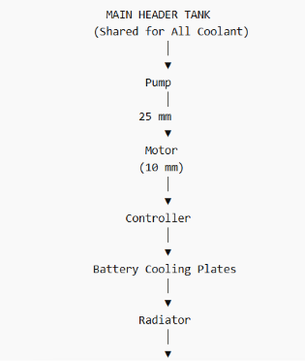
Figure 54 - Single Loop Diagram

2.4.3 - Heat Load and Cooling Requirements
The cooling system is essential for removing heat generated by inefficiencies in the motor, controller, and battery packs. While electric powertrains are significantly more efficient than internal combustion engines, they still produce considerable heat under high load conditions.
The motor operates at approximately 95% efficiency and is estimated to generate around 6.3 kW of heat. The motor controller adds another 3.6 kW, and the battery packs contribute roughly 4.8 kW under load (Engineering Toolbox, 2024). This totals about 15 kW of heat, representing a worst-case scenario used for conservative design purposes (Cengel & Ghajar, 2020).
To effectively dissipate this heat, a coolant flow rate of around 20 to 25 litres per minute is required, assuming a temperature rise of about 10°C across the system. However, a higher design flow rate of 30 litres per minute was chosen to provide a safety margin. This accounts for inefficiencies, pressure losses, and transient operating conditions, ensuring that the system adequately maintains cooling even during peak power output or less favourable ambient conditions.
Additionally, selecting a relatively low temperature rise promotes a more uniform temperature distribution throughout the system. This reduces the risk of localized overheating and enhances overall thermal stability.

2.5.4 - Comparison to Internal Combustion Engine Cooling Requirements
A useful comparison can be made between the cooling requirements of electric powertrains and internal combustion engines (ICE), which typically operate at efficiencies of approximately 60%. ICE systems are significantly less efficient and therefore reject a much larger proportion of input energy as heat.
For example, if an ICE produces 100 kW of useful power at 60% efficiency, the total input energy is:
1000.6=166.7 kW
$$\frac{100}{0.6}=166.7 kW$$

This indicates that approximately 55 kW is lost as heat, much of which must be removed by the cooling system. In contrast, an electric motor operating at 95% efficiency, while producing the same output, would generate only about 5 kW of heat.
Despite this lower total heat load, electric systems pose different challenges. Heat generation is often more concentrated and transient, necessitating rapid heat removal. Furthermore, battery systems require tighter temperature control, typically kept below 40–50°C, whereas internal combustion engine (ICE) components can operate at much higher temperatures.
This emphasises that, although electric systems produce less heat overall, they require more precise and responsive cooling strategies.

2.5.5 - Pipe Sizing and Flow Behaviour
The main pipes in the system were chosen with an internal diameter of 25 mm, providing a good balance between flow capacity and pressure loss. At the design flow rate, this results in a coolant velocity of approximately 1 m/s, which is typical for automotive cooling systems (Bosch, 2018).

Selecting the right pipe diameter is crucial, as it directly affects both velocity and pressure loss. Larger pipes reduce velocity and, consequently, frictional losses, but they also increase system volume and can create packaging challenges. In contrast, smaller pipes increase velocity and pressure losses, leading to greater demands on the pump and potentially resulting in unstable flow conditions.
A primary constraint in the system is the motor cooling inlet and outlet ports, which have an external diameter of 10 mm. This reduction in diameter significantly increases the coolant velocity upon entering the motor. At the same flow rate, the velocity rises to over 6 m/s, which is approximately six times higher than in the main pipe. This increase has several important implications.
Firstly, higher velocities promote turbulent flow, enhancing heat transfer within the motor's cooling channels. However, this benefit comes with the trade-off of significantly increased pressure losses. Secondly, the high velocity makes the system more sensitive to changes in geometry—such as bends, fittings, and expansions—raising the likelihood of flow instability and additional energy losses.
The reduction in diameter becomes the dominant factor influencing the behaviour of the entire cooling system, overshadowing many of the design improvements implemented elsewhere.
Turbulence, Flow Separation and Backwash
The transition from the larger 25 mm pipe to the 10 mm motor port creates a contraction, followed by a sudden expansion as the coolant exits the motor and re-enters the larger pipe.
This rapid change in flow conditions results in turbulent flow behaviour (NASA, 2017), which includes flow separation at the outlet, recirculation zones, vortex formation and backwash effects.
Backwash occurs when fluid reverses direction locally due to pressure gradients created by the sudden expansion. This results in small circulation regions that do not contribute effectively to heat transfer and instead increase energy losses.
These effects reduce the overall efficiency of the cooling system and increase the load on the pump. In addition, the presence of recirculation zones can lead to uneven temperature distribution within the flow, further reducing cooling effectiveness.
To minimise these issues, gradual reducers were considered to smooth the transition between pipe diameters. However, due to packaging constraints within the chassis, it was not always possible to eliminate sharp transitions completely. This represents a limitation of the final design and highlights the importance of integrating fluid system design with mechanical packaging.
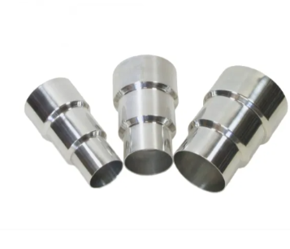
Figure 55 - reducers (Raceparts)

2.5.6 - Pressure Loss and System Resistance
Pressure losses in the cooling system arise from various factors, including pipe friction, bends, fittings, and flow restrictions. While the losses connected to straight sections of pipe are typically minimal, the motor cooling ports emerge as the most significant source of resistance within the system (Cengel & Cimbala, 2018).
Understanding the dynamic relationship between velocity and pressure loss is essential. The high flow velocities experienced in the narrower motor cooling ports lead to a substantial increase in system resistance. This increased resistance directly impacts the performance of the pump, which must overcome these losses to maintain the required flow rate.
A comprehensive estimate of the total pressure drop throughout the system ranges from 0.2 to 0.4 bar. Most of this pressure drop occurs at tight corners and variations in the pipe's inlet and outlet diameters. This observation highlights the critical role of the motor ports in influencing the hydraulic characteristics of the entire system.
Additionally, the impact of minor losses caused by bends, junctions, and fittings should not be underestimated. In a compact cooling system with limited pipe routing options, these seemingly minor factors can accumulate and significantly affect performance. Therefore, careful attention to these losses during the design process is crucial for ensuring optimal system efficiency.

2.5.7 - Additional Fluid Behaviour Considerations
At the high velocities present within the motor cooling channels, the flow is fully turbulent and highly energetic. While this enhances heat transfer, it also increases sensitivity to disturbances and imperfections in the flow path.
Any misalignment in fittings, sudden changes in direction or surface roughness can significantly increase local turbulence and pressure losses. This means that manufacturing tolerances and assembly quality can have a noticeable impact on system performance.
Furthermore, the expansion of flow after the motor results in incomplete recovery of pressure, as some of the kinetic energy is dissipated as turbulence. This contributes to additional energy losses and further increases the demand on the pump.
These factors highlight the importance of considering not only theoretical calculations but also real-world factors such as manufacturing and assembly when designing fluid systems.

2.5.8 - Evaluation of the Y-Split Configuration
The Y-split configuration was investigated as a compromise between the dual-loop and single-loop systems. By splitting the flow into two branches, it allows the motor/controller and battery systems to receive coolant at similar temperatures.
However, in practice the flow distribution in a parallel system is governed by resistance rather than design intent. Because the motor branch contains smaller ports compared to the battery cooling system, it experiences higher resistance.
As a result, the majority of coolant flow would naturally flow through the battery branch, where resistance is lower. This would reduce the flow available to the motor and controller, potentially leading to insufficient cooling under high load conditions.
While it is possible to address this issue through the use of flow restrictions or balancing valves, these solutions introduce additional complexity and require experimental validation.
Due to these uncertainties, the Y-split configuration was not considered suitable for the final design.

2.5.9 - Pump Selection – Davies Craig Electric Pump
A Davies Craig electric water pump was selected as the most suitable option for the cooling system. (Davies Craig, 2023)
Because the pump is electrically driven, the coolant flow rate is independent of motor speed. This allows more consistent cooling performance, particularly during low-speed operation or when the vehicle is stationary. The pump can also operate after shutdown, reducing the risk of heat soak.
The pump allows for variable flow control based on temperature, meaning it does not always operate at full capacity. This flexibility improves efficiency and reduces unnecessary power consumption.
However, the performance of the pump is directly affected by system resistance. As pressure losses increase, the achievable flow rate decreases. This is particularly relevant in this system due to the restriction imposed by the motor ports.
Additionally, the reliance on electrical power introduces a potential failure mode, as pump failure would result in immediate loss of coolant circulation. This risk must be considered when evaluating the overall system design.

2.5.10 - Header Tank and Coolant Volume
The total coolant volume within the system was estimated at approximately 3.9 litres, including the motor, battery plates, controller and pipework. The pipework volume was calculated using a CAD model, which gave an approximate pipe length of 2.7 m.
The header tank was sized to approximately 1 litre, representing around 15–20% of the total system volume. This provides sufficient capacity for thermal expansion and ensures effective removal of air from the system.
Positioning the header tank at the highest point in the system allows air bubbles to rise naturally into the tank, improving system stability and preventing the formation of air pockets.

2.5.11 - Component Selection
The cooling system consists of the following key components:
- Davies Craig electric water pump (Davies Craig, 2023)
- Aluminium header tank (1 L) (obp Motorsport, 2025)
- 25 mm silicone coolant hoses
- 25–10 mm pipe reducers
- Water-glycol coolant mixture
- Hose clamps and fittings
These components were selected based on compatibility, availability and ease of integration within the chassis, as well as their suitability for the expected operating conditions.

2.5.12 - Packaging and Integration
Packaging of the cooling system was a significant constraint throughout the design process. The available space within the chassis limited the positioning of components and influenced pipe routing.
The pump would ideally be positioned low within the circuit to reduce the risk of cavitation and ensure consistent coolant supply. The header tank was positioned at the highest point so that air bubbles naturally rise into the tank, improving system stability and preventing air pockets.
Pipe routing was designed to minimise sharp bends and avoid interference with suspension components. However, due to space limitations, some compromises were required, resulting in less-than-ideal flow paths.
The requirement to route pipes over sections of the chassis introduced additional bends and elevation changes, which increase pressure losses and reduce system efficiency.
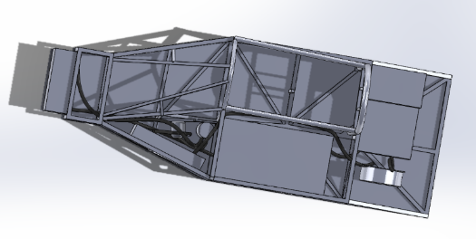
Figure 56 - Birdseye of a Possible Layout
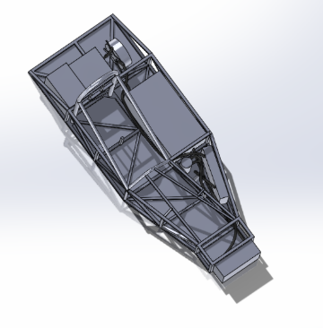
Figure 57 - Routing Layout

2.5.13 - Engineering Evaluation
The final cooling system design represents a compromise between thermal performance, fluid behaviour, packaging constraints and project time limitations.
Although the dual-loop and Y-split configurations offered theoretical advantages in thermal control, the final single-loop system was selected due to its simplicity, reliability and predictable flow behaviour.
The 10 mm motor cooling ports were identified as the dominant constraint in the system. They significantly influence coolant velocity, pressure losses and overall system performance, and ultimately limit the effectiveness of more complex cooling architectures.
This investigation demonstrates the importance of considering both thermal and fluid dynamic behaviour in cooling system design, as well as the practical constraints imposed by real-world implementation.

2.6 Jac Graham-Davies – CAD

2.6.1- Role Description and Requirements
At the beginning of this project numerous roles were assigned to different members of the group. The computer-aided design role involved the team member to in charge of general CAD tasks and any other projects to do with CAD. Some of these tasks included things such as modelling the chassis allowing for the use by other team members for tasks such as weight management and packaging. Other tasks were also to assist other team members with designing parts such as mounts for motors and radiators. It was also proposed that this role would manage any changes required to the bodywork to fit our needs, and in turn also conducting computational fluid dynamic or CFD on this bodywork to understand the aerodynamic characteristics of the bodywork and car allowing for improvements to be made where it was saw fit.

2.6.2 - Chassis Modelling
The first task which was undertaken was a fundamental and crucial piece of the project. The modelling of the chassis was an important step in the development of project for serval reasons. The first main reason being for weight distribution. By modelling the chassis it allowed for correct material to be assigned to it allowing for calculation to be made on where the best positions are for components to be mounted as it was assumed the car would already be rear heavy as the addition of batteries and their corresponding components would be significantly heavier than the engine and gearbox that were originally meant to be in this car. It also allowed other team members to produce CAD models of their own required components and assign them their correct weights. Not only did this assist with weight distribution calculations but it also allowed for the ability to test fit components without the need to physically produce mounts for said components. This also meant a series of different components could be test fit in the chassis without the need for purchasing the parts and hence allowing us to narrow down the choice of components reducing the time required to order and receive the necessary parts.
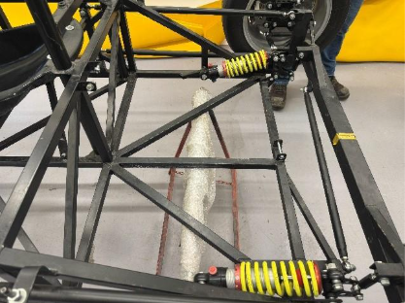

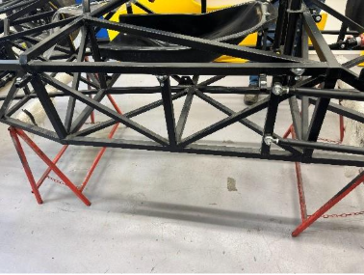
Figure 58 – Back of Car
Figure 59 – Side of Car
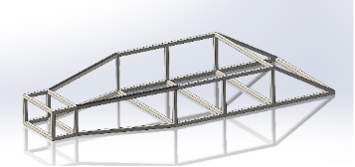
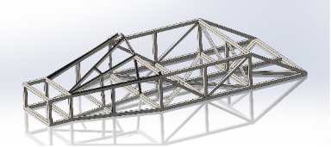
Onto the modelling of the chassis itself. There were numerous steps involved with this task. First step was to gather all of the required measurements from the physical chassis. Figure 58 and Figure 59 shows some segments of the physical chassis that was be measured. The first stage of this process was measuring all of the main outer bars and tubes. These were measurements had to be extremely accurate and precises as all of the other subsequent measurements were based off of these initial measurements. In order to make sure the measurements were correct and accurate there a few steps that were taken. The first step being that the equipment that we used was accurate. When measuring rules, digital callipers and metre rule were used as well as checking the rules were straight and the callipers were zeroed. To provide another layer of accuracy all of the measurements were taken twice and double checked by two different team members. This same process was then subsequently used for the measuring of all of the other different bars such as the cross-members used for bracing the chassis and the cockpit and roll hoop.
Figure 60 – CAD of Chassis Iteration 1
Figure 61 – CAD of Chassis Iteration 2
Once all of the measurements were gathered, they were then recorded ready for use in the model.
The model was created in numerous stages to make sure that the model maintains its accuracy. Much like the measurement stage noted previously, the model was done in the same way. The first stage of modelling was the basic structure of chassis. The first series of measurements were used for this and Figure 60 shows this first basic model of the chassis. The next stage of the modelling process was to add in all of the supporting cross-members to the previous version. Figure 61 shows this stage. And the final stage of the modelling process was to add in the final supporting bars and tubes as well as the cockpit roll hoop. This final stage is shown in Figure 62. After the modelling process was complete the material could be assigned to the model. This material was found to be A mild or plain carbon steel. Once this material was assigned to the model accurate weights and distributions could be seen.
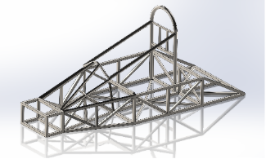
Figure 62 – CAD of Chassis Iteration 3

2.6.3 - Firewalls
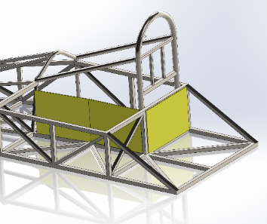
Figure 63 – Firewall CAD
Another task that assigned to the CAD role was the cars firewall material. Having the correct firewall material was crucial for this project and fires involving the lithium-based batteries that were intended to be used in the project burn much hotter than standard ICE fire and much more violently. Research as conducted on these types of lithium-based batteries and it was found that they typically burn at a temperature anywhere from 600-800°C but they have a potential to spike to over 1200°C. With this information it was deemed crucial that the correct firewall material was chosen. The firewall found in electric vehicles is typically constructed from an aluminium alloy (e.g. 6061-T6) for structural integrity, combined with high-temperature insulation such as ceramic fibre or silicone-based materials to protect the passenger compartment (in this case the cockpit) from thermal runaway events exceeding 600°C. From this it was determined that sheets of aluminium would be layered with a firewall material called ProCell PCL-350 and secured around the cockpit. PCL-350 is a filled silicone elastomeric material that meets the requirements for the thermal heat propagation for the batteries used. This firewall layer was modelled in CAD and was then added to the previously made chassis model. Figure 63 shows this; the firewall material is yellow for illustrative purposes.

2.6.4 - Battery Box
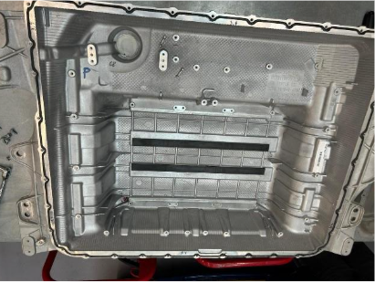
Figure 64 – Open Battery Box
Batteries are the key fundamental aspect of this project and are vital to its success. For this project it was planned that we would be using the individual cells from a Jaguar Land Rover battery box. These battery boxes are from Jaguar Land Rover’s hybrid range of vehicles, and they were chosen for a reason. Hybrid batteries have the capability to release more energy much quicker than a typical EV battery. For the projects proposed purpose this is a great benefit as the project isn't solely relying on range but more so speed. And the ability for the batteries to discharge their power rapidly makes the hybrid batteries perfect. However, these battery boxes are extremely large, and it would be impractical for this box to be fitted into the chassis. Figure 64 shows one of the empty original battery boxes. So, it was proposed that these individual cells would be removed from the original box and two smaller battery boxes would be fabricated to the specifications require for the project. It was planned that two boxes would be made to accommodate two banks of batteries. One alongside the cockpit and one behind to make sure the weight distribution was correct. It was planned that these boxes would be designed in CAD with considerations to cooling and space requirements which were specified by the team members in them roles. These designs were then to CNC machined from aluminium by an external company. This was one of the later tasks in the project but unfortunately this task was met by set back after set back. Due to this the battery box was not completed. Due to university’s insurance requirements as well as the PPE policies in place regarding high voltage batteries the original box was never split and in turn the batteries that were planned to be used were not accessible for key things such as dimensions. Meaning designing the battery box was extremely difficult.

2.6.5 - CFD and Bodywork
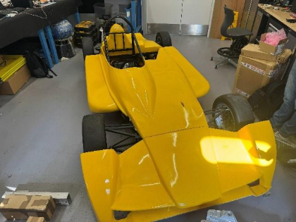
Figure 65 – Car with Bodywork
The final proposed main task that accompanied this role was CFD of the bodywork. It was already known electrifying this Formula 750 car would mean that it is going to be more rear heavy than its ICE counterpart, so grip was discussed and taken into consideration. While other team members in charge of weight and suspension investigated how best to distribute weight within the car the option of aerodynamics were brought up to help with the handling of the car. It was planned that the bodywork would undergo a CFD analysis and simulation to see how the car would behave aerodynamically and where changes could be made to mitigate potential issues as well as where improvements could be made. This task was already planned to be one of the final tasks of the project as it was not necessary until the fundamentals of the car were complete, for example the drivetrain and suspension. One task however was slightly more important was the any changes that the bodywork would need. Due to there being a much wider range of components that were required in comparison to the ICE counterpart space and weight distribution were large factors in where said components were to be place as previously stated. Due to this, components were planned to be place in sections of the chassis where previously no components were designed to go and, in some places, these new components would be protruding into the bodywork. For initial testing this would not prove an issue as these tests would be conducted with no body as it was simply not necessary. However, after these initial tests, the car was to be tested with the bodywork on in order to gather useful real-world data as if it was competed in the F750 series. And hopefully then compete in the series. But for this to happen we would need the body work correctly fitted and adjusted to the complete car. It was decided when it came to this task, the original chassis model would be updated to include all of the components, and everything would be mounted in their final place. In turn there would be a complete CAD model of the final car. The next step would have been to take a 3D scan of the current bodywork. Figure 65 shows the original bodywork on the car.

Once this 3D scan had been taken it could be import in the CAD software and overlay with the CAD model of the complete car and in turn show where there are any conflicts between the components in the chassis and the current bodywork. From this model areas where these conflicts can be marked on the bodywork. From this the bodywork could be cut and adjusted in accordance with the components allowing for everything to fit properly. CFD was then to follow this. Once the bodywork had been adjusted and fitted to the car another scan was to be taken, providing another model which could then have a CFD simulation ran on it. From there any issues with the aerodynamics of the car would be visible allowing for changes to be made as well as improvements to be made to the car. However, much like the battery boxes these changes did not come to fruition. This came down one main issue: the incompletion of the car. Due to this it was unclear where every component was set to be within the chassis of the car and it was unclear where and if any changes had to be made to the bodywork. This was also the reason the bodywork wasn’t improved as it was not known if any changes had to be made. Furthermore, this task was deemed not as important by the group collectively as many of the other task as the project was falling behind. So, it was decided this this task would be put to the side and focusing on more time critical task.

2.6.6 - DVT Software
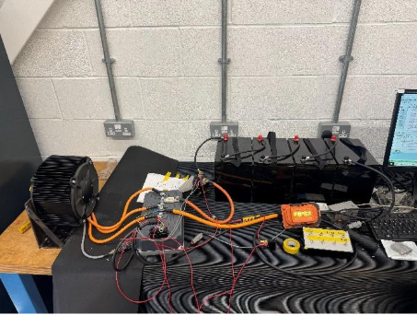
Figure 66 – Testing Rig
Due to a somewhat poor attendance by the group at times many of the more time sensitive tasks were delegated to other team members. Because of this and the fact that the need for CAD modelling and similar tasks was slowing down this role was tasked with helping with the programming and motor aspects of the project. It was established that a smaller motor and smaller controller were used for testing as well as a lower voltage; this being four 12 Volt car batteries in series equating to ≈48 Volts. This was done for a few reasons. The smaller motor and controller would act much like the intended one for the actual project but were smaller and easier to work with. It also meant they would work better with the lower voltage. This lower voltage was also much safer to work with. With this a test bench was setup allowing for the testing and programming of the motor. This test bench is shown in Figure 66.

This test bench allowed for the group the learn the software which was required to program the controller and in turn control the motor. The software which was used was BorgWarner DVT. This is a design validation testing software, and it allows for the testing and configuration of the controller. When assisting with this different feature such as drive mode, forward and reverse options and a handbrake were configured in the software and were linked to switches. Through this there were numerous errors within the software in relation to the controller and motor. One error that proved difficult to resolve was to do with the lack of a pre-charge resistor within the physical circuit. This was then resolved after research what rating resistor was need and after more trial and error from another group member all the errors and issues the software had produced had been resolved and fixed. The motor and controller were then operational and with the understanding gained from the test bench the motor and controller for the car could be programmed. This would have to be done after both components were fitted into the chassis but due to delays with driveshafts and other fundamental components being delayed the motor and controller could not be installed. Furthermore, because there was no access to the batteries the controller and motor would not be able to receive the correct power further hindering attempts for setting it up in the car as well as programming it.

2.7 Tristan Short – Packaging and Wire Harness

2.7.1 - Introduction
In this group project involving the electrification of a Formula 750 (F750) race car, I was responsible for both packaging and the development of the wiring harness. This role required consistent communication and coordination with all team members to ensure that electrical and mechanical components could be successfully integrated within the constraints of the vehicle. Particular attention was given to spatial limitations. The role also required consideration of safety, serviceability, and future maintenance.

2.7.2 - Diagnosed The Wiring Harness
With assistance from the group leader, George, the wire colours were systematically compared against the available wiring diagram to accurately identify each wire’s function, as shown in Figure 68. This process was essential due to the lack of clear labelling on the existing harness, requiring careful inspection and cross-referencing.
Once identified, the wires were grouped according to their respective destinations and functions (figure 68). This grouping process helped to simplify the harness layout and improve clarity for future installation and troubleshooting. Suitable connectors were then researched and selected for each section of the harness, ensuring compatibility with both current and future components while also considering durability and ease of assembly.
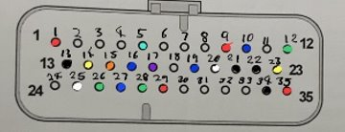
Following the selection process, an order request was submitted for the required connectors. This step ensured that the harness could be properly assembled and prepared for installation once all other vehicle systems had been finalised. Consideration was also given to routing paths within the vehicle, with the aim of minimising interference, reducing the risk of damage, and maintaining a clean and organised layout.
Figure68 Wire harness main connector with coloured dots for wire colours
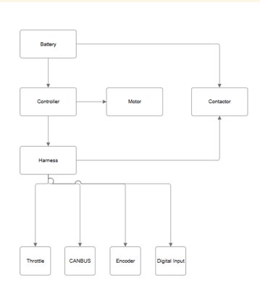
Figure 69 A basic line drawing of what the wire harness connects to,
The next planned stage involved assisting with the wiring of the Battery Management System (BMS), which is a critical component for monitoring and protecting the battery pack. However, due to insurance restrictions preventing removal of the batteries from the original casing, progress in this area was not possible. This limitation also impacted the development of new battery housing solutions for the F750, delaying further integration work.

2.7.3 - F750 Floor
Using the CAD model of the chassis (Figure 70), the floor dimensions measured to determine the required material size and shape. This ensured that the selected material would fit accurately and provide full coverage of the chassis underside.
To inform material selection, discussions were held with other university race teams to understand commonly used materials and best practices. This information was supported by additional online research into material properties such as strength, weight and cost. Based on these considerations, 1.6 mm thick aluminium sheet was selected as it offered a strong balance between structural integrity and weight efficiency.
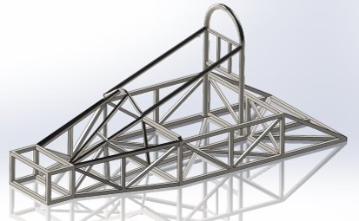
Figure 70 CAD model of the chassis
Two design configurations were developed using CAD software. The first option was a three-piece floor design, which would simplify installation due to smaller individual sections and allow for easier and more cost-effective replacement if damage occurred. The second option was a single-piece floor, which would provide a continuous surface with no joints.
The single-piece design offered several advantages. It reduced the risk of edges catching on curbs or uneven track surfaces and provided increased structural strength due to the absence of joints. Additionally, the larger contact area between the floor and chassis improved load distribution and overall rigidity.
Following team evaluation, the single-piece design was selected as the most suitable solution. Although the estimated material cost was approximately £350, a suitable aluminium sheet was available within the university workshop, eliminating additional expense.
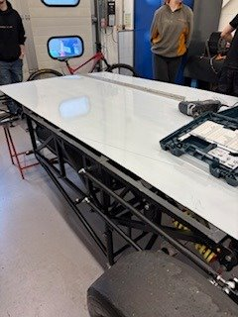
Figure71 The F750 flipped upside down with aluminium sheet on top
For installation, the vehicle was inverted to allow easier access to the underside of the chassis. The aluminium sheet was clamped securely in place (Figure 71), and the outline of the chassis was carefully cut using a jigsaw. A press cutter was used for smaller edges to achieve a higher-quality finish.
To secure the floor, a combination of silicone and rivets was used. The silicone served to reduce noise and vibration while also helping to seal the interface between the floor and chassis. Rivets were spaced approximately 3–6 inches apart to ensure even load distribution and a secure attachment.
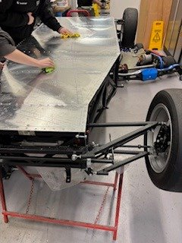
Figure72 Finished flooring on the car

2.7.4 - Motor Mount
The initial stage of the motor mount design involved measuring the motor’s mounting points and assessing the available space within the rear of the vehicle. Several design concepts were sketched to explore different configurations and ensure that the mount would fit within the allocated space without interfering with other components.
To refine the design, the forces acting on the motor mount were calculated. These forces included both propulsion forces during acceleration and opposing forces generated during regenerative braking. As a result, the mount needed to be capable of withstanding loads in multiple directions without deformation or failure.
The force calculated:
$$Force From The Motor$$
$$F=\frac{τ}{r}$$
$$F=\frac{500}{134x{10}^{-3}}$$
$$F=3731.34 Nm (2 d.p.)$$

Several design options were modelled in CAD, including both adjustable and non-adjustable configurations. After team discussion, a non-adjustable design was chosen as it provided greater structural integrity and improved packaging efficiency within the limited space.
The final design was manufactured using available steel sections. The structure consisted of box section cut diagonally and reinforced with vertical square bar to support the motor. All components were welded together to ensure sufficient strength and rigidity.
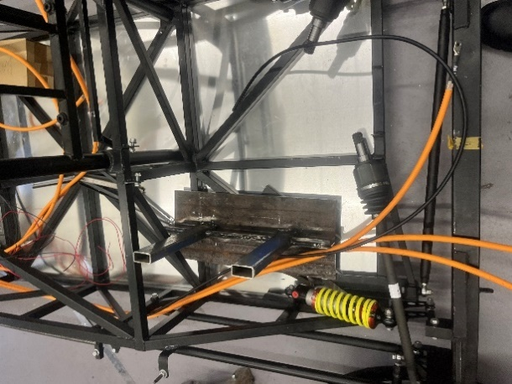
Figure 73 Motor mount in car without the motor
The motor was then installed onto the mount and positioned within the vehicle to verify fitment and clearance (Figure 73). This step ensured that the design did not interfere with surrounding components and allowed for any necessary adjustments before final installation.
Two mounting methods were considered for securing the mount to the chassis: bolting and welding. Welding was identified as the preferred method due to its superior strength and the limitations of using bolts within the existing chassis structure.
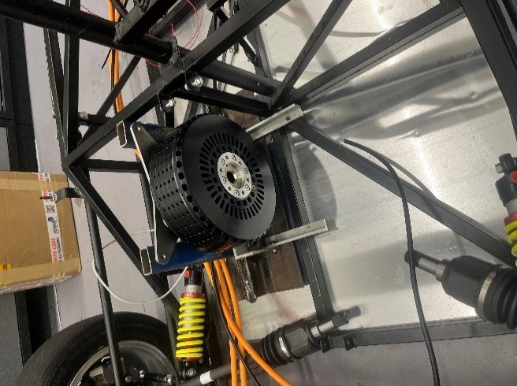
Figure74 Motor mount in car with the motor

2.7.5 - Differential Mount
To design the differential mounting system, the mounting points were measured and several concepts were developed. Due to the selection of a non-adjustable motor mount, it was necessary for the differential mount to incorporate adjustability. This would allow for proper chain tensioning and provide the ability to compensate for wear over time.
After reviewing the proposed designs, the team selected an alternative concept developed by another member. This design was chosen due to its simplicity, ease of manufacture, and effectiveness in achieving the required adjustability.

2.7.6 - Front Radiator and Nose Mount
The design of the front radiator and nose mount began with measuring the available space and identifying the mounting points on the chassis. Additional reference was made to existing F750 vehicles to understand common design approaches and constraints.
As the radiator is mounted at the front of the vehicle, it was necessary to integrate it into the nose mount design. The radiator dimensions were measured; however, the existing mounting points were not suitable for the intended configuration. Since the radiator is constructed from aluminium, the original mounts can be removed and repositioned by a trained professional to better suit the new design.
Mild steel box section was selected for the mounting structure, as it matches the chassis material and provides sufficient strength while remaining cost-effective.
A CAD model of the front assembly was created (Figure 75), with each component designed individually to ensure accuracy and ease of fabrication. The radiator was modelled as a simplified geometry to allow for precise real-world adjustments during installation.
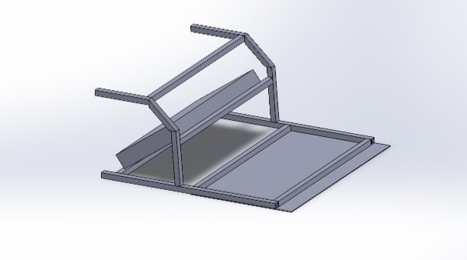
Figure 75 CAD model of front assembly with radiator
A thin plate was incorporated beneath the frame to improve airflow under the vehicle and provide a mounting surface for the nose cone. The nose cone would be bolted from underneath, while the plate itself would be attached using silicone and rivets, similar to the floor installation.
The structure was designed to withstand minor impacts from track conditions and contact with other vehicles without compromising stability or control. Final validation of the design will be carried out through physical testing, with any necessary reinforcements added based on observed performance.

2.8 Tasha Freeman – Batteries
My role within this project was the batteries. This wasn’t my first choice as my knowledge within this area was extremely limited, however no one else volunteered for it.
The batteries used in this project are from a Plug-in Hybrid Range Rover, which are Samsung lithium ion 43.2V 12S1P modules.
The batteries for this project had been predetermined meaning I did not have to research and choose suitable batteries which slightly reduced my workload initially. However, due to my lack of knowledge on batteries within an automotive application I had to research how batteries worked within electric cars and how they were integrated, with respect to cooling and management. Furthermore, I had to research the difference between hybrid and electric car batteries, as the batteries provided where for a hybrid range rover and I need to understand how it would impact the car. For example, a plug-in hybrid battery is typically lighter and smaller than an electric vehicles battery which is more beneficial for our car as we are limited on space and would ideally like to keep it as light as possible (The Differences between Hybrid and EV Batteries, 2021).
Due to the batteries being from a hybrid range rover, there was no data sheet for the batteries, meaning there was a lack of data for the batteries. In addition to this, it was not possible to test the batteries, as a student, due training being required to comply with health and safety regulations. As a result, I had to work with limited and unreliable data I was provided with from Alibaba. There was no data sheet for the batteries on this website either. Unfortunately, this meant I had to use the data that was in the description of the product.
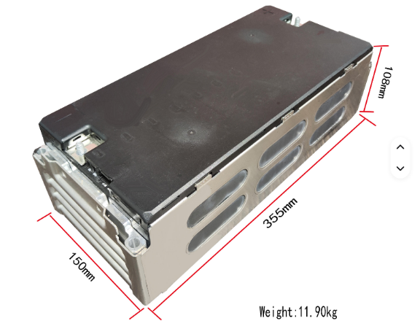
Figure 76 – Battery with Dimensions
The data provided on Alibaba contradicted itself several times with regard to the dimensions of the batteries, as shown in the images taken from the website below. (Lithium Ion Battery Module 12s1p 43.2v 44.4v Sdi 50ah 51ah 55ah Rechargeable Ncm Batteries For Electrical Vehicle - Buy 12s1p ev Battery electrical Vehicle Battery Product on Alibaba.com, no date)


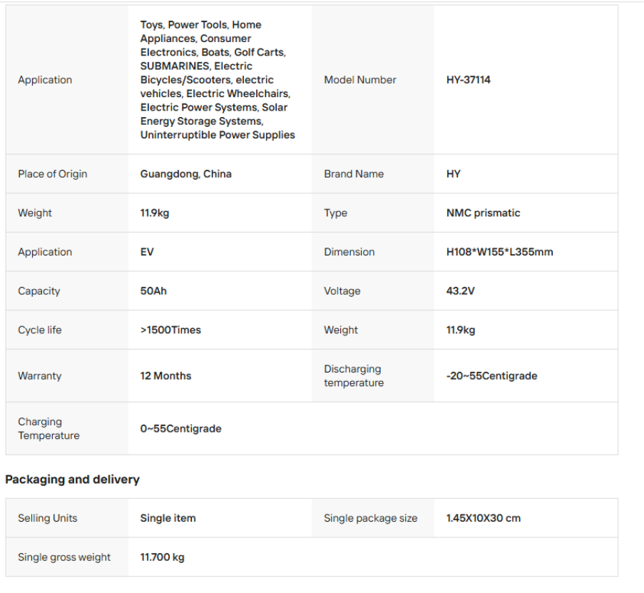
Figure 77 - Image of Battery Specification Table
Furthermore, there was also discrepancies with regard to what the nominal voltage is. This is also shown in the images from the website below (Lithium Ion Battery Module 12s1p 43.2v 44.4v Sdi 50ah 51ah 55ah Rechargeable Ncm Batteries For Electrical Vehicle - Buy 12s1p ev Battery electrical Vehicle Battery Product on Alibaba.com, no date).


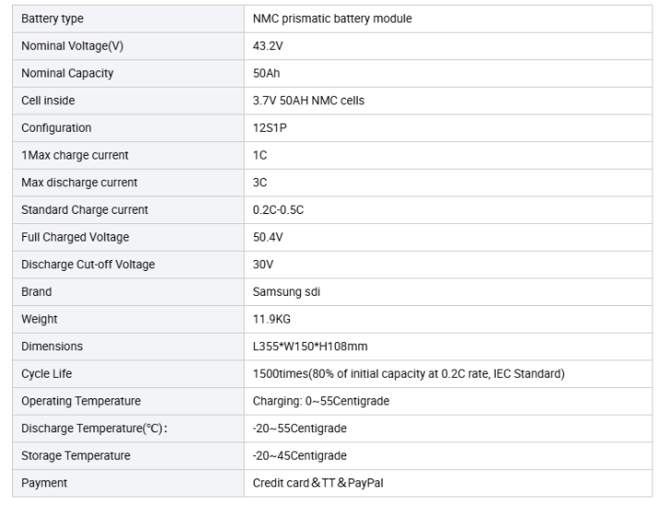
Figure 78 – Image of battery specification table

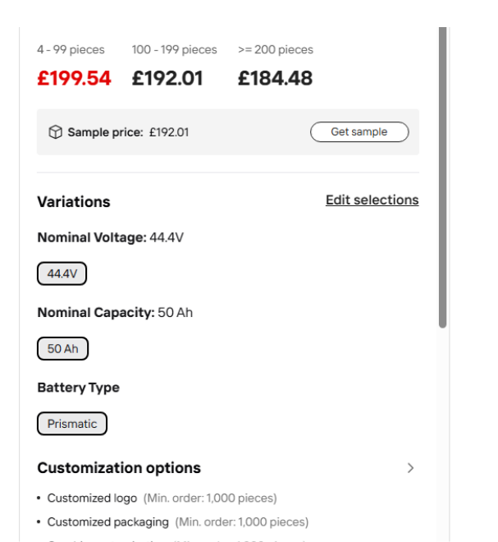
Figure 79 - Image of nominal voltage section


Figure 80 – Image of Battery with dimension
Having noticed these discrepancies, I asked for a data sheet or some clearer data and I was given a link to Starmax Energy. However, this only led to more confusion and unreliable data as the dimensions were also inconsistent. This is shown in the images taken from the website below. (Starmax Energy – Lithium Ion Battery Manufacturers – Battery Energy Storage System Suppliers NCM 43.2V Module, no date)


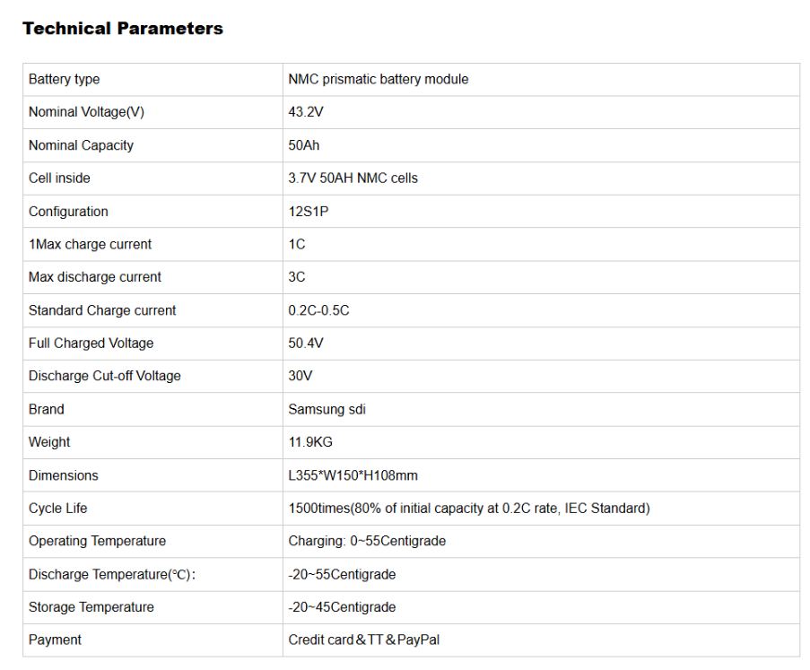
Figure 81 – Image of Battery specification page
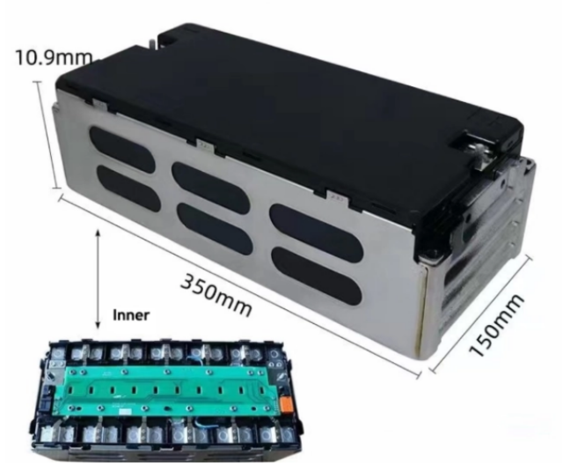
Figure 82 – Battery with dimension on image
In order to solve this issue, I asked if the batteries could be taken out for measurement and to be tested. However, the university did not have the correct PPE in order to do this, but it would be ordered. In the meantime, I had to work with what I had been given to provide the rest of the group with some values about the batteries to help with their calculations. I used the data from Alibaba as best as I could to calculate the power output from the batteries, as well as the total voltage for 14 packs, voltage per pack and voltage per cell.
Another task I had to complete was to research the requirements for the battery housing. This involved looking into what was needed to go into the housing and how to cool the batteries within the box, as well as how big the box would need to be. Through research of battery cooling in automotive settings, I found that the batteries would be best cooled using indirect water cooling, using cold plates with a thermal interfacing material, TIM, between the batteries and the cold plates (Togun et al., 2024) (Etengoff, 2025). This is due to other options, such as air cooling, being too inefficient and too difficult to implement in the vehicle with regard to logistics, such as location of the batteries in relation to the air flow. As well as that, liquid cooling is very popular and therefore components are widely available (Togun et al., 2024). Another requirement I needed to research for the battery housing was the safety aspects, which resulted in the box needing a manual disconnect mechanism, such as a kill switch, to ensure safety for maintenance and emergencies (ISO 6469-3:2021, no date). Additionally, the batteries needed a management system that would need to be integrated into the housing, this is to monitor the temperature, voltage, current and state of charge of the batteries to prevent them from overcharging, overheating and overall ensuring they are safe and efficient (Baťa and Mikle, 2019). The final part of researching the requirements for the battery housing included looking at how big the battery box would need to be. This would be to help the other team members decide where to put the battery housing boxes and the overall weight distribution. It also helps with choosing where to put the rest of the components as the battery boxes take up a lot of space. However, due to the inconsistencies in the battery dimension, it was only possible to come up with a rough size for the boxes.
This research into the battery housing resulted in another task, which was to research and choose the battery management system, BMS, for the car. This task was more difficult and time consuming than I initially expected due to my lack of understanding and experience with this technology. I had to research what a BMS does, how they work and how they are integrated into a car. Furthermore, the majority of BMS available to buy are for low rated voltages, intended for small electronic systems. This meant that it was difficult to actually find a suitable BMS for our intended purpose as we needed one that was rated for a high voltage. Despite this, multiple suitable systems were found from which the most suitable one was chosen (Standard Orion 2 BMS kit, no date). Once this BMS had been found, I had to do further research into the multiple add-ons, such as slave board kits and sensors, to find out what we needed for our specific batteries.
Outside of my specified role, during the start of this project, I assisted with taking measurements of different components of the car, including the motor, controller and batteries. However, it was later discovered that the battery that I measured was not the same as the actual batteries we were going to be using. From the measurements I had taken, I made a simple model of the controller in CAD software to be used to get a basic understanding of where it could go in the CAD model of the vehicle.
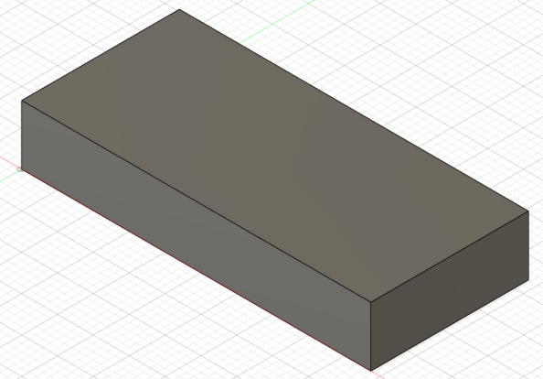
Figure 83 – Simple Controller Model CAD
Additionally, during the project we were trying to find a suitable differential and driveshaft from a Mazda MX-5 for our car. As I knew someone who was scrapping their MX-5, I suggested we used that differential and driveshaft. We were able to get the driveshafts, however, the differential was not able to come out of the car due to seized bolts preventing it.

2.9 Ellis Phillips – Driver and Safety
2.9.1 Introduction
During the 750-electrification project, I was responsible for the safety of the driver when in the vehicle and ensuring the driver can utilize the car to its maximum potential. This includes considering many aspects of the vehicles production such as the location of hazardous components, implementing preventive measures, ensuring all cockpit regulations are passed and communicating with other areas of project to improve drivetrain output and handling.
2.9.2 Understanding regulations
The group was advised to use MSUK regulations to create a car as close to eligible as possible and after thorough analysis of these regulations they provided key information on fire extinguishing systems, extinguishant activation location and the required safety lights needed on the external of the vehicle and in the cockpit but these regulations were deemed too vague to use as the sole guidelines for my area of the project. Through research into more scrutinized championships such as FSAE and Formula Student, championships for student run single-seat race teams, I discovered further inspiration for ensuring driver safety and assurance that the car would be eligible.
2.9.3 Firewall design
During a serious crash, there is potential for damage to battery cells or wiring, which can create internal short circuits and thermal runaway in the battery cells potentially leading to the production of high temperature fires which are difficult to extinguish, however the risk this poses to the driver can be prevented with a firewall which covers any area of the cockpit exposed to tractive electrical equipment. The Formula Student Germany regulations for EV (Electric Vehicle) firewalls are as follows – the fire wall between driver and components must be composed of two layers:
- “One solid layer, facing the tractive side, must be made of aluminium with a thickness of at least 0.5 mm”
- “The second layer, facing the driver, must be made of an electrically insulating and fire-retardant material … The thickness of the second layer must be sufficient to prevent penetrating this layer with a 4 mm wide screwdriver and 250 N of force.”
(FormulaStudent,2025)
Using these guidelines and further research, I settled on using 2mm thick aluminium sheeting for the tractive side layer to ensure sufficient damage protection; it was also easily available and relatively low cost. For the second, driver facing, layer, I decided on Nomex honeycomb sheeting as it is held in high standard for thermal and electrical insulation (used by Boeing and F1) as it slows the heat transfer across the material due to air pockets in the membrane. Nomex is also a lightweight alternative to other thermal insulation which will aid in keeping the overall weight of the car down. The firewall would be sealed with insulating tape and mounted to the chassis using rivets. Unfortunately, due to unforeseen personal circumstances during my 2nd term, the firewall was not produced to be added to the chassis, but I am confident in the composition chosen.

2.9.4 Track Data Analysis
The 750 Motor Club collects all previous race results for the Formula 750 championship and stores them in an archive accessible on their website. Using the data from the 2025 championship allowed me to gather information on track lengths, race durations, number of turns and lap times to calculate average speeds for all 6 tracks in the championship calendar. This data was then shared with the group and discussed to help complete battery charging and output calculations to better understand how the controller has to communicate with the batteries over the course of the 15-minute race.

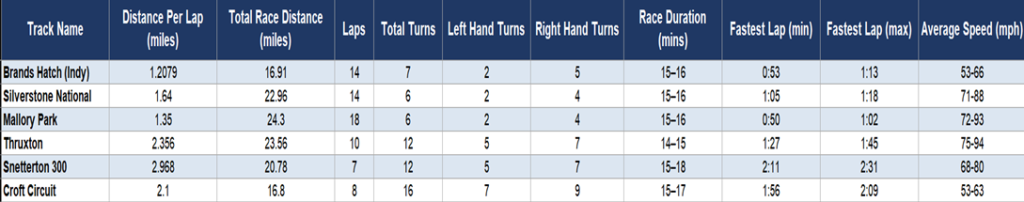

Figure 84 - Track Data – 2025 F750 Championship

2.9.5 Driver Control
The set up of a race car in accordance with the driver's style is vital to compete in any race championship. Adjustments of the Accelerator pedals travel allow for changes in pedal responsiveness and rate of power output from the motor while also allowing the BMS to use throttle demand to manage battery temperatures. Depending on the track and drivers' preferred choice of line, future suspension tuning could take place to further personalize the driver's experience. From the cockpit, the driver must be able to activate the fire extinguishing system easily and view a number of lights which indicate whether the BMS of the vehicle is on, charging, charged or ready to drive. MSUK regulations for fire extinguishing in EVs only permit the use of Novec 1230 systems or FX G-TEC systems (MotorsportUK, 2026) which posed as a challenge to the budget as new versions of these products can cost upwards of £500.

​​References​
BorgWarner(2024) Explore our Technologies AC Motor Controller Gen4 LV size 2/4/6 Reference Manual V4.4 Available at: Gen4 size 2/4/6 Product Manual (Accessed: 20 March 2026)
BorgWarner(2024) Explore our Technologies AC Motor Controller Gen4 HV size 8/10 Reference Manual V4.2 Available at: Gen4 size 8/10 Product Manual (Accessed: 20 March 2026)
Davies Craig (2023) Electric Water Pump Technical Specifications. Available at: https://daviescraig.com (Accessed: 21 March 2026).
Engineering Toolbox (2024) Thermophysical Properties of Water-Glycol Mixtures. Available at: https://www.engineeringtoolbox.com (Accessed: 1 Februaury 2026).
Bosch (2018) Automotive Handbook (10th ed.). Wiley.
Cengel & Cimbala (2018) Fluid Mechanics: Fundamentals and Applications. McGraw-Hill.
Cengel & Ghajar (2020) Heat and Mass Transfer: Fundamentals and Applications. McGraw-Hill.
NASA Glenn Research Center (2017) Reynolds Number and Flow Regimes. Available at: https://www.grc.nasa.gov (Accessed: 16 February 2026).
1.5 litre aluminium header tank (vertical) (2025) obp Motorsport. Available at: https://www.obpltd.com/product-page/1-5-litre-alloy-header-tank-vertical/ (Accessed: 21 March 2026).
Racetech 25mm blue silicone hose 1mtr length (no date) Raceparts. Available at: https://race.parts/Catalogue/Hoses-Fittings/Silicone-Hose-Accessories/Blue-Silicone-Hose/25mm-Blue-Silicone-Hoses/25mm-Blue-Silicone-Hose-1mtr-Length-rtsh25s (Accessed: 16 March 2026).
Three stage reducers (no date) Raceparts. Available at: https://race.parts/Catalogue/Cooling/Ducting-2/Three-Stage-Reducers (Accessed: 12 March 2026).
Baťa, M. and Mikle, D. (2019) ‘Battery Management System Hardware Design for a Student Electric Racing Car’, IFAC-PapersOnLine, 52(27), pp. 74–79. Available at: https://doi.org/10.1016/j.ifacol.2019.12.736.
Etengoff, A. (2025) ‘What role do thermal interface materials (TIMs) play in EV battery systems?’, Battery Power Tips, 14 May. Available at: https://www.batterypowertips.com/what-role-do-thermal-interface-materials-tims-play-in-ev-battery-systems/ (Accessed: 22 March 2026).
ISO 6469-3:2021 (no date) ISO. Available at: https://www.iso.org/standard/81746.html (Accessed: 22 March 2026).
Lithium Ion Battery Module 12s1p 43.2v 44.4v Sdi 50ah 51ah 55ah Rechargeable Ncm Batteries For Electrical Vehicle - Buy 12s1p ev Battery electrical Vehicle Battery Product on Alibaba.com (no date) www.alibaba.com. Available at: https://www.alibaba.com/product-detail/Lithium-Ion-Battery-Module-12S1P-43_1600576799024.html (Accessed: 22 March 2026).
Standard Orion 2 BMS kit (no date) EVShop.EU. Available at: https://evshop.eu/en/bms/558-standard-orion-2-bms-kit-configurator.html (Accessed: 22 March 2026).
Starmax Energy – Lithium Ion Battery Manufacturers – Battery Energy Storage System Suppliers NCM 43.2V Module (no date) Llithium Ion Battery Manufacturers from China. Available at: https://szxhbattery.com/products/lithium-ion-battery-module-12s1p-432v-444v-sdi-50ah-51ah-55ah-rechargeable-ncm-batteries-for-electrical-vehicle (Accessed: 22 March 2026).
The Differences between Hybrid and EV Batteries (2021) Car and Driver. Available at: https://www.caranddriver.com/news/a15345397/battery-taxonomy-the-differences-between-hybrid-and-ev-batteries/ (Accessed: 22 March 2026).
Togun, H. et al. (2024) ‘A critical review on the efficient cooling strategy of batteries of electric vehicles: Advances, challenges, future perspectives’, Renewable and Sustainable Energy Reviews, 203, p. 114732. Available at: https://doi.org/10.1016/j.rser.2024.114732.
FormulaStudent (2025), Formula Student Rules 2025, p44, T4.8.7, Available at: https://www.formulastudent.de/fileadmin/user_upload/all/2025/rules/FS-Rules_2025_v1.1.pdf
MotorsportUK (2026), 2026 National Competition Rules, p296, 14.1, Available at: https://www.motorsportuk.org/the-sport/regulations/
EMRAX d.o.o. (2020) Manual for EMRAX motors / generators. Version 5.4. Available at: Download manual (Accessed: 22 March 2026)

The Engineering ToolBox (2003). Specific Heat of Common Liquids and Fluids. [online] Available at: https://www.engineeringtoolbox.com/specific-heat-fluids-d_151.html [Accessed 21/03/26].

Jay, A. (2026) ‘Power usage F750’. Available at:
https://uowtsd-my.sharepoint.com/:x:/r/personal/2416946_student_uwtsd_ac_uk/Documents/Power%20usage%20F750.xlsx [Accessed 22/03/26]
RacingAspirations (2024) Thruxton 750 formula. Available at: https://www.youtube.com/watch?v=oONx1gvh990 [Accessed 8/03/26]
BTS24 (n.d.) Front sprocket 14 tooth pitch 520. Available at: Front sprocket 14 tooth pitch 520 [Accessed 20/03/26]
Amazon (n.d.) D.I.D 520VX3 Steel X-Ring Chain. Available at: https://www.amazon.co.uk/ [Accessed 22/03/26]
The Chelsea Magazine Company (2022) 750 Motor Club. Available at: https://issuu.com/chelseamagazines/docs/rcesept/s/16506798 (Accessed: 22 March 2026)
Racecars Direct (2024) 750 Formula Car - SDAR/24. Available at: https://racecarsdirect.com/Advert/Details/145856/750-formula-car---sdar24 (Accessed: 22 March 2026)
Motorsport UK (2025) 2026 National Competition Rules (C.7). Available at: https://motorsportuk.s3.eu-west-2.amazonaws.com/wp-content/uploads/2025/12/Motorsport-UK_NCR-2026_Edition-2_020326.pdf (Accessed 21 March 2026)
ExcelCalcs (2023) 50-50 Ethylene glycol-water and air properties. Available at: https://www.excelcalcs.com/calcs/repository/Fluids/50-50-Ethylene-glycol-water--and--air-properties/#:~:text=Density:%20Approximately%201060%20kg/m%C2%B3,C%20(68%C2%B0F) (Accessed 22 March 2026)
Danda, F, Pradecta, M, Huda, L, Majid, A (2019) Design evaluation and thermal calculations of the developed automotive radiators for student formula SAE vehicle “Bimasakti”. Available at: https://ui.adsabs.harvard.edu/abs/2019AIPC.2187b0048D/abstract#:~:text=The%20vehicle%20used%20a%20KTM,study%20of%20the%20radiator%20performance (Accessed 22 March 2026)
Williams, O (2026) Heat Transfer and Heat Dissipation. Available at: https://uowtsd.sharepoint.com/teams/Level4889_GRP/Shared%20Documents/ACHA5011%20Thermodynamics%20and%20Combustion/Week%201.8%20-%20Heat%20Transfer%20and%20Heat%20Exchangers.pdf (Accessed 22 March 2026)
Stone, R. & Ball, J. (2004). Automotive Engineering Fundamentals. Available at: https://tjtlibrary.com/Automobile/Automotive%20Engineering%20Fundamentals.pdf (Accessed 22 March 2026)
EVShop.eu (2026) Standard Orion 2 BMS kit. Available at: https://evshop.eu/en/bms/558-standard-orion-2-bms-kit-configurator.html (Accessed 22 March 2026)
EVShop.eu (2026) Mechanical Drawing For 84-108 Cell Models (PDF). Available at: https://www.orionbms.com/downloads/drawings/orionbms2_mechanical_108.pdf (Accessed 22 March 2026)

