Critical evaluation of braun’s multiplier and wallace tree multiplier using vhdl

Name: Lewy Harrison Student Number: 2321772 Module Code: ACDA6001
  - Electronics 2

- Introduction
This report presents a critical evaluation of two combinational multiplier architectures: the Braun multiplier and the Wallace tree multiplier, implemented using VHDL and analysed through simulation and synthesis tools. Both designs perform 8-bit by 8-bit binary multiplication, generating a 16-bit output product through the formation and addition of partial products. Although they achieve the same functional outcome, the internal architectures differ significantly in how these partial products are organised and processed. The Braun multiplier uses a regular array-based structure with a systematic flow of sums and carries through a grid of adders, while the Wallace tree multiplier employs a hierarchical reduction approach that combines partial products in parallel using carry-save addition stages.
The purpose of this evaluation is to critically evaluate the performance of the two architectures in terms of correctness, timing performance, resource utilisation, and power consumption, in order to assess their suitability for FPGA-based implementation. Using Vivado for synthesis and implementation, both designs are analysed under identical conditions to ensure a fair comparison. The results are then used to explore the trade-offs between structural simplicity and computational efficiency, particularly in relation to how each architecture scales and performs under hardware constraints.

- Background Research Related to Current Developments in Multiplier Techniques
Background research into multiplier design techniques shows a continual evolution in digital arithmetic aimed at improving speed, reducing hardware complexity, and optimising power consumption. Advancements in multiplier techniques include modified algorithms such as Booth multiplication, which reduces the number of partial products generated by encoding input operands more efficiently. Booth’s algorithm is particularly effective for signed multiplication and can significantly reduce the number of addition operations required, especially in cases where input data contains long sequences of repeating bits. In modern research, hybrid architectures that combine aspects of tree-based reduction and encoding techniques are also being explored to balance speed, area, and power efficiency [1].
More recent developments have also focused on optimising multipliers for emerging computational domains such as machine learning and artificial intelligence. In these applications, multiply-accumulate operations dominate processing workloads, leading to increased interest in highly parallel and pipelined multiplier structures. Techniques such as operand isolation, pipelining, and dynamic voltage scaling are increasingly being integrated into multiplier designs to reduce power consumption while maintaining high throughput. These advancements demonstrate that multiplier research continues to be an active field, driven by the demands of modern high-performance computing systems [2].

- Applications and Advantages of the Multipliers
Multipliers are fundamental components in digital systems, forming the backbone of a wide range of arithmetic-intensive applications. Their primary advantage lies in their ability to perform high-speed binary multiplication in hardware, significantly outperforming software-based arithmetic routines. This is particularly important in applications where real-time processing is required, such as digital signal processing, image processing, and communication systems. In these domains, multiplication is frequently used in operations such as convolution, filtering, and transform algorithms, where large volumes of data must be processed efficiently and with minimal latency [3].
One of the key advantages of hardware multipliers is their ability to exploit parallelism to improve computational speed. Architectures such as the Braun and Wallace tree multipliers demonstrate different approaches to achieving this, with both aiming to reduce the time taken to generate and accumulate partial products. This makes them highly suitable for FPGA and ASIC implementations, where deterministic timing and high throughput are essential. Additionally, dedicated multiplier hardware reduces the need for sequential instruction execution, freeing up processor resources and improving overall system efficiency [4].
Multipliers are also widely used in embedded systems and scientific computing, where operations involving scaling, matrix multiplication, and floating-point arithmetic are common. In modern applications such as machine learning and neural networks, multipliers play a critical role in performing large numbers of multiply-accumulate operations, which form the basis of training and inference algorithms. As a result, improvements in multiplier efficiency directly translate to performance gains in these high-demand computational fields [5].

- A Flowchart/Pseudocode Showing the System Operation
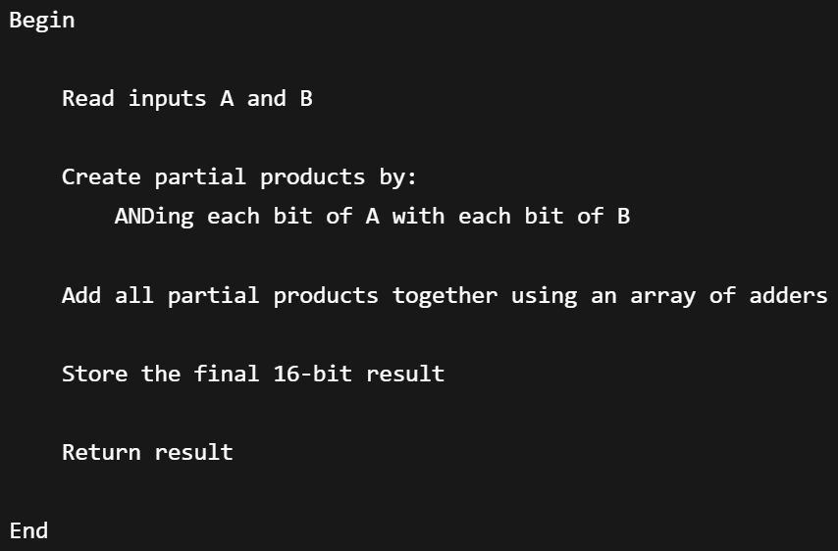
Figure 1: both multiplier methods’ pseudocode
The pseudocode method described applies to both the Braun multiplier and the Wallace tree multiplier, as both methods follow the fundamental process of binary multiplication. Initially, partial products are generated by performing a logical AND operation between each bit of the multiplicand and multiplier. These partial products represent the intermediate results of each individual bit multiplication and are then combined through a series of addition stages to produce the final output. This process allows the multiplication of two 8-bit binary values to be completed and represented as a 16-bit product.
Although both multiplier architectures use the same initial process of partial product generation, the main difference lies in the way these partial products are accumulated. In a Braun multiplier, the partial products are added using a structured array of adders, where the addition occurs in a regular and sequential arrangement. In comparison, the Wallace tree multiplier reduces the partial products using a tree-like structure of adders, allowing multiple additions to occur simultaneously. Despite this difference in implementation, the overall operation described by the pseudocode remains applicable to both methods, as both rely on generating, reducing, and combining partial products to obtain the final multiplication result.
- Methodologies Explaining the Design Process
The both multiplier processes begin with the generation of partial products, where each bit of the 8-bit multiplicand is logically ANDed with each bit of the 8-bit multiplier. This creates 64 individual partial product bits, arranged into eight rows corresponding to each bit of the multiplier. Each row is shifted by its respective bit position, representing the correct binary weighting required for multiplication. These partial products are then combined using an array of adders to produce the final 16-bit product.
In the Braun multiplier architecture, the addition of partial products is performed using a structured array of full adders and half adders. Each adder cell receives three inputs: the current partial product bit, the sum output from the previous addition stage, and the carry output generated from the adjacent adder. The first stage takes another partial product instead of the sum output of the previous stage (which does not exist). When a full adder processes these inputs, it produces a sum output and a carry output. The sum output is passed vertically down through the multiplier array to the next row, where it is combined with the next partial product. The carry output, however, is passed horizontally along the adder row to the next higher-order bit position [Figures 3 and 4]. This arrangement allows the carries to propagate across the array while the partial sums continue moving through the multiplication stages.
The main characteristic of the Braun multiplier is its regular array structure, where each stage of addition follows the same pattern. As the partial products move through the array, the sum values are progressively reduced through each row until the final product bits are produced. The least significant bits are generated earlier in the process, while the higher-order bits require the accumulated carries from previous stages. Although the parallel structure allows multiple additions to occur simultaneously, the propagation of carry signals through each row introduces a delay, as each carry must travel through the preceding adder stages before reaching its final position.
The Wallace tree multiplier also performs an 8-bit by 8-bit multiplication using the same initial partial product generation process. The 64 partial product bits are generated using AND gates and arranged according to their binary significance. However, instead of using a fixed array of adders to combine the partial products, the Wallace tree architecture reduces the number of partial product rows through multiple stages of carry-save addition. At each reduction stage, groups of three bits with the same positional weight are processed using full adders, while pairs of bits may be processed using half adders. Each full adder produces two outputs: a sum bit that retains the same bit position and a carry bit that is shifted to the next higher bit position.
Unlike the Braun multiplier, where the carry propagates horizontally through the adder array, the Wallace tree method passes both the sum and carry outputs down into the following reduction stages. The sum output is passed to another adder operating at the same bit position, while the carry output is passed to a separate adder at the next significant bit position. This allows multiple groups of partial products to be reduced simultaneously without waiting for carry propagation through a complete row of adders. The process continues through several reduction layers until only two rows of values remain, consisting of the final sum and carry components.
The final stage of the Wallace tree multiplier uses conventional adders to combine the remaining sum and carry rows, producing the final 16-bit multiplication result. The use of multiple reduction stages allows the Wallace tree architecture to shorten the critical path compared with the Braun multiplier, as carry signals are not required to travel through long chains of adders. However, this improvement in speed comes at the cost of a more complex and less regular hardware structure, as the connections between reduction stages are more intricate than the fixed array arrangement used in the Braun design.
- Multipliers Block Diagram and Equations
Braun multiplier:
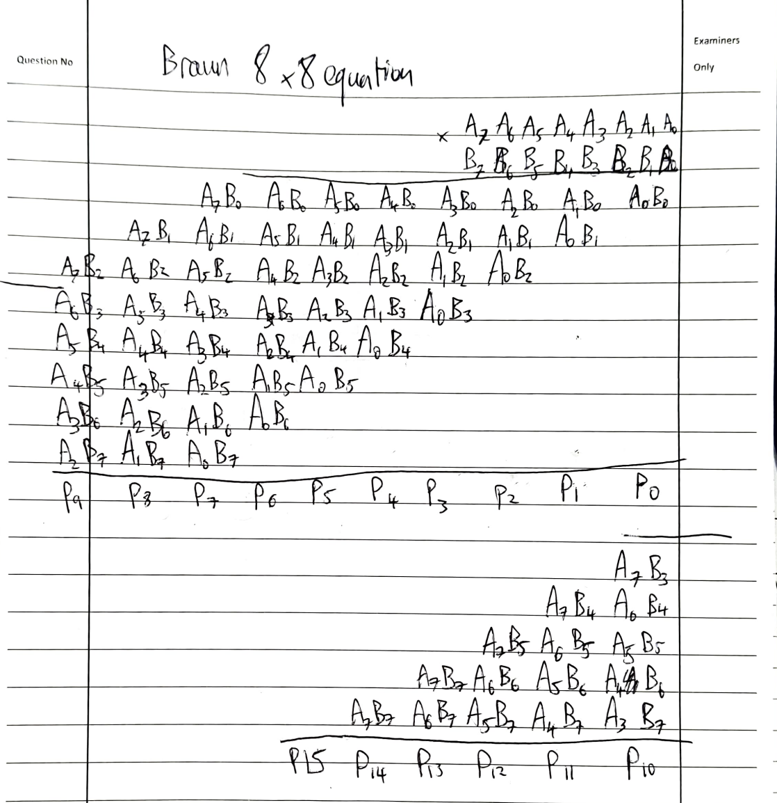
Figure 2: Braun Multiplier Equation
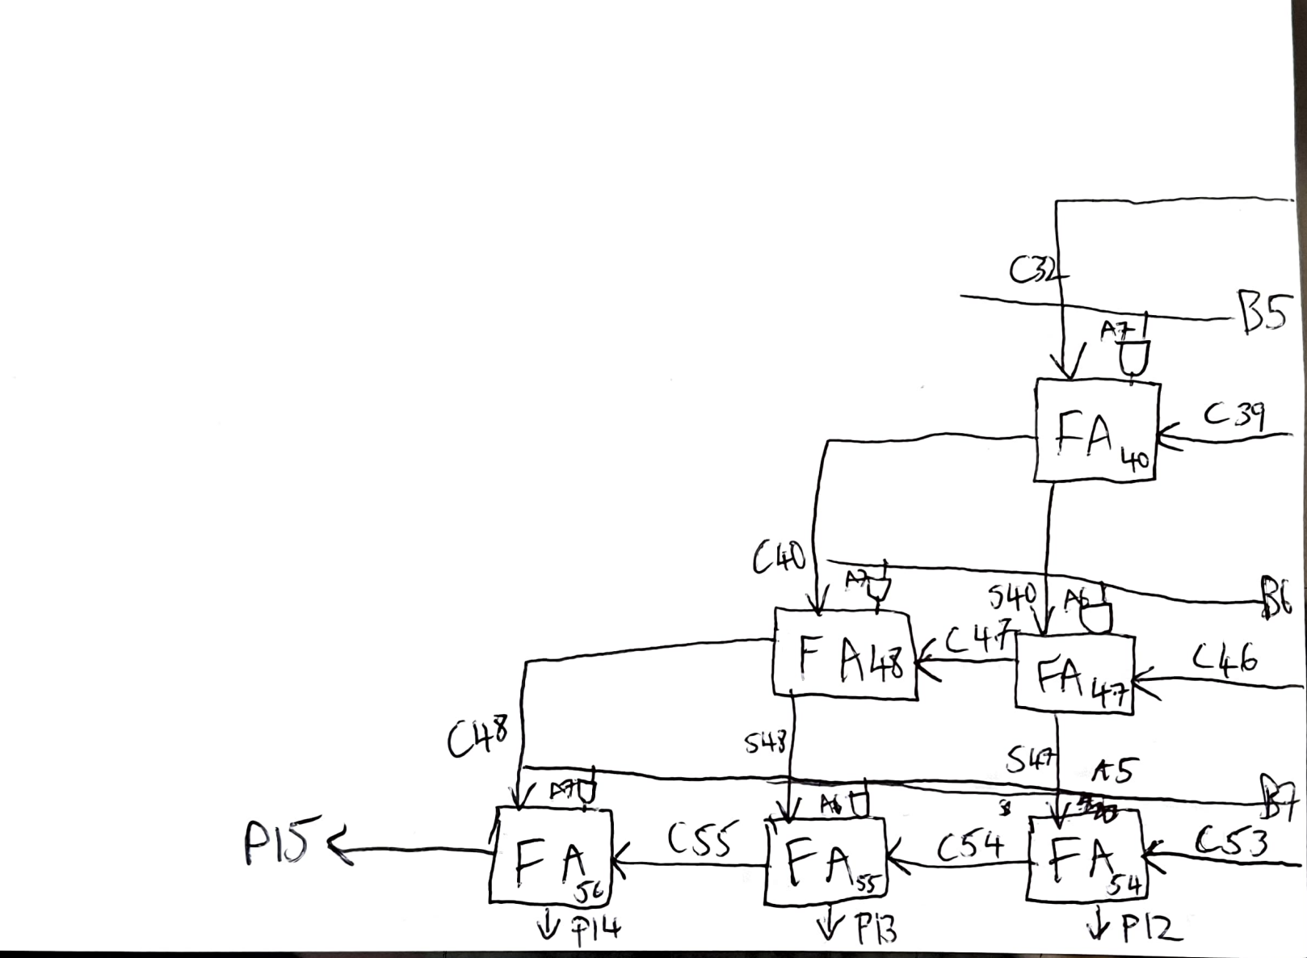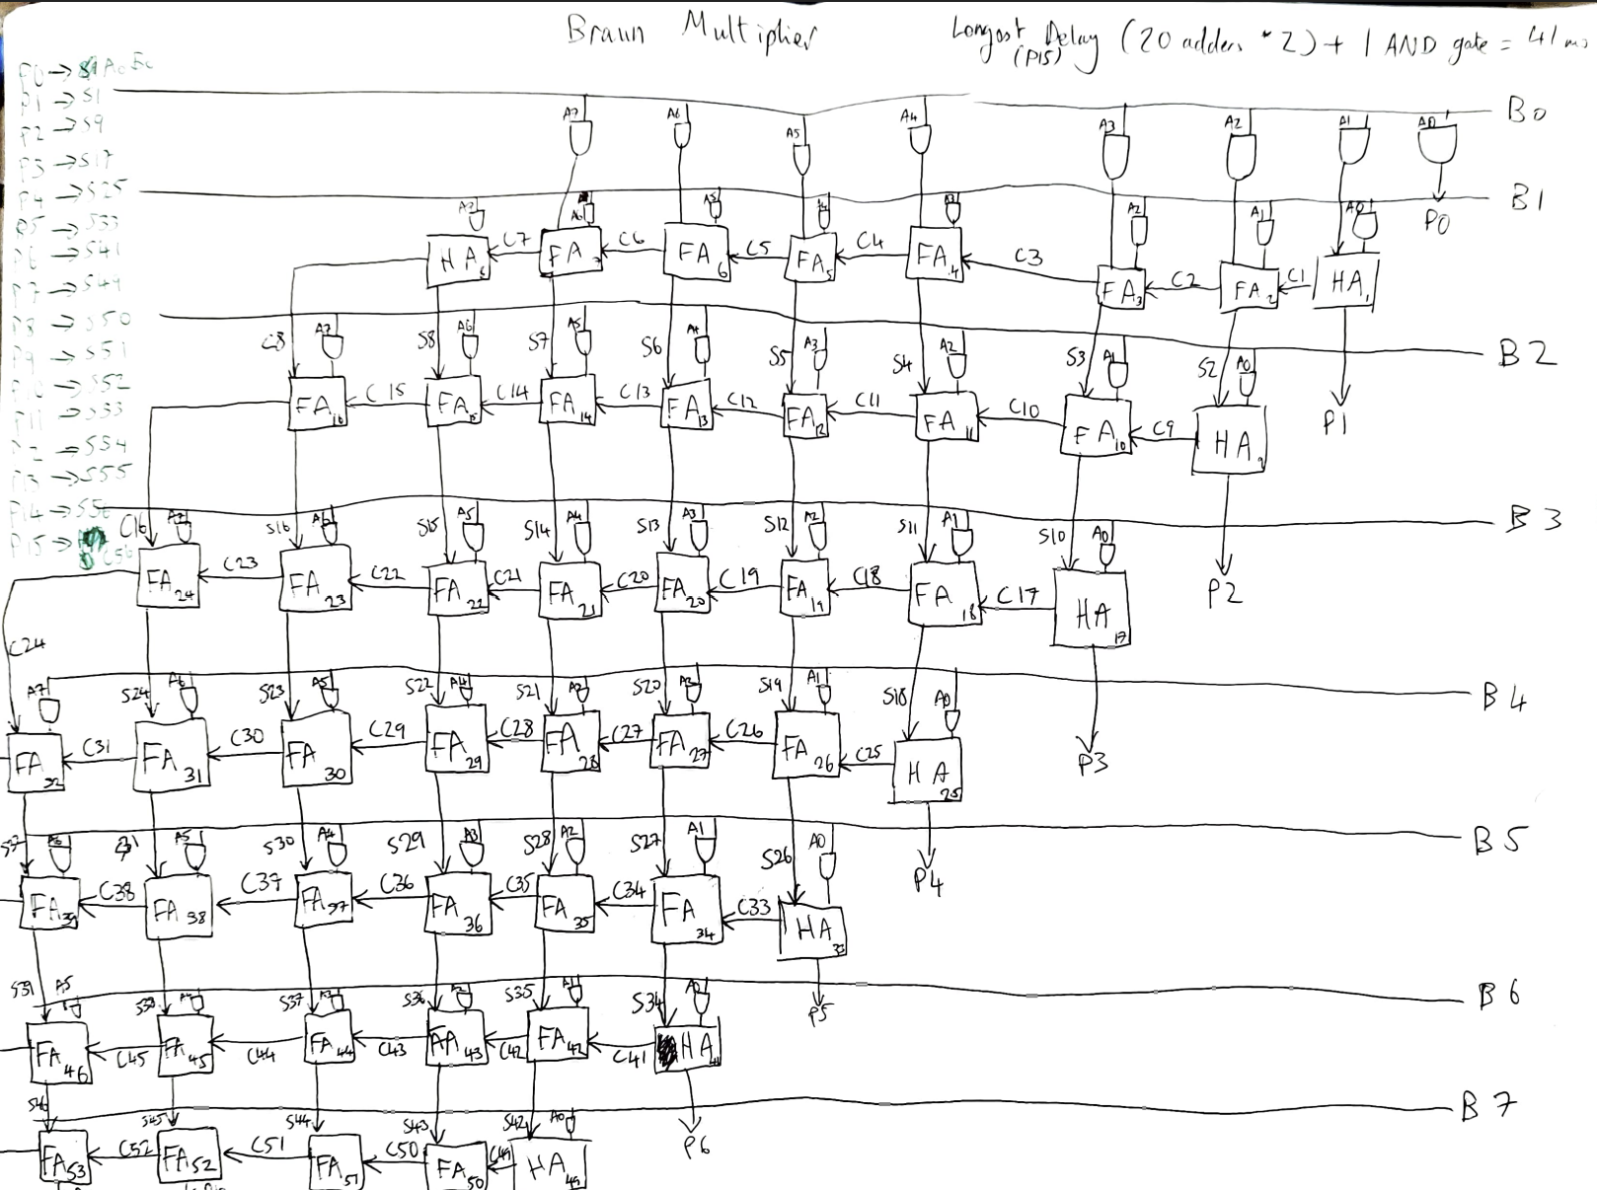
Figures 3 and 4: Braun multiplier Logic Circuit Diagram (left figure was drawn on other page so it’s lined up as best as possible)

Wallace Tree Multiplier:
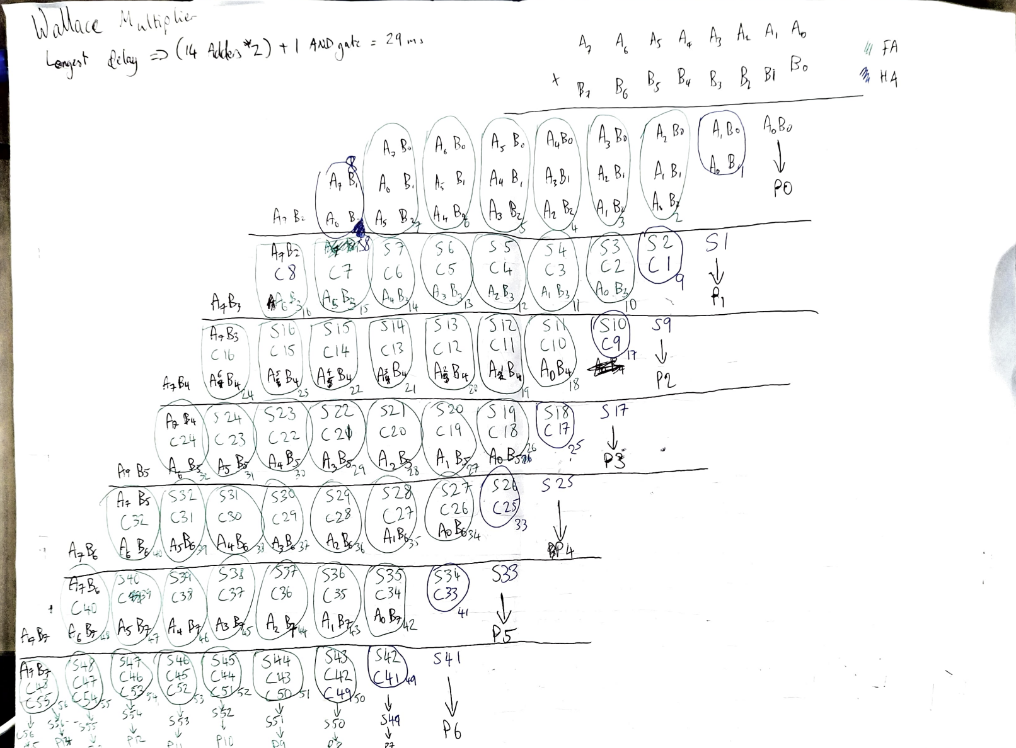
Figure 5: Wallace Tree Multiplier Equation. The dot diagram would be the same as this, with the partial products replaced by dots.
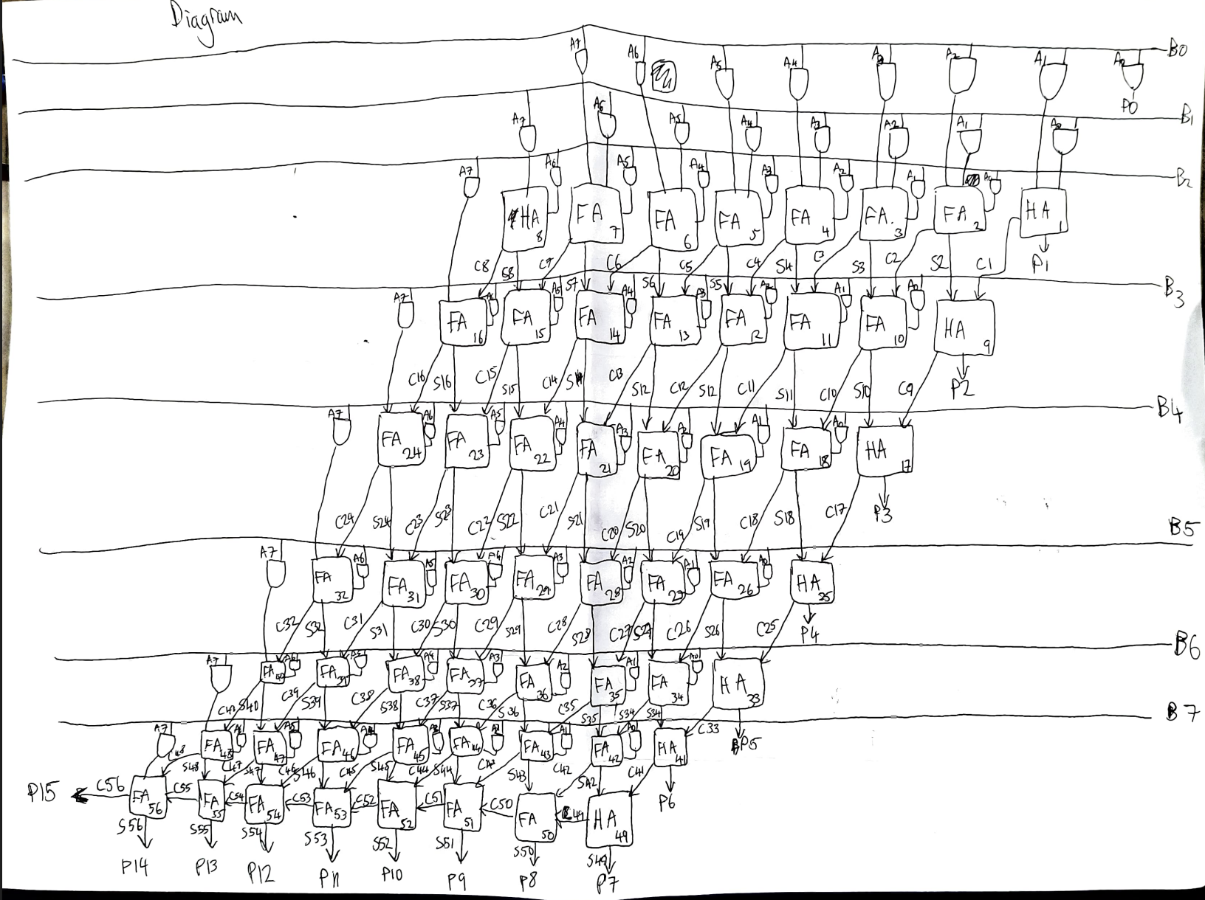
Figure 6: Wallace Tree Multiplier Logic Circuit Diagram.
- VHDL Code
Code for Full Adder Subroutine:
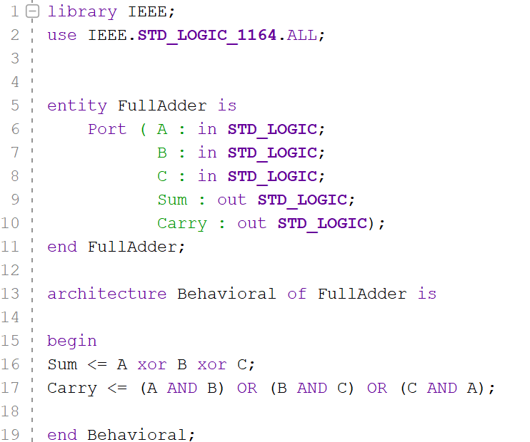
Figure 7: Performs the operation of a full adder.
Code for Half Adder Subroutine:
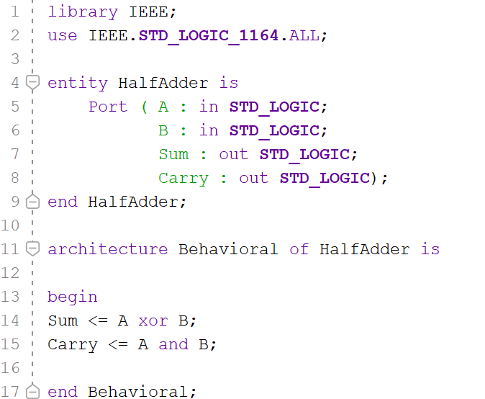
Figure 8: Performs the operation of a half adder.

Code For Braun Multiplier:
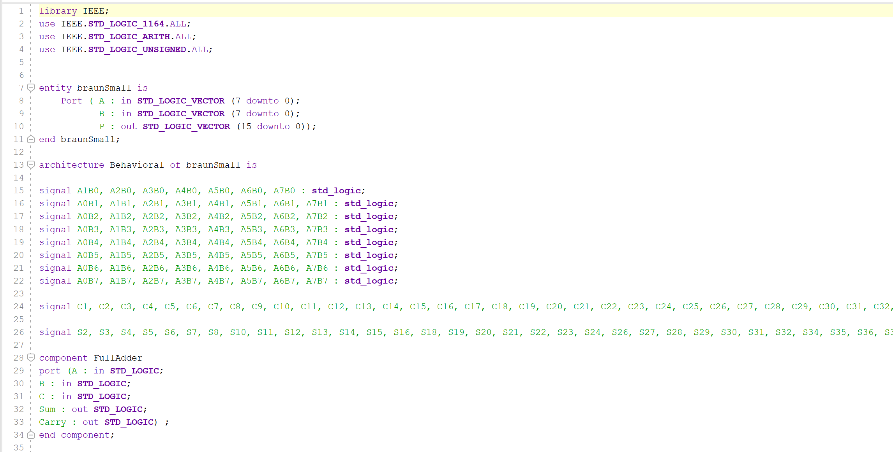
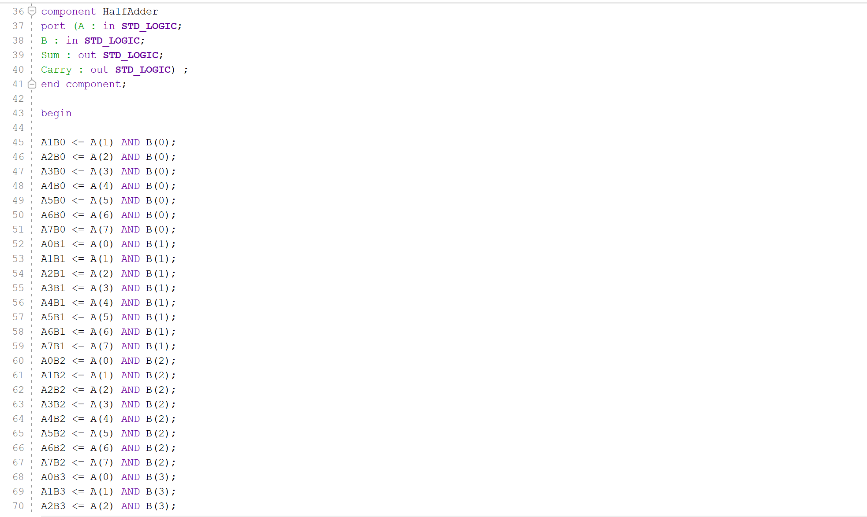
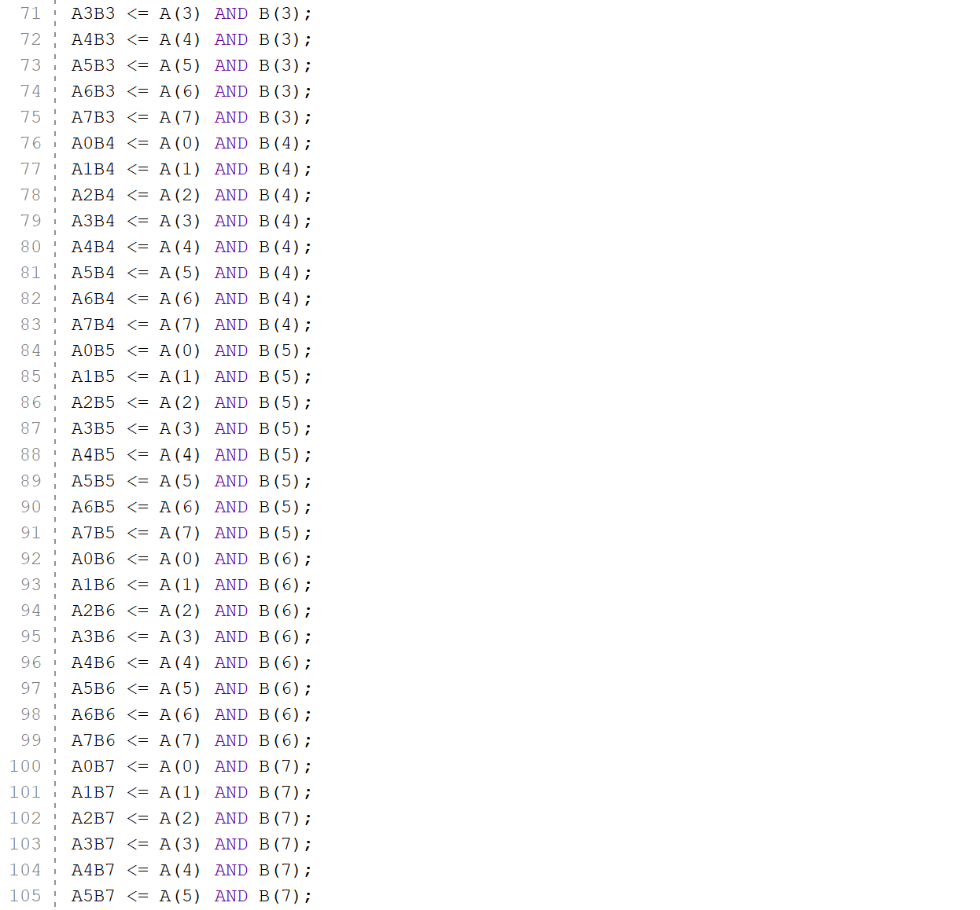
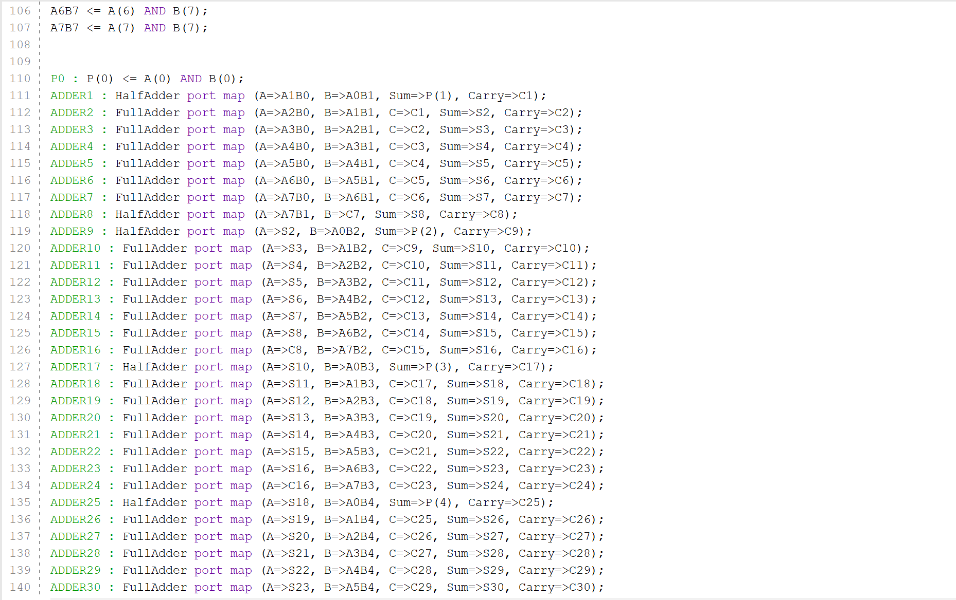
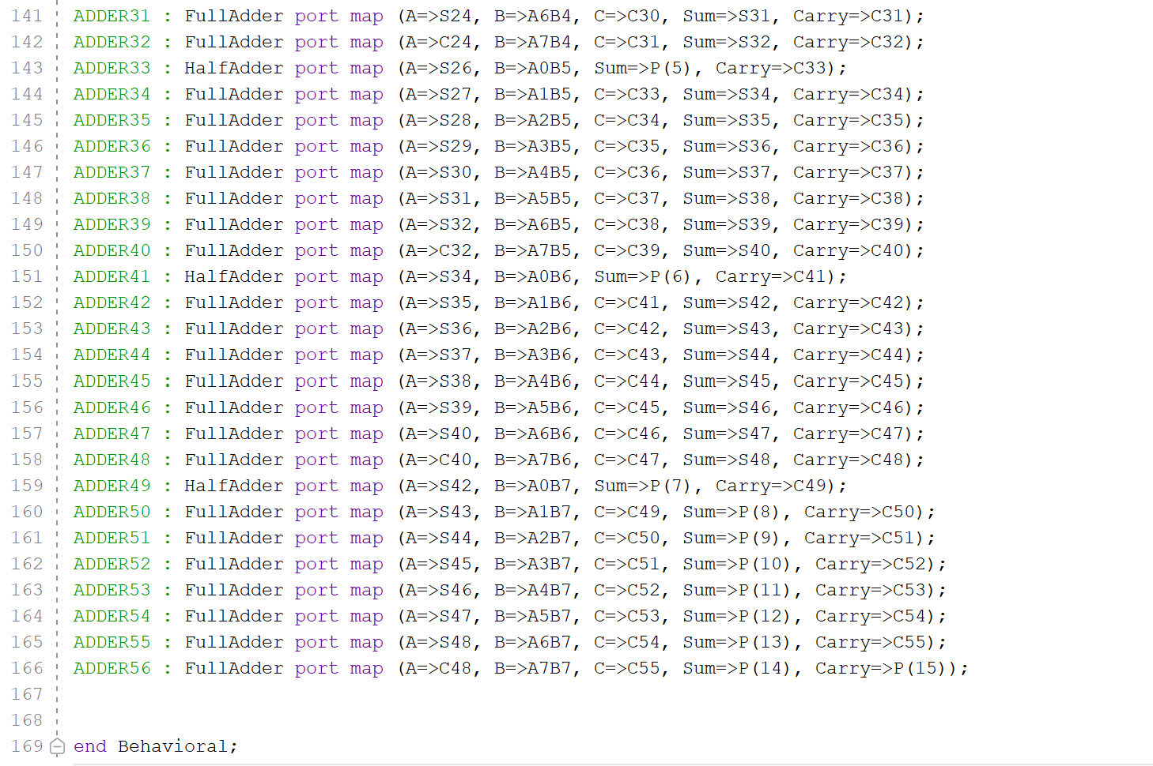
Figures 9-13 shows VHDL code for Braun Multiplier
Lines 7 – 11 define the variables and make them vectors. A and B are set to 0 – 7, they are the two 8-bit inputs that will be multiplied. P is set as 0 – 15 as that is the 16-bit output. Lines 15-22 then define the partial products of A and B. A0B0 is not defined there as the product of those is directly a value of P. Line 24 then defines each carry that will come from an adder. Carry 56 is missed out because it is a P value. Line 26 does the same but for sum values. Sums 1, 9, 17, 25, 33, 41 and 49 – 56 are all missed as they are the values for P, and do not need to be put in a variable before being an output. Lines 28 – 41 call in the previously made full adder and half adder subroutines. Lines 45 – 107 individually assign each partial product with their A value and B value. Line 110 performs the AND operation on the A0 value and the B0 value to get the P0 value. Lines 111 – 166 have the operations for all the adders for the Braun multiplication method. The number of the adder matches up with the drawn diagram in [Figures 3 and 4]. The structure for the adders goes as follows:
$\left[Adder+number\right] : \left[half or full\right] port map \left\{ \left(define A\right), \left(define B\right),*\left(define C\right),* \left(define sum\right), \left(define carry\right) \right\};$
C is only defined for a full adder.
Code for Wallace Tree Method:
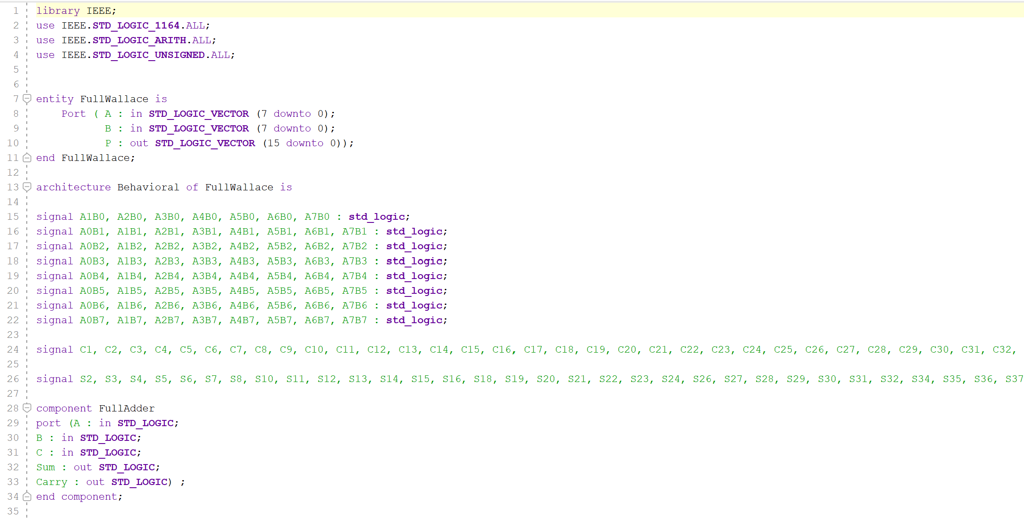
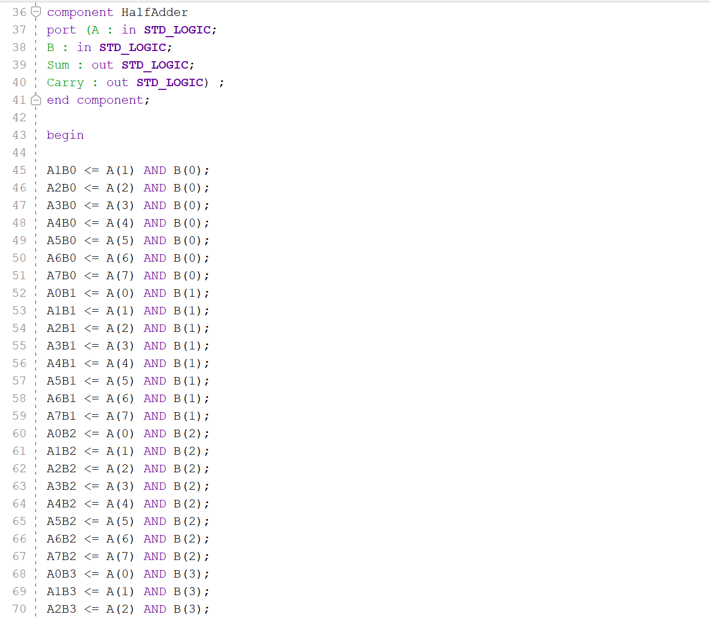
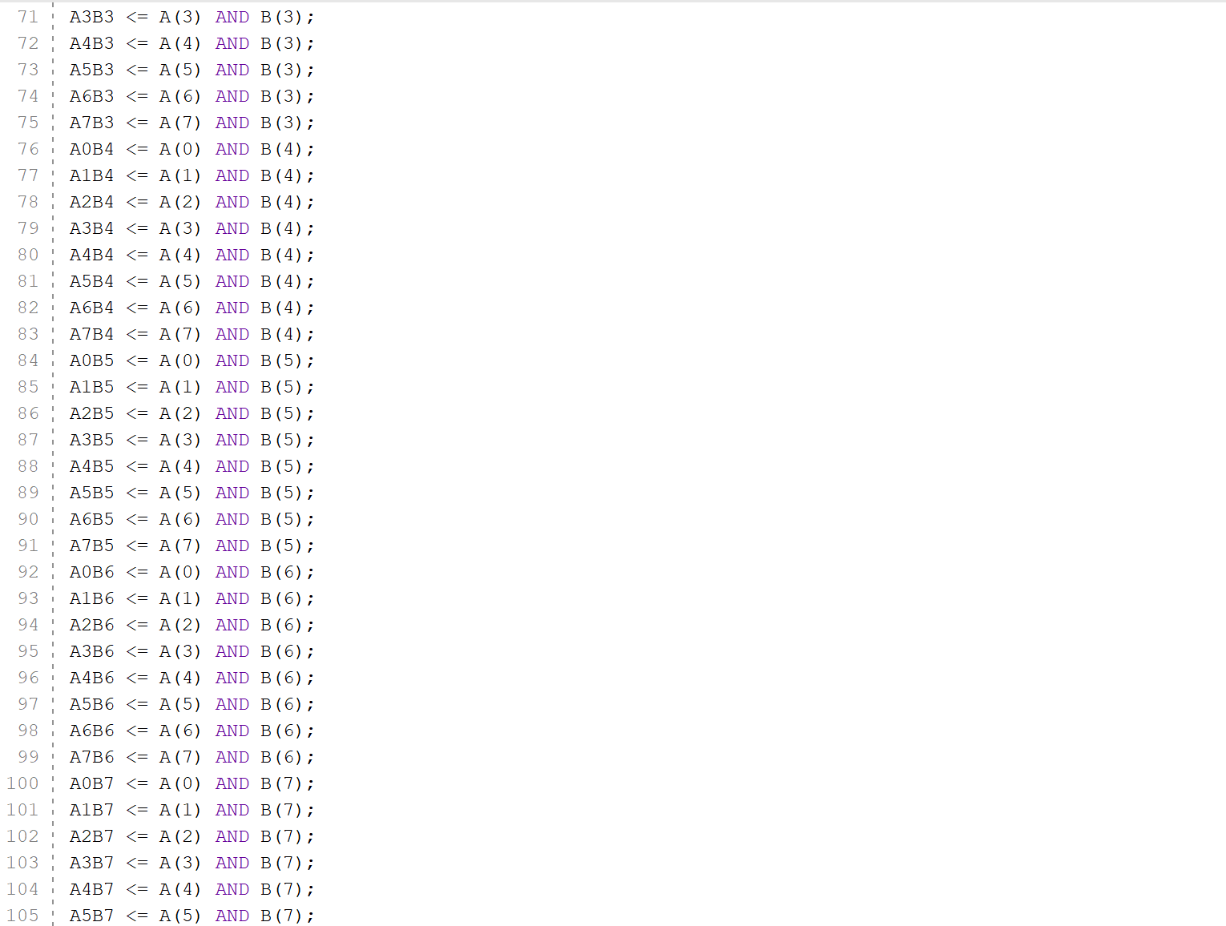
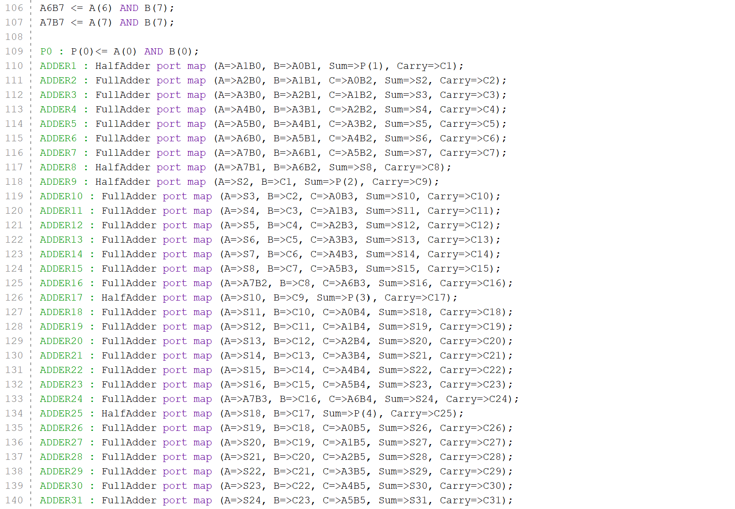
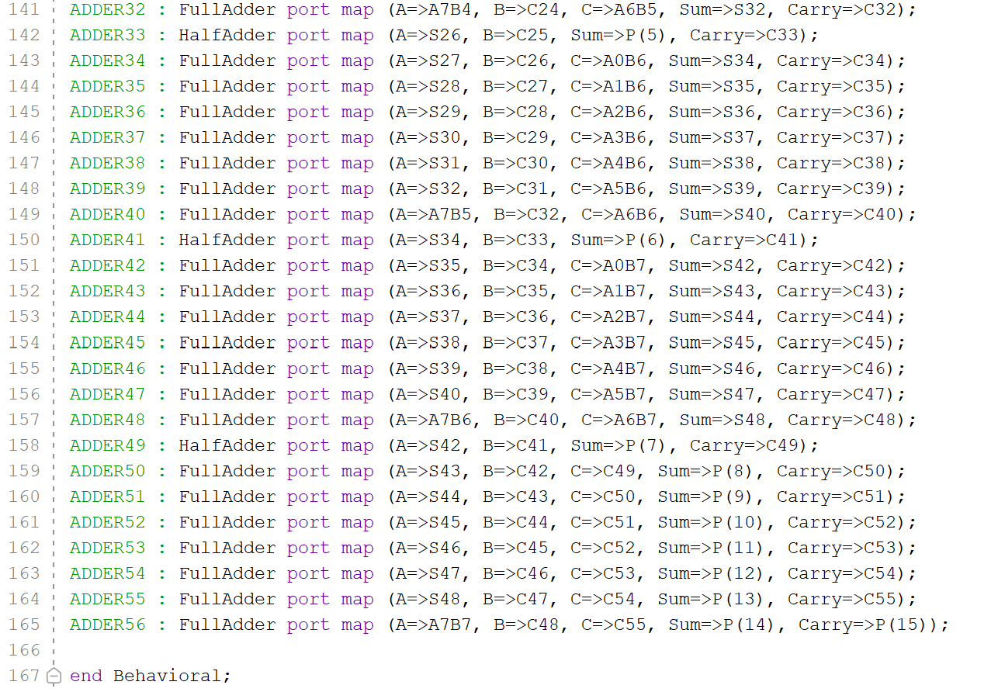
Figures 14-18: VHDL code for Wallace Tree Multiplier
The structure of the code is almost identical to the Braun multiplier code. The difference is where the carries and sums go between the adders. See the Braun code description for a detailed breakdown of the lines of code.
- Timing Diagrams and Schematics of the Designs
Braun Multiplier:
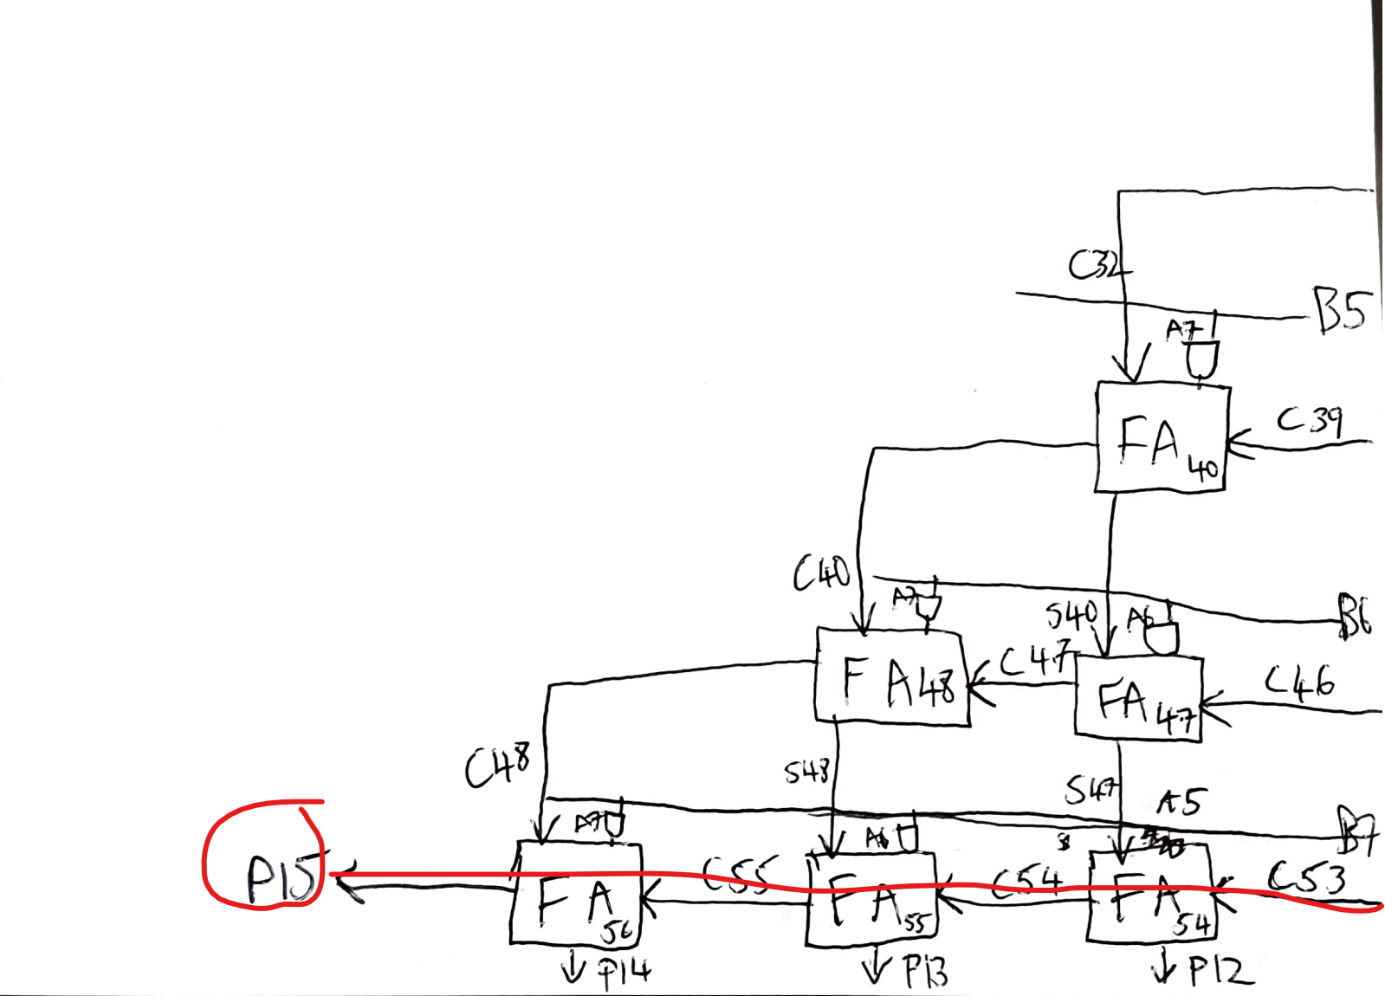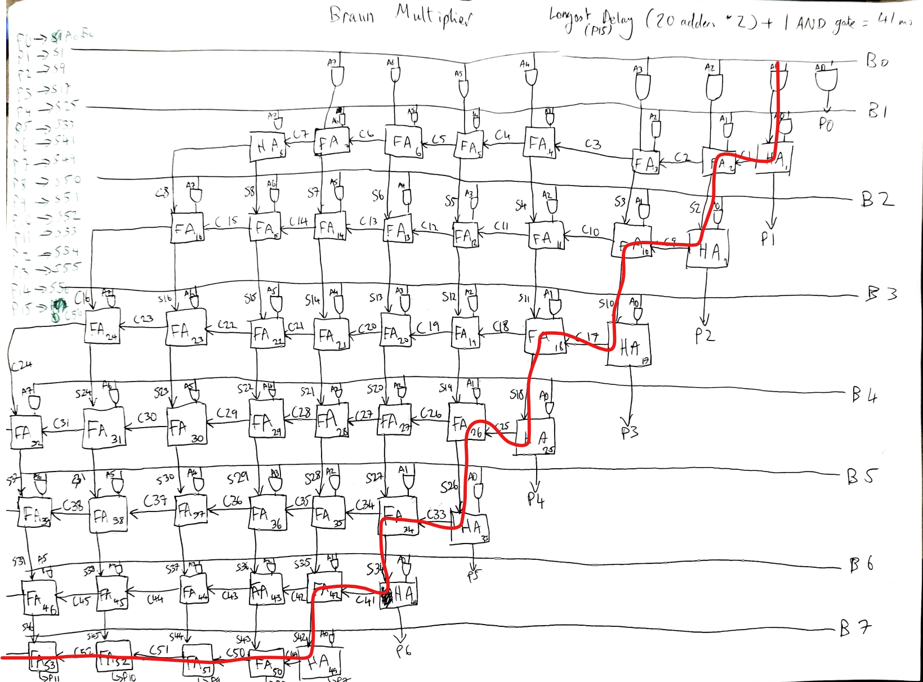
Figures 19 and 20: Braun multiplier longest delay line.
The red line in the figures above show the longest delay within the Braun multiplication. Given the assumption that an AND gate gives a delay of 1ms and an adder (full or half) gives a delay of 2ms, P15 passes through 20 adders and an AND gate which gives a delay of 41ms.
Figure 21: setting the time delay parameters in Vivaldo
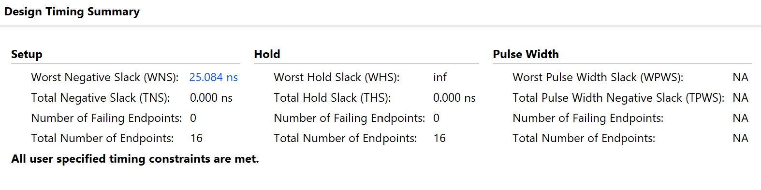
Figure 22: the time delay that Vivaldo calculates in the synthesis phase for the Braun multiplier (Worst Negative Stack). The bold sentence at the bottom means that the calculation we made was sufficient.
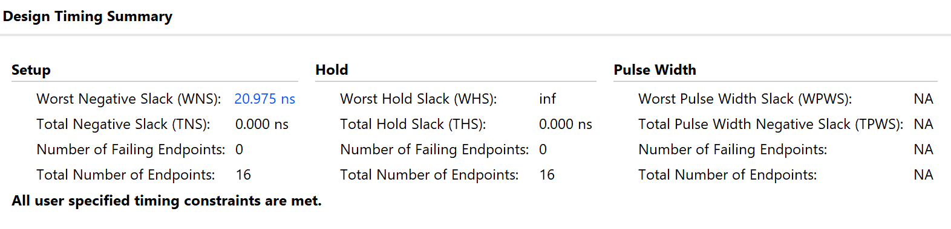
Figure 23: the time delay that Vivaldo calculates in the implementation stage.
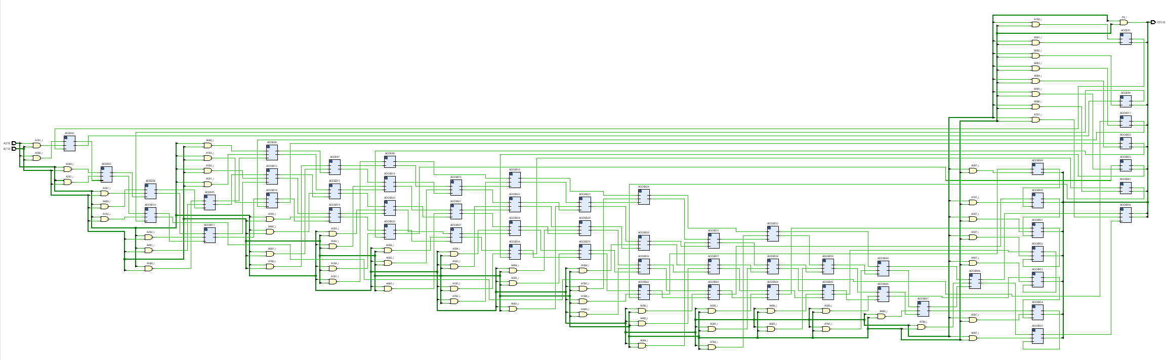
Figure 24: RTL design for Braun multiplier
The RTL design shown above shows how data moves between registers and the logical operations that transform the data.
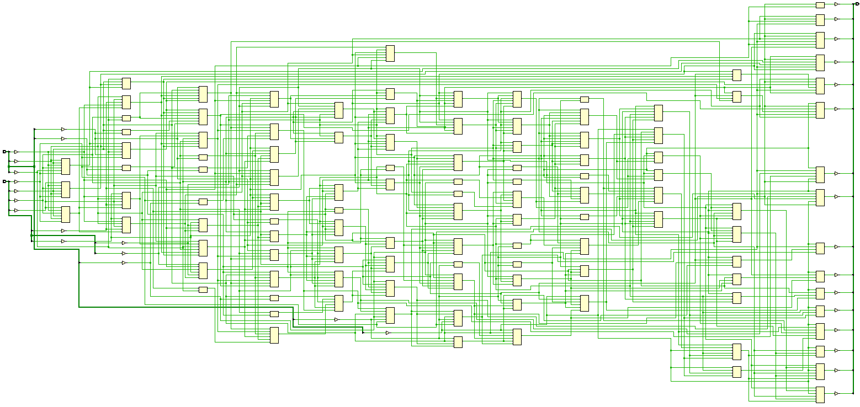
Figure 25: Implementation Schematic of Braun Multiplier
This shows the final state of the hardware. It displays exact physical wires, routing paths and delays designed across the FPGA. Commonly used for advanced debugging, diagnosing critical path bottlenecks and resolving timing slack failures.
Wallace Tree Multiplier:
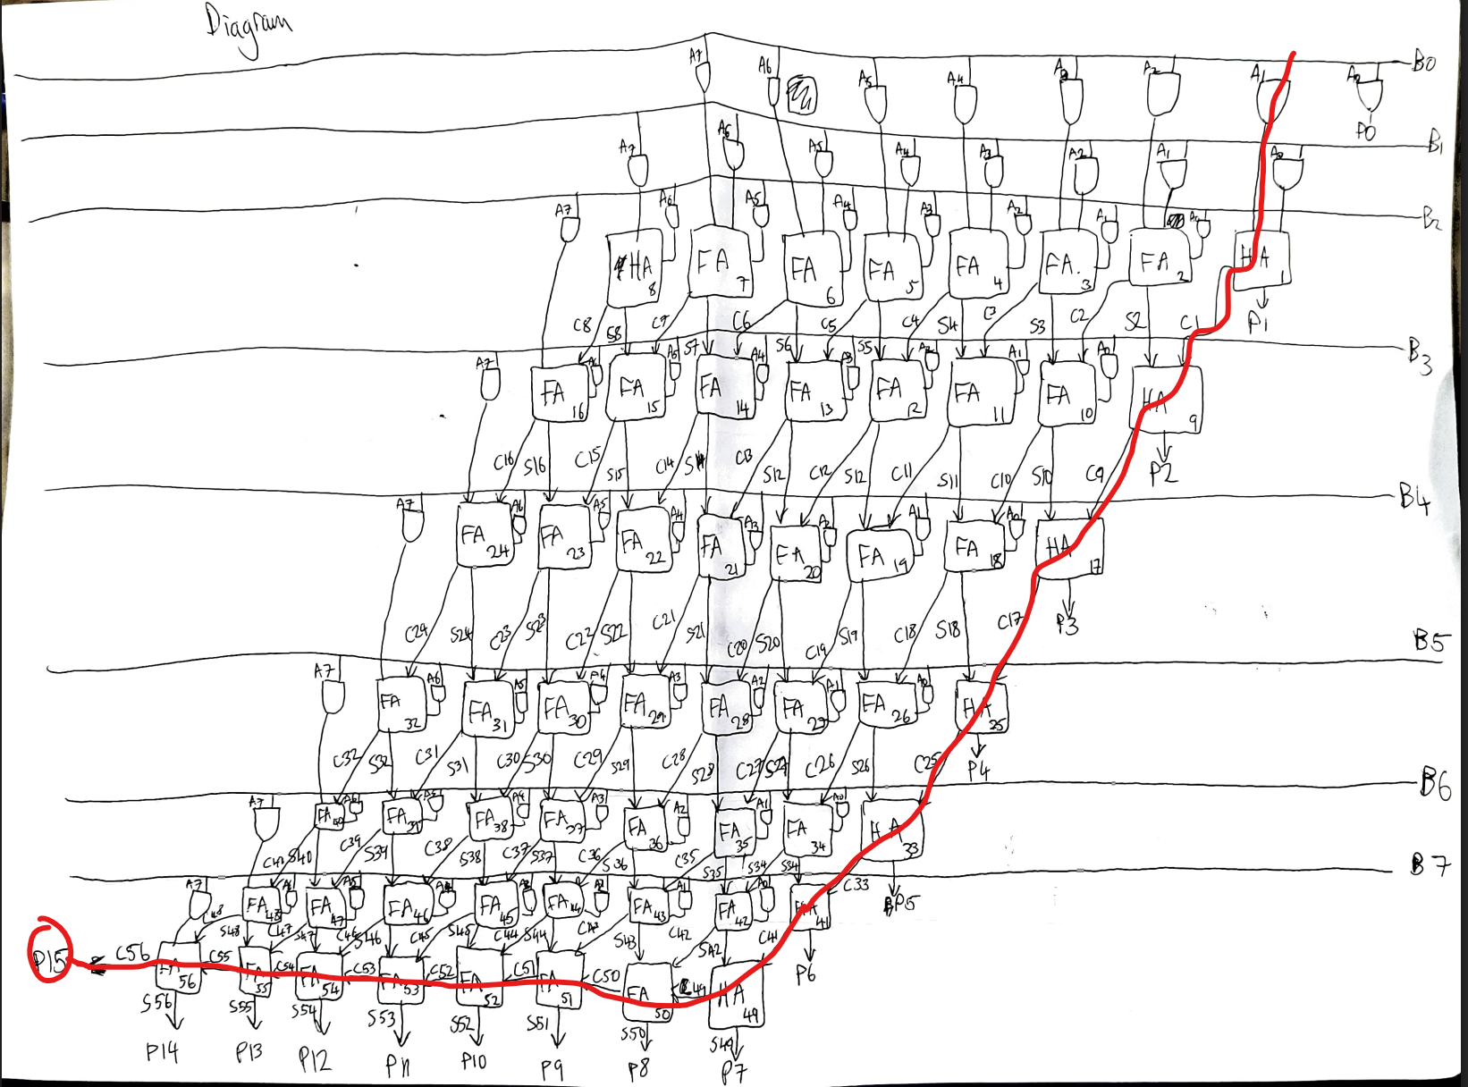
Figure 26: Shows the longest delay in Wallace Tree Multiplier
The red line in the figures above show the longest delay within the Wallace Tree multiplication. Given the assumption that an AND gate gives a delay of 1ms and an adder (full or half) gives a delay of 2ms, P15 passes through 14 adders and an AND gate which gives a delay of 29ms.
Figure 27: setting the time delay parameters in Vivaldo.
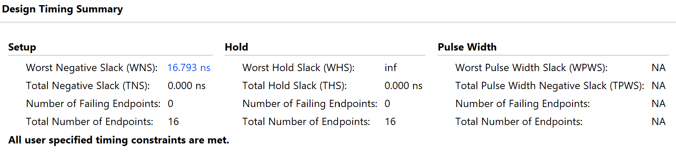
Figure 28: Design Timing Summary from synthesis phase for Wallace Tree Multiplier. Simulated longest delay was WNS. Bold sentence at the bottom shows the delay we calculated was sufficient.
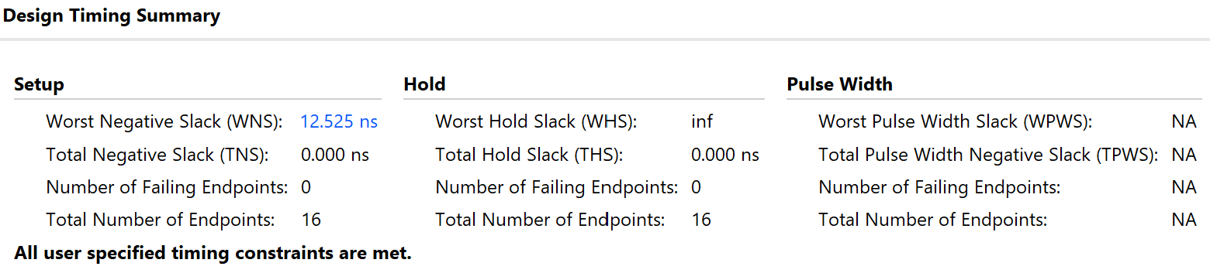
Figure 29: Timing summary from implementation phase for Wallace Tree Multiplier.
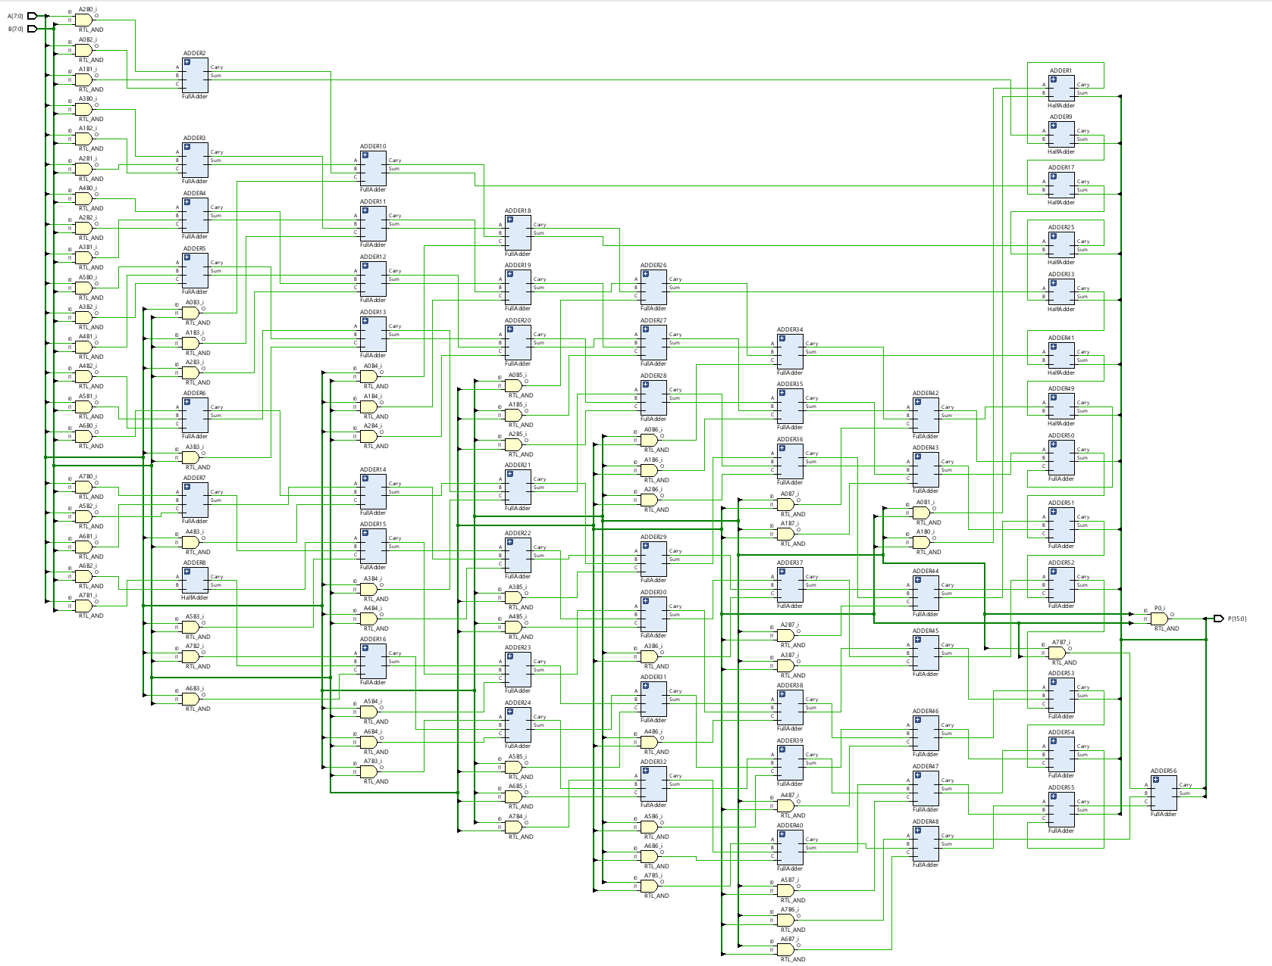
Figure 30: RTL design for Wallace Tree

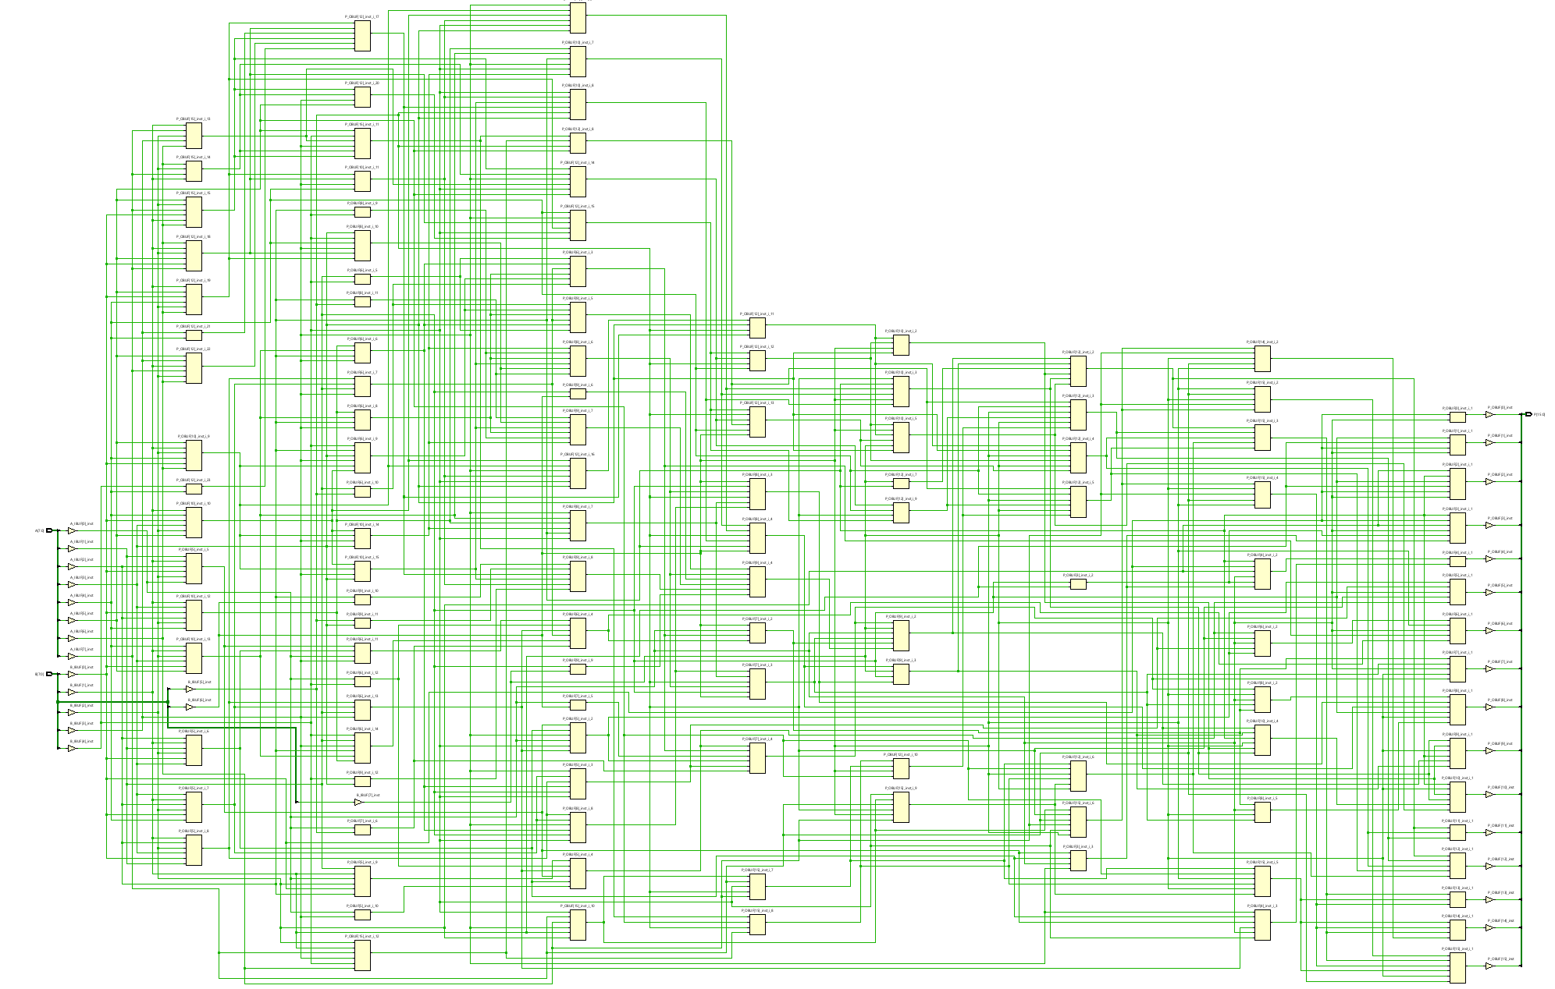
Figure 31: Implementation Schematic for Wallace Tree
- FPGA Design Screenshots with Pin Allocation
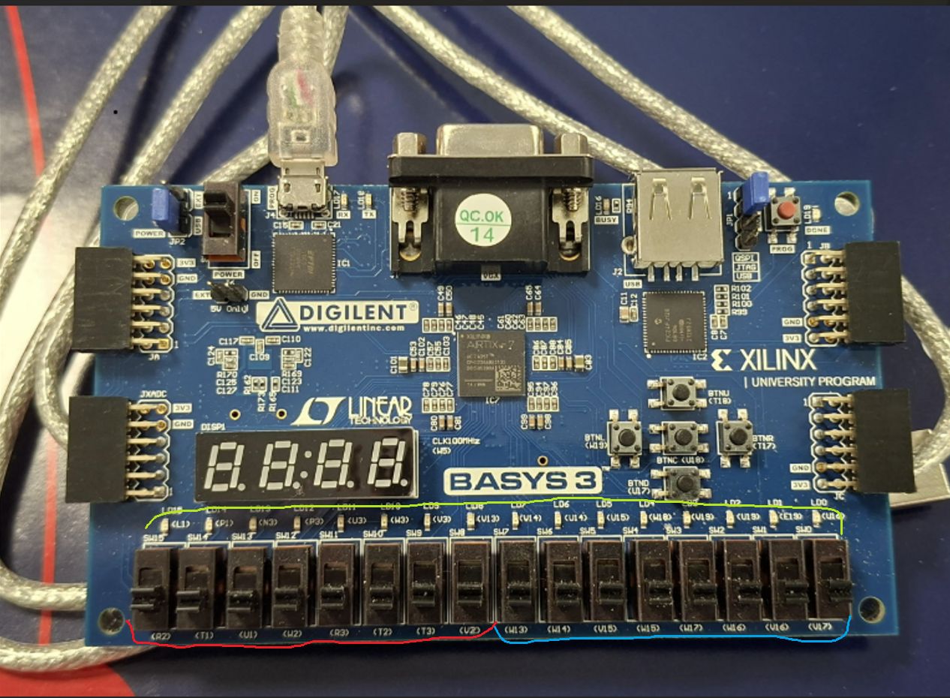
Figure 31: FPGA used for simulating these multiplication methods. The switches at the bottom were used as inputs (left 8 are for A (red) and right 8 are for B (blue)). The 16 lights just above those switches are for P (green). Most significant bit is on the left.
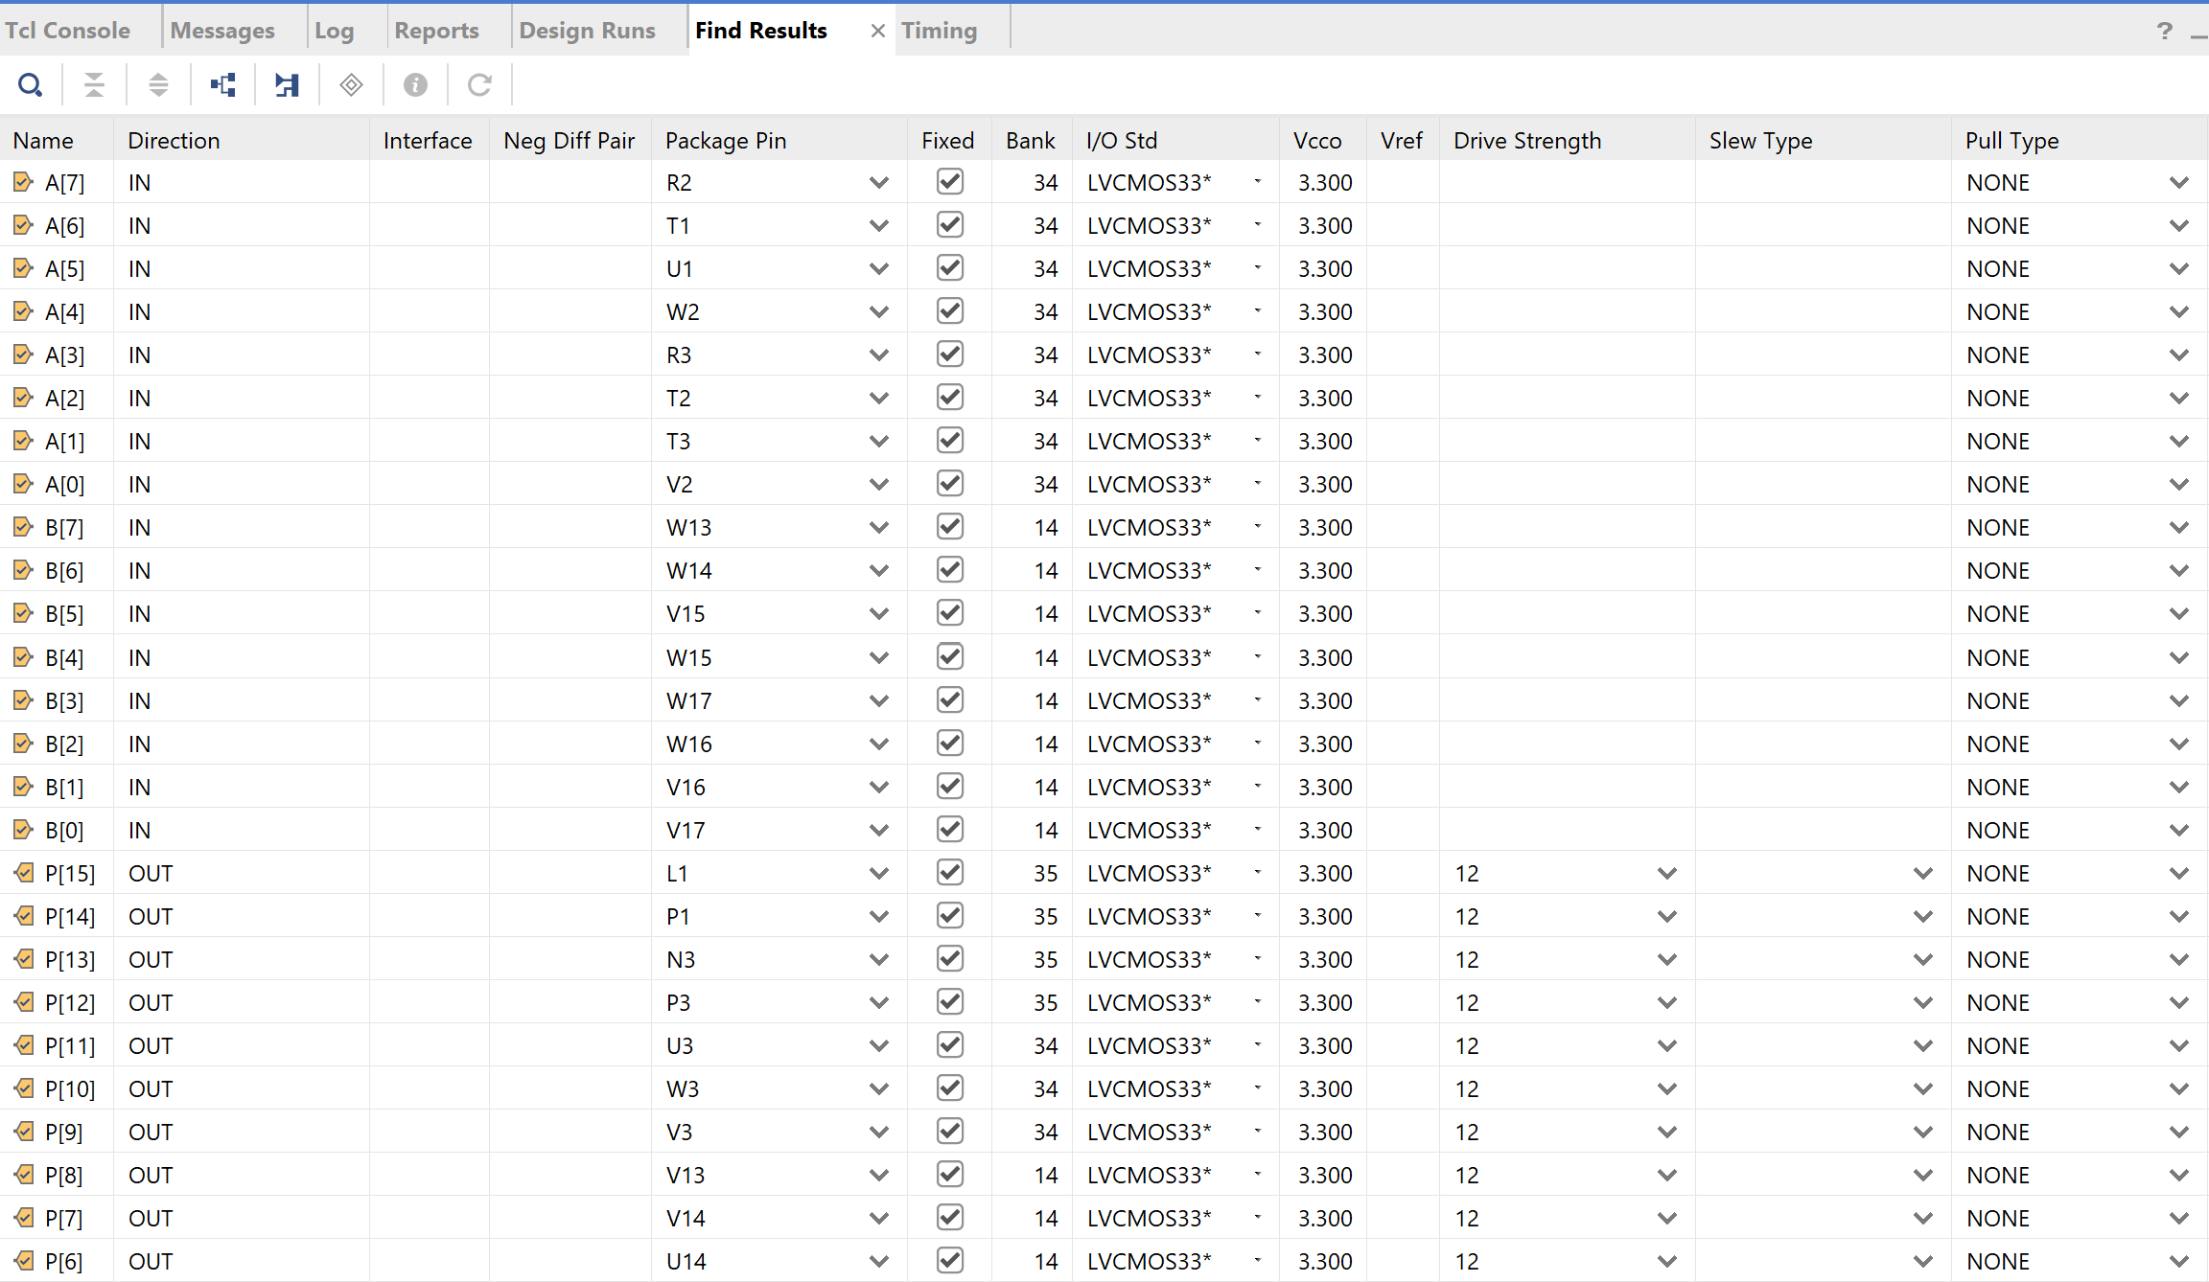
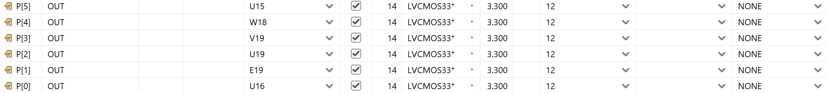
Figures 32 and 33: Pin assignments for FPGA board
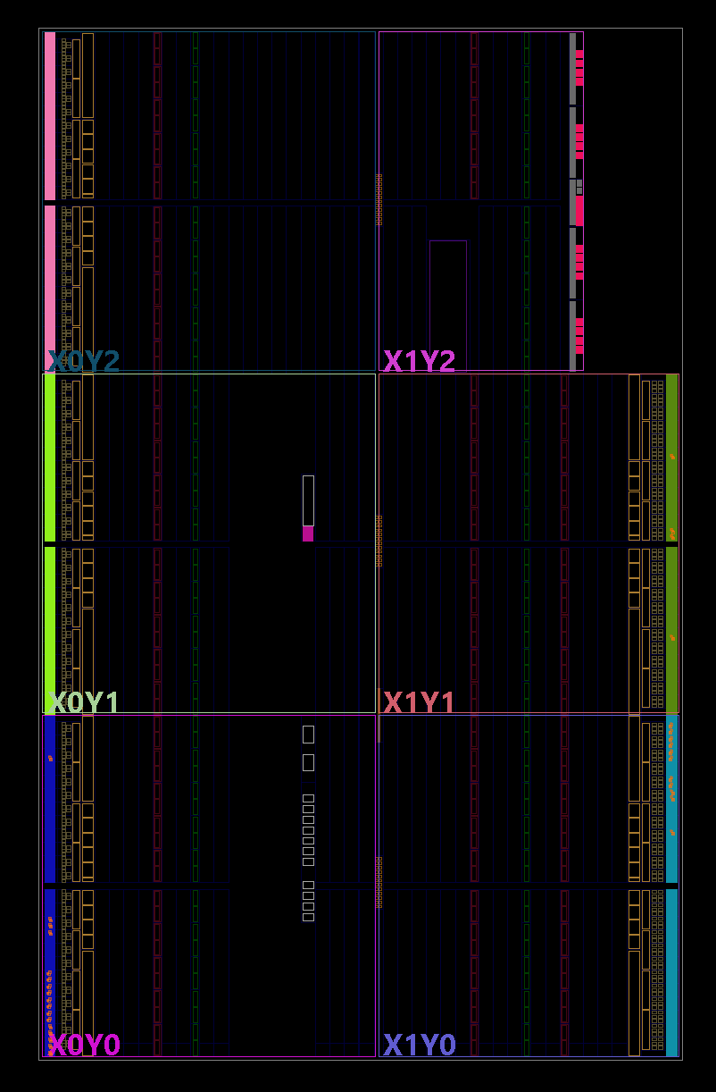
Figure 34: Device of Braun Multiplier
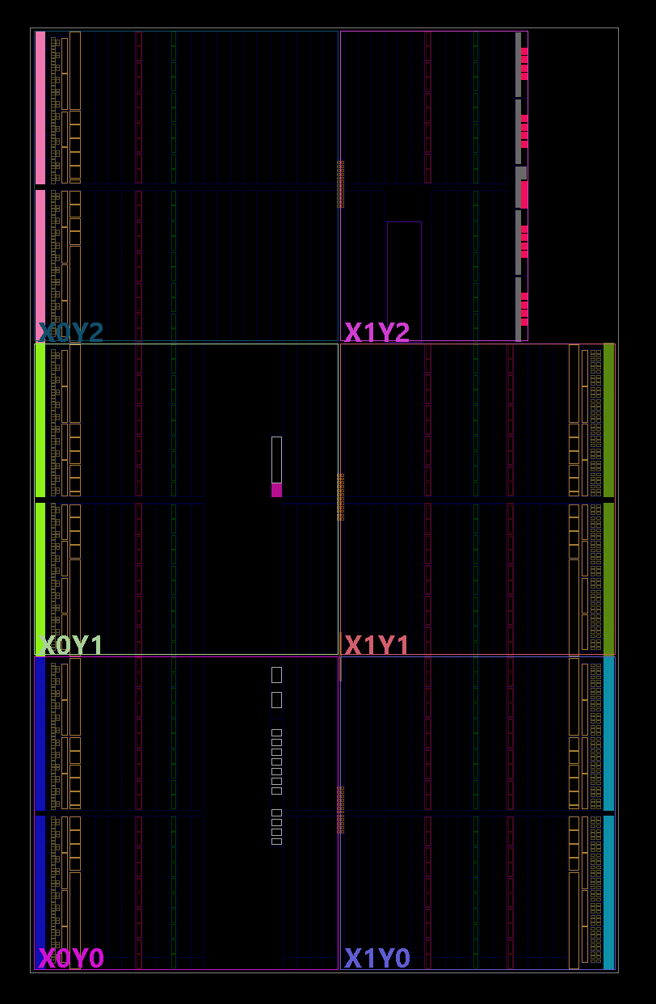
Figure 35: Device of Wallace Tree Multiplier
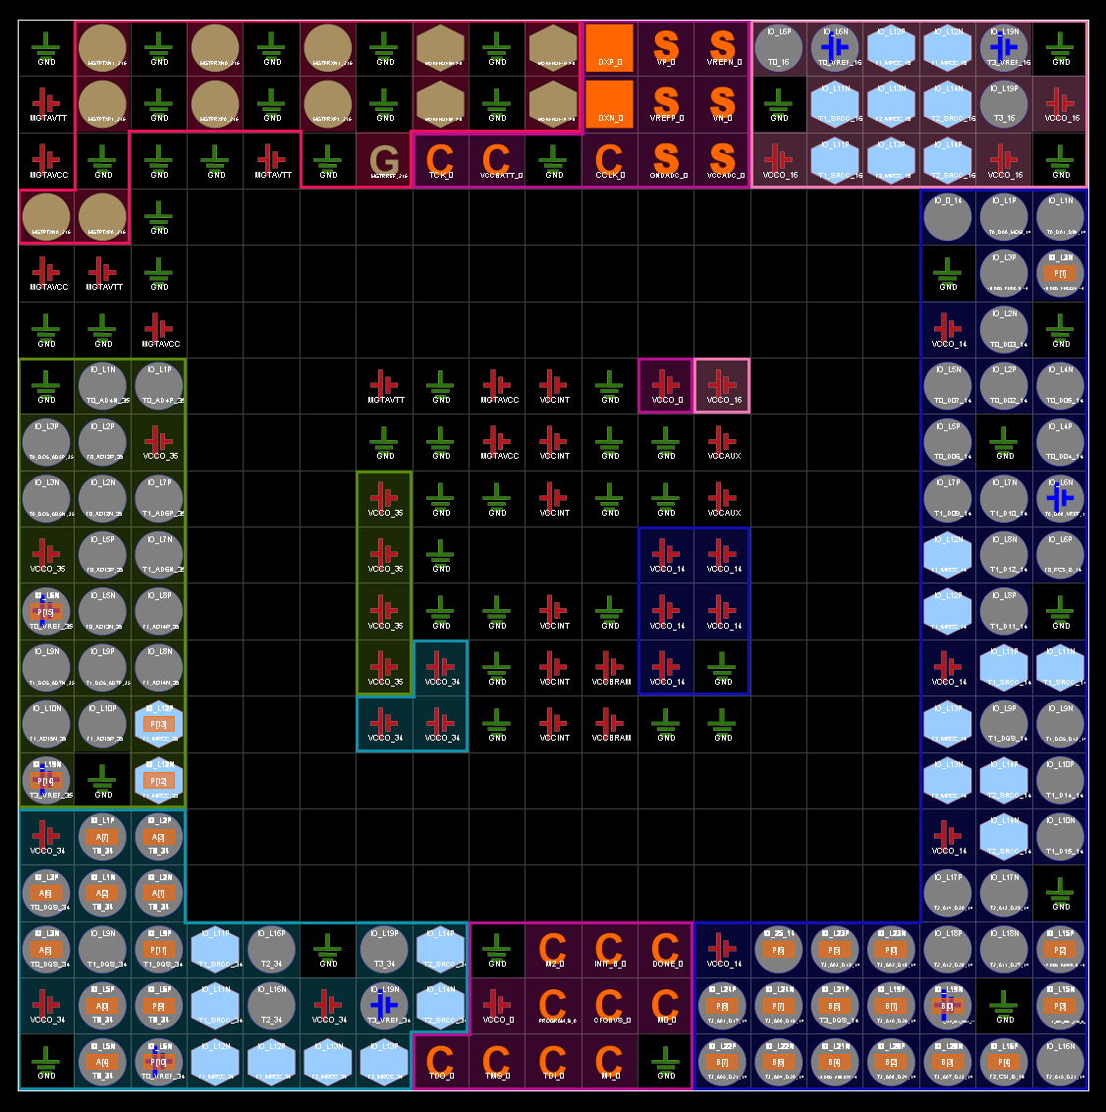
Figure 36: Input/Output mapping for Braun Multiplier
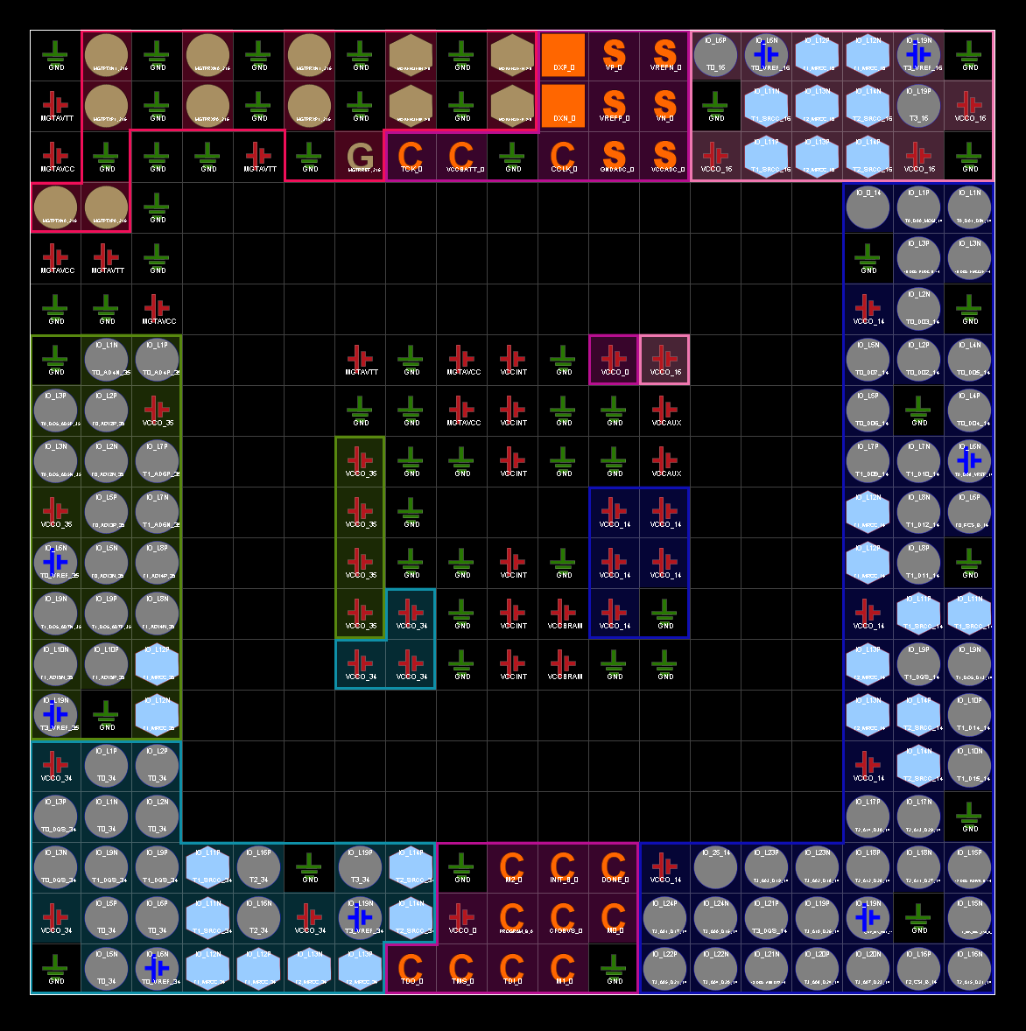
Figure 37: Input/Output Mapping for Wallace Tree Multiplier

- Simulation Results
See section 13 for details of testing including inputs and expected outputs
Braun Multiplier Results:
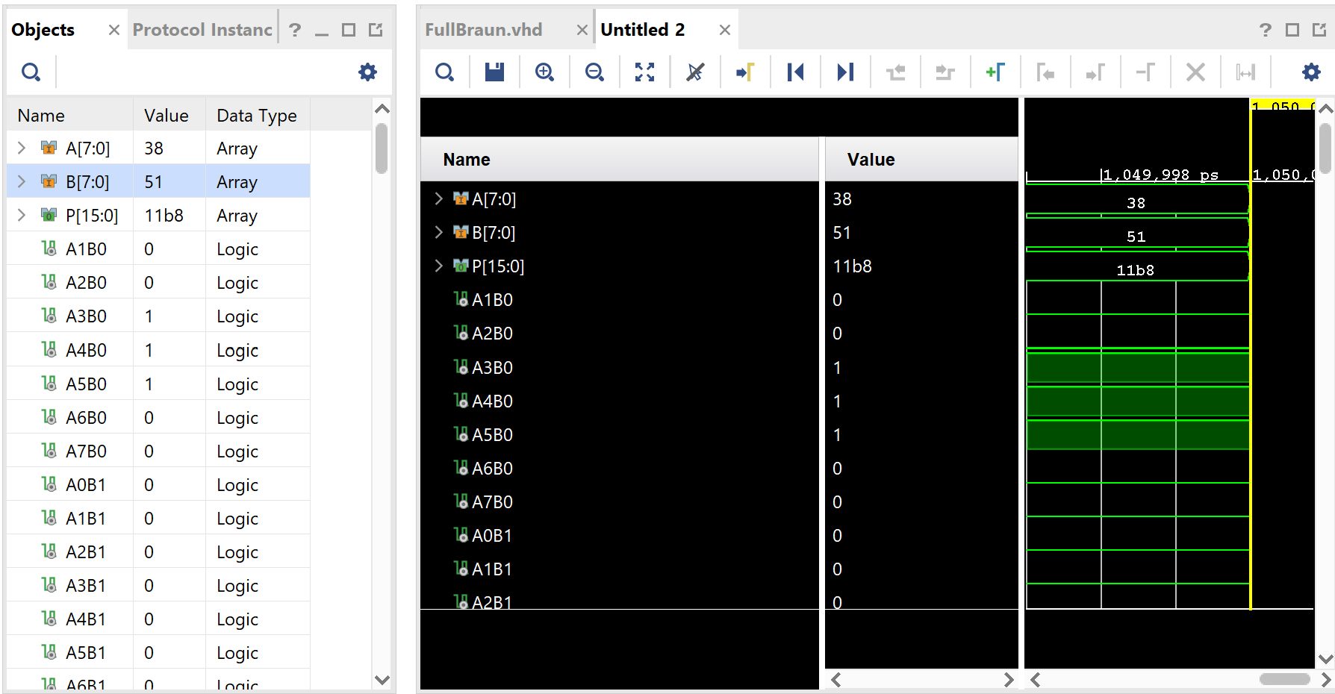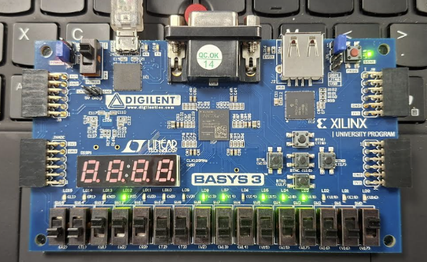
Figures 38 and 39: Equation 1
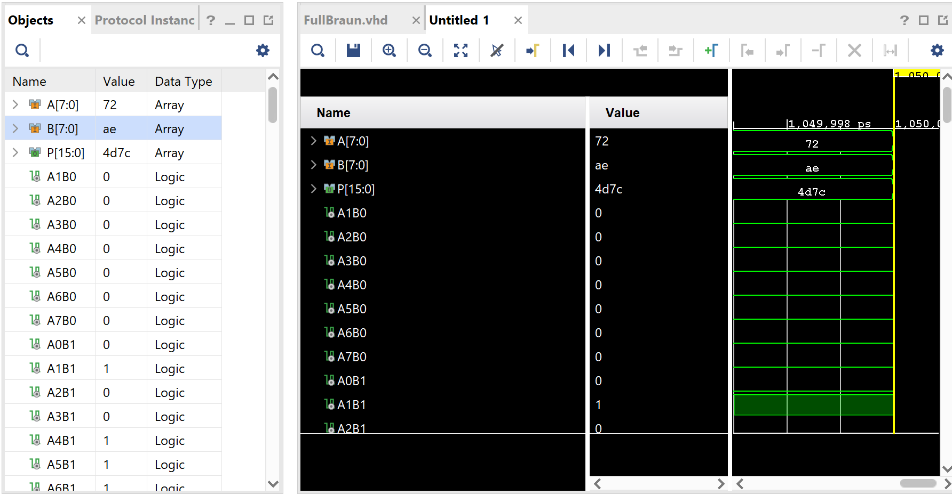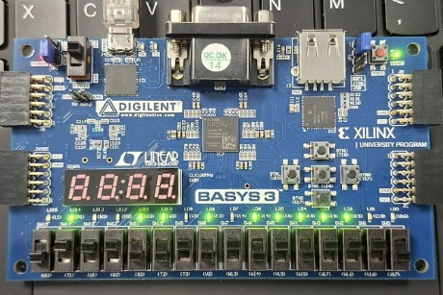
Figures 40 and 41: Equation 2
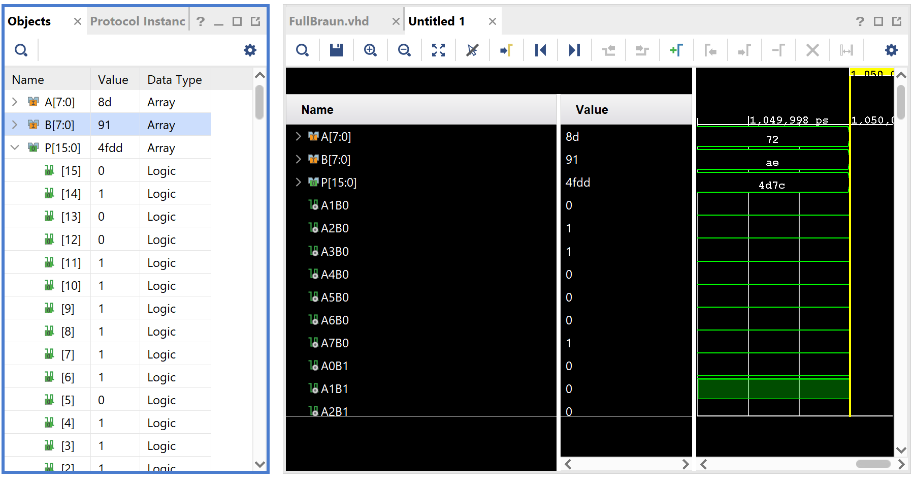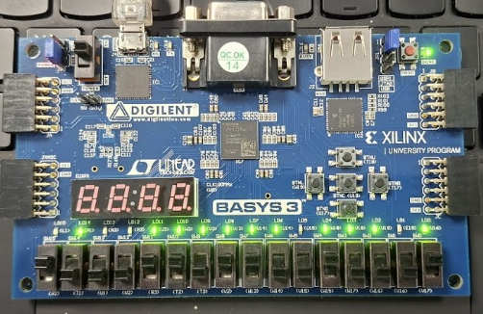
Figures 42 and 43: Equation 3
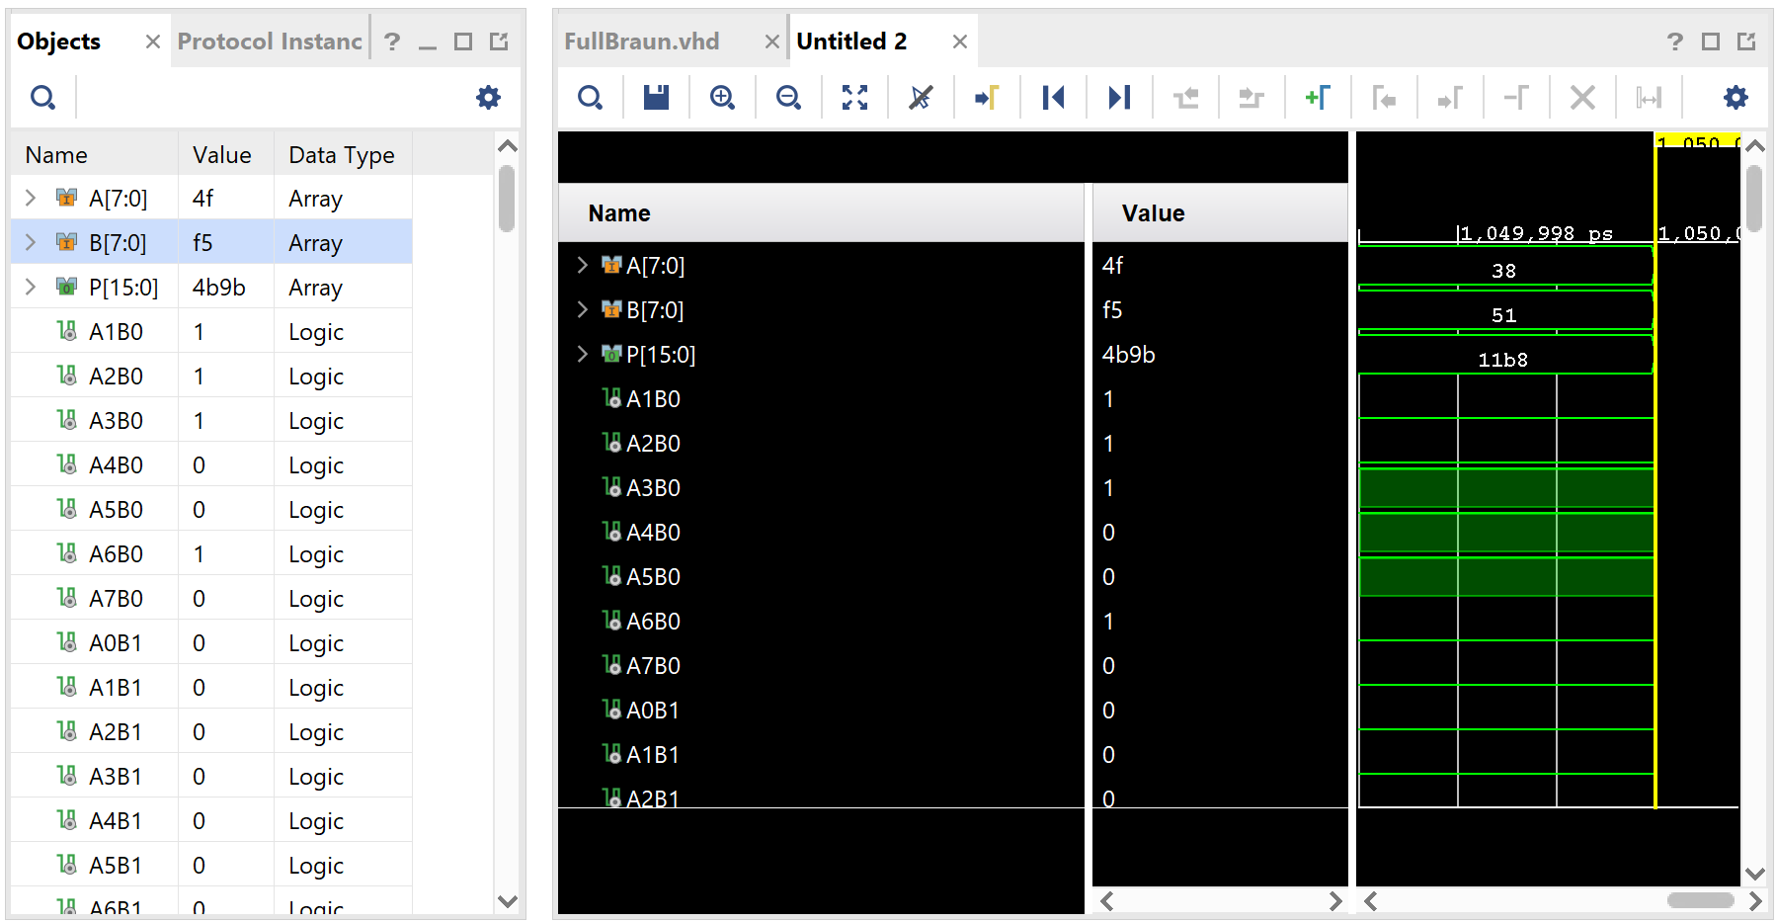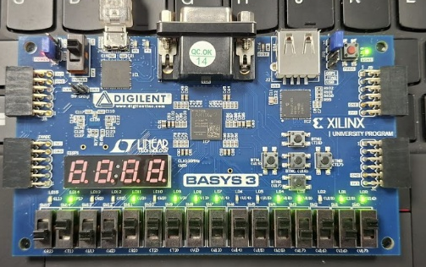
Figures 44 and 45: Equation 4
Wallace Tree Multiplier Results
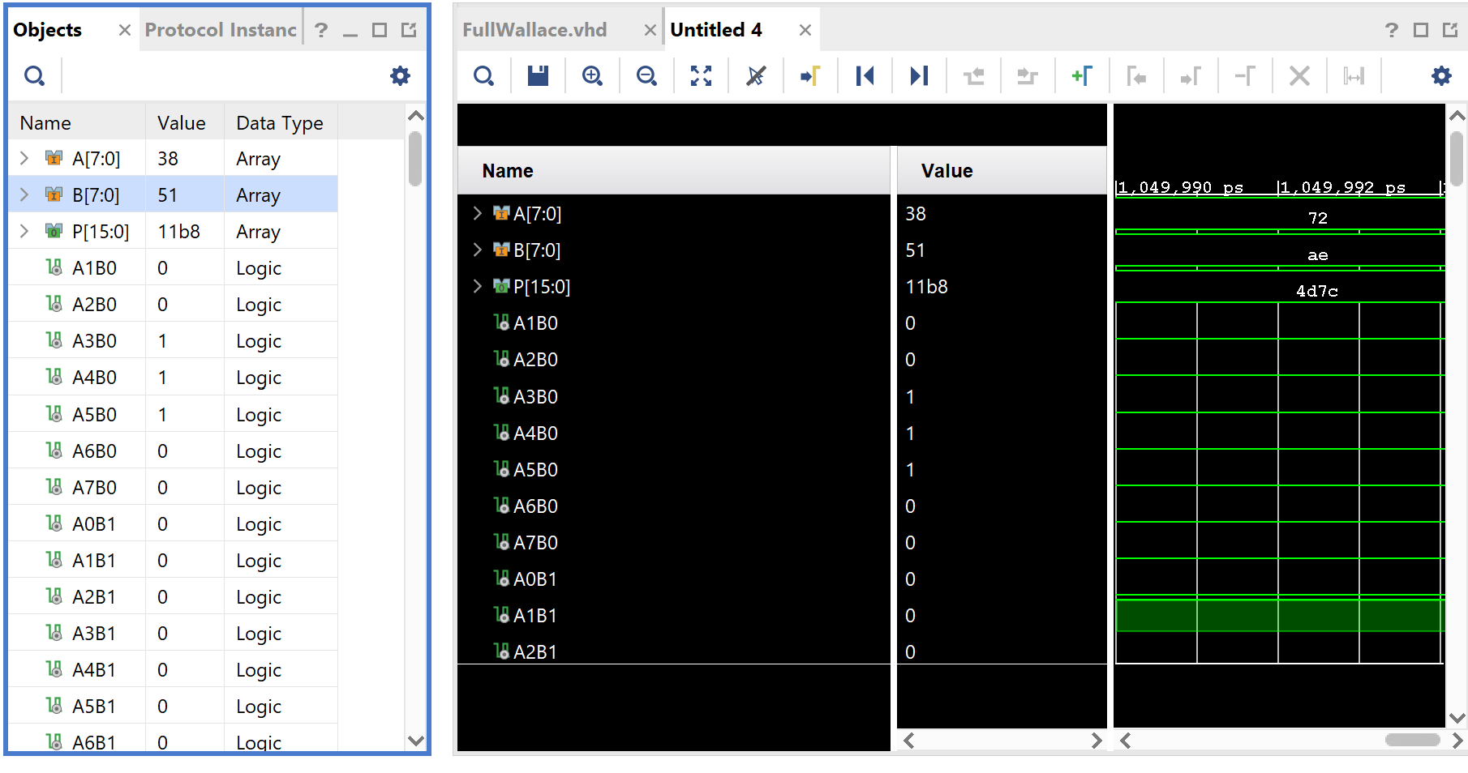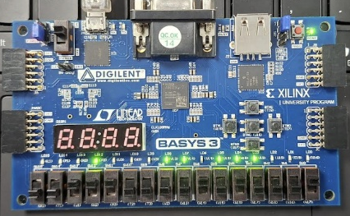
Figures 46 and 47: Equation 1
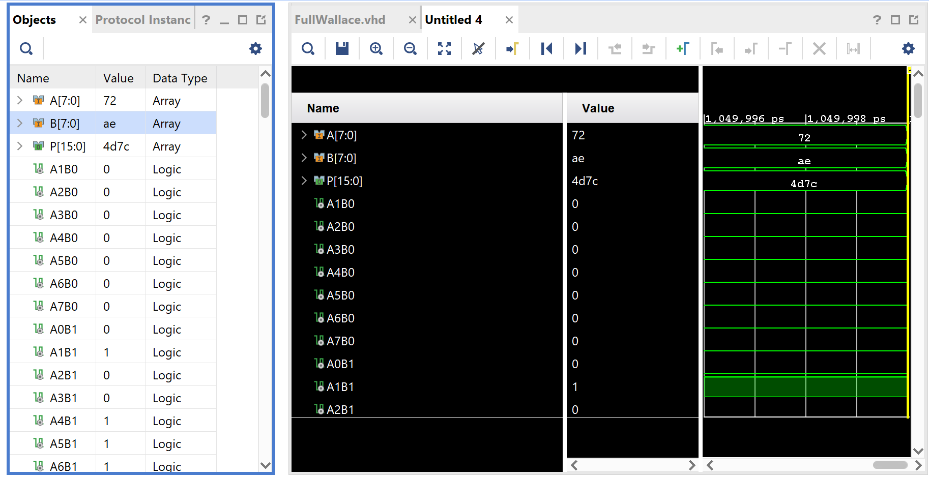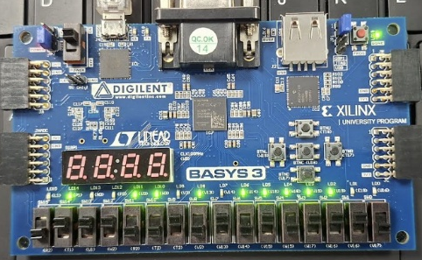
Figures 48 and 49: Equation 2
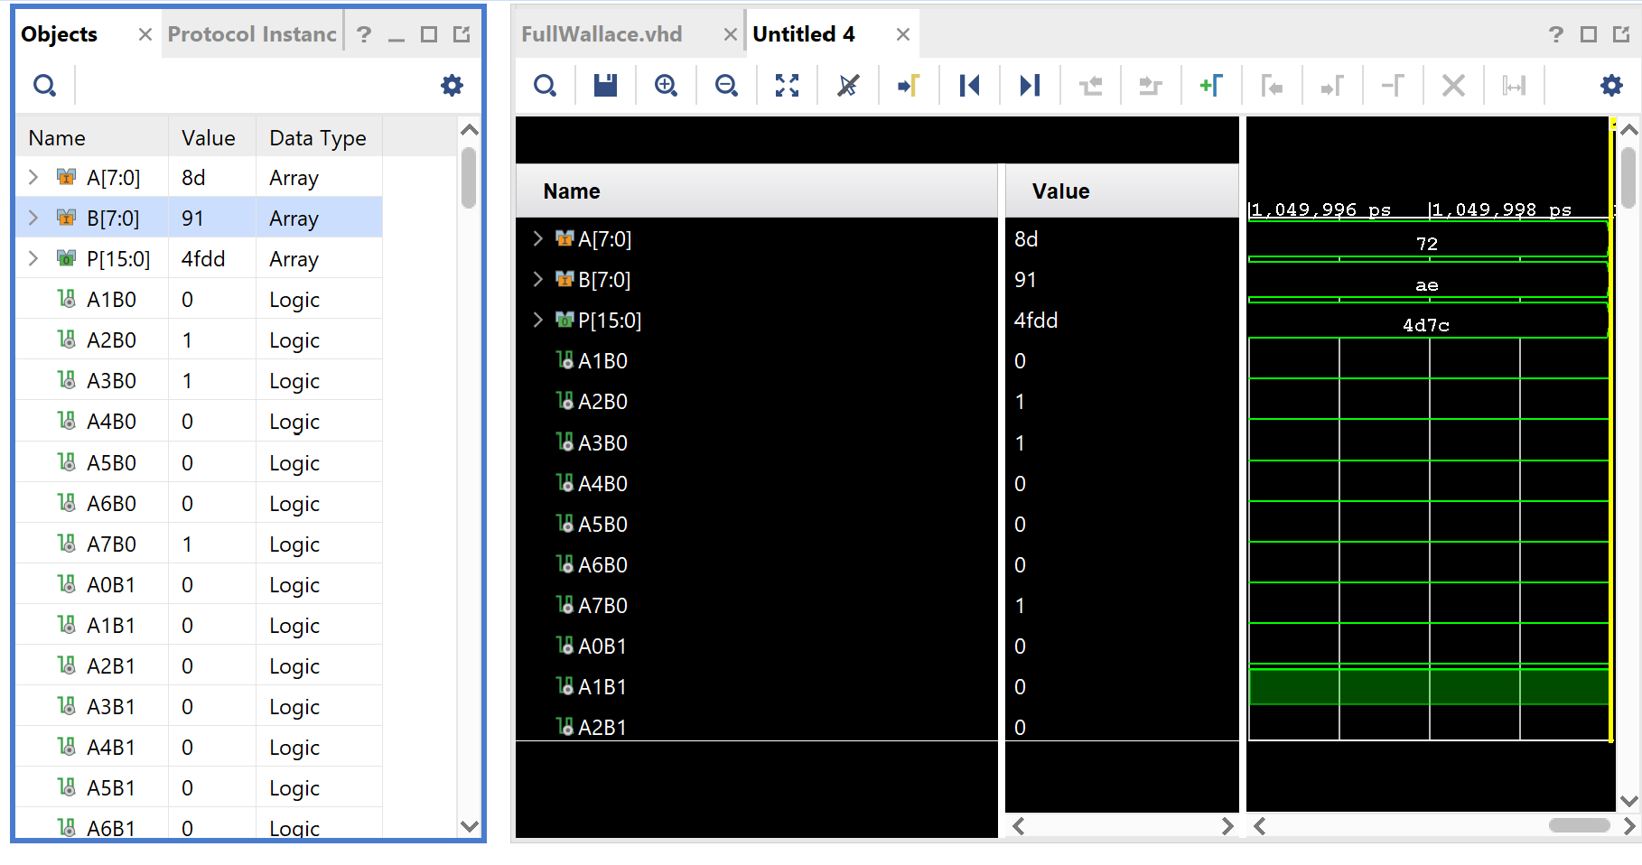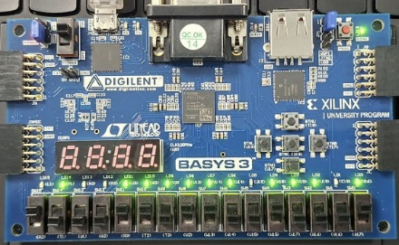
Figures 50 and 51: Equation 3
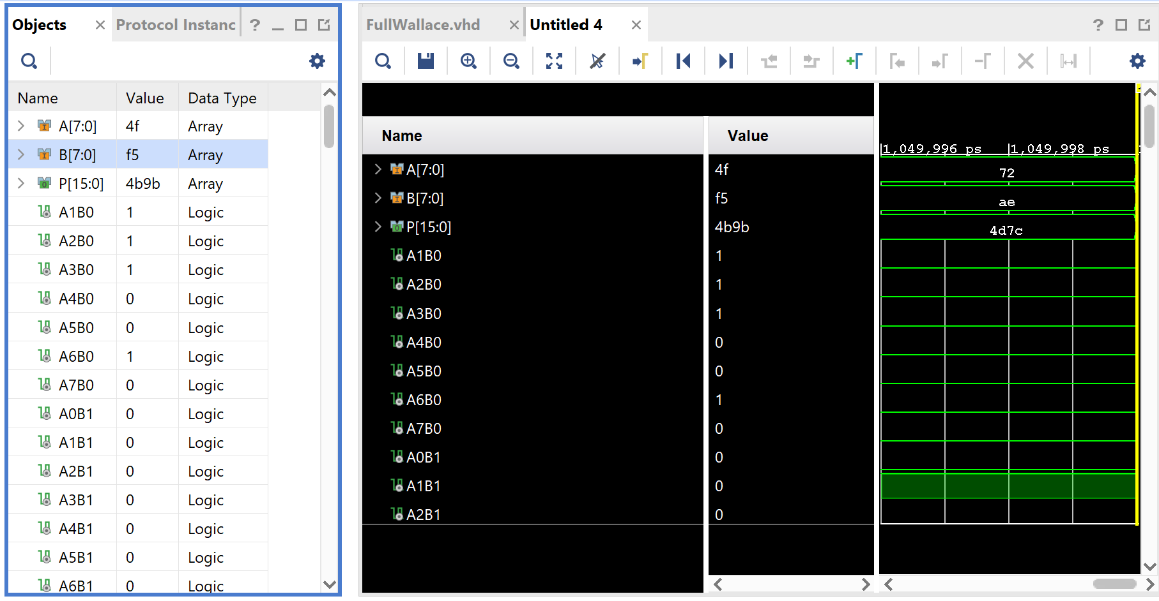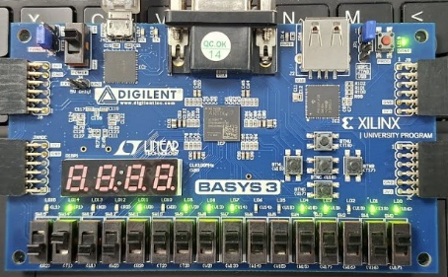
Figures 52 and 53: Equation 4

- Comparison, Analysis, and Interpretation of Results

The simulation results for both the Braun and Wallace tree multipliers produced identical mathematical outputs, confirming that both architectures correctly implemented 8-bit binary multiplication. Despite this functional equivalence, there were clear differences in performance between the two designs when comparing synthesis and implementation results. The calculated longest delay for the Braun Multiplier was 41ms and for the Wallace Tree it was 29ms. The Braun multiplier recorded a synthesis time of 25.084 ms and an implementation time of 20.975 ms, whereas the Wallace tree multiplier achieved significantly faster results, with a synthesis time of 16.793 ms and an implementation time of 12.525 ms. The difference between the calculated longest delay and the simulated one is the assumptions that we made with the delay of an adder and an AND gate. Despite the figures being quite far apart, the same pattern was shown, with the Braun multiplier being much slower than the Wallace tree. The difference between the two architectures can be attributed to the structural organisation of them. The Braun multiplier uses a more regular but sequential array of adders, which creates longer combinational paths and increases complexity during optimisation. In contrast, the Wallace tree reduces partial products in a more parallelised manner using a hierarchical reduction structure, allowing the synthesis and implementation tools to optimise timing more effectively and reduce overall critical path delays.
In terms of resource utilisation, the results show a relatively small difference between the two designs. The Braun multiplier used 90 LUTs and 32 I/O devices, while the Wallace tree used slightly more resources at 94 LUTs, with the same number of I/O devices. The increase in LUT usage for the Wallace tree is expected due to its more complex reduction network, where additional logic is required to manage multiple levels of carry-save addition. However, the identical I/O usage indicates that both designs operate on the same external interface structure and data width, meaning the differences are purely internal architectural choices rather than input/output complexity.
Power consumption results also show only a minor variation between the two multipliers, with the Braun design consuming 0.08 W compared to 0.084 W for the Wallace tree. The slightly higher power usage in the Wallace implementation can be explained by its increased internal switching activity, as more adders operate in parallel across multiple reduction stages. Although the Wallace tree is faster in terms of timing performance, this additional parallel logic leads to a marginal increase in dynamic power consumption.
Overall, the results highlight a trade-off between speed and efficiency, where the Wallace tree achieves improved performance at the cost of slightly higher resource usage and power consumption compared to the more regular Braun array structure.
- Interpretation of Power Utilization and LUTs
In Vivado, the synthesis and implementation stages represent two distinct phases in the FPGA design flow, each producing different levels of accuracy in performance, resource usage, and power estimation. Synthesis is the process in which the high-level HDL description is translated into a technology-specific netlist composed of logic elements such as lookup tables (LUTs), flip-flops, and input/output blocks. At this stage, the tool performs logical optimisation but does not yet consider the physical placement or routing of these components on the FPGA fabric. As a result, the synthesis stage provides an early and relatively abstract estimate of design performance and resource utilisation.
The implementation stage, by contrast, takes the synthesised netlist and maps it onto the actual physical resources of the FPGA. This process includes placement, where logic elements are assigned specific locations on the device, and routing, where connections between these elements are physically established. Because implementation accounts for real hardware constraints such as routing congestion, interconnect delays, and timing paths, it produces significantly more accurate results compared to synthesis. This makes implementation the more reliable stage for evaluating how the design will behave when deployed on hardware.
One key difference between the two stages is the estimation of speed. During synthesis, timing analysis is based on an idealised model that assumes simplified interconnect delays, meaning the reported maximum frequency is often optimistic. In implementation, however, actual routing delays are included, and the resulting timing analysis typically reveals slower performance than initially estimated. This difference is especially pronounced in larger or more complex designs where routing delays contribute significantly to the critical path.
Resource utilisation is also reported differently between synthesis and implementation. Synthesis provides an estimate of how many LUTs, flip-flops, and I/O blocks the design is expected to require, based on the logical structure of the HDL code. However, these estimates may change during implementation due to optimisation decisions such as logic packing, resource sharing, and replication. In this case, neither of the methods show a change in LUTs or I/O devices between synthesis and implementation.
Power consumption estimates can also vary between the two stages. Synthesis provides a preliminary power estimate based on statistical switching activity and assumed interconnect behaviour. This estimate is relatively coarse, as it does not account for actual routing lengths or physical capacitance. In implementation, power analysis becomes more accurate because it incorporates real placement and routing information, allowing the tool to model dynamic power consumption and signal switching more precisely. As a result, implementation reports generally provide a more realistic representation of expected power usage in the final hardware design. However, much like with utilization, in this experiment, the power estimate between synthesis and implementation was the same for both methods.
Braun Method Synthesis Results:
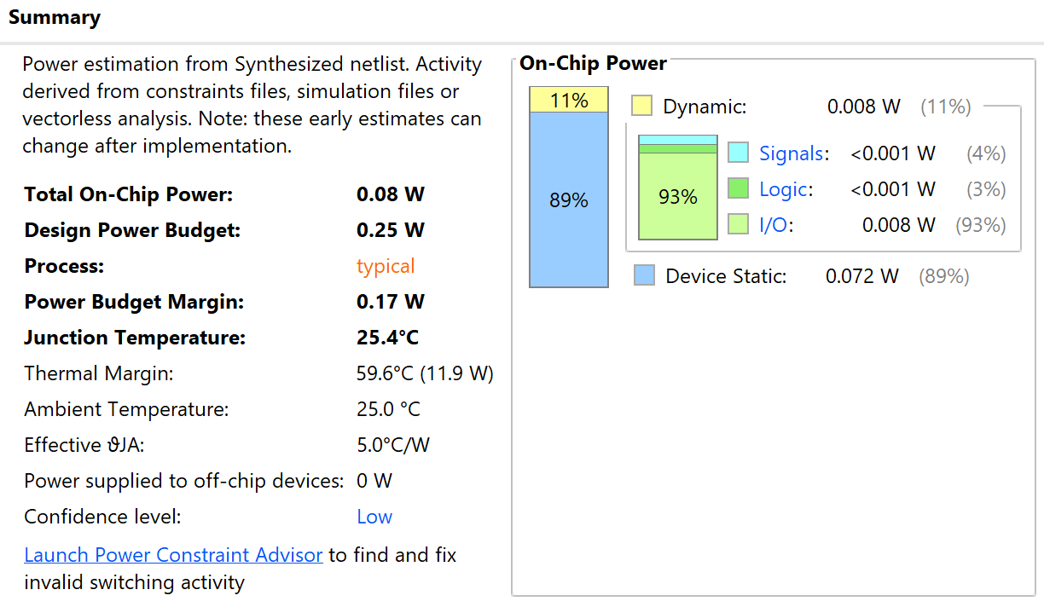
Figure 54: Power consumption
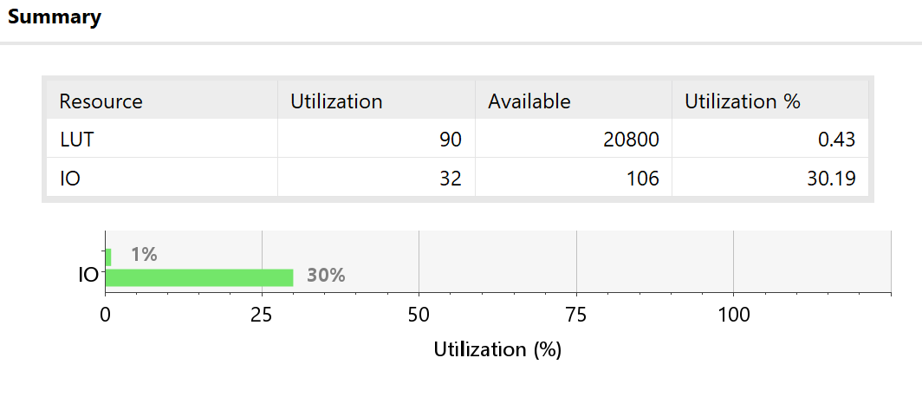
Figure 55: Utilization of LUTs and I/O devices

Implementation results:
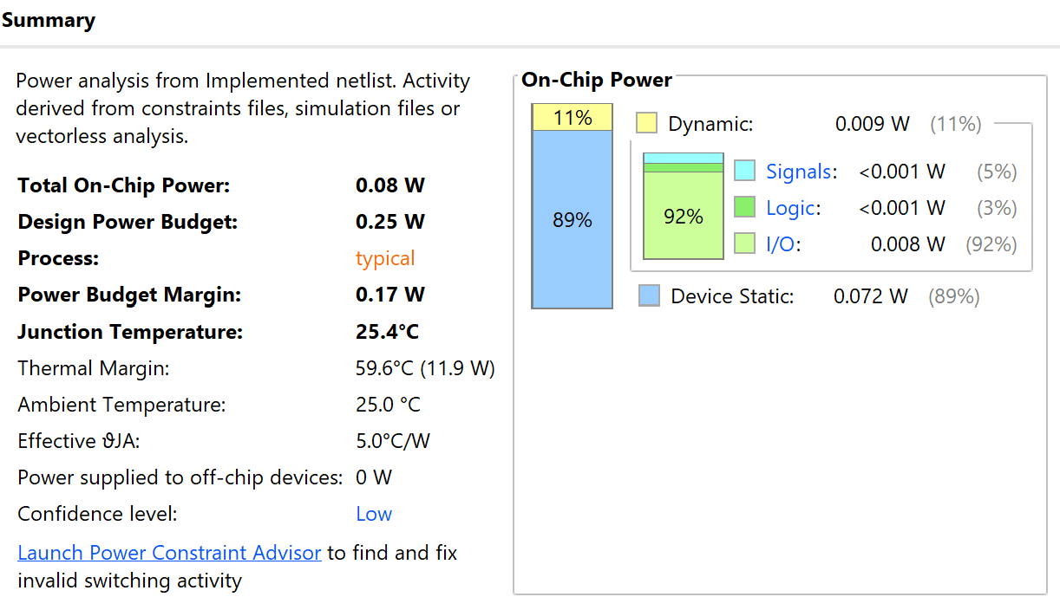
Figure 56: Power consumption
Figure 57: Utilization of LUTs and I/O devices
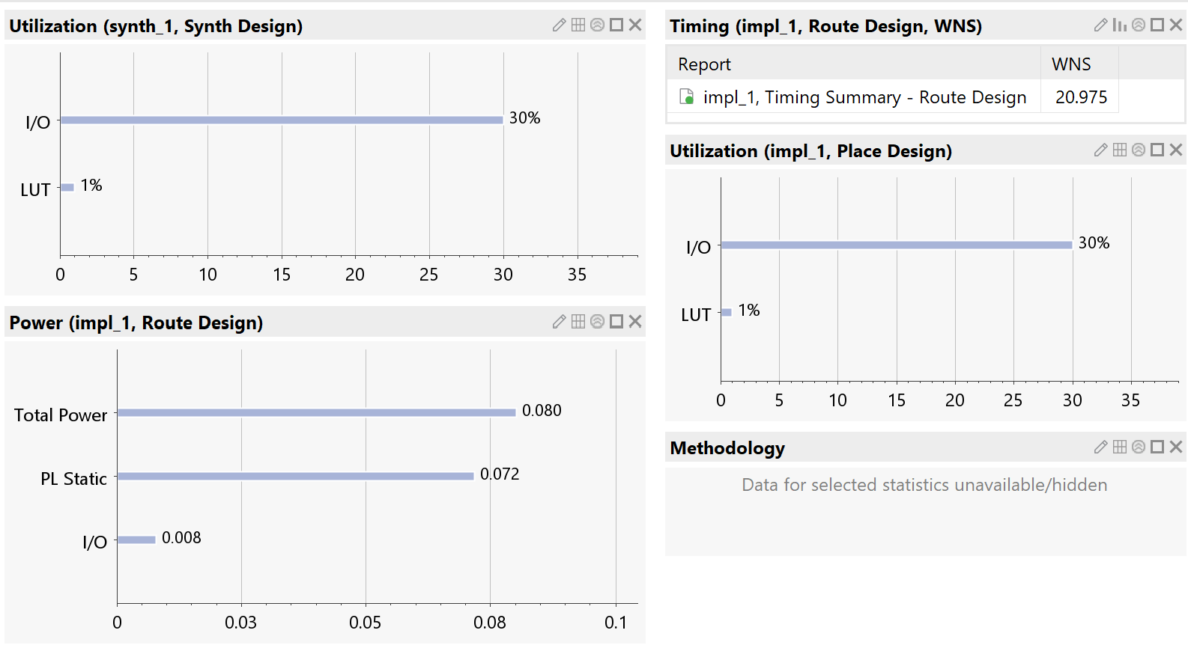
Figure 58: Project Summary. A collection of both utilization graphs (synthesis and implementation) and power

Wallace Tree Multiplier Synthesis Results:
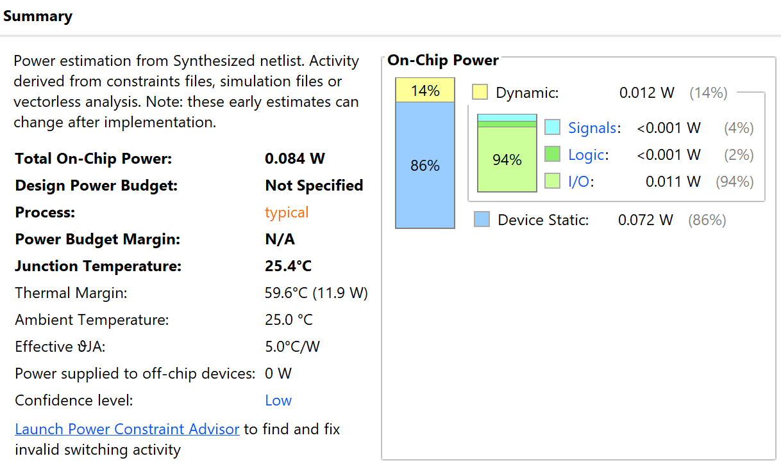
Figure 59: Power Consumption
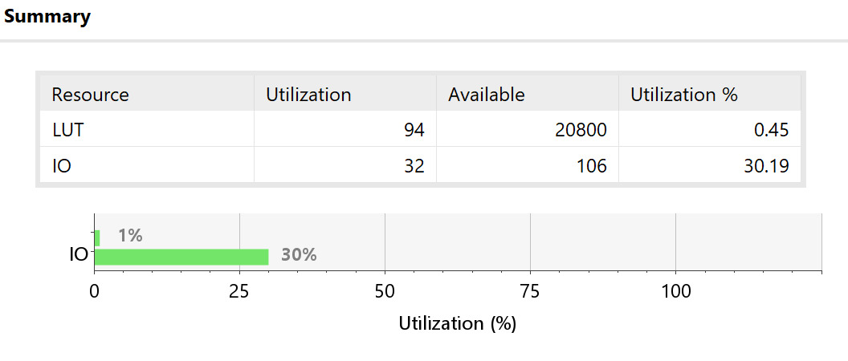
Figure 60: Utilization of LUTs and I/O devices

Implementation Results:
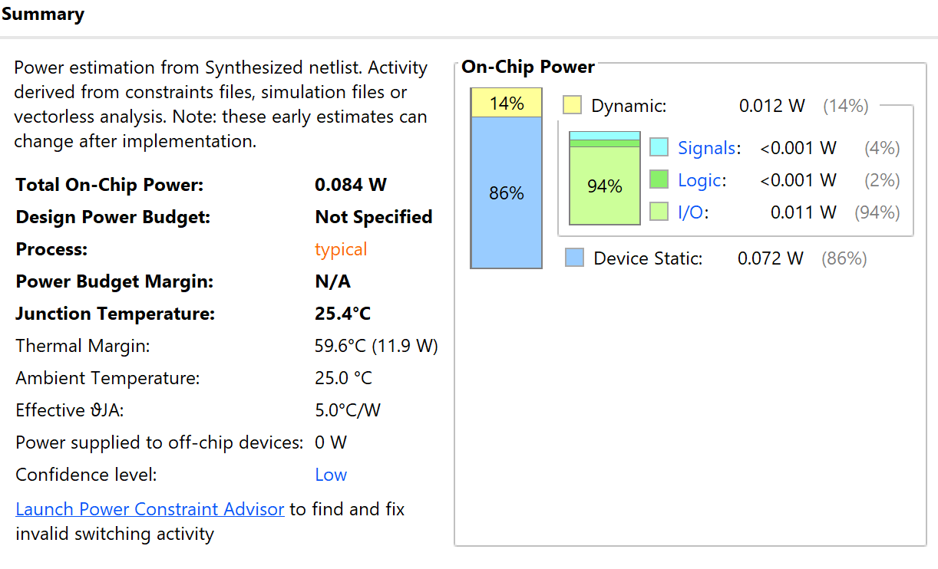
Figure 61: Power Consumption
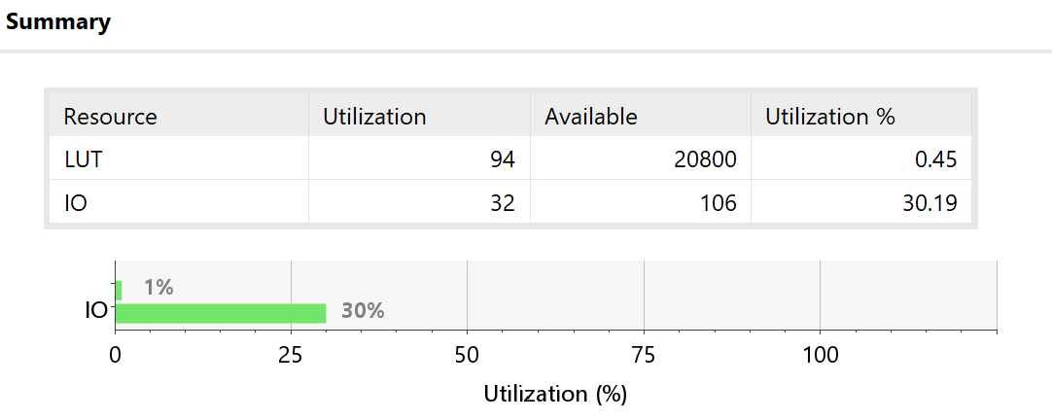
Figure 62: Utilization of LUTs and I/O devices
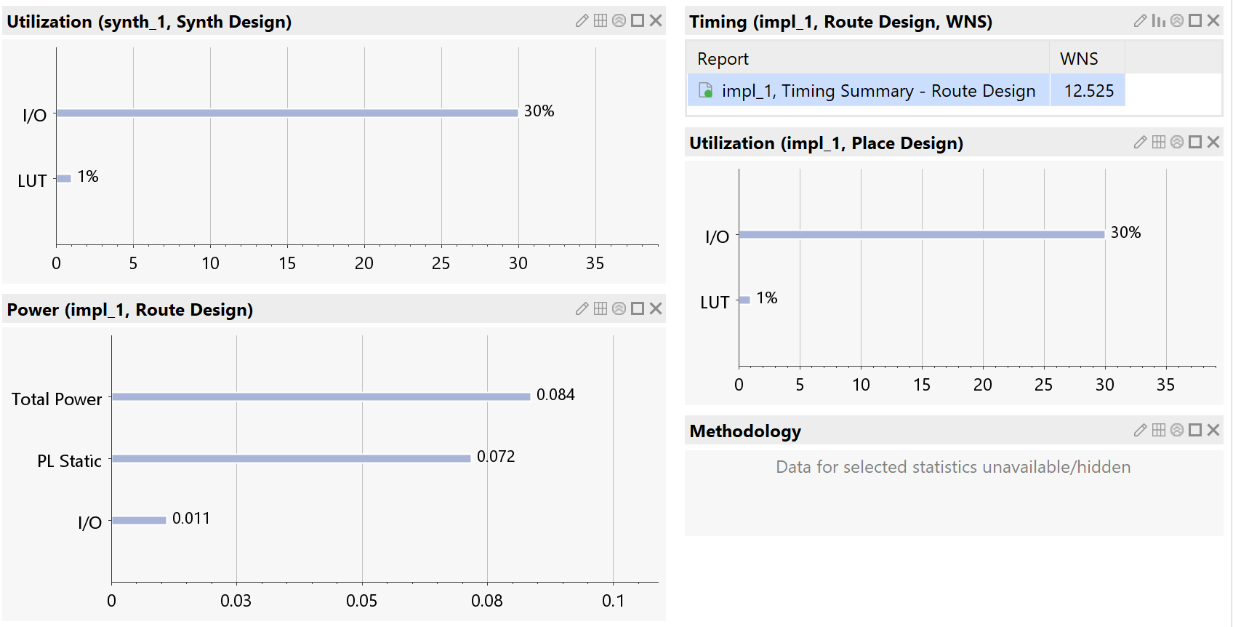
Figure 63: Project Summary

- Details of Testing and Recommendations for Future Improvements

Both multipliers were given the same four multiplication inputs. Those were:
$$1. 38*51=11B8$$
$$2. 72*AE= 4D7C$$
$$3. 8D*91=4FDD$$
$$4. 4F*F5=4B9B$$
These equations were selected to test a range of numbers, starting at the lower end and building up. These were kept consistent between the two multipliers to ensure a fair test took place. The test consisted of first simulating the result using the Vivaldo software, then recreating it on the FPGA board and checking the two results against each other.
The process of testing these structures begins with laying the foundation for the test. Making use of the Vivaldo software, a file for the half adder and full adder were created, allowing them to be used as a subroutine and called many times without writing out the full operation each time. For each architecture, code was written to simulate the logic circuit diagrams (figures 3 and 4 (Braun) and figure 6 (Wallace Tree)). Both codes were tested using the four equations above to ensure they were working as expected. They were then both put through the synthesis and implementation stages, taking notes and pictures of the results to compare later. Then, an FPGA (Field-Programmable Gate Array) was plugged into the computer. The pins were assigned using the Vivaldo software, so the layout in figure 31 was achieved. Then the code was programmed onto the device. The same four equations that were used before were then simulated on the FPGA board and notes of their results were taken.
The Wallace tree structure used in this design offers a relatively clear and intuitive approach to understanding how partial products are reduced through successive layers of carry-save addition. Its tree-like organisation makes it easier to follow conceptually compared to more optimised multiplier architectures, particularly when analysing how sums and carries are propagated between stages. However, despite this simplicity in interpretation, it is not the most efficient method in terms of either hardware usage or speed. More advanced multiplier architectures can achieve better performance by minimising the depth of the addition stages, making this particular Wallace tree a useful but not optimal design choice.
In terms of future development, the design could be improved through better scalability for larger bit-width multipliers, such as extending beyond the current 8-bit implementation while maintaining manageable timing and resource usage. Additionally, the Booth multiplication method could be considered, as it reduces the number of partial products generated, although this was not explored in this design. From a testing perspective, the reliability of results could also be improved by increasing the number of experiments beyond a minimal set of test cases. Rather than relying on a small number of random inputs, a more structured testing strategy could be used, incorporating systematically chosen values such as boundary cases, evenly distributed mid-range values, and repeating patterns to ensure more comprehensive coverage of possible input combinations.

- Conclusion
This report has presented a critical evaluation of the Braun multiplier and Wallace tree multiplier architectures through their implementation in VHDL and analysis using Vivaldo. Both designs successfully performed 8-bit by 8-bit binary multiplication, with simulation results confirming that the mathematical outputs produced by each architecture were identical. Despite achieving the same functional objective, the internal organisation of the two multiplier structures resulted in noticeable differences in performance, resource usage, and power consumption.
The results demonstrated that the Wallace tree multiplier provided improved synthesis and implementation times compared with the Braun multiplier, due to its parallel reduction structure and reduced critical path delay. However, this performance improvement came with a slight increase in hardware utilisation and power consumption, as the Wallace tree required additional logic resources to support its more complex arrangement of carry-save adders. In comparison, the Braun multiplier offered a simpler and more regular structure, requiring fewer LUTs and slightly less power, although with slower processing performance due to carry propagation through the adder array.
Overall, the evaluation highlights the trade-off between architectural simplicity and computational efficiency when selecting a multiplier design. The Braun multiplier remains a suitable option where simplicity, predictability, and lower resource usage are prioritised, while the Wallace tree multiplier is more appropriate for applications requiring higher processing speeds. Future improvements could involve exploring more advanced multiplier techniques, such as Booth-based architectures or hybrid designs, to further reduce partial products and improve the balance between speed, area, and power efficiency. Additionally, expanding the testing process with a larger and more structured range of input cases would provide a more comprehensive evaluation of the designs under different operating conditions.
- References

References

[1] | “Booth's Multiplication Algorithm,” geeksforgeeks, Feb 2023. [Online]. Available: https://www.geeksforgeeks.org/dsa/booths-multiplication-algorithm/. [Accessed June 2026].
[2] | T. J. J. K. A. Teffi Francis, “Modified MAC unit for low power high speed DSP application using multipler with bypassing technique and optimized adders,” in IEEE, Tiruchengode, India, 2013.
[3] | F. E.-G. A. A. S.S. Kidambi, “Area-efficient multipliers for digital signal processing applications,” IEEE Transactions on Circuits and Systems II: Analog and Digital Signal Processing, vol. 43, no. 2, pp. 90-95, 1996.
[4] | AMD, “Adaptive SoC & FPGA Support,” AMD, [Online]. Available: https://adaptivesupport.amd.com/s/?language=en_US#documentation. [Accessed April 2026].
[5] | M. U. H. H. M. H. B. Zarrin Tasnim Sworna, “A LUT-based matrix multiplication using neural networks,” in IEEE, Montreal, QC, Canada, 2016.

