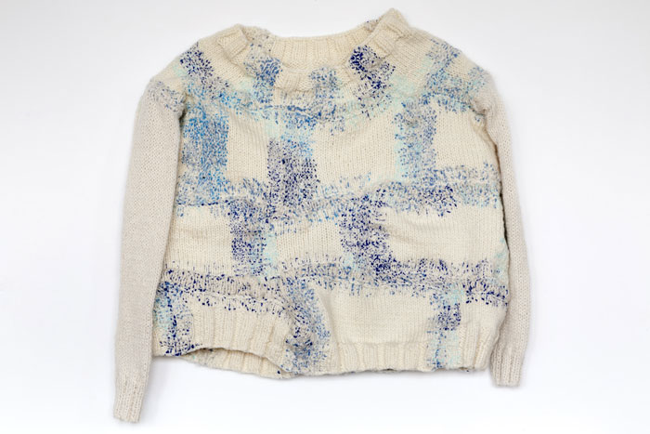
Project proposal, Surface Pattern & textiles

Scarlett Davies
Wordcount: 2994
My narrative is shaped by my connection to home, community, and the quiet beauty of the countryside. As someone who experiences anxiety, I have found that being surrounded by the open countryside offers a sense of peacefulness and comfort, while cities are usually busier and noisier environments causing less quiet, serenity. The ethos behind my project is about slow living, sustainability and emotional wellbeing. My work will focus on developing patterns for homeware, expressed through sustainable materials, like cotton, advocating not only for the importance of our environment, but also for the role natural spaces play in supporting mental wellbeing. 'Researchers say increased greenery in towns and cities could improve mental health in the population as well as those with a history of anxiety and depression.' (Sarah Rodgers, 2024.) The theme of my work explores the relationship between people and nature. This can be demonstrated by highlighting the calming effects of the countryside, showing how even simple visual exposure to natural patterns and colours can reduce stress and anxiety. 'The relative abundance of greenery visible from the home or in the neighbourhood was associated with reduced depressive/anxiety symptoms and lower depression/anxiety rates.’ (National library of medicine, 2020.) This shows more greenery in your home is linked to better mental health, contributing to lower stress levels, improved emotional balance, and a stronger sense of wellbeing.
The context of my project is shaped by the emotional and societal need for calmness and slowness in a world that is increasingly overstimulating and fast-paced, causing anxiety levels to rise. My work draws from a sense of heritage reflecting ideas from my own home, Ross-on-wye, which is a place of peace and belonging. I would like to create an atmosphere that fuels a homely aesthetic which feels familiar and emotionally reassuring throughout my project and homeware collection. By referencing Ross-On-Wye’s rural traditions like canoeing, walking by the river and shopping at independent businesses will enable me to gain access to other ideas and how to express them in my work. As well as traditions, natural motifs, including leaf patterns, florals, branch silhouettes, water ripples and cloud shapes, my project will connect cultural memories of simplicity and comfort. The audience for this work includes individuals who want to release the pressures of modern life, offering a sense of rest and emotional ease within the home. Through countryside motifs and muted greens, blues and earthy brown colours that evoke, softness and a connection to place, my project responds directly to the growing need for nature led homeware that supports mental wellbeing.

The materials I want to include in my project will be sustainable including, organic cotton, bamboo, and recycled cotton reduce reliance on synthetics and are more biodegradable when they have no more use. 'Organic cotton is a natural, biodegradable fabric. It is an eco-friendly, like-for-like alternative to its conventional counterpart, cotton; the most widely used natural fibre crop.’ Amelia Zimmerman (2022.) Cotton (1970), explains; 'because it is a plant, cotton can biodegrade naturally and doesn't create microplastics.' Lastly Miranda Howard (2023) says 'Bamboo exhibits exceptional biodegradability characteristics...they undergo a gradual breakdown process, ultimately transforming into harmless organic matter.' Using recycled cotton and organic cotton materials can last a lot longer and reduce waste over time which improves sustainability. Exploring different textures in textiles materials is something I want to incorporate into my research as well as the potential that could come from discarded materials.

Another area I will be focusing on is how materials can reflect identity and environment, in relation to the countryside and the growing trend towards sustainable practices. Many approaches emphasis reducing carbon footprint, improving energy efficiency and supporting environmental preservation, which has influenced how people use and value materials. “Rather than outdated structures that we hope to replace, older buildings should be valued as climate assets that we cannot afford to waste.” Jim Lindberg (2022.)
Although Lindberg is referring to buildings, I am using his point as a metaphor here. Just as older structures are recognised as climate assets worth preserving, I see existing cloth in the same way. Keeping, reworking, and extending the life of textiles is similarly far more sustainable than discarding them and producing new material.

Natural textures reflect the features of rural landscapes which will play a significant role in my project. Materials like cotton visually reflect elements of the countryside through organic textures and worn surfaces which make them feel naturally connected to outdoor environments. ‘Natural elements bring a certain calm to a space that's hard to replicate with synthetic materials…organic fibers mirror those of the outdoors, fostering a soothing, balanced environment… natural elements also offer numerous benefits for wellbeing, creating a sanctuary that connects you to nature.’ AHB home (2019) The availability of resources strongly influences how people in rural areas use and adapt to materials: for example, recycled fabrics, hand me downs and repaired garments are commonly used because they are practical and accessible. ‘It is one of these things that helps everybody, recycling goods…making the most of what is already made, less reliant on scarce resources, reduced production and making clothing more affordable.’ Ritch, EL (2019.) Recycled materials often show signs of wear, repair, and long-term use, this reflects a slower pace of life that the countryside resembles while embracing the natural landscape. Using sustainable materials becomes a way of expressing identity through everyday garments, by incorporating these elements into my research and design, I aim to show how textiles can carry narratives about the environment, identity and sustainable living.
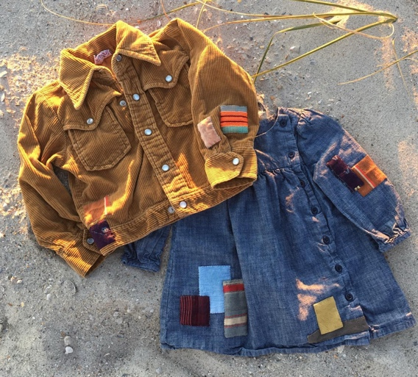
The processes I intend to use in this project explore both the material attributes of discarded clothing and personal stories that worn garments can hold. Techniques such as hand-stitching, embroidery, and the digital free hand stitcher allow me to work closely with the fabric, focusing on signs of wear and repair that can reflect someone’s identity and lifestyle. Visible mending is when you repair rips or patches on clothes in a way that deliberately shows the repair in a decorative or expressive way, rather than hiding them. It is sustainable as it keeps clothing in use longer, reducing waste and the need for new garments, while still being personal and telling a story.
Picture 1. Think_natural_ (2019)

‘Visible mending is wonderful because it highlights the wear and tear loved clothing goes through … I cherish my clothes even more once they are repaired because it adds a little extra piece to the story of that clothing item.’ Izzy Mcleod (2020.) The same principle applies to homeware, textiles such as old curtains, tablecloths, or bedding can be repurposed into entirely new objects, carrying their history into a fresh context.
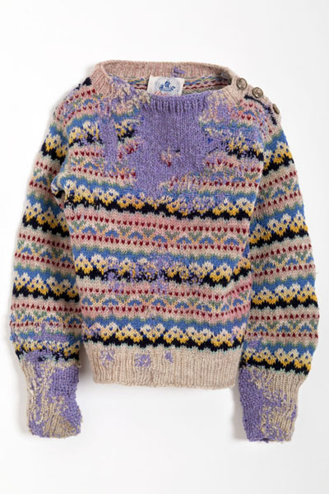
Celia Pym’s work offers an important perspective within her practice, rooted in visible mending, storytelling, and the celebration of wear. Celia repositions damage not as failure but as a site of knowledge, care, and human connection. Rather than ‘restoring’ objects to a pristine state, she reframes repair as a process that makes patterns of use and personal connection.
Picture 2. Cecilia Pym (2014)

‘In that act of mending, in that act of care, setting expectations and taking time to listen to the owners of the things I’m mending is very important.’ (Ceila Pym, 2014.) Repair becomes an act of care that preserves both the material item and the relationship people have with it, valuing the object’s history rather than hiding it. For my own project, Pym’s approach expands the role of the designer from maker to caretaker, suggesting a practice where repair becomes a tool for rethinking value and material agency.

Using natural dyes, bleaching, and screen-printing onto recycled cotton will allow me to study how marks and textures can be changed, allowing the material to take on a new meaning. Digital tools like photoshop enable me to test ideas by, experimenting with collages, exploring different colour ways and plan compositions before physically making them. These digital developments feed directly into other processes like laser cutting and engraving, where visual ideas take place in a tangible material form. These processes allow me to challenge ideas of waste and consider how personal and material histories can be reimagined and modified into functional pieces. By blending these techniques together, it allows me to explore how homeware, can be reworked in ways that reveal a history while also creating something new. This approach connects directly to my interest in storytelling, identity and the potential found in garments that would otherwise be thrown away.
Many practitioners critique the traditional cycle of mass production and disposal in fashion and interiors, instead advocating for circular design and up cycling. Filipino Ricci, co-founder of reclaim to wear, says, ‘it is possible to make large volumes of desirable collections by up cycling large volumes of industrial textile waste.’ Redress (2021.) This viewpoint challenges the assumption that sustainable design must remain small scale, instead proving that large scale production can coexist with responsible, sustainable material practices. This aligns strongly with my project, which explores the creative potential of discarded textiles, and proves how reuse can lead to both aesthetic innovation and environmental benefit. My work positions itself within a wider movement that values resources, reduced waste and the reimagining of unwanted materials as valuable design assets.

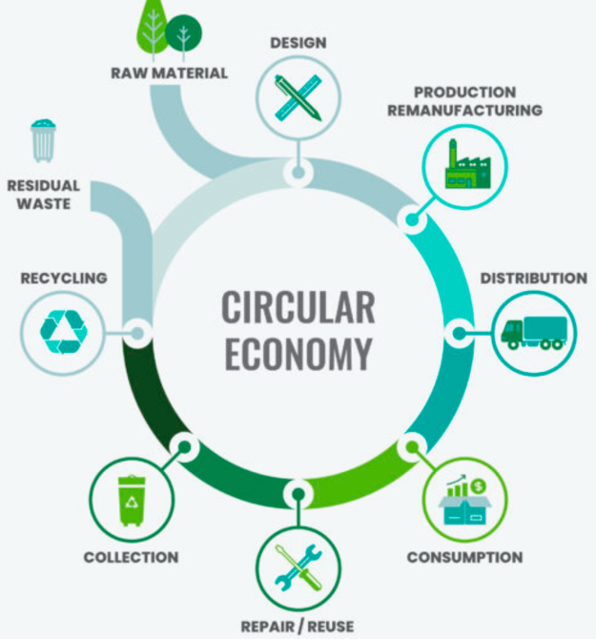
Circular design works in homeware and interiors by encouraging using materials for as long as possible, repairing instead of replacing, and creating products that can be reused, adapted, or recycled. In practice, this might involve repurposing old textiles into pillows or soft furnishings, choosing durable materials, and designing objects so their components can be separated and reused. ‘Designers can create products and systems that are more sustainable and have a smaller environmental footprint…significant benefits for both the environment and society, as well as economic benefits for the companies that adopt these practices.’ Imvelo (2022.) This approach is especially relevant to my project because I am working with discarded textiles while exploring how materials can be given a second life through deconstruction, reconstruction and visible mending. Circular design not only reduces environmental impact but encourages deeper connections to material history, identity and the environments our textiles come from, which supports the themes and ambitions of my project.
Picture 3. Imvelo (2022)

Another critical perspective to delve into during my project is the connection between design and wellbeing, humans have an instinctual need to connect with nature, particularly how certain materials, patterns and environments can play into your emotions. ‘Biophilic design can reduce stress, enhance creativity and clarity of thought, improve our well-being and expedite healing.’ Terrapin Bright Green (2014.) This idea forms the basis of biophilic design, which focuses on incorporating natural forms, textures and patterns into objects and spaces to promote calmness and focus. This is important in a modern-day context where stress, visual overload and fast paced consumption consume daily life. For my project, the reused and organic qualities of cotton textures reflect familiar elements of rural landscapes, which supports the biophilic approach by creating a sense of grounding and a connection to the countryside.

Complex patterns can contribute to stress and cognitive fatigue, while simpler, more spacious patterns help reduce anxiety and create a more soothing visual experience. For example, ‘attention restoration theory (ART) by Kaplan, suggests the ability to concentrate may be restored by exposure to natural environments.’ Ohly, H. et al. (2016) Involuntarily attention is triggered by things that hold our interest like, clouds moving, trees swaying or birds flying, also called soft fascination. ‘The theory claims, is to take time out from attention-demanding tasks associated with modern life and spend time in natural environments that demand less of our cognitive resources and enable us to recover our attentional capacities.’ Ohly, H. et al. (2016) More coherent and spacious patterns function like natural environments by engaging our attention through ‘soft fascination’ while placing fewer demands on our cognitive resources. Whereas chaotic patterns cause the brain to work harder to process, filter and organise incoming information, contributing to stress and overload. Pattern density can change the mood of a design, if my patterns are too crowded, they will contradict the message I am trying to communicate.

Ulrich Stress Reduction Theory is another dominant method as to how nature brings positive responses in humans. ‘Being in a natural environment or viewing natural elements, activates a positive emotional response, a decrease in blood pressure and heart rate, indicators central to the stress response; sustained attention is evoked, which blocks negative thoughts and emotion.’ By incorporating leaves, branches and fields as motifs in my patterns, I aim to replicate these calming effects in my work. I can also demonstrate biophilic principles while referencing natural landscapes which help people feel relaxed. ‘Spending time in the natural environment improves our mental health and feelings of wellbeing. It can reduce stress, fatigue, anxiety and depression. It can help boost immune systems, encourage physical activity and may reduce the risk of chronic diseases such as asthma. It can combat loneliness and binds communities together.’ Ulrich, R. S. (1981). This quote highlights how natural environments improve mental health, reduce stress and fatigue and strengthen the feeling of connection. By incorporating natural motifs and biophilic principles into my designs, I aim to bring these restorative qualities into my project. This way, when people are indoors the patterns, I create can evoke positive emotions and responses that are associated with spending time in nature. Bringing these ideas together helps to place my project within a wider conversation about contemporary design. By exploring ideas like biophilic design, emotional restoration and material honesty I can strengthen the purpose behind my work. The ethos behind my project is about slow living, sustainability and emotional wellbeing.

My vision for Semester two is to develop a collection of work that addresses the growing frequency of anxiety while staying sustainable throughout. By re-thinking about how everyday home environments can act as subtle emotional support systems. I want to visualise homeware items from the living room and kitchen for example, coasters, table runners, blankets, rugs, pillows, and duvet covers. These are the spaces and objects in our home we pass through constantly but rarely reflect on, I would like my collection to become a grounding space rather than background elements. A crucial part of my vision going forward is sustainability not just as an environmental responsibility but as a mindset for longevity, repair, and emotional attachment. When I am feeling anxious and disconnected or overwhelmed the most effective way for me to reset is a quiet moment in the countryside. Open fields, shifting light and textured surfaces allow my mind to slow down in a way which feels instinctive. I am intrigued and excited to see how these grounding, restorative qualities of rural landscapes can be applied onto homeware appliances.
When I start designing patterns for my project I will be thinking about the logic of nature indoors, forms that feel soft and organic, textures that encourage touch and colours that reflect the rural calmness. Beyond emotional comfort, I see sustainability as a part of wellbeing, I want to challenge the culture of fast consumption by creating objects that invite long-term attachment, care and repair.

My vision merges environmental responsibility with emotional resonance, framing sustainability not as a trend but as a way of living that supports both the planet and mental health. The innovation in my project is embedded in the wellbeing sustainability, and digital design. One of my core approaches is the concept of ‘visual mending,’ where imperfections, wear and repairs become a positive aesthetic. I am inspired by natural places, growth and longevity within my design. I want to explore how this philosophy can shift the user’s emotional relationship with objects, instead of perfectionism or disposability, objects become things that evolve with us.

I frequently draw on Photoshop using my iPad, which gives me the ability to experiment quickly with shapes, textures and patterns inspired by natural elements and environments. Using digital drawing, I can layer, distort curves and test how shadows soften a form. This method lets me explore sensory qualities visually before moving onto cloth. It becomes a space to test emotional responses, how calming a shape feels or how a motif might replicate the experience of looking at sunlight through leaves.
Material innovation and testing is central to my ambitions as well. I want to explore biodegradable or recycled materials, tactile finishes, soft edges, and surfaces that subtly encourage grounding behaviours. Examples include patterns that encourage moments of visual pause and reflect the calming feelings of walking in a rural landscape. Through these elements, the project aims to craft a sensory experience that improves wellbeing through everyday use.
Finally, my work aims to innovate at a behavioural level, by designing objects that encourage slower, more mindful thinking, I want to guide users into calmer routines. This design, rooted in empathy, biophilia and sustainability, affects not just the appearance of the objects but the way people live with them.
My ambition for Semester two is to develop research led collection that proves how homeware can actively support emotional wellbeing. I want to produce a body of work that reflects both digital and physical exploration, detailed photoshop illustrations, material experiments, samples and refined designs. I aim to create outcomes that are not only visually cohesive but emotionally grounded and functional.

Looking beyond third year, I want to continue exploring the relationship between design, wellbeing and sustainability on a professional level. I see my future practice sitting at the intersection of emotional design, sustainable product development and digital illustration. I am particularly interested in roles or pathways where I can combine my digital drawing skills with material research.
Long-term, my ambition is to build a practice that uses design to create calmer, more caring environments. I want to challenge the disconnect between fast-paced living and the emotional needs we ignore, offering instead a design language rooted in nature, repair and mindful interaction. Ultimately, my goal is to contribute to a design future where sustainability and wellbeing are treated not as separate areas but as interconnected forces that shape how we live, breathe and feel in our homes.

Sarah Rodgers (2024) Local green spaces are linked with better mental health. Available at: Green spaces are linked with better mental health (27.11.25)

National library of medicine (2020) Does greenery experienced indoors and outdoors provide an escape and support mental health during the COVID-19 quarantine?
Available at: Does greenery experienced indoors and outdoors provide an escape and support mental health during the COVID-19 quarantine? - PMC (27.11.25)

Amelia Zimmerman (2022) Organic cotton: how does it compare to other sustainable materials? Available at: Organic cotton: how does it compare to other sustainable materials? (27.11.25)

Miranda Howard (2023) Is bamboo biodegradable?
Available at: Is bamboo biodegradable? (27.11.25)

Cotton (1970) Cotton: the sustainable choice
Available at: Sustainability - Cotton | The Fabric of Our Lives (27.11.25)

Jim Lindberg (2022) The Reuse Imperative
Available at: The Reuse Imperative | National Trust for Historic Preservation (27.11.25)

Izzy Mcleod (2020) Clothing Love Stories - Visible Mending
Available at: Clothing Love Stories - Visible Mending (27.11.25)

Picture 1. Think_natural_ (2019) Visible mending jackets
Available at: Instagram

AHB home (2019) Incorporating natural elements: the benefits of bringing the outdoors in
Available at: Incorporating Natural Elements: The Benefits of Bringing the Outdoors (27.11.25)

Ritch, EL (2019) 'From a mother to another’: creative experiences of sharing used children’s clothing', Journal of
Marketing Management, vol. 35, no. 7-8, pp. 770-794. https://doi.org/10.1080/0267257X.2019.1602555

Redress(2021) Upcycling guide
Available at: Upcycling Guide — Redress Design Award

Filipino Ricci, co-founder of reclaim to wear, says, ‘it is possible to make large volumes of desirable collections by upcycling large volumes of industrial textile waste.’ Redress(2021)

Imvelo (2022) Circular Design and design for recycling – an important element of circular economy
Available at: https://imveloltd.co.uk/design-for-recycling-an-important-element-of-circular-economy/

Picture 2 Imvelo (2022)

Terrapin Bright Green (2014)14 Patterns of Biophilic Design: Improving Health & Well-Being in the Built Environment
Available at: https://www.terrapinbrightgreen.com/wp-content/uploads/2020/05/14-Patterns-of-Biophilic-Design-Terrapin-2014e.pdf?utm_

Ohly, H. et al. (2016) ‘Attention Restoration Theory: A systematic review of the attention restoration potential of exposure to natural environments’, Journal of Toxicology and Environmental Health, Part B, 19(7), pp. 305–343. doi: 10.1080/10937404.2016.1196155.
Available at:
Full article: Attention Restoration Theory: A systematic review of the attention restoration potential of exposure to natural environments

Ulrich, R. S. (1981). Natural versus urban scenes: Some psychophysiological effects. Environment and Behavior, 13,523–
Available at:
The Science

