C Exercises 3b – Input and Calculations

1. Write a program to allow the user to enter two temperature readings, in Celsius. The two readings are as follows: 28.4C and 21C.

Print out the average temperature (ie add them and divide by 2)

Print out the result. Hint: All inputs and the output should be of float type.

Sample output:
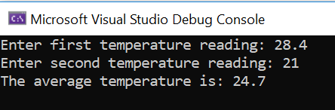

2a. The area of a triangle is calculated by the formula ½ base * height

(Sometimes written base * height )
------------------
2 …or in programming (base * height) / 2

Write a program to allow the user to enter base * height and calculate the area of a triangle.
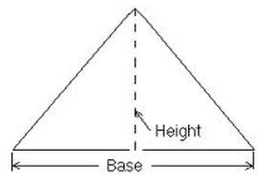

Sample output:

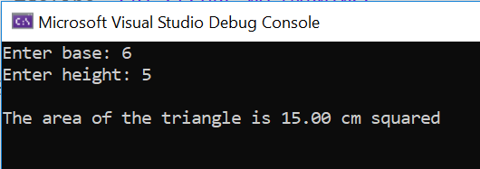

2b. A person would like to calculate how much room there is in their tent. Here is a picture of the tent:

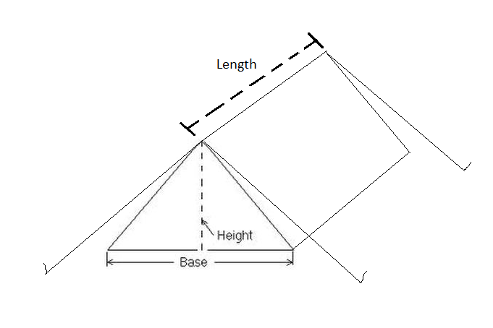
Adapt your program from 5a above to calculate the volume of the tent and print the result on the screen.

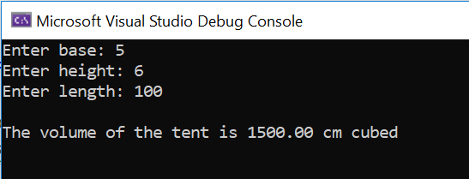

3. Post-Covid, I am going on holiday to USA. I have saved £230.55 to spend on American snacks I want to change my pounds to dollars in advance. Write a program to allow me to calculate the amount in dollars and print the result on the screen.

(Hint: you could use a website such as http://xe.com to look up the current exchange rate)

Sample output:


