

Programme: BA Business Management

Module: Entrepreneurship
Module code: LCBB5001
Module Lecturer: Dr John-Paul Okeke

Assignment Title: Assessment 2
Student Name: Boscanean Maria
Student ID: 2021937

]
Table of Contents

Introduction 3
Business Description 3
Industry Analysis 4
Porter's five forces model 4
Operations and Management Team Plan 5
Marketing Plan 7
Four P’s framework 7
Financial Plan 7
Market Research 8
PEST Analysis 8
Conclusion 10
References 11

Introduction
The purpose of this study is to describe a business plan for a startup company and then analyze the management plan, operational plan, and marketing plan. Becoming an entrepreneur is not an easy task, but the passion and capability within an individual are what make the difference. This study is going to present a company that is trying to start a business and the business is about delivering food, especially to senior people or old age people. Being a startup business, the company has to take several risks and there would be many issues also even after the business will flourish, therefore entrepreneurs must be ready to face all such things. This study will shed light on the entire business plan, through Porter's five forces model the analysis of the industry will be presented, leadership styles and team management plan, marketing plans, budget, and PEST analysis.

Business Description
The plan of the startup business is that the company will be delivering food products to senior or older aged people. It would be home delivery. So, the company is going to hire individuals who are interested in such a kind of job where they had to deliver food products that are ordered by senior people.
The mission statement is considered widely a strategic tool that has great significance to the identity and uniqueness of the organization (Alegre, et al. 2018). Therefore, the mission statement of the company is to deliver hygienic and good quality food products to senior and old age people at their doorsteps so that they do not have to take any pain to get out of their house just to have food.
Intellectual property (IP) is considered as mental creations, like symbols, or images utilized in commerce (UpCounsel, 2022). Therefore, the Intellectual property of this business will be a logo where an image of a food item on a plate with the spoons will be designed.
The ownership structure of this business will be a Sole proprietorship Business structure.
The application for the business licenses would be taken into consideration so that in the latter there are no legal issues that the company has to encounter.

Industry Analysis

Porter's five forces model
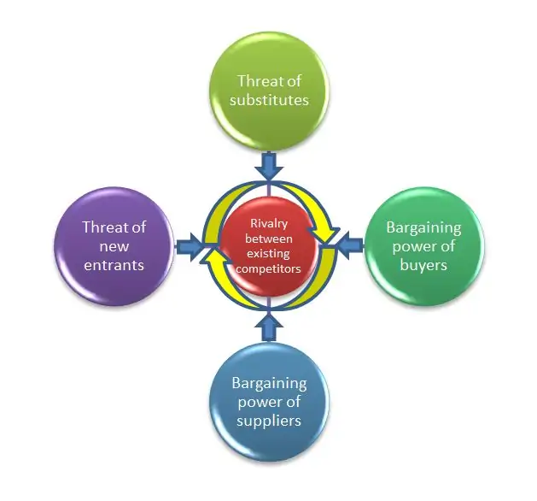
Figure - 1
Source - abdo.org.uk, 2022.

Porter’s Five Forces Model offers a framework to recognize industry-related threats, scopes, and opportunities (Higherstudy, 2020). This framework promotes the idea that there are 5 forces and these forces determine and control competitive intensity along with the attractiveness of a market. These five forces are -
- Bargaining Power of Suppliers
Since this is a business where the raw materials that are the vegetables, fruits, and the species are considered to be the suppliers to this company. Therefore, in the UK there are several markets for such raw materials, so there is a lesser threat from the suppliers.

- The threat of New Entrants
Since this is a startup company, therefore, there is no such huge threat as of the present time. But since there are other companies like this, therefore this organization has to be very careful and plan in a strategic manner so that it could be able to establish and accomplish good fame.

- Bargaining Power of the customers
The price of all the food products is deliberately kept affordable so that the company gets a lot of customers who would be taking the advantage of getting items at a cheaper rate.

- Risk of Substitute Services or Products
Customers have the power to shift from one company’s products or services to the other. Therefore, this food delivery company must ensure that their food products are not only of good quality but the delivery of the products is also done at the correct place and time as stated.

- Rivalry among the Existing Firms
There are not many firms that are delivering food products to senior and older people, therefore, there is a lower risk for the company in this aspect.

Operations and Management Team Plan
Opening a business and making a plan is not enough to continue the business. Rather it is the management of the business each and every day is the basic requirement. For this purpose, a team and a leader are required who are going to help in running the business successfully. Of course, an efficient team is needed who could manage every situation. A leader is essential as the team needs constant guidance to perform best. The fundamental purpose of a leader is to inspire others or followers, in order to engage together to accomplish the aim and objective (Malik, and Azmat, 2019). So, for this company, a democratic leadership style would be best. Democratic leadership style is also known as participatory leadership (Peker, Inandi, and Gilic, 2018). In such a style, the members of the team take an active part in the process of decision-making. As the company is about delivering food to the old age people, therefore, there would be many delivery people required who are going to be going to the houses of those people who have ordered food. Hence, they would be getting to more about the what other things that the old age people require or if is there any feedback from them. This will be easier for the manager or the leader to take any final decision more correctly if the leader makes all these delivery people put their opinions and ideas.

Belbin Team Roles
As per Belbin, there are nine team roles and these are categorized into three distinct divisions. They are thought-oriented, action-oriented, and people-oriented roles (Indeed, 2021).

Thought-oriented team roles
The Monitor Evaluator
This person has to be smart and a strategist in order to perceive all the possibilities (Bednár, and Ljudvigová, 2020). Also, possess the precise judgment-making capability.

The Specialist
Provides the knowledge to the entire team which is going to help the business to accomplish success and grow more.

The Plant
If any challenging situation arises, the plant will be taking the responsibility to resolve the issue as this person is free-minded and generates creative ideas.

Action-oriented team roles
The Shaper
Shapers always remain positive despite any challenging situation the shaper tries to motivate the other members of the team. This would help the other members to get influenced and perform better in difficult times.

The Implementer
A very practical as well as a reliable person. This individual put all the ideas into action. Therefore, it will become easier for the company to function properly.

The Completer
The company requires such a kind of person to make sure that the members of the team are producing good-quality work.

People-oriented team roles
The Coordinator
This person is very confident and in the company, the coordinator searches for every person’s strength so that those people are provided with those tasks that they are good at.

The Team Worker
Team Workers are primarily good listeners and work in cooperation as a whole unit. Harmony is established within the team so that no bigger conflict arises within the team.

The Resource Investigator
This person is one who is very much an extrovert and due to such a personality, making new contacts is not a big issue. These contacts help the business to grow and expand more.

Marketing Plan

Four P’s framework
The framework of the four P’s comprises Product, Price, Place, and Promotion. These are examples of the marketing mix (Coursera, 2022). Any enterprise that wishes to serve the market will strive or attempt to direct the activities of marketing so that the correct product is sold, at the correct place, price, and perfect time (Smith, Kolassa, and Pray, 2020).

Product
The company has intended to deliver food to the homes of the senior and old age people who are going to order food from this company. There will be a menu card that will be provided or shared with the clients so that it becomes easier for them to give the order as per their choices.

Price
Since it is a startup business, therefore, the prices of all the food items are kept at affordable prices so that each and every person who is interested to place an order does not have to think twice. They could easily order food items that they like to have.

Place
Considering the fact that the company is going to be delivering food packets to the houses, therefore, the place where the company is going to be structured or positioned is not a huge matter. Through if it is placed in a good position where it becomes easier to travel in any direction will become easier for the delivery persons.

Promotion
It has been intended that the marketing will be done on the social media platform as it is one of the best places for promotion. Apart from it, there is a plan that advertisements in newspapers and in a few magazines.

Financial Plan
Budget
It has been planned to take a loan from the bank.
- Firstly the Incorporation Fees would be approximately $145.
- Research Expenses - $100–$30,000 approx.
- Equipment - $11,000–$125,000 approx.
- Marketing or Advertising would be Up to 7%–8% of Revenue
- Development of the website - Up to $10,000
- Office Supplies and Furniture - $200–$1,000 per Month
- Insurance - $46–$86 per Month, per Policy

Materials or resources required | Prices or cost
Raw material (vegetables, spices, and so on.) | $80,000 per month
Delivery Staff | $30,200 per staff
Chefs | $20,000 - 40,000 per month
Employees taking down orders via phone calls | $16,000 per month, per staff
Employees taking down orders via digital platforms | $16,000 per month, per staff
Staff for packing the food items | $12,000 per month, per staff
Staff for buying the raw materials | $12,000 per month, per staff
Accountant | $20,000 per month

Market Research

PEST Analysis
PEST analysis is considered to be a method that is utilized to recognize, evaluate, and assess the external factors that are affecting an organization’s performance with the objective of collecting details to guide decision-making strategically. PEST analysis is one of the primary kinds of marketing analysis (Tokmurzina, 2018). This analysis includes the evaluation of an array of macroenvironmental variables such as political, economic, social, and technological - and these can influence the organization potentially (Amihm, 2021).
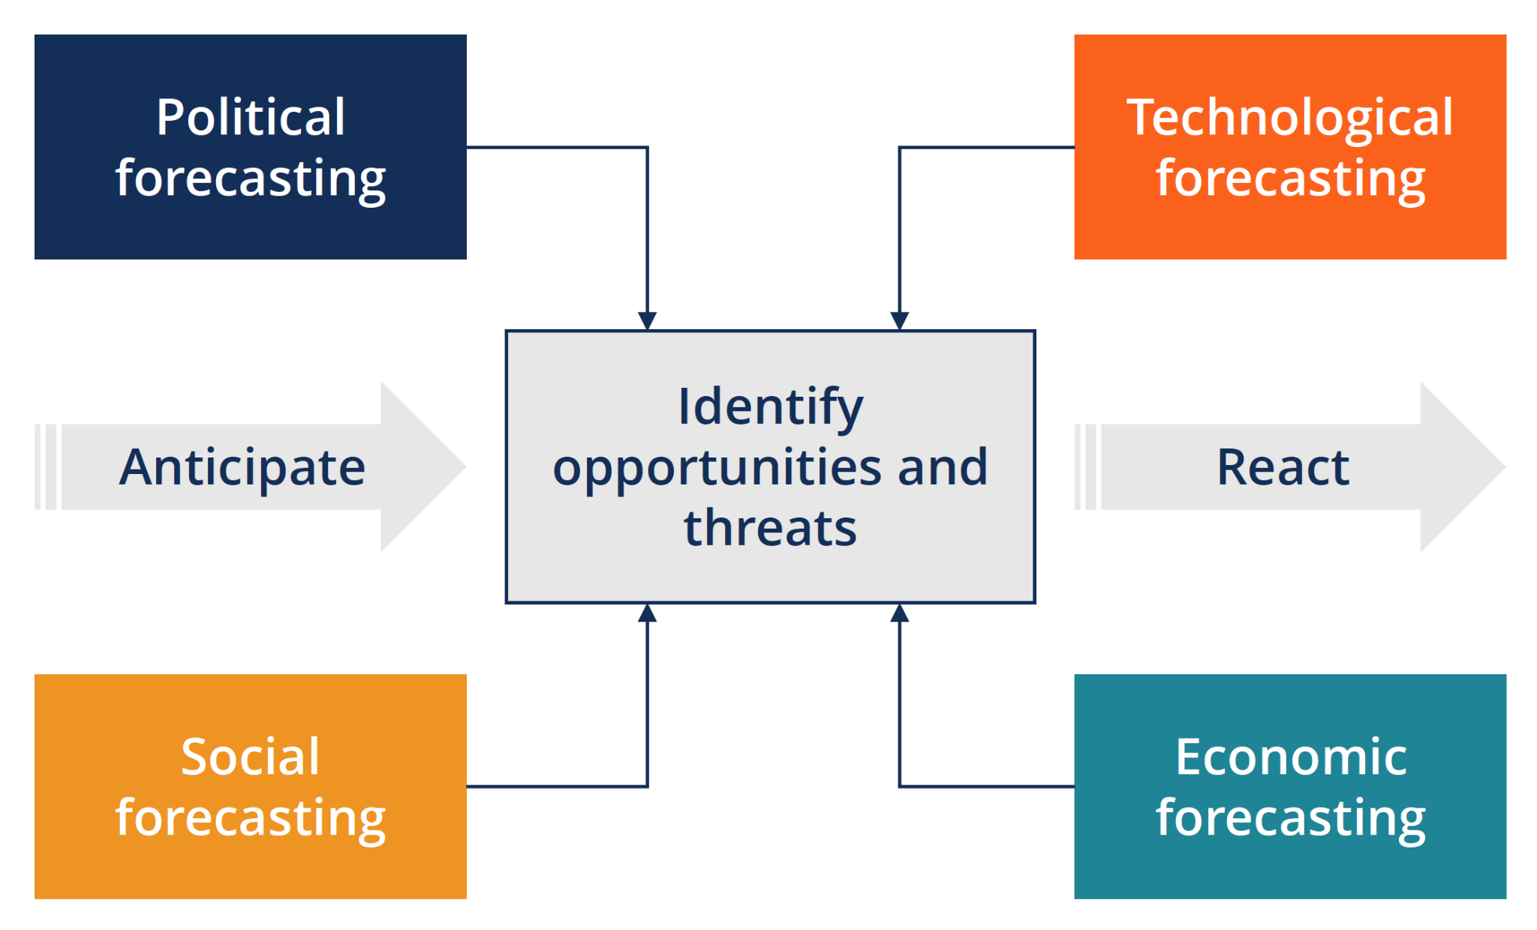
Figure - 2.
Source - CFI, 2022

Political Factors
The political factors either help the business or else hinders it (Businessnewsdaily. 2022). Since the company is going to be starting its first branch in the UK, therefore the political environment is good enough for the organization to begin.

Economic Factors
Since the economic growth rates are good in the UK, therefore for the present time, there will be no such issues in this respect for the company. The GDP of the United Kingdom is 3376 in the year 2022 (Statista, 2022).

Social Factors
Social pressures and norms are significant in determining consumerist behavior in society (CFI, 2022). The company is reaching out to a wider extent as the very thought of the organization is to deliver food products only to the senior and old age people - the company is maintaining the social norms and cultural aspects of the society.

Technological Factors
Technology plays a very crucial and significant role in today’s life (Raja, and Nagasubramani, 2018). Therefore, the company has already intended to open a digital platform where its customers can easily order their desired food products from the menu that will be present there.

Conclusion
To conclude the study it could be seen that it is very important for a startup company to first analyze the industry and the market before starting a company. Through Porter’s five forces model and PEST Analysis, it could be clearly assessed what are the risks or threats that the company could face and from which portions the organization could achieve success. It is due to such a kind of market research there are several companies that have accompanied its objectives and aims. Therefore, in order to stay and survive in the market successfully, one must be doing the research perfectly and get hold of all the things that will be essential for the organization. After this, the marketing plan is another most crucial and of prime importance for the company to become well-known and recognized to a greater extent. This is what would be helping the company to get success. Therefore, the startup company must be performing all the necessary things that are required before starting up a new business.

References
Alegre, I., Berbegal-Mirabent, J., Guerrero, A. and Mas-Machuca, M., 2018. The real mission of the mission statement: A systematic review of the literature. Journal of Management & Organization, 24(4), pp.456-473.
Amihm, 2021. The PEST Analysis. Available at - https://www.amihm.org/the-pest-analysis/ (accessed on 28 July 2022).
Bednár, R. and Ljudvigová, I., 2020. Belbin team roles in a start-up team. In SHS Web of Conferences (Vol. 83, p. 01002). EDP Sciences.
Businessnewsdaily. 2022. What Is a PEST Analysis? Available at - https://www.businessnewsdaily.com/5512-pest-analysis-definition-examples-template.html (accessed on 28 July 2022).
CFI, 2022. PEST Analysis. Available at -https://corporatefinanceinstitute.com/resources/knowledge/strategy/pest-analysis/ (accessed on 28 July 2022).
Coursera, 2022. The 4 Ps of Marketing: What They Are and How to Use Them. Available at - https://www.coursera.org/articles/4-ps-of-marketing (accessed on 28 July 2022).
Higherstudy, 2020. Porter’s Five Forces Model of Competition Analysis. Available at - https://higherstudy.org/porters-five-forces-model-competition-analysis/ (accessed on 28 July 2022).
Indeed, 2021. The 9 Belbin Team Roles (With Examples). Available at - https://www.indeed.com/career-advice/career-development/belbin-team-roles (accessed on 28 July 2022).
Malik, M.A. and Azmat, S., 2019. Leader and Leadership: Historical Development of the Terms and Critical Review of Literature. Annals of the University of Craiova for Journalism, Communication and Management, 5(1), pp.16-32.
Peker, S., Inandi, Y. and Gilic, F., 2018. The Relationship between Leadership Styles (Autocratic and Democratic) of School Administrators and the Mobbing Teachers Suffer. European Journal of Contemporary Education, 7(1), pp.150-164.
Raja, R. and Nagasubramani, P.C., 2018. Impact of modern technology in education. Journal of Applied and Advanced Research, 3(1), pp.33-35.
Smith, M.C., Kolassa, E.M. and Pray, W.S., 2020. The “Four P’s”. In Government, Big Pharma, and the People (pp. 25-57). Productivity Press.
Statista, 2022. Gross domestic product (GDP) in current prices of the United Kingdom (UK) from 1987 to 2027. Available at - https://www.statista.com/statistics/263590/gross-domestic-product-gdp-of-the-united-kingdom/ (accessed on 28 July 2022).
Tokmurzina, K.R., 2018. THE BASIC TYPES OF MARKETING ANALYSIS. PEST-ANALYSIS OF FIRMS. In ЭКОНОМИКА, БИЗНЕС, ИННОВАЦИИ (pp. 52-55).
UpCounsel, 2022. Intellectual Property for Startups: Everything You Need to Know. Available at - https://www.upcounsel.com/intellectual-property-startup (accessed on 28 July 2022).

