HKBM7000 Approaches to Research and Academic Communication
Research Proposal
Open innovation Model in the Greater Bay Area : The Case of Shenzhen and Hong Kong

Wong Lai Fong Yvonne
(Student ID: 1922252)
Total 5630 words

Introduction

Open innovation was first proposed by H. Chesbrough in 2003 and it discussed the open exchange of knowledge to drive innovation among companies. In the discussion of open innovation, it would associated with information exchange, knowledge transfer, technology diffusion etc. Open innovation and related concepts such as national or regional innovation system, triple (or quadruple) helix models, innovative city clusters are frequently applied to study the development of innovation and technology industries in different countries.

In recent days, the development of Guangdong-HongKong-Macau Bay (GBA or Greater Bay) has become a hot discussed topic. With 71 million of population: about 71 mil (comparable to the population of world 21st country, UK) and GDP of 10 trillion RMB (1.6 trillion USD) making it the world’s 13th-largest if it were a stand-alone economic entity and accounts for 11% of GDP of China. However, GBA is just 56 000 square km (less than 1% of total area of PRC). The Outline Development of the GBA is a “framework for an international first-class bay area and world-class city cluster” and one of its positions is “developing an International Innovation and Technology Hub”. How to facilitate development of innovation and technology in the Greater Bay area has drawn much attention. Shenzhen and Hong Kong are pillar cities in the GBA and their cities development and cooperation means much to a thriving GBA. In fact, 2020 is the 40th anniversary of Shenzhen Special Economic Zone, the collaboration between Shenzhen and Hong Kong in the past forty years after the open-up reform should be an interesting case to study its regional open innovation. During the Chinese People's Political Consultative Conference (CPPCC) special GBA meeting on 22 July 2020, it mentioned that GBA should enhance its “one corridor, one center, three hubs and multiple platforms development”. It should build more research facilitates and have better coordination and flow of talents and capital between different cities (Ho, 2020).

Shenzhen was viewed as one of the first stepping stone of Hong Kong industrialists to enter the China market in the 1990s (Meyer, 2016). A number literature has studied the development of Shenzhen from copycat culture to the Silicon Valley of China. The importance of Shenzhen is that it is a pilot zone for the open-up reform policies. According to the Shenzhen Government Online 2013, Shenzhen wish to work with Hong Kong and build its financial centre. Qianhai Shenzhen-Hong Kong Modern Service Industry Cooperation Zone was established in 2012. Subsequently, Qianhai-Shekou Free Trade Area was establish on 27 April 2015. This recognized the cooperation with Hong Kong in the four major areas, namely, finance, information services, modern logistics, technology and other professional services.

Since 2000s, Hong Kong started to develop its techno-entrepreneurial capability through various strategies (Wong et al 2017) such as the establishment of the Hong Kong Science and Technology Park, the Cyberport Management Limited, the Hong Kong Applied Science and Technology Research Institute (ASTRI), Create Hong Kong and the Innovation and Technology Bureau etc. Hong Kong government has spent much effort and allocated much resources to the research and development programme in the universities. Compared to other cities in the Greater Bay Area, Hong Kong is strong at basic research and the universities in Hong Kong possess high world QS rankings.

Chan (2018) suggested that internationalisation and integration of the universities’ social capital in Hong Kong is the main driver for the GBA’s innovative knowledge economy development. Universities in Hong Kong supported the entrepreneurial activities in the GBA such as in Shenzhen Qianhai. Universities serve as the platforms of “education, training, incubation transformation, international cooperation, and entrepreneurship and innovation research”. Both Shenzhen and Hong Kong are knowledge-based economies and their city’s innovation systems framework can give implication for the future of GBA and develop as an International Innovation and Technology hub.

Xu & Yu (2013) has applied the “extended open innovation model” to analyze how to the strength and weakness in “development technology and innovation industry in Hong Kong”. They found that the paradigm shift of open innovation could benefit Hong Kong. Extended open innovation model is a good framework to analyze the research and development of the innovation and technology industry. Xu’s paper discussed how small innovation and technology enterprises upgrade themselves from the extended open innovation model through their partnership and exchange with large corporation, research institutions and governments. Research institutes can join hands with small innovation and technology enterprises for the commercialization of research projects to the market. In the research of Xu & Yu, venture capitalists are only viewed as professional service providers l to bridge the gap between small innovation and technology enterprises, research institutes and funding sources. However, the role of entrepreneurial financial associations in facilitating the relationship among university-industry-research institutes are not fully discussed and examined. Therefore, in my paper I will revisit this extended innovation model and add on the discussion through the study of the Shenzhen-Hong Kong collaboration in the innovation and technology industry of the Greater Bay Area.

Open innovation is a popular topic to study the development of innovation-led economy of different countries. For example, Abulrub and Lee (2012) applied the open innovation theory to survey 85 South Korean companies. The research used industry type, company size, market type, and R&D intensity as environment factors to find out nature and challenges of open innovation. Ismail et al. (2017) also conducted a quantitative study of open innovation in Malaysia. He found out IP Management in universities, government policy and laws are prevention factors for the adoption of open innovation in Malaysia. Zhang, S. et al. (2018) studied the relationship of open innovation and firm’s performance of the mechanical manufacturing industry in China. He found that “an inversed U-shape relationship between open innovation and firm profitability”. Education level of employees would increase the positive impact of open innovation in technology-oriented firms. However, such relationship did not hold in the production-oriented firm. On the other hand, Džupka, et al. (2016) have applied open innovation to study innovative start-ups in Slovakia. They found that bank loans were the major funding source of start up in their initial phase. Industry or university collaboration had a “positive impact on prosperity of the start-up company in terms of higher profitability and better access to funding”.

Akpinar and Qi (2020) also applied triple helix model to study the innovation ecosystems in China. They found that research-oriented state-run national universities, public research institutes and corporate research and development spending are key actors of the China’s innovation ecosystem. However, insufficient research funds and talented engineers limit the innovation capabilities of the technology industry. We need to propose ways to boost university-industry-research collaboration by encouraging commercialization of research projects and encourage intellectual property trade. In this respect, we need to encourage more open innovation. Traditional open innovation modeled talked about the free flow of technological resources between supplier, academia, industry and research institutions. However, it does not mentioned about the roles of entrepreneurial financing institutions in facilitating open innovation as a whole.

Open innovation is the use of “purposeful inflows and outflows of knowledge to accelerate innovation internally while also expanding the markets for the external use of innovation” (Chesbrough, 2003). Traditional researches on open innovation would focus on the university-industry collaboration. Industry-led partnerships in open innovation may enhance the commercialisation of research projects. Some studies indicated that government, industry (e.g. small and medium-sized enterprises (SMEs) as well as large enterprises), academia play important roles in open innovation and collaboration as they helps the transformation of industries in the digital economy (Business Times; Singapore 07 Aug 2018). However, the traditional approach did not mention about how entrepreneurial financial institutions or individuals such as venture capitalists, angel investors, bank etc. in facilitating open innovation. Financial institution can play a role in the valuation of intellectual property of research projects so that the projects can get the funding for further research and development. At the same time, the financial institutions can transfer industry know-now and bring industry networks to facilitate commercialization of research projects.

It is recognized that many of the inventions in the university are not sufficiently commercialized. Unlike the Tokyo bay, technology transfer among universities, research institutions and industries are not well developed in the Guangdong-Hong Kong Macau Bay area. It is because the concept of industry commissioned research was not well promoted. Also, the government research funding system does not give enough incentives for university researchers to commercialize their intellectual property (IP) and facilitate technology transfer to the industry. On the other hand, industry players did not have much incentives to transfer their market knowledge and latest research expertise back to universities. For example in the Fintech area, professors seems not aware the balance between advanced technology development and the compliance of laws and regulations.

In Silicon Valley (San Francisco Bay), Silicon Valley Bank and venture capitalists played a role in entrepreneurial financing and the innovation start-ups ecosystem. It helped start ups to get funding in their incubating stage. However, the role of banking or financial institutions in promoting open innovation in an extended way needs further investigation.

Statement of the Problem:
To fill in the collaboration gap between university, research institutions and industry in the open innovation model, I wish to study the role of entrepreneurial financial institutions as the fourth pillar in facilitating open innovation. According Sheffield University Advanced Manufacturing Research Center Model, it mentioned the role of banks in helping the financing of technology start-ups. In fact, banks (investment banks or retail banks), venture capitalists, stock markets, angel investors, crowd funding are major financial resources for technology startups and it can also play a role in bridging the “valley of death” (death of ventures due to insufficient funding). They should be part of the open innovation model in promoting the flow of technology, knowledge, talents and capital in the innovation ecosystems.

The relationship between university, research-institutions, entrepreneurial financial institutions through the supply of capital and values and improve the industry-knowhow of engineers will be studied. Due to resource limitation, the role by government and society in the open innovation will not be studied.

Purpose of the Study:
Given the benefits of open innovation, it is found that patenting, licensing, joint ventures and new venturing should change from closed activities to open innovation in order to motivate the academic entrepreneurs and the entrepreneurial academics to engage with industry and end-users. (Alexander , Miller and Fielding, 2015). There are public programmes that support innovation and knowledge transfer from universities to the commercial sector. However, interested groups such as universities, programme organisations, private evaluators, professional bodies, and multiple suppliers are also key players in the transfer and may or may nor work in the same interest of the government programme (Vega, Brown and Chiasson, 2012).

My purpose of this study is to enrich the discussion in open innovation and encourage more innovation in the industry. This research wishes to a better framework for local government or policy drivers (e.g. public organizations or professional bodies in the industry) in the formulation of future innovation policies for the innovation and technology industry in the Greater Bay Area.

Review of the Literature:
- Open innovation
“Open Innovation model” (Chesbrough, 2003) discussed how companies have shifted from so-called closed innovation processes towards a more open way of innovating. Open Innovation combines internal and external ideas as well as internal and external paths to market to advance the development of new technologies.

Figure 1 : The Open Innovation Model of Henry Chesbrough (Source: Xu & Yu 2013))
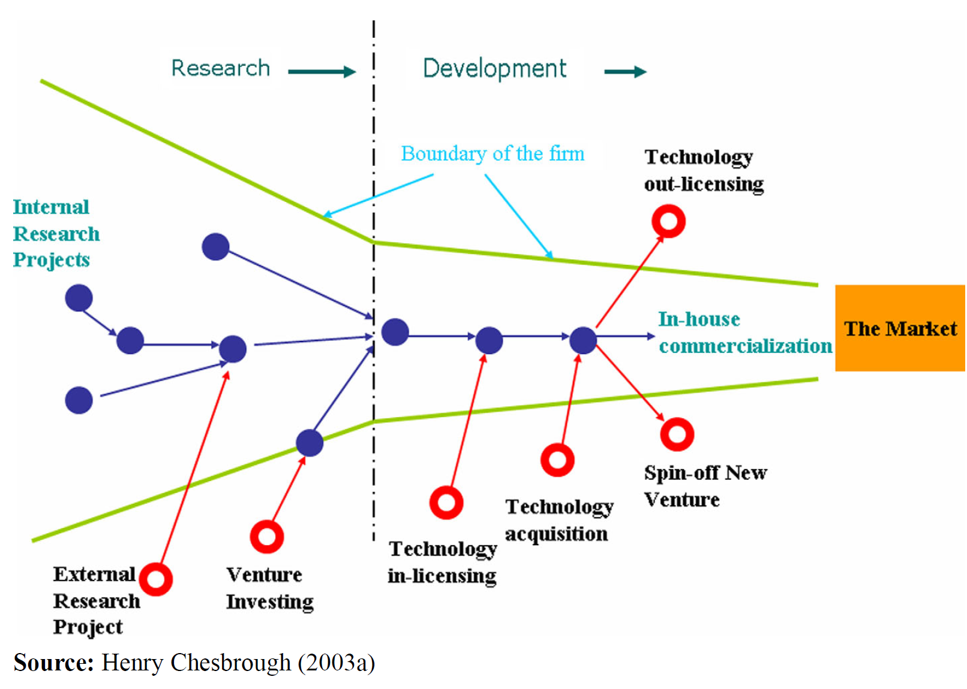

A number of researches discussed about the university-industry partnership, public-private partnership in promoting entrepreneurial activities, technology transfer, enhanced knowledge and talent exchange through open innovation. Universities are both suppliers and consumers of knowledge and partnerships because the can gain from knowledge and partnership exchange for their own research and educational assignments (Mika Kautonen et al. 2014). Participatory research between universities and enterprises can enhance their mutual exchange of knowledge and technology resources in the open innovation process (Laine, Leino and Pulkkinen, 2015). However, university may refuse to collaborate with the industry due to the threat of losing control. Industry may have the concern of disclosing its business secrets to the university or research institutes. As a result, university-industry-research institutes would tend to adopt the closed innovation model and limit their degree of partnership.

- University-industry-government relationship, PPP, triple helix, quadruple-helix

Cai & Lui (2015) illustrated government-university-industry Triple-Helix relationship in the China’s regional innovation systems through their studies of the Tongi Creative Cluster in Shanghai. They found that “the university produces and transfers more knowledge to industry while gaining additional funding sources from industry and government to strengthen the conduct of research”. University can commercialize their knowledge through patent and license of projects, direct cooperation with industry and university-run or spin-off enterprises. Liu & Cai (2018) has applied triple helix model to study the institutional logics of Shenzhen. They found that with the balanced interaction of Shenzhen city government, industry and university contributed to the market-oriented economy and innovative knowledge society of Shenzhen. With the loosen control of the central government, private enterprises like Huawei, ZTE, Tencent, BYD are emerged in Shenzhen and build the city’s indigenous innovation capability (Liu & Cai, 2018).

Triple-Helix approach is adopted study the relationship among the state, universities and private firms (Becker and Eube, 2018). Universities are knowledge suppliers and they should remain their openness in collaborating with business. Intermediary agents and innovative technologies in the triple helix model can enhance trust relationships between stakeholders.

In the study of Quadruple helix model, the relationship of government, university, industry and society are studied. In the quadruple helix open innovation model, government, university, industry and Society co-create values with each other by sharing of resources and knowledge for the sustainability economy, environment and society (Yun & Liu, 2019).

Figure 2: Quadruple Helix Model (Yun & Liu 2019)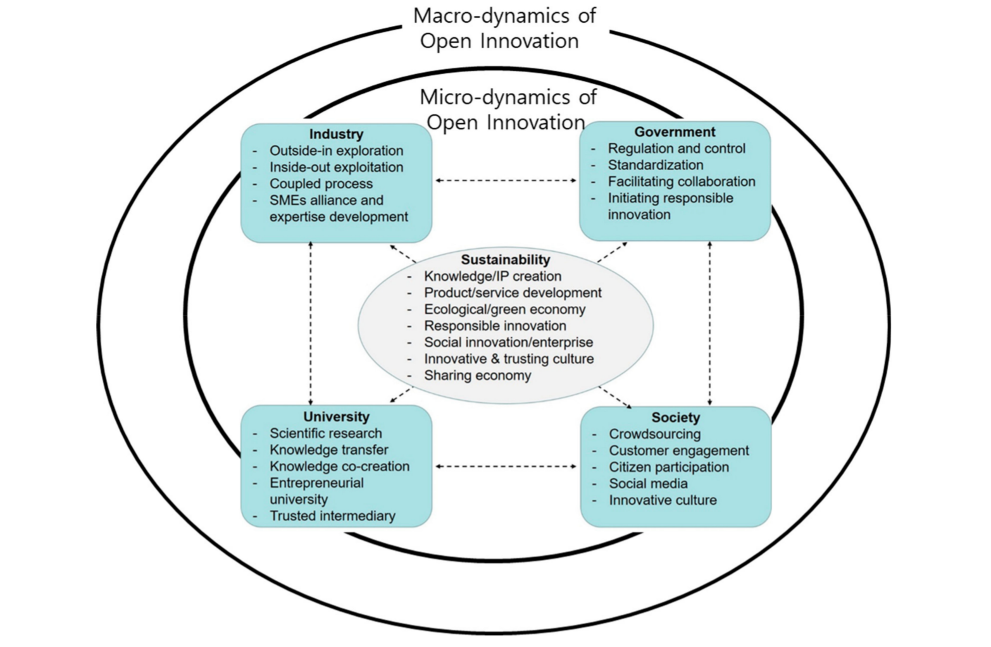

Thomas G. Pittz and Rebecca White (2016) discussed that public-private partnerships (PPPs) exhibit continual renewal and repeated acts of entrepreneurship as they explore novel solutions to intractable social problems. With recognition of goal interdependence between partner firms and a structure of open governance, PPPs create unique opportunities for innovative ideas and knowledge exploration and exploitation. Enhanced absorptive capacity and knowledge spillovers can contribute to enduring entrepreneurship and long-lasting partnerships.

- Start-up developments and Valley of death
Seed funding and venture capital are important funding source for start-ups. In the research of by Čalopa, Horvat and Lalić, (2014), they mentioned that Cvijanović et al (2008) discussed the five stages of corporate financing namely, “experimental or seed; start-up; expansion; recapitalization, and buyout”. At the seed or experimental stage, entrepreneurs tend to use personal saving or borrowing money from friends or relatives. In other stages, entrepreneurs will try to other financing methods such as bank loans, angel investments, venture capital etc. Bank loan is the most traditional and conservative way to get funds. However, due to complicated procedures, the needs for machine or property guarantee, start-ups would tend to avoid to use bank loans. Seed start-ups would try to get support from private investors and the successful chance is relatively higher (Brkan, 2010). Entrepreneurs at the seed or start-up stage would prefer to attach themselves with incubators as it is easier to connect with angel investors. As the business expands, innovative entrepreneurs will choose work in accelerator and try to pitch funding from venture capitalists Y Combinator , 500 Startup are famous examples of accelerators. The gap between research economy and commercial economy is the valley of death. That means small technology enterprise die before its research projects being commercialized and pushed to market. That means the enterprises die before its start-ups or expansion phase. Strengthen the entrepreneurial culture is critical to innovation success and pass the valley of death (Jucevicius et al 2016). University-industry partnership is a way to bridge the valley of death and improve the survival chance of technology start-ups.
Figure 3: Valley of Death (Jucevicius et al 2016)
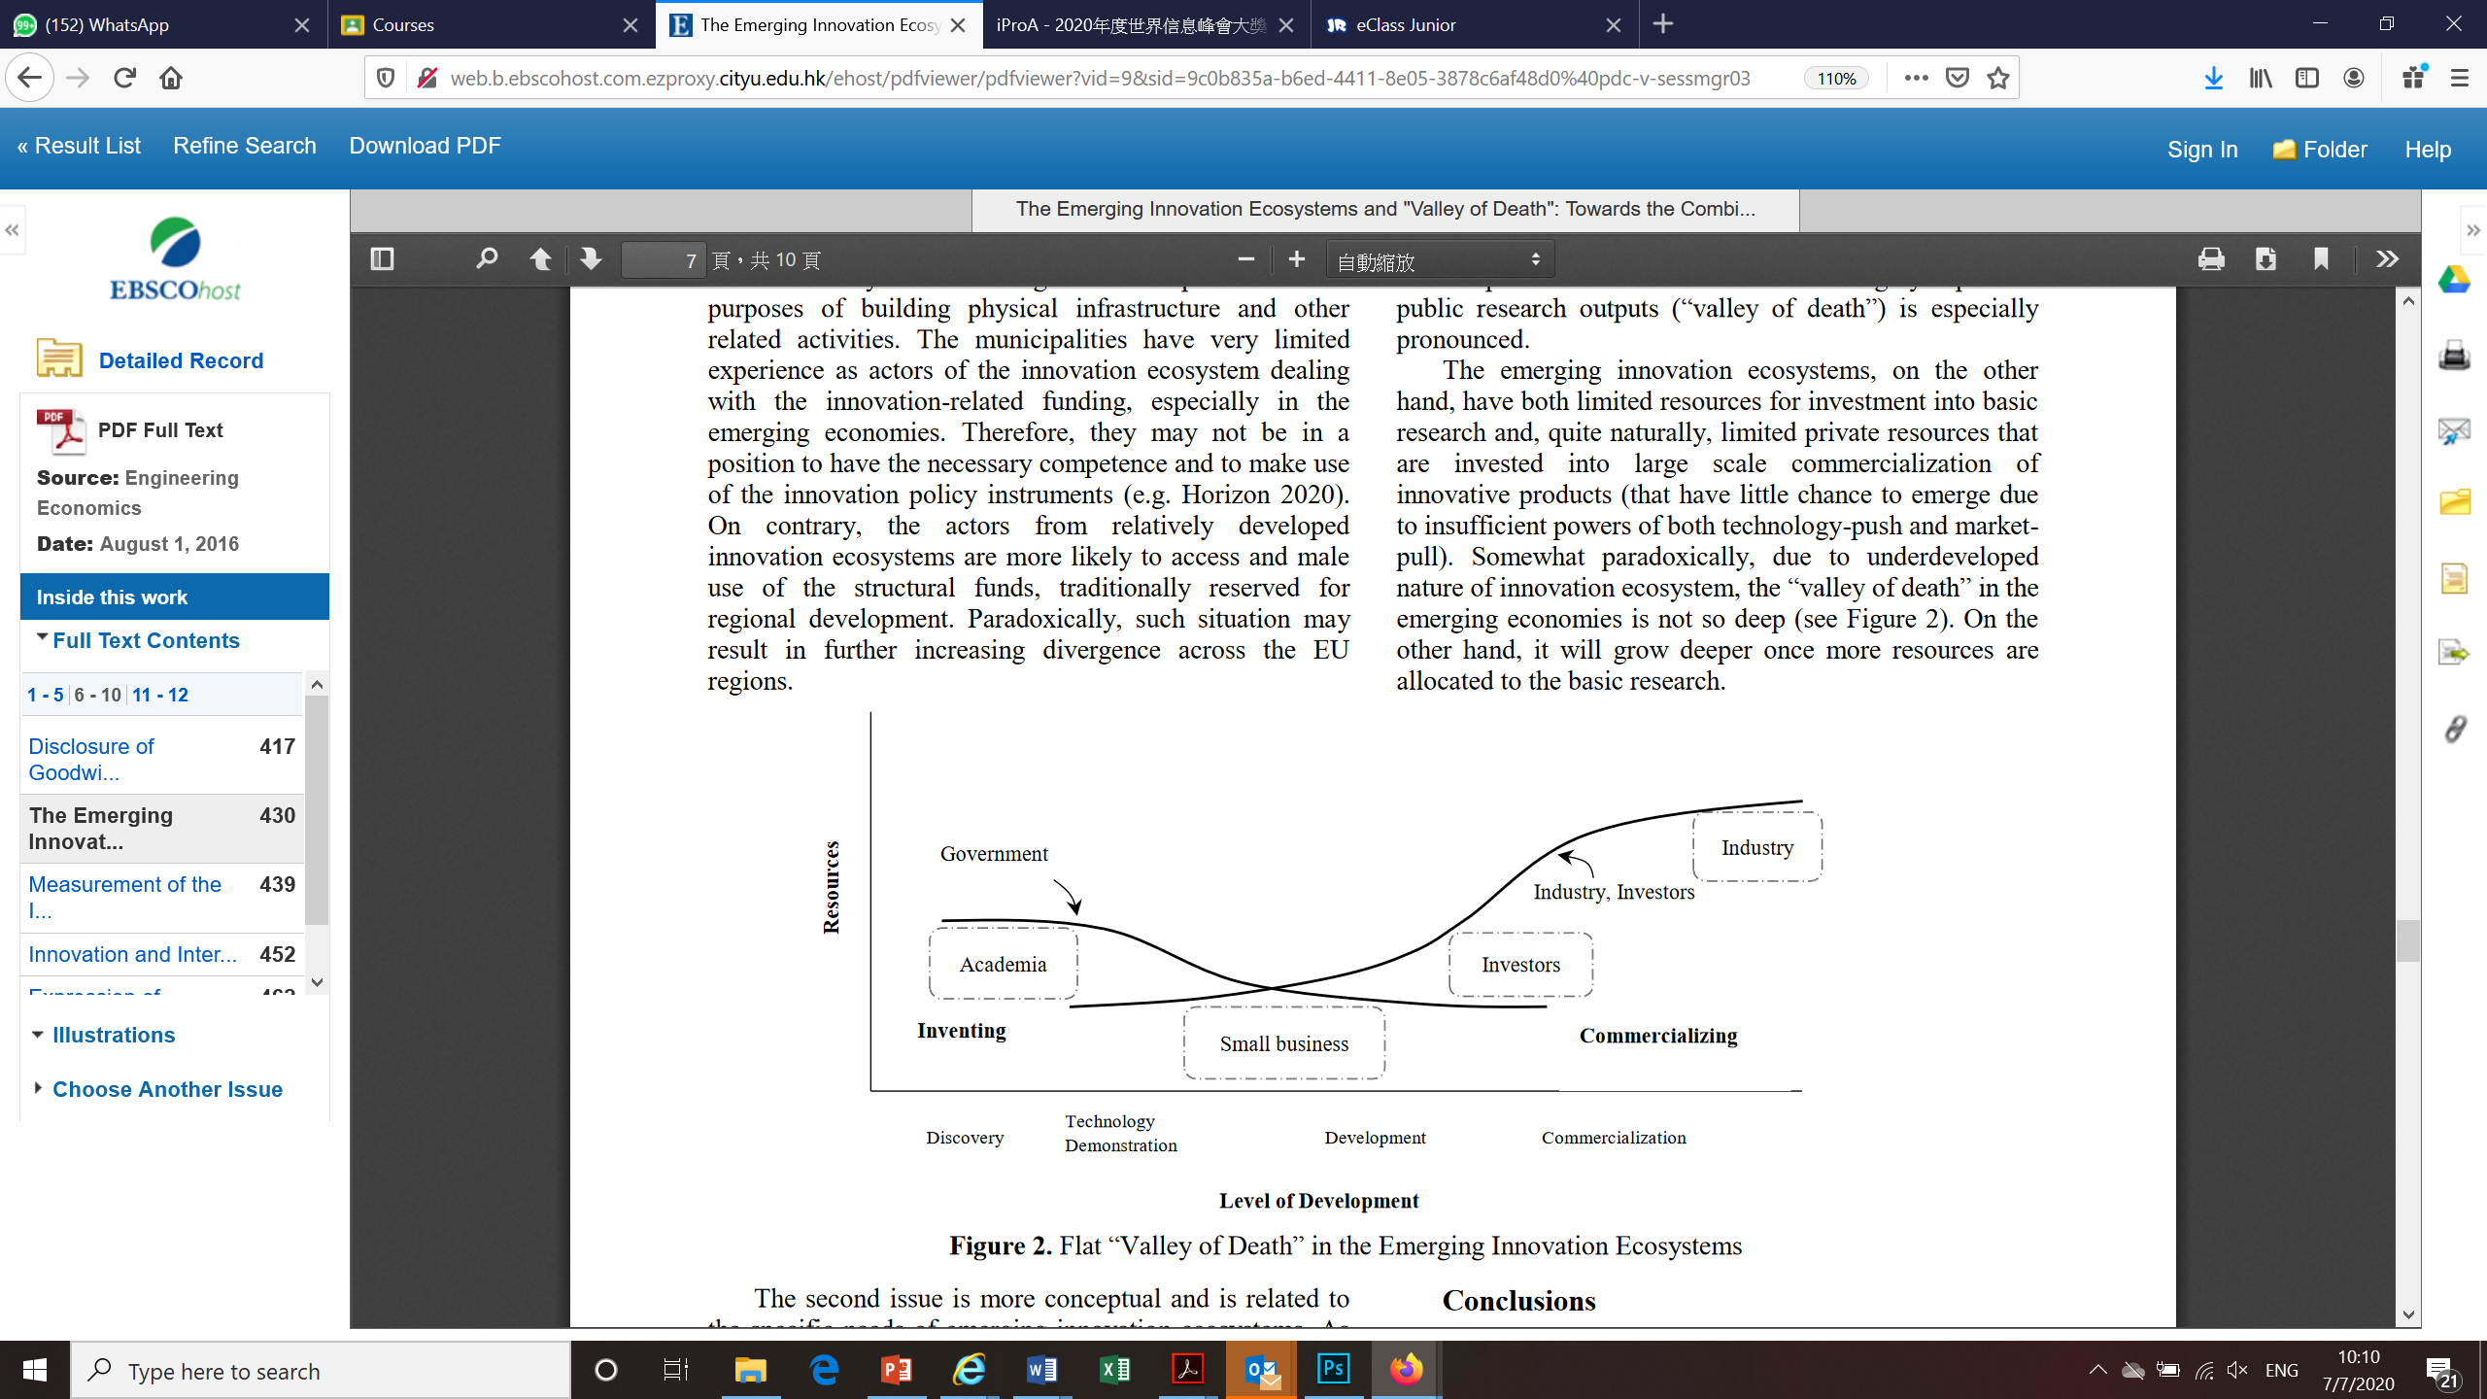

- Regional integration , regionalisation of PRD, GBA, cities cluster etc.

City cluster is commonly used by the government in pushing up the development of innovative and technology industry and promoting entrepreneurial culture. The clustering of start-ups can create a critical masses and self-sustaining value chain. Silicon Valley and Kyoto cluster are two famous examples. Lbata-Araens (2009) found that the interaction of innovative coalitions, entrepreneurial strategic support networks and entrepreneurial culture are driving force for Kyoto city cluster.
Fu (2012) found that the institutional first-over advantage, competitive and diversified firms and interactive learning mechanism have contributed to the regional innovation systems of Shenzhen. Under the impetus of globalization and regionalization, Chen (2017) claimed that regional integration of the Greater Bay area should be the joint efforts of government and the market so as to strengthen the functions of cities and have clear positioning of different industries.

- The Sheffield’s AMRC Model

According to the website of the AMRC, The Advanced Manufacturing Centre (AMRC) is established by the University of Sheffield in 2001 with a collaboration of £15 million with aerospace giant Boeing. AMRC is also supported by Yorkshire Forward and the European Regional Development Fund. University of Sheffield has centuries-long history expertise in metalworking and innovation. The University of Sheffield has been a leader in metallurgy and engineering research. It has close working partnership with the industry in developing novel manufacturing techniques and technologies.
The AMRC with Boeing is a world-class centre for “industry-focused research and development of technologies used in high-value manufacturing sectors”. AMRC group gathers both specialists and expertise in the area of high-tech engineering such as “machining, casting, welding, additive manufacturing, composites, designing for manufacturing, testing and training”. AMRC is reputable for helping companies tackle manufacturing problems. AMRC is a good model to illustrate collaborative research among universities, academics and industry. AMRC group also includes the Nuclear AMRC and AMRC Training Centre. In which, the Nuclear AMRC focuses on civil nuclear sector which AMRC Training Centre which provides training to talents from apprenticeship to MBA or even doctorate level.

University of Sheffield will provide manpower, capital and equipment support to the industry through its AMRC Training and Research Centres for the industry grade of the whole industry. In addition, the university will gain equipment and capital support from the global industry giants. Small industry suppliers are tenants of AMRC and they provide technical equipment and support to the global giants with the order and loan support by the bank or financial institutions. The AMRC demonstrated the University-Industry-Research-Finance partnership in facilitate open innovation.

Figure 4 : The Advanced Manufacturing Research Centre Model of the University of Sheffield
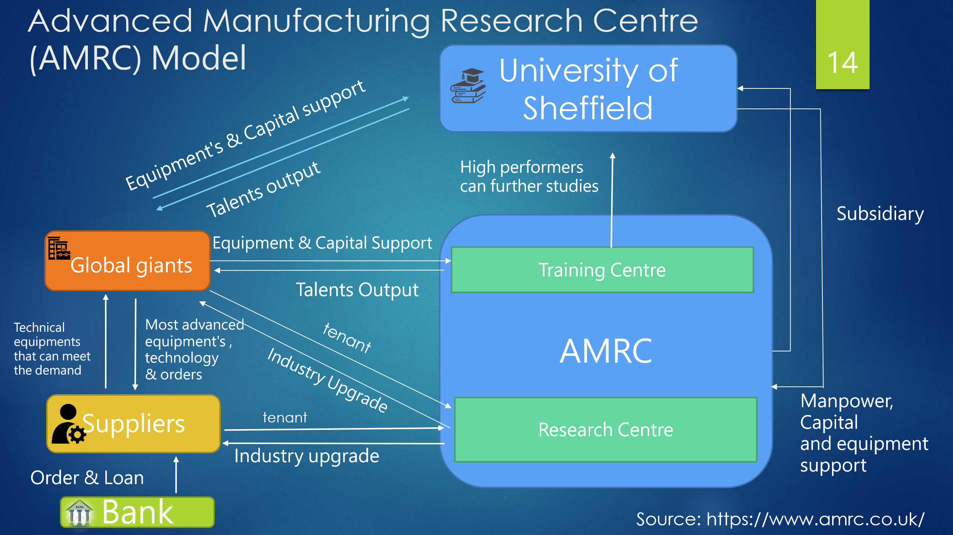

However, the role of entrepreneurial financial institutions in open innovation model and regional innovation system researches looks inadequate. To enrich the discussion of open innovation model with empirical findings, the role of entrepreneurial financial institutions in facilitating open innovation among university-industry-research institutes in terms of capital and value transfer will be studied in this thesis.
Figure 5: The Extended Open Innovation Model: Relationship among University-Industry-Applied Research Institutions- Financial Institutions
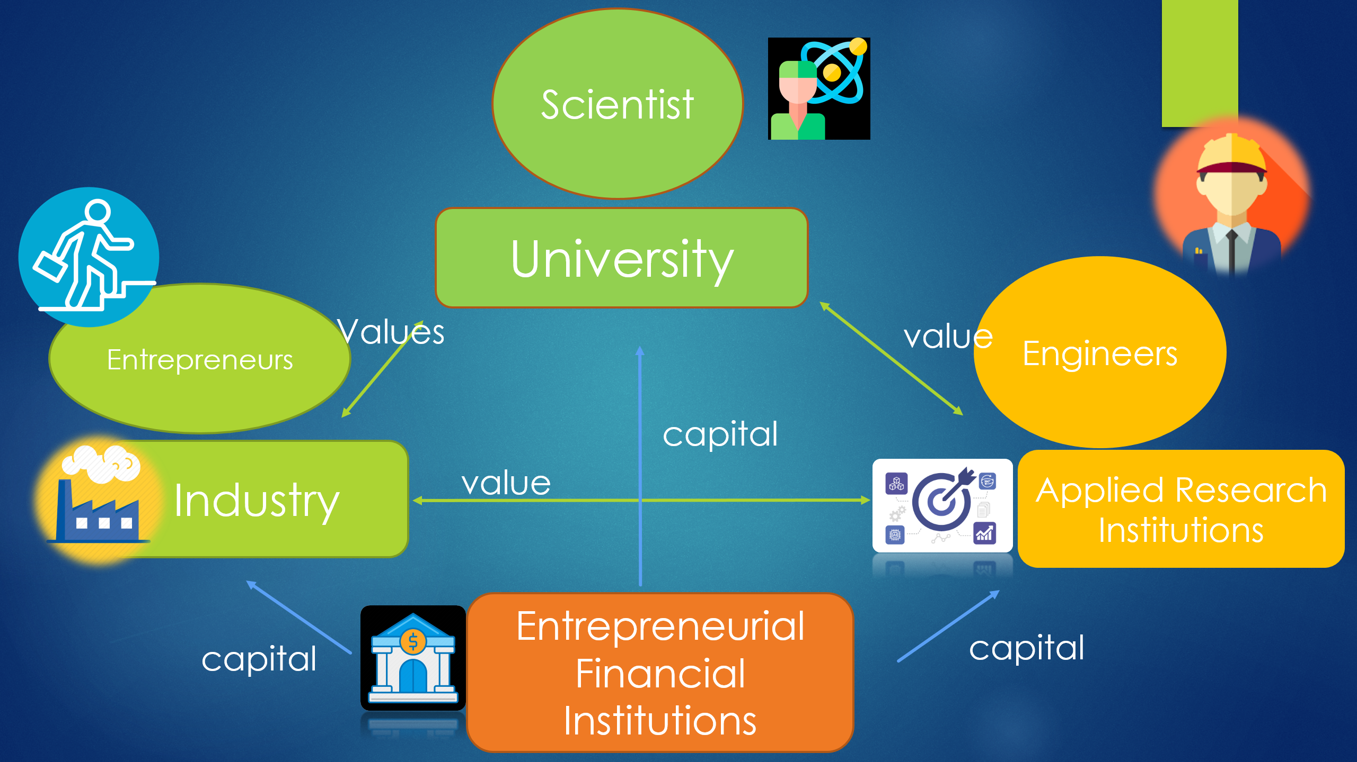

Research Hypotheses and Proposed Model:
H1 : Entrepreneurial financial institutions can facilitate the university-industry cooperation in research and development of innovation and technology industry through capital support.
H2: Entrepreneurial financial institutions can facilitate the applied research institute-industry cooperation in research and development of innovation and technology industry.
H3: University and innovation and technology industry can provide values with each other.
H4: University and applied research institute can provide values with each other.
H5: Innovation and technology industry and applied research institute can provide values with each other

Research Methodology:
Qualitative research is adopted in this study because it is very hard to use a self-administrated questionnaire to find out abstract concepts likes value and open innovation. It is also difficult to expect respondents from the business sector to complete a long and complicated self-administrated questionnaire. As a result, I will send invitation letters or emails to targeted respondents to invite them to join an one-hour hour one-to-one interview or two-hour focus group interview. The focus group interview is targeted for innovation & technology companies because more insights can be gained through the interaction of industry players.

My targeted respondents or interviewees would be from 4 major sectors. Firstly, respondents from universities in Hong Kong and Shenzhen and especially for those related to knowledge transfer department or centre of entrepreneurship. It is expected to get four respondents in this category. Secondly, I would identify respondents form the applied research institutes in both Hong Kong and in Shenzhen For example the Applied Science & Research Institute of Hong Kong, the LCSM and some higher-education research institutes in Shenzhen are my targeted interviewees. Thirdly, about fifteen to twenty innovation and technology companies in Hong Kong and Shenzhen are invited to join the one-on-one interviews or the focus group. Fourthly, entrepreneurial financial institutions in Hong Kong and Shenzhen such as angel investors, bank, venture capitalists etc. will be interviewed and the expected sample size is 6.

Sampling:
Since it is very hard to define the population pool of innovation & technology companies in both Hong Kong and Shenzhen as a sampling frame, non-probability sampling is adopted. In other words, snowball and convenience sampling will be used to increase the response rate and interviewees are located through my personal network or referral by respondents.

Operationalization of variables:
In my research, three variables are measured, namely, open innovation, capital and values, Open innovation is measured by acquisition of external and internal knowledge such as types research & development activities conducted by the firm, IP licensing , recruitment or training of talents, degree of technology disclosure, commercialisation of research projects, advices on projects commercialisation, advices on academic projects, technology spin-off etc. Frequency of such innovative activities in the past 3 years will also be studied. Secondly, capital is measured by the amount of funding support, percentage of shares purchased, stages of fundraising in the past 3 years and so forth. Thirdly, with reference to the research of Aranha et al (2015) in value creation, values are measured by industry know-how & extent of exchange (by Likert scale); personal network, interorganizational network, R&D related knowledge etc. brought to the counter-part ; frequency of exchange with counter-part the past 3 years.

My proposed extended model will testify the relationship of four types of actors, namely, entrepreneurial financial institution, university, applied research institutes and industry players. In which, entrepreneurial financial institutions refer to venture capitalists, angel investors and university refers to tertiary institutions in Hong Kong and in Shenzhen. Applied Research Institutes means those university related research institutes or government related research institutes such as ASTRI in Hong Kong and Shenzhen Institutes of Advanced Technology.

Data Collection:
Primary and secondary data will be collected in my thesis. Primary data would be collected from questionnaire for individual interviews and focus group. To complement with those data which are unable collected through formal interviews or focus group, informal talks will adopted to collect more data for analysis. Probing techniques will be adopted in the individual interview and focus group so as to facilitate data collection. On the other hand, secondary data would be collected through the innovation and technology industry reports, related GBA research reports, university reports about commercialisation of research and development projects, government report and statistics and so on. .

Data Analyses
With reference to the study of quadruple helix relationships of university technology commercialisation by McAdam et al (2016), cross-case analysis will adopted to compare the commonalities and differences of different groups will be used. My research will divided the innovation and technology enterprises into three major groups. Group 1 includes those innovation & technology enterprises got the support from financial institutions successfully. Group 2 includes innovation & technology enterprises who failed to get the support from financial institutions. Group 3 includes innovation & technology enterprises without getting the support from financial institution intentionally. Group 3 also serves the function of control group. The feedback of respondents from university, research institute, entrepreneurial financial institutions will be used to verify and supplement the cross-case analysis.

Table 1: Cross-case comparison matrix:
Group 1: I&T enterprises got the support from financial institutions successfully | Group 2: I&T enterprises failed to get the support from financial institutions | Group 3: I&T enterprises without support from financial institution intentionally (control group)
Group 1A – Shenzhen Enterprises having partnership with  University / research institute in mainland | Group 2A – Shenzhen Enterprises having partnership with  University / research institute in mainland | 3A – Shenzhen Enterprises having partnership with  University / research institute in mainland
1B – Shenzhen Enterprises having partnership with  University / research institute in HK | Group 2B – Shenzhen Enterprises having partnership with  University / research institute in HK | Group 3B – Shenzhen Enterprises having partnership with  University / research institute in HK
Group 1C – Shenzhen Enterprises without having any partnership with  University / research institute | Group 2C – Shenzhen Enterprises without having any partnership with  University / research institute | Group 3C – Shenzhen Enterprises without having any partnership with  University / research institute
Group 1D – HK Enterprises having partnership with  University / research institute in mainland | Group 2D – HK Enterprises having partnership with  University / research institute in mainland | Group 3D – HK Enterprises having partnership with  University / research institute in mainland
1E – HK Enterprises having partnership with  University / research institute in HK | 2E – HK Enterprises having partnership with  University / research institute in mainland | 3E – HK Enterprises having partnership with  University / research institute in mainland
1F – HK Enterprises without having any partnership with  University / research institute | 2F – HK Enterprises without having partnership with  University / research institute | 3F – HK Enterprises without having partnership with  University / research institute
Preliminary Observations:
Table 2 : Status of Innovation Performance of Hong Kong and Shenzhen
 | Hong Kong |  |  |  |  |  |  |  |  |  |  |  | Shenzhen
 | 2014 | 2015 |  |  | 2016 |  | 2017 | 2018 |  |  |  |  | 2014 | 2015 |  |  | 2016 | 2017 | 2018
Demographic and Socioeconomic#
GDP per capita (nominal) (current USD) | 40315.3 | 42431. 9 |  |  | 43734.3 |  | 46220.5 | 48717.3 |  |  |  |  | 21147.6 | 22348.2 |  |  | 23681.6 | 25904.8 | 26815.9
Human Capital in R&D#
Total R&D Personnel (FTE) | 29169 | 30110 |  |  | 31282 |  | 32355 | 33576 |  |  |  |  | 164103 | 172608 |  |  | 198556 | 239606 | 301839
Total R&D personnel per '000 labour force | 9.3 | 9.7 |  |  | 9.6 |  | 10.1 | 10.4 |  |  |  |  | 6.33 | 6.23 |  |  | 6.62 | 7.07 | 8.51
Gross Domestic Expenditure on R&D (GERD)#
GERD as a percentage of GDP | 0.74 | 0.76 |  |  | 0.79 |  | 0.8 | 0.86 |  |  |  |  | 3.89 | 4.07 |  |  | 4.20 | 4.34 | 4.80
GERD - performed by higher education % | 51.60 | 52.27 |  |  | 52.10 |  | 50.93 | 50.44 |  |  |  |  | 1.18 | 0.84 |  |  | 0.66 | 0.91 | 0.39
GERD - performed by business enterprise % | 44.46 | 43.75 |  |  | 43.26 |  | 44.23 | 44.87 |  |  |  |  | 93.92 | 94.08 |  |  | 94.34 | 92.61 | 93.75
GERD - performed by government % | 3.93 | 3.97 |  |  | 4.64 |  | 4.84 | 4.69 |  |  |  |  | 4.61 | 4.86 |  |  | 4.84 | 6.23 | 5.77
Education*
Government expenditure per tertiary student as % of GDP per capita (%) | 24.59 | 23.32 |  |  | 24.33 |  | 23.05 | 24.20 |  |  |  |  | 13.00 | 10.05 |  |  | 13.02 | 13.74 | 14.39
Government expenditure on education as % of GDP (%) | 3.57 | 3.26 |  |  | 3.29 |  | 3.31 | 3.32 |  |  |  |  | 2.00 | 1.60 |  |  | 2.07 | 2.26 | 2.41
Science & Technology Outcomes*
High-technology exports (% of manufactured exports) | 11.41 | 12.32 |  |  | 13.50 |  | 61.56 | 64.65 |  |  |  |  | 55.34 | 60.45 |  |  | 54.80 | 48.80 | 54.13
Patent applications, residents | 192 |  | 239 | 233 |  | 324 |  |  | 314 |  |  | 82254 |  |  | 105481 | 145294 |  | 177103 | 228608
References:
1 CNY = 0.141458 USD
UIS Statistics (http://data.uis.unesco.org)
# data were obtained and calculated from http://data.uis.unesco.org and Shenzhen Statistical Yearbook 2019
* data were obtained and calculated from http://data.worldbank.org and Shenzhen Statistical Yearbook 2019

According to the innovation performance of Hong Kong and Shenzhen, the GDP on R&D (GERD) input in Shenzhen is mainly contributed by business enterprises and there is room for more cooperation with the university. On the other hand, the GERD contributed by Hong Kong is mainly contributed by government and higher education institutes, more cooperation with the innovation and technology industry is expected.
Shenzhen-Hong Kong Innovation Circle program was first proposed in 2007 to promote the cooperation of innovation and high-tech industry in Shenzhen and Hong Kong. It is a bridge for Chinese high-end corporation to the international markets and improve the research and development strengthen of both cities. Mainland high-tech firms are encouraged to collaborate with Hong Kong universities in commercialization, productization, mass production and marketization. After more than one decade of effort, Shenzhen has already moved from “copy-cat” (shānzhài) culture to “self-governed innovation”. Technology firms do not only learn from the foreign brands, they even develop new features themselves. For example, Tencent’s We Chat was named as a replica of Whatsapp before. After years of modification, We Chat can develop functions not available in Whatsapp such as electronic payment, red packet, e-government services and even health check-ins. The development of internet finance of Shenzhen is even faster than that of Hong Kong. We Bank, the first virtual bank in China was established in 2014 but the first virtual bank in Hong Kong was only launched in 2019. Nowadays, Shenzhen is viewed as the one of the stepping stone for Hong Kong firms to enter the China Market.
With the preferential and convenient policies for Hong Kong firms such as tax benefits and support funds through the Guandong Free Trade Zones and the GBA Outline Development Plan, more cooperation between university-industry-research institutes between Hong Kong and Shenzhen is expected. Furthermore, in the past 5 years, different policies and measures are issued to aid Hong Kong innovative youth and start-ups to enter the mainland market such as the innovative carrier polices, 36 measures for Hong Kong youth in 2019, 26 measures to facilitate financial cooperation in 2020, facilitating Hong Kong professionals such as solicitor, tax planners, architects, housing manager, engineers and social workers to practice in GBA etc. Recently, there is further release of CEPA to assist Hong Kong engineers to participate in mainland construction projects and in which, Qianhai and Heqin have specific measures to assist Hong Kong engineers to engage in their local civil engineering or building projects.
In fact, The Hong Kong University, The Chinese University of Hong Kong, The Hong Kong University of Science and Technology University etc. have already set up their Shenzhen Campus. Their Shenzhen teams actively searched collaboration with mainland enterprises especially in the science and technology aspects. The Hong Kong Science and Technology Park, Cyberport Management Limited and the ASTRI of Hong Kong have initiated cross-border technology industry partnership in the Greater Bay Area. In order to fuel industry upgrade and digital economy restructuring, there is a demand for silicon valley-like entrepreneurial financial institutions in major GBA cities. More university-industry-research institutes partnership is expected to build GBA as “an international first-class bay area for living, working and travelling in 2035”.

Expected Findings:
Entrepreneurial financial institutions can facilitate the valuation of intellectual property (IP) , commercialisation of IP and IP trade & enhance University-Industry-Research collaboration
Instead of Technology transfer model – push from academia & research to industries
High-tend industry development should be “pulled” by industry, academia and research should serve the industry’s needs

Limitations :
Open innovation is a dynamic process. Involved parties with vested interest in the open innovation model may have concern in knowledge transfer and talents transfer due to loss of control. Furthermore, external innovation and university-research-industry collaboration and public-private partnership takes time. Mutual trust and interorganizational relationship needs time to build. For simplification, effect from national or local government policies, trade or industry association and customer relationship, civil society (such as crowd funding) etc. are not included in my proposed research due to resource limitation. Furthermore, since the respondents are just identified by convenience sampling, it may have selection bias.

Research recommendations:
- Promoting open innovation from organizational perspectives
University should improve its collaboration with the industry and use their strength to complement with each other. It is proposed to build the university-industry-research institutes (U-I-R) knowledge sharing platform for better resources allocation. As a result, the cooperation or collaboration of U-I-R can integrate both endogenous resources for research and development and utilize exogenous resources to improve organizational effectiveness and efficiency. U-I-R partnership can achieve the effort of knowledge sharing and diffusion; creation of new knowledge; commercialisation of research projects and achieve organic partnership. At the same time, duplicated inputs can be avoided and minimise the chance for resource wastage. University to transform the government investment to knowledge to commercialise the knowledge to solve the market pain points on one hand and create something beneficial to human society on the other hand. Traditional “push-model” that university push its research and development or talents to the market cannot ensure that both university, industry and research institute share the same goal and we should propose a mind-set change. With reference to the successful practice of the Tokyo Bay, more industry-commissioned research or joint university-industry research should be encouraged. With the alliance of U-I-R and their joint research entities, the development and flow of knowledge and technology can be promoted and facilitate the marketization of research and development projects. To foster interaction among U-I-R, intellectual property protection, trading and best practices; error tolerance culture and trial-and-error culture should be fortified. U-I-R alliance is a good platform cannot only enhance the technical capability of each player, but also induce new techniques, new equipment, new technology and new product development and breakthrough and finally contribute to the regional innovation systems of GBA.

- Supporting open innovation from talents perspective
To facilitate talents or manpower exchange, a revolving door between university, industry and research institutes should be set up. In this way, university professors are encouraged to set up spin-off companies with their research students and commercialise their projects because they are the best promoters to push their projects to the market. For example, Sense Time Artificial Intelligence application and DJI Drones are well-known university projects being commercialised. At the same time, senior managements from the industry are encouraged to conduct teaching in the university and transfer their business knowledge to the new generations in the undergraduate and taught master level. University should invite industry specialists in their curriculum design and bridge the gap with the market needs. “Revolving door” between university and industry can reduce the chance of “ivory tower” research with low market value and fuel for research and development in the public and private sector. On the other hand, policies and environment are needed to attract international research, technical and creative talents. High-end talent immigration measures and liveable environment to attract English-speaking foreign talents can help to boast the development of GBA and stimulate more innovation in the regions.

- Better positioning of universities for open innovation
University should have different position and division of labour (Xu 2018) and avoid homogenous malignant competition. In China, we have state-run national universities, provincial, municipal and private universities. Different types of universities should have different positioning. Stated owned Project 985 universities should focus on state-of-art basic research or high-end researches. Provincial and municipal universities should focus on the cultivation of applied research talents for the industry upgrade and transform traditional companies with digital companies. Private universities and higher institutions should focus on frontline technical talents training for the development of innovation and technology industry.

- Support open innovation from corporate financing perspective
From start-ups fund-raising perspectives, we need an innovative technology ecosystem composed by industry giants, small enterprises and entrepreneurial financial institutions for risk diversifications and innovative cost reduction. In this way, industry giants are first batch of customers to support the survival of start-ups. Entrepreneurial financial institutions can provide cash flow for the continuous survival of start-ups in different stages. Good financial and technical support can help to cultivate entrepreneurial culture and accumulating entrepreneurial experience in a society. With a healthy entrepreneurial environment, more engineers or talents are willing to contribute themselves as entrepreneurs and serial entrepreneurs. Entrepreneurs can bring innovation and energy to a society and drive it towards an innovation-driven economy. When the business keeps on going, they may opt for restructure of capital, re-valuation, re-distribution of shares or another round of fundraising. When the enterprises grow to a certain stage, it may choose initial public offering or merger and acquisition with appropriate partners. As a result, entrepreneurial financial associations played an important role for the innovative technology ecosystem in different stages. In addition, angel investors or venture capitals with entrepreneurial experience will bring their industry knowledge and networks to infant entrepreneurs or start-ups and help them to be more resourceful in tackling business problems and enhance their survival chances. . Since the risks for start-up loans in the new economy is very high, Silicon Valley Bank is established in 1982 to support start up in Silicon Valley. The business of Silicon Valley Bank nowadays covered different countries and regions. In addition to providing seed funding for start-ups, it also operate personal banking business for matured start-ups. Silicon Valley Bank has closed relationship with the venture capital organizations and it have more than 10-billion US dollar fund for investing start-ups at B-round. Silicon Valley Bank ranked highest Internal Rate of Return (IRR) in US with good track records. To support the innovation and technology industry of the region, start-up investment banks like Silicon Valley Bank should be established in the GBA.

Conclusion:
It is believed university-industry-research-finance open innovation model can facilitate the flow of technological resources, knowledge and talents in the innovation and technology industry in the Greater Bay and address the current weakness of lacking close collaboration. The Greater Bay Area with the position as future innovative city cluster should devise incentives to promote the financial institutions to offer more support to the innovation and technology industry so as to enhance their collaboration with university, research institutions for the benefits of innovation technology value chain.

References:
Abulrub, A.-H.G. and Lee, J. (2012). Open innovation management: challenges and prospects. Procedia - Social and Behavioral Sciences, 41, pp.130–138.

Alexander, A.T., Miller, K. and Fielding, S. (2015). Open for Business: Universities, Entrepreneurial Academics and Open Innovation. International Journal of Innovation Management, 19(06), p.1-15.

Alves Aranha, E., Prado Garcia, N.A. and Corrêa, G. (2015). Open Innovation and Business Model: A Brazilian Company Case Study. Journal of technology management & innovation, 10(4), pp.91–98.

Becker, B. A. and Eube, C. (2018) ‘Open innovation concept: integrating universities and business in digital age’, Journal of Open Innovation, 4(1), p. 1.

Brkan, I., 2010. Salepod Dobio Seed Investiciju Hrvatskih Poslovnih Anđela. (SalePod funded by Croatian business angels’ seed investment) [online] Netokracija. Available at: <http://www.netokracija.com/salepod-seed-investicija-crane-3411> [Accessed 15 Jun 2020].

Carayannis, E. & Grigoroudis, E. 2016, "Quadruple Innovation Helix and Smart Specialization: Knowledge Production and National Competitiveness", Foresight and STI Governance, vol. 10, no. 1, pp. 31-42.

Chesbrough, H., 2003. Open Innovation. Boston, Mass.: Harvard Business School Press.

Chesbrough, H., 2017. The Future of Open Innovation. Research-Technology Management, 60(6), pp.29-35.

Christiansen J., (2009). Copying Y Combinator, A Framework For Developing Seed Accelerator Programmes. MBA. University of Cambridge.

Cai, Y. and Liu, C. (2015) ‘The roles of universities in fostering knowledge-intensive clusters in Chinese regional innovation systems’, Science & Public Policy (SPP), 42(1), pp. 15–29. doi: 10.1093/scipol/scu018.

Čalopa, M., Horvat, J. and Lalić, M., (2014). Analysis of Financing Sources For Start-Up Companies Management, 19(2), pp.19-44.

Cvijanović V., Marović M., & Sruk, B. (2008). Financiranje malih i srednjih poduzeća. Binoza Press.

Džupka, P., Klasová, S. and Kováč, V. (2016) ‘Analysis of Innovative Start-Up Companies - Case of Košice Region’, Quality Innovation Prosperity / Kvalita Inovácia Prosperita, 20(1), pp. 40–56. doi: 10.12776/QIP.V20I1.641.

Etzkowitz, H. (2012) ‘Triple helix clusters: boundary permeability at university-industry-government interfaces as a regional innovation strategy’, Environment & Planning C: Government & Policy, 30(5), pp. 766–779. doi: 10.1068/c1182.

Etzkowitz, H. and Chunyan Zhou (2006) ‘Triple Helix twins: innovation and sustainability’, Science & Public Policy (SPP), 33(1), pp. 77–83. doi: 10.3152/147154306781779154.

Gassmann, O. (2006) ‘Opening up the innovation process: towards an agenda’, R&D Management, 36(3), pp. 223–228.

Gassmann, O., Enkel, E. and Chesbrough, H., (2010). The future of open innovation. R&D Management, 40(3), pp.213-221.

‌Ho, Matt. (2015) “China’s Greater Bay Area Stymied by Lack of Coordination, Review Finds.” South China Morning Post, Available at: www.scmp.com/news/china/politics/article/3094448/chinas-greater-bay-area-stymied-lack-coordination-and-research [Accessed 26 July 2020].

Ismail, Houssam S. , Rosnah M. Yussuf and Norzima B. Zulkifli (2017) ‘Factors Influencing Implementation of Open Innovation Concept in Malaysian Industries’. Journal of Advanced Management Science, vol.5, pp.35-39

Laine, K., Leino, M. and Pulkkinen, P., 2015. Open Innovation Between Higher Education and Industry. Journal of the Knowledge Economy, 6(3), pp.589-610.

"Funding from Friends Family and Fools," in The Business Professor, updated March 12, 2015, last accessed July 26, 2020, https://thebusinessprofessor.com/lesson/funding-from-friends-family-and-fools/.

Laursen, K. and Salter, A.J. (2006). Open for innovation: the role of openness in explaining innovation performance among UK manufacturing companies. Strategic Management Journal, 27(2), pp. 131-150.

Frølund, Lars, Fiona Murray and Max Riedel (2018) “Developing Successful
Strategic Partnerships With Universities” MIT SLOAN MANAGEMENT REVIEW WINTER 2018 pp. 71-79

Lenok, David H . (2019) Morgan Stanley Attempts to Bridge the "Valley of
Death" Wealth Management ; New York (Jun 4, 2019).

Klačmer Čalopa, M., Horvat, J. and Lalić, M. (2014) ‘Analysis of Financing Sources for Start-Up Companies’, Management: Journal of Contemporary Management Issues, 19(2), pp. 19–44.

Kautonen, M. et al. (2014) ‘Open Innovation in University-Industry Collaboration: Towards Mutually Benefiting Relationships’, Proceedings of ISPIM Conferences, (25), pp. 1–14.

Rabeh Morrar (2015) ‘Technological Public–Private Innovation Networks: A Conceptual Framework Describing Their Structure and Mechanism of Interaction’. Technology Innovation Management Review August 2015 (Volume 5, Issue 8)pp. 25-33

Pittz, T. G. and White, R. (2017) ‘Enduring Entrepreneurship in the Context of Public-Private Partnerships’, Journal of Strategic Innovation & Sustainability, 12(1), pp. 38–46

Vega, A., Brown, D. and Chiasson, M., 2012. Open innovation and SMEs. International Journal of Entrepreneurial Behavior & Research, 18(4), pp.457-476.

Ward, A., 2015. Biotech start-ups look to crowd funding. Financial Times, [online] Available at: <https://www.ft.com/content/54a832a4-b08b-11e4-9b8e-00144feab7de> [Accessed 26 July 2020].

Xu, Y. & Yu, C.C. 2013, "Strengths and weaknesses of Hong Kong's technology and innovation industry with reference to the extended open innovation model", Journal of Science and Technology Policy in China, vol. 4, no. 3, pp. 180-194.

Zhang, S. et al. (2018) ‘Open innovation and firm performance: Evidence from the Chinese mechanical manufacturing industry’, Journal of Engineering & Technology Management, 48, pp. 76–86.

丁焕峰，邱梦圆，谯丽，朱丹妮，叶志想，刘畅（2019）。粤港澳大湾区国际科技创新中心的推进路径与广州策略。在曾伟玉，吴业春编，粤港澳大湾区建设与广州发展报告2018（页53-84）。北京：社会科学文献出版社

尹晓水、毛宏黎、宋智 (2018) 新时代科技创新城成长路径及发展模式的研究 智能城市应用 VISER (页82-87)

马东景（2014）。开放式自主创新与实施战略探析。江淮论坛(5) 页61-65

许长青（2019）。高等教育、区域创新与经济增长：粤港澳大湾区建设中大学的角色与作用研究。在杨小蓉，张仁寿编，粤港澳大湾区发展研究（页77-87）。广州：中山大学出版社

吴婷, 李德勇, 吴绍波, 陈谦明. (2010) 基于开放式创新的产学研联盟知识共享研究. 情报杂志 3(29) 页: 99-102

周立群, 刘根节. ( 2012)由封闭式创新向开放式创新的转変.经济学家 页: 53-57.

陈劲，尹西明（2018）。建设新型国家创新生态系统加速国企创新发展。科学学与科学技术管理

曾萍，李熙（2014）。产学研合作研究综述：理论视角、合作模式与合作机制。科技管理研究(22) 页 28-32

Silicon Valley Bank Introduces "Access to Innovation" to Increase Opportunities for Underrepresented People in the Innovation Economy Oct 01, 2019 PR Newswire https://www.prnewswire.com/news-releases/silicon-valley-bank-introduces-access-to-innovation-to-increase-opportunities-for-underrepresented-people-in-the-innovation-economy-300928387.html

Chen , Yang and Tam 2017. A Study of Regional Economic Integration
陳廣漢、楊柱、譚穎等著，《區域經濟一體化研究－以粵港澳大灣區為例》。（北京：社會科學文獻出版社，2017年7月5日）。\\

‌

