Bachelor of Science Health and Social Care

Module: BMHP5015

Changemakers: Building your Personal Brand for Sustainable Employment

Component 1: Portfolio of Set Exercises

Lecturer: Olufemi Oluranti

Rumena Islam: 2329559

Content Page

Task 1 - My Personal Brand 3

Task Two - Networking and Rationale 4

Task Three - Blog 5

Task 4 - NHS Equality, Diversity, and Inclusion 6

Task Five - A letter to Myself 7

Task Six - Gantt Chart 2026 8

Task Seven - Making Changes - Report 9

Task Eight - Self-Reflection Through Gibbs Reflective 10

Reference’s 11 - 12

Task 1 - My Personal Brand
Personal branding refers to the way individuals communicate their values, skills, and professional identity. It is essential as it promotes trust, credibility, and professional recognition. This allows for supporting personal development and an enduring career progression (Montoya and Vandehey, 2008, p. 4).
I aspire to be part of communities that are dedicated to supporting and empowering the most vulnerable members of society. My personal and professional ethos is firmly grounded in the principles of integrity and trust.
As I continue to develop confidence in the workplace, particularly in high-pressure situations, I recognise that this area of weakness can be addressed through adopting a constructive mindset that views them as valuable opportunities to learning from experienced team members. This approach supports ongoing growth in confidence and the effective management of pressure. Maintaining these standards reduces the risk of falling short of the expectations placed upon me as a service provider and ensures that I consistently uphold a high level of professional practice (Harper, 2024, Pereira, 2024).
My personal brand is defined by integrity, with a firm belief that trust and continuous personal and professional growth are essential to delivering meaningful and effective practice. I have adopted a growth-oriented mindset, viewing challenges as opportunities for development rather than as obstacles to progress.

Task Two - Networking and Rationale
Networking in social and professional settings involves developing and maintaining relationships to share information, support, and resources. Professionally, it enables collaboration, knowledge exchange, and career growth. Socially, it promotes connection, trust, and community engagement (Ibarra and Hunter, 2007).

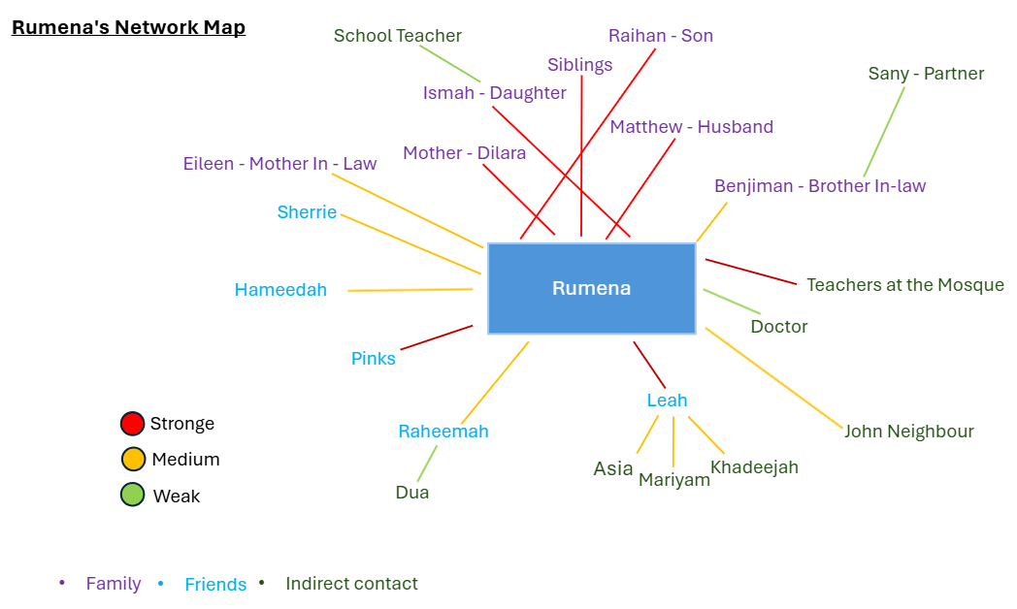
I am a relatively introverted individual with a predominantly closed network, consisting of a small number of trusted relationships that provide support, reliability, and mutual understanding. While this offers stability, it can limit my access to diverse perspectives and opportunities. To address this, I am purposefully expanding my network by engaging selectively with wider professional groups while staying aligned with my values and communication style (StellaStra, 2025).
By moving beyond familiar circles, I will strengthen bridging networks that support my career development and professional growth. These bridging connections can be strategically utilised to develop linking social capital by engaging with individuals in positions of authority who can offer guidance, mentorship, and professional insight. This approach enhances access to career opportunities, broadens professional pathways, and supports informed career progression. Ultimately, strengthening trusted relationships within my network while expanding connections across diverse professional groups enables my networking to extend beyond social interactions and become professionally focused and purposeful (Claridge, 2018, p. 1).

Task Three - Blog
Mental Health Awareness in Adolescence - Supporting Teens Together
Adolescence is a time of rapid change and self-discovery, but it can also be a period of emotional challenge. Pressures from school, friendships, family expectations, and social media can affect a young person's mental health. Raising awareness about mental health during adolescence is important not only for teenagers, but also for parents, so they can recognise concerns early and provide the right support.
Mental health includes emotional and social wellbeing. During adolescence, it is normal to experience mood swings, stress, and anxiety, however ongoing feelings of sadness, withdrawal, irritability, and changes in sleep and behaviour maybe a sign of mental health issue. Open communication between teenagers and parents is essential. When young people feel listened to without judgement, they are likely to talk about their worries and seek help (NHS, 2023, Worth-it, 2025).
Technology can play a positive role in supporting adolescent mental health when used safely. Mental health apps, online counselling services, and wellbeing trackers allow teenagers to access support discreetly and at their own pace. Online resources can also help parents learn more about mental health conditions and coping strategies. In addition, moderated online communities can reduce feelings of isolation by reminding young people that they are not alone in their experiences (Chen et al., 2024).
If parents can recognise these signs early, they can help their teenage child better understand their feelings and guide them towards the appropriate support. Mental health can be difficult to navigate, especially during adolescence, so early recognition and intervention are important for both parents and young people.
Mental health awareness in adolescence helps teenagers feel supported and understood, while enabling parents to recognise when help is needed. By combining open communication, education, and the responsible use of technology, families can work together to promote resilience and wellbeing. Supporting mental health early can have a lasting positive impact into adulthood.
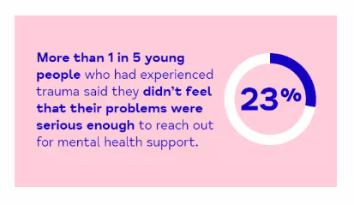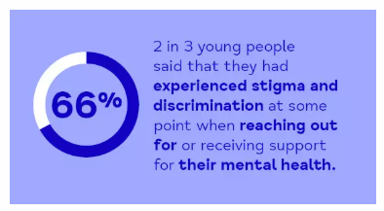
(Carlisle Eden Mind, 2026)

Task 4 - NHS Equality, Diversity, and Inclusion
- What is the primary goal of the NHS Equality, Diversity, and Inclusion Improvement Plan? To strengthen inclusion across the NHS and enhance staff sense of belonging to improve experiences at work.

- How does the NHS EDI Improvement Plan propose to tackle the gender pay gap? By analysing pay data, the NHS addresses gender inequalities through targeted actions, flexible working, and fair, transparent pay structures.

- What is meant by the term ‘intersectionality’ as used in the NHS EDI Improvement Plan? Intersectionality recognises that overlapping identities shape individual's experiences of inequality, helping the NHS create fair and inclusive policies for all staff.

- Why is it important for the NHS to create a psychologically safe work environment? Enables staff to speak up without fear, reducing stress and improving performance in line with NHS values.

- How does the NHS EDI Improvement Plan suggest improving the experience of internationally recruited staff? Structured induction programs help international staff understand the NHS, UK culture, and their roles, while ensuring equal access to development opportunities.

- What role does leadership play in advancing EDI objectives according to the NHS Improvement Plan? Inclusive and compassionate leadership strengthens EDI by creating a supportive culture where staff feel valued and deliver high-quality care.

- Identify one way the NHS EDI Improvement Plan aims to reduce health inequalities within the workforce. Line managers are encouraged to hold regular wellbeing conversations, supported by NHS health and wellbeing resources.

- Why does the NHS EDI Improvement Plan emphasise the importance of collecting and analysing data on protected characteristics? Tracking inequalities helps the NHS ensure fair access and progress in equality, diversity, and inclusion.

- Explain how flexible working policies can contribute to equality and inclusion in the NHS workforce. Flexible working in the NHS supports diverse staff, reduces barriers, and promotes wellbeing and work life balance.

- What is one strategy mentioned in the NHS EDI Improvement Plan to combat bullying and harassment in the workplace? The NHS fosters a safe, supportive workplace where staff can speak up, with boards reviewing progress annually.

Task Five - A letter to Myself
Dearest Younger Rumena,
Despite feeling physically and mentally drained, you remained committed to raising your children and making the most of the resources available. Sometimes life felt like climbing a mountain with no peak in sight, managing school runs, packed lunches, and endless activities largely on your own. Despite the challenges, you kept going each day, learning to adapt and did the best for your children. It never dawned on me this was resilience in practice.
Often you felt hopeless and exhausted, telling yourself to be strong without understanding what that meant. It was overwhelming as you pushed through each day carrying emotions you did not know how to process. When I look back, I realise you did not have the knowledge or understanding needed to address your problems, which is why I felt so stuck at the time. Once you began to gain that understanding, you were able to take steps towards learning more and positively moving forward.
I have become more self-aware and in tune with myself, especially since starting my educational journey. Learning new life concepts has helped me understand my experiences and make better sense of them. I finally realised that I needed to understand my own feelings before facing the world and discovering this was incredibly liberating. I regret being so hard on myself and wish I had been kinder and more compassionate to you.
Rumena, keep growing and learning by strengthening your emotional intelligence and resilience.
Yours sincerely Rumena.

Task Six - Gantt Chart 2026This Gantt chart outlines a career action plan for progressing toward a career in Health and Social Care. The plan begins with research and career planning, alongside investigating job opportunities in the sector. This initial stage allows me to explore potential roles, understand required qualifications, and identify areas of interest, ensuring that subsequent actions are targeted and informed.
In the following months, I will update my CV with new acquired qualifications and prepare a tailored cover letter to strengthen my applications for relevant roles. Simultaneously, I will complete Level 5 studies to maintain academic progress while gaining essential knowledge for professional practice. Continuing volunteering and seeking shadowing opportunities will provide hands-on experience, allowing me to develop practical skills, gain insight into day-to-day responsibilities, and build professional networks.
Midway through the plan, I will decide on my career path, attend job fairs, and actively apply for positions in my chosen field. Engaging in career advice, networking, and reviewing interview skills will further support my employability and readiness for professional roles. Finally, I will continue with Level 6 studies while preparing to graduate with a defined career path. I intend balance education, practical experience, and professional development, while providing a clear and achievable pathway towards a career in Health and Social Care with my plan (University of Derby, 2026).

Task Seven - Making Changes - Report
Introducing a Staff Mentorship Program to Improve Care Home Performance
As a manager of a care home, I aim to introduce a structured staff mentorship programme to support professional development, improve staff retention, and enhance the quality of care for residents. To guide this change, Lewin’s Three-Step Change Model will be used. The model includes three stages unfreeze, change, and refreeze which help organisations prepare for change, implement new practices, and ensure improvements are sustained (Harvard Business School Online, 2017). This approach provides a clear structure for successfully introducing the mentorship programme while supporting staff throughout the process.
Unfreeze
New and junior staff may feel unsupported when adapting to care home demands, leading to stress, low morale, and reduced performance. Pairing them with experienced staff will provide guidance, knowledge sharing, and emotional support. This stage focuses on raising awareness of mentoring benefits and preparing staff for the change.
Change
I will plan and organise mentor pairings while monitoring progress to ensure responsibilities are clear and staff receive adequate support. Mentoring sessions will be scheduled to avoid disrupting care routines. Open communication and strong interpersonal skills will help build trust, encourage engagement, and resolve challenges.
Refreeze
To embed the programme into regular practice, mentoring will be integrated into staff development processes and regularly evaluated for its impact on staff and resident care. Barriers such as staff resistance, time constraints, or inconsistent mentor engagement will be addressed through mentor training, aligning mentoring with existing schedules, and recognising contributions. This approach will make the programme sustainable, support staff wellbeing, and improve care quality (Skills for Care, 2022; NHS Employers, 2021).

Task Eight - Self-Reflection Through Gibbs Reflective
I will use Gibbs’ Reflective Cycle to evaluate my learning, skills, and development from this module (Athal, 2025).
Description
This module has been highly informative and has allowed me to reflect on my personality, and career goals. I have gained a clearer understanding of my strengths, weaknesses, and areas for development within Health and Social Care. The activities and discussions helped me consider how I can apply my skills in future professional practice.
Feelings
I feel encouraged by the strengths I have identified, particularly my willingness to learn and my ability to communicate openly with others. These qualities give me confidence that I can build positive relationships and provide effective support in my future career. However, I also recognise areas where I need to improve, especially in networking and gaining practical experience.
Evaluation
One positive outcome of this module is recognising the importance of interpersonal and communication skills in Health and Social Care. However, I have also realised that I need to expand my professional network and seek opportunities to gain practical experience, which will improve my employability.
Analysis
This module has increased my self-awareness and understanding of emotional intelligence in professional practice. Reflecting on my strengths and weaknesses has helped me identify areas for improvement. Networking, training, and practical experience are important steps for developing my professional skills.
Conclusion
Overall, this module has encouraged the importance of reflection, emotional intelligence, and continuous professional development in achieving my career goals.
Action Plan
I will pursue networking, volunteering, and placements as part of my employment strategy. I will also continue reflecting on my progress and using available resources to support my professional development.

Reference
- Carlisle Eden Mind. (2026) Children and young people’s training. Available at: https://cemind.org/training/children-and-young-peoples-training/ (Accessed: 12 March 2026).
- Chen, T., Ou, J., Li, G. and Luo, H. (2024) Promoting mental health in children and adolescents through digital technology: a systematic review and meta-analysis. Frontiers in Psychology, 15, 1356554. Available at: https://pmc.ncbi.nlm.nih.gov/articles/PMC10963393/ (Accessed: 12 February 2026).
- Claridge, T. (2018) Functions of social capital – bonding, bridging, linking. Social Capital Research, Dunedin, New Zealand, p. 1. Available at: https://www.socialcapitalresearch.com/wp-content/uploads/2018/11/Functions-of-Social-Capital.pdf (Accessed 01 January 2026).
- Ibarra, H., and Hunter, M. (2007) How leaders create and use networks, Harvard Business Review, 85(1), pp. 40–47.
- Montoya, P. and Vandehey, T. (2008) The Brand Called You: Make Your Business Stand Out in a Crowded Marketplace. New York: McGraw Hill Professional. Available at: https://books.google.co.uk/books?id=Keuf3qByh_IC&printsec=frontcover&source=gbs_ge_summary_r (Accessed: 19 January 2026).
- Harper, H. (2024) The 23 best personality tests in ranking order (2025 update). WorkStyle. Available at https://www.workstyle.io/best-personality-test(Accessed: 19 January 2026).
- Harvard Business School Online (2017) A 3-step framework for managing organizational change. Available at: https://online.hbs.edu/blog/post/a-3-step-framework-for-managing-organizational-change (Accessed: 12 March 2026).
- NHS Employers. (2021) Flexible working in health and care settings: Guidance for managers. Available at: https://www.nhsemployers.org (Accessed: 5 March 2026).
- NHS. (2023) Worried about your teenager? Advice for parents, NHS. Available at: https://www.nhs.uk/mental-health/children-and-young-adults/advice-for-parents/worried-about-your-teenager/ (Accessed: 12 February 2026).
- Pereira, D. (2024) Personal SWOT Analysis. BusinessModelAnalyst. Available at: https://businessmodelanalyst.com/personal-swot-analysis/(Accessed: 19 January 2026).
- Skills for Care. (2022) Workforce development and flexible working in adult social care. Available at: https://www.skillsforcare.org.uk (Accessed: 5 March 2026).
- StellaStra. (2025) Closed vs Open Networks. Available at: https://stellastra.com/closed-vs-open-networks/ (Accessed: 01 January 2026)
- University of Derby. (2026) Gantt charts. Available at: https://libguides.derby.ac.uk/develop-at-derby/self-direction-and-planning/gantt-charts (Accessed: 6 March 2026).
- University of Wales Trinity Saint David. (2025) (NHS equality, diversity, and inclusion (EDI) improvement plan). Moodle. University of Wales Trinity Saint David. Available at: https://moodle.uwtsd.ac.uk/pluginfile.php/945495/mod_resource/content/1/B2044_NHS_ED_Workforce_Plan.pdf (Accessed: 28 February 2026).
- Worth-it. (2025) Understanding and addressing teenage mental health issues, Worth-it. Available at: https://www.worthit.org.uk/blog/mental-health-teenagers (Accessed: 12 February 2026).

