Rhys David Wilson (2025642)
Module code: ACPA7002
Financial Management and Planning
McLaren Business review utilising published Financial Statements to create an in-depth ratio analysis

potential joint venture opportunity

Content

- Executive Summary

- Introduction

- Use and Limitation of Ratios

- Ratio Analysis

- Summary of Findings

- Conclusion and Recommendation

- References & Appendices

Executive Summary
In this financial report I have been investigating McLarens published financial reporting's over a period of 3 years to gain a comprehensive understanding whether McLaren is a possibility for a collaboration project. This report has also included any company developments, strategy alterations and business restructuring.
This report has found that a collaboration with McLaren is a viable option for the company and could result in profitability. McLaren has had some financial difficulties over recent years and shown massive losses and demonstrating negative profitability, however McLaren has put in place the structure going forward to potentially succeed in turning the business around via external investments, restructuring of key management, reduction of stock and selling of assets that should deliver a return on investment.
These alteration with the addition of further research and development combined with a strong business plan should see McLaren reduce company debt and recover their losses from previous financial troubles.

Introduction
This report is to highlight the financial viability of a collaboration project with McLaren Group. I will be sourcing all the data and financials to aid in the final decision to collaborate with McLaren Group based on their annual reports and published figures (McLaren Investors, 2021.), combined with any relevant company information and structuring.
The data presented in this report will be obtained from McLarens 2019 and 2020 end of year reports combined with their latest 2021 Q3 published figures found via McLarens investors website (Investors link - https://investors.mclaren.com/ ).
Using these figures to work out McLaren's key business ratios in order to get a better understanding of the company and how they are preforming. These ratios will consist of profitability, liquidity, activity, leverage, and investor ratios. This report will also take into account any future developments, company restructuring and future business developments that may affect the financials to strengthen or potentially weaken the collaboration prospective.

Use and Limitations of Ratios
Ratio analysis is a tool that is used for financial analysis of a company or individual business. It is used to visualise and extract information from their published financial statements (CFI, 2021). It focuses on ratios that reflect profitability, efficiency, financing leverage, and other vital information about a business. However, there are also several limitations to using ratio analysis and to develop a complete understanding of a company through this process it is important to fully understand the pitfalls and how to avoid them.
These are the formulas used to calculate the financial ratios, and I have used these to calculate whether McLaren is a viable collaboration partner for this project.

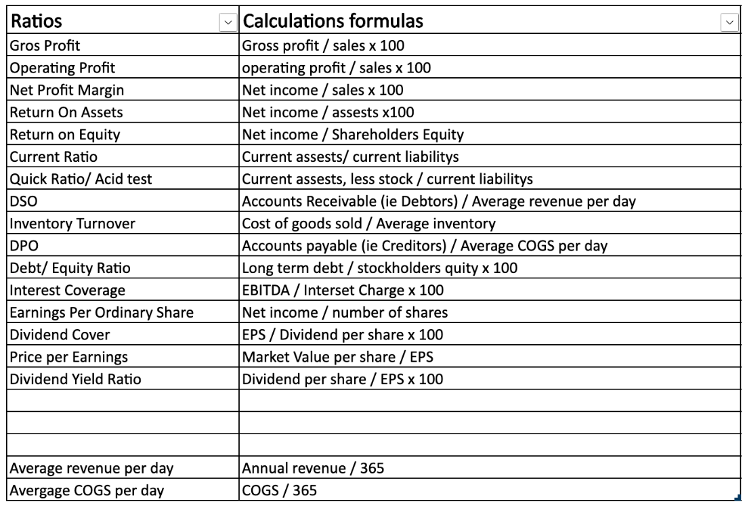

Ratio analysis limitations
The information to calculate ratio analysis of a company is gathered from data that is recorded and published by that company in their financial statements reports. It is important for the potential investors doing these financial analysis ratios are aware that this information could have been manipulated by the company's directors and management team in order to show a better result than its actual performance. Due to this potential factor ratio analysis may not accurately reflect the true performance of the company, as the misrepresentation of information will not be made clear through ratio analysis, so it is vital that all investigations into potential investment and collaborations with companies using ratio analysis is also met with an Indepth research report.
One of the limitations of ratio analysis is due to the fact that it uses published figures, therefore these figures are historical data about the company. Potential investors could miss the most recent changes and latest future developments relying on the historical published data to guid their decisions and understanding of the company whilst not seeing a true picture of the current and future company performance.

Another pitfall could be alterations in the company's accounting policies and procedures If the company has changed the way it handles its accounting the new systems could affect financial reporting and result in big differences in data. The financial ratio analysis data reported in the new method might not be comparable to the results recorded before the latest changes. However, these changes can usually be found under the notes section in the company's financial statement report.

Operational changes are a key factor for potential investors to research before a decision is made to invest or not a company could massively alter its operational structure, from their current supply chain to the actual products they currently offer. When large operational changes occur between financial statements being published a comparison of different quarter reports before and after the operational change could potentially lead to false data being produced about the true performance of that company and the viability of investment.

Seasonal factors may also play a part and need to be adjusted for if the company does a large amount of its business at certain times of the year. This could potentially result in limitations of ratio analysis and may lead to false interpretations of data.

Another thing for potential investors to be aware of is that a company's financial statements are released periodically throughout the year in four quarters, and there are time differences between each release due to collating and publishing that data. If inflation occurred during these time differences between publications, then actual current prices are not reflected in those published statements. Making different periods not comparable and they will need to be altered to allow for the different rates caused by the inflation.

Ratio Analysis
Once completing my ratio calculations these are my results, these results clearly show a turnaround in profitability and an improvement across all ratios.
These ratios combined with further research into McLarens future plans and developmental changes will give a clear picture whether they are a viable company for a collaboration and joint venture project.

Profitability Ratios |  | 2019 | 2020 | Q3 (2021)
Gross Profit Margin |  | 30.42 | 18.64 | 31.76
Operating Profit Margin |  | 1.67 | 38.36 | 4.8
Net Profit Margin |  | -2.3 | -83.09 | 13.9
Return on Assets |  | -1.91 | -38.3 | 4.63
Return on equity |  | -13.19 | -207.72 | 10.26
Liquidity Ratios
Current Ratio |  | 0.81 | 0.84 | 1.837
Quick Ratio/ Acid test |  | 0.61 | 0.66 | 1.32
Activity Ratios
DSO |  | 97.47 | 159.71 | 164.14
Inventory Turnover |  | 6.73 | 5.56 | 2.44
DPO |  | 263.92 | 356.71 | 254.49
Leverage Ratios

Debt/ Equity Ratio |  | 3.02% | 2.44% | 0.75%
Interest Coverage |  | 34.61% | -69.57% | 67.48%

The research I have carried out into McLaren over their 2020 reporting year is that they have reduced overhead running costs by £56 million, capital expenditure was also reduced by £81 million 26% overall to £238 million. In reports published by McLaren they had stated that they had planned to reduce production in the 1st half of 2020 to flush excess inventory out of the dealer network. The massive reduction in overhead costs has been achievable due to the Covid 19 global pandemic resulting in all dealerships and sales floors being closed helping McLaren meet and overachieve their forecast goals on running costs and overheads (CarBuzz, 2021). McLarens total group revenue for 2020 came in at £772.8 million, which was down 48% against 2019 mostly as a direct result of the COVID –19 global pandemic. McLaren also had to make a quarter of its staff redundant and seek an additional £150 million in emergency funding in 2020 so it could remove a portion of its outstanding debt. (www.cityindex.co.uk, 2021.).

Profitability Ratios-

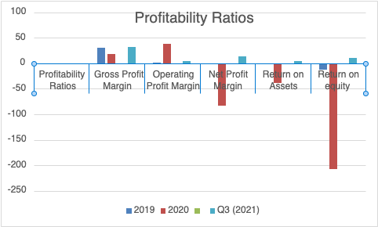

During 2020 McLaren reduced their dealership stocking levels by over half of what they had in stock in 2019. The big benefit of McLaren reducing this stock was the reduction in the funds McLaren had been using to support sales to stock their dealerships this dropped by £92 million in 2020 to £64 million (CarBuzz, 2021). This reduction leaves McLaren in a much better financial position for the future, and more flexibility and affordability with production turning towards the new models that they will have in production over the next several years. During the Covid 19 Global pandemic McLaren was able to achieve the reduction in dealer inventory much faster and more efficiently than previously predicted.

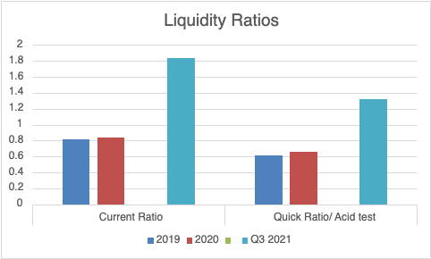
McLaren also has a large amount of long-term debt of over £6.3 million that will need to be settled. They have recouped some cash through the lease and sale of their Headquarters and assets raising an additional £170 million. However, they will be hit with another large bill in the form of their future product developments costs forecast at £802 million. McLaren has acted towards solving some of their financial issues however by restructuring their management team with some new additions, over a twelve-month period McLaren have acquired Paul Walsh in the form of an Executive Chairman, Kate Ferry as the new Group Chief Financial Officer, & Gareth Dunsmore as Chief Marketing Officer all as part of their new team at the McLaren Automotive Group. This would suggest that these changes have resulted in the recent changes to sales and stocking levels at dealerships along with new incentivisation schemes for retailers and customers.

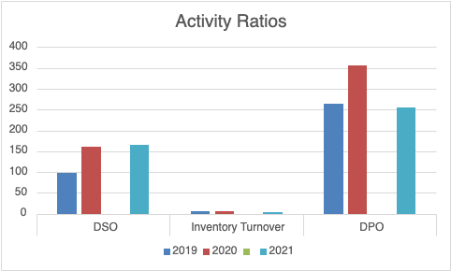

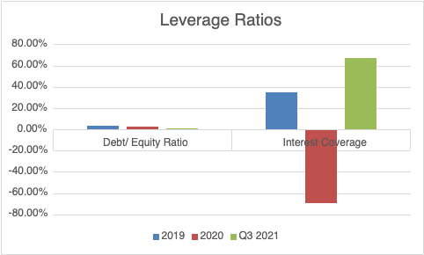
I was unable to extract enough data to form McLaren's Investor ratios as they do not publish these figures and the results would be inconclusive.

McLaren also had some potentially troubling issues and reported that cash flow from their operations was in at a minus £220 million which was a big drop from a positive position of £451 million in 2019. Also, McLaren reported a working capital outflow of £223 million additional to 2019, from new models being produced and loss in sales due to covid future working capital could be an area of concern. Operating profit shows a negative £291 million for 2020 and is down from a positive £25 million achieved in 2019. McLaren ended 2020 with total Liquidity of £105 million, Cash on hand of £67 million and long-term Debt of £630 million.
There are some positives to be seen in McLaren's Formula 1 Team despite initial losses they have been a continued valuable profit contributor. However, the fact that The F1 Team has been sold to a US based consortium in return for an investment of £185 million over a three-year period. As a result of this investment, F1 Team is no longer a part of the McLaren Group’s financial results. From an accounting perspective, the F1 Team will now be treated as a joint venture so this needs to be considered when viewing the financial statement for investment and collaboration purposes.
McLarens core business is their two-seater sports and super car offerings and their commitments to stay ahead of their competition in terms of research and developments they are honouring this in their new business Plan and are committed to their industry leading 20 to 25 percent of their turnover that is to be invested in to research and development for their future products and developments of new technologies. Over a six-year term, this will represent a total investment of around £1 billion and McLaren has stated that this will lead to the launch of 15 new cars and system advancements.

Summary of Findings
McLaren is not currently profitable. The company saw pre-tax losses increase to £312.9 million in 2020 as the coronavirus pandemic caused sales fall by more than 60% to £389.2 million. (www.cityindex.co.uk, 2021.) However, McLaren has a good range of offerings and has made some positive moves recently with their change in management and business model regarding its approach in stocking levels however McLaren still has a large amount of debt that has been created by extensive product development costs and dealer incentives. Now that McLaren has hired a new Chief Financial officer in 2021 this shows that they have identified their problems and recognised the challenges they face to overcome their debt issues. There was also reported issues of complaints about McLaren's build quality during 2018 and 2019 (by, 2021) that will have a negative effect on potential new and existing customers.
There will also be a long delay for McLaren's next Ultimate Series cars as they are not due for sale until 2025 so McLaren will have to find new and inventive streams of revenue to bolster sales until this new line arrives and starts to show a return on investment.

However, now with McLaren turning towards its new hybrid supercar, the Artura, steady sales through its latest offering should help to stabilise their core business for the next couple of years through a strong marketing campaign and competitive price point (cars.mclaren.com, 2020.).
To eradicate the current stigma of the poor McLaren build quality, the Artura will have to be scrutinised though every step of the production phase to ensure the highest quality is achieved. McLaren automotive is situated in a highly competitive market where there are many luxury car brands with different offerings for customers to choose. The global luxury car market was valued at $495.65 billion in 2018 and is projected to reach $733.15 billion by 2026 (Mordor Intelligence, 2021). McLaren has some large competitors to contend with that dominate the market such as Audi, Land Rover, BMW, Jaguar, Mercedes Benz, Porsche, Maserati, Pagani, Koenigsegg, Aston Martin, Ferrari, Lamborghini, Bentley, Bugatti, Rolls Royce (Luxatic, 2021).
McLaren will be gaining a large investment of £550 million from Saudi Arabia's Public Investment Fund and investment company (Campbell, 2021), Ares Management where as a large portion of will be given into McLaren in preference shares and equity warrants and the remaining investment will be from existing shareholders and convertible preference shares this will enable McLaren to repay their previous loan amount from the year before with favourable terms.
McLaren's largest majority shareholder Bahrain's Mumtalaket sovereign investment fund that has been an Investor in McLaren in previous years now Combined with this new large equity investment will greatly help McLaren turn things around financially and help them achieve future goals and developments with research plans. This investment has already shown positives in McLarens financial reports from their first business quarter of 2021, revenue has increased by 145% over the same period in 2020
With the addition of McLarens new management structure they have announced a new business plan named Track 22 and with the launch of this new six-year Business Plan McLaren plan on launching 15 new cars within their existing ranges including alternative model platforms and also a pledge to develop a new engine architecture that will debut towards the end of this business plan. With this new business plan also, McLaren has stated that at least 50 percent of their new offerings will feature hybrid technology. McLaren has also stated that their engineering team have begun working on a prototype that will be used to evaluate the possible benefits of a fully-electric powertrain to be used in one of McLarens Ultimate Series cars. (Sytner.co.uk, 2022).

Conclusion and Recommendation
McLaren did well in 2020’s extremely challenging environmental and economical market situation. McLaren made a several vital changes and managed to survive the complete market shut down brought on by the covid –19 global pandemic, brought in new key members to their management team all to prepare McLaren for a more successful future. However, the financial reports indicate that although McLaren is currently in a stable position, the company's future is extremely dependent on the long-term debt and the restructuring of that debt. McLaren has done well using the global shutdown to reduce their dealer inventory back down to a healthy level. The next goal will be McLaren regaining the buyers trust with their build quality and reliability along with a strong marketing campaign.
As it stands McLaren’s revenue is expected to show an annual growth rate of 10.31%, resulting in a projected market volume of £253.3 million by 2025 (www.cityindex.co.Uk, 2021.).
After the enormous success McLaren saw with the sale of its hybrid-powered McLaren P1, McLaren has confirmed that at least 50 percent of its cars will feature hybrid technology by the end of the track 22 six-year business plan.
Based on McLaren's financial data and the research I have carried out it shows that they have begun to turn the company around and are generating profits with their new business plan and management team so I believe they would be a good candidate for a joint venture and collaboration project. If they continue on their current path with what they have forecast with their new developments research projects and financial gains they should deliver a good return on investment over the project's lifecycle.

References & Appendices
Campbell, P. (2021). McLaren raises £550m and adds Saudi Arabian wealth fund as investor. Financial Times. [online] 16 Jul. Available at: https://www.ft.com/content/443ec936-8426-4f3f-8a4f-f5b78dd767dc.

‌ CarBuzz. (2021). McLaren’s Latest Investor Brings Huge Sigh Of Relief. [online] Available at: https://carbuzz.com/news/mclarens-latest-investor-brings-huge-sigh-of-relief [Accessed 17 May 2022].

cars.mclaren.com. (2021.). McLaren Artura - New High-Performance Hybrid Supercar | McLaren Automotive. [online] Available at: https://cars.mclaren.com/gb-en/artura.

CFI (2021). Limitations of Ratio Analysis - Ratios are Popular, Learn About the Problems. [online] Corporate Finance Institute. Available at: https://corporatefinanceinstitute.com/resources/knowledge/finance/limitations-ratio-analysis/.

Gegumall. (2021). mclaren poor quality - Gegu Mall. [online] Available at: https://gegumall.com/mclaren-poor-quality/ [Accessed 24 May 2022].

Luxatic. (2021). These are the 20 Best Luxury Car Brands of 2021. [online] Available at: https://luxatic.com/best-luxury-car-brands/.

McLaren Investors. (2021.). Investors. [online] Available at: https://investors.mclaren.com/investors.

Mordor Intelligence (2021). Luxury Car Market Share, Growth, Size, Analysis, Forecast (2019-24). [online] www.mordorintelligence.com. Available at: https://www.mordorintelligence.com/industry-reports/luxury-car-market.

Sytner.co.uk. (2022). [online] Available at: https://www.sytner.co.uk/mclaren/news/mclaren-launch-six-year-investment-programme-/ [Accessed 24 May 2022].

www.cityindex.co.uk. (2021.). A guide to McLaren Group: will McLaren IPO in 2021? [online] Available at: https://www.cityindex.co.uk/market-analysis/mclaren-ipo/.
‌

Appendix A- Ratio calculations
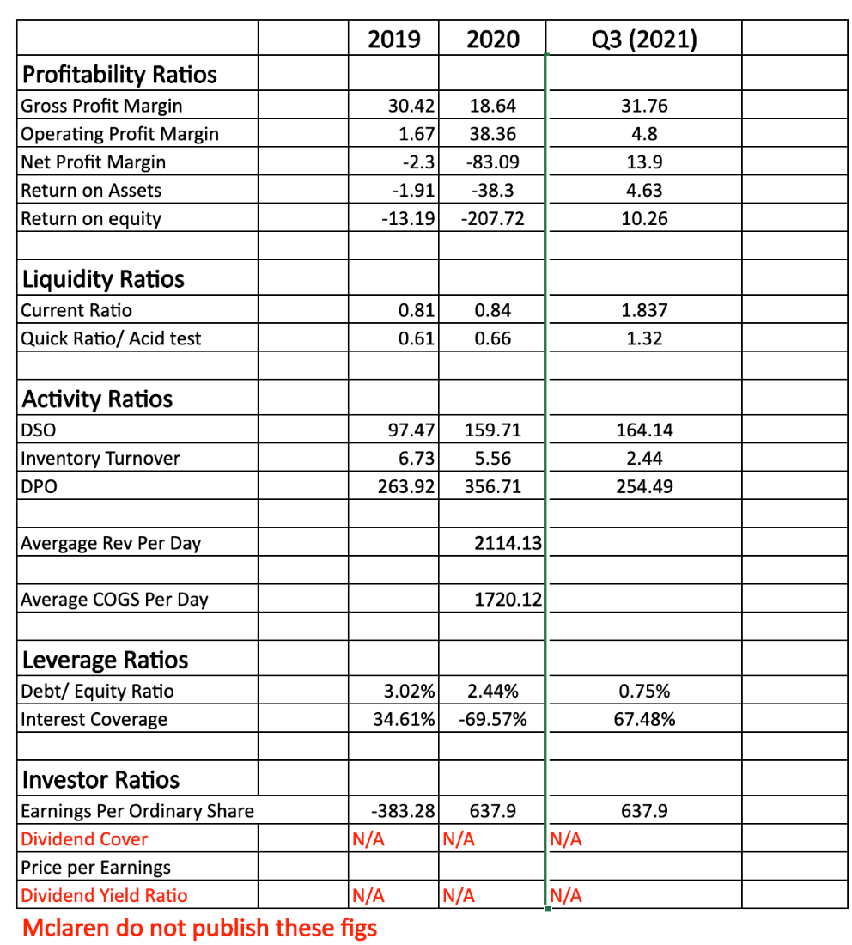

Appendix B – Ratio visual sums
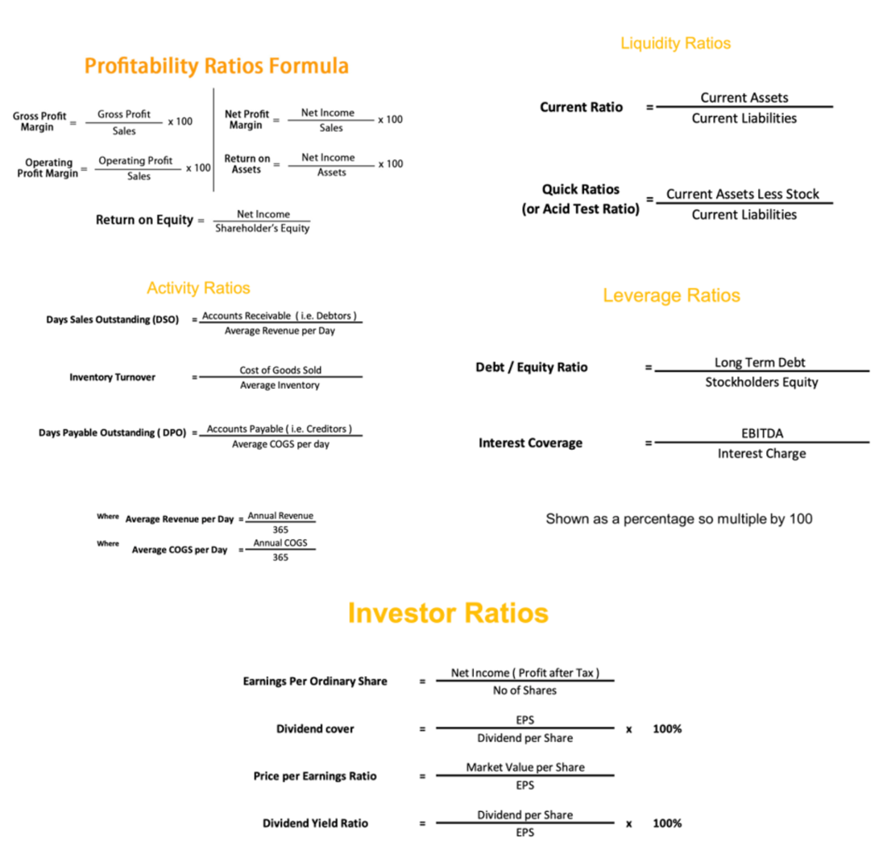

Appendix c – McLaren Profit and loss account report
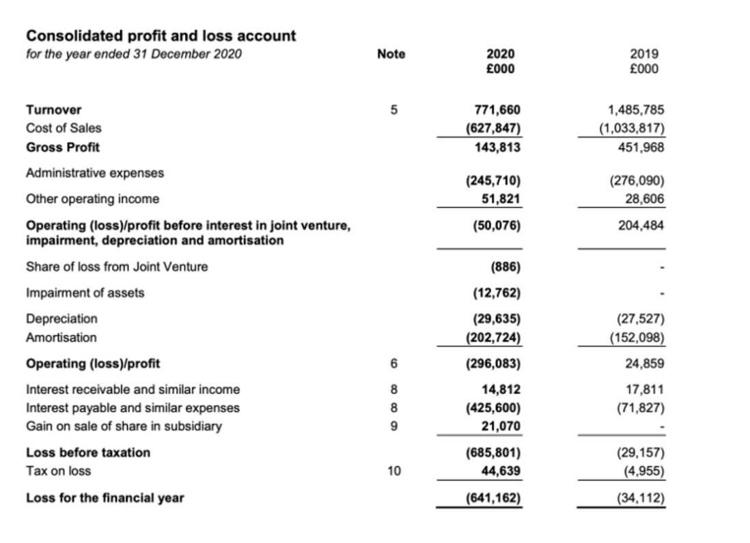
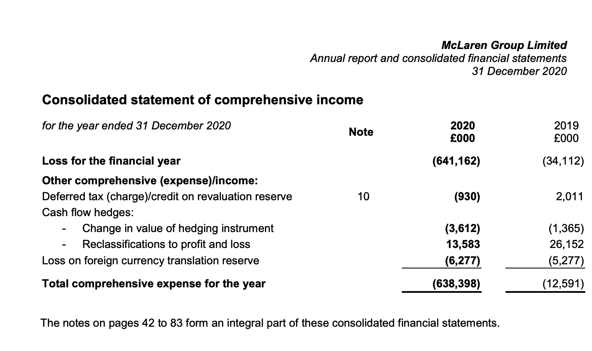

Appendix c continued
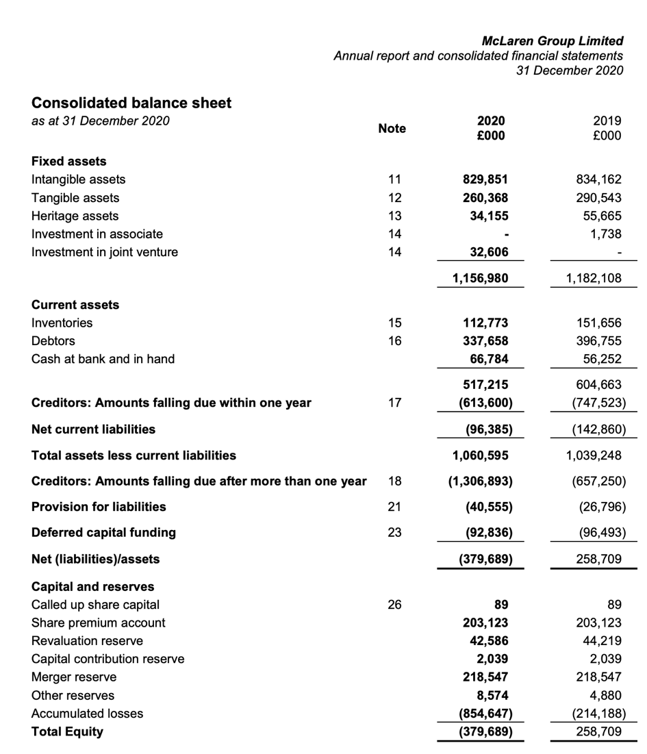

Appendix c continued

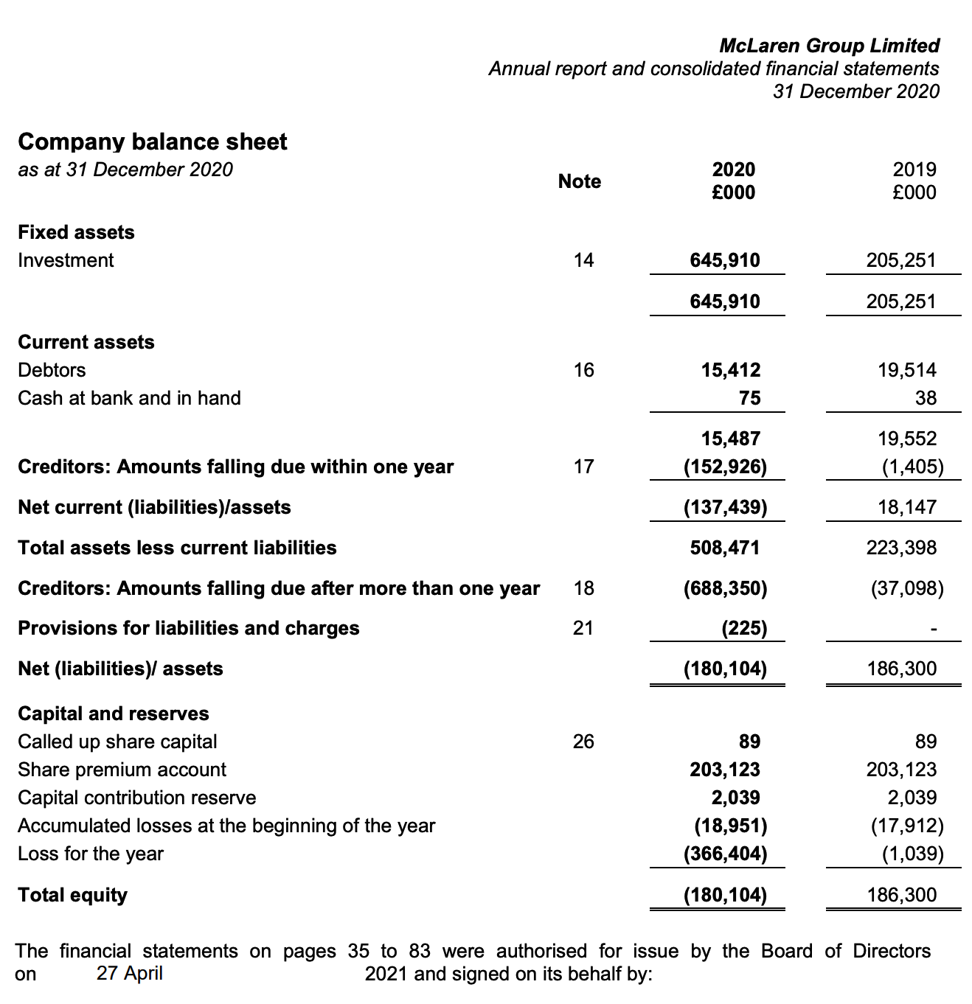

Appendix c continued

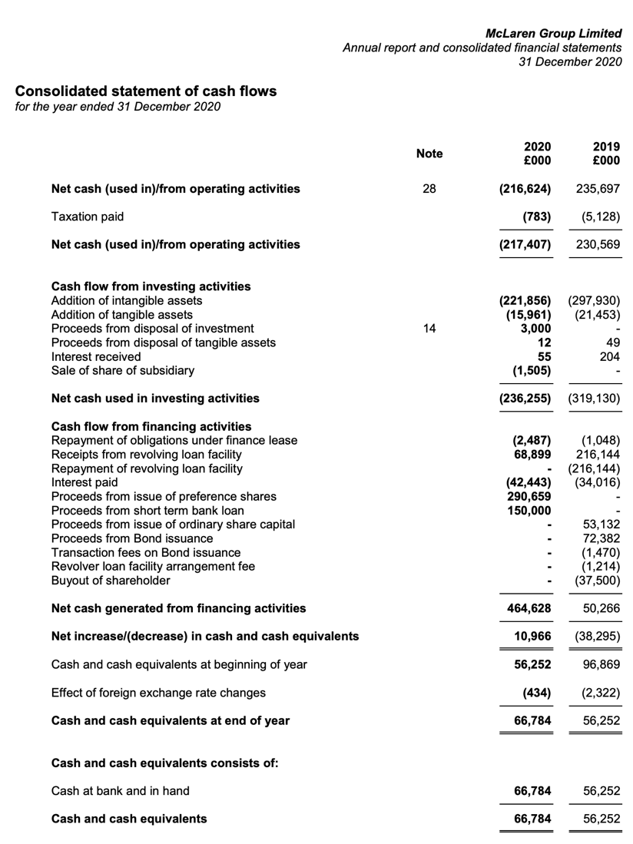

Appendix D- Ratio Calculations table


