University of Wales Trinity Saint David

Wales Institute of Science & Art



Kinetic Energy Recovery

Alternative Propulsion Systems, ACHA5010

Ella Chaves

1802962

15/01/2023

Table of Contents
1 Introduction 2
2 Vehicle Selection and Dynamic Characteristics 3
3 Worldwide Harmonised Light Vehicle Test Procedure (WLTP) 4
3.1 Tractive Energy 5
3.2 Braking Energy 5
3.3 Power input and energy storage 7
4 Kinetic Energy Recovery System Selection 7
4.1 Returned Kinetic Energy to Wheel Road Contact 8
5 Analysis 8
6 Conclusion 11
7 References 12

Introduction
The intent of the following technical report is to analyse the efficiency of an internal combustion engine kinetic energy recovery system. The Kinetic Energy Recovery System (KERS) will also aid in reducing vehicle fuel consumption and could also pose other benefits which could work for the chosen vehicle. Information about the vehicle will need to be sourced in order to identify required dynamic characteristics which will later be used for specific calculations of the vehicle in order to specify a suitable Kinetic Energy Recovery System and finding its efficiency. Explained calculations, plotted graphs and detailed explanations will be used along with some assumptions which will be made clear.

Vehicle Selection and Dynamic Characteristics
The selected vehicle is a 2007 Audi TT 8J 2.0L TFSI, the dynamic characteristics have been identified as:
Test Mass/Curb Weight – 1260kg
Frontal Area (width x height x 0.85) – 2.117 m^2
Rolling Resistance Coefficient – 0.01
Coefficient of Aerodynamic Drag – 0.3
The reasoning for choosing this vehicle is because it can be used as a baseline in comparison to its 4-wheel drive counterpart which shares the same chassis, dimensions, engine and rate of fuel consumption. Although both models have the same fuel consumption, the 4-wheel drive model weighs 100kg more than the front wheel drive, this is because of the automatic gearbox. The goal would be to offer better fuel consumption on the manual by introducing a Kinetic Energy Recovery System.

Worldwide Harmonised Light Vehicle Test Procedure (WLTP)
Worldwide Harmonised Light Vehicle Test Procedure, also known at WLTP, is a new test developed by the European Union in 2017 with the aim to be used globally to be able to compare pollutant, C02 emissions and fuel consumption. WLTP uses actual driving data which is collected to get a better representation on everyday driving profiles, it does this by dividing the test into four sections with different average speeds (low, medium, high and extra high) with a variety of driving phases, stops, acceleration and braking phases. (What Is WLTP: The Worldwide Harmonised Light Vehicle Test Procedure? - WLTPfacts.Eu, n.d.)
Each vehicle will fall under different categories (Class 1, Class 2) based on the vehicle classification. Class 2, version 5 was chosen for this vehicle due to the classification requirements being:
Vehicle with a ratio of rated power in W divided by curb mass in kg is greater than 34.
The Audi TT has a rated power of 200BHP (149140W) and a curb mass of 1260kg meaning it surpasses the requirement of 34 and is a total of 118.36. Other measurements are taken in order to produce future calculations. Test Mass is the first measurement needed and it is known to have a curb weight of 1260kg. The estimated frontal area of a vehicle is calculated by multiplying the width by the height and then again by 0.85 meaning the estimated frontal area of this vehicle is 2.1168264. The rolling resistance of the vehicle is an assumption that is made due to not knowing the exact numbers, the assumption is that ordinary car tyres on concrete have a rolling resistance of anywhere between 0.01-0.015, in this case the lower number was chosen to use. Lastly, the coefficient of drag has been previously worked out for the vehicle to be 0.3.

Tractive Energy
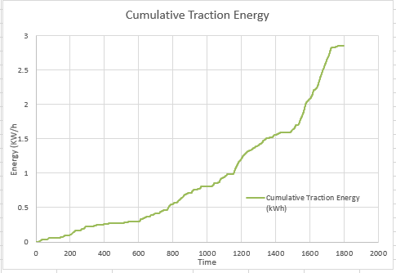
Tractive Energy is defined by the force acting between a vehicle’s wheels and the road surface which produces a motion by using friction.
Figure 1 - Cumulative Traction Energy
Figure 1 is a graph showing the cumulative traction energy (kWh) plotted against time (s) produced from calculations that were made using the dynamic characteristics of the vehicle. The graph shows the total energy (kWh) dispersed over time, based on this outcome, we can see how much power is put down at the wheels and how much power would need to be produced in an electric motor depending on how much performance would want to be gained from it.

Braking Energy
Braking energy is the energy that is produced during a braking cycle. Braking energy is usually wasted as thermal energy.
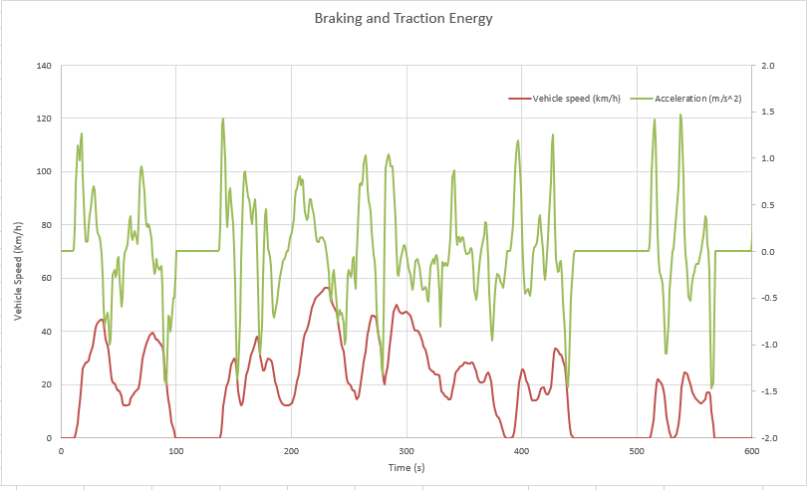
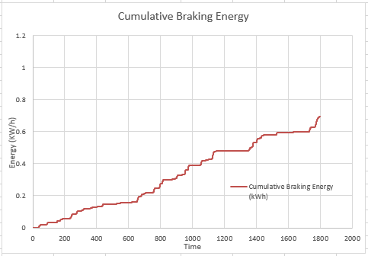
Figure 2 shows the plotted cumulative braking energy (kWh) against time (s). The graph shows overall calculated energy dispersed over a duration of time which were the four phases of the WLTP. By knowing how much braking energy is produced allows for calculations to be made to know how much of this energy can be reused and converted into electricity.
Figure 3 - Braking and Tractive Energy
Figure 2 - Cumulative Braking Energy
Figure 3 is a graph that shows the braking and tractive energy plotted together against the time of the first phase of the WLTP. Shown is the vehicle speed (km/h) and the vehicle acceleration (m/s²) and the relation between them. It is visible that when the speed drops off, as does the acceleration however, the speed is clearly alternating more smoothly and less abrupt than the acceleration.

Power input and energy storage
When looking at the data for the power output, it was found that over all four phases, the maximum kinetic energy (kJ) was found to be in phase four/extra high at 838kJ. This means that the KERS system that is chosen will need to be able to store at least 838kJ for the system to be efficient enough to not be wasting any energy.

Kinetic Energy Recovery System Selection
Kinetic Energy Recovery Systems (KERS) work by using momentum to generate electricity and there are two types: Passive or Active. Passive KERS take energy from the vehicles motion whereas active systems store energy for later use after recovering it during braking. The KERS which would be best suited to this vehicle and is the chosen system for this report is the flywheel hybrid system, also known as the ‘Flybrid’ system. The heat that is generated during a braking period is usually wasted, however, the flywheel hybrid system utilises electric motors on the axle which convert the left-over kinetic energy sourced from the heat into usable energy. The flywheel hybrid system takes power from a mechanical flywheel motor to enhance the power from an internal combustion engine (ICE) for short time periods. This would work as a mapped in override system to the standard vvt-i that the engine supports, this means while the vehicle and brakes are warming up, the engine would continue to use the standard vvt-i system. Once the brakes are dissipating enough heat to be generated into electricity, this would then take over in replacement allowing for the engine to not have to produce as much power or use as much fuel allowing for a much better fuel consumption while still having the full effect of the vvt-i: the driver of the vehicle would still experience the same feedback and feel the boost of power. Depending on size and specifications of the flywheel, it is possible to add more power boost than what the vvt-i could offer, and a torque element is also possible to improve handing and traction. This system would only work in the front wheel drive model due to weight and space issues, due to the four-wheel-drive having less space for the flywheel and already weighing 100kg more than the front wheel drive counterpart, it would only add to the weight and take up valuable passenger space. If the flywheel would only need to store a small amount of energy to convert in order to give the engine around 15-20bhp boost for small amounts of time, it would be possible to make the flywheel more compact using a lightweight material such as cast aluminium. This means that assuming the rear differential alone of the four-wheel-drive weighs around 45kg, it would be possible to put the flywheel in place of the differential and still allow for the total weight of the front wheel drive to be less than the Quattro counterpart and over all more fuel efficient and environmentally friendly.

Returned Kinetic Energy to Wheel Road Contact
The flywheel hybrid system is a type of KERS that comes under returned kinetic energy to wheel road contact. Returned kinetic energy to wheel road contact would be in relation to braking energy, braking energy can be utilised as regenerative braking which means using the left over energy from the braking period to recharge the battery of a vehicle, or in this case to return to a separate battery which would be used to send extra power to the engine for short time periods at higher engine speeds.

Analysis
In order to implement the flywheel hybrid system to the Audi TT 8J, more specific calculations would need to be made. An extra battery would need to be added to the vehicle and according to the blow graph, would to be able to put out around 34800W.

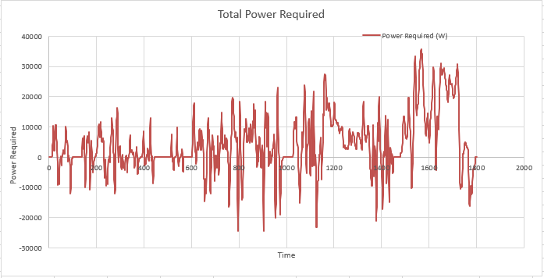
The battery would fit in the “spare wheel” space under the boot carpet where the standard battery sits, the cars do not come with a physical spare wheel, rather a tyre inflation kit meaning there is plenty of room to store an additional battery. If the vehicle KERS required constant output from the battery, it would need to have a 290amp leisure AGM battery which mostly weigh around 50kg, however the flywheel hybrid system would only need to battery to be able to release in small periods. This means there are batteries that are capable of releasing 290 amps which are extremely lightweight, these are usually used for motorbikes and small vehicles and can weigh anywhere between 1.4kg and 30kg. For this installation, a battery that weighs between 15-25kg would be ideal as it is still lightweight enough to keep the curb mass of the vehicle below 1360kg, but large enough to be able to release for longer periods of time. If the battery weighs between 15-25kg and the flywheel could be made compact enough out of a lightweight material, overall, the added weight to the vehicle would ideally be between 55-75kg which means the overall curb mass would be 1330-1360kg. The system could possibly equal the same curb weight as the Quattro (1360kg) and would also fit in the same place as the rear differential but ideally would be made lighter. We also know that split between both rear axles, the electrical motors would need to be able to withstand 0.7kWh of braking energy and the flywheel itself would need to be able to store 838kJ of kinetic energy for the system to be efficient enough and not waste any energy. If large enough to store more energy for longer periods of time, it could have the potential to generate more power to the ICE than what it would normally have to produce with vvt-i in the same amount of time distribution (top end acceleration). The flywheel hybrid system in this instance could allow for over 20bhp boost in short bursts which are delivered smoother and more efficiently which will allow for substantial improvements in fuel economy. Although the driver of the vehicle would still feel the push of extra power, the acceleration will more than likely feel more linear than the abrupt push from the vvt-i.
Figure 4 - Total Power Required

Conclusion
In conclusion, kinetic energy recovery systems could be very beneficial for most vehicles, whether it to improve engine performance, torque output, vehicle handling, fuel consumption or emissions. There are multiple options of KERS for multiple applications and can benefit automotive, motorsport and motorcycle industries. There are many aspects of the vehicle that need to be considered before a suitable system can be chosen, including vehicle specs and calculations made to determine four most important aspects which would aid in a KERS decision: cumulative braking energy, cumulative tractive energy, total power required and total kinetic energy. All these aspects will allow for system, battery and power output specifications to be met.
(2006 Audi TT Coupe (8J) 2.0 TFSI (200 Hp) | Technical Specs, Data, Fuel Consumption, Dimensions, n.d.; Drag Coefficient, n.d.; Energy Recovery Systems (ERS) for Motorsport: For Sale | Zytek, n.d.; Rolling Resistance, n.d.; Traction Force - Definition, Formula, Explanation, FAQs, n.d.; What Is WLTP: The Worldwide Harmonised Light Vehicle Test Procedure? - WLTPfacts.Eu, n.d.)

References
2006 Audi TT Coupe (8J) 2.0 TFSI (200 Hp) | Technical specs, data, fuel consumption, Dimensions. (n.d.). Retrieved January 12, 2023, from https://www.auto-data.net/en/audi-tt-coupe-8j-2.0-tfsi-200hp-4877
Drag Coefficient. (n.d.). Retrieved January 12, 2023, from https://www.engineeringtoolbox.com/drag-coefficient-d_627.html
Energy Recovery Systems (ERS) for Motorsport: For Sale | Zytek. (n.d.). Retrieved January 14, 2023, from https://www.zytek.co.uk/product/elec/energy-recovery-ers/
Rolling Resistance. (n.d.). Retrieved January 12, 2023, from https://www.engineeringtoolbox.com/rolling-friction-resistance-d_1303.html
Traction Force - Definition, Formula, Explanation, FAQs. (n.d.). Retrieved January 14, 2023, from https://byjus.com/physics/traction-force/
What is WLTP: the Worldwide Harmonised Light Vehicle Test Procedure? - WLTPfacts.eu. (n.d.). Retrieved January 12, 2023, from https://www.wltpfacts.eu/what-is-wltp-how-will-it-work/

