

Task 1 – Reading Task Template
Upload your photo of your A3 in-class notes here:

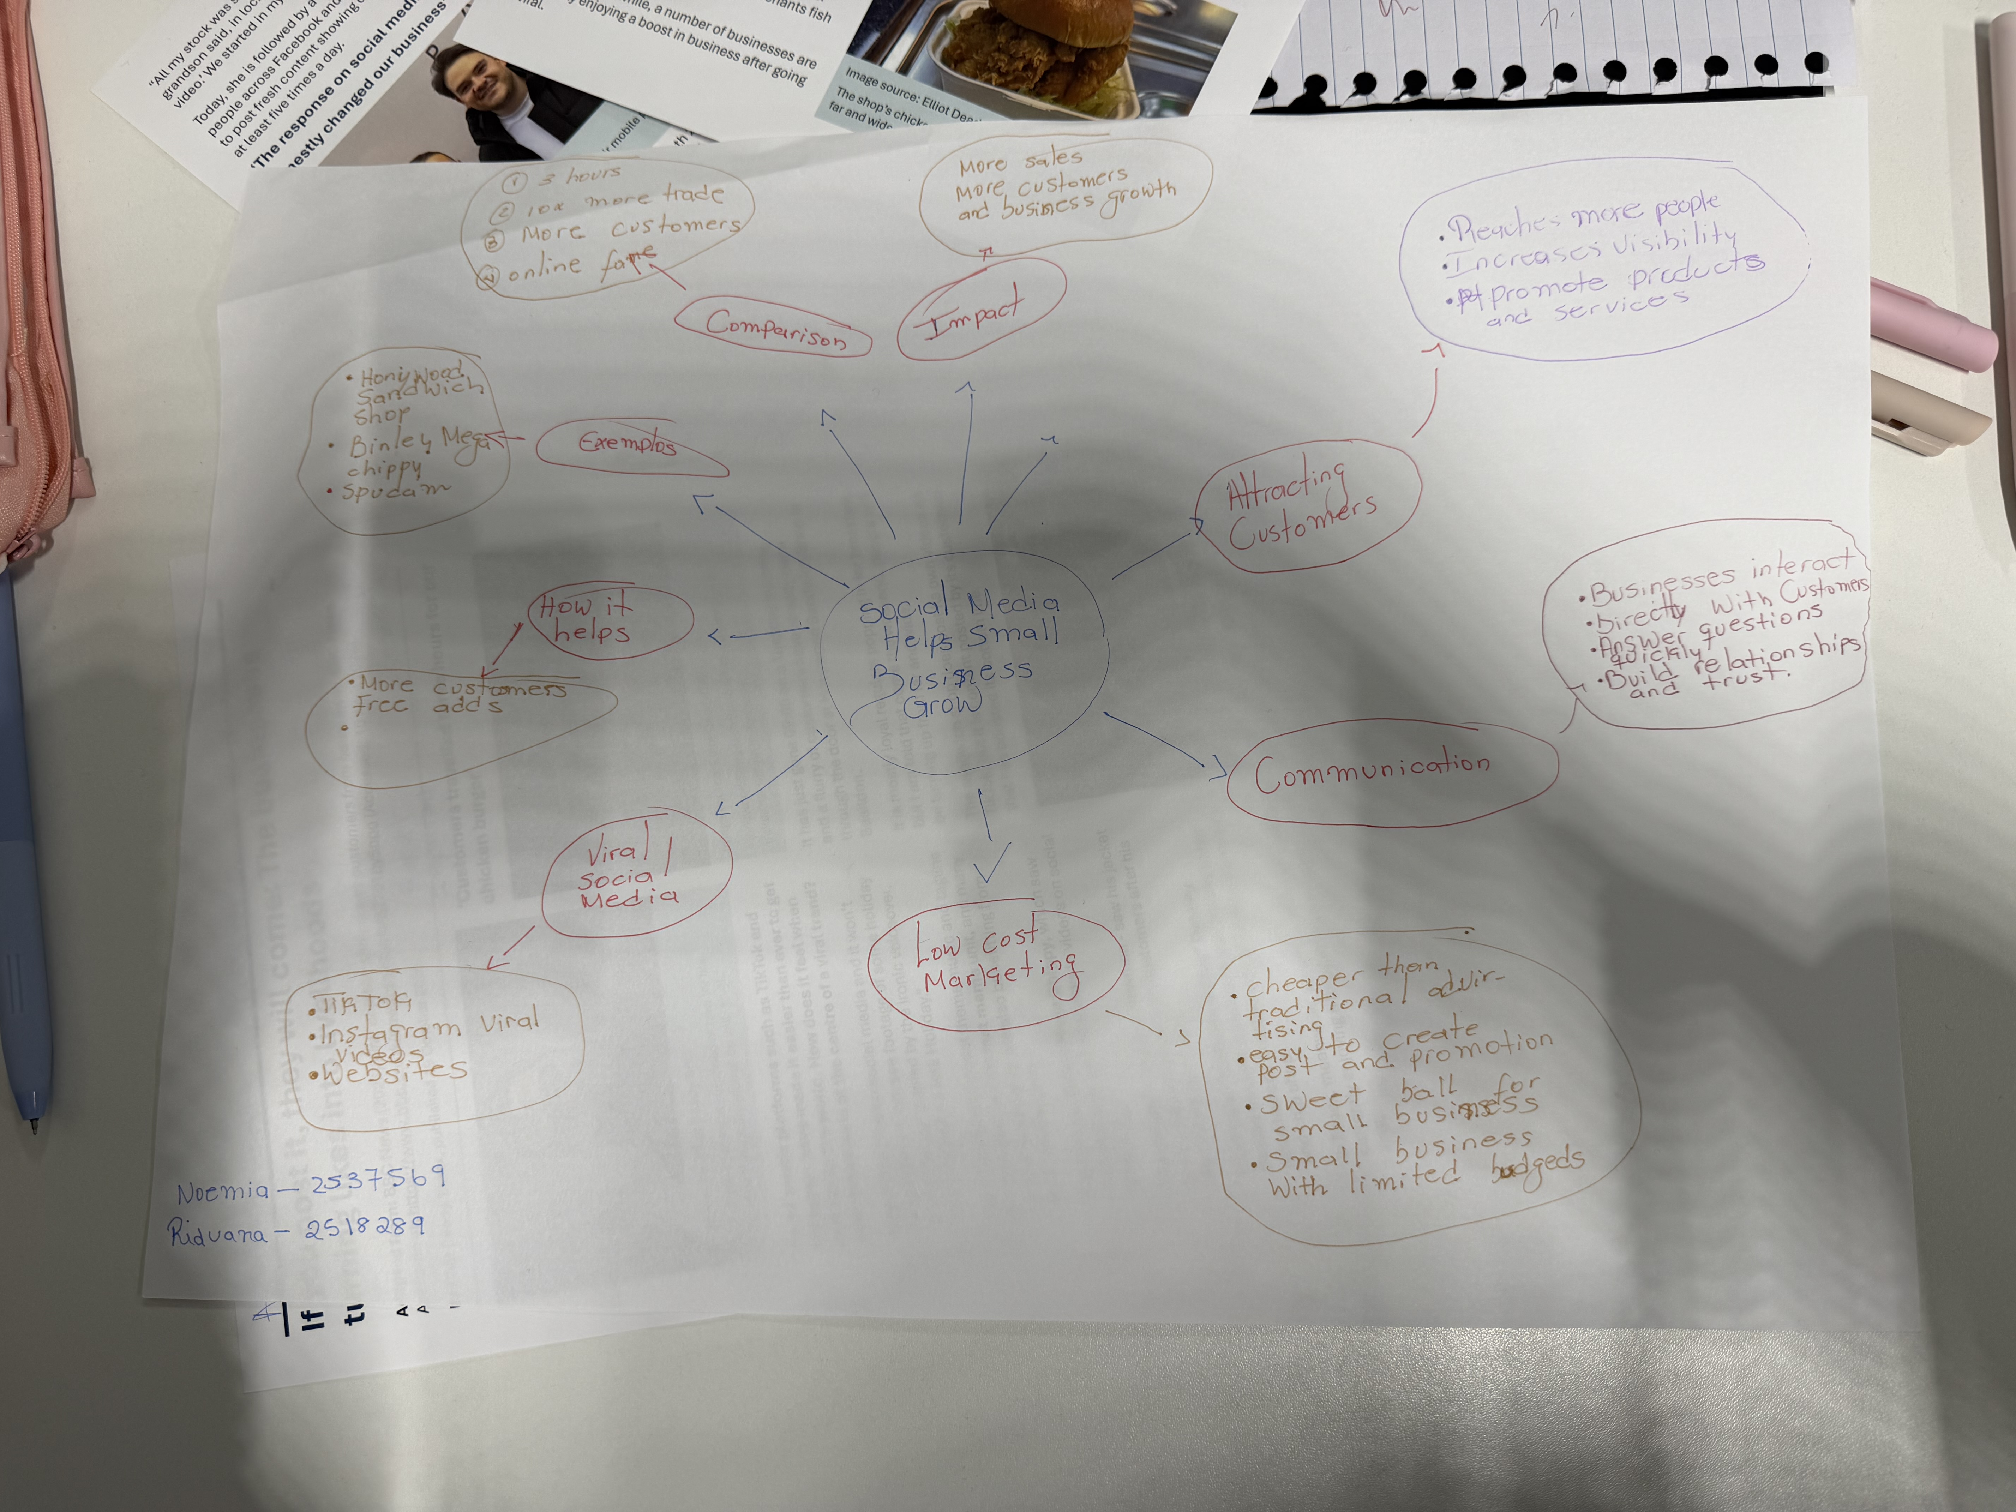
1. Answer these questions using the sentence starters below
a. What is the main idea of the text?
The main idea is that
b. What are two key points?
One key point is
Another key point is
c. What part of the text did you find most important? Why?
The most important part is
d. Was anything unclear or difficult to understand?
I was not sure about
e. How did your group help you understand the text better?
My group helped me by
3. One sentence reflection
Question: What did you find challenging about this task?
The hardest part was

