Qualification: CIPD Diploma in Applied Human Resources

Module Name: Coaching and Mentoring in the Organisation - On the job Training Three Tasks

Word Count: L01 = 645 words
L02 = 268 words
L03 = 271 words

Student Name: Nicola Westcott
Student Number: 1909408
CIPD Membership Number: 55478551

By signing below, I confirm that the work/evidence presented is my own, unaided work. I understand the regulations pertaining to candidate malpractice and the action that may be taken as a result.

Signed: N Westcott
Date: 19/02/2021

1. Evaluate whether or not your organisation’s approach needs a review, based on your reading of current trends.
The People Development Department at MAWWFRS is responsible for delivering training and development to all employees. Strategic aim 1 - Our People in the Corporate Plan 2020-25, aims to ensure all staff have the right knowledge, skills, capabilities providing them with the freedom to make valuable contributions to the delivery of the Service to communities they serve (MAWWFRS, 2021a).
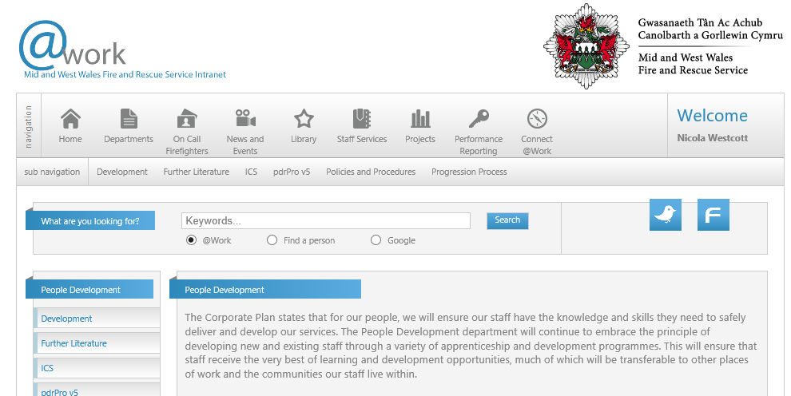
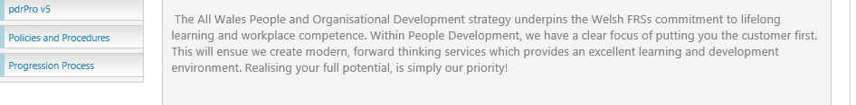
Source: MAWWFRS (2021c)
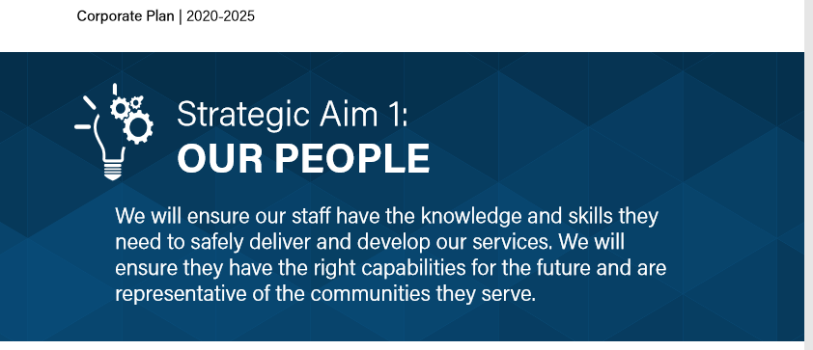

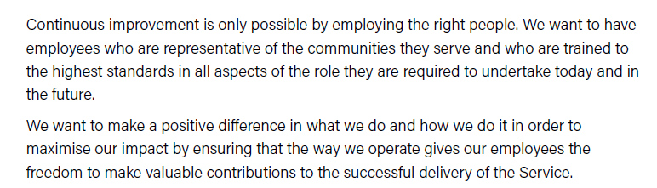
Source: MAWWFRS (2021a)
In line with CIPD (2020), MAWWFRS recognises that coaching and mentoring is a valuable development tool, that can be used to support the development and career progression, alongside other mechanisms such as training courses, self-directed learning, networking.
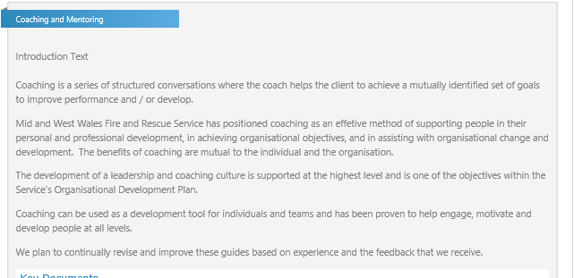
Source: MAWWFRS (2021c)

In 2013, MAWWFRS realised the value of coaching and mentoring could offer, and coaching and mentoring courses were procured to help the Service move forward with this initiative (MAWWFRS, 2021b).



Source: MAWWFRS (2021b)
Aligning to Connor (2012), view that coaching and mentoring relationships that are implemented in organisations, help people to take ownership of their own development and release their potential to achieve results, a coaching and mentoring scheme was introduced in MAWWFRS. Individuals of the appropriate management level, with a combination of skills/experience/credibility, interested in the scheme were able to receive formal coaching and mentoring. Once trained they were able to become coaches or mentors to individuals across the Service.
All employees both operational and support staff who believe that they will benefit from having a coach or mentor, are eligible to be considered for the scheme by submitting a request form. Mentors and coaches are allocated based on the coachee/mentee role and responsibilities. Once a suitable match is identified, the process begins. Regular meetings/sessions are held between the individuals. MAWWFRS uses coaching models such as GROW and OSCAR which help to clarify aims, objectives and plan. Reflection and reviews of the process are also undertaken regularly to ensure the process is meeting the development needs that were identified. Learning logs are useful to capture thoughts and reflections. Both sides can learn benefit from a coaching/mentoring relationship.

MAWWFRS recognises that there can be benefits for both the individual and organisation:

MAWWFRS understands that coaching can also help the employee deal with personal issues which could be impacting on performance at work, aligning with Clutterbuck et al, (2016) definition of coaching ’through direct discussion and guided activity, helps an individual to solve a problem, or do a task better than would otherwise have been the case’.
The Service commits to providing the necessary tools to ensure employees have a more balanced lifestyle in terms of general health and well-being. This can help reduce absenteeism, encourage good mental/physical health, reduce stress/anxiety which aligns with the findings of the IES (2013) study.
Research by Gallup International found that only 15% of worldwide workers are fulfilled at work (Gallup, 2019), MAWWFRS recognises that coaching and mentoring can help individuals feel more fulfilled in their roles by providing a work environment in which they can thrive.
As a public sector organisation MAWWFRS has seen many changes over the years due to re-organisations and financial constraints. Coaching can be very helpful at time of organisational change, helping to move forward a change agenda across the organisation.
MAWWFRS recognises that coaching/mentoring is very effective in supporting other training and development initiatives, helping individuals reflect on and reinforce their learning. As part of the Service’s commitment to the Welsh language, affords staff opportunities to learn Welsh and has set up a Welsh Learners Mentoring Scheme to improve and encourage the use of Welsh in the workplace.
Overall, I do think that MAWWFRS approach to coaching and mentoring is very good. The value of the programmes to individuals and the organisation is recognised and effective measures have been put in place to support these.

The only issue that I noticed is that although the scheme is open to all employees, it does tend to be seen as focussing on operational staff more than those in support staff roles, leading to an unequal take up. For example, some of the wording in the mentoring procedure states (MAWWFRS, 2021c):
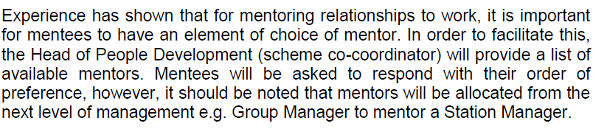
Source: MAWWFRS (2021c)
This immediately implies operational staff and could put support staff off thinking they are not eligible. Therefore, I think care should be taken in the wording of such documents to avoid this.
2. Examine the learning and development policy and any policies directly relating to coaching and or mentoring and make some notes as to whether you think the content meets the best practice requirements you have studied in class and within your literature research.
MAWWFRS has put together a coaching guide for coaches and managers as well as one for employees.
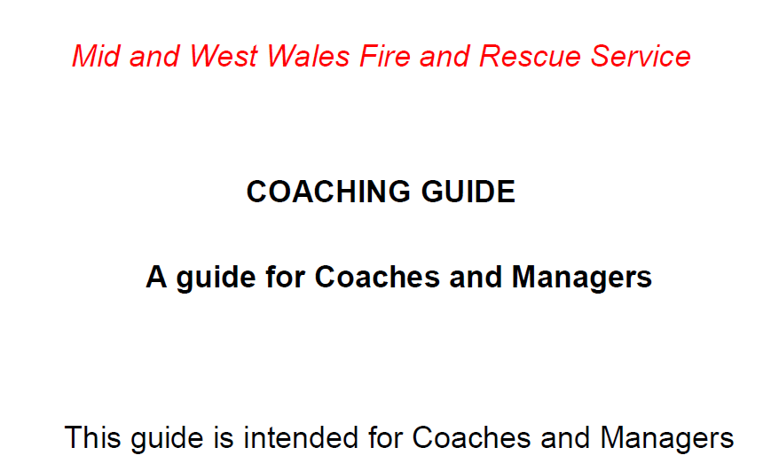
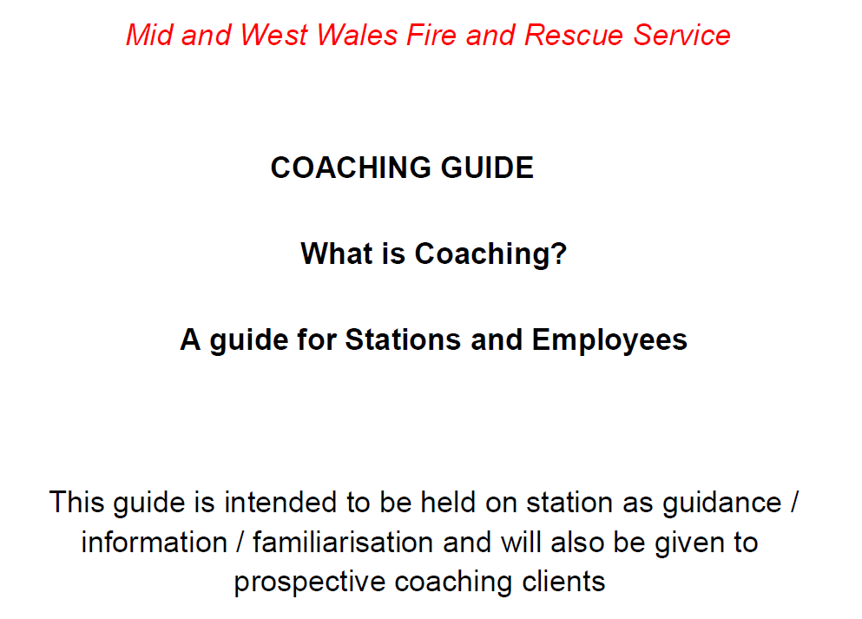

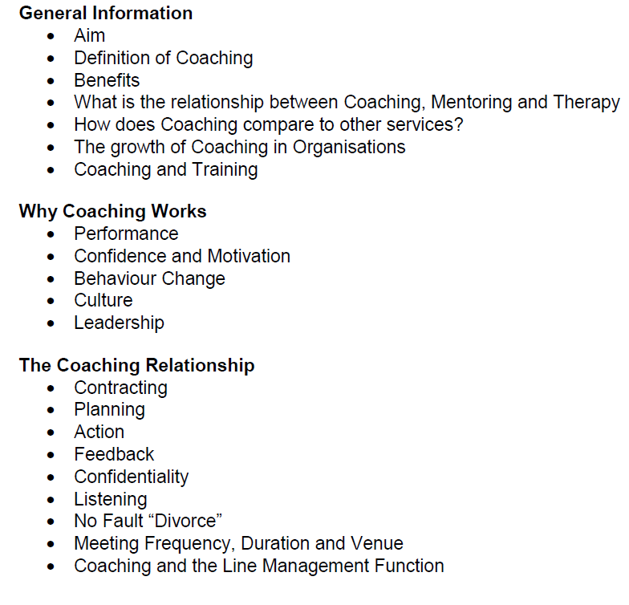
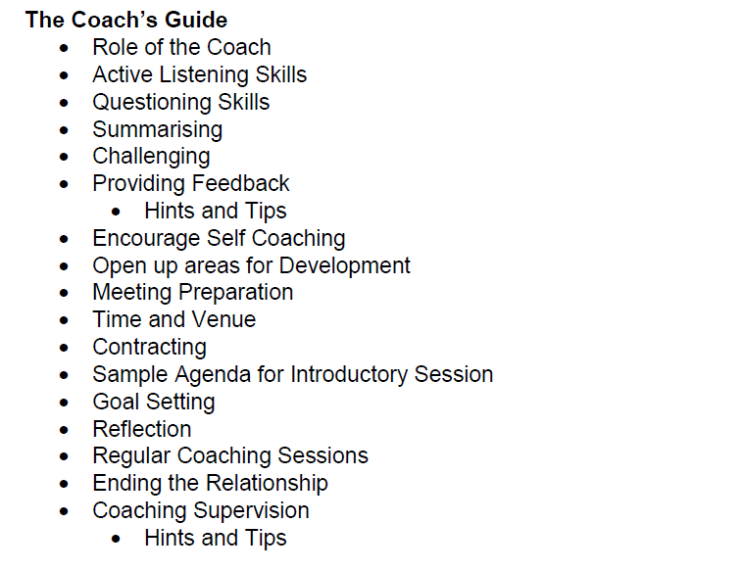
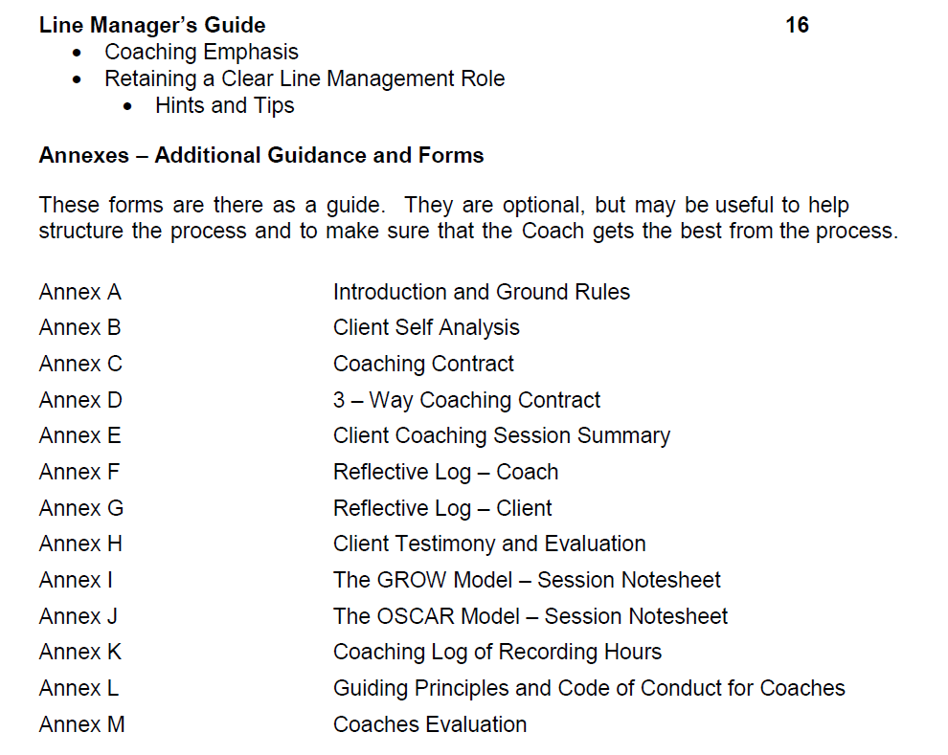
Source: MAWWFRS (2021b)
These guides are extremely useful for all concerned and the content follows best practice from what I’ve studied. From the offset the aims as well as the benefits to both individual and organisation are noted, explanations of what is expected from both sides, coaching models such as GROW and OSCAR are followed as well as the importance of reflection, which aligns to Gibb’s Reflective Cycle (1988).
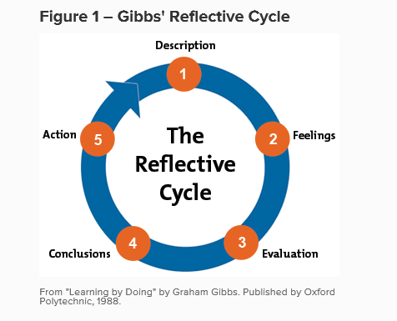
I noted in the line manager guide (MAWWFRS, 2020b) and in line with CIPD, (2020) that it is recognised that LM’s play a vital role of ensuring the organisations mission/goals and values are passed down to employees, and thus by helping individuals identify their goals/outcomes ensures the organisation also receives the benefit of the coaching.
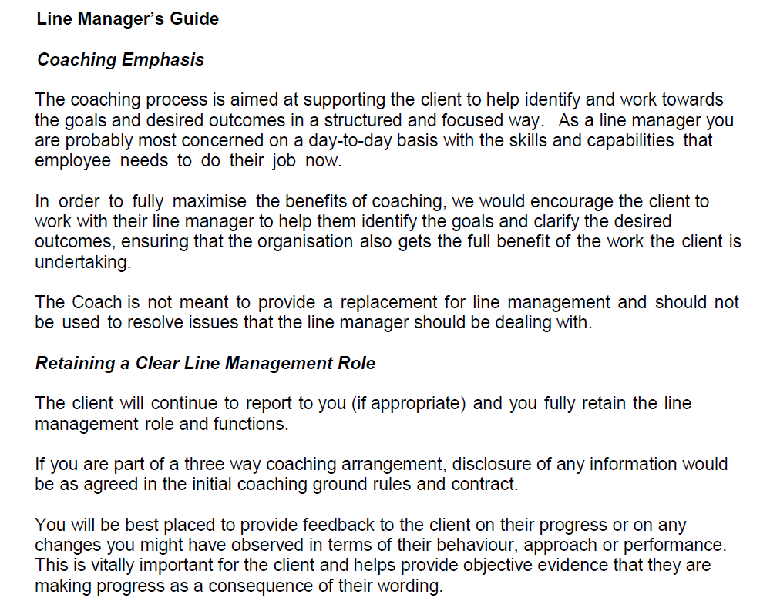
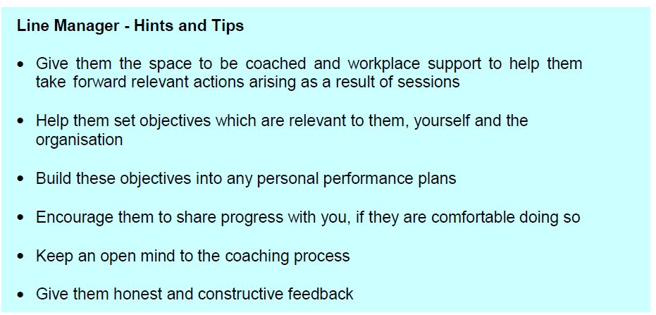
Source: MAWWFRS (2021b)
MAWWFRS also has a Mentoring procedure in place and recognises that by drawing on the skills and expertise of members of the organisation can help other develop their skills and become more effective, thus in turn providing benefit to the organisation, aligning with CIPD, (2020) view of mentoring.
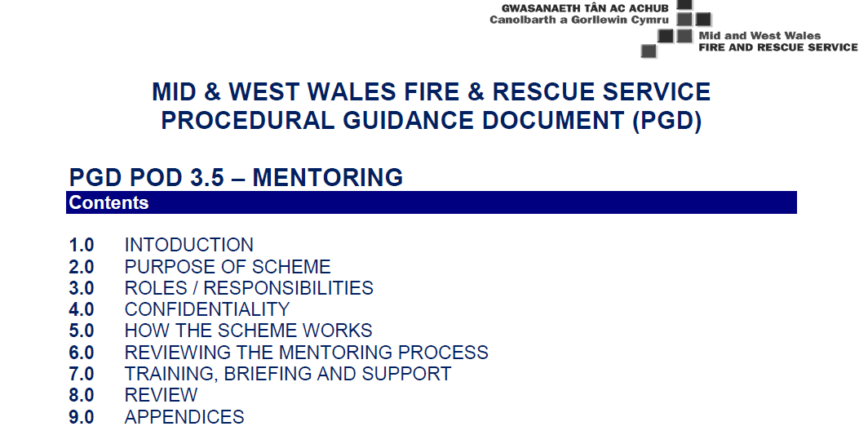
Source: MAWWFRS (2021b)
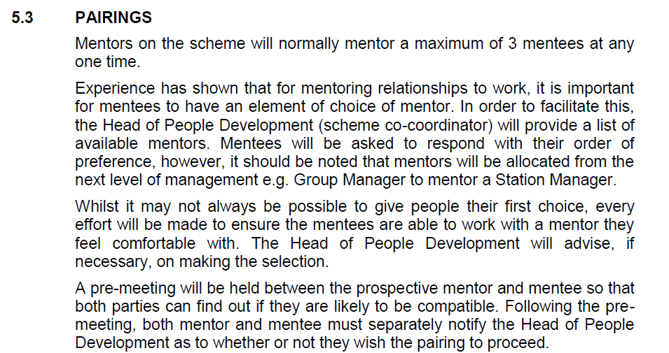
I noted in the Mentoring Procedure that MAWWFRS recognises the importance of the relationship between the mentee/mentor and the steps put in place to facilitate this to get the best out of the relationship
Based in this I do think the procedures and guidance that MAWWFRS has put in place does seem to meet best practice to what I have studied. The only thing I noted as in point 1 is to be careful not to inadvertently exclude groups of employees by wording issues. Apart from that I think MAWWFRS is an organisation with a ‘coaching culture and mindset’ (CIPD, 2017, (Imru-Mathieu 2018 & Forbes, 2019).

3. Discuss your development needs with your line manager as a result of the above activities, using the CIPD Profession Map as a basis for your discussion. Consider whether or not your skills in this area require improvement.
Following research into coaching and mentoring for this module and discussions with my line manager, I now having a clearer understanding of how this links into organisational objectives.

I understand the difference between coaching and mentoring and how the two approaches can be confused when being discussed. Through my studies and discussion, I can see when and how to use them to support learning.
In MAWWFRS there is a People Development Department that deals specifically with coaching and mentoring programmes, therefore in my role I do not have much to input. However, through my discussions with them and reading of the procedures and guidance, I now have a much better understanding of how it works as a learning tool, why it is in place, what the benefits to both individual and organisation (CIPD, 2020).
We discussed that my role involves supervising two members of the team and I have been on various line manger training courses, which provided me with the tools to carry out this role effectively. I can see that I do provide informal peer mentoring to both individuals on a daily basis through my experience and knowledge of MAWWFRS which is in line with Connor (2012), a relationship between people where more experience or knowledge of a particular area/field and shares and supports the knowledge and skills to support a less experienced person such as newly recruited staff.
I would like to understand a bit more the links of coaching and mentoring has to employee well-being and about the various well-being initiatives that the Service has introduced to see if they are benefitting not only the employees but the Service overall.

References

CIPD (2017) Coaching: It’s a culture thing [Podcast] 5 Sep 2017. Available at: https://www.cipd.ae/knowledge/podcasts/coaching-culture (Accessed 31 Jan 2021).
CIPD (2018) Profession Map Available at: https://peopleprofession.cipd.org/profession-map/specialist-knowledge/learning-development (Accessed 19 Feb 2021).
CIPD (2020) Coaching and Mentoring [Factsheet] 03 Aug 2020. Available at: https://www.cipd.co.uk/knowledge/fundamentals/people/development/coaching-mentoring-factsheet (Accessed 31 Jan 2021).

Clutterbuck, D. and Megginson, D. and Bajer, A. (2016) Building and Sustaining a Coaching Culture. London: Chartered Institute of Personnel and Development.

Connor, M., P. (2012) What is effective coaching and mentoring at work? in Connor, M., P. and Pakora, J., B Coaching and mentoring at work. Open University Press.

Forbes (2019) How does coaching actually help leaders? [Article] 28 Mar 2019. Available at: https://www.forbes.com/sites/carleysime/2019/03/28/how-does-coaching-actually-help-leaders/ (Accessed 13 Feb 2021).

Gallup (2019) What engaged employees do differently [Article] 14 Sep 2019. Available at: https://www.gallup.com/workplace/266822/engaged-employees-differently.aspx?utm_source=workplace-newsletter&utm_medium=email&utm_campaign=WorkplaceNewsletter_November_TEST-A_110519&utm_content=learnthepatternsofbehavior-TextLink-1&elqTrackId=97b6e749911746afacd443b665445891&elq=a153f67cfd3b4e87a8109621e19391a4&elqaid=2545&elqat=1&elqCampaignId=587 (Accessed 14 Feb 2021).

Gibbs, G. (1988) Learning by Doing: A guide to teaching and learning methods. Further Education Unit. Oxford Polytechnic: Oxford

IES (2013) Impact of coaching on employee well-being, engagement and job satisfaction. Brighton: Institute for Employment Studies.

Imru-Mathieu. S. (2018) Leaders who coach are creating better workplaces, and so can you. [Youtube video TEDxLausanne Event] 18 Sep 2018. Available at: https://www.youtube.com/watch?v=ypKRJ0IPP-k&feature=emb_logo (Accessed 10 Feb 2021).

MAWWFRS (2021a) Corporate Plan 2020-25. Available at: https://www.mawwfire.gov.uk/media/3197/jr0943-corporate-plan-2020_25_eng.pdf (Accessed 02 Jan 2021).
MAWWFRS (2021b) Internal documents / Surveys.
MAWWFRS Intranet (2021c).

