
University of Wales Trinity Saint David
School of Engineering

Analysis of Student Grades using Statistical Methods in MATLAB
Written by Joshua Hadden
Student Number: 2206081
Engineering Management
Date Written: 03/05/2024
Module Name: Engineering Practice and Study Skills Module Code: ACMA4007

Table of Contents
Table of Contents 2
Table of Figures 2
Introduction 3
Results 4
Table of Averages Analysis 4
Correlation Between Gender and Exam Performance 4
Other Variables and their Correlation with Exam Scores 5
Histograms for Exam 1, Exam 2 and the Total Exam Results 6
Understanding the Cumulative Distribution 7
Conclusions 9
Bibliography 10
Appendices 11
Appendix A – Matlab Code 11

Table of Figures
Figure 1 - Table of Averages for Student Grades Variables 5
Figure 2 - Null Hypothesis Test Regarding the Correlation of Gender to Exam Scores 5
Figure 3 - Full Correlation Matrix of All Measured Qualitive Variables 6
Figure 4 - Ogive Graphs of Exam 1, Exam 2 and Exam Total 8

Introduction
Matlab is a powerful tool that can make calculating heavily populated spreadsheets more time efficient, while maintaining a high standard of quality when analysing data. Matlab is unique in the sense that calculations are completed by writing logic scripts to complete the functions; this can make automating and repeating mathematical functions simple and consistent when repetitive tasks are being completed.
Additionally, Matlab can be an asset in the manufacturing environment. Hardware can be compatible with Matlab and enable direct feedback into written scripts with certain inputs. Various languages can be used to write the programs via Matlab, by using external language interfaces such as C, C sharp, Fortran, Java, Python etc. The online community surrounding Matlab (accessed through the site on MathWorks) is a brilliant asset, as ‘ready to use’ software’s can be found via other members of the community.
The data analysed below is extracted from an excel document titled ‘student_grades.csv’. Matlab is compatible with excel folders, so this document was uploaded directly with the code ‘Data = readtable(‘student_grades.xlsx’(MathWorks, 2024); as per appendix A.
Various tools were used to analyse this data, including histograms, scatter diagrams and ogives which plots the cumulative distribution functions (CDFs) of the exam score variables. The command window was also used to generate quick but valuable reference data, such as the results of a two-sample t-test, and a table defining the various averages of several qualitative variables listed in the provided spreadsheet.

Results

Table of Averages Analysis

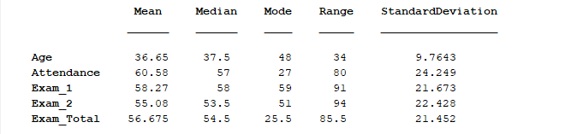
Figure 1 - Table of Averages for Student Grades Variables
Figure 1 shows the table of averages relating to the various qualitive variables listed in the provided spreadsheet. The data gives an overall insight into the background of the students that completed the exams:
- The students did slightly better on the first exam, although the scores were very similar.
- The students are on average in their mid-30s, however the most frequent age in the class is 48. There is a large range of 34 years between the oldest and youngest student however, which indicated the students are at various positions in their lives.
- The students at a whole seem to have poor attendance, in which most students only attend class 57-60% of the time. There also appears to be a small number of students that only attend class about 27% of the time; this figure being the mode indicates it is likely a pair or group that miss class at the same time.

Correlation Between Gender and Exam Performance
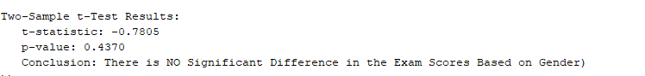
Figure 2 - Null Hypothesis Test Regarding the Correlation of Gender to Exam Scores
Figure 2 demonstrates the results of a two-sample t-test in which the qualitive variable gender was measured to determine if one gender has a higher correlation of good test results. The null hypothesis is that ‘there is no correlation between gender and the performance of an exam’.
(JMP Statistical Discovery, 2024)
The conclusion of the test listed in the command window was “There is NO Significant Difference in the Exam Scores Based on Gender”, this indicated the null hypothesis was accepted.

Other Variables and their Correlation with Exam Scores
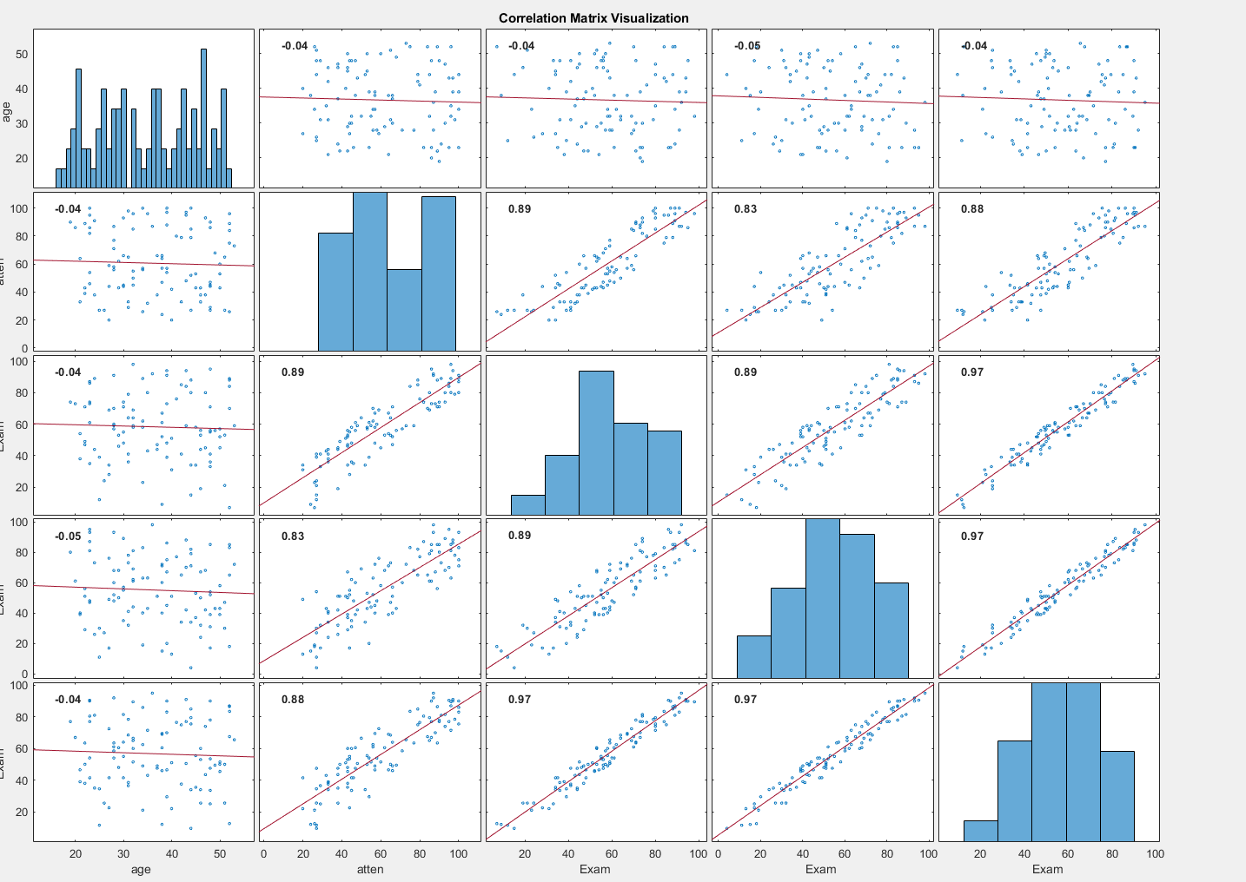
Figure 3 - Full Correlation Matrix of All Measured Qualitive Variables
The above correlation matrix shows bar charts and scatter graphs indicating the correlation between all of the variables. The graphs in which the data points are more scattered indicate that there is no obvious correlation between the variable, however the graphs where the datapoints are plotted closely together and following a trajectory indicate there is a strong correlation between these variables.
The graphs above indicate there is no correlation between age and exam results. There is also no correlation between age and attendance. However, there appears to be a strong correlation between attendance and exam results.
All the graphs that measure attendance and exam 1, exam 2 and the total exam (in order from left to right) show the data is following a positive correlation. The correlation being positive indicated that the students with a low attendance tend to score poorly on the exams, whereas the students that have a higher frequency score higher on the exams.

Histograms for Exam 1, Exam 2 and the Total Exam Results
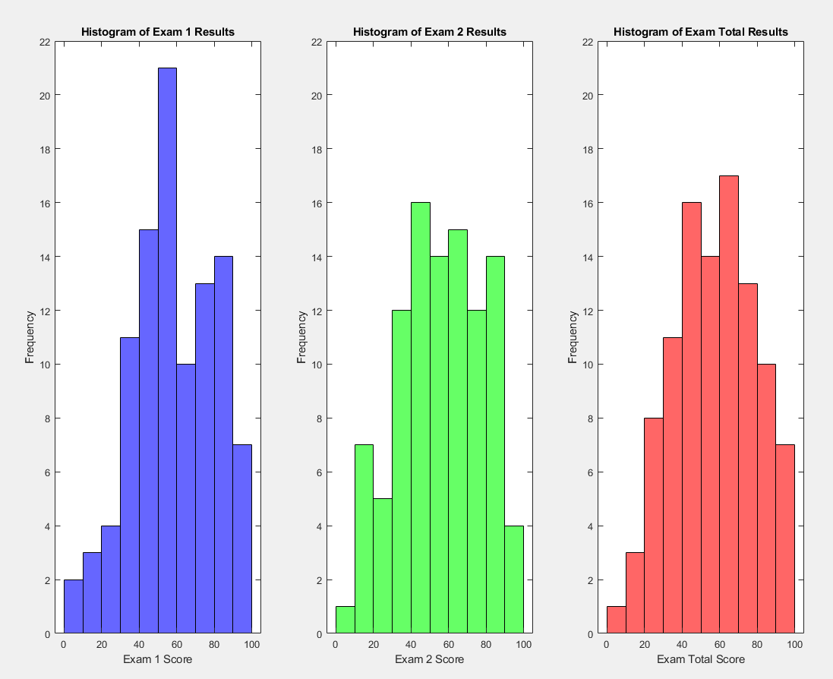
The histograms above show the population of exam results. Histograms are a brilliant tool for objectively measuring the data distribution of a sample of data. Histograms tend to follow a set of patterns:
- Normal distribution – also known as a bell curve, a normal distribution is the desired result for data to indicate there are no underlying variables drastically altering the data. It is often observed that smaller sample sizes produce a non-normal distribution, the sample size above appears to be sufficient(Krithikadatta, 2014).
- Right Skew – Contrary to the name, a right skew is when the data is positively skewed and can be diagnosed as the data heavily populating the left side of the graph.
- Left-skew – Mirroring the effects of right skew, left skew is when the data is negatively skewed and populated the right side of the graph.
- Uniform Distribution – In this instance, the data is equally spread and there are no peaks.
- Bimodal Distribution – Bimodal essentially means there are two peaks in the data, this is an indication there are likely multiple sets of data being measured at the same time and the data may benefit from being separated. Examples may be two operators completing an inspection on a product, but their measuring instruments and producing different results.
(Labxchange, 2021)
The data in the histograms above all displays a normal distribution. This indicated there are likely no variables drastically impacting the results. A small number of students scored less than 30, however most students in all exams seemed to score between 50-70. In exam 1, there was a particularly high peak of student scoring between 50-60. The exams do seem to have a very slight left skew, which can be acknowledged by there being a higher number of students scoring between 80-100 than there are students score between 0-20. Ideally, the results of these histograms would have a strong left skew as this would indicate a high number of students receiving exceptionally good marks on their exams.

Understanding the Cumulative Distribution
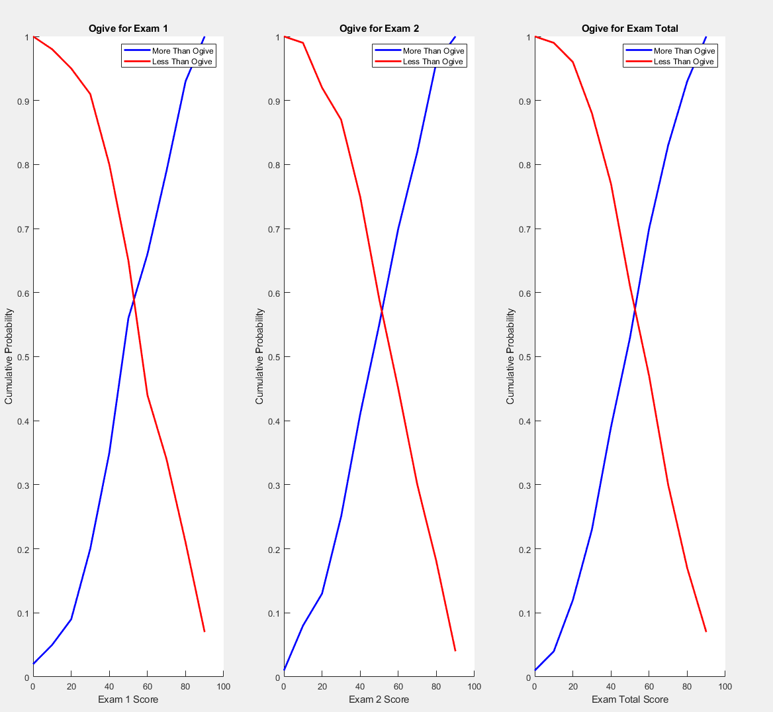
Figure 4 - Ogive Graphs of Exam 1, Exam 2 and Exam Total
The final chart generated using the Matlab software was the ogive charts. These charts are generated using the cumulative distribution frequency of a set of data and are therefore also referred to as ‘CDF’s).
The CDF’s above have similar characteristics to histograms, as they are generated after splitting the data sample into classes much like the procedure for generating a histogram. To generate the ogives, the frequency distribution is then accumulated by creating an additional column with the data and populating it by adding the value of the previous row of data until the last row of data is the total sample size. An additional column is then created in which the reverse accumulative frequency is calculated, this data is then plotted into a line graph.
Using the relationship of the more than ogive and less than ogive in this context enables us to see the relationship between the total sample of the data. Much like the histograms, Figure 4 demonstrated a relatively normal distribution as the interception between the two calculations is almost completely central.
The interception point of the data is the visual representation of the median value, this can be confirmed by referring to figure 1, which indicated the median for exam 1, exam 2 and exam total in order are: 58, 53.5 and 54.5. Visually displaying the median can be very useful for detecting skewers in the data, it indicates if most data in a sample is mostly in one direction of the scale. This is one of the main disadvantages of the mean, the average most used, as it does not provide Insite into any outliers.
In figure 3, it appears there are no extreme outliers in the data, however the entire spectrum of the scale does appear to be in use. It does appear there is a slight skewer in exam 1 however, as the interception point falls slightly to the right of the centre of the graph. This indicated the median site above the 50% marker, which when referring to figure 1 indicates the median value for this graph is 58. This means that 50% of the students achieved a mark equal to or greater than 58.
(Byjus, 2023)

Conclusions
Matlab has proven to be a highly efficient tool for analysing the provided data for the analysis of student’s grades. Now the original program is created, this exercise as an annual practice has almost entirely been automated, regarding the columns remain identical, the script could be used with other compatible spreadsheets with just a small change in the importing codes.
The analysis concluded there appears to be no significant correlation between the gender and age of students and the test results they received. However, there does appears to be a strong correlation between high attendance and performing well with all the exams listed. This data can be used to justify future efforts to improve attendance.
The histogram and ogive charts provided suggest the data follows a normal distribution, with a slight bias towards higher scores. This observation is further supported by the table that was generated, indicating the median average of all the exams sits above the 50% mark, more so in exam 1 than in exam 2. This suggests most of the class achieved marks withing the top 50% of the marking criteria.
Various tools were used to edit the visual representation of the graphs, such as the key table provided on the ogive chart, and the colour co-ordination of the histograms, as well as the boundary outline of the bars on the histograms to define the classes more clearly. These editing tools provide evidence that the graphs can be customized to the same standards as excel.

Bibliography
Byjus. (2023, February). Ogive. Byjus. https://byjus.com/maths/ogive/
JMP Statistical Discovery. (2024). The Two-Sample t-Test. JMP Statistical Discovery. https://www.jmp.com/en_gb/statistics-knowledge-portal/t-test/two-sample-t-test.html
Krithikadatta, J. (2014). Normal Distribution. Journal of Conservative Dentistry and Endodontics, 17(1), 96–97. https://www.ncbi.nlm.nih.gov/pmc/articles/PMC3915399/
Labxchange. (2021, July 6). How to Interpret Histograms. Labxchange. https://www.labxchange.org/library/items/lb:LabXchange:10d3270e:html:1
MathWorks. (2024). Math. Graphics. Programming. MathWorks. https://uk.mathworks.com/products/matlab.html

Appendices

Appendix A – Matlab Code
% Good practice. Adding 'clc' erases any data currently in the command
% window, 'clear' removes any data in the workspace. the ';' symbol ensures
% these lines of code do not get displayed in the command window.

clc;
clear;

% Import dataset from the provided excel spreadsheet 'student_grades.xlsx'
% and assign the data to 'Data'.
Data = readtable('student_grades.xlsx');

% Define the variables from the excel spreadsheet.
variables = {'age', 'attendancePercentage', 'Exam 1', 'Exam 2', 'Exam Total'};

% Calculate the mean of Exam 1 and Exam 2 to generate a new variable for
% the total exam score of the students.
Exam_Total = (Data{:,'Exam_1'} + Data{:,'Exam_2'}) / 2;

% Combine all data into one matrix. the {:, 3:6} extracts the data from the
% Data matrix in the following way. The first slot defines the Y-axis and
% the ':' symbol extracts all the data from these columns. The second slot
% defines the X-axis and is a formula to start at column 3, then move up
% one column until column 6 is true.
all_data = [Data{:, 3:6}, Exam_Total];

% Calculate the specified average for all the data and plot it into a
% matrix. the ' symbol ensures the data is plotted vertically as oppose to
% horizontally.
Mean = mean(all_data)';
Median = median(all_data)';
Mode = mode(all_data)';
Min = min(all_data)';
Max = max(all_data)';
StandardDeviation = std(all_data)';

% Define the titles of the rows to plot into a table
variable_names = {'Age', 'Attendance', 'Exam_1', 'Exam_2', 'Exam_Total'};

% Calculate the range by extracting the min value from the max value.
Range = max(all_data)' - min(all_data)';

% Create the table, and define the rows column with the variable_names
% matrix
Table = table(Mean, Median, Mode, Range, StandardDeviation, 'RowNames', variable_names);

disp(Table);

% Compute the pairwise linear correlation coefficients
correlation_matrix = corr(all_data);

% Display the correlation matrix
disp(correlation_matrix);

% Create a figure for the correlation matrix
figure;
corrplot(all_data, 'varNames', variables);
title('Correlation Matrix Visualization');

% Import the gender variable from the 'student_grades.xlsx' spreadsheet
gender = Data.gender;

% Perform two-sample t-test using the ttest2 function to compare the exam
% total between males and females. A logic index is created with the strcmp
% function for the male and female data. The variables are defined as h, p,
% ci and stats, in which 'h' stands for whether the null hypothesis is
% rejected (1) or accepted (0), 'p' is the p-value which is the calculation
% of the similarity between the variables in which a smaller p-value
% indicates the null hypothesis is incorrect. 'ci' is the confidence
% interval between both variables and 'stats' the t-statistcs and degree of
% freedom.
[h, p, ci, stats] = ttest2(Exam_Total(strcmp(gender, 'Male')), Exam_Total(strcmp(gender, 'Female')));

% Display test results. if the null hypothesis is accepted then the h value
% is 0 and there is no difference in the exam score based on gender. If the
% value is 1 then the null hypothesis will be rejected and the second
% fprint will be displayed in the command window.
disp('Two-Sample t-Test Results:');
fprintf(' t-statistic: %.4f\n', stats.tstat);
fprintf(' p-value: %.4f\n', p);
if h == 0
disp(' Conclusion: There is NO Significant Difference in the Exam Scores Based on Gender)');
else
disp(' Conclusion: There IS a Significant Difference in the Exam Scores Based on Gender)');
end

% Determine frequency of Exam_1 results grouped in classes of width 10
[exam1_counts, exam1_centers] = histcounts(Data.Exam_1, 'BinWidth', 10);

% Determine frequency of Exam_2 results grouped in classes of width 10
[exam2_counts, exam2_centers] = histcounts(Data.Exam_2, 'BinWidth', 10);

% Determine frequency of Exam_Total results grouped in classes of width 10
[exam_total_counts, exam_total_centers] = histcounts(Exam_Total, 'BinWidth', 10);

% Create a figure with three subplots
figure;

% Plot histogram for Exam 1 in blue with a black outline for better
% visability. The Y-axis has been set for easier comparison of graphs.
subplot(1,3,1);
histogram(Data.Exam_1, 'BinWidth', 10, 'FaceColor', 'blue', 'EdgeColor', 'black');
title('Histogram of Exam 1 Results');
xlabel('Exam 1 Score');
ylabel('Frequency');
ylim([0, 22]);

% Plot histogram for Exam 2 in green with a black outline for better
% visability. The Y-axis has been set for easier comparison of graphs.
subplot(1,3,2);
histogram(Data.Exam_2, 'BinWidth', 10, 'FaceColor', 'green', 'EdgeColor', 'black');
title('Histogram of Exam 2 Results');
xlabel('Exam 2 Score');
ylabel('Frequency');
ylim([0, 22]);

% Plot histogram for Exam Total in red with a black outline for better
% visability. The Y-axis has been set for easier comparison of graphs.
subplot(1,3,3);
histogram(Exam_Total, 'BinWidth', 10, 'FaceColor', 'red', 'EdgeColor', 'black');
title('Histogram of Exam Total Results');
xlabel('Exam Total Score');
ylabel('Frequency');
ylim([0, 22]);

% Determine cumulative distribution functions (CDFs) for Exam 1, Exam 2,
% and Exam Total.
cdf_exam1_more = cumsum(exam1_counts);
cdf_exam2_more = cumsum(exam2_counts);
cdf_exam_total_more = cumsum(exam_total_counts);

cdf_exam1_less = flip(cumsum(flip(exam1_counts)));
cdf_exam2_less = flip(cumsum(flip(exam2_counts)));
cdf_exam_total_less = flip(cumsum(flip(exam_total_counts)));

% Ensure CDFs are displayed on the same scale for easy comparison.
cdf_exam1_more = cdf_exam1_more / max(cdf_exam1_more);
cdf_exam2_more = cdf_exam2_more / max(cdf_exam2_more);
cdf_exam_total_more = cdf_exam_total_more / max(cdf_exam_total_more);

cdf_exam1_less = cdf_exam1_less / max(cdf_exam1_less);
cdf_exam2_less = cdf_exam2_less / max(cdf_exam2_less);
cdf_exam_total_less = cdf_exam_total_less / max(cdf_exam_total_less);

% Plot more and less than ogives for Exam 1, Exam 2, and Exam Total
figure;

% Plot Exam 1 ogives.
subplot(1,3,1);
hold on;
plot(exam1_centers(1:end-1), cdf_exam1_more, 'b-', 'LineWidth', 2);
plot(exam1_centers(1:end-1), cdf_exam1_less, 'r-', 'LineWidth', 2);
title('Ogive for Exam 1');
xlabel('Exam 1 Score');
ylabel('Cumulative Probability');
legend('More Than Ogive', 'Less Than Ogive');
hold off;

% Plot Exam 2 ogives.
subplot(1,3,2);
hold on;
plot(exam2_centers(1:end-1), cdf_exam2_more, 'b-', 'LineWidth', 2);
plot(exam2_centers(1:end-1), cdf_exam2_less, 'r-', 'LineWidth', 2);
title('Ogive for Exam 2');
xlabel('Exam 2 Score');
ylabel('Cumulative Probability');
legend('More Than Ogive', 'Less Than Ogive');
hold off;

% Plot Exam Total ogives.
subplot(1,3,3);
hold on;
plot(exam_total_centers(1:end-1), cdf_exam_total_more, 'b-', 'LineWidth', 2);
plot(exam_total_centers(1:end-1), cdf_exam_total_less, 'r-', 'LineWidth', 2);
title('Ogive for Exam Total');
xlabel('Exam Total Score');
ylabel('Cumulative Probability');
legend('More Than Ogive', 'Less Than Ogive');
hold off;

