ECAD5010- What are the pupil’s and staff’s perceptions of Assessment for Learning?

The research question which the researcher will be focusing on is “What are the pupil’s and staff’s perceptions of feedback within the classroom?” This question will be used to evaluate the Assessment for Learning (AfL) strategy of feedback looking at the approaches used and strategies put in place within the school. One of the objectives within this study is to discover which approaches are used by staff or put into place for the children, these approaches will be highlighted by the children and teachers within the questionnaire and noticed by the researcher within the observation. Another objective within this study is to interview the children and teachers of Year 2 and Year 5 to capture their views on the feedback techniques, directing the focus towards which techniques are used, the benefits and the limitations. An additional objective that is used within this study is using an observation to identify the effectiveness of the feedback tools used within the Year 2 and Year 5 classes. Finally, the listed objectives will be used to reflect and critically evaluate the benefits and limitations of feedback. The hypothesis for this study is that the use of feedback, when used correctly, will increase the amount of learning within the classroom, this is support by Black and William (2001) as they state that the use of AfL can increase the amount of learning in a year by 8 months.

AfL is typically referred to as formative assessment and is used to help develop an idea of what to teach in the future, this is completed through a continuous review of progress (Briggs et al, 2008). The use of AfL has become more prominent within teaching as teachers and researchers have discovered that it increases the amount of learning time that is accessible. The Welsh Assembly Government (WAG, 2010; pg 26) states that the use of AfL is critical and should be used frequently rather than being ‘end loaded’. This use of AfL will then encourage the children to develop their skills, alone or with a more knowledgeable other. The use of this more knowledgeable other will increase the child’s knowledge and further their development as shown in Vygotsky’s work (McLeod, 2018a)

The specific AfL strategy, that will be the focus of this research, is feedback. The strategy of feedback has been chosen as it is seen as one of the most powerful influences on learning and a child’s development, as states by Hattie and Timperley, 2007. This view of the importance of feedback is shared with Gadsby and Beere (2012), as they state that effective feedback is an AfL strategy that ‘causes thinking to take place.’ The use of feedback has been implemented for many years, through grades and marks. However, the WAG (2010) have discovered that feedback which is shown as grades or marks, actually has a negative effect on learning and child development. The negative influences of grades and marks are due to the constant focus on the grade achieved and not the improvements made, or the children spend their time trying to decipher the meaning of the grade. The WAG (2010) goes on to say that the use of comments, written or verbal, will only be beneficial if they are used to guide the child’s work in the correct direction.

Although some forms of feedback are proven to have a negative effect on learning, Hattie (cited in Gadsby and Beere, 2012) states that, one of the most effective forms of feedback is a two-way assessment method. This is an effective form of feedback as he states that teachers who allow for feedback from their students, about what they want to learn or improve on, are able to synchronise teaching and learning. One of the strategies that is focused on within this research task is the use of traffic lights. The use of traffic lights, as well as being a method of self- assessment, is beneficial since the teacher can then use these colours to see how the children are feeling and use it to give the children clear targets for an increase in the child’s development. This technique also allows the teacher to decide if the learning objectives need to be revisited, especially if the majority of the class have not understood or misunderstood the task (Arthur and Cremin, 2010). The researcher has decided to complete a research project to discover what the children and teachers perceive feedback to be and to see their opinions on some of the different types of feedback that are used in their class.

The children that were selected as a part of the research were all given a consent form for their parents to fill out as BERA (2018) suggests that a researcher may want to gain consent from the parent or guardian (appendix 1). Due to the ethical issues within the research, no names have been recorded during the observations and all children, throughout all three research methods, are given the chance to ‘opt-in or opt out’ to ensure the appropriate consent is given and all participants are happy to continue (BERA, 2018; pg 15). Also, the researcher has ensured that they used a total of 3 research methods to ensure the most reliability within the data.

In order to assess the perceptions of feedback within the classroom, there will be an observed lesson. This has allowed the researcher to view the responses of the children and teachers towards the feedback given which has been proved to be beneficial as it allows for a collection of ‘live’ data, as stated by Cohen, Manion and Morrison (2007, pg. 396). The information from the observed lesson has been recorded in a table (appendix 2). The benefits of using this table is that the researcher is not too focused on taking notes as it is assessed using tally marks and rating the effectiveness out of 10. There has been an observation in both the Year 2 and Year 5 classes. Within these classes, five children have been selected as the main focus for the effectiveness on an individual. Although the use of a selected small focus group allows for the researcher not to miss any vital information, the data produced is not an accurate representation of the whole class as some of the other children in the class may find the use of feedback more or less effective, also you cannot always identify a child’s emotions towards the use of feedback. Additionally, an observation is limited due to the lack of control of the situation, therefore some of the observed situation may not cover the information the researcher needs, this was supported by Bailey (1994, pg 245-246, cited in Cohen, Manion and Morrison 2007). Overall, it was decided to complete an observation as the information gathered will be taken from the environment. Although the use of controlled situations is limited, it can also be beneficial as it allows for a greater range of behaviour, this is supported by SharnaAbby (2017). Although this reference supports the use of observations using valid responses, it must be recognised that the website cannot be fully trusted as the evidence could have been written by anybody. Also, the researcher has discovered, after previous simple observations, that feedback is given in different forms at this particular school. To avoid the limitation of not being able to accurately identify how the children are feeling, there will be a questionnaire to follow on from the lesson. If this observation was completed a second time, the researcher would have arranged for either a longer session or an extra observer to allow for a larger focus group, this would allow for a more accurate response to the question.

The next method used to assess the proposed question regarding feedback in the classroom is questionnaires. These questionnaires will be completed by the children who were the focus of the observation, this will allow the children to share their opinions on a list of feedback strategies. There are two differentiated questionnaires (appendix 3 and 4), one for Year 2, one for Year 5. Prior to giving these questionnaires to the target audience, they were given to a small sample group to provide an idea of the average time to complete the questionnaire. Although this helped the research gain an idea of how long the questionnaires would take, they were completed by a group of people who were older than the target audience, meaning the results were not completely accurate. The questionnaires have been designed to gain information about the feedback strategies that are typically used within a lesson. Each of the three questionnaires will be completed separately and all children are entitled to either ask for help or decide not to answer/ would prefer not to say. The use of questionnaires are beneficial as they are a quick and easy way to analyse and visualise data as supported by Debois (2019). Another benefit of using a questionnaire is that it can be made anonymous. The use of an anonymous questionnaire is beneficial as the participants feel that they are not obligated to answer a particular way which allows for a more varied and unbiased set of answers. Unfortunately, the use of questionnaires also has its limitations as McLoed (2018b) states that questionnaires lack detail, therefore all of your data has a more fixed response. This typically leads to respondents not answering using their true feelings. Although questionnaires can limit the information given, the researcher has ensured the questionnaires are to the point and structured, this will allow for the most beneficial answers. This method, along with the observations, have helped direct the data to where the topic that the researcher would like. To further develop this data, interviews will take place with the selected children and teachers. If this research method was completed again, the questions within the questionnaires would have given the participants a chance to explore their answers more as most of the questions were tick boxes.

To further assess the perceptions of feedback within the classroom, the researcher interviewed the selected children from each year and their teachers. The interview was used to gain a response to the focus question with a small group of 5 children from each class in a semi-structured environment, all sets of interviews were completed separately. These interviews were voice recorded and transferred into a transcript. Once the transcript was made, the files were deleted in the presences of the class teacher. The benefit of using an interview within this research is that the interview can be ‘matched to the individual and the circumstances’ (Patton 1980, pg 206, cited in Cohen, Manion and Morrison, 2007, pg 353). To further develop the benefits of the interview, the researcher decided to make it a group interview. Group interviews are beneficial as they produce qualitative data, allowing the children to talk in some depth, as stated by McLeod (2014). However, McLeod (2014) also addresses the limitations of group interviews, some of which include a lack of validity, less reliability and some of the participants may not keep the information private. These limitations are developed by Travers (1970; pg 132) as he states that an individual may not want to disclose the information. Although the children will not be forced to answer, the children will have met the researcher before. To minimise the limitations, the researcher has spoken to all of the participants prior to the interview to ensure the data will not be taken outside of the interview. If the interviews were completed again, the researcher would have done a few individual interviews to assess if some of the findings were biased.

The use of the research methods allowed the research to discover that the teachers find that the use of feedback is beneficial for the children and encourages them to increase their knowledge. However, the children found that only some of the forms of feedback that they were given actually had an impact on their learning.

One of the feedback techniques that the research observed was the use of verbal feedback. It was noticed that the use of verbal feedback is significant within both Year 2 and Year 5. The use of verbal feedback was beneficial as it was observed that the children were encouraged to complete more of their work as well as allowing them to be able to see their errors in their own work. Within Year 2, the use of verbal feedback was matched with written feedback. This was beneficial for the class as they could read the feedback if they forgot what they had to do to improve and they could have the teacher give them examples of how to do it, these benefits of verbal and written feedback were expressed within an interview with 5 Year 2’s. Pupil T expressed that they enjoyed having points to improve their work as it would allow them to do better next time (transcript available in appendix 5). Through the use of the questionnaire (results in appendix 9-12), the researcher was able to discover that verbal feedback was used, on average in Year 5, in some of the lessons. Although this type of feedback is used in some of the lessons, the participants find that it is not the most helpful form of feedback used. These results were shocking as within the interview with one of the school’s teachers, they stated that the children respond better to verbal feedback than anything else (transcript in appendix 8). Although these results give the expected responses, the researcher has to be conscious that some of the children may not understand what the term verbal feedback means which could then lead to the children guessing or answering the question how they think they should not how they actually feel.

Another feedback technique which was focused on within this research was the use of traffic lights. The use of traffic lights was not seen within the observation that was completed, however, the researcher looked through the children’s books and found that in Year 2, traffic lights were used in a few lessons. Within the Year 5 class, it was seen in the children’s books showed that the traffic lights were used in nearly every lesson to assess against their learning objectives or success criteria. Through the questionnaire, it can be seen that using traffic lights is the most helpful way of improving work, according to the children of both Year 2 and Year 5. Within the interviews, it was found that nearly all of the children, especially in Year 5, enjoyed the use of traffic lights and found them the most effective way of giving feedback. The children in this interview (transcript available in appendix 6) discussed that the use of traffic lights is effective as it allows the children to express how they are feeling about a topic and it gives the teacher a chance to help the children understand more. This is supported by Arthur and Cremin (2010), who state that traffic lights are an effective method of giving feedback as it allows for further development when there is misunderstanding. This form of feedback is also supported by Gadsby and Beere (2012) as traffic lights are a form of assessment from both the teacher and the child. Within interview this (transcript in appendix 7), they state that the teacher leaves a comment on the colour that was chosen; allowing the children who need extra help, to have extra time to gain more knowledge around the topic. Although this use of an interview was effective and answered the research focus question, some of the children within the interviews were noticeably withdrawn from the discussion. These children were not forced to answer; however, the researcher must be aware that these results may not depict the whole classes opinions.

Additionally, the use of the RAP (Reflect and Plan) board is another form of feedback with the assessed classroom. This particular method was not one of the original focuses of the research project, therefore, there was no focus in the questionnaire. However, within the classrooms, the researcher noticed the RAP board. There was no use of the RAP board within this particular lesson but the researcher decided to ask a few questions around the RAP board to develop a better understanding about the technique as well as assessing the children’s perceptions of this technique. The RAP board allows the children to show the things that they already know about a particular topic and discuss the things that they would like to learn throughout the topic. Within Year 5, there was a mixed opinion on the use the RAP board. One of the opinions was that the use of the RAP beneficial, this was due to the children feeling that the teacher was listening to them and that their input is helping build their lessons (transcript available in appendix 6). On the other hand, in a different interview (available in appendix 7) the children had decided that the use of the RAP board was not beneficial for them. This was further developed by Pupil GE as they said that the board is not used enough to benefit their learning. After a discussion around this, Pupil GE stated that they thought the RAP board would be more beneficial if they were able to update their ideas every week or every lesson so that they can constantly see the progression. The benefits of children’s participation are supported by Education Scotland (2018) as they state that the use of allowing children to lead their own learning improves engagement, empowerment and attainment.

To conclude, the use of feedback as an AfL strategy has been perceived to have a positive effect on the learning and development. Throughout this study, it has been discovered that all children have their own preferences with which technique they think is best for their own development and the researcher has developed an understanding of which techniques typically work better within different year groups. For the Year 2 pupils, it was noticed that they benefitted more from the use of verbal feedback, typically alongside written feedback, as the children can then have examples of what they should do to develop their work. Within Year 5, it was found that the children prefer the use of traffic lights as it allowed the children to assess their own knowledge and gives them the choice of if they think they need to focus on the work more. However, from the view of the Year 5 teacher, the use of verbal feedback and written feedback is the most beneficial for them, this is due to the encouragement from the teacher and the support given. From the data that was found, the researcher has noted that there can be an improvement within teaching practise through an increase of the use of feedback within the lessons. The feedback strategies that the researcher believes should have more emphasise on the use of verbal feedback, written feedback and a two-way assessment through methods such as traffic lights.

References:
Arthur and Cremin (2010), ‘Learning to Teach in the Primary School’, London: Routledge, Taylor and Francis Group

Black and Wiliam (2001), ‘Inside the Black Box’, King’s college London School of Education, available at:
https://weaeducation.typepad.co.uk/files/blackbox-1.pdf (last accessed on:)

Briggs et al (2008), ‘Assessment for Learning and Teaching’, Exeter: Learning Matters Ltd

British Educational Research Association (BERA) (2018), ‘Ethical guidelines for educational research’, fourth edition, London.
https://www.bera.ac.uk/publication/ethical-guidelines-for-educational-research-2018-online (last accessed on:)

Cohen, Manion and Morrison (2007), ‘Research Methods in Education’, Sixth edition, available at:
https://moodle.uwtsd.ac.uk/pluginfile.php/350220/mod_resource/content/1/rme-edu-helpline-blogspot-com.pdf (last accessed on:)

Debois (2019),’10 Advantages and Disadvantages of Questionnaires’, available at:
https://surveyanyplace.com/questionnaire-pros-and-cons/ (last accessed on:)

Education Scotland (2018), ‘Learner Participation in Educational Settings (3-18)’, available at:
https://education.gov.scot/improvement/Documents/learner-participation.pdf (last accessed on:)

Gadsby and Beere (2012), ‘Perfect Assessment for Learning’, Bancyfelin: Independent Thinking Press

Hattie and Timperley (2007), ‘The Power of Feedback’, available at:
https://journals.sagepub.com/doi/pdf/10.3102/003465430298487 (last accessed on:)

McLeod (2014), ‘The Interview Method’, available at:
https://www.simplypsychology.org/interviews.html (last accessed on :)

McLeod (2018a), ‘Lev Vygotsky’, available at:
https://www.simplypsychology.org/vygotsky.html (last accessed on:)

McLeod (2018b), ‘Questionnaire: Definition, Examples, Design and Types’, available at:
https://www.simplypsychology.org/questionnaires.html (last accessed at :)

SharnaAbby (2017), ‘Advantages and Disadvantages of Observational Methods’, available at:
https://getrevising.co.uk/grids/advantages-and-disadvantages-of-observational (last accessed on:)

Travers (1970), ‘An Introduction to Educational Research’, third edition, London: Collier- Macmillan

Welsh Assembly Government (WAG) (2010), ‘How to develop thinking and assessment for learning in the classroom’, available at:
https://moodle.uwtsd.ac.uk/pluginfile.php/306235/mod_resource/content/1/how-to-develop-thinking-and-AFL-en.pdf (last accessed on:)

Appendix 1:

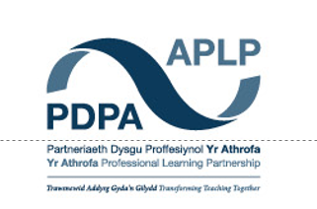

ECAD5010 Consent Form

Student teachers must gain the following written consent of the head teacher before trialling their research tools.

To be completed by the school:

I agree to ____________________________________ as a representative of Yr Athrofa to:

-Take photographs (Tick accordingly)

-Interview

-Take video

-Observe

-Quote school policy documents

-Questionnaires

Name of Head teacher ________________________ Signed _____________________

Name of school _______________________________

To be completed by the student teacher:

If I am granted such permission, I agree to abide by the ethics embodied within the EWC Code of Conduct and BERA Ethical Guidelines (2018) and will not distribute any such material to audiences beyond the University authorities without their permission.

Name of student teacher: Signed:

Student teacher UWTSD e-mail address:

Programme (e.g. BA Ed/PGCE Primary):

Date:

Appendix 2:

Strategy | Class | Group | Individual | Effectiveness
Traffic Lights
Time to answer feedback
Verbal feedback
Mini Whiteboards
Self- assessment
Peer- assessment

Appendix 3:
https://forms.office.com/Pages/DesignPage.aspx?origin=shell#FormId=-REPTm4EBUWcuNshUjEeIVM7EU-MMuJArp-qU_mosB1UMUM5WVBHR1VJQ0ZQTTVUSjA2UzhOWDNMMi4u

Appendix 4:
https://forms.office.com/Pages/DesignPage.aspx?origin=shell#FormId=-REPTm4EBUWcuNshUjEeIVM7EU-MMuJArp-qU_mosB1UQThHTlVPNUlBRlVHNjg0QVZUSllRREMzUi4u

Appendix 5:
Transcript 2:
Researcher: Who can tell me what feedback is?
T: Questions? Like using questions?
Researcher: Feedback is when somebody tells you what you have done good and what you can do better. So, do you think feedback is helpful?
R: Yes
Researcher: Okay, why? What is helpful about feedback.
M: It helps us learn
ML: Does it make your work better or not?
C: Better!
Researcher: Can you look at the page you have open and tell me if you can see any feedback on it
R: Yes, my teacher has written in here
Researcher: how does that writing help you?
T: it helps me to get it right and do it right next time.
Researcher: Do you use traffic lights? Where you colour in your book?
T: Yes, we have it so we colour green if we had no help, orange if you had a little help and red if you had loads of help.

Appendix 6:
Transcript 1:
Researcher: What do you think feedback is?
M: Feedback is an explanation you give back to your teacher
E: Or if a teacher marks your work. They can say if you have achieved the LO or Success Criteria
Researcher: Okay, so do you think that feedback is helpful?
M: yeah it is, because you get to express about your work and see if you can improve
Researcher: Anything else?
E: We can see what we did well and what we could do better
Researcher: I’m looking at the books you brought with you and I can see there is some writing from your teacher. What kind of things does your teacher normally write here?
E: Basically, how you have done
M: Or if you have had an excellent understanding
Researcher: Okay, so what is this, here, by your Learning Objectives?
M: It’s called traffic lights
Researcher: Traffic lights? Can you tell me what they mean?
E: To see how we felt
M: Yeah, it’s like Miss is asking if you thought the work was hard or easy
E: And she can see if you need help
Researcher: Why do you think these traffic lights are helpful?
E: We can see what we have done in our work and what we found easy or hard
Researcher: What happens if you put an orange or red traffic light
M: Yellow is like you struggled a little bit
E: Or if you need a bit more support
Researcher: What does your teacher do if you put yellow or red?
M: They try to help you understand more.
Researcher: Okay, I saw the RAP board in your class, can you tell me about it?
M: It explains what you have done through the week and what you want to learn.
Researcher: Do you think your teachers use this information to plan your lessons?
BOTH: YES!
M: Once, someone asked to learn about Victorian Art and to do a project and we did it.
Researcher: With the questionnaires you have completed, it says that you don’t use a lot of whiteboards. Do you think using whiteboards would be helpful?
M: In some ways
Researcher: What ways?
E: To help us with our working out, instead of using our books
Researcher: From the questionnaire, which was your favourite type of feedback?
M: The traffic lights or when we write in blue
Researcher: What does writing in blue mean?
M: You’ve looked at your work and you correct your answers
E: I prefer when other people mark my book in purple pen
Researcher: What if they don’t understand the work they are marking?
E: Miss usually writes the answers on the board so we can check with her.

Appendix 7:
Transcript 3:
Researcher: Do you find feedback helpful
G: Yes, it is helpful for you and your teacher
Researcher: Do you have a favourite feedback method?
E: Traffic lights because you can say if you understand the work
Researcher: okay
GE: My favourite way is writing down because if I write it, I can express my feelings
Researcher: Looking at your pages, I can see the traffic lights. What do they mean?
GE: You colour a box. Red means you need loads of practise. Orange means you need some practise and green means you don’t need practise
Researcher: Does your teacher look at this?
GE: Yes, the teacher writes a comment about the colour we chose
Researcher: Are there any strategies you don’t like to use?
GE: Mini whiteboards
Researcher: Okay, why?
GE: It is a waste of time having to wipe the board
Researcher: Okay, would you say the RAP board in your class is helpful
GE: Not really because we don’t use it enough
Researcher: how would you improve this?
E: we could do it every week or after every task so we can add to it and reflect.
Researcher: What would be the benefits of this?
G: We can update it and add to more topics if we want to learn more.

Appendix 8:
Transcript 4:
Researcher: My first question is, do you think that feedback is beneficial for youself as a teacher?
EE: Yes, I do
Researcher: Why?
EE: It informs me, rather than just looking into books. I don’t see any value in that. It lets me really focus on the Learning Objectives and to notice if they have achieved it. I think giving feedback, writing or orally, is the way forward because it is the way that they learn.
Researcher: You said that it is beneficial for the children, which technique do you think is the most beneficial for the class you have currently?
EE: At the moment, they can do with the written. But some children, I feedback orally. This is because they pay more attention to that then going back. Even though I give them time to go back and look in their books to see what the teacher has written, some of them won’t do it. So then, what I like to do, while they are working, is call them out and mark the book with them to give them pointers from there. That way it isn’t left until the end.

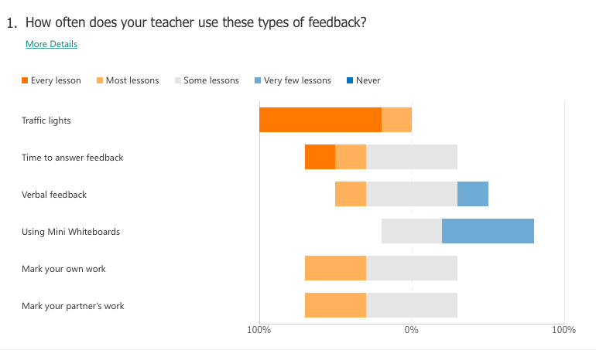
Appendix 9:

Appendix 10:
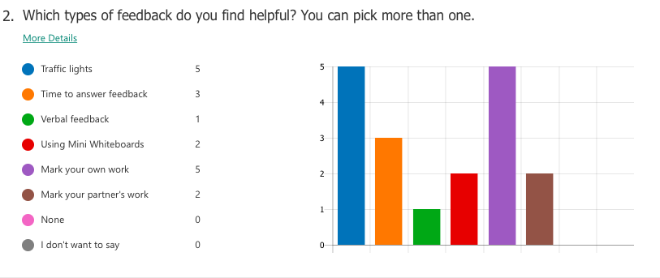

Appendix 11:
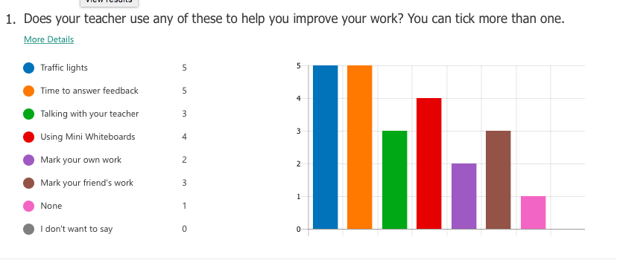

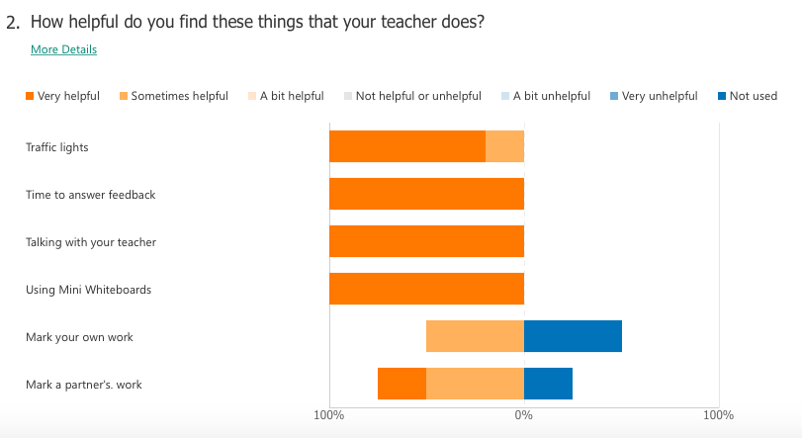
Appendix 12:

