Manufacturing and Quality Systems (M5X01177)
Alex Collier (1707158)
BEng Material Science
22/11/2019

Table of Contents

Introduction 2
Problem 2
DMAIC 3
Define Phase 4
Problem statement 5
Cause and effect 5
Hardness test 6
Scope 6
Process route 7
Charter 7
Measure Phase 8
Data collection 8
Process capability 8
Thermal profile 9
Material composition 10
Incoming material data 11
Processed material data 12
Analyse Phase 14
Pareto 14
A3 problem solving report 15
Ishikawa 15
5 Whys 15
Asset care 15
Histogram 16
GEMBA 16
Conclusion 17
References 18
Appendix 19

Introduction
The authors employer is a top tier COMAH (control of major accidents and hazards) chemical plant within the manufacturing sector. The organisation mass produces nickel plated steel disks by electroplating. ‘Electroplating is an electrolytic process for depositing a layer of metal upon a substrate, to enhance the appearance or properties of a component’ (Rose, 2014).
During the month of September, a Pareto chart was compiled of right first time data to show defects that had been recorded within the area.
The team used a DMAIC (Define, Measure, Analyse, Improve, Control) six sigma tool to find the root cause of the problem that has led to high levels of quarantine work. The report focusses on the Define, Measure and Analyse sections of the investigation which took place, in order to establish root cause.

Problem
The chosen problem originates from the ‘blank processing’ area of the organisation. This department has two main processes: -
- Annealing (heat treatment) – A form of heat treatment to alter the crystal structure of a material. Although referred to as annealing, in this case it is not strictly true. This form of heat treatment is fundamentally the removal of all the work hardening and stress that has been into the product from prior processes. Without this process, the disks would be too hard for final forming.
- Finishing – A surface treatment involving a high energy centrifugal bowl, stainless steel media and a mixture of chemicals to ensure that the finished product has acceptable lustre.
There has been an issue with the annealing of nickel plated steel denominations within the Blank Processing area. During normal production running, it was found that the majority of the disks had achieved specification, whilst with some blanks, the required hardness would not be achieved after processing. This is known within the organisation as ‘fliers’. This defect was witnessed across all annealing furnaces that the product was processed on.
The preferred method for solving the ‘fliers’ defect was the DMAIC tool. This method of problem solving falls in line with the company’s continuous improvement philosophy.

DMAIC
DMAIC is an acronym for Define, Measure, Analyse, Improve and Control (pronounced de-may-ic). It is a problem solving system which was based on Walter A Shewhart’s plan – do – check – act cycle, although, according to Harvey (2004), the DMAIC approach is more meticulous. Broken down, the five steps are as follows:
Define – The business problem, scope, goal and customer
Measure – The current process or product performance. Decide which outputs and frequency and how this will be measured.
Analyse – The problem by selecting a solution, use all data collected and tools of analysis.
Improve – The issue/ problem now root cause has been established.
Control – The improved process. Validate improvements and embed the changes to ensure sustainability.

Define Phase
Demand for steel plated disks is increasing year on year with a cost benefit to the business that can be passed on to the customer. Electroplating of steel disks accounts for 60% of the products produced within the organisation.
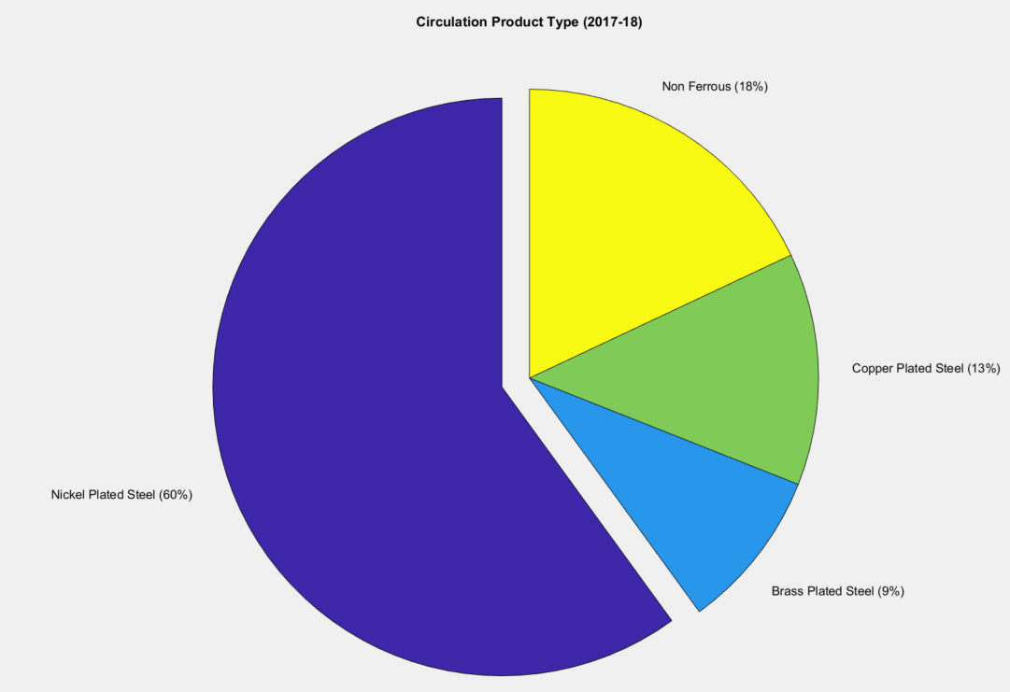
Once it was decided that a team should be formed to resolve this issue, an initial meeting to refine the problem they were tasked to overcome was held. There were discussions on how the team should undertake and manage this issue as a small project and at what stage/department the changes will have the biggest impact once implemented. It was understood that the next downstream process, forming, bare the largest financial burden as they are the department that deal with the repercussions of ‘fliers’. This includes tooling, reduced production and mechanical faults causing downtime. Although forming would not be directly involved in the investigation, s the customer, the team scheduled a meeting with the department team leaders to discuss the needs and expectations of their department. A further meeting was arranged with the customer’s department manager to collate the team leader’s views and form the voice of the customer.

Problem statement
‘At annealing within the blank processing area, it was found that ‘fliers’ were being produced across all annealing furnaces, whilst running nickel plated steel product. The levels of fliers were at approximately 8% with no method of sorting on a production scale. Fliers accounted for 70% of all quarantined batches in the month of September. This is not acceptable for the forming department; how can this issue be eliminated?’

Cause and effect
All repetitive activities of a process have a certain amount of fluctuation. Input, process, and output measures also fluctuate, this fluctuation is called variation. Variation frequently occurs during normal operation of processes. Sources of variation have been input into an Ishikawa diagram. An Ishikawa diagram, otherwise known as the cause effect diagram, show the causes of a specific quality problem in their mutual dependence. Typically, in manufacturing settings, the appearance of the noncompliance is analysed due to main causes such as: Man, Machine, Material, Method, Management and Environment (Dziuba et al, 2014).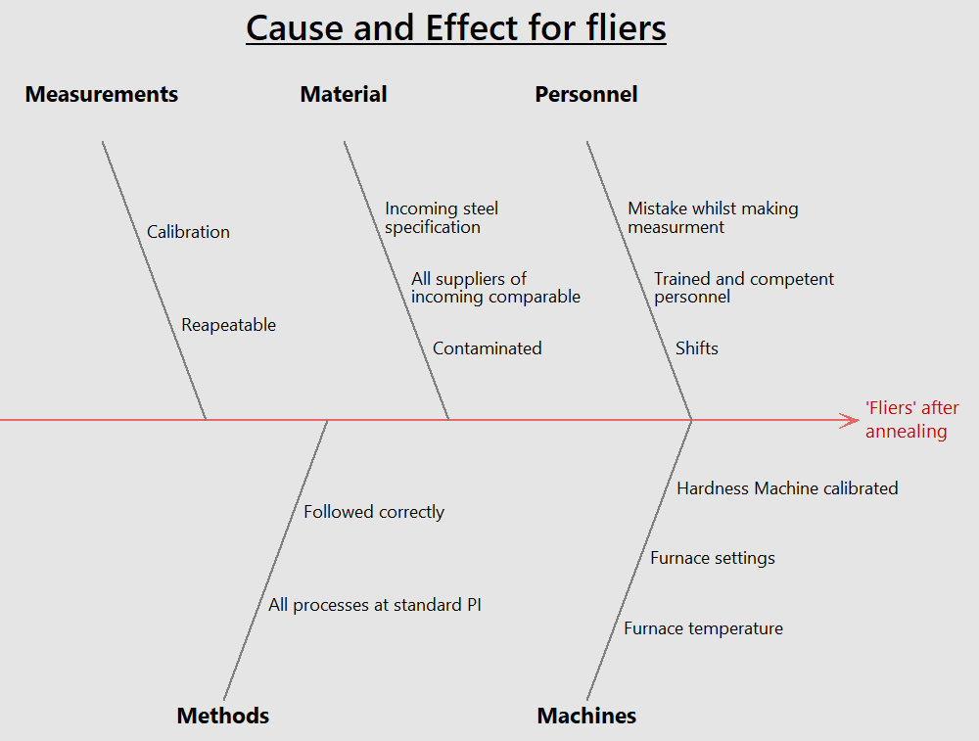

Hardness test

Hardness is the resistance of a material to plastic deformation by scratching, abrasion or indentation. The Vickers hardness (HV) of each test sample was measured with the hardness testing machine. A diamond indentation was made on each test sample using a diamond tipped indenter with an applied load of 30kg. Each load was applied for 15 seconds and removed. The diameter of the indentation was measured and the Vickers hardness was calculated using the values of the applied load and the diameter of the indentation.
HV = 1.854(F/D²)
The hardness machine is measured by an independent contractor every six months, as well as an internal calibration taking place once a month.

Scope
From the cause and effect analysis there were areas of the investigation that could be eliminated from the team’s study as there was no value to further exploration. Also from the brainstorming session, some previously identified possible causes were examined and became exempt from the rest of the investigation.

Process route
To understand the issue, the process route must be looked at in detail to highlight areas in which the defect could be produced. Below is the process route of nickel plated with each of the possible defect sites highlighted.
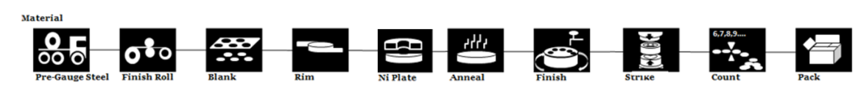
Knowledge of this process and the cause and effect diagram, gave the team areas of the business to target.

Charter
A charter was drawn up by the team tasked with the investigation and resolution, that detailed the objective, deliverables, key milestones, resources, benefits, measures and critical success factors to the project.
Objective | Deliverables | Key Milestones | Resources
To reduce the amount of product quarantined for fliers by 100% | Analysis of the problem.  Implemented corrective actions. | Agree team week 27  Start Project week 27  Scoping and initial data sort week 28  Route cause analysis week 29  Corrective actions week 30  Report and complete week 31 | SC – Sponsor  RD – Process manager  AC – Process lead
Benefits | Measures |  | CSF’s
Reduction in working capital due to reduced quarantine stocks.  Improvement of die life at forming | Total quarantine stock for fliers.  Furnace temperature profiles |  | Availability of annealing furnaces  Access to data from all departments  3 weeks of allowable time to determine root cause

Measure Phase

Data collection
There is a very good data collection application used by the business, every container of product has a barcode that holds information about the product inside. The bar code holds information in the process route the product has to take, the processes that it has already completed, its weight, if it is good work or quarantined and if it is quarantined, the reason it has been quarantined for. Each and every movement is scanned in to the central database with a record of the date, time and who has made the movement. Critical to quality process checks associated with each container can also be accessed through the database, giving a huge amount of data for the product.

Process capability
Process capability analysis is a well-established statistical technique with wide application in product life cycle, process design, manufacturing process planning, and as well as in actual manufacturing at shop floor level (Podder et al, 2018). A process capability was carried out to determine the ability of the annealing process. Capability studies are beneficial to improve quality of products by identifying root cause of variation and eliminating such causes during the production process.
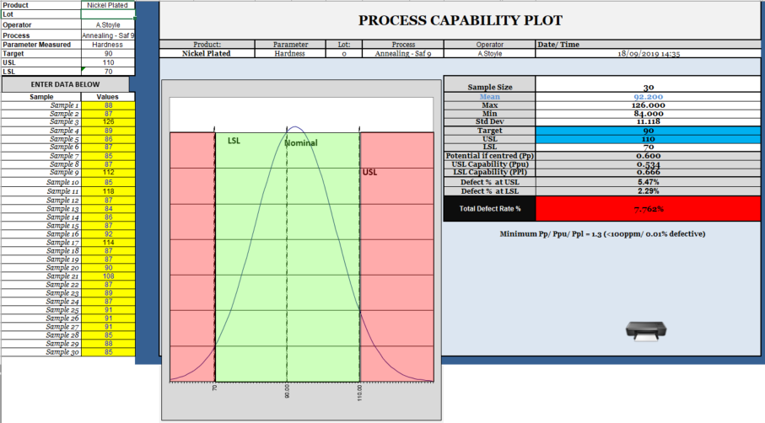
The study shows that the process is currently inadequate to satisfy the forming department. It is clearly evident that measures must be taken up to reduce variation in hardness.

Thermal profile
It was decided by the team that the actual temperature of the furnaces producing the defect should be measured and compared. This data was captured using a twenty-five-metre-long thermocouple attached to a data logger. The thermocouple was passed through the furnace at standard speed and temperatures whilst placed into a body of nickel plated steel disks. Firstly, the data was compared to the digital readout displayed by the furnace. The data was then cross referenced with maintenance logs from when critical machine parts/kits were replaced or repaired, to investigate if there is a correlation with the incidents of the ‘Flier’ defect.
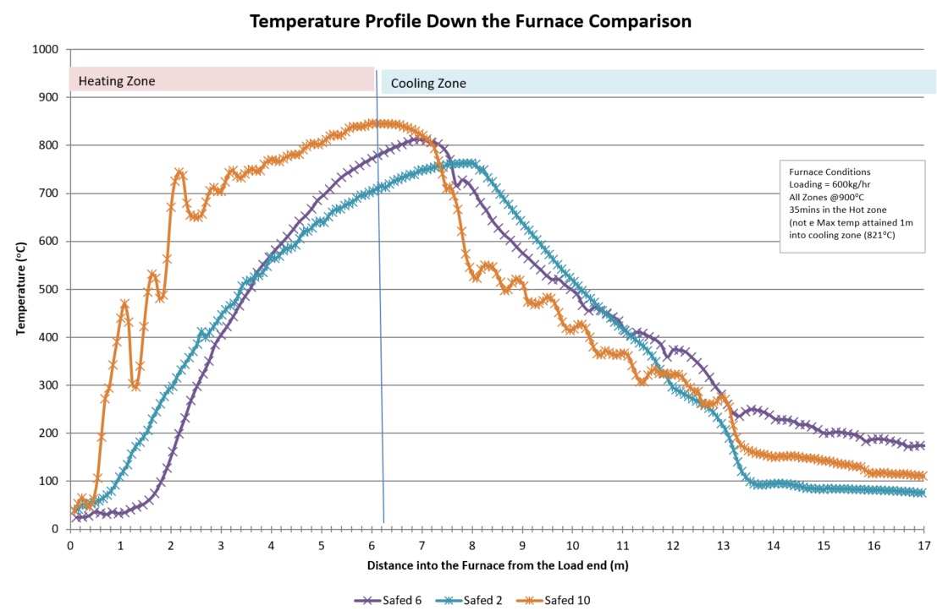

Material composition
Three steel disks from each supplier were tested for composition. The results are displayed below with the columns highlighted in yellow the constituents which may have the greater influence on hardness and the cells in orange are ones which differ significantly from the others. All the data collected was compared to the organisations supplier specifications (see appendix).
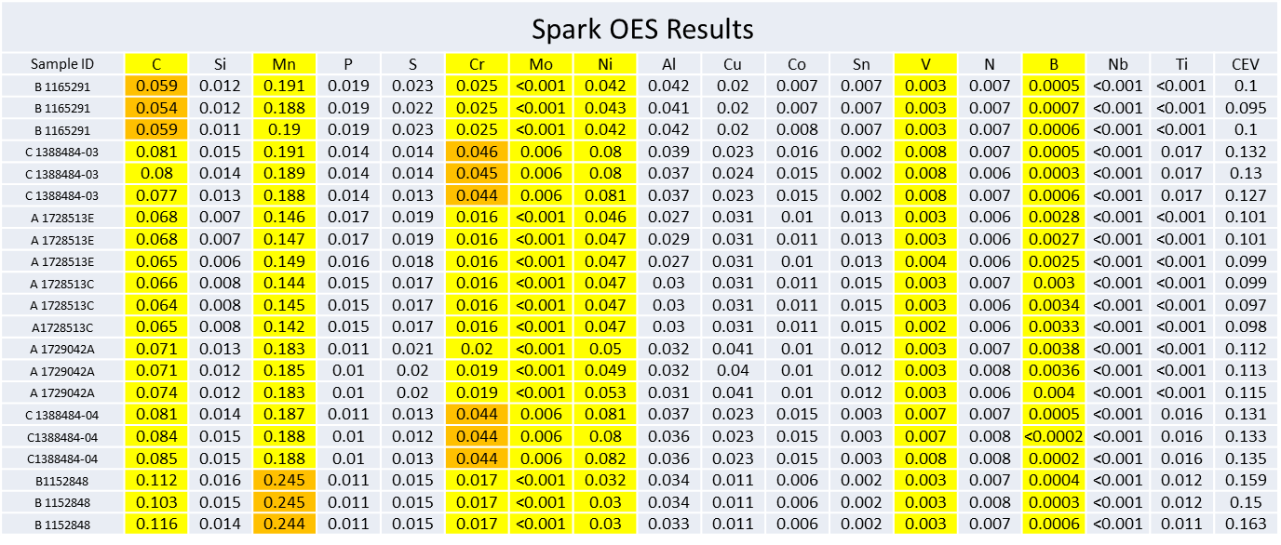

Incoming material data
Before disks are manufactured the steel is bought in from different suppliers at a standard gauge, then rolled to the correct gauge for the product that is to be produced. Rolling is a cold working process whereby a coil of material is passed through two rollers whilst below recrystallization temperature. Achieving final gauge can take a number of attempts, dependant on the final product specification. This is called reduction and is measured as a percentage. There are two different mills at the organisation, the frohling mill and the finishing mill. Both are used for the same purpose. As all material is delivered with a certificate of conformity, minimal data is collected at this stage.
For the purpose of identifying root cause of the ‘fliers’ issue, it was decided that data from the three different suppliers should be collected, where possible, at different stages of rolling.
From the data (below), the effect of rolling the product to the correct gauge the mechanical properties of the material are altered significantly. This is due to a change in microstructure as a consequence of work-hardening.

 | HARDNESS CHECKS ON INCOMING MATERIAL
 | INCOMING STEEL
Supplier | A | A | A | B | C |  | A | A | B | C
Coil Number | 1728513E | 1729042A | No coils | 1165291 | 1388484-04 |  | 1728513C | No coils | 1152848 | 1388484-03
Gauge | 2.0mm | 2.0mm | 2.5mm | 2.5mm | 2.5mm |  | 2.0mm | 2.5mm | 2.5mm | 2.5mm
Carbon content
Hardness (VPN) HV 30 | 95.8 | 101 |  | 124 | 120 |  | 98.4 |  | 107 | 118
 | Rolled / Blanked steel
Mill | Finishing | Finishing | Finishing | Finishing | Finishing |  | Frohling | Frohling | Frohling | Frohling
Final Gauge | 1.143 | 1.143 | 1.143 | 1.143 | 1.143 |  | 1.143 | 1.143 | 1.143 | 1.143
% reduction | 42.85% | 42.85% | 54.28% | 54.28% | 54.28% |  | 42.85% | 54.28% | 54.28% | 54.28%
Amount of passes | 2 | 3 | 4 | 4 | 4 |  | 1 | 2 | 2 | 2
Hardness (VPN) HV 30 | - | - | - | - | - |  | - | - | - | -
1st pass | 150 | 137 |  | - | - |  | - |  | 174 | 181
2nd pass | - | 161 |  | - | - |  | - |  | - | -
3rd pass | - | - |  | - | - |  | - |  | - | -
Final pass / Gauge | 174 | 172 |  | 210 | 207 |  | 177 |  | 207 | 210
Hardness after Blanking (Average of 30 sample) | 171 | 176 |  | 211.93 | 207.73 |  | 175 |  | 193.53 | 208.73
Complete
 | INCOMING STEEL
Hardness spec | <140 HV30

Processed material data
It was decided from data captured whilst investigating the compositional and mechanical properties from different suppliers, that each should be processed individually and the data captured. Below is a table showing the hardness of each material by supplier.
Coil | Batch 1  Annealed 2.5mm  Supplier B  1 Pass Frohling Mill | Batch 2  Annealed 2.5mm  Supplier C  Finishing mill | Batch 3  Annealed 2.0 mm  Supplier A  2 Passes  Finishing Mill | Batch 3  Finished 2.0 mm Supplier A  2 Passes  Frohling Mill | Batch 4  Annealed 2.5mm  Supplier B  Finishing Mill | Batch 5  Annealed 2.0mm  Supplier A  1 Pass  Frohling Mill | Batch 5  Annealed 2.0mm  Supplier A  1 Pass  Frohling Mill | Batch 6  Annealed  2.0mm  Supplier A  3 Passes Finishing Mill | Batch 6  Annealed  2.0mm  Supplier A  3 Passes Finishing Mill | Batch 7  Annealed 2.5mm  Supplier C  2 Passes Frohling Mill
Mean | 106.8 | 127.2 | 89.3 | 95.5 | 107.5 | 94.6 | 96.9 | 93.4 | 95.0 | 116.8
Min | 90.0 | 118.0 | 85.0 | 86.9 | 91.0 | 83.0 | 89.0 | 82.0 | 82.0 | 104.0
Max | 120.0 | 136.0 | 96.0 | 111.0 | 118.0 | 99.0 | 112.0 | 99.0 | 102.0 | 127.0
Range | 30.0 | 18.0 | 11.0 | 24.1 | 27.0 | 16.0 | 23.0 | 17.0 | 20.0 | 23.0
Incoming Coil Hardness | 107 | 120 | 95.8 |  | 124 | 98.4 |  | 101 |  | 118
Difference annealed v coil hardness | 0.2 | 7.2 | 6.5 |  | 16.5 | 3.8 |  | 7..6 |  | 1.2

From the above data, it can be seen that all 2mm gauge from supplier A were of an acceptable standard. This data was surprising to the team and a GEMBA walk was conducted of the rolling area. GEMBA is a term within manufacturing organisations referring to a place that creates value, usually the factory floor (Serena, 2019).

Analyse Phase

Pareto
Pareto analysis is regularly carried out across the organisation. Named after the Italian economist – Vilferdo Pareto, Pareto analysis is a simple and effective statistical method which ranks the items in decreasing order of their frequency. The total frequency is then summed up to 100. The chart represents the various factors in descending order and a clear pointer which overlays the line graph (Bajaj et al, 2018). The Pareto Principle, suggested by management consultant Joseph Juran and named after Italian economist Vilfredo Pareto, refers to the concept that in many systems, roughly 80% of the effects come from 20% of the causes (Daly, 2016) .
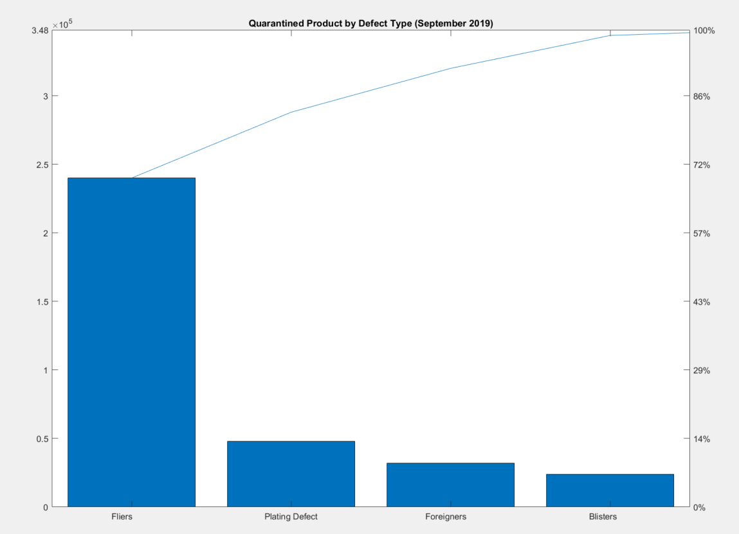

It can clearly be seen by the Pareto chart that ‘Flier’ defects were by far the worst category of defect within the blank processing area.

A3 problem solving report
According to Sobek and Liker, the A3 problem solving too was created by the Toyota Motor Corporation. The A3 Problem Solving Report is a tool that describes how consensus on complex decisions can be efficiently reached. Much like the DMAIC problem solving tool, the background to A3 reports are based on the Plan-Do-Check-Act cycle, a high level problem solving algorithm developed by Walter Shewhart in the 1930s (Shewhart, 1939). This tool was used by area team leaders at the time the incidents were occurring. It was important to capture data whilst the event was taking place, to ensure staff that were not available at the time were presented with precise data.

Ishikawa
The project team revisited the cause and effect analysis with the premise of, what will cost the least to change and give the biggest impact. This

5 Whys
During the fishbone analysis, an exercise called ‘the 5 whys’ was carried out with the operators and team leaders. This exercise is designed to help get to the root cause of problem. By the end of the exercise it became clear that the furnaces were not achieving temperatures which they were set at, although, recrystallization was taking place on 92% of nickel plated disks. It was also questioned why composition varied so much between three different suppliers, yet, all samples analysed met the specification of pre gauge mild steel for electroplating.

Asset care
The furnaces undergo regular preventative maintenance. After speaking to the operators and results of the five whys, it became clear that a review of the equipment was needed. The area maintenance manager was contacted and tasked with providing the team with review of the maintenance schedule focussing on thermocouple care.

Histogram
From the process capability data gathered in the measure phase, a histogram was created for quick analysis of the data. A histogram is a frequency bar graph that takes measurement data and displays its distribution. It shows the frequency with which data falls into specific categories.

GEMBA
Within the organisation, the term GEMBA is used when you visit an area of the business in person, usually as a group to carry out analysis or an audit. GEMBA walks were developed at Toyota and is a term which means ‘the real place’. This in-person observation allows teams to see the difference between what they assumed is happening, and what is actually happening. It also gives a chance to interact with the people doing the job and see exactly where it is done, as opposed to imagining it from another area (Six Sigma Daily, 2018).

Conclusion
The problem of ‘fliers' was a good example of an issue/defect that could be solved using six sigma theories and the DMAIC methodology. The brief that was given to the team before any work was completed was simple. After initial meetings, the scale of the task became evident. The team correctly defined the project to give a clear scope and created a charter to measure against. The customers were identified and their feedback was received with expectations outlined as a result of the investigation. Operators and team leaders were involved with the cause and effect exercise, along with discussions using the 5 why analysis. The engineering department were called upon to ensure that the equipment was fit for purpose.
The organisation possesses an industry leading data collection application along with procedures with which staff have a full understanding of. There was more than enough data either within its database or manually measurable available to the team. The A3 was carried out at the time the incident as is standard procedure at the organisation, establishing factual information at the time of the event. This allowed for a good baseline to compare against any newly gathered data.
All analysis was carried out by the team involved, analysts, quality, maintenance and production staff. It was important to do this exercise as a large team, due to each department possesses unique knowledge of the processes and equipment. This was useful in eradicating and challenging theories that added no value. Using the cause and effect diagram, along with the process route and measurements from multiple departments throughout the organisation, it was suggested that further investigation into the variation of incoming material from three different suppliers. As part of the GEMBA, it was discovered that batches are often mixed within containers.
The process followed allowed the organisation to define the root cause of the issue through data collection and working procedures. Batches from rolling are no longer mixed and the issue has been resolved. Analysis is continuing into percent reduction and material composition effect on achieved hardness.

References

Bikramjit Podder, TD. (2018) Process capability study of flow formed shell diameter. Materials Today: Proceedings 5. pp. 27094–27099 .
Daly, K. (2016). Pareto Principles in the Boardroom. Director. pp. 4.
Harvey, J. (2004). Match the Change Vehicle and Method to the Job. Quality Progress. pp. 41 - 48.
Liker, JK. (2004) Make decisions slowly by consensus. In: The Toyota way: 14 management principles from the world’s greatest manufacturer. New York: McGraw-Hill. pp. 237–249.
Rose, I and Whittington, C. (2014) Nickel Plating Handbook, (Second Edition) Brussels: Nickel Institute.
Serena, M. (2019, 11 18). What is Gemba: Definitions and tools. Retrieved from insights.btoes: http://insights.btoes.com/resources/what-is-going-to-gemba-lean-kaizen-definition-introduction
Shweta Bajaj, RG. (2018) Total quality management: a critical literature review using Pareto analysis. International Journal of Productivity and Performance Management. pp. 128 – 154.
Six Sigma Daily. (2018, January 17). Six Sigma Daily. Retrieved from https://www.sixsigmadaily.com: https://www.sixsigmadaily.com/what-is-a-gemba-walk/
Sobek DK III and Smalley A. (2008) Understanding A3 thinking: A critical component of Toyota’s PDCA management system. Boca Raton: Productivity Press. pp.165.
Shewhart DA and Deming WE. (1939) Statistical method from the viewpoint of quality control. Washington, D.C: Graduate School of the Department of Agriculture. pp. 155.
Szymon, T and Dziuba, MA. (2014) Applying the 5 Why method to verification of non-compliance causes established after application of the Ishikawa diagram in the process of improving the production of drive half-shafts. Production Engineering Archives. pp. 16 - 19.

Appendix


