

Children, Young People and Families
(BMHP5004_LON)

Assessment Component 2

Written Essay

Childhood as a Social Construction

Student name: Achiaa Boakye
Student I.D.: 1916597
Lecturer: Bianca Sanfilippo
Group: One
Submission Date
Word Count 2000

Introduction
This essay about concept of childhood as a construction will focus on the history of how the term childhood came into existence and the history behind childhood during the era of Ancients Greek and Romans time from 16th and 17th century until Medieval and Victoria time, the attitude towards children started to change drastically. This essay will also focus on the factors that led to contribute the changes in legislation and medicalisation of childhood at early stage. To be able to talk about child protection Act 1989, and how it has been created, the term child protection and it related issues of harm and abuse like physical, emotional and neglect cannot be ignored. Again, the essay will focus on factors that have contributed to the changes in recent times and provide some government interventions in UK that support the risk of children under privileged and how best inequalities can be reduced.
Childhood as social construction
According to (UNCRC, 1991) defined term child as everyone at the age of 18 years, under the law is applicable to becomes child, adulthood is achieved earlier. The association aims is to take measures in accordance’s in retaliation to child protection issues that will be steer the affairs of children by putting children best interest at the centre of the problem. (Commission for Human Right 1989) To start with, childhood as a social construction has a level of records globally or universal history that identify the child as innocent, child who is still learning, vulnerable, and who is developing socially, emotionally, physically and cognitively together with other household members. (Prout,2015). Again. Collins Dictionary also defined childhood as ‘’a young human being below the age of pubescence or below the legal age of adulthood’’. Childhood construction has proved to have no universal definition because experience may differ from one family to other or country visa-vasal. For example, a child whose grow from Africa may have different experience from virginal mutilation, early marriage and child labour according to their cultural diversity and socio-economic than a child who’s grow in United Kingdom. For example, when compare Ivory Coast to UK, according to (BBC,2011) Ivory Coast are still exploiting about 800,000 children to work in industries often in dangerous job, because they are the world’s leading chocolate companies. On the other hand, in England, children from the ages of 5 years and 16 years are mandatory to be in school or training until you are above 18years. This shows a clear difference between the two countries in terms of child education and child labour. (GOV.UK, 2021) Moreso, In Africa child marriage is very common whilst in England legal marriage from aged 16 and above. (Children Commissioner,2021). Prostitution in other countries is common but in United Kingdom, its punishable by law with prisons sentencing. The concept of family is recently shifting in UK for example, there are different kinds of family such as single mother family, fostering mother, same sex family and nuclear family. Currently, children needs are affected by family. Family is responsible for the welfare of their children, example, being a single parent needs to work in order to be able to provide for your children.
Throughout the history, childhood have debated by such as Aries (1962), cited in Oliver and Pitt (2011) that researchers and constructive argument of a childhood as babies and infants that were cared for in terms of biological features. However as soon as they can look after themselves becomes mature instantly. On the other hand, Archard (1993) also cited in Pound (2014) failure to acknowledge the views of Aries (1962) that there was no concept of childhood before seventeen centuries only small adults who have same rights, skills and ideas made them to contributed towards the societies. Another concept from Rousseau (1712) argues that childhood seem innocent and born as angel until childhood was influence by the world. This means the conceptualization of childhood has tremendously changed throughout the history to the modern days of childhood.
The construction of European childhood identifies three major problems such as children were treated as evil and wildness between 16th and 17th century. Again, children were seen as blank slate but not evil or good between (1632-1704) and can be shaped through education propose by John Locke.
Again, during the Romans and Ancient times, infants' mortality rate was too high that babies were not named immediately they were born. Babies were left exposed to die especially females, however, female children with low income between seven years were made to stayed home with mothers to help house chores and assist their young siblings, whereby the middle- and upper-class children were encouraged to learn a trade or play music and football. (Wright,2015).
During the revolution era, (1760-1803) lower class children were exploited deliberately to work in factories and mills for longer hours with small paid. (Wright,2015) until Victorian era between 1837-1901) Britain population started to grow a big difference towards families with the middle- and upper-class. Society realizer the needs of children and decided to be developed new strategies system for them whereby children from the riches were protected and cared for by nannies and government, but children from the poor were left to become pick pocking, work in bad condition and sometimes left to die dues to severe injuries at factories and mills without taken them to hospital for treatment. Again, there were gender inequality whereby girls were given out marriage at the tender age fifteen and boys were allowed to become builders, coppersmith and other work. Because Children condition were deteriorated policies like health and education policy was introduced to help relieve the stress of under privileged children and set up certain hours and age on work and education. 19th century during the latter part of Victoria, Education system became compulsory through the increase in funding by government and raising of school leaving age. Again, policy that was introduced to restrict child labour becomes very important instrument leading to exclude children from paid jobs.
The medicalisation of childbirth and early childhood reduced infant mortality rate by providing comprehensive maternity care to mothers and babies through NHS. The policy that paved way for children to get more money to spent towards child development also assist mothers to engage their children frequently or actively. Moreso, the introduction of child protection and welfare legislation has also encouraged the aspect of child service through safeguarding policy. Furthermore, the idea of child Right introduced by united Nations Convention (1992) has also given children the voice to speak out in society.
There are numbers of factors that has also help in contributing to the changing live of children through Victorian time until recent time and helping to reduce the inequalities amongchildren and adolescent together the right of all children such as policy and legislation.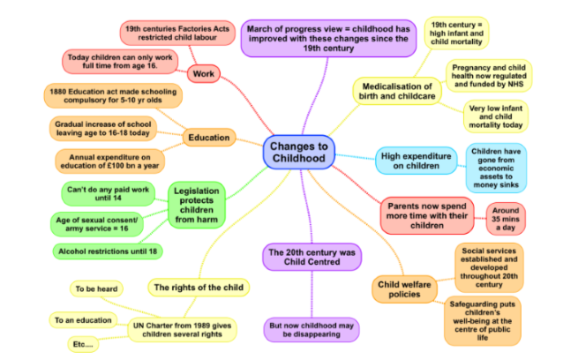
Legislation: The introduction of safeguarding policies such as “ United Nations Convention on the Right of Child” ( NNCRC,1992) in England in assisting education, work and child health and safety through 1833 factories Act in 19th century which put an end to child labour at the age of 9 and supported today laws about child employment law that states that children must stay in schools until the age of sixteen (GOV.UK, 2021).This part of legislature supported child labour to make sure children are protected from harm and abuse and children are not exploited but stays in education in shaping and changing the lives of children and that has help gradually towards “child centre society”.( UNICEF,2016). The legislature related in education in 1880 called Education Act, introduced mandatory education for all school age children between ages of 5-11 years old. Just recently the law in the UK changed mandatory education from 5-16 years in full education until 18years of age (GOV.UK, 2021). In doing the policy of mandatory education has helps to eliminate children from factories and helps to change the lives of children.
Another legislation that safeguards children from abuse and harm such as sexual consent at the 16 and alcohol restriction under the age of 18 years. This piece of instrument has made a lot of impact and contributions in the lives of teenage children. According to (NHS,2021), early alcohol consumption is harmful and reduced the healthy development. Furthermore, Childline (2021) also secure the protection of child from sexual abuse as sex with a child or teenager is serious offence or breach of law under UK law as a child have no capacity to give consent. Again, the introduction of United Nations Conventions of the Rights Child (UNCRC,1991) was very important as it was able to ensure every child have a right to life, education, non-discrimination supporting children from harm and abuse and healthy growth, (Save the children, 2021).

Sociological factor
The emergence of child development stage and as a subject matter has help in promoting the necessary things and pinpoint the importance of providing good childhood memory to all children and highlighted the negative influence on a child development in future. Neurosciences provide evidence by damages cause on children’s brain within the five years of the developmental stage. Child development and neuroscience has contributed immensely to the lives of children developing stage and this has impacted sociological factor as now parents spend more time with their children. As neuroscience stress the importance of every child having stimulus environment to growth. Child development also consist of different characteristic of many aspects and services in a society. For example, government spending more money on free healthcare (NHS). Another vital theory of child development that impacted children services was Bronfenbrenner (1977) ecological theory argue that child development controlled by five different components related to external family. such as microsystem: the child and mesosystem the family, teachers, nursery and play group the relationship they have with them play important part in their developing stages. The Exosystemic that consist of health services, people in a community, friends, and external part of the family. And last but not the least, the macrosystem that deals with the law, legislation and values in the society.
Physiological Needs
Again, Maslow also present another theory of physiological needs. According to Maslow ask (1954) there are basic human needs that needs to be achieved to be able to become self-actualisation, means achieving full capacity needs to other needs in a scale of preferences. The common needs such as food, water and toilet.
Safety needs such shelter and protection. Human good relationship that makes us feel secured.
Love belongingness needs that support in making friends and relationship
Esteem needs: being self-confident and respect to others.
Self- actualisation needs achieving full capacity.

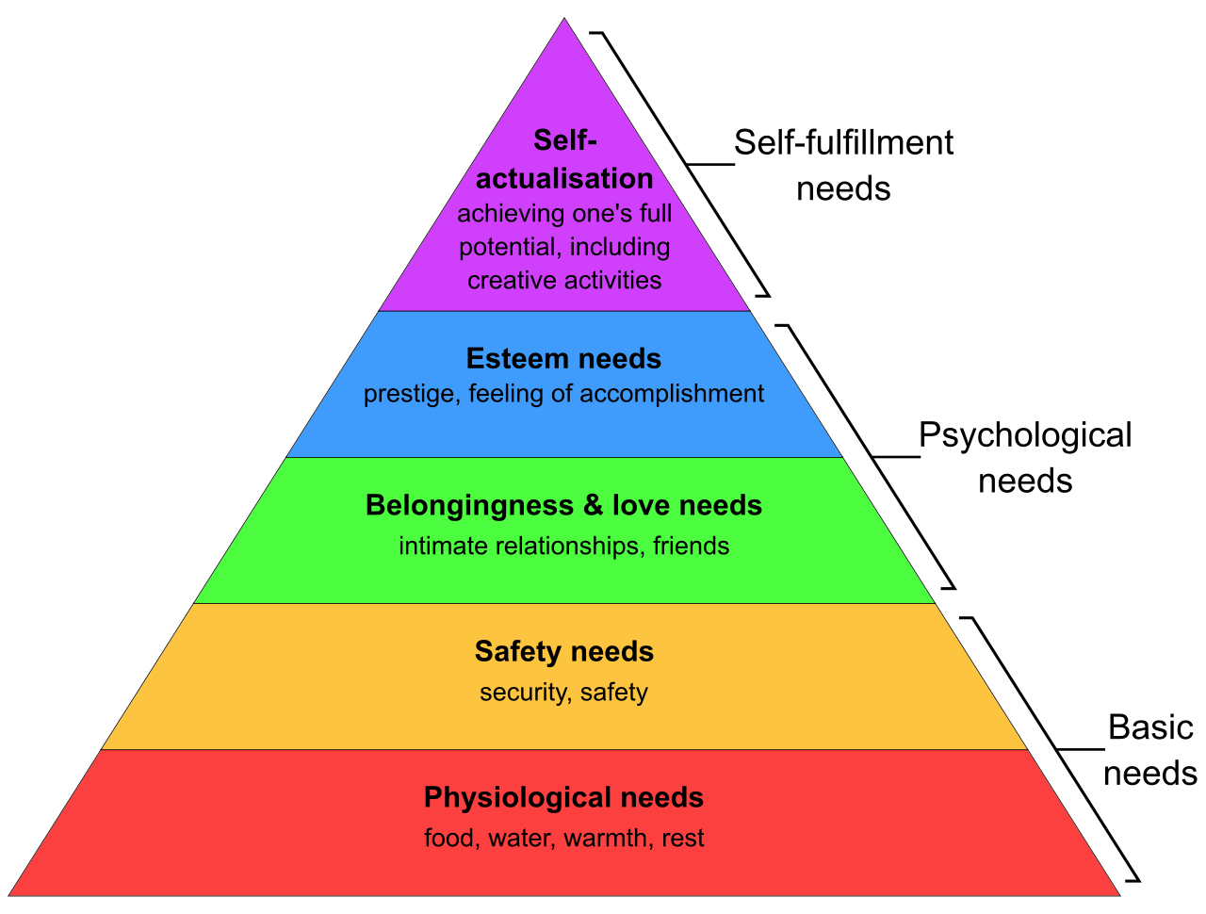
https://simple.wikipedia.org/wiki/Maslow%27s_hierarchy_of_needs#:~:text=By%20Androidm

There are several legislations that protects and safeguard children from abuse such as policy working together to safeguard children. “A guide to inter-agency working to safeguard and promote the welfare “(2018) ensures the multiagency intervention when a child is endangering or at risk.
For example, UK, there are several policies that see to the needs of child well-being such as child benefit, child tax credit, universal credit and free school meals depend on your parents’ income.
Again, there are a lot of social intervention and approaches to support families and children in reducing inequalities such as GP, NHS, free dental care, 15 hours for child day care to support mothers to go back to work. And free school meal for those who qualify at tier one level.
At second tier whereby families and children started to experience difficulties situation and there is a need for these targeted services like school counselling and parental programme to support the child and the parents.
Tier three targeted service is very important for parents to be able to access specialist services for children with disabilities and mental health issues. These special needs cannot be met without the involving the Children Social Care (Children Act 1989) another agency for assessing and referrals
Tier four is also vital for parents with complex needs such as child protection Impatient child, autism child or adolescent with mental health issues and children in the adoption plan and who are involve in the criminal justice system. This kind of services always lead by social service and other statutory requirement.
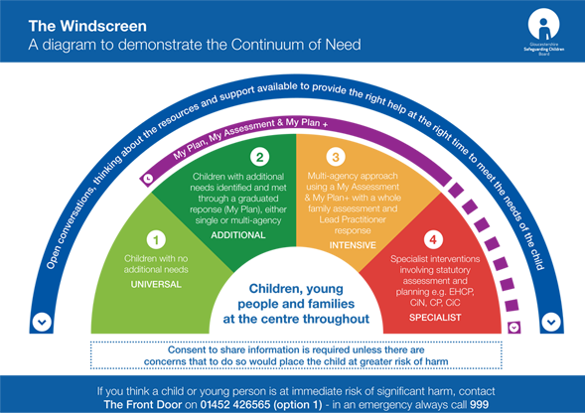

Again, many social intervention and approaches that has helps in reducing social inequalities among children and support their well being such as free school meal. According to neuroscience, about 90% of a child brain develop at early stage so for a child to have free access to free school meal is very crucial or important period that lays foundation for children lives and set better path toward creating more defendable societies. Furthermore, free school such as breakfast club support children to interrupt and bond with their school classmate. Also, for a child to be able to access free school meal boost their physical, emotional and cognitive to be able to function well and concentrate in class activities. (Bronfenbrenner, 2005)

Conclusion
Despite the fact, the lives of children have changed drastically compared to the Romans and Victorian’s years. However, there are still number of children who are still under privileged or live below the threshold according to (Budget,2018). Majority of children in poverty lives with working family. This has course for serious attention to reform the Universal Credit (UN) for families with children that can keep most of their wages. Again, society believe work should eliminate poverty, yet record from 2016/2017 indicates that one million working families are cut off in poverty for the past three years, this shows that about three million children are connected in poverty, despite living with working families. These indications set to rise in future if nothing has been done as Uk prepared for Brexit there is a need to build a better way by restructure the format for universal credit to support the income of about 10 million families and children in a low come working families is very crucial as it was indicating in 2018 financial budget. Again, I will suggest that there should be free school meal for all children in poverty living with working families. According to (Department for Education, 2018) early intervention is more important to give to children or family when the problem becomes visible than to wait for the problem to escalate before intervening as the policy highlight the instruction in department for education. Early intervention is the key to solved problems.

Reference
Bronfenbrenner, U. (2005) Making human beings human: Bioecological perspectives on human development. Thousand Oaks, CA: Sage
Center of the Developing Child – Harvard University (2021) Three Core Concepts in Early Development https://developingchild.harvard.edu/resources/three-core-concepts-in-early-development/(date accessed: 02/08/2021).
Kehily, M.J. (2013) Understanding Childhood: A Cross Disciplinary Approach. Milton Keynes: Open University Press.
Maslow, A.H. (1954) Motivation and personality. New York, NY: Harper & Row Publishers.
UNICEF (2014) Neuroscience is redefining Early Childhood Development. (online) Available at: https://blogs.unicef.org/blog/neuroscience-is-redefining-early-childhood-development/ (date accessed: 02/07/2021).
https://www.gov.uk/know-when-you-can-leave-school (Accessed: 10/08/2021)
https://www.cps.gov.uk/legal-guidance/prostitution-and-exploitation-prostitution (Accessed: 10/08/2021).
https://www.jrf.org.uk/report/budget-2018-tackling-rising-tide-work-poverty?gclid=Cj0KCQjw0K-HBhDDARIsAFJ6UGhZziANnA9pas7QwIN6Xz9hX6uo5yYhrdFSoi4LBGXM3qYOj0IrT-saAtxcEALw_wc
https://www.sustainweb.org/childrensfoodcampaign/free_school_meals/ (Sustain, 2021

