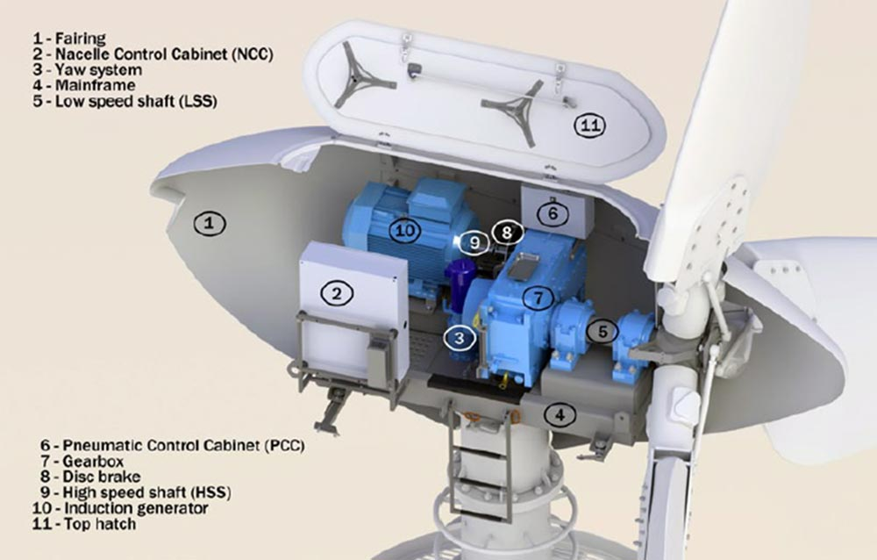
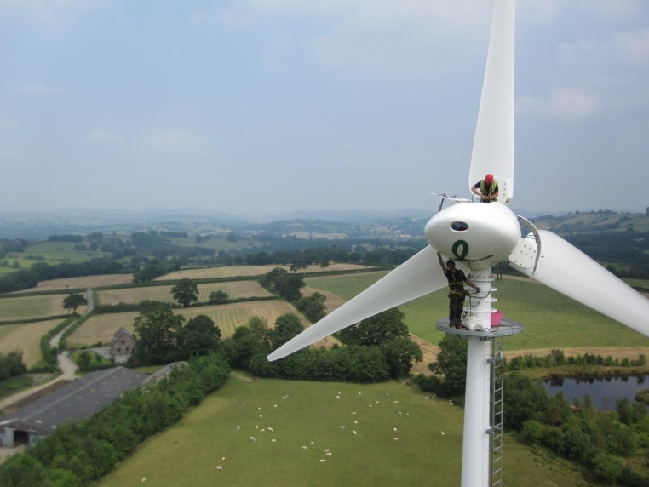
What are the main components on an endurance wind turbine?
In this section of the presentation main components are looked at and where they are located on the turbine. in figure two, shows what the inside o the nacelle looks like. There are also component names and there are corresponding to the numbers.

Figure 2 – 03/04/2022
In this presentation the subject is focused on the main components on an endurance wind turbine
What is an endurance wind turbine?
In figure one shows what the endurance 50kw wind turbine looks like. The endurance wind turbine is a type of turbine
Figure 1 – 03/04/2022
Endurance 50kw wind turbines

