

Title page
Student name: Nusrat Yasmin Shitara
Student number: 1712117
Module: Project Planning and Management in Workplace
Module code: BMSW5004
Assignment title: Project Planning and Management in Workplace
Tutor name: Paul Ranson

Contents
Introduction 3
Company overview 3
Possible risks of the project 4
Tools and techniques 4
Steering group 9
Stakeholders communication/engagement 10
Personal reflection, recommendation 10
Self-development plan 11
Conclusion 12
References 13

Introduction

Vintners Antiques shop is a family run business and are looking to move their business from Shirley to Sparkhill. They have seeked the help of our company to assist them with this project. We will provide a critical assessment of the risks associated with the project by using project management tools and creating a user story. Some of the tolls we used were the Delphi Forum, the MoSCoW method, and a Gantt chart. We have shown how a live Gantt chart will be used to communicate the project plans to the stakeholders. Finally, we have provided a personal reflection of our ability to manage the project, with future recommendations and improvements we could make to improve our own performance.

Company overview

The Vintner family have run the business for decades. The business in now on its third generation of owners. The owner’s grandfather had bought the shop over three decades ago.
Member of the Vintner’s Antique group | Role
Doreen Vintner | She is an accountant and runs a light business. She abides by all rules of the business
Denis Vintner | He searches for the antiques and is highly passionate about them
Suha Madani | She handles the customer service aspect of the business and is liked by most people
Omar King | He is a general all-rounder and has worked at the warehouse since he was young,
Paul Ranson | He is a friend of the Vintner family and knows all about the business, being able to help with any questions we may have

The family have had a really good offer to buy the shop that they own outright in Shirley. This is very exciting for the family because they are aware that the shop is not as successful as it previously was. They also own a warehouse in Sparkhill. It is very basic and has only been used for storage. The warehouse is simply a lockup, with no electric, phone or internet. There is no office space and only a concrete floor.
Now they want to move location from Shirley to the new warehouse in Sparkhill.

Possible risks of the project

  - Misunderstandings of roles within the team
As a family business, members of the family may not be clear with what their role entails and what is expected of them, therefore could pose as a potential risk to the whole project. It is important for all members of the family to communicate well, so any misunderstandings and mistakes can be discussed and corrected.
  - User stories
We created user stories without the involvement of the business, so they are not aware of what we must have, want to have, could have and would be nice to have. They may not understand what we want to do nor why we may want to do it, meaning we would have to create the user story all over again while involving them, which isn’t very efficient.
  - Planning
Planning may not be done in enough detail or haphazardly so problems may arise e.g. suppliers not being able to meet the demand for resources or not being able to deliver goods on time. These obstacles are unforeseen and can have a detrimental effect on the overall quality of the outcome of the project.

Tools and techniques

  - Iron Triangle
The Iron Triangle is a model of the factors that can affect a project in project management. The three factors are scope, schedule and cost and the ability to control and adjust these has been linked to being successful in project management. Scope is the number of and complexity of tasks in the project. Cost it the funding and resources that are needed to complete the project. Schedule is the time given to complete and deliver the project. This project management tool highlights that the project manager should be able to reach a reasonable conclusion based on these three factors.
Project managers have the tough task of trying to find a balance between the project delivery and the overall quality of the project as well as the key factors that limit the project. A project’s quality is, therefore, restricted by the amount of funding it receives, as well as the resources it can access, any deadlines and dates that tasks need to be completed by and the amount and complexity of tasks the project consists of.

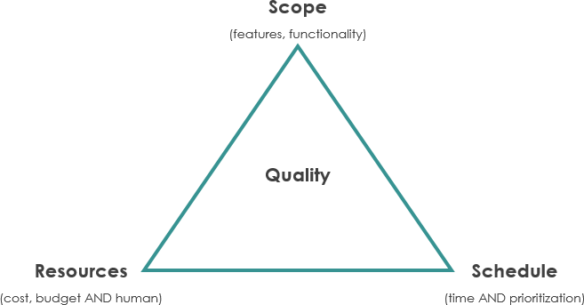
Figure:1 Iron Triangle

  - User story
User stories are short natural sentences and informal language descriptions of the attributes of software systems that are often noted down on post it notes, index cards or in project management software. They may be written and annotated by a variety of stakeholders such as users, managers, clients and development team members, depending on the project.
The format of a user story should be:
As a someone, we need something, for some reason

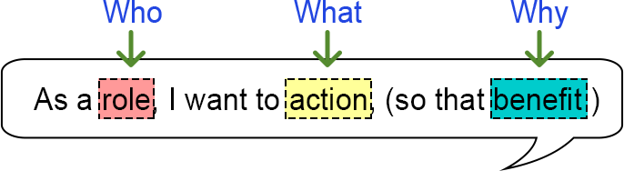
Figure:2 User Story

In the diagram above:
Role = person/system that may collaborate with the system that is in place to reach a specific goal.
Action = a user's expectation that can be reached through collaborating with the system.
Benefit = value that is astern the collaboration with the system.

  - Chevron (Moscow)
When it comes to managing a project, having a deep understanding of what the customer requires and their priorities is critical. The chevron approach attempts to work out what must be done and what would be nice to have. Many projects begin with basic criteria of what the customer requires, but later realise that the customer’s needs haven’t been fully understood.
Once a clear criteria has been set, ranking and ordering them is essential. This is helpful to all as it aids in understanding what parts of the criteria are of high importance and what carry less importance, what order they should be developed in and what is oaky not to be delivered if there is a shortage of resources.

A good method for creating a prioritised and ordered list of requirements is the MoSCoW method.
MoSCoW stands for:
M = must = these must be included to meet the needs of the business
S = should = if possible, these should be included
C = could = these could be included if other aspects of the project are not affected
W = would = these would be nice to include
The Must criteria is the most important as failing to meet even one of them will lead to the failure of the whole project.
To be able to deliver a successful project, it is necessary to have a list of requirements that are clear and have been discussed with and agreed to by the customer, along with a timescale, criteria and overall objective.

Figure:3 Moscow Method
  - Delphi technique
The Delphi method is a framework that is built on the answers from questions that are sent to a body of experts. This method is helpful at coming to collective decision or conclusion, based on the questions that the body had answered earlier. The body of experts go through multiple rounds of questioning, and through each round, the answers are shown to the group, while being kept anonymous. As each round passes, if a member of the body finds their interpretation of the ‘collective response’ has changed, they are given the opportunity to change their answers. Through consensus, the Delphi method looks to reach a response that is correct, due to the several rounds of questioning and the body being exposed to what the group thinks collectively.
Firstly, the group coordinator gathers a body of experts who specialise in the topic that is being discussed. After those that are participating have been confirmed, members of the body are given the questions, and are instructed to note down their thoughts on each topic, taking into account their personal opinions, experiences, and any prior research they may have done. The questionnaires are then given back to the group coordinator who gathers the notes and makes printouts of them. These copies are sent to each participant, along with the opportunity to comment further.
At the end of each session of discussion, all the notes are returned to the group coordinator who makes the decision of whether another round is necessary or if the results from these discussions are ready to be published. The rounds of questions and discussions can be repeated as many times as needed to achieve a sense of consensus. The final result should be an accurate consensus of the group’s thoughts.

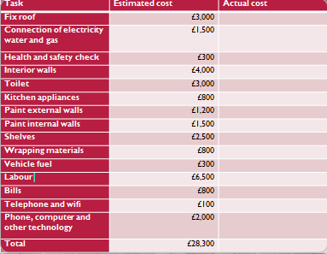

Figure:4 Delphi Technique

  - Gantt chart
The Gantt chart is a highly effective and useful way of showing activities and tasks and the amount of time they need to be completed. On the left, a list of activities can be seen. Along the top, a time scale can be seen Here, a bar represents each task, with the length and positioning of the bar reflecting the duration, start and end date of the according activity. This allows you to see:
The many tasks and what they are
The date that each task starts and ends
Overlapping activities and how much they overlap
The dates that the whole project starts and ends
In summary, a Gantt chart displays what must be done and in what time period it must be done in.
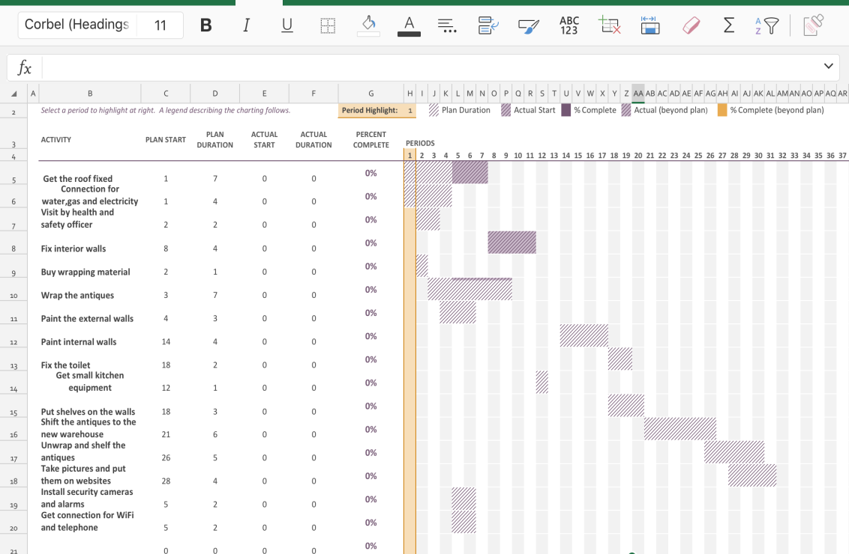

Figure:5 Gantt chart

Steering group

A steering group is a collection of experts who look over and observe a project to make sure that everyone is following protocol, and provide advice and help where deemed necessary. Below are the members of Vintner’s steering group:
Doreen is the sponsor of this project. She is the accountant of the company and has got a clear idea about the financial side of the company.
Deniss is the antique expert and displays a lot of passion towards it. She is the specialist so will know how to handle the antiques, e.g. how to pack the antiques, how to store them, how to move them and how to deal with problems such as restore damages.
Suha is the office manager. She is liked by most people so they will be willing to carry out any instructions given by her.

Stakeholders communication/engagement

Stakeholder engagement is the process used by a business or organization to communicate and engage with stakeholders, which usually outlines a clear purpose of achieving outcomes that have been agreed to by all stakeholders.
It helps to improve the relationship between companies and their stakeholders.
  - Stand ups with team
The project management team briefly meet up every morning to review and discuss key points and tasks of the day. This ensures that any misunderstandings and problems can be dealt with and ensures that all members are aware of their tasks for the day.
  - Gantt chart with steering group and sponsor
The project management team uses a ‘live’ online version of the Gantt chart that is shared with the Vintner family so that they can track the progress of the project whenever they want to. This means the Vintner family are aware of all the tasks that are and will be carried out and over what time period.
  - Informal chat with everyone
An informal chat is had with each member of the project management team often. This is an effective way to communicate as people may raise concerns and discuss issues that they wouldn’t have been comfortable with doing in front of the other members of the group.
  - Email
The project management team communicate via email to share documents and work that need to be seen by other members. The members of the team also use emails to discuss any misunderstandings or problems that arise during the development of the project.

Personal reflection, recommendation

Self reflection is the act of taking a look and reviewing the things that you think about and do, and analyzing your motive for these thoughts and actions. Self reflection is something that is beneficial for everyone. One of the main benefits of self reflection is that it can help you identify and come to terms with who you are and set up goals to aid in self-improvement.

  - Team work
A lack of good team work and communication between members of the group made working efficiently a difficult task. Members of the team weren’t clear with what their roles were and what tasks they were assigned to carry out, meaning some tasks were repeated and some were not even done. To improve, the group members need to communicate thoroughly and make sure that everyone is aware and understanding of their roles and tasks before actually starting the project.
  - Lack of resources
A lack of resources made it difficult for members of the project management team to carry out tasks and complete them by the deadlines set in place. This was detrimental to the overall quality of the outcome of the project as members were not able to work as efficiently as they could have, if they were to have the appropriate resources. To improve, the team needs to make sure that all resources that are needed are available, and need to have reserves in place if those resources aren’t accessible.
  - Sufficient planning
The project management team had started the project without a proper plan or structure, leading to a lot of confusion with what tasks were meant to be carried out, by who and when. To improve, a detailed plan needs to be created and discussed with all members of the team before starting the project, to ensure that things run as smoothly and efficiently as possible.

Self-development plan

A self-development plan is a penned account of self-reflection and goals to improve, which can also act as a personalised action plan used to help us reach personal, academic or career based goals.
In the future, I would like to continue working on my role as a project manager and excel in my workplace. Enrolling myself into a course that teaches the Prince 2 project will aid in my knowledge of project management and will help me in the future, as any firm will recognise that I have a certificate in advanced project management.
Furthermore, I would like to enrol for the Agile Project Management. The concept of this project is Vision, Broad, Direction, Adapt, and home in on a target. Enrolling for this course would improve my performance in an abstract way.

Conclusion

By participating as a project manager in the Vintner’s move from Shirley to Sparkhill, I have come to learn that managing a project efficiently requires a series of carefully reviewed steps. I have realised that communication is a vital component in completing the project to a high standard.
Overall, being a project manager has allowed me to gain knowledge of all the pro tools and how crucial they are to project management and the success of a project.

References

Gantt.com. 2020. What Is A Gantt Chart? Gantt Chart Software, Information, And History. [online] Available at: https://www.gantt.com/ [Accessed 23 March 2020].
group?, W., 2020. What Is A Steering Group? | INVOLVE. [online] Invo.org.uk. Available at: https://www.invo.org.uk/what-is-a-steering-group/ [Accessed 25 March 2020].
Investopedia. 2020. How The Delphi Method Works. [online] Available at: https://www.investopedia.com/terms/d/delphi-method.asp [Accessed 21 March 2020].
McConnell, E., Linman, D., McConnell, E. and Linman, D., 2020. Project Sponsor – The Role And Responsibilities. [online] Mymanagementguide.com. Available at: https://mymanagementguide.com/project-sponsor-indentifying-project-sponsor-role-and-responsibilities/ [Accessed 26 March 2020].
Prince2.com. 2020. PRINCE2 Qualifications Explained | UK. [online] Available at: https://www.prince2.com/uk/prince2-qualifications-explained [Accessed 28 March 2020].
Productplan.com. 2020. What Is A User Story? | Definition And Overview | Agile Glossary. [online] Available at: https://www.productplan.com/glossary/user-story/ [Accessed 17 March 2020].
Productplan.com. 2020. What Is Moscow Prioritization? | Overview Of The Moscow Method. [online] Available at: https://www.productplan.com/glossary/moscow-prioritization/ [Accessed 19 March 2020].
Project Smart. 2020. Delphi Technique A Step-By-Step Guide. [online] Available at: https://www.projectsmart.co.uk/delphi-technique-a-step-by-step-guide.php [Accessed 21 March 2020].
Project Smart. 2020. Moscow Method. [online] Available at: https://www.projectsmart.co.uk/moscow-method.php> [Accessed 19 March 2020].
ProjectManager.com. 2020. The Ultimate Guide To Gantt Charts - Projectmanager.Com. [online] Available at: https://www.projectmanager.com/gantt-chart [Accessed 23 March 2020].
reed.co.uk. 2020. Personal Development Planning: What You Need To Know | Reed.Co.Uk. [online] Available at: https://www.reed.co.uk/career-advice/personal-development-planning-what-you-need-to-know/ [Accessed 27 March 2020].
SearchCIO. 2020. What Is Agile Project Management? - Definition From Whatis.Com. [online] Available at: https://searchcio.techtarget.com/definition/Agile-project-management [Accessed 28 March 2020].
Sprintzeal.com. 2020. Delphi Technique PMP - Explained In Just 3 Minutes. [online] Available at: https://www.sprintzeal.com/blog/education/delphi-technique-and-its-importance-in-project-management [Accessed 22 March 2020].
Stakeholdermap.com. 2020. Project Management Triangle - Time, Cost And Quality - Iron Triangle. [online] Available at: https://www.stakeholdermap.com/project-management/project-triangle.html [Accessed 19 March 2020].
Study.com. 2020. [online] Available at: https://study.com/academy/lesson/self-reflection-project-ideas.html [Accessed 27 March 2020].
Visual-paradigm.com. 2020. What Is Iron Triangle Of Projects?. [online] Available at: https://www.visual-paradigm.com/project-management/what-is-iron-triangle-of-projects/ [Accessed 16 March 2020].
Visual-paradigm.com. 2020. What Is User Story?. [online] Available at: https://www.visual-paradigm.com/guide/agile-software-development/what-is-user-story/ [Accessed 16 March 2020].
Youmatter. 2020. Stakeholder Engagement - Meaning, Definition And Strategies. [online] Available at: https://youmatter.world/en/definition/stakeholder-engagement-meaning-definition-and-strategies/ [Accessed 27 March 2020].
Youtube.com. 2020. 7 Red Lines - Youtube. [online] Available at: https://www.youtube.com/results?search_query=7+red+lines [Accessed 15 March 2020].

