Christopher B (2322626)

Abstract
This report covers 3 different tasks, one designing two wave guides with differing wall material, one designing a dipole antenna, and the last discussing RADAR improvements.
Design and Analysis of Electromagnetic Systems

Contents
Table of figures 2
Introduction 4
Task 1a 4
Methodology 4
Modes in the wave guide 4
Port field display 4
Magnitude and Vectors for E and M fields. 5
Rectangular graph and frequencies 8
Cut of frequency calculations: 8
Task 1b 9
Modes in the wave guide 9
Port field display 9
Magnitude and Vectors for E and M fields. 10
Rectangular graph and frequencies 12
Frequency cut off calculations 12
Conclusion and comparison 13
Task 2 14
Length calculations 14
Operating frequency of antenna 14
Design and simulation/Method 14
S-parameter plots and identification of operational frequency 14
Radiation pattern 15
Conclusion 15
Task 3 15
Introduction 15
Literature review 15
Discussion 16
Environmental and societal impacts: 17
Conclusion: 17
Bibliography 18
Appendix 19
Task 1a 19
Method for simulation – repeated for task 1b 19
Port 2 modes 20
Magnitudes and vectors 21
Task 1b 25
Port 2 modes 25
Magnitudes and vectors 27
Task 2 30
Simulation screenshots 30

Table of figures
Figure 1:TE10 mode, on port 1 4
Figure 2:TE20 mode on port 1 5
Figure 3: TE01 mode on port 1 5
Figure 4: E field magnitude for mode 1 6
Figure 5: H field magnitude for mode 1 6
Figure 6: E field vectors for mode 1 7
Figure 7: H field vectors for mode 1 7
Figure 8: Rectangular graph with cut off frequencies 8
Figure 9: Port 1 mode 1 9
Figure 10: Port 1 mode 2 9
Figure 11:Port 1 mode 3 10
Figure 12: Mode 1 mag E 10
Figure 13: Mode 1 mag H 11
Figure 14: Mode 1 vect E 11
Figure 15: Mode 1 Vect H 11
Figure 16: Cut off frequency rectangular graph 12
Figure 17: this shows the antenna S parameter plot 14
Figure 18: realised gain/radiation pattern 15
Figure 19: Dimensions for rectangular waveguide 20
Figure 20: port 2 TE10 20
Figure 21:port 2 TE20 20
Figure 22: Port 2 TE01 21
Figure 23: mode 2 mag E 21
Figure 24: mode 2 mag H 22
Figure 25:Mode 2 vect e 22
Figure 26: mode 2 vect H 23
Figure 27: Mode 3 mag E 23
Figure 28: Mode 3 mag H 24
Figure 29: Mode 3 Vect E 24
Figure 30: Mode 3 vect H 25
Figure 31:port 2 TE10 25
Figure 32:port 2 TE20 26
Figure 33:port 2 TE01 26
Figure 34: Changing the sources 27
Figure 35: mode 2 mag E 27
Figure 36:mode 2 vect e 28
Figure 37:mode 2 mag H 28
Figure 38: mode 2 vect e 28
Figure 39: mode 3 mag e 29
Figure 40:mode 3 mag H 29
Figure 41: mode 3 Vect E 29
Figure 42: mode 3 vect H 30
Figure 43:Dipole dimensions 30
Figure 44: Dipole antenna vacuum gap and port 31
Figure 45: radiating boundary for antenna 31

Introduction
The purpose of task 1a/b is to create 2 wave guides, while differing the material used in the walls of the waveguide, and analysing the simulation results, while task 2 covers the creation of a dipole antenna and the discussion of its performance.

Task 1a

Methodology
Determining waveguide dimensions a and b, from student number 2322626.
Width (A) = 23 mm
Height (B)=22/2 = 11mm
Length 50mm
The simulation of the wave guide with 3 modes, with a frequency sweep of 2GHz to 30GHz. This wave guide was created with the PEC walls and filled with vacuum. A step break down is included in the appendix.

Modes in the wave guide
In a rectangular wave guide, the dominant mode is TE10 [1], this can also be seen in the rectangular graph, as it has the lowest cutoff frequencies. The other propagating modes can be seen via the images in the next section, however are recorded to be TE01, and TE20.
Modes can be identified by the number of half wavelengths in either the wider dimension, and the number of half wavelengths in the narrow dimension of the wave guide.

Port field display
The following images are the port field displays for port 1, showing 3 modes, identifiable as TE10, TE01, and TE20.
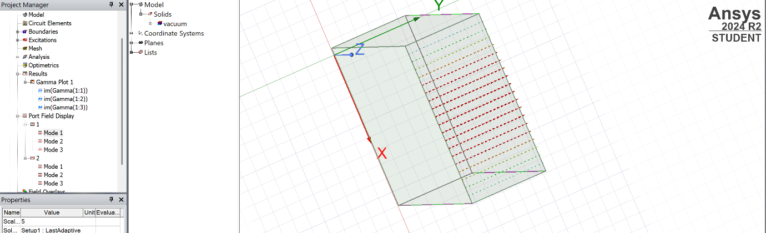
Figure 1:TE10 mode, on port 1

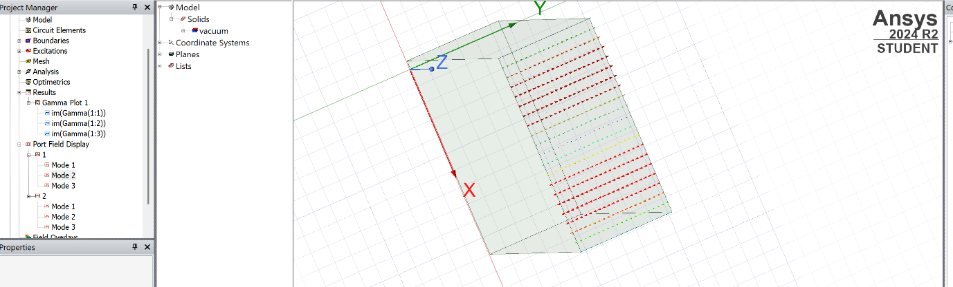
Figure 2:TE20 mode on port 1

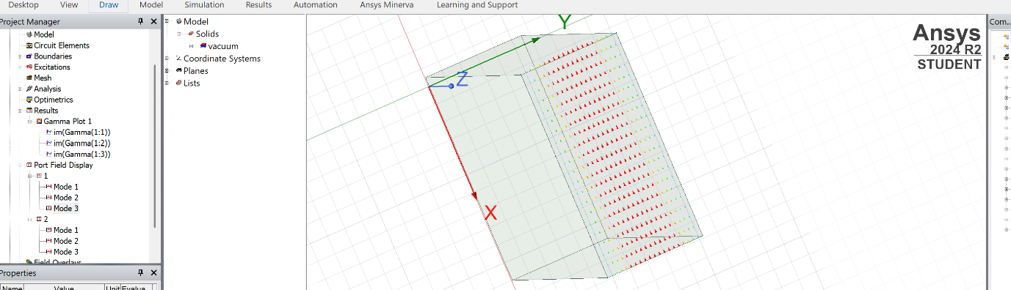
Figure 3: TE01 mode on port 1

These modes have magnetic components propagating in the direction of the wave, with electric components perpendicular.
The port 2 modes will be listed in the appendix.

Magnitude and Vectors for E and M fields.
The magnitude and vectors for the electric and magnetic fields are shown below. These screenshots are from sweep simulations at 30Ghz, and with port 1, mode 1 being the active source. The active sources were changed and noted, and will be shown in the appendix.

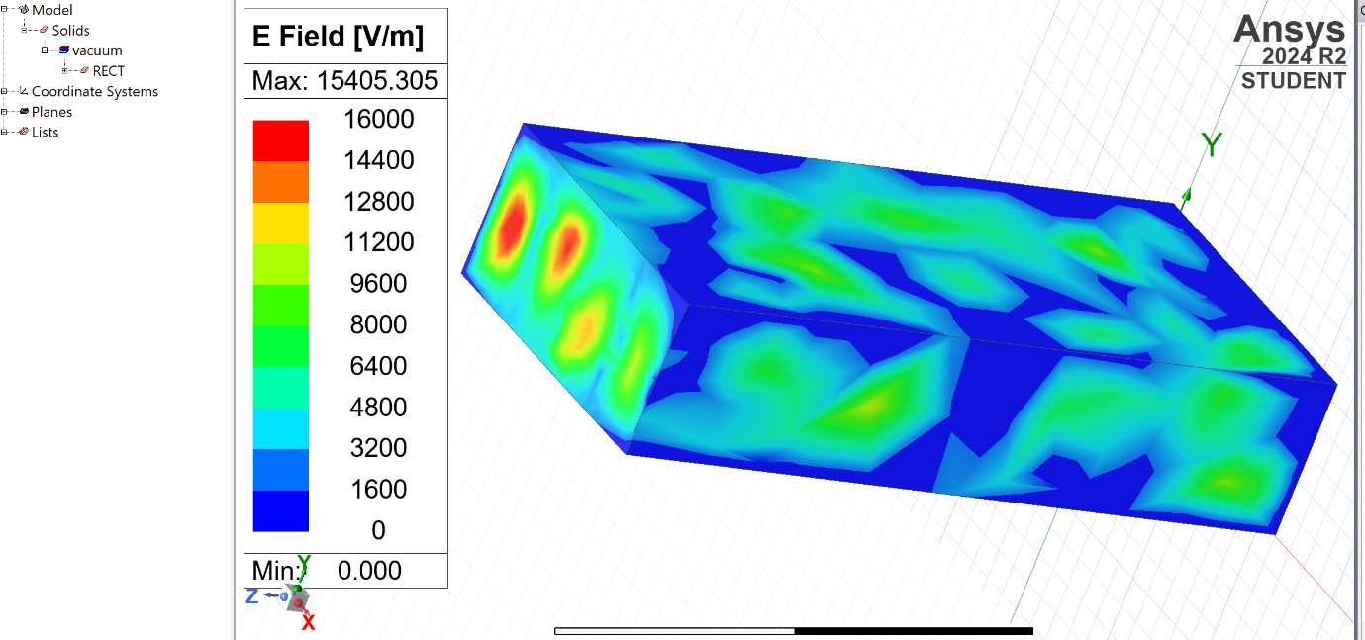
Figure 4: E field magnitude for mode 1
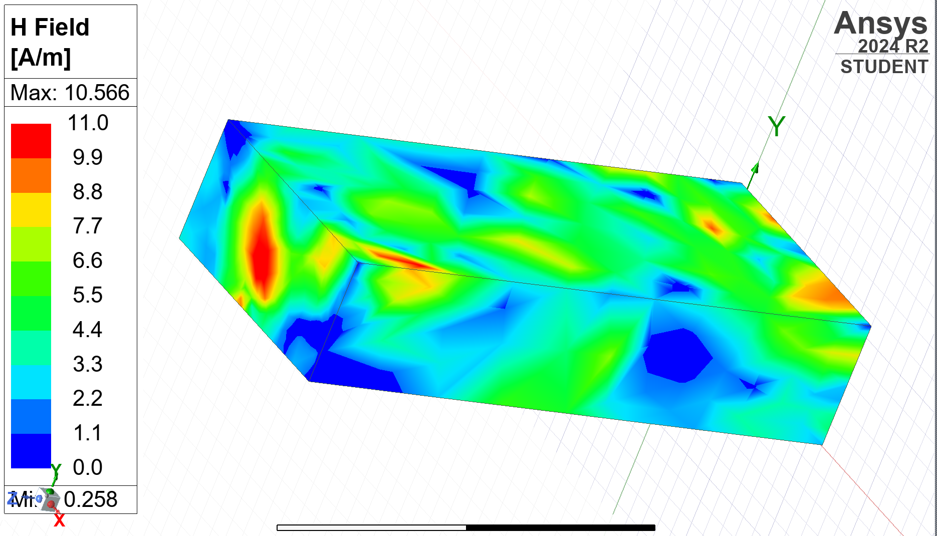
Figure 5: H field magnitude for mode 1

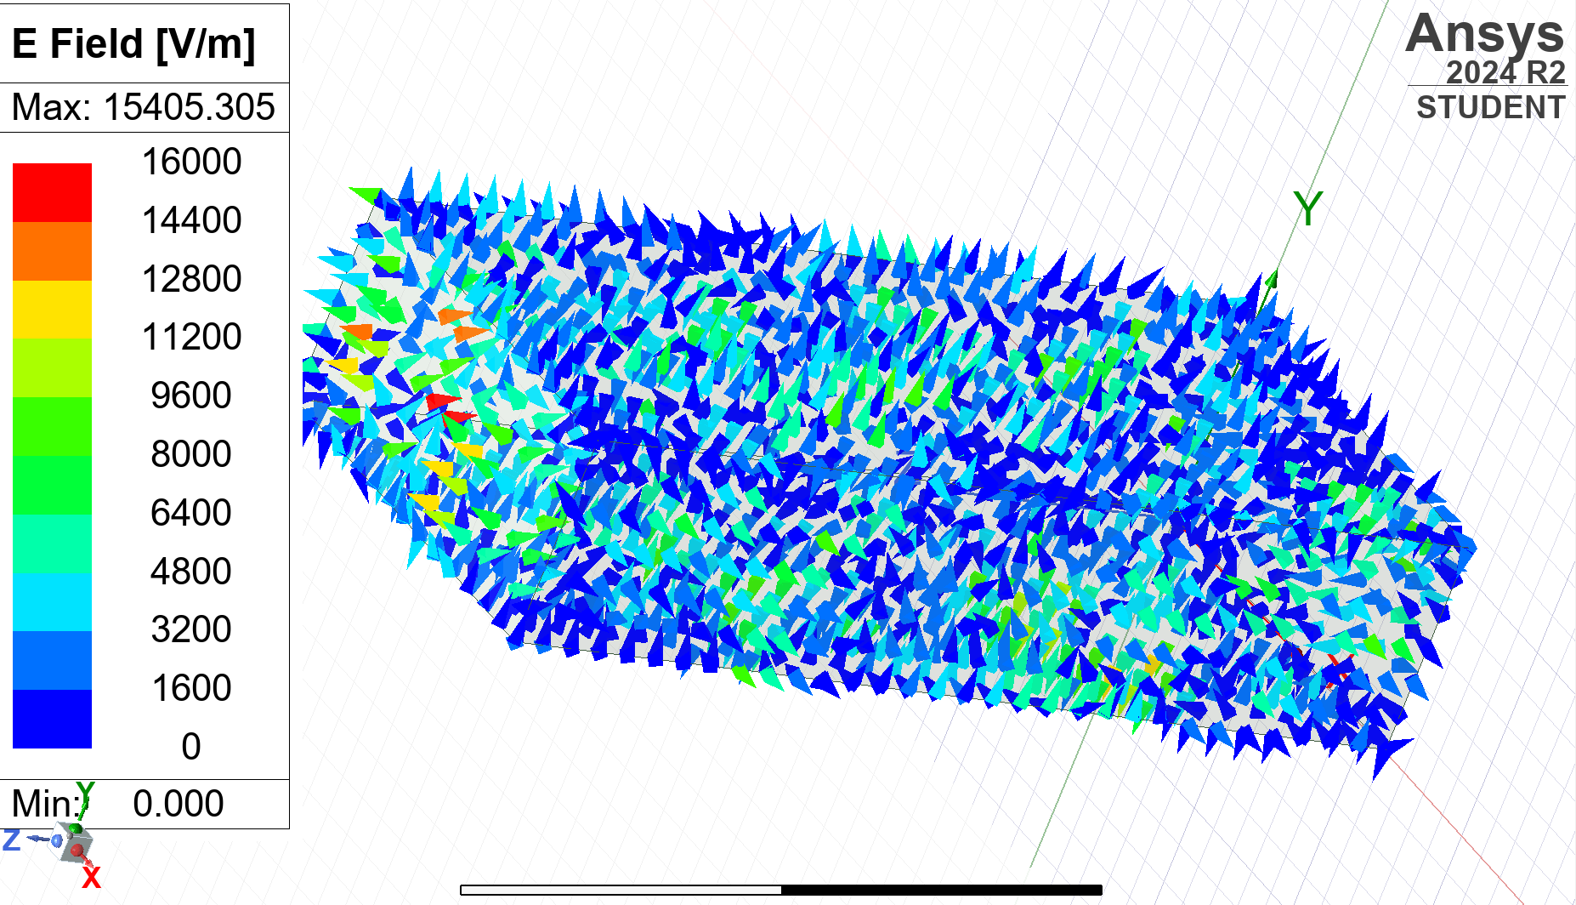
Figure 6: E field vectors for mode 1
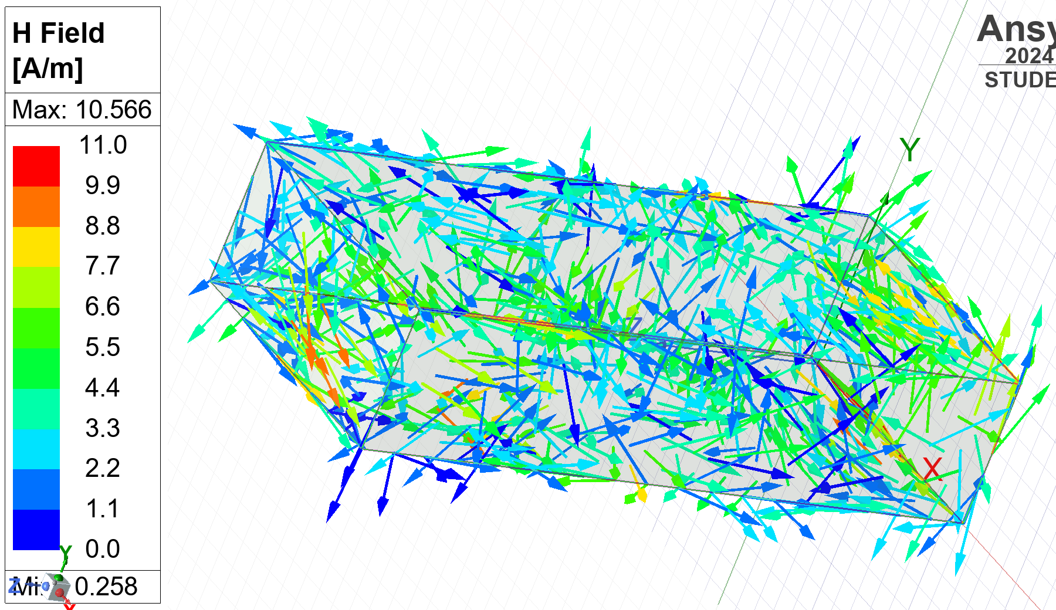
Figure 7: H field vectors for mode 1

Rectangular graph and frequencies
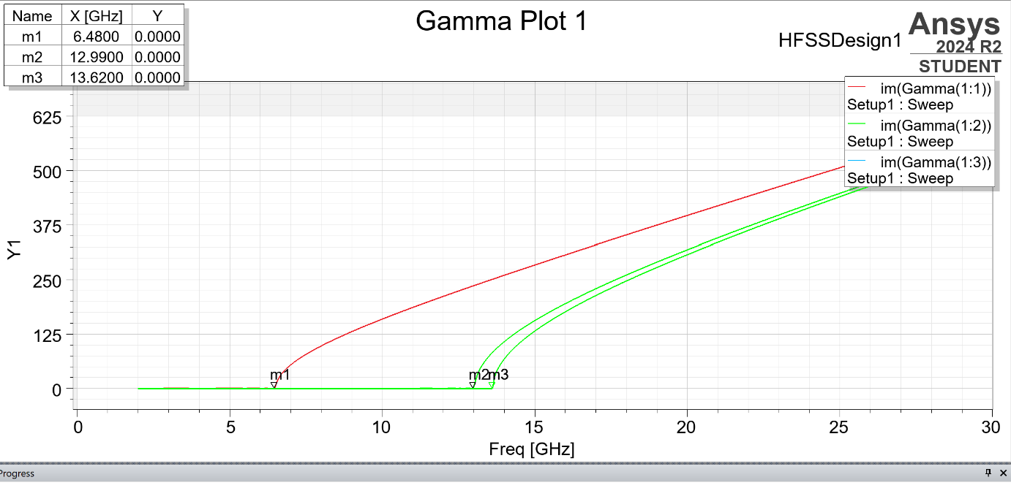
Figure 8: Rectangular graph with cut off frequencies
There is a marker on each cut off frequency, m1 – 6.48Ghz, m2-12.9900Ghz, m3-13.6200Ghz.
Each marker is placed at the cut off frequency for each mode. With the dominant mode TE10 being the lowest cut off frequency (m1,6.48Ghz), TE20 the next (m2,12.99Ghz), and TE10 the last(m3, 13.62Ghz).

Cut of frequency calculations:
The first three modes are TE01, TE10, and TE20.
The frequency cut off calculation is $fc=\frac{c}{2}\sqrt{{\left(\frac{m}{a}\right)}^{2}+{\left(\frac{n}{b}\right)}^{2} }$with c=${3x10}^{8}$, as this is the speed of light in a vacuum
So, with m=0, n=1, a=0.023m, b=0.011m and c= 3x10^8 cut off for TE01 =
$fc=\frac{3x{10}^{8}}{2}\sqrt{{\left(\frac{1}{0.011}\right)}^{2}}$=13.6 Ghz
with m=1, n=0, a=0.023m, b=0.011m and c= 3x10^8 cut off for TE10 =
$fc=\frac{3x{10}^{8}}{2}\sqrt{{\left(\frac{1}{0.023}\right)}^{2}}$=6.52 Ghz
with m=0, n=1, a=0.023m, b=0.011m and c= 3x10^8 cut off for TE20 =
$fc=\frac{3x{10}^{8}}{2}\sqrt{{\left(\frac{2}{0.023}\right)}^{2}}$=13.043 Ghz
As can be seen, the calculated results are close to the simulated results.

Task 1b
This wave guide uses the same dimensions as task 1a, however the wall is filled with Teflon.

Modes in the wave guide
As in the previous simulation, the dominant mode is TE10 [1], and is again shown in the rectangular graph, with the lowest cutoff frequency, the propagation modes (TE10, TE01, TE20) will be shown in the port field display.

Port field display
The port field display for each mode, in port 1 are shown below, and for port 2 will be in the appendix.
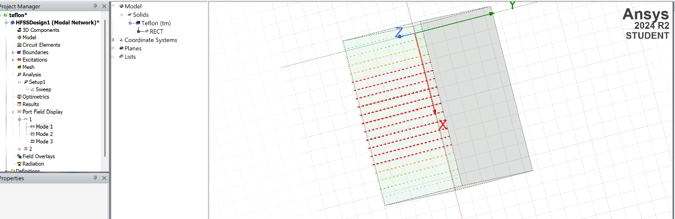
Figure 9: Port 1 mode 1
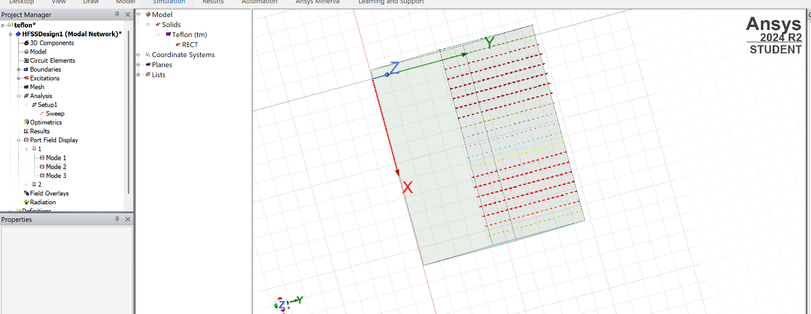
Figure 10: Port 1 mode 2
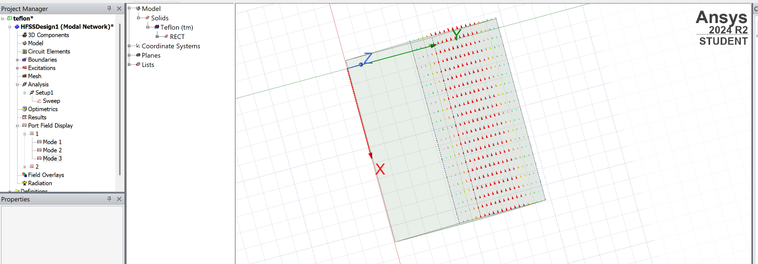
Figure 11:Port 1 mode 3

Magnitude and Vectors for E and M fields.
The magnitude and vectors for the E and M fields are shown below, using mode 1 as the source, the other modes were used as sources as well, and shown in the appendix.
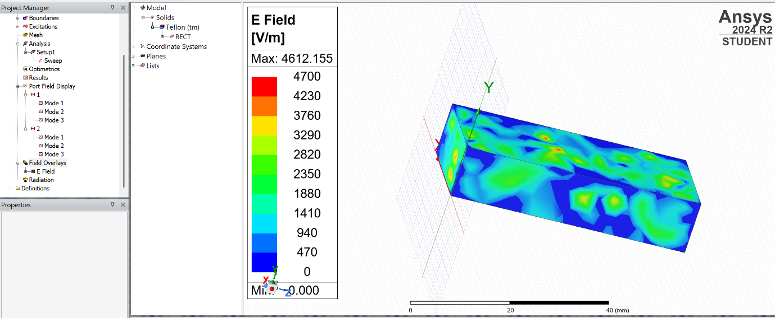
Figure 12: Mode 1 mag E
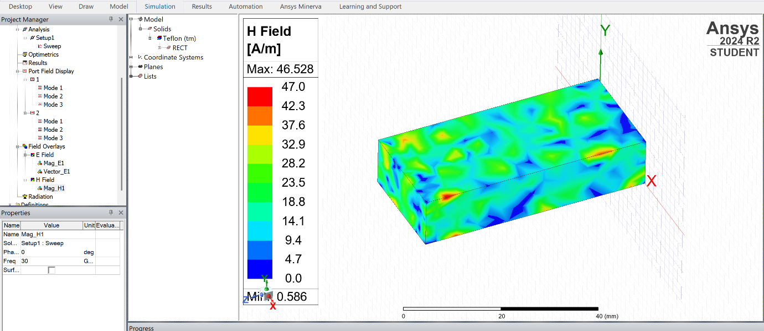
Figure 13: Mode 1 mag H
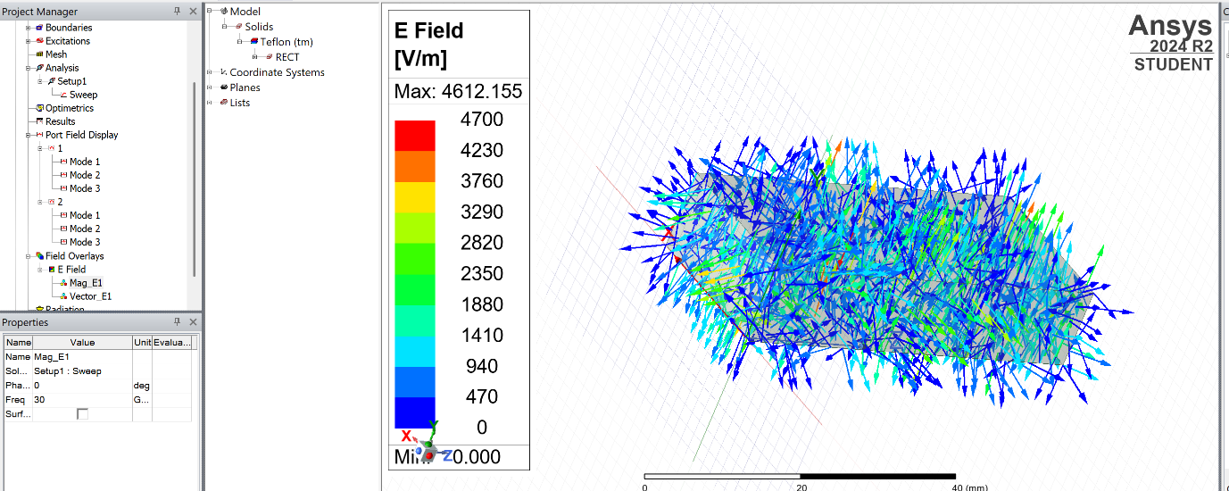
Figure 14: Mode 1 vect E
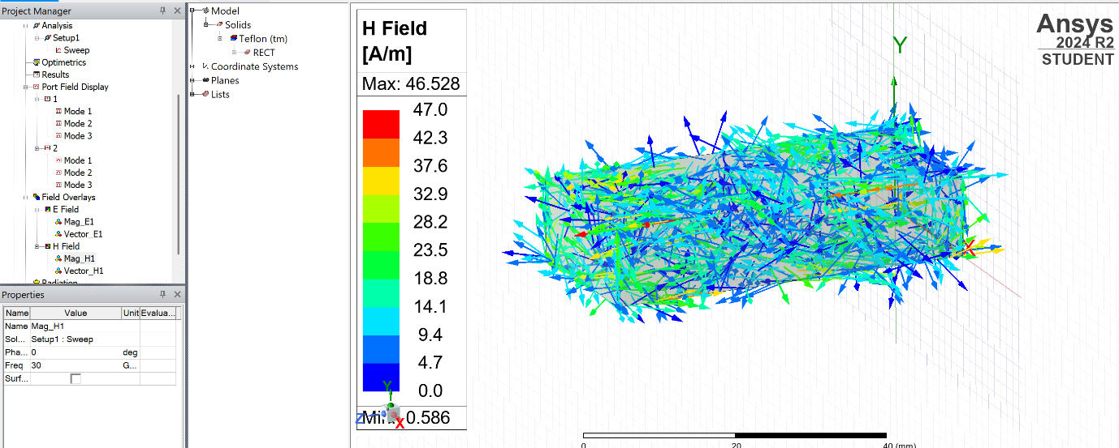
Figure 15: Mode 1 Vect H

Rectangular graph and frequencies
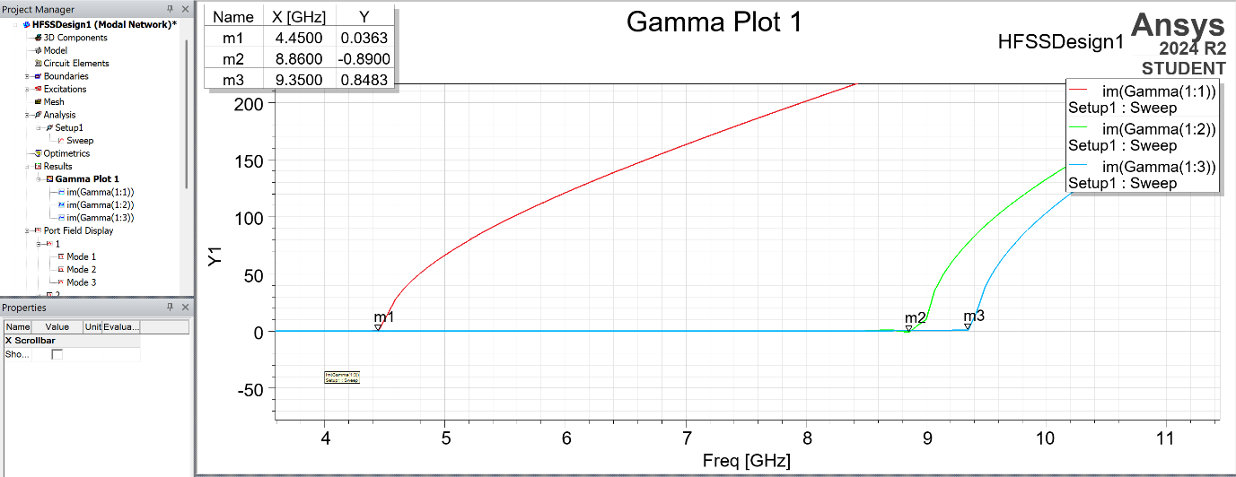
Figure 16: Cut off frequency rectangular graph
This graph shows the cut off frequency of each mode, with TE10 being the dominant mode. TE10 cut off frequency is 4.45Ghz, TE20 cut off frequency is 8.86Ghz, and TE01 cut off frequency is 9.35Ghz.

Frequency cut off calculations
Much like the last wave guide, the first three modes are TE01, TE10, and TE20.
The frequency cut off calculation is $fc=\frac{c}{2}\sqrt{{\left(\frac{m}{a}\right)}^{2}+{\left(\frac{n}{b}\right)}^{2} }$
However, c is no longer the speed of light, as the material has changed to Teflon. To calculate c, the equation $c=\frac{1}{\sqrt{εμ}}$ with ε(permittivity) = ε0εr, and μ(permeability)=μ0μr. The subtext of 0 and r represents vacuum and relative respectively.
εr and μr are provided in HFSS, and are 2.1 and 1.
ε0 and μ0 are 8.854x10^-12F/m and 4πx10^-7H/m [2].
$$ε0εr=ε=2.1x8.854x{10}^{-12}=1.8593x{10}^{-11}F/m$$
$$μ0μr= μ=1 x 4π^{-10}H/m$$
$$c=\frac{1}{\sqrt{1.8593x{10}^{-11}.4π^{-10}}}=2.069x{10}^{8}m/s$$

So, with m=0, n=1, a=0.023m, b=0.011m and c= $2.069x{10}^{8}m/s$ , cut off for TE01 =
$fc=\frac{2.069x{10}^{8}m/s}{2}\sqrt{{\left(\frac{1}{0.011}\right)}^{2}}$=9.404 Ghz
with m=1, n=0, a=0.023m, b=0.011m and c= $2.069x{10}^{8}m/s$ cut off for TE10 =
$fc=\frac{2.069x{10}^{8}m/s}{2}\sqrt{{\left(\frac{1}{0.023}\right)}^{2}}$=4.497 Ghz
with m=0, n=1, a=0.023m, b=0.011m and c= $2.069x{10}^{8}m/s$ cut off for TE20 =
$fc=\frac{2.069x{10}^{8}m/s}{2}\sqrt{{\left(\frac{2}{0.023}\right)}^{2}}$=8.995 Ghz

Conclusion and comparison
As can be seen with both wave guides, the calculated results are close to the simulated results, this may be due to rounding differences or variation in the simulations.
These results differ from the previous results, for example TE10 is 6.52 Ghz, but with Teflon walls it drops down to 4.497 Ghz. The same is true for the other modes, TE01 is 13.6 Ghz and drops to 9.404 Ghz, TE20 was 13.043 Ghz but dropped to 8.995 Ghz. This is due to the fact that the speed at which the waves travel is lower when vacuum walls are not used, the impact of the lower speed can be shown in the cut off frequency equation:
$$fc=\frac{c}{2}\sqrt{{\left(\frac{m}{a}\right)}^{2}+{\left(\frac{n}{b}\right)}^{2} }$$
This is due to the fact that there are more particles in the Teflon medium, this slows down the propagation of EM waves.
The field overlays for both wave guides show that near the cut off frequencies, the overlays produce a more organised and evenly distributed pattern of the electric or magnetic fields , however when that frequency was raised, the overlay patterns were less organised, showing a less efficient propagation.

Task 2

Length calculations
Student number of 2322626 gives λ of 232mm and the given radius is 1mm.
Length of the antenna can be calculated via $L=\frac{λ}{2}$ this gives $l=\frac{232x{10}^{-3}}{2}=116mm$

Operating frequency of antenna
The operating frequency can be calculated via $f=\frac{c}{λ}$ with $f=\frac{3x{10}^{8}}{232x{10}^{-3}}=1293103448hz=1.29GHz$

Design and simulation/Method
To design this antenna, first a cylinder object needed to be created, this was then changed to have a radius of 1mm, as laid out in the assignment, and a height of 116mm, which had been worked out earlier. Then, it must be assigned a material, in this case PEC. After this, another cylinder was created in the centre to be a gap, and this was assigned vacuum material. Then, a lumped port was created in this gap, with an impedance of 50ohm as specified. Then finally, an open region should be created, this is the open space used to simulate the antenna in.
Screenshots of some of this process can be found in the appendix.

S-parameter plots and identification of operational frequency
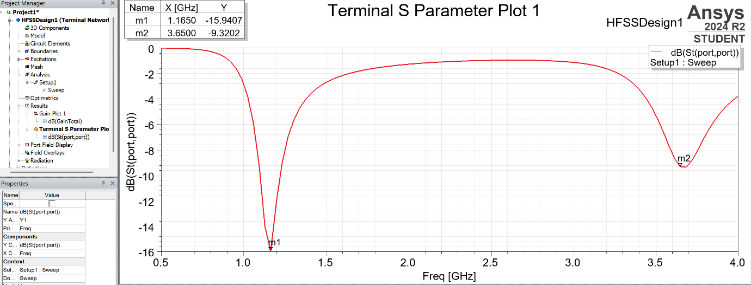
Figure 17: this shows the antenna S parameter plot
From the S parameter plot shown above it can be seen that its operating frequency is best at 1.165Ghz, which is very close to the theoretical calculations, it also shows that it can also perform at 3.65Ghz, albeit at a worse performance. It is likely that it is a harmonic for the wavelength used.

Radiation pattern
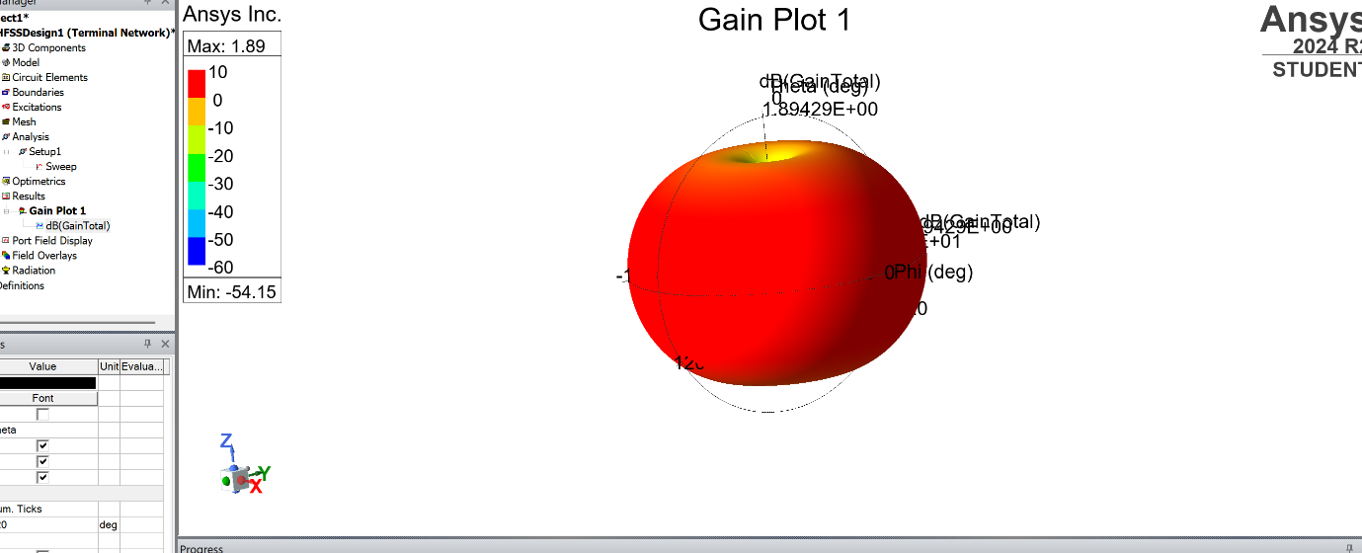
Figure 18: realised gain/radiation pattern
This image above shows the dipoles radiation pattern, and it shows that it has unidirectional radiation, but minimum gain in the horizontal plane, due to the antenna physically occupying. that space. The gain is shown at a maximum of 1.89dB.

Conclusion
For the theoretical operating frequency a frequency of 1.29Ghz was calculated, but when simulated, an operating frequency of 1.165Ghz was measured. This could be due to the fact that in HFSS we used a 1mm thickness for the antenna, however, this was never factored into the calculation for operating frequency. The realised gain plot meets the expectational shape of a toroid shape [3] when compared to that of an isotropic source and shows a maximum gain of 1.89dB.

Task 3

Introduction
This report will cover the recent technological advancements in radar technology with a focus on drone and Unmanned Areal vehicle(UAV) detection. It will cover current technologies, and what improvements could be made to improve effectiveness while also considering the general societal and environmental impacts.

Literature review
Currently UAVs are located and tracked with radar based systems that can determine both a UAVs velocity and position. However these have issues with range and resolution trade-offs, as well as environmental clutter [4] and can have a need for high elevation installation to avoid object obstruction. One of the ways these drawbacks can be improved on is the combination of radar based detection with optoelectrical systems, acoustical systems, and RF based methods [4].
Most radar systems operate by sending out signals at specific frequencies and measuring the response reflected back, to detect an object, the object must have a detectable radar cross section (RCS). The higher the radar systems frequency, the smaller an RCS it can detect [5]. The issues then comes when traditional radar systems try to detect objects with small RCS, as the resolution of the RCS it is able to detect is determined by the frequency(due to its relationship with wavelength) [6] [7].While this is useful for detecting planes or other large objects, this can lead to issues with detecting small objects, or objects with low RCS (e.g Northrop Grumman B-21). The RCS of an object is a complex combination of multiple scattering sources [7] for example, wings, nose, propellers, and can be impacted by the size, material, shape, edges of an object , or by wavelength and polarisation [8].
Current common radar systems (ie those used on modern navy warships) operate mostly on S-band (2-4Ghz) or X-band(8-12Ghz) [9], with S-band radars being larger, having a longer range, and being more reliable in adverse weather conditions, and X band having a smaller antenna size and a higher target resolution, but a smaller effective range.

Discussion
Across all ranges of radar detection, the main detection parameter is an objects RCS, however, it can be difficult to detect small RCS’s, or to distinguish different objects with similar RCS’s, for example a bird and a small drone [10]. To help identify the type of object being detected, it is proposed that you can use a similar method to how an objects velocity is measured, using the doppler effect. This technique is referred to as micro-Doppler signatures, or Doppler signal to clutter ratio (DSCR) [10] [11]. These micro-doppler signatures take advantage of small motions within the target object(e.g propellers or bird wings) to create unique signatures that can be attributed to specific objects thus increasing the accuracy and effectiveness of the radars detection. However, one downside to micro-Doppler detection is that it is mostly undetectable in lower frequency bands [12], and so it can only be used in higher frequency bands, limiting its range to roughly 150m (for now, in the experimental NetRAD system) [13], which could be increased by increasing general transmission power, however this has other impacts which will be discussed later. Another downside to this is the dependence on the drones material. Most drone blades are either carbon fibre, or plastic. While carbon fibre can be modelled as a near perfect electrical conductor, plastic has a much lower RCS as it is more dielectric, this can significantly impact the systems ability to detect these micro Doppler signatures [13].
Another improvement to radar detection systems could be to pair it with other detection systems. Due to the environmental noise, radar systems can often ignore small signals, or signals that are just below the threshold, however, pairing it with other systems to check possible drones and validate detections. One example of this is to include multiple microphone arrays, these can help determine the direction of a drone, and by having multiple, eliminate noise and increase the SNR(signal-to-noise-ratio) [14]. This can be paired with an optical solution to help validate and pinpoint the location of the drone, by using all three systems together, they can compensate for their limitations and provide more accurate detection.
The previously mentioned solutions all work on extracting wanted signals from noisy environments, often by taking samples and using known values to eliminate noise. However, this may not provide accurate results when faced with a changing environment, e.g. a city. Across these systems it would be possible to employ a machine learning model to try and distinguish threats or false alarms, by using known features, neural networks could be trained to look for features, and distinguish drones from birds, both via optical methods, and by analysing the received radar signals [4].

Environmental and societal impacts:
There are multiple impacts that radar systems, and future advancements can have. As mentioned earlier, you can increase the transmission power of the radar system to increase its range, however, that will require more power and this could have environmental impacts unless that energy can be provided from clean energy sources, this is also true for combining radar systems with other detection systems, or implementing AI/machine learning modules, as these are often processing intense tasks, and therefore power intense. This increase in power also exacerbates issues caused by EM waves in general. There is research to suggest that EM waves can raise the body temperature of animals, as it can penetrate the skin, this can lead to increases in the incidence of thermoregulatory behaviours in birds [15], and can be detected as an auditory sound in some mammals [15] . This added stimulus can change behaviours and make them less able to detect other stimuli, which could lead to mating changes, as well as flight or fight response changes. This change in body temperature has also been observed in humans, which can have links to increased fertility [16] and anger issues [17], as well as links between exposure to RF and raised cancer concerns [18]. All of these issues can directly impact society and human behaviours . Radar systems can also have more impacts on the environment, as radar systems have to have unobstructed views to be effective, this can lead to deforestation and destruction of natural habitats if radar is installed in remote locations. However, there can be positive impacts to increased radar implementation. For example, increased efficiency in defence systems can lead to decreased casualties as well as decreased infrastructure damages, decreasing general costs for society as well as a decrease in negative experiences for people. This increase in effective defence can also have environmental benefits, for example, a drone with an explosive payload blowing up a ship, can release large amounts of chemicals into the ocean, potentially harming marine life, and those that consume it (humans, birds etc). This increase in defence can decrease the likelihood/frequency of these types of environmental disaster.

Conclusion:
In conclusion, there are multiple ways to increase the effectiveness of radar systems, mostly by pairing them with other, emerging technologies. However, all these improvements, as well as radar as is, has myriad negative implications on society and the environment, and steps should be taken to further understand and mitigate these effects, but there is also positive effects by increasing defence measures, as outlined earlier.

Bibliography

[1] | C. MATHAD, PARAMESHA and D. S. RAO, “RECTANGULAR WAVEGUIDE CHARACTERIZATION USING HFSS,” International Journal of Electrical, Electronics and Data Communication,, vol. 1, no. 1.
[2] | G. Leuchs, M. Hawton and L. L. Sánchez-Soto, “Physical Mechanisms Underpinning the Vacuum Permittivity,” Physics 2023, vol. 5, no. 1, pp. 179-192, 2023.
[3] | G. Aragao, E. Pires, G. Fontgalland and R. R. M. doValle, “Proposal of a new compact isotropic antenna,” IEEE International Symposium on Electromagnetic Compatibility.
[4] | V. Semenyuk, I. Kurmashev, A. Lupidi, D. Alyoshin, L. Kurmasheva and A. Cantelli-Forti, “Advances in UAV detection: integrating multi-sensor systems and AI for enhanced accuracy and efficiency,” International Journal of Critical Infrastructure Protection, vol. 49, 2025.
[5] | H.-J. Li and Y.-W. Kiang, “10 - Radar and Inverse Scattering,” in The Electrical Engineering Handbook, Academic Press, 2005, pp. 671-690.
[6] | robin radar systems , “Why Traditional Radar Isn’t Effective at Tracking Drones,” [Online]. Available: https://www.robinradar.com/why-traditional-radar-isnt-effective-at-tracking-drones. [Accessed 04 04 2025].
[7] | Purdue University, “Rayleigh Scattering, Mie,” [Online]. Available: https://engineering.purdue.edu/wcchew/ece604f19/Lecture%20Notes/Lect34.pdf. [Accessed 04 04 2025].
[8] | J. C. Toomay and P. J. Hannen, “Radar Cross Section,” in Radar Principles for the Non-Specialist . 3rd . 2004, 2004.
[9] | Leonardo DRS, “What are S- and X-Band Radar and How Are They Used Today?,” 19 December 2022. [Online]. Available: https://www.leonardodrs.com/news/thought-leadership/what-are-s-and-x-band-radar-and-how-are-they-used-today/. [Accessed 04 04 2025].
[10] | University of St Andrews, “Drone detection,” [Online]. Available: https://mmwave.wp.st-andrews.ac.uk/radar/drone-detection/. [Accessed 04 04 2025].
[11] | J. Gong, J. Yan, H. Hu and D. L. Deyong Kong, “Improved Radar Detection of Small Drones Using Doppler Signal-to-Clutter Ratio (DSCR) Detector,” Special Issue Intelligent Recognition and Detection for Unmanned Systems), 2023.
[12] | V. C. Chen, The Micro-Doppler Effect in Radar, Second edition, Artech House, 2019.
[13] | P. Prof. M.Sc Demirev V., “Drone detection in urban environment - the new challenge for the radar system designers,” International Scientific Journal "Security & Future", no. 3.
[14] | S. Ding, X. Guo, T. Peng, X. Huang and X. Hong, “Drone detection and tracking systems based on fused acoustical and optical approaches,” Advanced intelligent systems, vol. 5, no. 10, 2023.
[15] | E. Sheridan, J. Randolet, T. L. DeVault, T. W. Seamans, B. F. Blackwell and E. Fernández-Juricic, “The effects of radar on avian behavior: Implications for wildlife management at airports,” Applied Animal Behaviour Science, vol. 171, pp. 241-252, 2015.
[16] | CDC, “About Heat Exposure and Reproductive Health,” National Institute for Occupational Safety and Health (NIOSH), [Online]. Available: https://www.cdc.gov/niosh/reproductive-health/prevention/heat.html#:~:text=Key%20points%201%20Being%20exposed%20to%20high%20heat,about%20protecting%20yourself%20from%20heat%20stress%20at%20work.. [Accessed 11 04 2025].
[17] | K. S. E, Y. Kim, H. M, H. Y, K. O, H. Y and &. K. H, “Positive Association of Aggression with Ambient Temperature.,” The Yale journal of biology and medicine, vol. 96, no. 2, pp. 189-196, 2023.
[18] | P. M, B. EM, M. Deitch, O. Nativ and E. Richter, “On radar and radio exposure and cancer in the military setting,” Environ Res., 2023.

Appendix

Task 1a

Method for simulation – repeated for task 1b
- Create box with dimensions needed
- Set box material (vacuum or Teflon)
- Set wall material to PEC
- Assign boundaries to 4 larger sides
- Create excitations at the two waveguide openings
- Set modes for the ports (3)
- Set impedance to 50ohm at each port
- Add a solution step with frequency at cut of calculated
- Add settings for sweep
- Validate and analyse project
- Create rectangular plot with all modes
- Create port field displays
- Plot fields for magnitude and vectors for E and H fields respectively
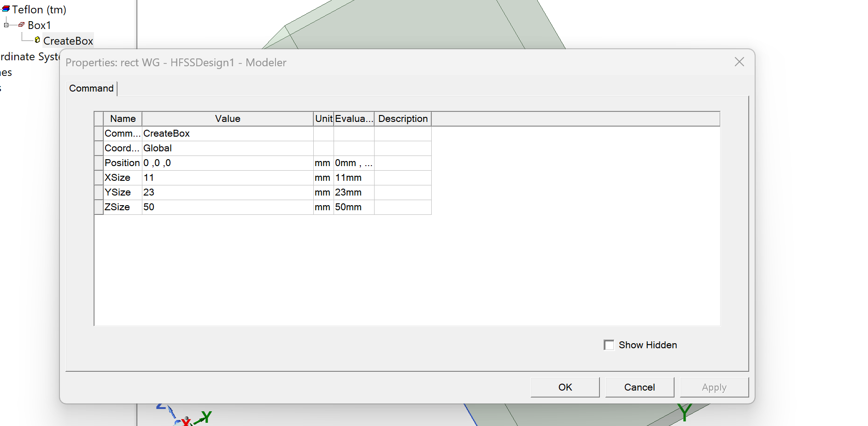
Figure 19: Dimensions for rectangular waveguide

Port 2 modes
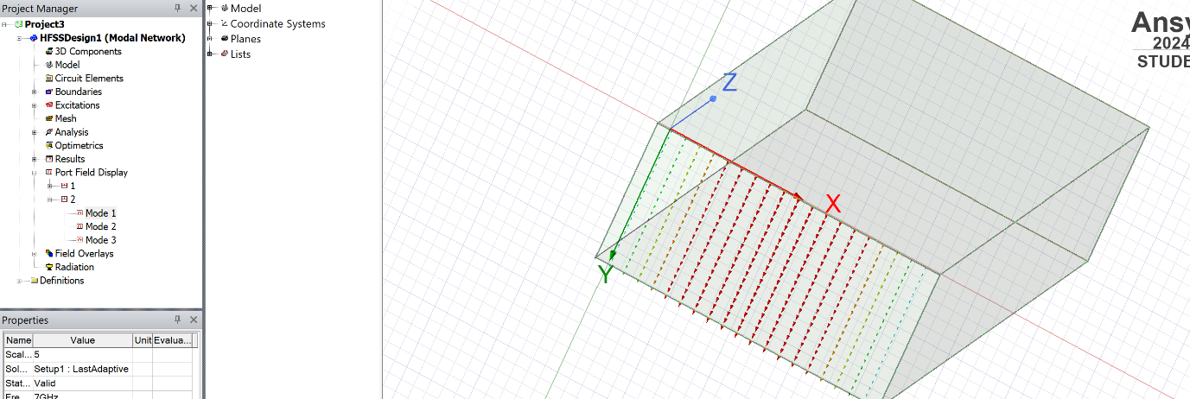
Figure 20: port 2 TE10
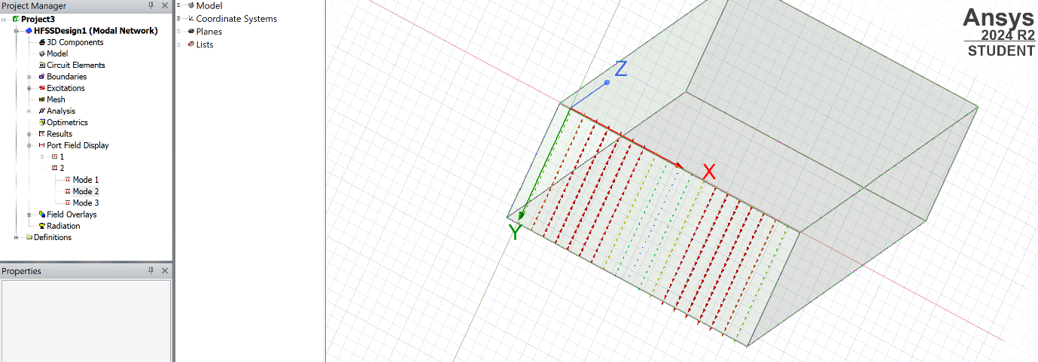
Figure 21:port 2 TE20
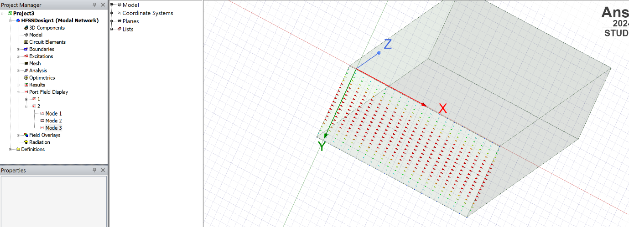
Figure 22: Port 2 TE01

Magnitudes and vectors
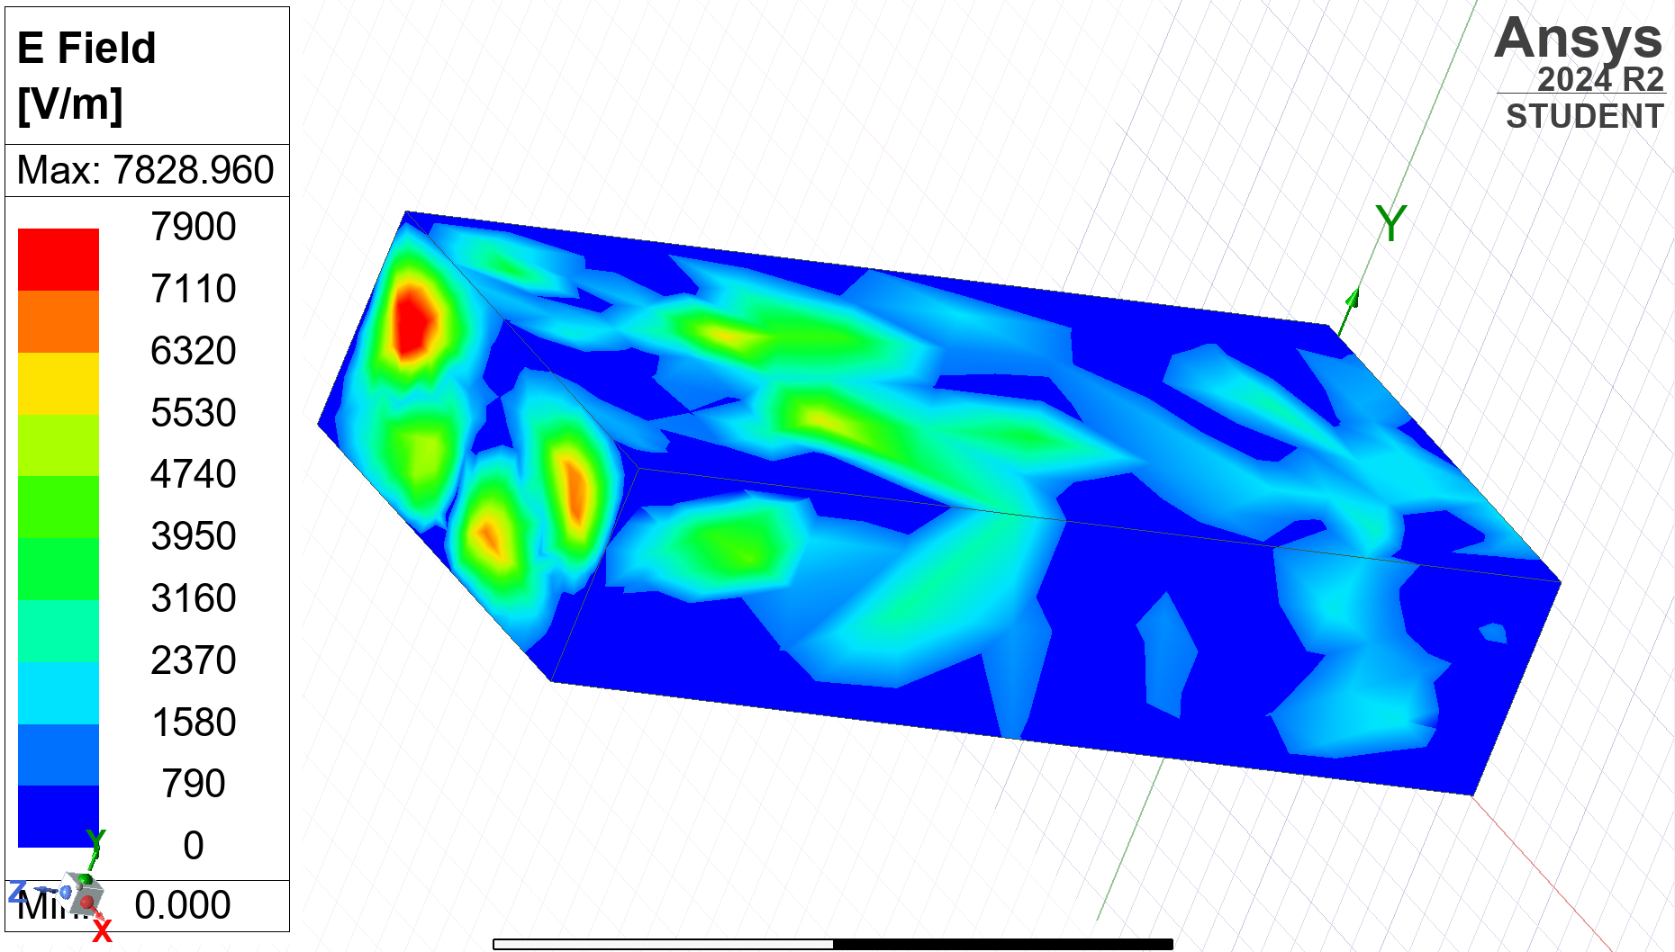
Figure 23: mode 2 mag E
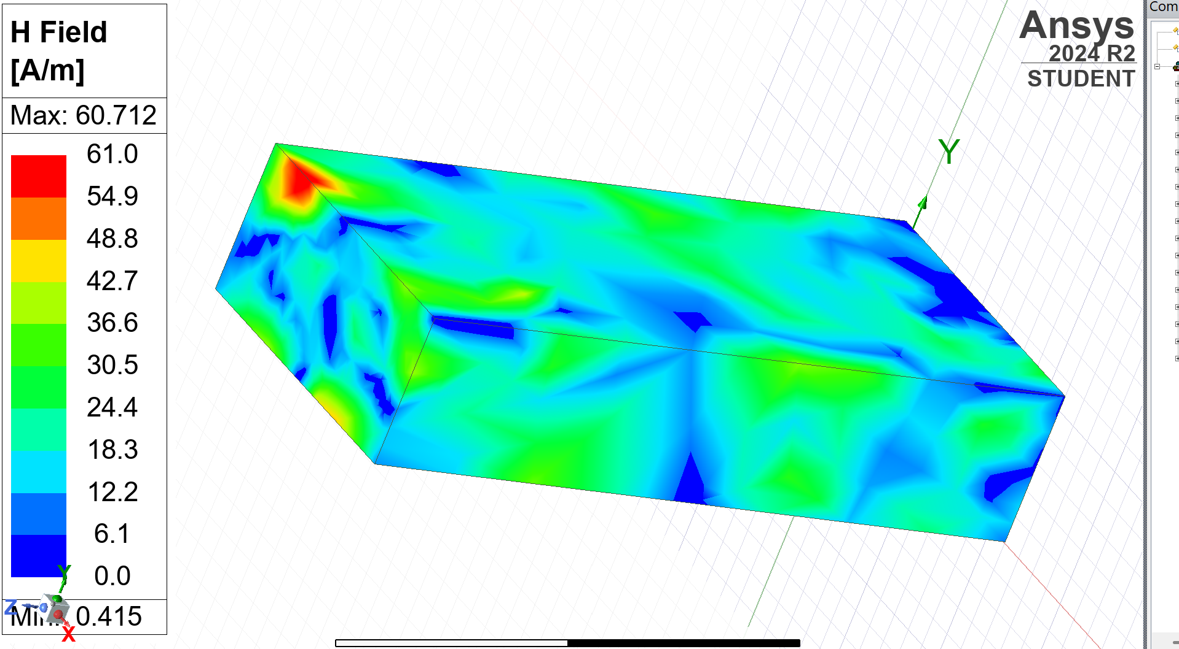
Figure 24: mode 2 mag H
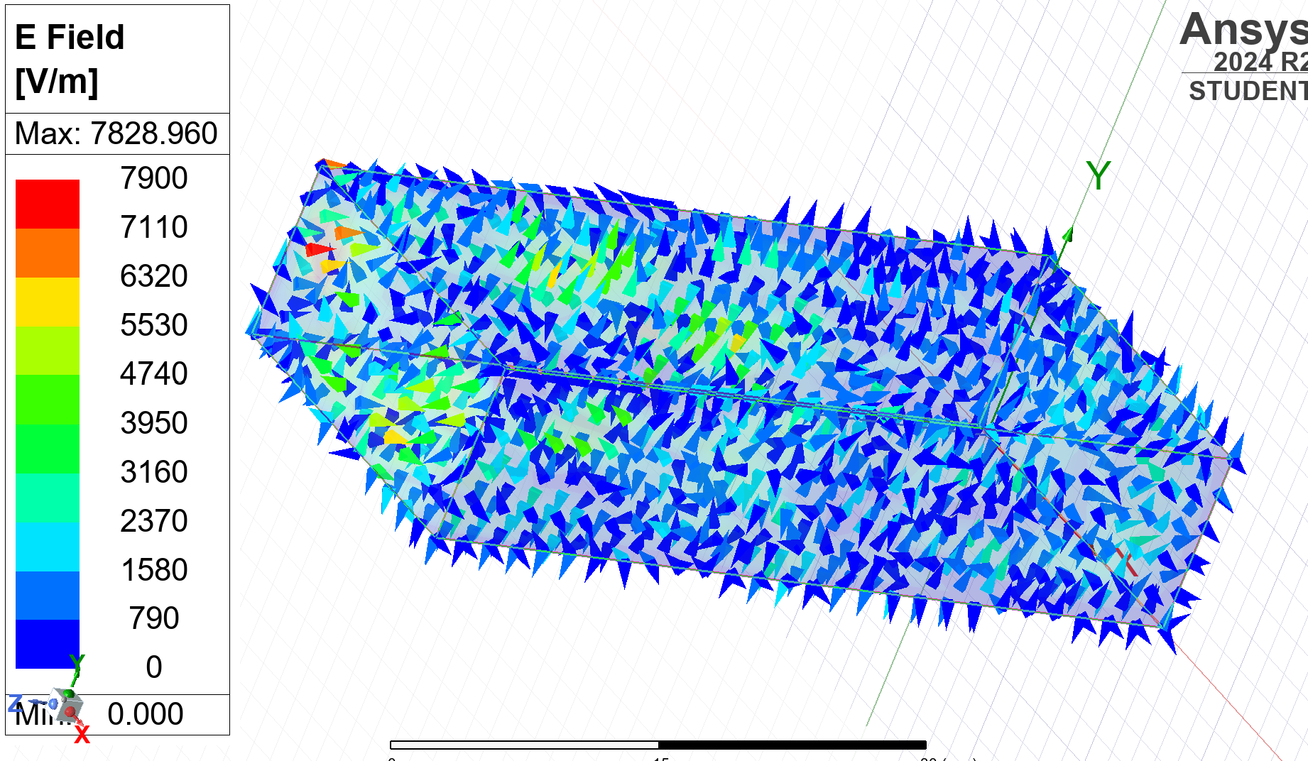
Figure 25:Mode 2 vect e
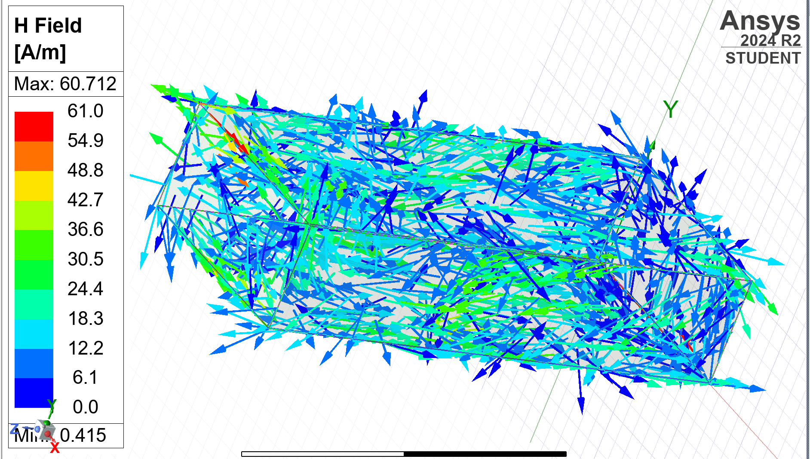
Figure 26: mode 2 vect H
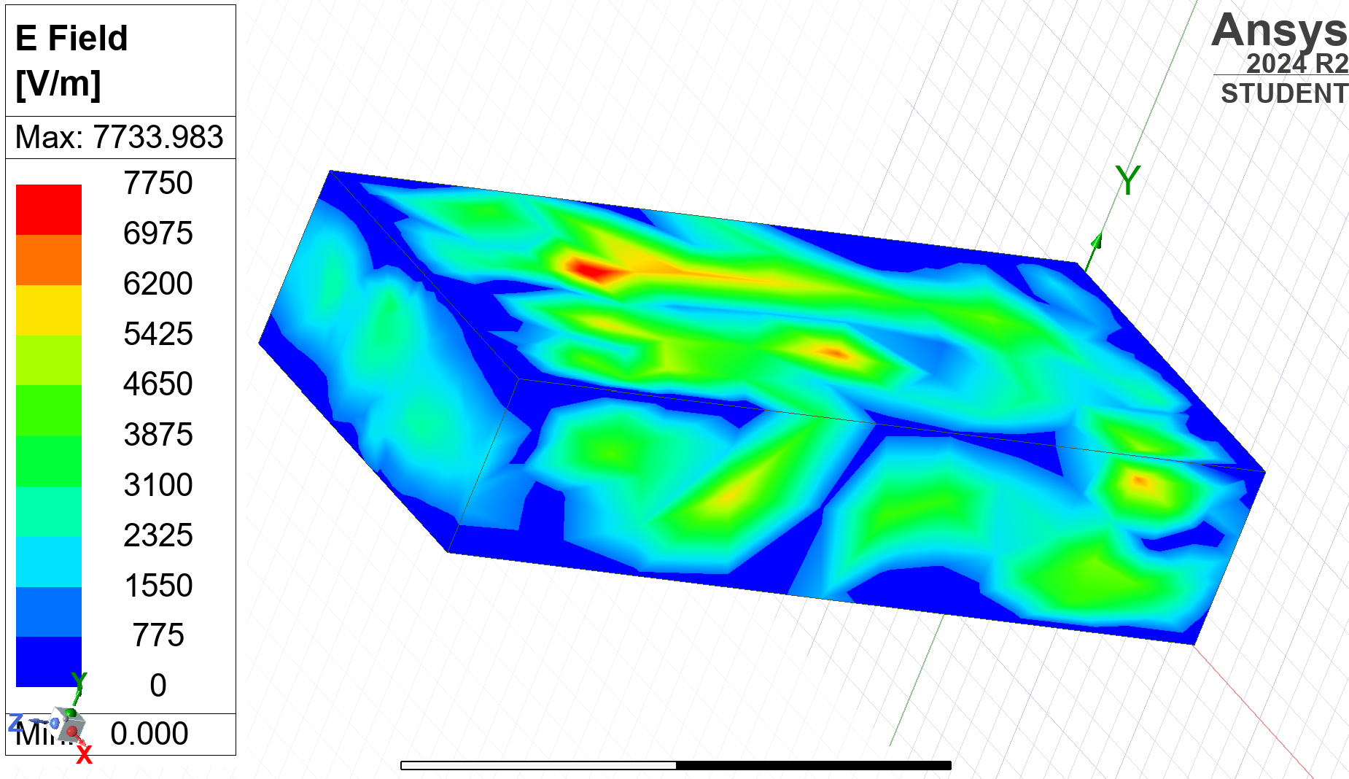
Figure 27: Mode 3 mag E
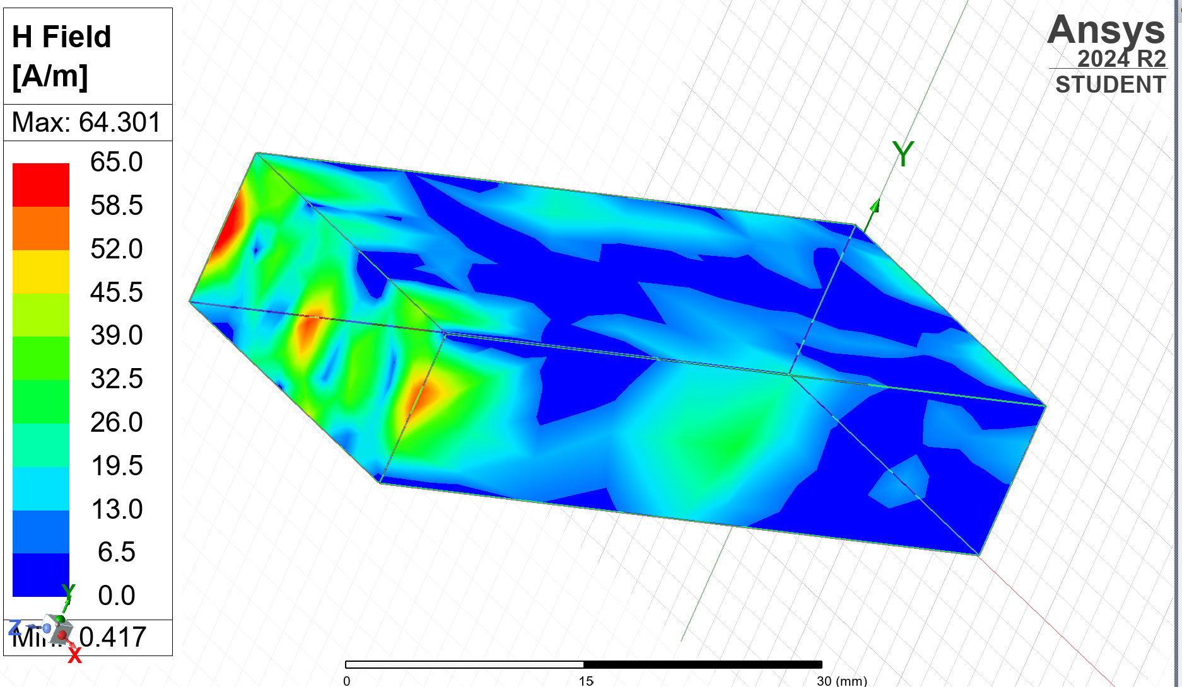
Figure 28: Mode 3 mag H
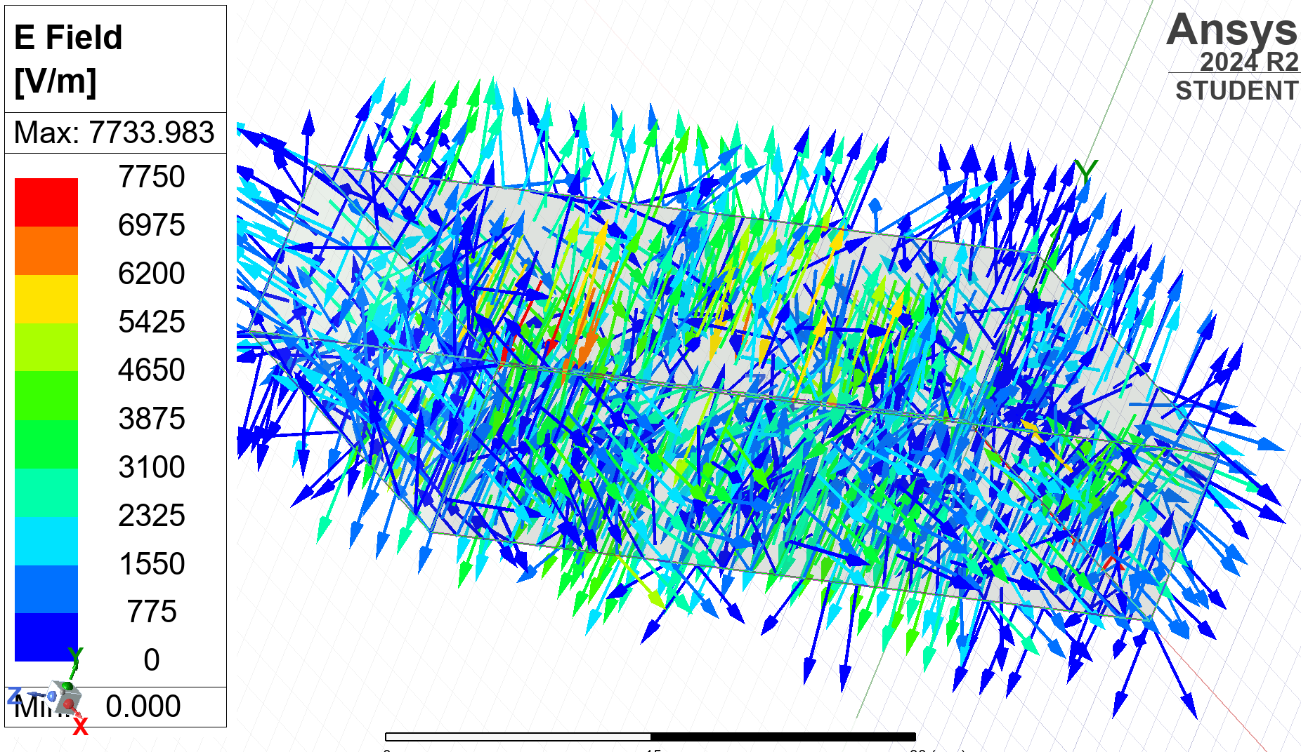
Figure 29: Mode 3 Vect E

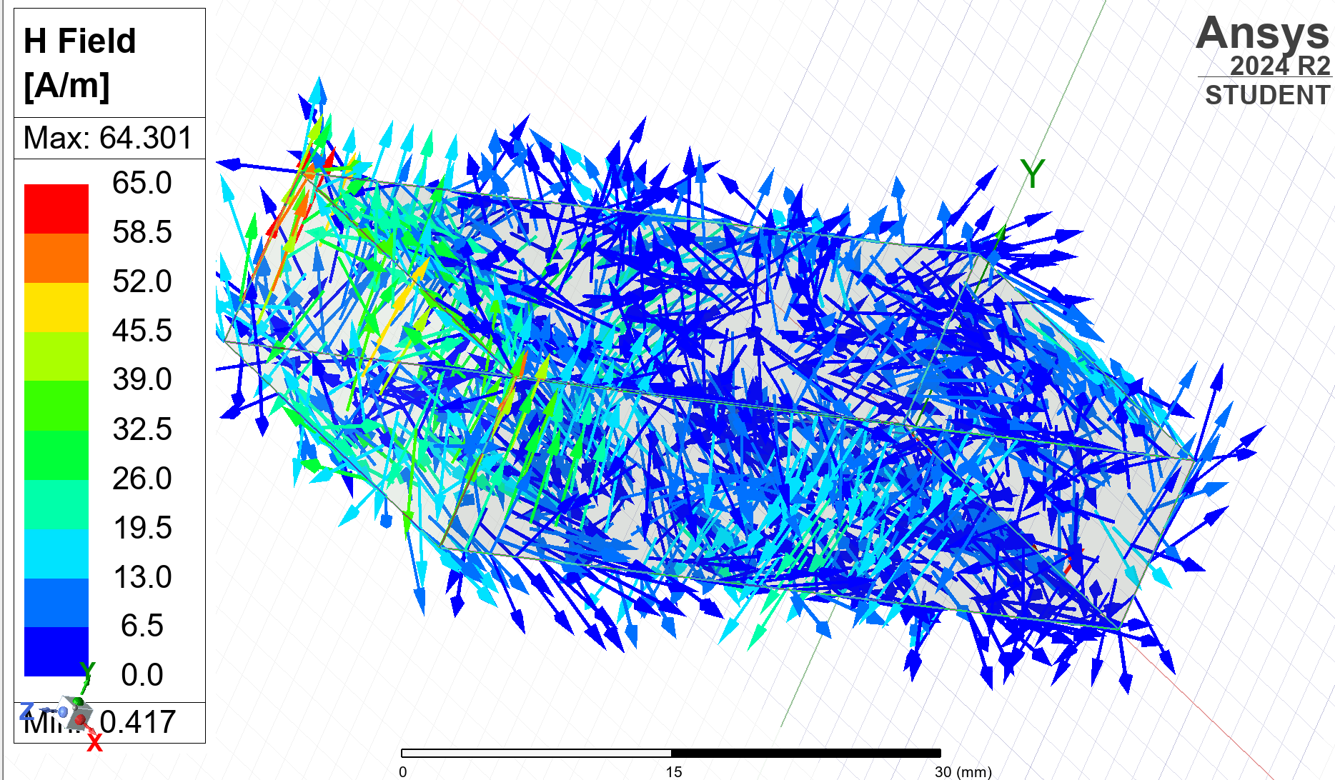
Figure 30: Mode 3 vect H

Task 1b

Port 2 modes
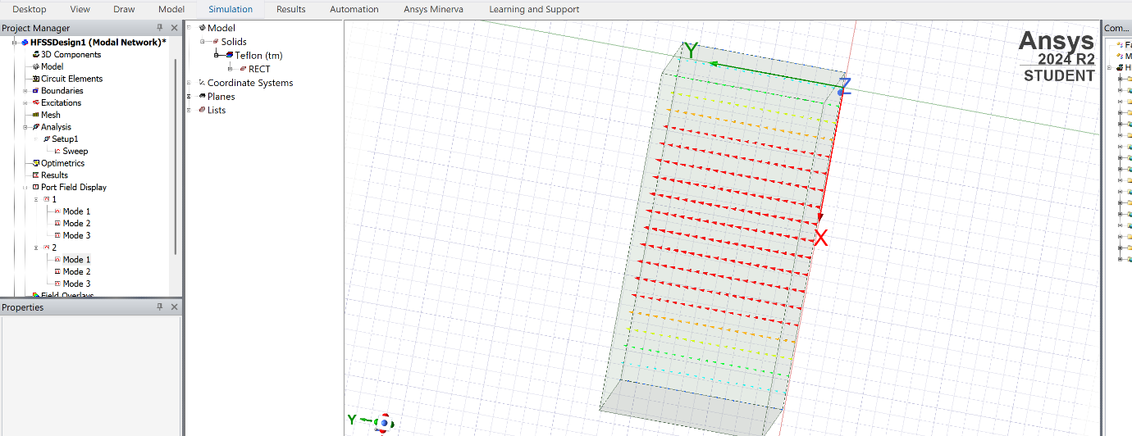
Figure 31:port 2 TE10
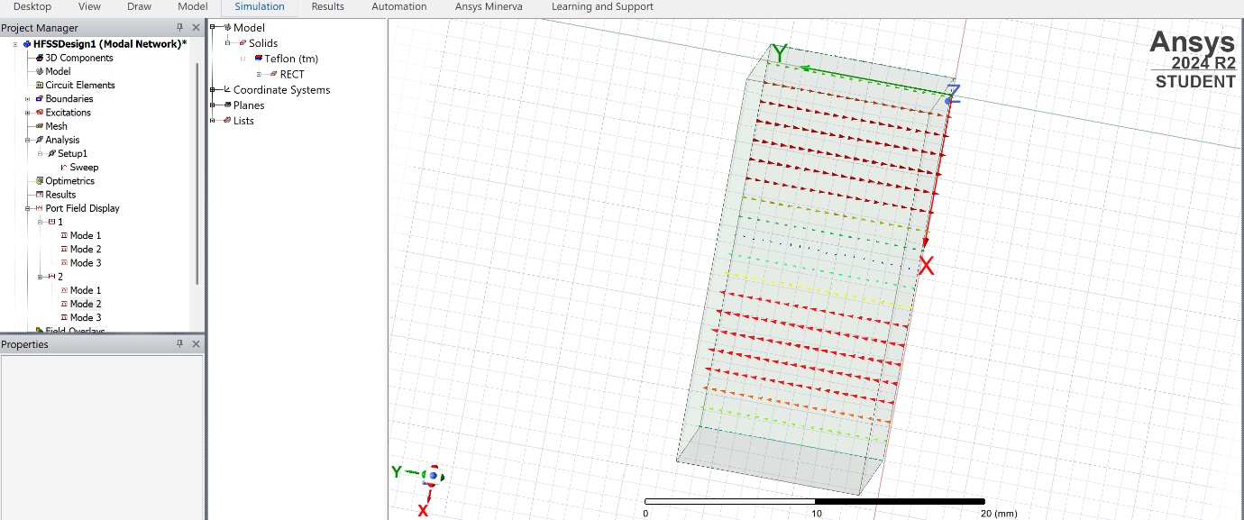
Figure 32:port 2 TE20
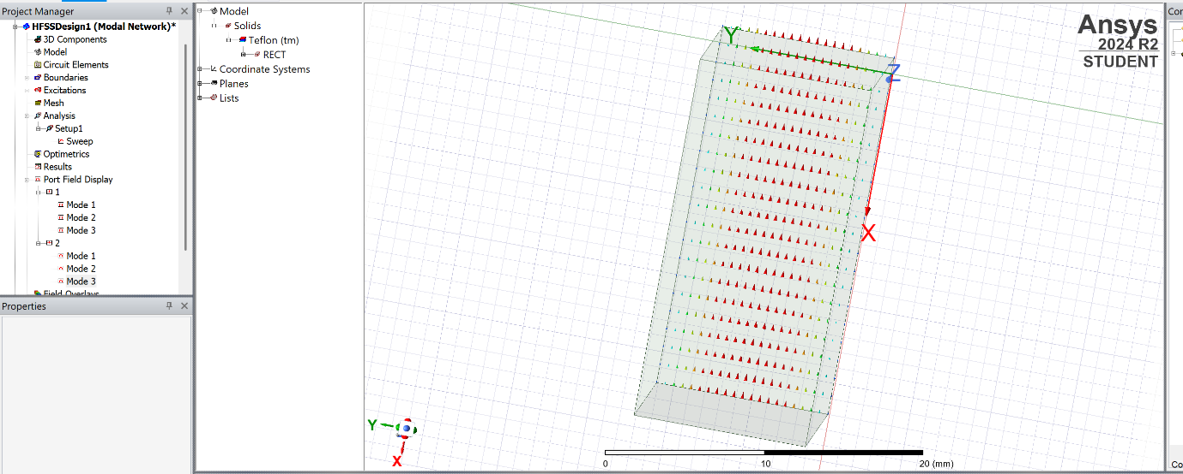
Figure 33:port 2 TE01

Magnitudes and vectors
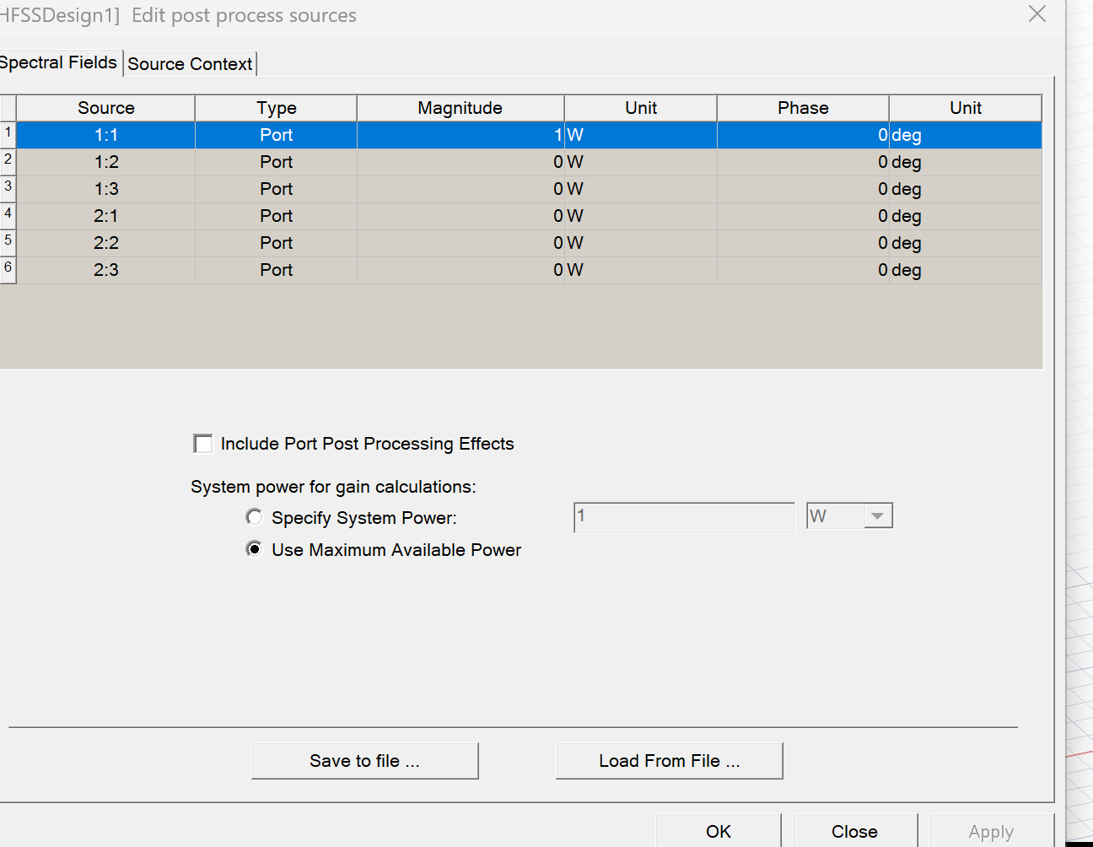
Figure 34: Changing the sources
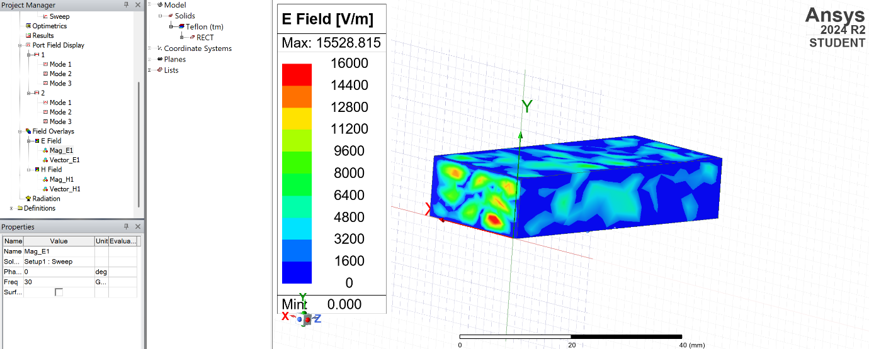
Figure 35: mode 2 mag E
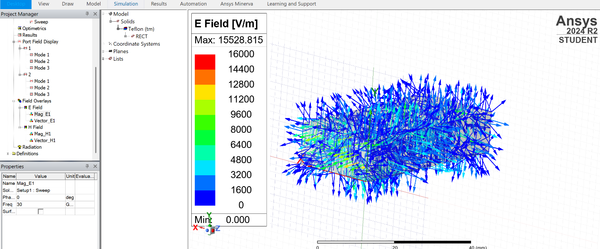
Figure 36:mode 2 vect e

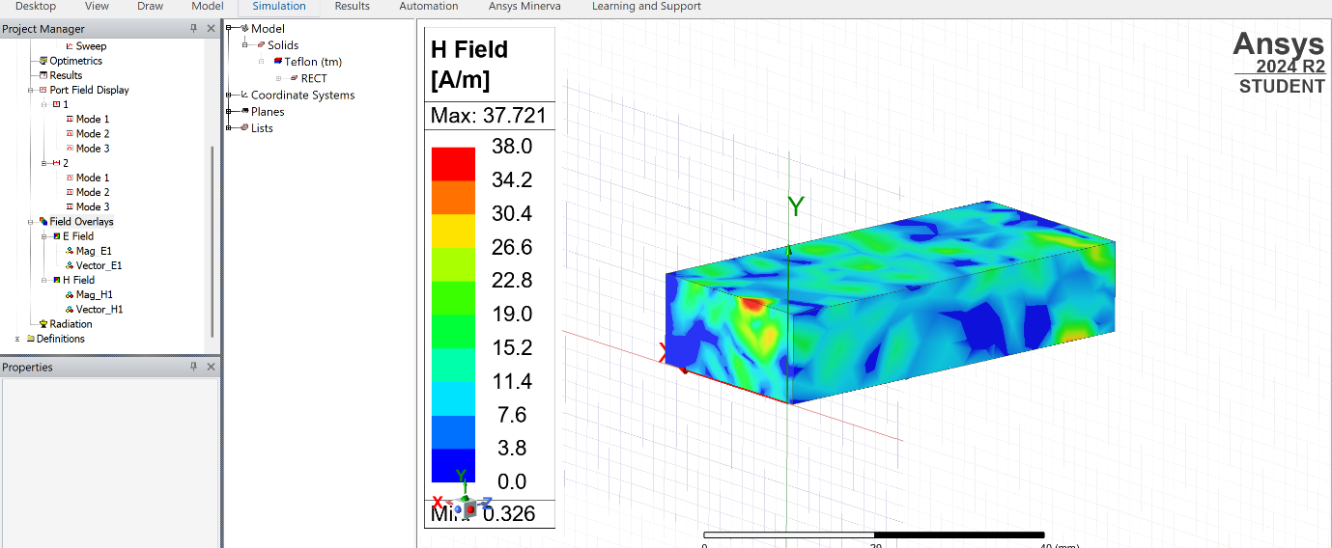
Figure 37:mode 2 mag H
Figure 38: mode 2 vect e
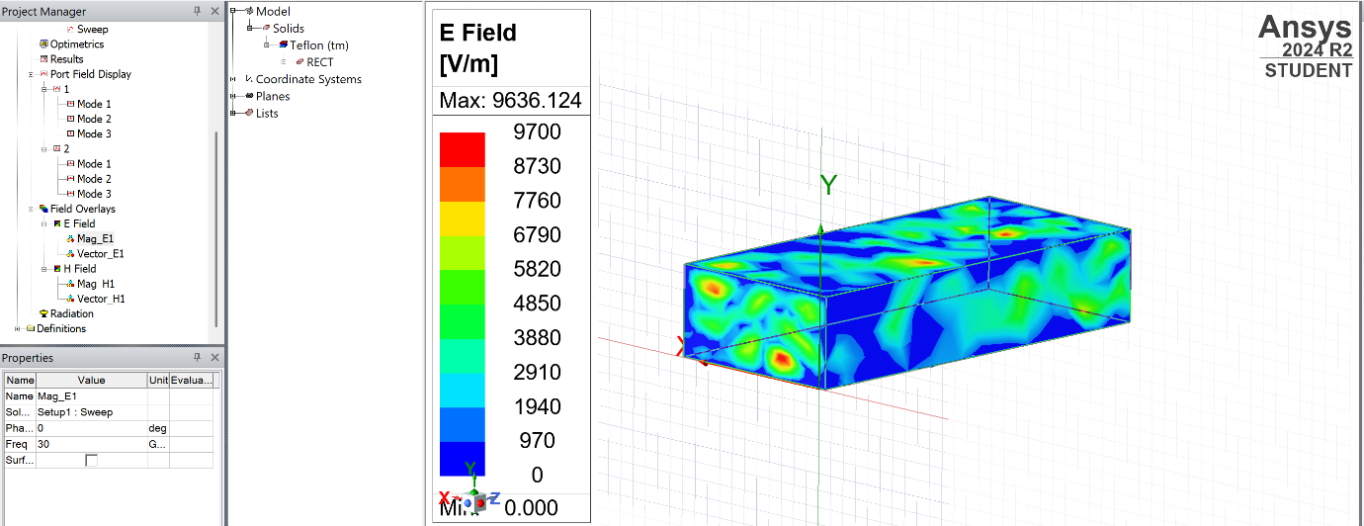
Figure 39: mode 3 mag e

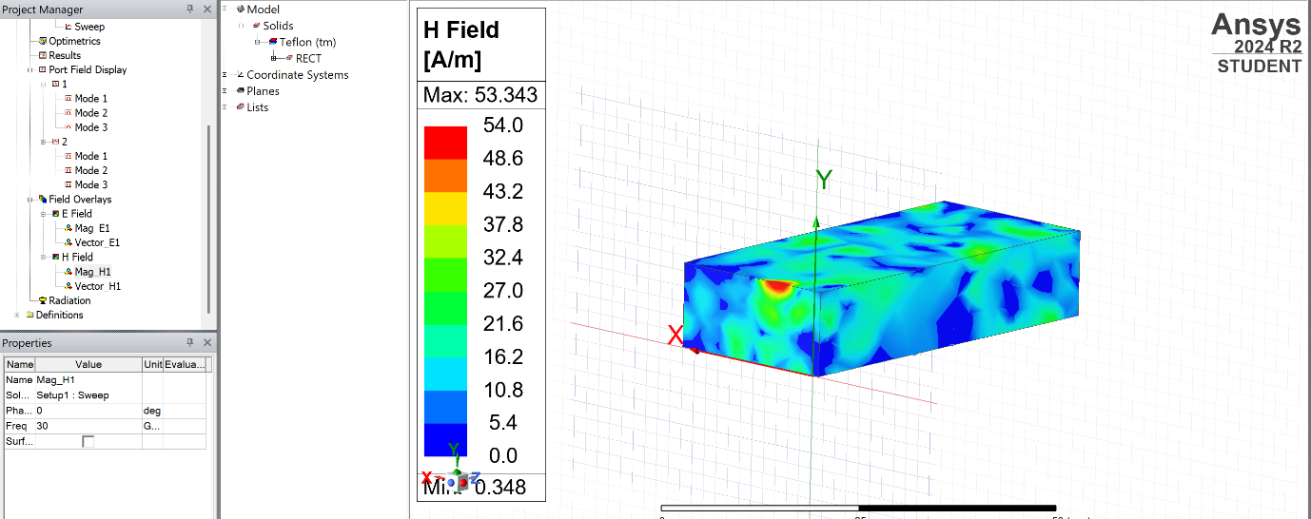
Figure 40:mode 3 mag H
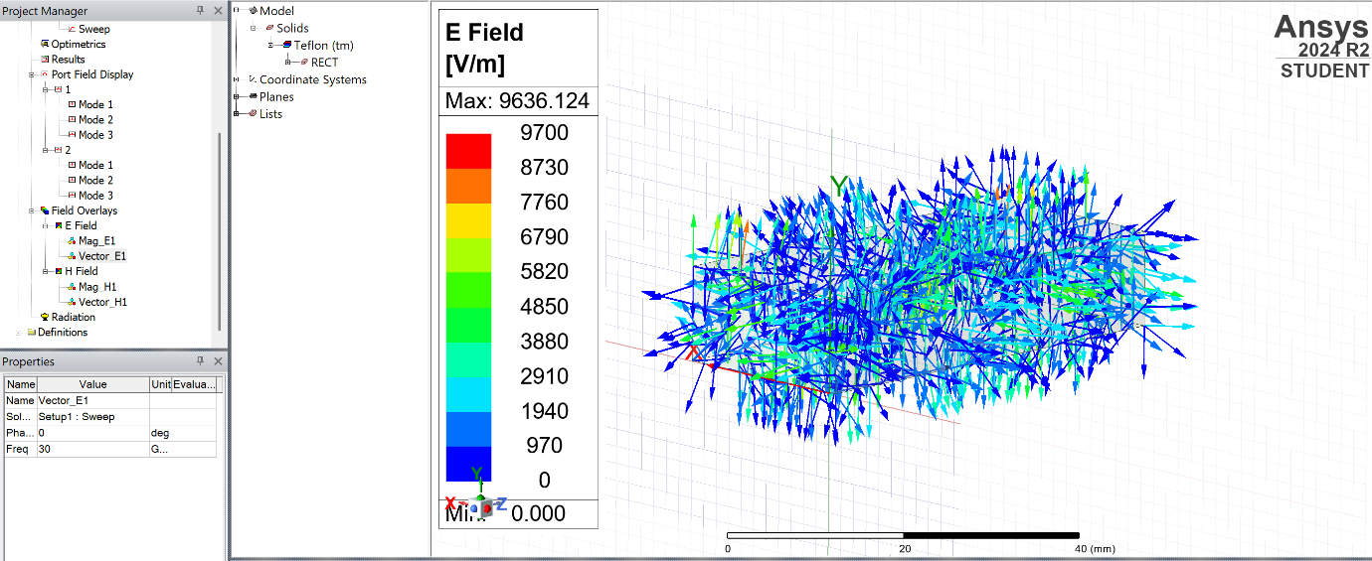
Figure 41: mode 3 Vect E
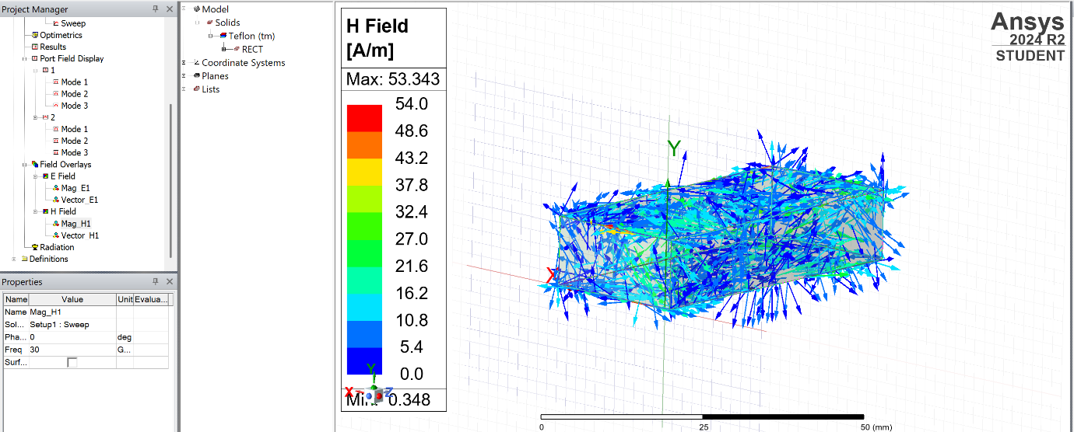
Figure 42: mode 3 vect H

Task 2

Simulation screenshots
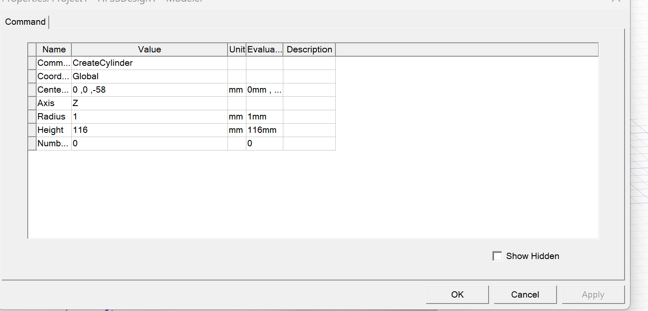
Figure 43:Dipole dimensions
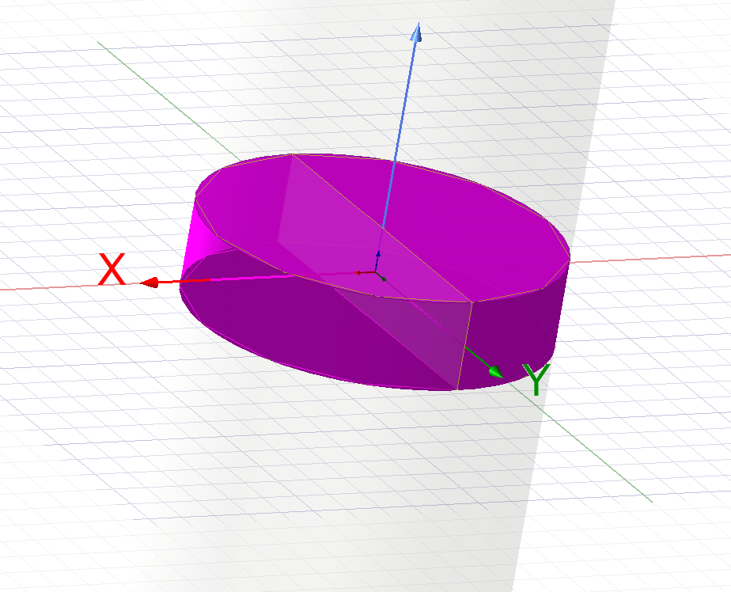
Figure 44: Dipole antenna vacuum gap and port
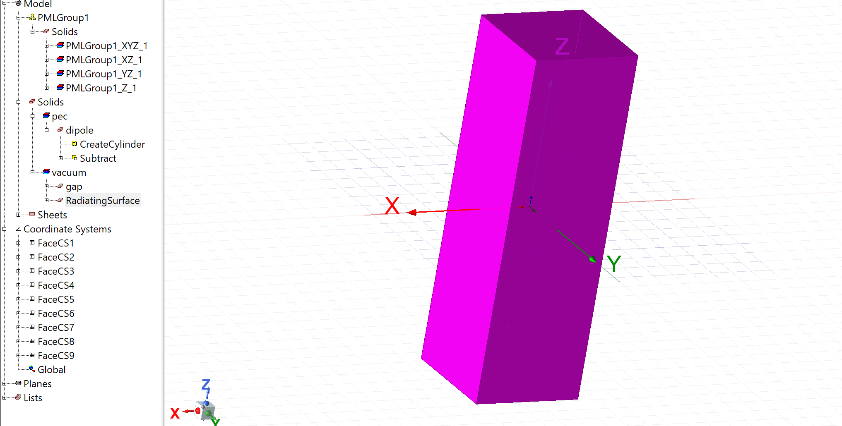
Figure 45: radiating boundary for antenna

