Mobile Application Development II
  - Lecture 12 Lab Tutorial Exercise

The Criminal Intent App Part VII

Objectives
In today’s exercise, you will update the app to implement a Two-Pane Master-Detail interface for tablet (larger) devices.

Exercise 1: Making Single Fragment Activity Flexible
Presently, SingleFragmentActivity always inflates the Activity_Fragment activity. This exercise will:
- make it possible for any class inheriting from SingleFragmentActivity to specify the ID of the resource to inflate
- as well as define a default activity layout (Activity_Fragment) to inflate.
- Open up SingleFragmentActivity.
- Add the following new method.
// Define the default layout resource to inflate
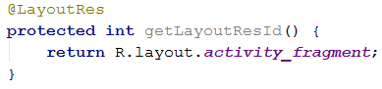
- Note: any activity class inheriting from SingleFragmentActivity that wishes to specify an alternative fragment activity will need to override the getLayoutResId() method.
- Now make the following change in the onCreate method, so that the fragment class uses the getLayoutResId() method to determine the layout to inflate instead of the hardcoded value of activity_fragment.
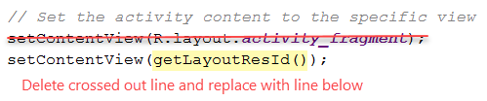

Exercise 2: Creating a Layout with Two Fragment Containers
- Create a new Layout resource file in the project
  - Name: activity_twopane or whatever you wish
  - Resource type: Layout
  - Root element: LinearLayout.
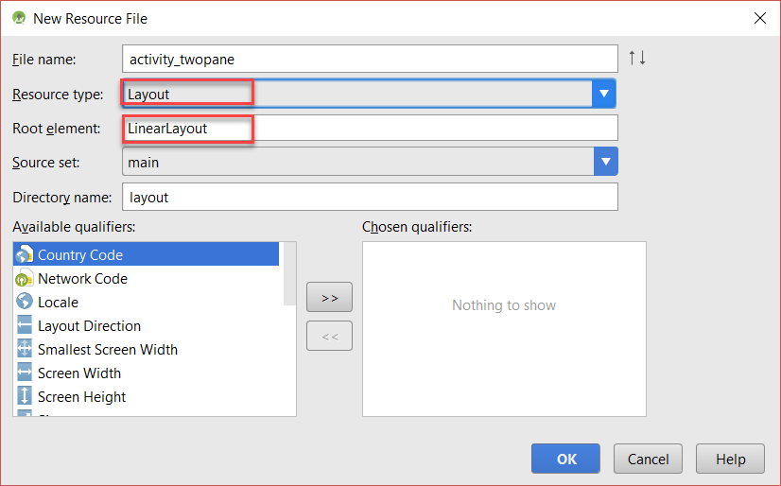
- Modify the Linear Layout as shown below
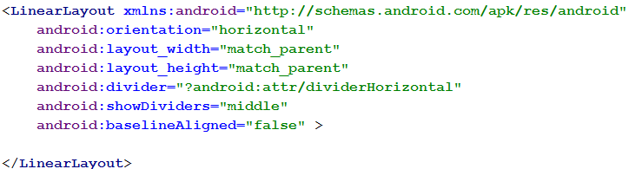
- Now add the following two frames to the Linear layout to host each of the fragments for the two-pane interface.
  - Frame 1
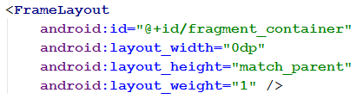
  - Frame 2
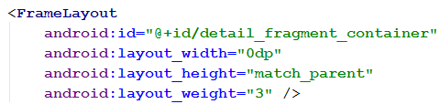

Exercise 3: Changing to the Two-Pane Layout for Crime List Activity
- Open up the CrimeListActivity class java file.
- You will notice that it inherits from SingleFragmentActivity.
- Recall that for an activity that inherits from this class to specify an alternative layout to use must override the getLayoutResId() method to return this alternative layout.
- Generate the override method as shown below. Note: you do not need the default call to super.getLayoutResId().
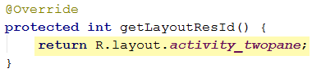
- Save your changes and test.
  - You should see the list on the left with the detail pane empty.
  - Nothing else happens at the moment and it is also still using the same layout for phone and tablet views.

Exercise 4: Using an Alias Resource
- Instead of duplicating the different components to different resource folders, you will use an alias resource.
- In the Project window, right-click the res/values folder and select New Values resource file. Name the file refs.xml.
- Add the following resource to it (shown on two lines for readability).
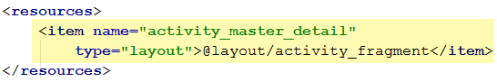
- This resource can now be used in place of activity_fragment.
- Open up CrimeListActivity.java and make the following change to use the alias resource instead.
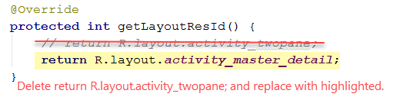
- Save and test that the new resource alias is working.
  - It should show the single-pane layout as you have now made this the default alias resource (refs was added to the default res/values folder).

Exercise 5: Creating Tablet Alternatives
- Next, you will create an alternative resource that the alias_resource activity_master_detail will point to activity_twopane.xml on larger devices.
- In the Project window, right-click the res folder and select New Android Resource file. In the window that opens, set
  - Name: refs.xml (or whatever you called the previous alias resource file)
  - Resource type: values
  - Available qualifiers: select Smallest Screen Width and set this to 600 (or whatever you think is an appropriate phone width).
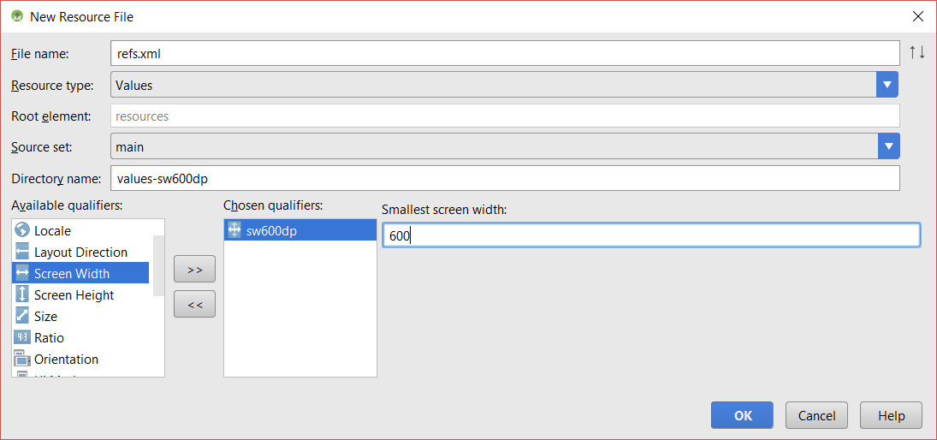
- Now add the following to the alternative resource file created so that it points to the two-pane layout.
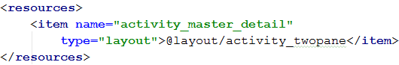
- If you have a tablet device or emulator set up, run and test your app.

Exercise 6: Adding a Callback Interface to Crime List Fragment
In this exercise, you will add a callback interface to CrimeListFragment, so that when a crime is selected, the host (container) activity can decide what to do.
- Open up CrimeListFragment.java.
- Add the following callback interface definition – it can be added anywhere, but you can add it before the onCreate method.
// Host container activity must implement this interface
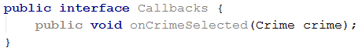
- Add the following private variable to store a reference to the callback interface. You will set its value shortly (Note: the variable should be accessible to all methods in this class).
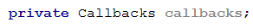
- Next, generate the onAttach method (Generate Override Methods…) and update it as follows to get a reference to the implemented callbacks interface by the host container activity.
Note: you could have used a try { } catch { } block to throw an exception if the host activity has not implemented the callback interface.
// If the host is an activity, get the implemented Callbacks Interface
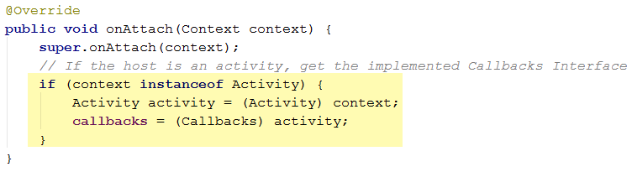
- Next, override the onDetach method and implement as shown below:
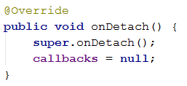

Exercise 7: Implementing the Callbacks Interface in the Host Activity
- Open up CrimeListActivity.java and add the highlighted change to its definition to make it implement the callbacks interface defined in the previous exercise (shown on two lines for clarity).
The red squiggly lines are warning me that I have not implemented the required callbacks methods.
- Generate the method to implement – right click and select Generate … Implement Methods … onCrimeSelected(Crime)
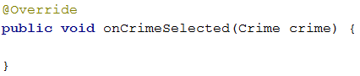
- This method needs to do one of two things:
  - If using phone interface, start a new CrimePagerActivity
  - If using tablet interface, put a Crime Fragment in the detail_fragment_container
- To determine which interface, you will check for the presence or absence of detail_fragment_container. Add the following to onCrimeSelected
// Check for presence or absence of detail_fragment_container
// If present, tablet interface, otherwise phone interface
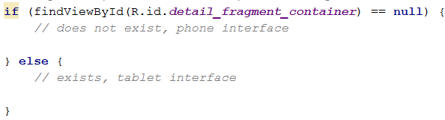
- For the phone interface section, add the following to start a new Crime Pager Activity
// Start new CrimePagerActivity with the ID of the crime to load
- For the tablet interface section, load a Crime Fragment into the detail_fragment_container
// Get a new Crime Fragment instance to load with the selected crime
// Load the fragment into the detail_fragment_container
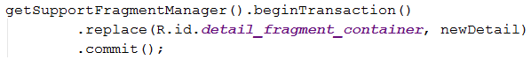

Exercise 8: Using the Callback Interface Methods in Crime List Fragment
- Return to CrimeListFragment.java
- You will replace all the places where you currently start a new CrimePagerActivity with a call to the callback interface method, onCrimeSelected, created earlier.

onOptionsItemSelected(MenuItem) Method
- Look for the onOptionsItemSelected() method and replace as shown below.
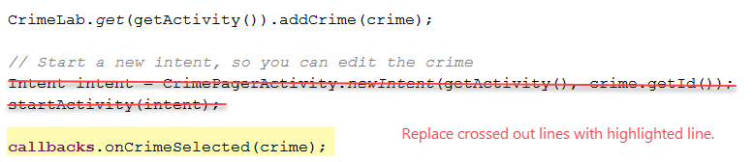

CrimeHolder onClick(View) Method
- Look for the onClick() method located in the nested CrimeHolder class, and do the same.
Note: the crime variable may be called crimeItem in this method.
- Save and test.
- Hmmm, did you notice the problem? If a crime is updated, the list does not get updated in the tablet view.
  - Presently, the update method is called when the crime list fragment resumes, but in the tablet view, this does not happen as the host activity does not change to cause the Pause and Resume methods to execute.
  - You will fix this with an onCrimeUpdated callback.

Exercise 9: Adding a Callback Interface to Crime Fragment
- Open up CrimeFragment.java
- Repeat the steps from Exercise 6: Adding a Callback Interface to Crime List Fragment and add a new Callbacks Interface for an onCrimeUpdated method.
Note: only step 1 is shown below.
// Host container activity must implement this interface
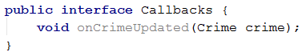

Exercise 10: Changing updateUI()’s Visibility in Crime List Fragment
- Open CrimeListFragment.java
- Look for the updateUI() method and make its access public instead of private as shown.

Exercise 11: Implementing the Callbacks Interface in the Host Activity
There are two host activities.

Crime List Activity
- Open up CrimeListActivity.java and add the highlighted change to its definition to make it implement the callbacks interface defined in the previous exercise (shown on two lines for clarity).
- Generate the method to implement – right click and select Generate … Implement Methods … onCrimeUpdated(Crime)
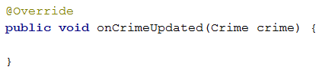
- Add the following to the implemented onCrimeUpdate method.
// Get a reference to the crime list fragment
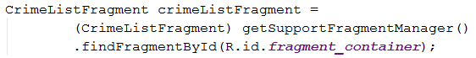
// Call its update UI method when a crime is updated

Crime Pager Activity
- The callbacks implemented in CrimeFragment must be implemented in all host container activities.
  - Thus, Crime Pager Activity must also implement CrimeFragment.Callbacks
  - However, the actual method can be blank – not contain any code as crime pager activity does not have a list to update.
- Open up CrimeListActivity.java and add the highlighted change to its definition to make it implement the callbacks interface defined in the previous exercise (shown on two lines for clarity).
- Generate the method to implement – right click and select Generate … Implement Methods … onCrimeUpdated(Crime)
- This time, however, you can leave the method empty as explained above. Crime Pager Activity does not need to update any list as it is a host for a single crime activity for swipe views.

Crime Fragment for Two-Pane Version
In the two-pane version, to handle the updates between the list on the left and the current fragment on the right, there will be some back and forth communication between CrimeFragment and the host activity. You will create a method to handle this interaction behaviour and ensure the host activity gets updated of any changes.
Note: Previously, we used the onPause event to update the crime, but this will not work in the two-pane view as the fragment does not get paused between crime selection changes as it is permanently loaded in the host activity.
- Create a new private method called updateCrime with a return type of void.
- Add the following to the method.
  - Send the updated crime to the database via the CrimeLab
// Send the updated crime details to Crime lab to update the database
  - Notify host activity, if applicable, of the change via the implemented callback
// Notify host activity, if applicable, that has implemented the onCrimeUpdated callback of the change so it can update its view

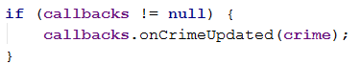
- Next, you will update the crime fragment to use the new updateCrime() method in a number of places.
  - onPause() method
    - replace the call to the CrimeLab.get(…).updateCrime(…) with a call to the updateCrime() method instead.
  - crimeTitleTextWatcher.onTextChanged Listener method:
    - Call the updateCrime() method after setting the crime title
  - CheckBox.OnCheckedChangeListener method
    - Call the updateCrime() method after set whether or not the crime has been solved.
  - onActivityResult() method: you also need to update the crime after the fragment sets the date using a date picker, or after selecting a contact as a suspect or taking a photo.
You have two choices to implement this.
    - Call updateCrime() three times in each if {} block i.e. after setting each crime property
    - Call updateCrime() once at the end of onActivityResult.
I went with option 2: add this to the end of onActivityResult before the closing curly brace “}”.
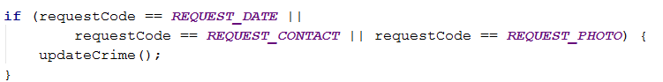
- While in the onActivityResult() method, could you also make the following highlighted, slight change to the if block for REQUEST_CONTACT
- Save your changes and test. Does it work?
- That’s all for today

Adapted from Android Programming: The Big Nerd Ranch Guide

