Student name: Andrea Bardoczi
Student No: 2209718
Module: BMIH5005 Personnel Resourcing and Development
Lecturer name: Deborah Lloyd
Word count: 1969

Contents Page
- Introduction and Background

- Discussion/Literature

- AI in Hospitality: Benefits and workforce concerns (cite relevant studies).
- Global Retirement Tide: Impact on industry knowledge and experience (cite demographic studies).
- Brexit and Economic Situation: Effects on recruitment and workforce diversity (cite economic reports).
- COVID-19 Pandemic: Shifts in employee expectations and operational challenges
3. Evaluation and Conclusion

4. References

Is the external challenge good or a bad?

- Introduction and Background
The Radisson Hotel London, an illustrious entity in the hospitality sector, stands as a symbol of luxuriousness and relief for its clientele. With its expansive global footprint and an unwavering dedication to surpassing industry standards, the Radisson Hotel has successfully etched its prominence in the annals of luxury accommodation. Its reputation is not merely a testament to its grandeur but also to its commitment to delivering unparalleled guest experiences. Yet, even with its esteemed stature, Radisson, akin to many of its contemporaries, grapples with the intricacies and unpredictability posed by external dynamics, particularly in the spheres of talent acquisition and sustenance.
A predominant concern that looms large for the hotel is the daunting task of employee retention. Delving deeper into the root causes, several internal factors appear as potential contributors to this predicament. The hotel industry, in recent times, has been plagued by a significant dearth of skilled workforce. This shortage of staff is further accentuated by the inadequacies in the existing training modules, which often do not equip employees with the requisite skills and knowledge. Additionally, managerial hurdles, ranging from communication gaps to lack of effective leadership, further compound the issue, leading to increased attrition rates.

2. Discussion/Literature
However, the internal challenges are merely one side of the problem. The external landscape presents its own set of trials. A notable external disruptor is the burgeoning influence of Artificial Intelligence (AI) within the hospitality domain. As AI continues to make inroads, there is an underlying apprehension about its potential to replace human roles, causing unease amongst the workforces. Coupled with this is the impending wave of retirements, which threatens to create a vacuum in the senior echelons of the industry. This impending shift, if not addressed proactively, could lead to a significant loss of institutional knowledge and ability.
Furthermore, broader socio-economic determinants cannot be overlooked. Factors such as changing demographics, evolving guest expectations, and the ever-shifting economic climate play pivotal roles in influencing the hotel's operational dynamics (Miller, Walker, & Drummond, 2009). In summation, while the Radisson Hotel continues to bask in its legacy of luxury, it still is imperative for it to navigate the multifaceted challenges of employee retention, ensuring its continued success in an ever-evolving industry landscape.
The hospitality sector, which includes prestigious entities such as the Radisson Hotel, is undeniably at a significant turning point. The external environment, punctuated by rapid technological advancements and socio-economic changes, is reshaping the very foundation of how establishments approach employee recruitment and retention.

Artificial Intelligence (AI): The emergence of AI in the hospitality realm is akin to a two-sided coin. AI's capabilities, ranging from streamlining back-end operations to offering personalized guest experiences, are revolutionary. Predictive analytics, powered by AI, can forecast consumer preferences, thereby allowing hotels to tailor their offerings, accordingly, leading to heightened guest loyalty and satisfaction. The extensive adoption of AI technologies raises legitimate concerns about the future of certain job roles. For brands like Radisson, the challenge is multifaceted: How can they use AI to its fullest potential while ensuring that their human workforce feels valued and irreplaceable? (Application of AI and robotics in hospitality)

“We believe data is key,” states Radisson Hotel Group vice president of digital Remy Merckx “We have recently partnered with Accenture Interactive to support us in building an advanced intelligence model to start predicting buying behaviours and patterns, better understanding our customer’s online journeys and the way they prefer to choose, book and stay with us; and connecting it to the demand and business generated for our hotels worldwide. These predictive models help us in getting most of our investments and initiatives and help us engage on a more personal level with our guests.”
Global Retirement Tide: A significant demographic shift is underway. As the older generation approaches retirement, industries across the board, hospitality included, are grappling with the potential vacuum left behind by seasoned professionals. This is not merely a challenge of filling positions but preserving the rich tapestry of knowledge and experience these veterans bring to the table (Kaewsaeng-On, n.d.). The ripple effects of this retirement wave could be profound, impacting everything from operational efficiency to guest satisfaction. (A report of research carried out by TNS-BMRB Report on behalf of the Department for Work and Pensions)
Current Affairs Impact:

Brexit and Economic Situation: The UK's political and economic landscape has been in a state of flux, with Brexit at its epicentre (How Brexit impacted the hospitality industry). The hospitality sector, which has traditionally benefited from the diverse talent pool within the EU, now faces potential recruitment challenges. The uncertainties surrounding Brexit, especially concerning immigration policies, pose significant hurdles. The potential restrictions on EU workers could lead to a talent crunch, compelling establishments like Radisson to recalibrate their recruitment strategies (Morgan & Kats, 2019).
Covid-19: The global onslaught of the Covid-19 pandemic has left no industry untouched, with hospitality being one of the hardest hits. Beyond the immediate operational challenges, the pandemic has ushered in a new era of employee expectations. The focus on health, safety, and overall well-being has never been more pronounced. Establishments like Radisson are now tasked with the dual challenge of ensuring guest satisfaction while simultaneously addressing the health and safety concerns of their employees (Turner & Broom, 2020). As we can see on the following graph the pandemic had a significant impact on the hospitality industry.
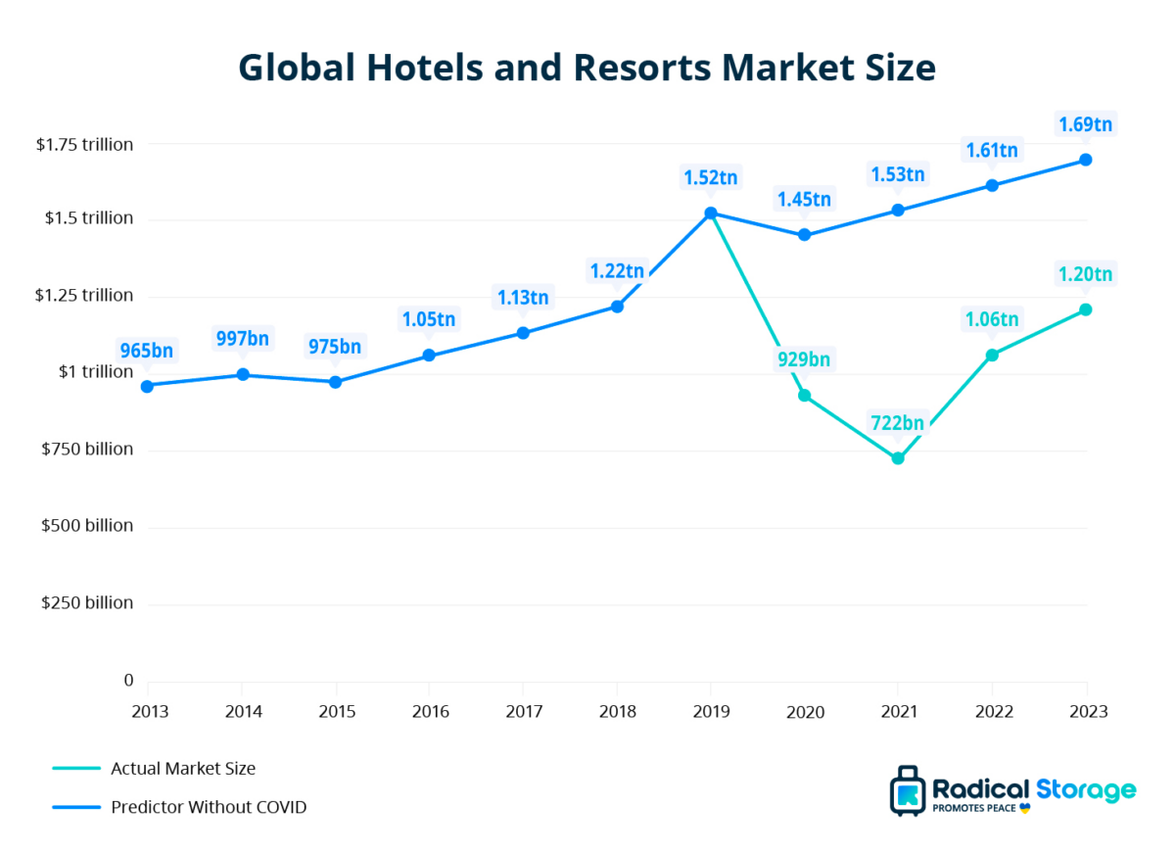
Industry Examples: Radisson Hotel's response to these challenges offers a blueprint for resilience and adaptability. In the AI domain, instead of adopting a defensive stance, Radisson has chosen to embrace the opportunity. They have launched comprehensive training initiatives aimed at empowering their employees to work alongside AI tools. This not only provokes fears of job losses but also positions the workforce for future success in an AI-augmented environment (Immaneni & Sailaja, n.d.).
In addressing the retirement wave, Radisson's strategies are both compassionate and pragmatic. They have recognized the irreplaceable value of their seasoned employees and have, in turn, rolled out policies that cater to their needs. From flexible working arrangements to phased retirements, these initiatives aim to keep the vast reservoir of knowledge these veterans have, ensuring a seamless transition of ability to the next generation (Brown & Thomas, 2021).
The hospitality sector is experiencing a dynamic shift, shaped by a mix of technological, demographic, and geopolitical influences. In navigating this complex landscape, Radisson Hotel stands out as a beacon of adaptability and foresight. Their strategies underscore the essence of viewing challenges as catalysts for innovation and growth. As the sector progresses, Radisson's forward-thinking stance stands as a testament to the strength of adaptability and innovation amidst challenges.
Sustainability and Environmental Concerns: Another aspect gaining prominence in the hospitality industry is the focus on sustainability and environmental responsibility. The modern traveller is more environmentally conscious and seeks out establishments that mirror their values. This shift in consumer preferences is driving hotels, including the likes of Radisson, to re-evaluate their operational practices. From reducing water consumption to minimising food waste and adopting renewable energy sources, the focus is on creating a more sustainable and eco-friendly guest experience (Greenwood & Meehan, 2019).
Digital Transformation: Radisson Hotel Group is one of the first adopters of these ground-breaking technologies driving increased customer engagement and booking conversions. Over the last three years, Radisson Hotel Group has cemented its position as a digital leader and pioneer in the industry with its digital transformation strategy to supply a localized and personalized digital experience to its guests by embracing modern technology innovation and immersive experiences.
With the launch of immersive experiences, the Group has blended the digital and physical worlds, where guests can move around, explore the hotel spaces virtually, see what the view from the room looks like, and even interact with surrounding objects, thanks to 3D virtual venue tours from their smartphones, computers, or VR devices. Guests can also book the specific place they see on their screen via a simple and seamless booking process
To date, 86 hotels have integrated virtual tours into their hotel web pages which have delivered a +279% increase in the number of clicks, a +3.85% increase in average time on page, and +20.91% interactions in 2022 versus 2021 when these pages had only static images. The Group’s aim is to roll-out the immersive experience across 100 hotels by the end of 2023. Digitalization is particularly important for the sustainability of a business as still up to this date just over 60% of the globe population is using the internet. Slowly but steadily is increasing as we can see in the following graph.
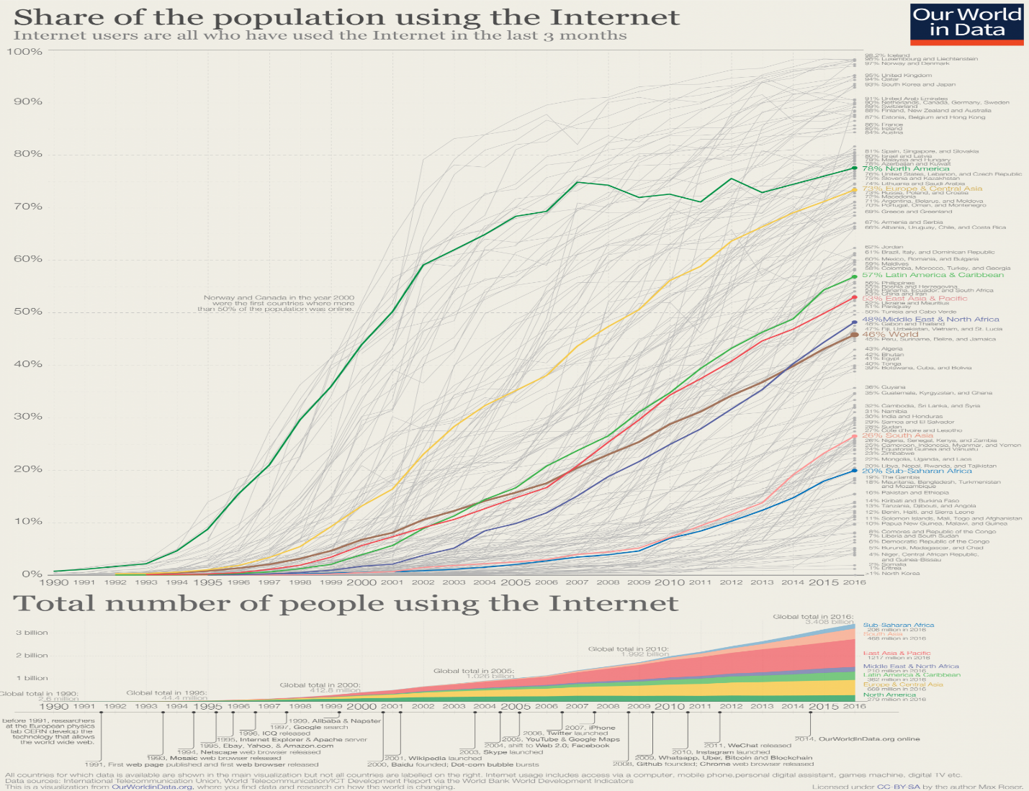

Cultural Sensitivity and Inclusivity: The global nature of the hospitality industry needs a deep understanding and appreciation of diverse cultures. Hotels are melting pots where cultures converge. For establishments like Radisson, it is imperative to foster an environment of inclusivity, where every guest feels valued and respected. Training staff to be culturally sensitive, offering cuisine that caters to diverse palates, and ensuring that hotel decor and practices are inclusive are all steps in the right direction (Singh & Kapoor, 2018).
Employee Well-being: Beyond the external challenges, there is an increasing recognition of the importance of employee well-being in the hospitality sector. A motivated and content workforce directly translates to superior guest experiences. Radisson has been proactive in recognising this correlation. They've instituted wellness programmes, mental health support, and continuous professional development opportunities, ensuring that their employees are not just equipped to handle their roles but are also mentally and emotionally supported (Thompson & Gregory, 2021).
In summation, the hospitality landscape is intricate, and shaped by a myriad of internal and external factors. While challenges abound, they also present opportunities for innovation, growth, and differentiation. Radisson Hotel, with its forward-thinking strategies and unwavering commitment to excellence, exemplifies how establishments can navigate this complex terrain. Their comprehensive approach, harmonizing ing guest contentment with staff well-being and environmental duty, speaks volumes about their vision for the future. As the industry continues its trajectory of evolution, Radisson's endeavors serve as an inspiring blueprint for others in the sector.
3. Evaluation and Conclusion
The external environment's challenges, while formidable, undeniably pave the way for potential growth and innovation. For establishments such as the Radisson Hotel, the essence of navigating these tumultuous waters lies in their ability to adapt to the evolving landscape, all the while upholding their foundational principles and core values (Smith, 2019).
In the modern hospitality industry, keeping employees has become a major issue, particularly considering the uncertain external surroundings. Tackling this needs a comprehensive and varied approach. One of the primary steps in this direction is the emphasis on continuous training. By equipping employees with the latest skills and knowledge, Radisson Hotel can ensure that its staff still is at the forefront of industry standards, thereby enhancing service quality and guest satisfaction (Jones & Thomas, 2020).
In a sector where long shifts and intense customer interactions are the norm, it is vital to make sure our staff feel appreciated and looked after. This not only aids in retention but also promotes a positive workplace culture, which can significantly impact guest experiences.
By creating an environment where every individual feels valued and has equal opportunities for advancement, Radisson can set itself apart as an employer of choice in the hospitality sector (Martin, 2021).
Drawing insights from industry peers and being proactive in anticipating future challenges can also play a pivotal role. By staying ahead of the curve and learning from both successes and failures within the industry, Radisson has the potential to not only retain its esteemed workforce but also significantly bolster its brand value in the eyes of both employees and customers alike (Peshave, n.d.; Thompson, 2022).
To conclude, it is evident that while the external challenges that the hospitality industry faces are rife with threats, they simultaneously present a myriad of opportunities for innovation and growth. With astute strategies and a forward-thinking approach, establishments like Radisson Hotel can adeptly transform these challenges into lucrative opportunities, thereby cementing their esteemed legacy in the ever-evolving world of hospitality (Peshave, n.d.; Davis, 2019).

4. References

- Application of AI and robotics in hospitality sector: A resource gain and resource loss perspective
- Global Hotels and Resort Market Size Graphic 1
- How Brexit impacted the hospitality industry
- Remy Merckx
- A report of research carried out by TNS-BMRB Report on behalf of the Department for Work and Pensions
- Kaewsaeng-On, R. (n.d.). Talent management: a critical investigation in the Thai hospitality industry.
- Immaneni, K. M., & Sailaja, V. N. (n.d.). A Review of HR practices and Employee Retention in Hospitality Industry.
- Peshave, M. A. (n.d.). A STUDY OF FACTORS INFLUENCING INCREASING ATTRITION RATE IN HOTELS OF PUNE, ITS IMPACT ON THE ORGANIZATION AND MEASURES UNDERTAKEN BY THE HOTELS TO CURB THE ATTRITION RATE.
- King, B., & Tang, C. M. F. (2020). Employee preferences for industry retention strategies: The case of Macau’s “Golden Nest Eggs’’
- Kazi Nazmul Huda, Alina Haque, & Khan, R. (2014). Effective Recruitment Challenges Faced by the Hospitality Industry in Bangladesh: A Study on Selected Star Rated Residential Hotels.
- Gursoy, D., Maier, T. A., & Chi, C. G. (2008). Generational differences: An examination of work values and generational gaps in the hospitality workforce. International Journal of Hospitality Management, 27(3), 448-458.
- Choi, Y., & Dickson, D. R. (2010). A case study into the benefits of management training programmes: Impacts on hotel employee turnover and satisfaction level. Journal of Human Resources in Hospitality & Tourism, 9(1), 103-116.
- Barron, P., Maxwell, G., Broadbridge, A., & Ogden, S. (2007). Careers in hospitality management: Generation Y's experiences and perceptions. Journal of Hospitality and Tourism Management, 14(2), 119-128.
- Poulston, J. (2008). Hospitality workplace problems and poor training: A close relationship. International Journal of Contemporary Hospitality Management, 20(4), 412-427.
- Blomme, R. J., Van Rheede, A., & Tromp, D. M. (2010). The use of the psychological contract to explain turnover intentions in the hospitality industry: A research study on the impact of gender on the turnover intentions of highly educated employees. International Journal of Human Resource Management, 21(1), 144-162.
- Graphic 2
- 3D Radisson

