University of Wales Trinity Saint David
BA(Hons) Creative computer games design – M6X01580

Critical Review
Self-Reflective Report

Nathan Small - P143486

Tutor - Richard Morgan
Word Count – 2,542
Abstract

This analytical report documents the growth of an aspiring sculptor who is increasing in technical skill and ability to present their work in a professional and academic standard.
A conclusion was determined that the trajectory of skill has increased each year as the assignments became more demanding of the student, thus pushing for an elevated level of maturity with a willingness to learn and ability to provide supplementary evidence of research sources and showing development pathways.

Table of Contents

Introduction 4
Three years on BA(Hons) Creative Computer Games Design UWTSD. 5
Year one: 5
Year two: 5
Year three: 6
Character Show Reel 7
Show reel: 8
Continuing practice: 10
Conclusion: 11
Bibliography 12
Appendix 13

Introduction

This report is a reflection on a student’s time studying Creative Computer Games Design at University of Wales Trinity Saint David (UWTSD) as part of a three year course. This will include comments on time-management, documenting of practice, collaboration with other students through the work pipeline, and how refining these skills can have an impact on reaching a professional standard. This report will also feature the students end of year show reel which has been focused on character creation, analysing why the selected models were used, as well as discussing where the student’s trajectory may take them once graduated.

Three years on BA(Hons) Creative Computer Games Design UWTSD.

Year one:
The first year of the course was understood to be the foundation where individuals were expected to cover the essentials of all aspects of game design. This meant learning the basics of all necessary programmes, including Maya, ZBrush, Substance Painter, and Unreal Engine4. Each student was subject to lectures dedicated to teaching these industry standard pieces of software, while simultaneously improving life skills like team work and planning. This combination indicated to me that in industry it takes more than good game design alone to succeed. Influenced by their development over the year, students eventually chose what aspect of games design they preferably wanted to focus on for the rest of the course.
Year One’s main focus was making students aware of the full scope of the creation pipeline and the fundamentals of working as a team with other students. Teams of three or four were given a brief to complete specific tasks, including designing an evil genius’ headquarters [Appendix A] or an alternative vehicle [Appendix B]. The main project was focused on creating an animated video titled ‘The Wicked’ [Appendix C, D]. This assignment was focused on working in collaboration with students from the Animation course at UWTSD. As first year students it was made clear that the task was not merely about the creation of a final product; it was also concerned with giving the students the ability to function as part of a team, who can plan and manage their time well [Appendix E], present themselves professionally in front of an audience, and document the processes undertaken to reach an end product.

Year two:
By year two students had an idea of their preferred role in the creation pipeline; being a concept artist, 3D modeller, texture artist or technical artist (Engine). From the beginning of year two it was expected from the students to research their specific role in and outside of University. This involved learning from a variety of different sources, from YouTube guides, forums, news articles, books, 3D artist magazines, seminars, and events such as SAND, an annual games convention.
Second year was comprised of similar methods of learning to first year; getting to know one’s peers through team building assignments alongside the major project, which involved the creation of a level for a game concluded by a boss fight. Students were expected to be able to apply what was learnt during team building to the main project. Additionally, they were expected to document and present the project at a level that surpassed the quality of the work produced in first year, thus demonstrating the ability to learn from previous mistakes and successfully document how their final outcome came to be. Alongside this major project of Trackers Express [Appendix F], additional assignments were carried out, including the creation of a video walkthrough of Sci-Fi Corridor [Appendix G] and an Interactive Witches Hut within Unreal Engine 4 [Appendix H].

Year three:
By the third year, it was expected that students had a higher level of understanding of time management, acquired from past years, involving using an in depth Gannt chart on Microsoft Excel. This standard software is useful for its ability to make changes quickly, which is beneficial for fast moving projects.
It was also necessary to utilise a professional approach to social interaction with other members of a team, being able to plan a major project coherently, while linking with one another and having regular group meetings to ensure deadlines would be met.
The safety of all digital files is of paramount importance, as having to repeat work can have devastating effects when working to a strict deadline, so files most be backed up on computer, external hard drive and Google Drive. This is effective at preventing any loss of work due to mistakes or freak accidents to equipment. How to approach incidents of that nature calmly and efficiently is documented in a Risk Assessment document [Appendix I].

Character Show Reel

The Critical Review module requires the creation of a show reel demonstrating a student’s skills and capabilities in their strongest choice of career direction. Nathan Small learnt the basics of each role in the creation pipeline and took to the modelling side of games design, wanting to pursue the role of a character modeller. A background in fine art has led to being able to visually recognise realistic anatomy for character proportions and their muscle flow, which in turn has been an instrumental part in being able to reproduce character sculptures which depict their orthographic drawings to a high standard.
“you face two core issues when you create realistic game characters, technology and artistic ability. Five years ago, the biggest problem was technology. We simply couldn't put enough polygons on the screen to get true realism. Today, artistic ability is the biggest factor limiting a 3D modeler's growth in the game industry. The demand for realism increases with technological advances.” (Kingslien, 2011)
The Show Reel is comprised of characters from Trackers Express, the dungeon crawler; the student having taken part in its production from years one and two; with characters making it into Trackers third year expansion. The learning experience from Trackers Express was limited in terms of character sculpting however, having to stay within the boundaries of a stylised form of Chibi, a Japanese manga style.
Freelance character artists will receive an increased number of job prospects when they are capable of adapting their sculpting methods to take on different styles of characters to fit a desired look of a game.
To ensure future employability a display of technical range and ability has to be demonstrated through multiple projects. This involved creating a first person puzzler game; The Untold Labyrinth, with focus on a mythological Egyptian art target. This project allowed for more complex character work, having to combine hard surface and organic sculpting along with first person arms sculpted to a fixed scale.
When working on a game in a small team it is not possible to only sculpt characters, the roles need to be diverse and in turn the character artist must take on environmental assets. With the assignment of creating a show reel of around two minutes, this poses a problem when there has not been enough character work planned in the major projects over the three years at UWTSD. To hit the brief’s time requirement personal works need to be added to the show reel, this would then be comprised of speed sculpts which took no longer than two and a half hours.

Show reel:

The title screen introduction to the show reel is where it needs to grab and hold the attention of the viewer, and to intrigue them to continue watching. This has been attempted by stimulating the brain and eyes with fast forwarded video of live sculpting [Appendix J].
This is a great method to use over black title place holders as it allows the viewers to not only see the final images but how they come to be moulded into their finished state.
The ‘Anubis’ character is from the third year game; The Untold Labyrinth. This model proved challenging as it consists of mixing organic human-like flesh with hard surface plate armour sculpting. The character is half human and half dog; being able to merge the two convincingly while adhering to the art target was a challenging and lengthy process, although ultimately its goal was achievable. A good sense of anatomy and studying human and animal structure was a key learning aspect in the creation of this character [Appendix K].
The ‘Ocelotling’ is a non-playable character for Trackers Express. The sculpt worked well for its role in the game and its uncanny resemblance to its orthographic drawings allowed it to be a good choice in being used as a modular level asset in year three’s Trackers Expansion. It was chosen to be in the show reel because it has been a widely used character, and it being a character that test players enjoyed interacting with. Although it is difficult to expand knowledge on sculpting models in the Chibi style because the detail on the model comes from the texture artist and not the modeller. This being the case the modeller can only seek satisfaction through being able to produce a quality 3D representation of a 2D orthographic drawing [Appendix L].
The ‘Gemmoth’ has functioned as a boss character in year two and as non-playable characters in Trackers Expansion serving as cattle. This character is used in the show reel because of it’s unique looks and because it reflects the orthographic drawings to a high standard even though it lacks in sculptural detail [Appendix M].
The ‘Crystaling’ is an enemy character in Trackers Express second year. This character is very basic and is used in the show reel because of it being modelled in Maya, signalling to the viewer that the sculptor is capable of using a range of methods to create 3D forms to a finished standard [Appendix N].
‘Era’s Glove’ is from the third year project The Untold Labyrinth. Although it is not a character, the glove is in the show reel because it is part of the protagonist and the asset is used to transition from two distinct realms in the game. Creating the glove itself was a strenuous task, having to be modelled to an exact fit, needing to be millimetre perfect to the pre-modelled first person arm or it would not look right or function correctly with the animations that accompanied it [Appendix O].
‘First Person Arms/Hands’ have been placed in the show reel specifically to show off the topology of the sculpt because hand topology is time consuming and can be difficult to get right. The flow of the topology and the joining of polygons have to be correct in order to ensure productive team pipeline, correct texturing and the syncing of the weight painting and animations [Appendix P].
The half way point of the video hits a ‘Speed Sculpt’ intermission helping to prevent the turntable from becoming stagnant. It breaks away from the turn table of characters and again visually shows how characters are created with a time-lapse of the werewolf character [Appendix Q].

The ‘Werewolf’ character took two hours and thirty minutes and used reference from the game World of Warcraft. The sculpt was ambitious with a small time scale and it needing plenty of detail throughout as it is displayed as a full body character [Appendix R].

The ‘Alien’ was a fast concepting sculpt, focusing on the skin of the creature, understanding where folds and creases would flow, this is much like how retopology functions; building around the flow of skin and muscle [Appendix S].

The purpose of the ‘Mollusc Creature’ was to gain knowledge of how to combine mollusc’s traits with a human-like figure. This sculpt did not meet personal expectations, although it was a thought provoking concept it has opened up future ideas of revisiting this area [Appendix T].

The ‘Woman in headscarf’ sculpt idea came from looking at Egyptian themed reference for the third-year major project, The Untold Labyrinth. In studying apparel linked to hot and sandy environments it helped provide an insight as to what the characters could wear. The focus of this sculpt was to practise the composition of facial features [Appendix W].

Continuing practice:

The ultimate objective for this student is to train to become a professional sculptor and gain a wide knowledge in the software used for 3D sculpting and successfully utilise ZBrush and Mudbox’s advanced techniques and tools in order to produce work of an elite caliber. I intend to actively search for job applications online for indie and AAA games companies looking to break into the industry as a sculptor. It will be helpful to apply for lower case jobs such as Q&A, marketing, advertising and play tester. This method is about getting a foot through the door, which in time could lead to a career as a full-time sculptor.
Working on an out of University side-project involving sculpting two characters for illustration students to be 3D printed has spiked an area of curiosity in which owning a 3D printer can have benefits. 3D printing opens a niche market in the Swansea area, being able to take on commissions or printing other people’s work for side-income. While earning income it will also further the progression of skills in sculpting, printing, software, and marketing (Appendix X, Y].
Having come from a fine art background, traditional clay sculpting will be practiced. With supplies being cheap in comparison to 3D printing it seems as though this route is economically sound, given the students current financial status; post graduate. This ancient method of sculpting is a worthwhile investment in training as a sculptor in ways computers cannot teach, as the rules of physics and gravity only apply in the real world.

Conclusion:

This student has demonstrated a well balanced skill set within each role, learnt from the assignments over the three years spent at UWTSD and aims to improve his skill set as a professional 3D character modeller.
The student has shown a continually improving trajectory of skill over the academic degree and a keen appetite for work outside of University. To continue growing as an artist it is understood that continuing to practice the art and self-determination can lead to a range of job prospects.
Holding down a full time job in the games industry would be easier now having improved on interpersonal skills and working co-operatively as a team, whilst documenting findings to a professional standard.

Bibliography

Blizzard Entertainment. (2017). World of Warcraft. [Available at: https://worldofwarcraft.com/en-gb/game/races] Accessed [15/01/2018]

Dephraction. (2012). Legacy of Kain: Soul Reaver (Story) HD. YouTube. [Available at: https://www.youtube.com/watch?v=TuVRUZwAX8U] [Accessed on: 12/12/17].

Karon, P. (2016). Digital vs. Traditional Sculpting. [online] CGCOOKIE. Available at: https://cgcookie.com/articles/digital-vs-traditional-sculpting [Accessed 15/03 20/2018].

Keller, E. (2011). INTRODUCING ZBRUSH 4. Indianapolis: Wiley Publishing.

Kingslien, R. (2011). ZBrush Studio Projects: Realistic Game Characters. 1st ed. Indianapolis: Wiley Publishing.

Legaspi, C. (2015). Anatomy for 3D Artists: The Essential Guide for CG Professionals. 1st ed. United Kingdom: 3DTotal Publishing.

Orange83. (2017). LEARN PREMIERE PRO IN 13 MINUTES! Basics tutorial for beginners. [Available at: https://www.youtube.com/watch?v=hzO3vrFaPRU] [Accessed on 09.04.2018].

Oskar Wetterbrandt (2016). Making of FPS Hands, Oskar Wetterbrandt, 3D Animator. [Available at: https://www.youtube.com/watch?v=6A2ZxsCV22Y] [Accessed on 15/12/2017].

Rogers, S. 2014. Level Up: The Guide to Great Video Game Design. New Jersey: Wiley Publishing

Smith, T. (2016). Model a Creature from Concept to Render, 3D World, Christmas 2016, 36-41

Appendix

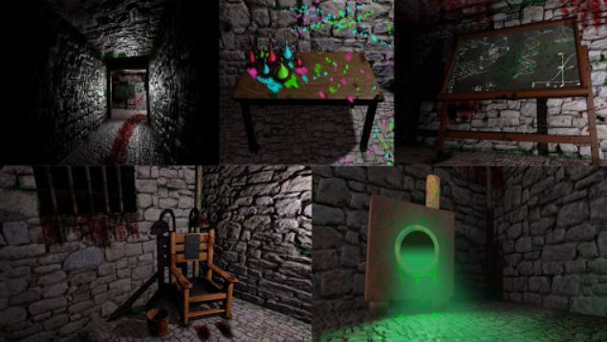

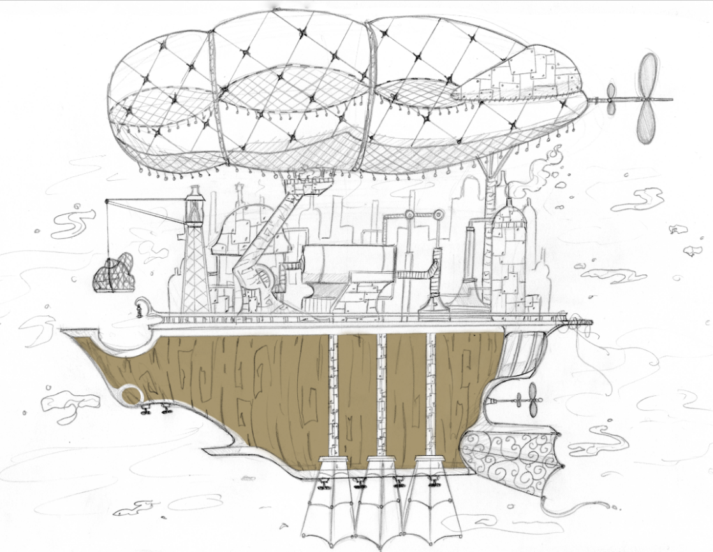

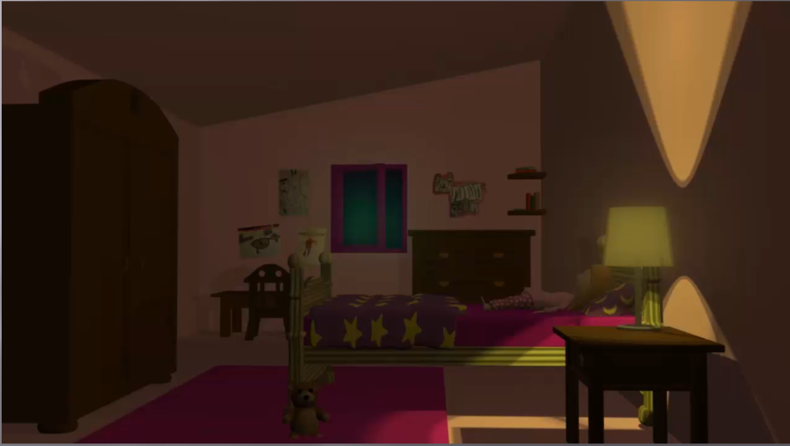
C)

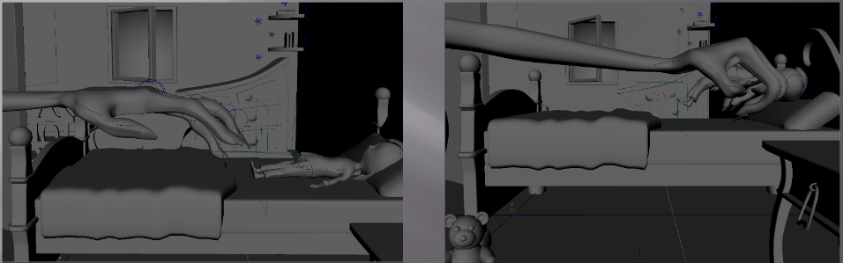
D)

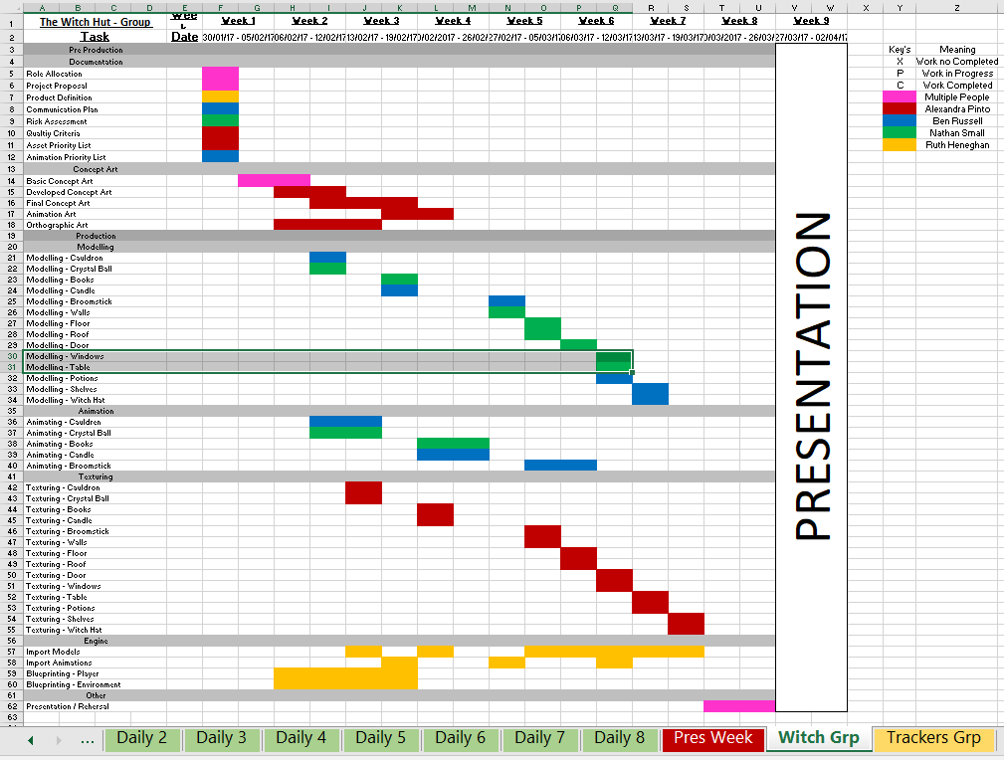
E)

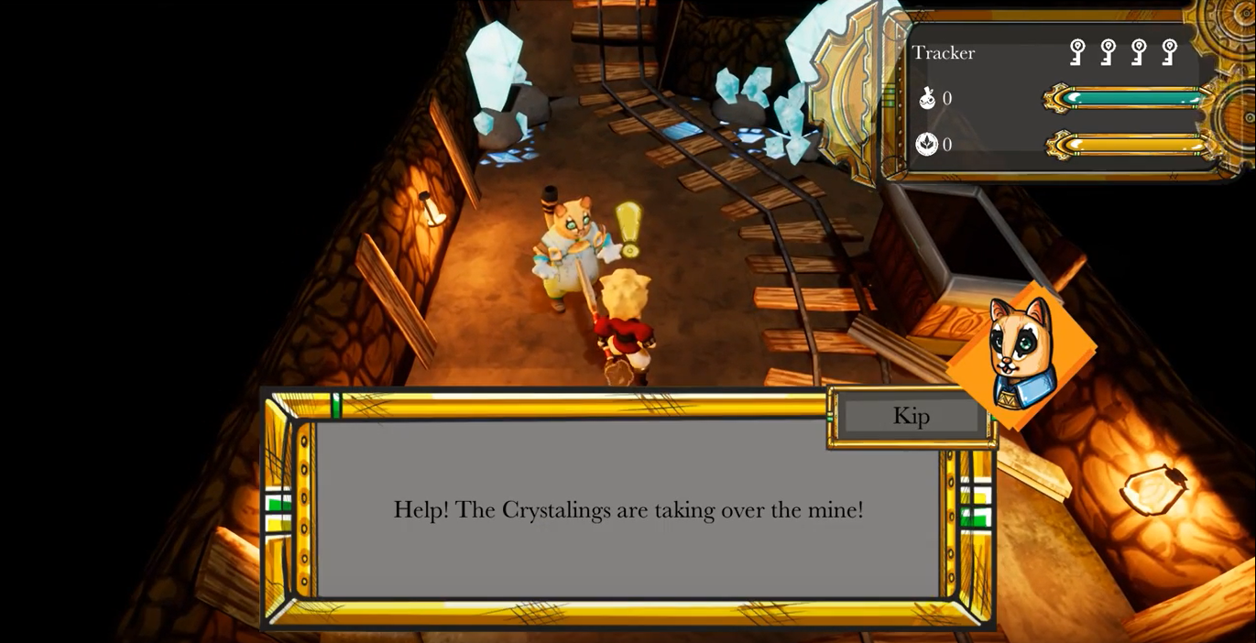
F)

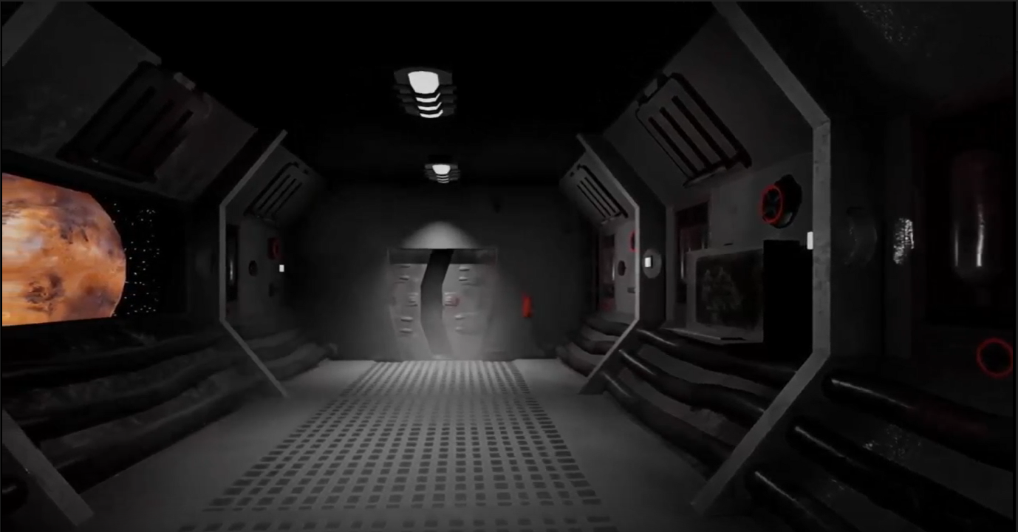
G)

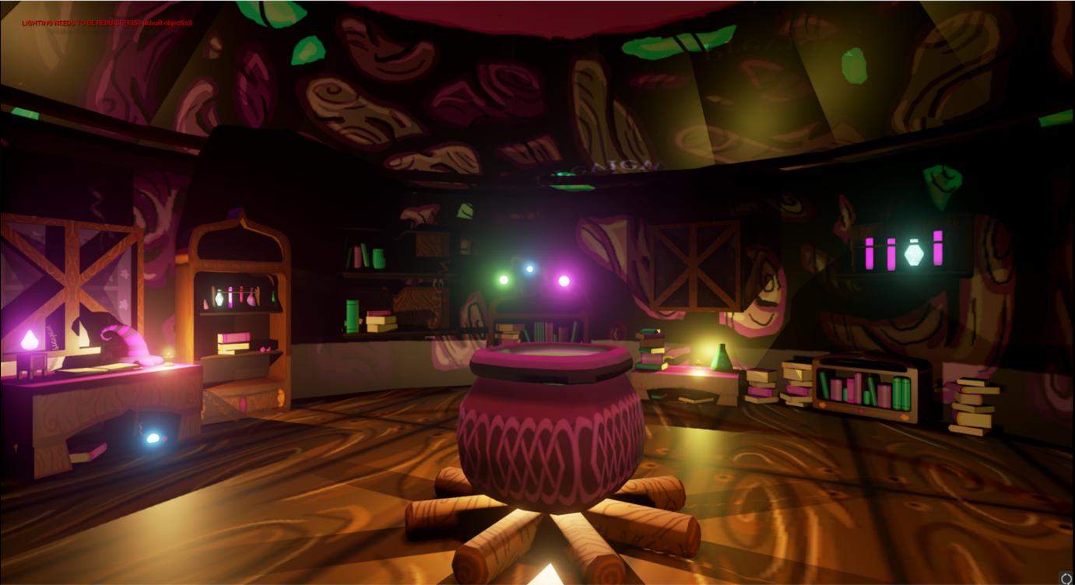
H)

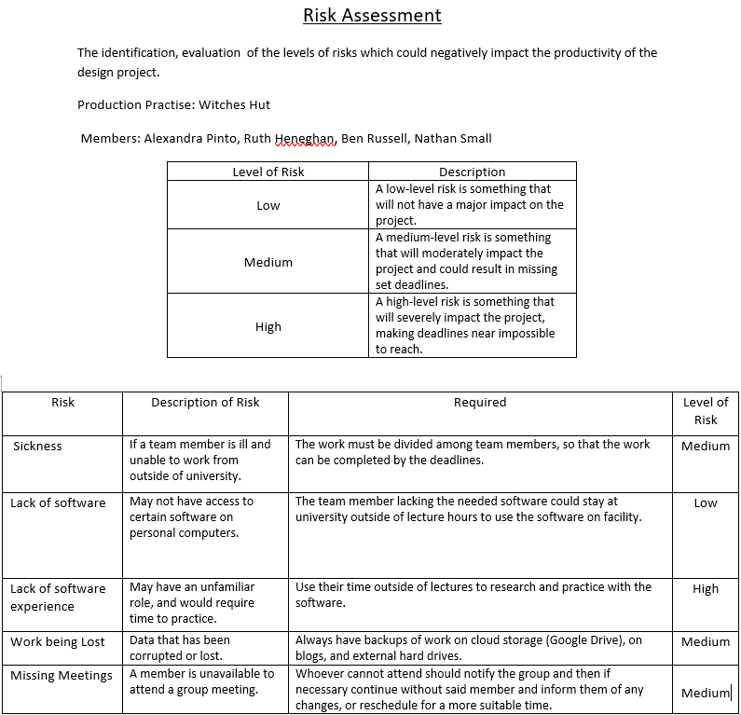

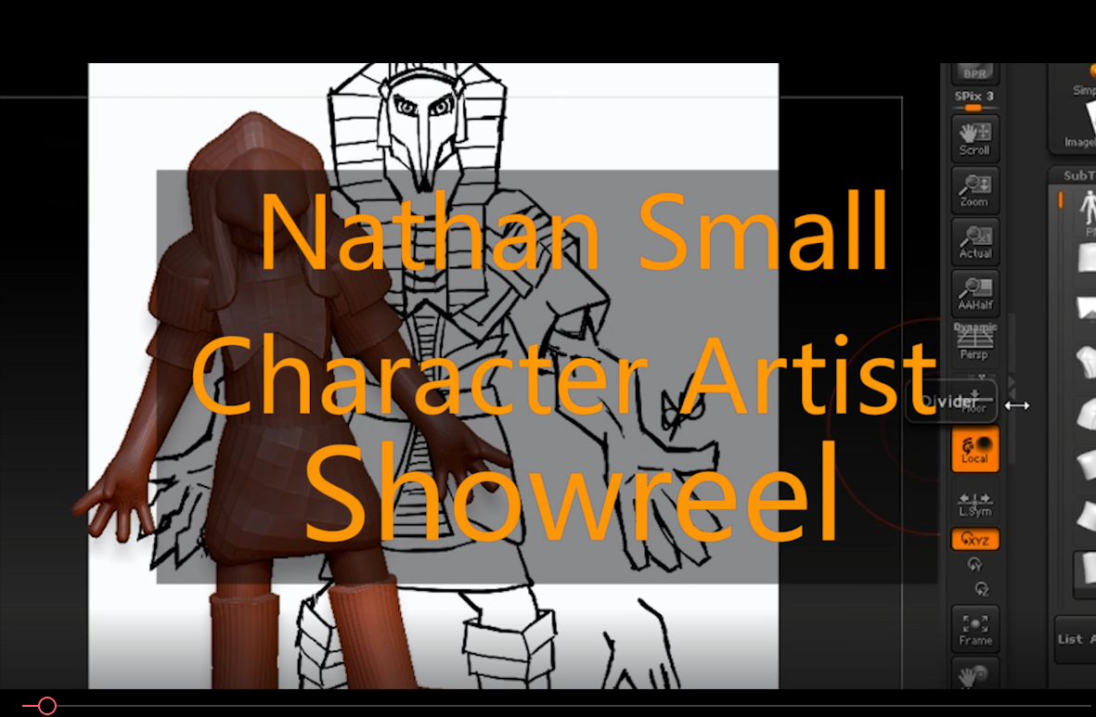
J)

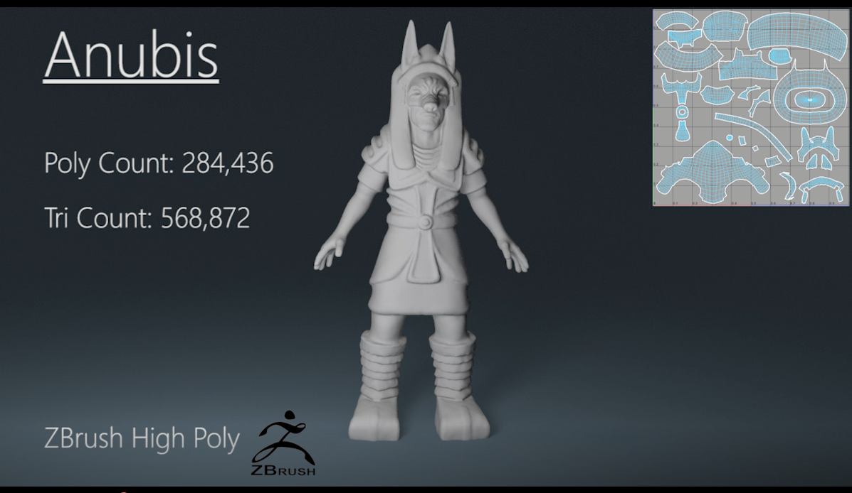
K)

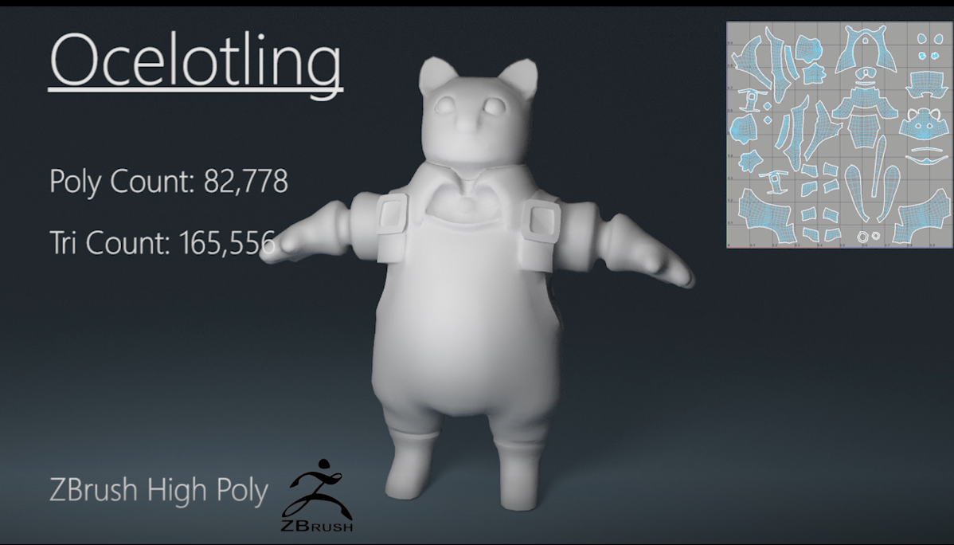
L)

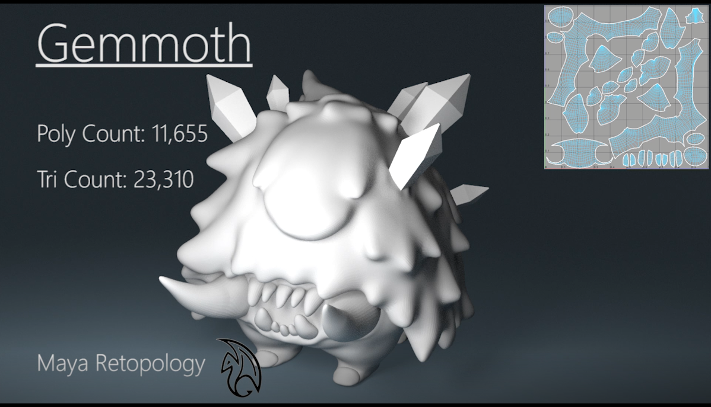
M)

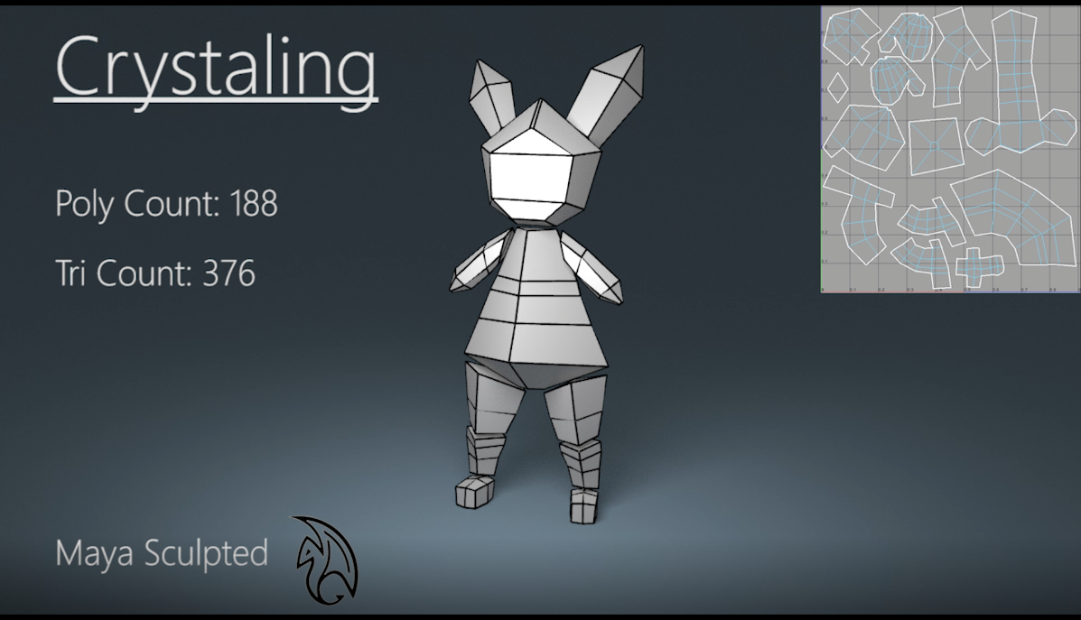
N)

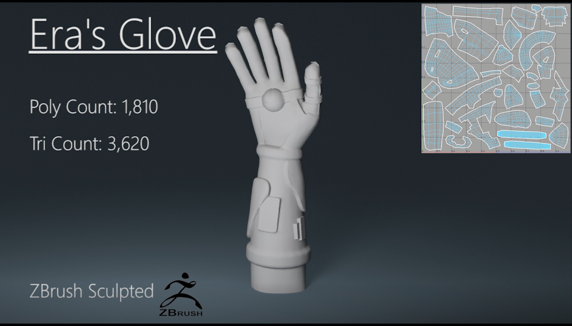
O)

P)
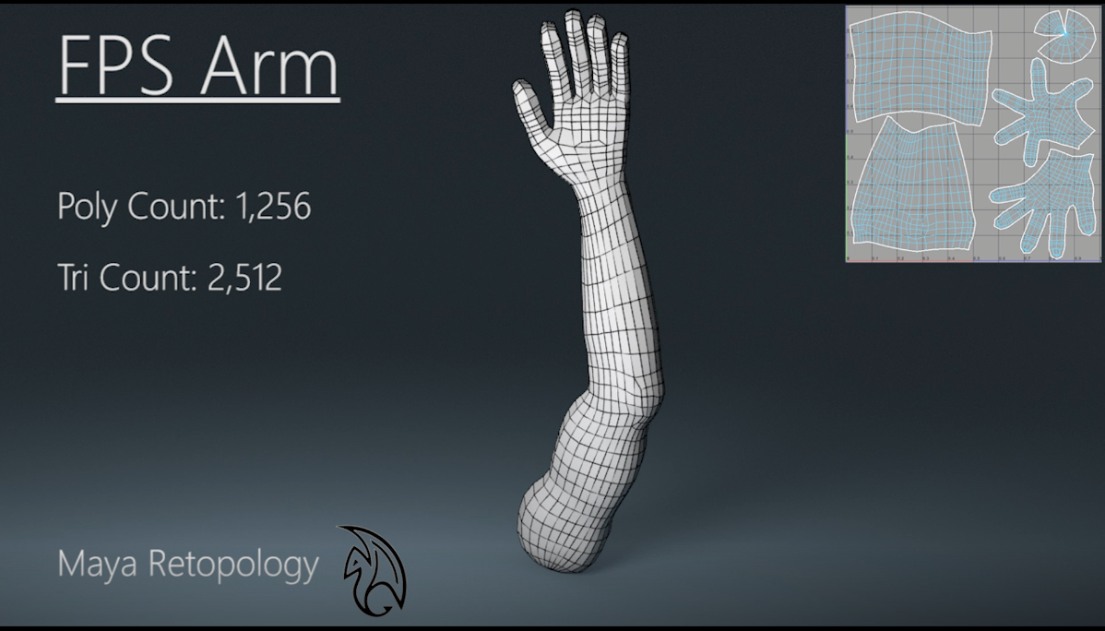

Q)
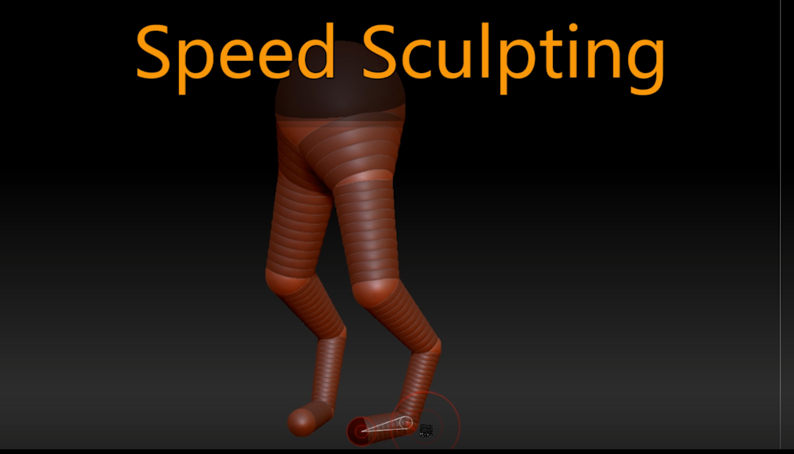

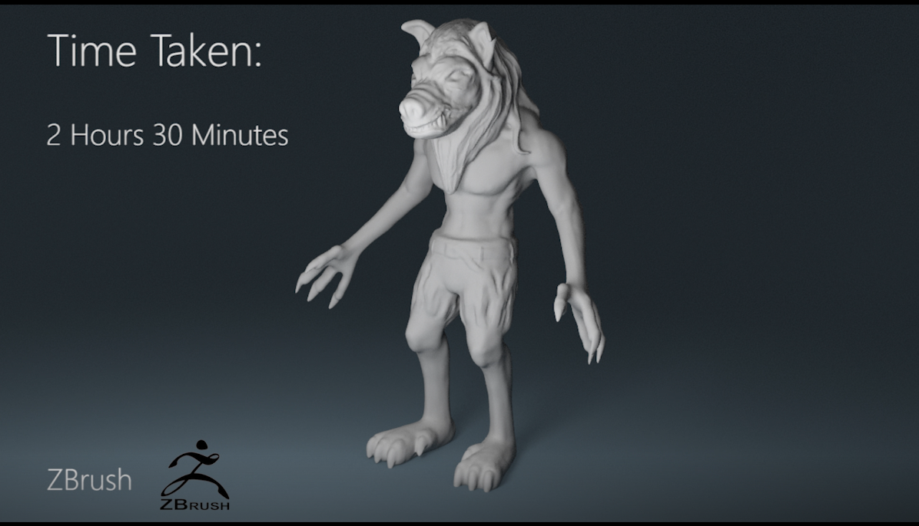
R)

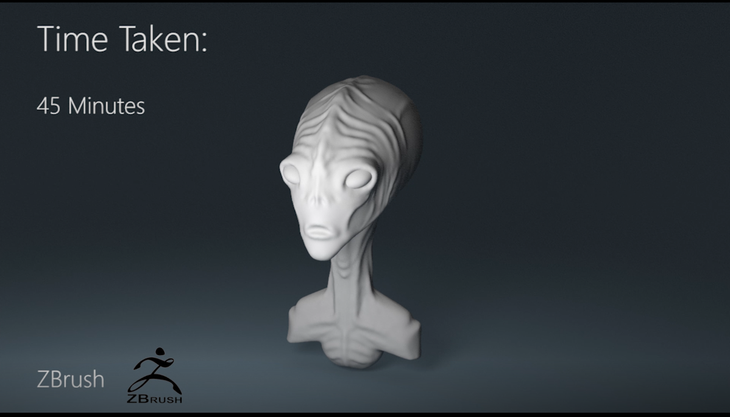
S)

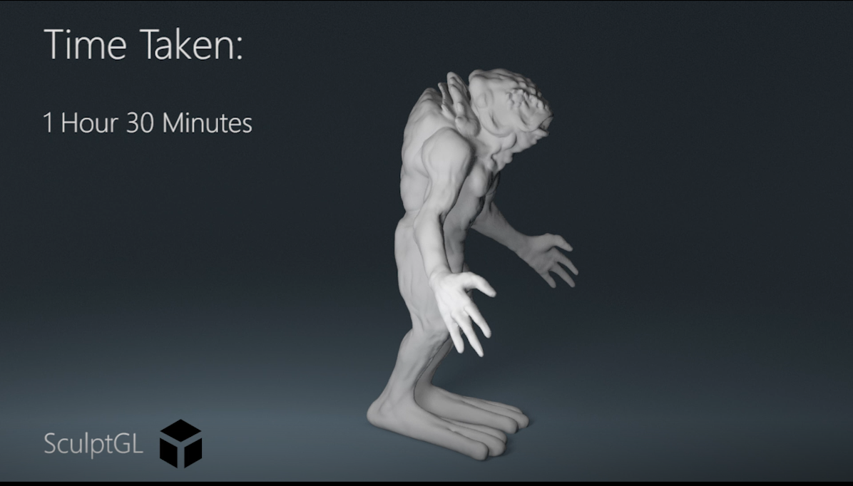
T)

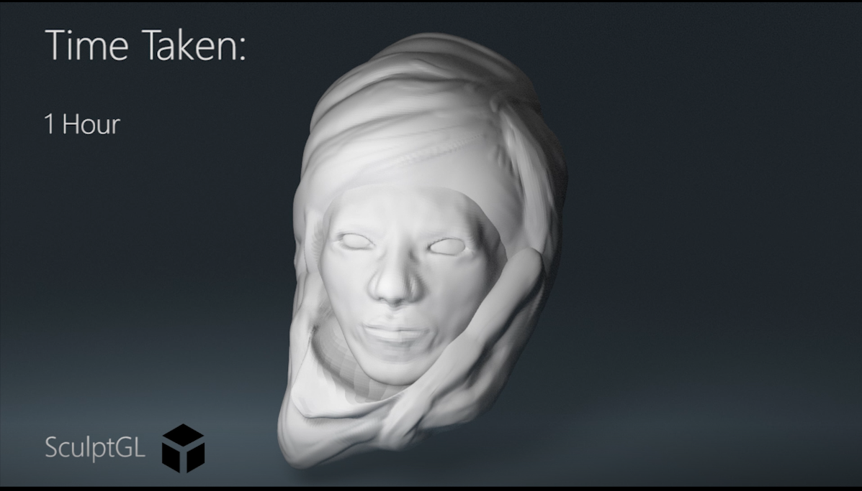
W)

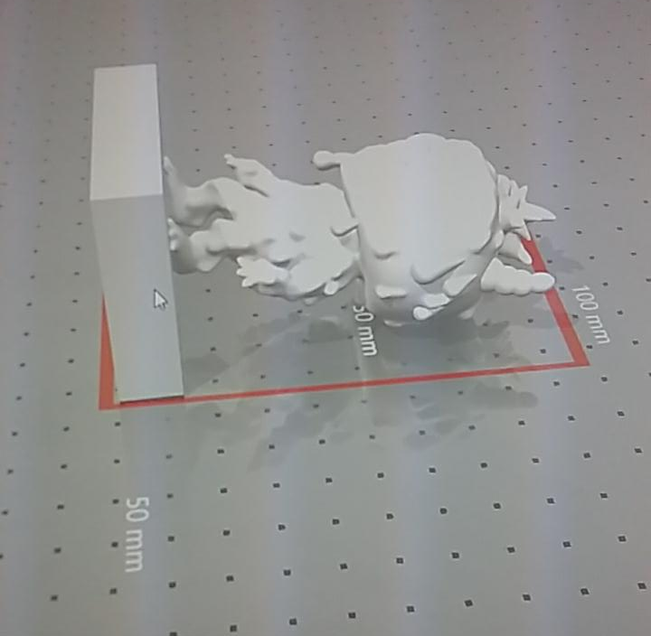
X)

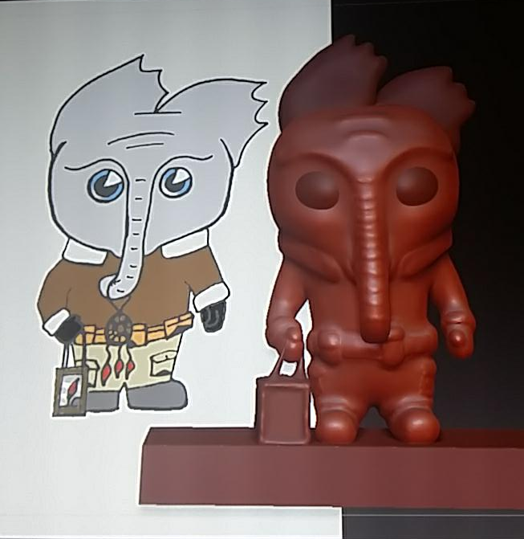
Y)

