Research Proposal

As a parent of two young people actively absorbed in the abundance of digital technology available today, it is matter of concern that their lives have become increasingly sedentary and seemingly solitary in contrast to the lively outgoing children they were. They have joined the ranks of the digital natives (Edwards, 2018), people born in to the age of technology who rely on digital connectivity as their umbilical to the outside world. Perhaps more concerning is the expansion of this observation beyond my personal relationships and in to the community. It can be agreed that it is very difficult to walk down the road, around a supermarket or even eating in a restaurant, not to notice very young children in prams and pushchairs deeply engrossed in a parental mobile phone or even a child size tablet. They can appear oblivious to the outside world, engrossed in whatever game or activity that has been selected for them to play by their parents or guardians. These second generation digital natives have presumably been given these devices to keep them occupied while parents and siblings continue with other necessary activities (Canadian Paediatric Society, 2017). A recent UK study found that about 51% of infants 6-12 months old use a touch screen daily (Canadian Paediatric Society, 2017). Even if the idea of this is not just to pacify but to help develop early learning, there is solid evidence to show that infants and toddlers learn easier and more efficiently through personal interaction with parents and care-givers as they have limited ability to transfer images from the screen to real life; their development being more efficient when experienced in a real time situation (Canadian Paediatric Society, 2017). This detachment could also have a detrimental effect on the ability of the child to form trusting and lasting relationships in later life, as indicated by John Bowlby’s attachment theory of an infants’ need for strong biological bonds to the primary caregiver for development of resilience and empathy (Pound, 2007, p. 44). Studies have also shown that children under 5 years old require active play and quality family time to develop essential life skills, such as language, self-regulation and creative thinking, a by-product of imagination (Canadian Paediatric Society, 2017).
Recent research by Ofcom has indicated that 23% of 8-11 year olds have a social media profile (Science and Technology Committee, 2019), along with 72% of 12-15 year olds (Edwards, 2018). The Organisation for Economic Co-operation and Development (OECD) reported that 94.8% of 15 year olds went on line either before or after school on a daily basis, with the average time spent on line being 6 hours a day (Science and Technology Committee, 2019). This use of digital technology has been accused of changing the world, and with the increase of children on-line of also changing childhood (UNICEF, 2017). A new bedroom culture has evolved where children lock themselves away in their rooms and converse with friends through social media (UNICEF, 2017) instead of going out, meeting, interacting and playing together. Many concerns have been raised about the effects this digital revolution has been having on the mental health of children and young people, launching many reviews and investigations by reputable institutions and media companies, none more so than the government investigation, Impact of Social Media and Screen-use on Young People’s Health, the findings of which were released in January of 2019 by the House of Commons Science and Technology Committee (Science and Technology Committee, 2019). It was concluded in this report, that even though the phenomenon is still quite young and the level of immersion by young people is prodigious, there is no evidence to support the claim that the use of internet technology or screen time is having an adverse effect on the mental health of children and young people (Science and Technology Committee, 2019), a deduction that was echoed in the majority of similar studies (Chassiakos, et al., 2016). Although the House of Commons report did feature a section on the effects on the physical development of children and young people, it claimed that only a limited amount of evidence had been received and they were unable to draw any conclusions (Science and Technology Committee, 2019, p. 18). Some even claim that in the long run it has many benefits; although there are risks involved, there are also positives connected with bringing education to remote locations and helping children with disabilities to participate and excel without fear of stigma (UNICEF, 2017).
However, as thorough and well intentioned as these reports and investigations are, they have focused on the mental and physical health effects that screen time and social media can have on children and young people. Very few of them have taken into consideration the development of the imagination and sense of self a child fosters through interactive play with peers, exploring the outdoors and taking risks. As early as Comenius and through Froebel, Pestalozzi, Rousseau, Montessori, Steiner, Owen, Dewey et al, the evidence has shown that what was key to human development and learning was sensory, experiential, creativity, imaginative play and interaction with peers and the environment (Pound, 2007). All these learned and experienced theorists have been relegated to the ‘alternative education’ sector and with creative and artistic subjects such as art, dance, movement and drama, being reduced or cut from the mainstream curriculum (Robinson, 2013) it is difficult to see where the opportunities for meaningful activities that will develop the creativity and imagination of children will come from, if not from self-motivation. It would seem that every step we take in education, social and community development, we are moving further away from the established foundations and theories of respected and established educationalists and what they perceive as beneficial influences on childhood development.
In these digital times, evidence has shown that young children with high exposure to screen time have developed anti-social behaviour, victimization, social isolation and proactive aggression in later childhood (Canadian Paediatric Society, 2017), a possible side effect of Bowlby’s attachment theory (Pound, 2007, p. 44). If a young child is left alone in a cot or pram with only a digital device for company, the lack of interaction with the primary care giver could result in a lack of empathy and resilience (Pound, 2007, p. 44). Could it be then, in a world where everything is becoming “smart”, and where comparisons are made daily about what phone we carry, what blogs we read, what is happening on social media sites and what games we play, we are reducing our ability to think for ourselves without using an app., asking “Google” or seeing what Wikipedia has to say about something? If, for the majority of people, the relationship with the outside world is through a screen, how will this reflect on children and their development of imagination, social interaction and a sense of self? If the role models of today are demonstrating a life of sedentary practices, how will children develop the ability to interact socially with others, to imagine themselves as a character in a game, and not as an emoji or avatar?
It is proposed that the intent of this research project is to establish to what extent this living of life through a screen is having an impact on the fundamental imaginative, communicative and social development of the children of today. As previous investigations have researched the high levels of mental health issues we are currently experiencing with our young people, this study intends to adopt a more physiological view; what the effects of extended screen time are having on imagination and play and what sort of impact it could be having on peer and social interaction. If creativity is being restricted in schools, what confines are the children of today imposing on themselves by reducing their exposure to the physicalities and realities of life being lived?
Without a doubt social research is an invaluable tool for policy makers, governments, advertisers, modern historians, community leaders and organisations. It is a method of understanding what is happening in society and the variety of cultures that share that community (BSA, 2002). The effects of political, economic and technological pressures on families and individuals and how that radiates out into communities has a profound impact on the greater society and how it is moving forward, and social research can determine how the individual perceives and acknowledges this (Creswell & Creswell, 2018).
Taking into consideration the anthropological element and the historic contexts of the nature of this study it would be more appropriate to take a qualitative approach as the foundation of the research (Creswell & Creswell, 2018, p. 4). Although a quantitative format could arguably provide a more accurate picture of the reason behind the phenomenon, the methodology and measuring tools necessary for this would not be suitable for use with the intended participants, for which a certain degree of reflective interpretation would be critical. Although ultimately a qualitative study, a degree of quantitative analysis would be necessary to determine the proportion of children, if any, that would be demonstrating indicators of the influence of technology over imagination. However as most qualitative studies would require a certain degree of quantitative interjection, the tools of data collection required for a quantitative study would not be appropriate for the observatory and participatory intention of this inquiry, with the anticipated outcomes not depended on numerical statistics (Creswell & Creswell, 2018, p. 4). With the intended participants being young children, by their very nature a rigid structure of research methods would not allow for anthropological interpretation, and with the reliance on numerical data being minimal, it would not be enough to warrant a mixed method approach in this instance.
Reliability in any research endeavour is key to establishing a true picture of the cause and effect of the phenomenon being investigated. Nonetheless it would need to be recognised that even the source of the collected data may be unreliable, with individuals, families and communities wanting to appear in control of the researched life aspects and wanting to give the best, or worst, impression. Children, in particular, can be influenced by the presence of a sanctioned stranger in their everyday routine which can prove exciting and may lead to a certain degree of reality reconstruction, proof perhaps of an active imagination. For all its obvious pitfalls social research remains the only way of understanding why society behaves the way it does and what influences have a bearing on it (Oliver, 2010).
Deliberation of the ontology of the pragmatic paradigm, which in theory could be applied to this particular research project due to the constantly changing nature of the digital world and its effects on consumers, would in practice not take in to consideration the human element of the historic and social structure that form the foundation of the consumer base. As the anthropological aspect of this study is key, this would suggest the more appropriate paradigm would be to adopt a constructivist stance. From the pragmatism point of view, although it would involve participatory research, the questions and data collected would need to be open to interpretation and reflexivity, rather than straight answers to closed questions pointing the researcher in the direction of a single solution (Creswell & Creswell, 2018, p. 4). By the very nature of the intended participants it is recommended that an open-ended approach is assumed, allowing the researcher to take into consideration every aspect of the environmental influence in to the response. This line of research is more conducive to the constructivist/interpretivism paradigm, however, rather than intending to develop a theory of cause and effect, the objective is to reinforce an already identified hypothesis (Creswell & Creswell, 2018, p. 8).
The theoretical perspective of this research proposal will be based around interpretivism taken from data collected from multiple site case studies. It will be based on phenomenological research but also incorporating ethnographical methodologies. The interconnection of both these methodologies would allow the researcher to investigate the identified hypothesis by interpreting the lived experiences of the individuals, and evaluating the findings whilst assimilating the information observed and recorded in respect of the cultural group, in this case children at play (Creswell & Creswell, 2018).
There will be a restricted budget available for this investigation as it will be self-funded by the researcher. The study would therefore be reliant on the funder as the sole researcher, who will collect, record and analyse all data. With the methodology being based at multiple sites the span of the data collection will need to cover several weeks, with the researcher visiting different sites on different days. A minimum of two to three days would be spent at each site in order to collect as much data as possible from individuals and groups of children, which will allow, to a small degree, for a change in attitude towards the researcher and a more relaxed mood from the children. The time allocated to data collection from these facilities would vary depending on the amount of responses from gatekeepers in respect of consent to granting of access and to the responses and attitudes from the children involved. In terms of letter returns, diary synchronising, data collection, analysis and formulation of the final thesis it is estimated that this research should not exceed three to four months. Resources would be minimal, with the necessity only for an identity badge, pre-printed sheet to record answers from the conversations, paper to make field notes, pen, pencil and clip board; any other considerations such as transport, wet weather clothes, drink bottles or hats would be at the researcher’s discretion The use of a computer would not be necessary at this stage, but access to one would be essential after all data has been collected to allow correlation of results and formulation of conclusion. Letters of request for the institutions to be included in the research project will be sent beforehand to the principal of the school, gatekeepers and leader of the club or community involved with an outline of the research proposal and the credentials of the researcher enclosed (appendix 1). Once participation is confirmed a further letter of request for participation of the children will be sent to the school or club to be forwarded to the families for confirmation of consent on behalf of their child/children (appendix 2), along with an outline of the questions that will form the basis of informal conversations with the children (appendix 3).
It is always difficult, when in conversation with children, not to be side-tracked or drawn in to their enthusiasm or imaginings about the subject or topic of discussion, that is why it will be necessary during the course of the observations and informal conversations forming the basis of the research, to remain focused on the initial question and hypothesis. In order to maintain continuity and integrity of the research an informal list of questions has been devised in order to centre the researcher, and to direct the conversation along the desired pathway of the research intention. This “questionnaire” is not intended as a direct interrogation of the children, or as a script for the researcher to follow, but solely as an outline of the direction of conversation in order to maintain continuity and connectivity of responses. The list will also form a guide during data analysis as a reference point for synthesis of field notes and gathered information.
As these questions are not ones that could be posed directly to the children as they would not provide adequate data by themselves, there will also need to be unstructured observations of the children whilst at play, which would be recorded as a series of field notes. During the observations a naturalistic approach will need to be adopted to separate the existing realities of the individuals to be able to make informed decisions about the structure of the play and the guiding influences. These unstructured observations would take the form of mingling with the children during their play/break times and making field notes of behaviours, forms of play and language used. The outline questionnaire that has been developed will be referred to during informal conversations with the children to gain an insight into their own personal access to technology and the influence it has on their daily lives and will have the answers recorded on a pre-printed answer form (appendix 4). No personal information will be noted on these forms as they are intended as tick sheets only for reference to common interests and games or activities with as much expediency as possible, to keep up with the flow of conversation.
As this research project is based on multiple case studies and will take place at various facilities, involving many children, it will be important that the field notes will be of a comparable structure, to enable the collection of synthesisable data (no personal or identifying information will be recorded on these sheets). Therefore it will be important for the researcher to be reflexive in their analysis and to be empathetic to the young participants and their relationship with new people (Thompson & Thompson, 2008). Throughout the process it will be imperative for the researcher to continually reflect on their interaction with the children, the Ethical Research Involving Children Charter (ERIC), backed by the UNCRC, actually demands the researcher to “continually reflect on their practice beyond formal ethical review requirements.” (Graham, et al., 2013). They also suggest that the researcher should be aware of influences they may unconsciously be having on the conversation or on the actions and behaviours of those involved (Graham, et al., 2013).
As the data collected will be documenting experiences, perspectives and relationships the data analysis will need to be a flexible and naturalistic process and as such will be interpreted through metasynthesis. Sometimes known as meta-ethnography, metasynthesis is a process that produces interpretive results from the integration and comparison of qualitative data (Erwin, et al., 2011), in this instance a collection of field notes from multiple sites. This means it is not a method of secondary analysis, but an interpretation of the primary data gathered in the field (Erwin, et al., 2011). The metasynthesis method of qualitative interpretivism should not be confused with meta-analysis which collects and condenses data to produce a standardised numerical value (Erwin, et al., 2011). Qualitative metasynthesis uses the data from multiple studies and by identifying patterns and common threads can interpret the information, acknowledging understanding of its original sources, as part of the process. Integrity and credibility of the results rely on the reflexivity of the researcher and their ability to record the observed data accurately, and correctly, to recognise their involvement in the proceedings, and to analyse the recorded data in a trustworthy and objective manner (BSA, 2002). The use of this process is intended to identify a common, recurring theme that would be able to justify or negate the theory of a damaging effect caused by the increasing use of digital technology as a replacement for interactive, imaginative play. If the data indicates the use of television programmes or computer game re-enactments as the basis for play scenarios then the evidence would suggest that exposure to these technologies is having an overarching influence on the imaginations of the children, rather than allowing them to devise their own games and themes for play and imagining themselves as a doctor or fireman for instance. If it suggests that friendship groups are formed on the basis of what digital games are played or what technology is owned, rather than the individual merits or character of the children, then this would indicate that children would be prepared to exclude potential friendships on the grounds of digital prejudice, possibly demonstrating a lack of empathy.
The researcher would need to understand that their observations form only a snapshot of the lives of the children and consideration should be made for a longer term perspective. The limitations of this short term observational procedure should be realised by the researcher as the danger of over interpreting the data could be detrimental to the integrity of the conclusion and subsequent recommendations. If, however, influences are recognised in the collected and analysed data then the recommendation would be for further long term investigations to be carried out in order to establish the extent of the incursion and to devise appropriate interventions and guidelines for the extended use of digital technology.
Direct observation and contact with young children, as is intended in this study, carries its own ethical and moral implications. The majority of ethical codes all agree that the researcher has “a duty to safeguard the proper interests of those involved in or affected by their work and report findings accurately and truthfully” (BSA, 2002). When the research involves children or other vulnerable individuals then the codes of ethics become more stringent and answerable to. According to ERIC respecting the rights of the child is core to any research and as such should always be conducted with respect for the child and their culture (Graham, et al., 2013). The ERIC charter encourages the use of reflexivity and for the researcher to ask themselves if they are ready to conduct the study by questioning their own assumptions about children and childhood and the impact the research will have on not only the child, but on their own experiences (Graham, et al., 2013).
The main question posed before any research involving children can be carried out is if the research is necessary, and will it benefit the children now or in the future. If the answer is no to these questions then the recommendation is that the study be abandoned (Graham, et al., 2013). On reflection of this question it is believed that a study of this kind could improve the health and well-being of children and young people by establishing the range of effects immersion in a digital culture is inflicting on their imagination and sense of self. By assessment of the anticipated root causes it will allow the researcher the ability to create guidelines for future digital content and usage in an informed attempt to assuage any future advances to the detriment of physical and imaginative development.
As with all research proceedings, a full risk assessment will need be expounded, to safeguard both the children and the researcher (BSA, 2002) (appendix 5). It is important to realise that risk could affect not only the participants but also the researcher and those connected to them. The risks to the researcher can take many forms such as mental harm created by prejudice or abuse, physical harm from participants or environment for example weather or structures around them. A knowledge of fire procedures from the facility would be imperative, along with the accompaniment of a chaperone from the institution to safeguard any accusations of prejudice or of inappropriate behaviour on behalf of the researcher. It will also be necessary for the researcher to make available to the institutions or gatekeepers proof of a current certification from the Disclosure and Barring Service or DBS Certificate.
Risks to the children would involve similar hazards and their well-being should be accountable for throughout the term of the study. The accompaniment of a chaperone would be crucial for safeguarding and to avoid any misunderstandings from all parties concerned.
As suggested in all ethical guidelines, ongoing informed consent will be gained from all stakeholders, i.e. parents, gatekeepers (school authorities, club/community leaders) and the children themselves. All children who have consent will be able to be included in these observations and discussions. Even though the formation of the conversations and observations will be informal and unstructured, no child will be made to feel pressurised in to having any form of involvement, and if at any point, a child would demonstrate any sign of distress or discomfort, the conversation and observation of them will be abandoned immediately, without any form of coercion or compulsion (BSA, 2002) (Graham, et al., 2013).
In line with GDPR regulations, and the universities own guidelines, the data will be completely anonymous. No names, personal details or any identifying information will be taken from the children during discussions or noted in the field notes during observations. These notes will be analysed solely by the researcher and digitally recorded on a password protected computer which will be securely stored during the process of content analysis and composition of thesis and recommendations, accessible only by the researcher. Once a conclusion has been reached and a written report produced along with any recommendations for future interventions or proposals, the original field notes and corresponding answer sheets, will be destroyed as a safeguarding measure.
All reports and papers produced rely on the ethics of the researcher and their integrity of character and probity (BSA, 2002). The ethical guidelines of ERIC, BERA and UWTSD, will all be adhered to throughout the research process. Details of which can be found at
https://www.ewc.wales/site/index.php/en/statistics-and-research/practitioner-research/research-ethics.html
Any report or thesis, along with future recommendations and proposals resulting from the research, will be presented to the University and will also be made available to the participating institutions, clubs and community leaders. Free and open access to these documents for the parents of the children involved and other interested parties will be granted at the discretion and competency of the participating institutions.
It has been demonstrated that over the last decade there has been rising concern about the increase in mental health issues relating to children and young people (Chassiakos, et al., 2016). Many organisations and agencies from governments to social media platforms, have launched investigations in to this phenomenon and its relationship to digital technology and the use of screen time and social media. Many of them have concluded that there is not enough evidence to support this theory and all recommend further investigation to be able to reach any satisfactory analyses (Science and Technology Committee, 2019). All have focused on mental health issues such as depression, anxiety, lack of self-esteem and feelings of isolation, some on physical affects such as obesity and muscle and bone underdevelopment. It is the intention of this study to focus the research on the effects of digital technology on the development of the creative capabilities of children and the expansion of their imagination and use of imaginative play. This is a crucial component of the evolving child and for the enhancement of young people to cultivate problem solving skills that enable them to view situations from an alternative perspective (LGfL, 2020). The ability to ‘think outside the box’ is a highly prized skill in the business world and for the emergent child it is an important element to be able to build a future of varied opportunity, a crucial capacity that has been overlooked in these previous investigations. As mentioned earlier in this paper, a child has difficulty transferring images from a screen in to meaningful reality, so without the mental faculty of imagination they would not have the ability to form concepts or ideas that have not physically been presented to them, for example to imagine themselves as a bus driver, fireman or nurse (Thompson, 1996). Without this aptitude a young person would not be able to plan a future or envision themselves in any other situation than the one laid before them. Their freedom of choice would be limited to lived experiences.
In the absence of any previous studies in this specific area, it is important that a research project on the subject of losing the ability for imaginative play could prove a crucial turning point for the opportunities available for children and young people and for their future choices. To allow them to develop their problem solving skills and become fully active and creative members of society with the ability to exceed the boundaries set by limited imagination.

References
Anon., 2019. World Health Organisation. [Online]
Available at: https://www.who.int/search?query=mental+health+children+and+young+people&page=1&pagesize=10&sortdir=desc&sort=relevance&default=AND&f.Countries.size=100&f.Lang.filter=en&f.RegionalSites.size=100&f.Topics.size=100&f.contenttype.size=100&f.doctype.size=101&
[Accessed 8 10 2019].
Brotherton, G., Davies, H. & McGillivray, G., 2010. Working with Children, Young People and Families. London: Sage.
BSA, 2002. Statement of Ethical Practice for the British Sociological Association. Durham: BSA.
Canadian Paediatric Society, 2017. Screen time and young children: Promoting health and development in a digital world. [Online]
Available at: https://www.ncbi.nlm.nih.gov/pmc/articles/PMC5823000/#s11title
[Accessed 20 January 2020].
Chassiakos, R. et al., 2016. NCBI:National Center for Biotechnology Information. [Online]
Available at: https://www.ncbi.nlm.nih.gov/pubmed/27940795
[Accessed 16 October 2019].
Cottrell, S., 2011. Critical Thinking Skills. 2 ed. Basingstoke: Palgrave Macmillan.
Creswell, J. W. & Creswell, J. D., 2018. Research Design: Qualitative, Quantitative and Mixed Method Approach. 5 ed. Los Angeles: Sage.
Edwards. J., 2015. mentalhealth.org.uk. [Online]
Available at: https://www.mentalhealth.org.uk/a-to-z/c/children-and-young-people
[Accessed 8 october 2019].
Edwards, C., 2018. Social Media and Mental Health. Newark: Trigger.
Erwin, E. J., Brothers, M. J. & Summers, J. A., 2011. Understanding Qualitative Metasynthesis: Issues and Opportunities in Early Childhood Intervention Research, London: Sage.
Graham, A. et al., 2013. Ethical Research Involving Children. Florence: UNICEF Office of Research Innocenti.
LGfL, 2020. The Lancashire Grid for Learning. [Online]
Available at: http://www.lancsngfl.ac.uk/creativelearning/download/file/Creative%20Learning.doc
[Accessed 15 January 2020].
Oliver, P., 2010. The Student's Guide to Research Ethics. 2 ed. Maidenhead: Open University Press.
Pound, L., 2007. How Children Learn. London: Step Forward Publishing.
Robinson, K., 2013. Youtube. [Online]
Available at: https://www.ted.com/talks/sir_ken_robinson_how_to_escape_education_s_death_valley#t-1135103
[Accessed 15 January 2020].
Science and Technology Committee, 2019. Impact of Social Media and Screen-Use on Young People's Health, London: House of Commons.
Thompson, D., 1996. The Oxford Compact English Dictionary. Oxford: Oxford University Press.
Thompson, S. & Thompson, N., 2008. The Critically Reflective Practitioner. Basingstoke: Palgrave Macmillan.
UNICEF, 1989. The United Nations Convention on the Right of The Right of the Child. London: UNICEF.
UNICEF, 2017. The State of the World's Children; Children in a Digital World, New York: UNICEF.
Welsh Government, 2016. The Welsh Health Survey, Cardiff: Welsh Government.

Appendix 1 
Name of Institution
Address
Address
Date
Dear Principle
My name is Alison Kinzett and I am studying for a Masters degree at the above university. I will be conducting research in to children losing the ability for imaginative play and how the influence of technology has a bearing on their choices.
My intent is to observe children at play, their interactions and choice of games, to hold conversations with the children, noting down their responses to informal questions, an outline of which is included with this letter. There will be no recording of conversations or video recordings made of the children at any time.
The research will take no longer than two to three days, taking up only play times for my observations and conversations. The data collected will be stored at the university in line with the UWTSD Data Management Policy with a formal paper describing my findings and conclusions being release to academic agencies, a copy of which will be made available to you.
I would very much appreciate your consent for your school/institution to be a part of this study.

University of Wales University of Wales University of Wales
Trinity Saint David Trinity Saint David Trinity Saint David
Carmarthen Campus Lampeter Campus Alex Design Exchange
Carmarthen Lampeter Alex Building
Carmarthenshire Ceredigion Swansea
SA31 3EP SA48 7ED SA1 5DU
Phone: 01267 676948 / 6837 Phone: 01570 424979 Phone: 01792 481050
The research will be fully compliant to the GDPR rulings and will fully adhere to BERA (British Educational Research Agency), ERIC (Ethical Research Involving Children), UNCRC (United Nations Convention on the Rights Of the Child) and the University’s ethical guidelines which can be found on the EWC Wales website https://www.ewc.wales/site/index.php/en/statistics-and-research/practitioner-research/research-ethics.html .
I have previous experience of working in school settings and am enrolled on the DBS up-date service, references from the university and any further information can be made available to you if required.
For further information please do not hesitate to contact me at the School of Social Justice and Inclusion at the Carmarthen Campus, address of which can be found below.

Best Regards

Alison Kinzett (student/researcher)

University of Wales University of Wales University of Wales
Trinity Saint David Trinity Saint David Trinity Saint David
Carmarthen Campus Lampeter Campus Alex Design Exchange
Carmarthen Lampeter Alex Building
Carmarthenshire Ceredigion Swansea
SA31 3EP SA48 7ED SA1 5DU
Phone: 01267 676948 / 6837 Phone: 01570 424979 Phone: 01792 481050
Appendix 2 Date
Dear Parent
I am studying for a Masters degree at the above university and will be conducting research in to children losing the ability for imaginative play and how the influence of technology has a bearing on their choices.
My intent is to observe children at play, their interactions and choice of games, to hold conversations with the children, noting down their responses to informal questions, an outline of which is included with this letter. There will be no recording of conversations or video recordings made of the children at any time.
The research will take no longer than two to three days, taking up only play times for my observations and conversations. The data collected will be stored at the university, in line with UWTSD Research DATA Management Policy, with a formal paper describing my findings and conclusions being release to academic agencies, a copy of which will be made available to the school/institution.
I would very much appreciate your consent for your child/ren to be a part of this study.
The research will be fully compliant to the GDPR rulings and will fully adhere to BERA (British Educational Research Agency), ERIC (Ethical Research Involving Children), UNCRC (United Nations Convention on the Rights Of the Child) and the University’s ethical guidelines which can be found on the EWC Wales website https://www.ewc.wales/site/index.php/en/statistics-and-research/practitioner-research/research-ethics.html .
I have previous experience of working in school settings and am enrolled on the DBS up-date service. Further information can be made available to you through the school/institution.
Best Regards

Alison Kinzett (researcher)
University of Wales University of Wales University of Wales
Trinity Saint David Trinity Saint David Trinity Saint David
Carmarthen Campus Lampeter Campus Alex Design Exchange Carmarthen Lampeter Alex Building
Carmarthenshire Ceredigion Swansea
SA31 3EP SA48 7ED SA1 5DU
Phone: 01267 676948 / 6837 Phone: 01570 424979 Phone: 01792 481050
PARENT/GUARDIAN RESEARCH CONSENT FORM

Name of Researcher(s)
Alison Kinzett
Title of study
Are Children Losing the Ability for Imaginative Play?

Please read and complete this form carefully. If you are willing for your child to participate in this study, circle the appropriate responses and sign and date the declaration at the end. If you do not understand anything and/or would like more information, please ask at the office.

- I have had the research satisfactorily explained to me in verbal and / or written form by the researcher. | YES / NO
- I understand that the research will involve: Playground observations and noting down of informal conversation and responses to questions about play and technology at home | YES / NO
- I understand that I may withdraw my child/ren from this study at any time without having to give an explanation. | YES / NO
- I understand that all information about my child/ren will be treated in strict confidence and that he/she will not be named in any written work arising from this study. | YES / NO
- I understand that audiotape or recording of any sort will not form any part of your research. | YES / NO
- I understand the research will take no longer than two-three days, taking up only play times for observations and conversations. The data collected will be stored at the university in line with the UWTSD data management policy, with a formal paper describing the findings and conclusions being release to academic agencies, a copy of which will be made available to me. | YES / NO
I freely give my consent for my child/ren to participate in this research study and have been given a copy of this form for my own information.

Signature: …………………………………………………………………….………….

Date: ………………………………………………………………………………………

Appendix 3 Outline of proposed Questions
The questions will be broad and unscripted but will however follow a pattern of investigation and will be lead by the response of the child or parent/guardian. They will be addressed informally and range around the following criteria:

- Do they own a computer/tablet Do they play games on them
- What type of games Do their friends play too
- How long do they play/what time Do they play everyday
- Do they have a garden Do they have pets, who looks after them
- Do they like to play outside Do they have friends over or visit friends
- When/if they do, do they play outside Are they in a club or group
- Do they have friends there Any friends outside school, neighbours etc
- Do they go to a park with family or friends What do they like to do on weekends
- Do they like to play in the rain/snow How much television do they watch
- Favourite programmes Who’s their hero/heroine
- Who do they mostly play with Do they have a phone
- Do they use social media What sites
- Do their friends connect with them Favourite game/toy

University of Wales University of Wales University of Wales
Trinity Saint David Trinity Saint David Trinity Saint David
Carmarthen Campus Lampeter Campus Alex Design Exchange
Carmarthen Lampeter Alex Building
Carmarthenshire Ceredigion Swansea
SA31 3EP SA48 7ED SA1 5DU
Phone: 01267 676948 / 6837 Phone: 01570 424979 Phone: 01792 481050
Appendix 4

 | Yes | No | Don't know | Further comments
Computer
Laptop
Tablet
Phone
Games
Friends play
How long
Social media
Friends connected
Garden
Pets
Outside play
Visits/sleepovers
Play outside
Clubs?
Friends there?
Outside school?
Park
Weekends
Rain/snow play
TV
Everyday
Heros?

Appendix 5
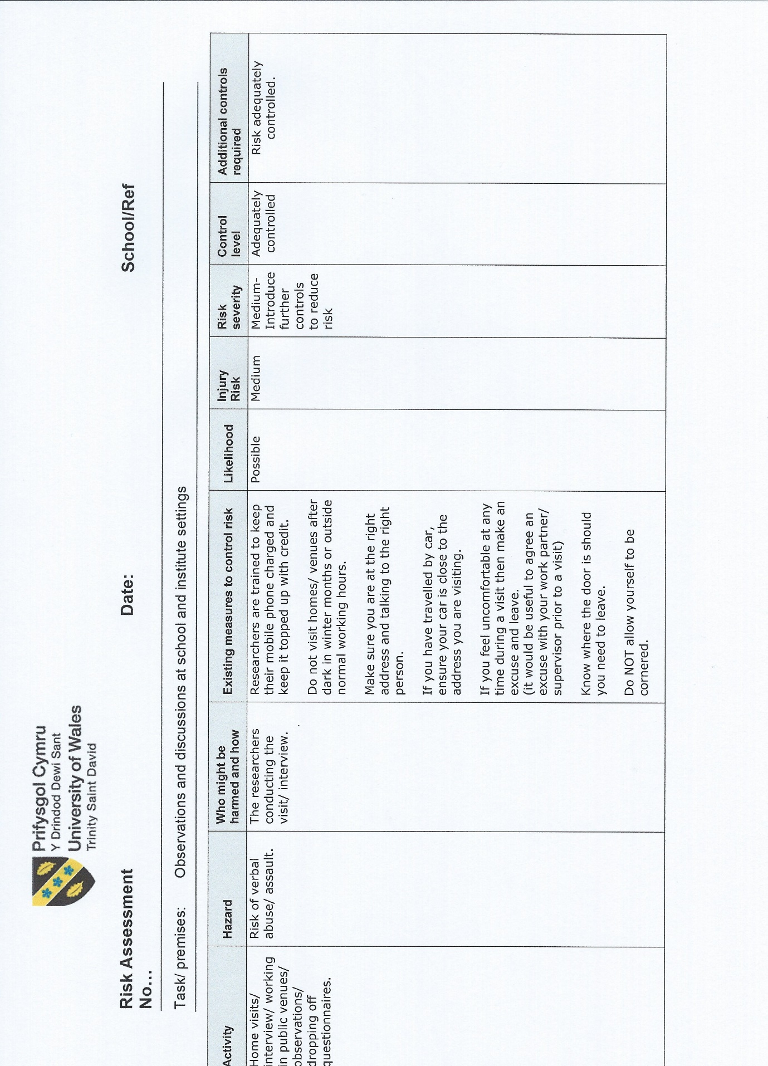

Appendix 5 a
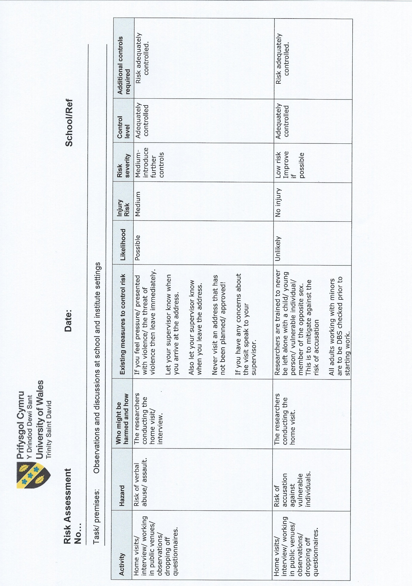

Appendix 5 b

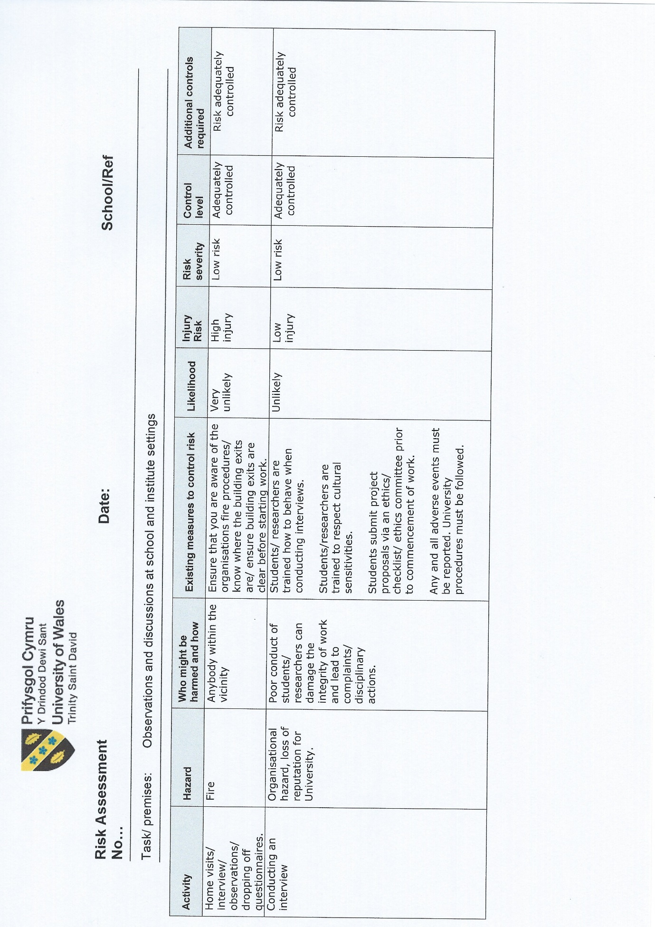

Appendix 5 c

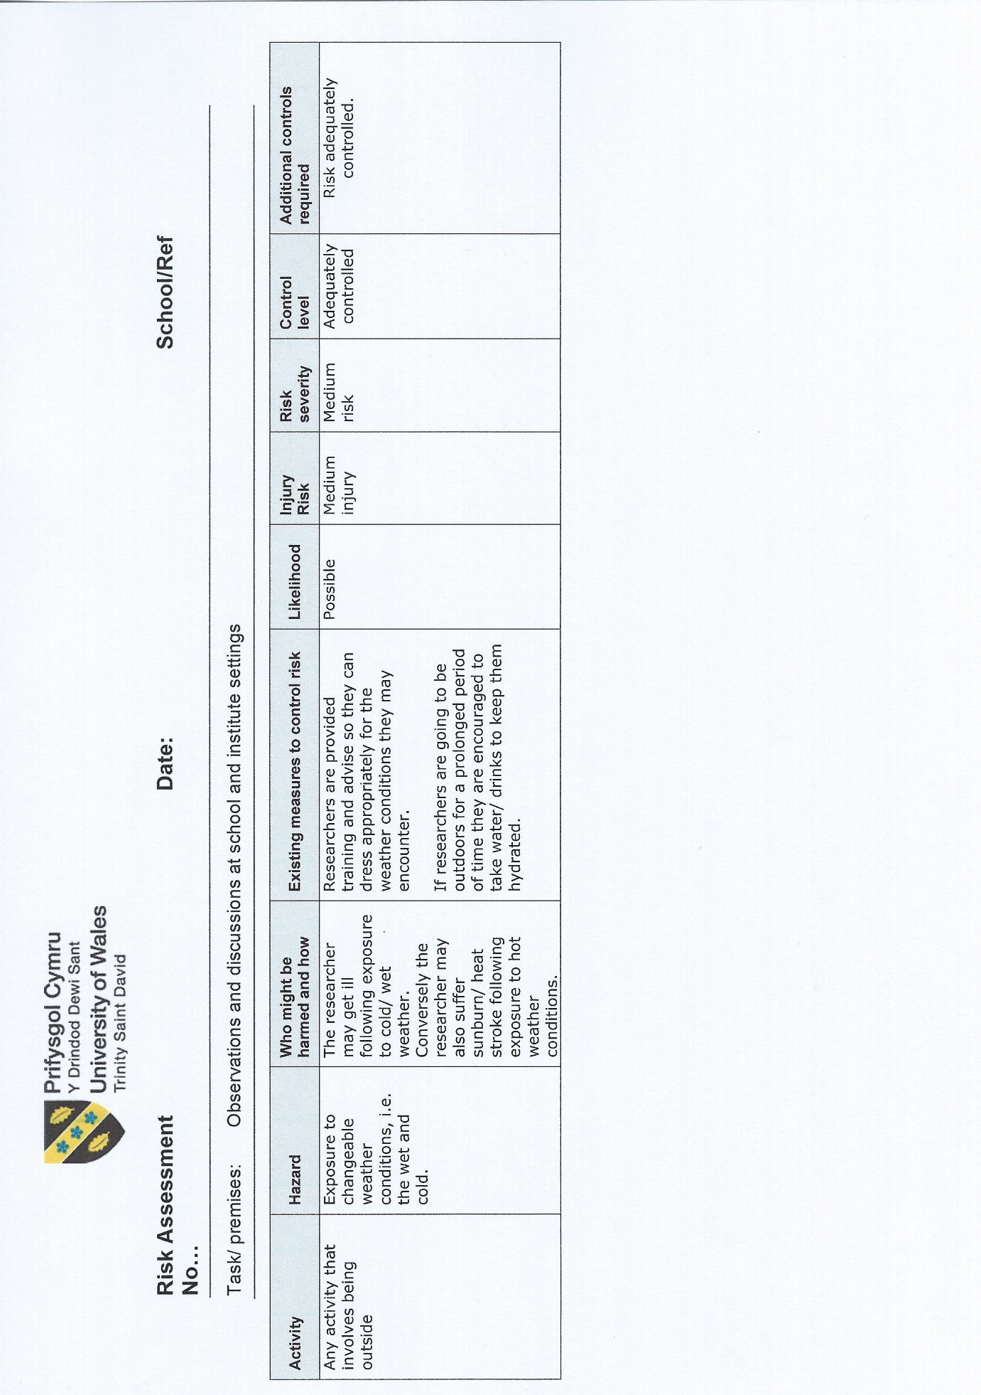

Appendix 5 d



