E-Commerce
Build a prototype e-commerce website
Ross Thomas
2016
Contents
Introduction 2
Development 2
Monetary Transaction 3
Marketing Metrics 4
Sol R Energy 4
Bibliography 8

Introduction
SolREnergy is a company which offers both customer and businesses with solar energy, they have asked to create a fully working e-commerce site which will help them grow and become internationally. The purpose of the e-commerce site is to allow customers and business to find out more about company, give contact information out and most importantly offer both customer and business’s will different solar cells. Having an e-commerce site will allow SolREnergy to work more efficiently, as the site will allow the user or business to make appointment over the internet, these can then be stored on a database. SolREnergy can also control how many appointment which can be booked each week with the stock control function of the site. At the moment SolREnergy are having to work much harder to keep on top of everything and even sometimes jobs don’t get started because of poor scheduling, having all these features in one place will defiantly keeping the business from staying on top of things and more important to help them grow and become international.

Development
There many options available to create a fully working e-commerce site and allow to add different features to the site and more importantly meet the requirements SolREnergy are looking for. You could have created a site with code such as java. You could have created the site with software applications such as Dreamweaver. Lastly you could have create an e-commerce site with online web builders such as Shopify, Wix and Sqaurespace.
Each option has its good and bad points, here are the explanations and why this was or wasn’t selected to create the e-commerce site for SolREnergy.
The e-commerce site could have been created in code, such as java or html, this option requires a lot of time and skill. If you are new to coding and have little background on it, making a website will become very difficult and complicated, the website won’t reach its full potential and become very simple and basic. If you have a good knowledge and background of coding, then great the e-commerce site will be very unique and different to sites already out there. You could many features to site and offer different aspect in which you don’t see all the time, but as mentioned this is very time consuming. It’s also the cheapest way to make the e-commerce site as the only thing you will be required to pay for is a domain name and server space. Application that are required for coding are notepad and visual studios. According to a website developer, the benefits of coding are “Building the website from scratch means you have deep knowledge of how it works and how to fix it if anything goes wrong.
You can extend it more easily. You’ve just gained an extra skillset”. (Francesco, 2015)

The e-commerce site could have been created with software such as Dreamweaver. Dreamweaver will allow you to code the website but also design the website with drag and drop tools. If you are not good at coding but can understand it, this is way to go for your site. You could design and create the site with the tools Dreamweaver has to offer and if you want to make things on the site a bit more different and unique then you can edit and alter the code to match your standard and what you are looking for. Dreamweaver is a very expensive software, however with the tools it has to offer it would be an effective way and wouldn’t require much time to make a basic site. The more advanced you are at the skill and the more time you put into the site, the better the site will become and more attractive it will look. However as well as paying for the software, you will still need to pay for the hosting, domain and server space for the site. Other software which offer the same services as Dreamweaver are nets-bean and TextWrangler.
Online website builders are the most effective way of making a fully working e-commerce site, epically if you have zero knowledge of code. All online site builders allow you to create sites with drag and drop tools, they give you different 1000’s of different templates to choose from which will match your company needs. Zero coding is needed as the website does this for you. Creating a site with an online website builder, will lower the chances of having a different and unique site, as another company may have already chosen the same template and had the same ideas as you for their site. The features and additionalities are very limited to what the builder has to offer. You could make a very simple very limited site very quickly, but the more time you spend on it, the better it will become and more features can be added when you have a better understanding of the tools and how to use the tools correctly, this will help the site reach its full potential more quickly. The templates which the builders have to offer make the site more professional and cleaner for the user to use. The builder also offer customer service, so if you are having problems and need help, the builders have a team available to answer any questions you may have and also to help you the best they can. To have full features and to publish the site, you will need to pay subscription fees to the online builder, these vary with the packages you want and the builder itself. Some website builders also allow you to code the site as well as the tools it has to offer. When choosing which website builder you want to use its important to consider” ace of use: The learning curve for creating a website and the technical knowledge needed for maintaining it. Customization: Not everyone needs high-end features. Here we’ll cover the common ground and raise a flag when features run into overwhelm. Portability: How easy will it be to hire a developer for custom changes, or migrate to another platform when you outgrow your current site“. (Jain, 2015)
After evaluating and analysing the different ways of making the site, the website builder WIX was decided because personally, there is a low level of knowledge of coding and using a website builder would allow to create a site with zero knowledge of code and get the website to good standard, as there will be more time to make the site look and feel better to use, also there will be more features to add with hardly any more effort to the site. Wix was chosen over the other because they offered the most templates and features which will allow to make the site more unique. Wix is also the cheapest and offer the better of the customer service.

Monetary Transaction
As customers and businesses will be making deposits on the site, it’s important that the payment method is secure. If the payment method doesn’t seem secure, it could lose you customers, as most people are very wary when paying online, due to all the scam and phishing that is around on the internet. There are payment methods like bank merchant and PayPal, which are known and trusted with people who use the internet. Having these implemented onto the site, will give the customer or business that confidence when placing their deposit. It’s down to personal choice when choosing which method you want to use on your site. Some methods do it for you and don’t charge any fees, PayPal will send the customer or business a receipt and send you the invoice to be taxed and they won’t even take a percentage of the fee. In order to use PayPal, both the user and company will need to have an account, it’s free to make a PayPal account but some people opt not to. Other methods such as a bank merchant will not do it for you, you will need to sort the invoice and you will need create the receipts and send them to the buyer. Bank merchant also take a transaction fee. When buying online you will need a debit or credit card, so the user won’t need to make any account, just enter the data of the card and it’s paid for. For the SolREnergy, personally wanted to keep cost down and spend more time on the design of the site, for payment method, PayPal was selected as they do most of it for you. The importance of having different payment methods “Making it as easy as possible for your customers to pay is essential for increasing conversions and sales. This is why your checkout page is critical. It’s the final stop for people shopping on your website. It’s the place where they hand over their credit card information and finally part with their hard-earned cash. “ (Papageorgiou, 2013)

Marketing Metrics
“The development of key metrics, the creation of dashboards that integrate information, and the implementation of business intelligence, provides reports and analysis needed to make fact-based decisions.” (Patterson, 2009) In order to make sure the site is working to its full potential, it’s important to know what the customers and business are doing when they are on the site. If this isn’t measured, how do SolREnergy know the site is working correctly? Is it just wasting time and resources? This can be done by seeing how many views the site gets and compare it to how many purchases its makes during this period. It’s also important to have a review system in place, so SolREnergy are aware of what is working well and what isn’t working well. This can give SolREnergy guidance on what they need to improve and what the user is looking for when using the site. As well as viewing how many people view to people buy, it’s important to look at how many people actually go through with the transaction and try and understand why people are changing their mind at the last minute, maybe they are uneasy with the payment method or maybe they seen cheaper and better service somewhere else. Following these metric will keep SolREnergy growing and progressing to their aim of becoming international.

Sol R Energy
Before creating and designing the website, it was important to plan the site, how it would work and map out the site.” A sitemap can be an effective planning tool for both designers and non-designers alike. It’s a centralized planning tool that can help organize and clarify the content that needs to be on your site, as well as help you eliminate unnecessary pages. And a sitemap, because it’s basically just an outline or flow-chart of the content your site needs, can be created by anyone, regardless of their design skills. Read on for more reasons why a sitemap should be the starting point for your new website design.” (Chapman, 2011)

Site Map.

Home
Introduce the company, showing the logo and photos, with social media buttons.
Contact us
Contact information, contact us form with map of location. Social media buttons.
Companies that use us
Buttons that link to different companies that use SolREnergy. Social media buttons
Services for Customer
Services SolREnergy offer customers. Social media buttons.
Services for business
Services SolREnergy offer businesses. Social media buttons

Product page
Product information
Cart
Products that are in the cart
Product page
Product information

Cart
Products that are in the cart

The website was created with WIX
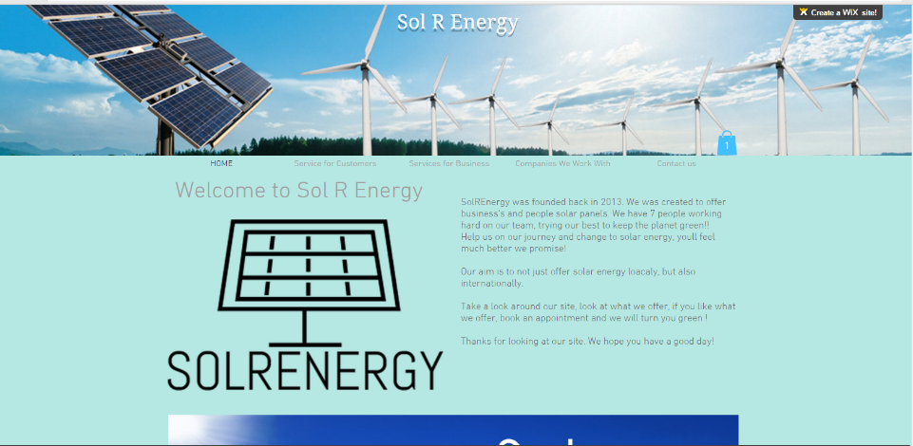
Home Page

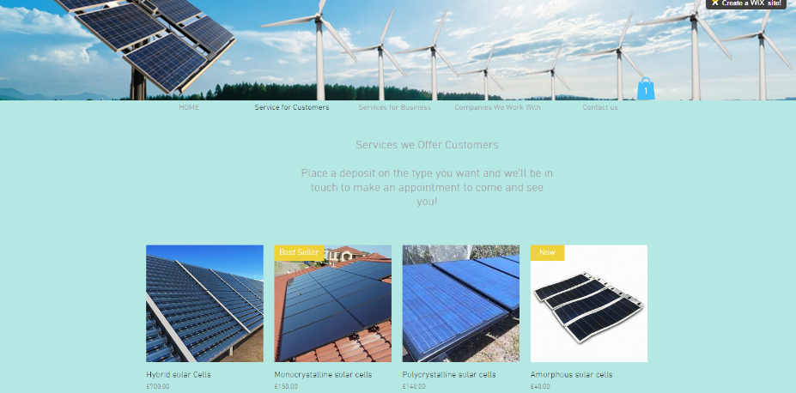
Services for customer
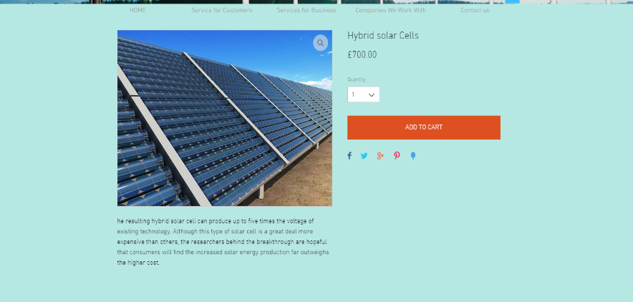
Product

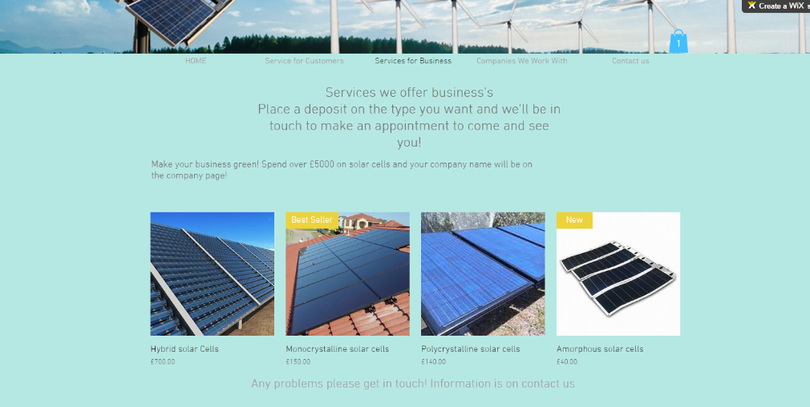
Services for business

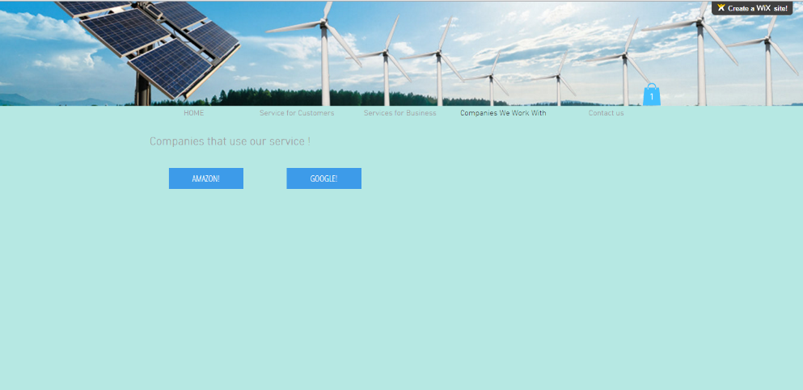
Companies that use us
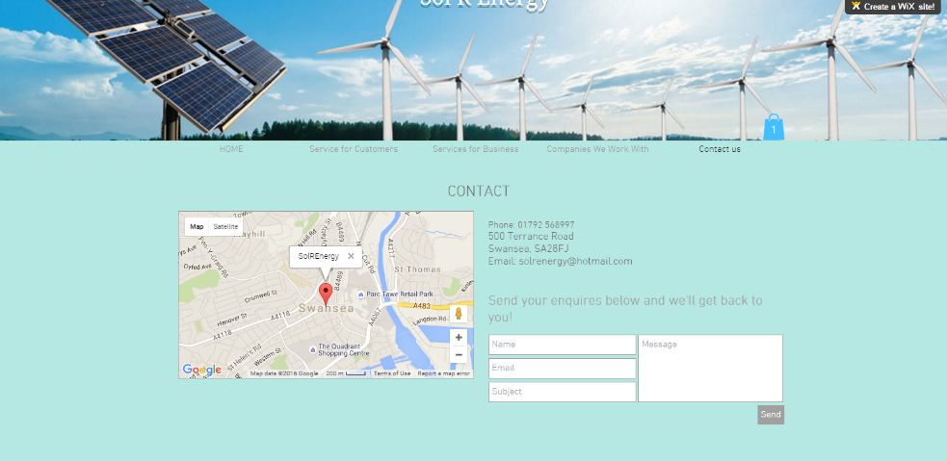
Contact us
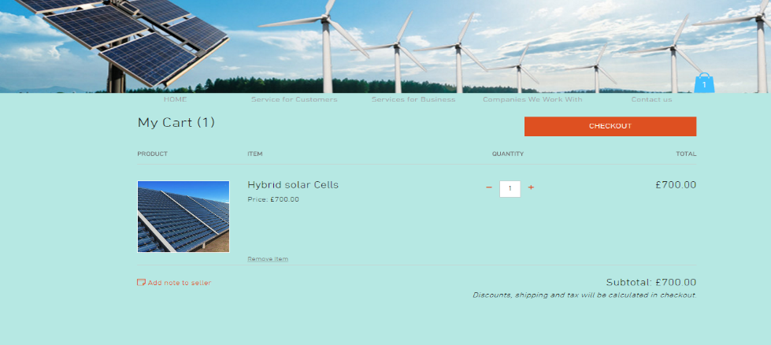
Cart

Bibliography
Chapman, C. (2011, May 19). SiteMap. Retrieved from KissMetrics: https://blog.kissmetrics.com/build-a-sitemap/
Francesco, H. D. (2015, April 8). What are the benefits of coding a website. Retrieved from Quora: https://www.quora.com/What-are-the-benefits-of-coding-a-website-from-scratch-or-learning-web-developing-languages-in-the-first-place-when-there-are-many-tools-builders-such-as-Dreamweaver-Squarespace-WordPress-etc
Jain, R. (2015, April 30). Website builder for you. Retrieved from WebDeisgn: http://webdesign.tutsplus.com/articles/choosing-the-right-website-builder-for-your-needs--cms-23699
Papageorgiou, K. (2013, August 30). Easy Payment Process. Retrieved from KissMetrics: https://blog.kissmetrics.com/easy-payment-process/
Patterson, L. (2009, May 4). Refresher. Retrieved from Marketing Metrics: http://www.refresher.com/using-marketing-metrics-to-create-a-competitive-advantage/

