BA Computer Games Design / BA Animation & VFX
Environment & level Design
ACCA4032
3D Diorama and Presentation
Philip Richmond 2212266
Please find below a You Tube Linke for my 3D Diorama Presentation:
https://youtu.be/0sa0AsxYw5c

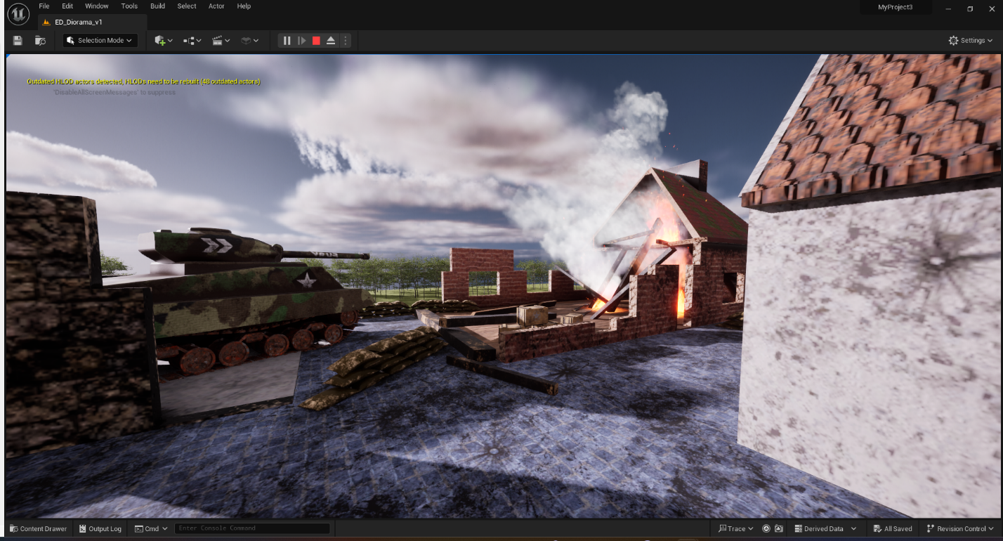
Figure 1
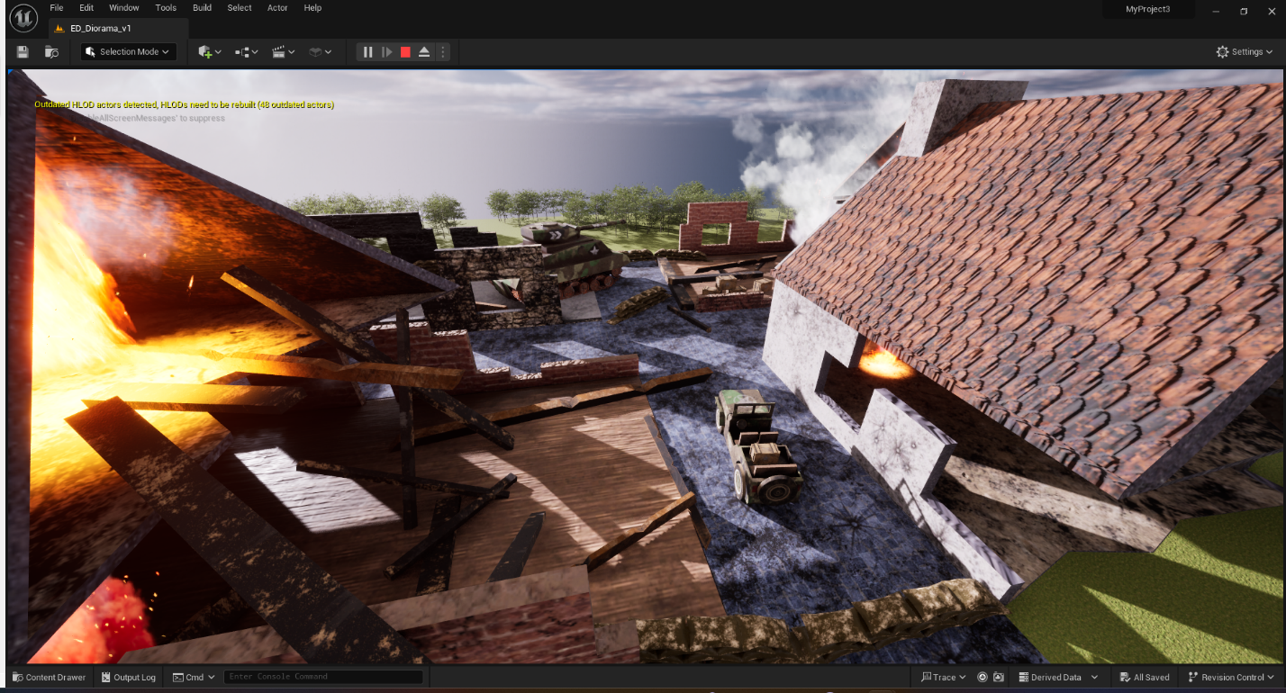
Figure 2

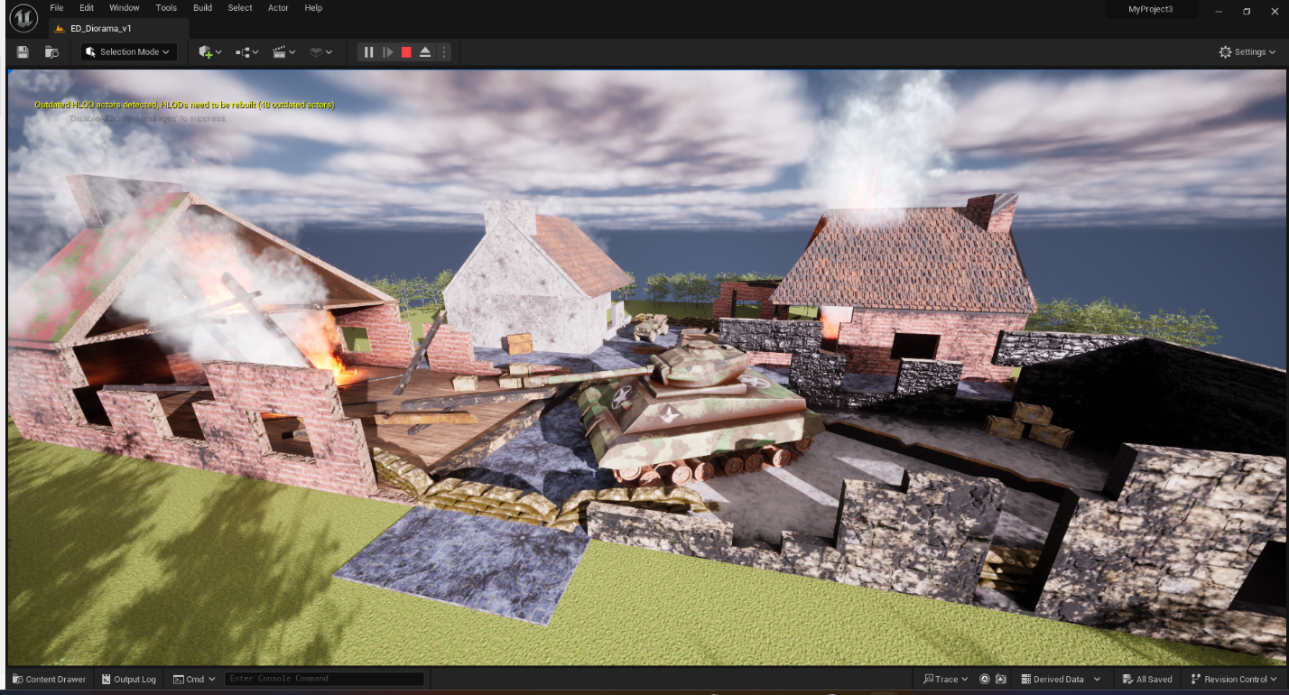
Figure 3
Bibliography
[1] “French Town House Ruins,” Printable Scenery, Aug. 22, 2016. https://www.printablescenery.com/product/french-town-house-ruins/ (accessed May 03, 2024).[2] “Steinway Upright Piano - Model V Dimensions & Drawings | Dimensions.com,” www.dimensions.com. https://www.dimensions.com/element/steinway-upright-piano-model-v
[3] “M4 Sherman HVSS US T66 Rubber Track Links -- Plastic Model Tank Track Links -- 1/35 Scale -- #35057 pictures by stevedkeith,” www.hobbylinc.com. https://www.hobbylinc.com/community/members/207656/174674_gallery.htm (accessed May 03, 2024).
[4] “Tracks: They Are a Weapon Too! | The Sherman Tank Site.” https://www.theshermantank.com/about/sherman-suspension-and-tracks-the-page-an-easy-to-find-place-for-sherman-suspension-info/tracks-they-are-a-weapon-too/ (accessed May 03, 2024).
[5 ] “World War 2 Damaged Building - Buy Royalty Free 3D model by AirStudios (@airstudios3d),” sketchfab.com, Jul. 19, 2023. https://sketchfab.com/3d-models/world-war-2-damaged-building-8c397d2f518145e6a365895c23d10a49 (accessed May 03, 2024).
[6] “How to make a TANK TRACK in Maya quickly. Animated with MASH. 3 steps to get working IN YOUR SCENE,” www.youtube.com. https://www.youtube.com/watch?v=R6WBrG1Pocw&t=4s (accessed May 03, 2024).
[7] BlueGalaxyDesigns, “M4 Sherman Medium Tank Blueprint,” Nov. 17, 2020. https://www.reddit.com/r/TankPorn/comments/jvs6x7/m4_sherman_medium_tank_blueprint/?rdt=54457 (accessed May 03, 2024).
[8] J. Reilly, “Photographs that capture how France was devastated 70 years ago,” Mail Online, May 28, 2014. https://www.dailymail.co.uk/news/article-2641660/Striking-photographs-capture-northern-France-devastated-70-years-ago.html (accessed May 03, 2024).
[9] “Google Maps,” Google Maps. https://www.google.com/maps/place/Pl.+du+March%C3%A9 (accessed May 03, 2024).
[10] “Wood crates & Ammo Boxes - Relics Replica Weapons,” www.relics.org.uk. https://www.relics.org.uk/wood-crates-and-ammo-boxes (accessed May 03, 2024).
[11] “Autodesk Maya 2018 Basics- MIRRORING- Duplicate/Duplicate Special/Mirror,” www.youtube.com. https://www.youtube.com/watch?v=dWGL1h9ZN6Q (accessed May 03, 2024).
[12] “Maya’s Fill Hole Tool,” www.youtube.com. https://www.youtube.com/watch?v=NTh3bTz05Pk (accessed May 03, 2024).
[13] “Maya’s Bridge Tool,” www.youtube.com. https://www.youtube.com/watch?v=4wIUIQNHIms
[14] “Ask DT: Maya - How to Transfer Individual Models from One Scene to Another,” www.youtube.com. https://www.youtube.com/watch?v=ShzjkFpwkJw (accessed May 03, 2024).
[15] “Merge Vertices and Target Weld in Maya,” www.youtube.com. https://www.youtube.com/watch?v=LsDnWZ4hHTk (accessed May 03, 2024).
[16] “Autodesk Maya Free Image plane: Setting up reference images for modeling,” www.youtube.com. https://www.youtube.com/watch?v=0DSa2V-cOMM (accessed May 03, 2024).
[17]“Maya’s Mesh Cleanup Tool,” www.youtube.com. https://www.youtube.com/watch?v=n4__dEcn0Q8
[18]“How to Animate a tank track in Maya 2023 ( 4K Video ),” www.youtube.com. https://www.youtube.com/watch?v=4PYaHZHLCWQ (accessed May 03, 2024).
[19] “6 UV Snapshot & Photoshop setup,” www.youtube.com. https://www.youtube.com/watch?v=t-7z5gvnjKg (accessed May 03, 2024).
[20] “3D House modeling in Maya 2020 made EASY #4 Walls & Floorplans,” www.youtube.com. https://www.youtube.com/watch?v=0l4MoIxpOXU (accessed May 03, 2024).
[21] “Maya 2016 tutorial : How to create twisted rope ( NEW ),” www.youtube.com. https://www.youtube.com/watch?v=T7lVqxvYg9U (accessed Jun. 10, 2021).
[22] “Low Poly Model Texturing in Substance Painter, texturing a low poly house,” www.youtube.com. https://www.youtube.com/watch?v=fiH9VCoQm5c&t=341s (accessed May 03, 2024).
[23] “Substance Painter to Unreal Engine 5 Workflow Tutorial | Exporting Textures from Substance to UE5,” www.youtube.com. https://www.youtube.com/watch?v=vxVd0Zk8ECg
[24] “Reset Maya Preferences To Default Settings,” www.youtube.com. https://www.youtube.com/watch?v=xdoMWdfSgP8 (accessed May 03, 2024).
[25] “Landscape for Beginners - Unreal Engine 5 Tutorial,” www.youtube.com. https://www.youtube.com/watch?v=FSsOS6M2u1s
[26] “Unreal Engine 5 Beginner Tutorial | Getting Started (2023),” www.youtube.com. https://www.youtube.com/watch?v=XRmn-EYt8wI&list=PLncmXJdh4q88DFCEVuGpOY3AGQwBvoQnh

[27] “3D and AR software - Adobe Substance 3D,” www.adobe.com. https://www.adobe.com/creativecloud/3d-ar.html
[28] “Substance 3D Community Assets Homepage on Substance 3D Community Assets,” substance3d.adobe.com. https://substance3d.adobe.com/community-assets?trackingid=PQ7SQ4FG&mv=in-product&mv2=cc (accessed May 03, 2024).
[29] “Old Stylish Brick Substance Material on Substance 3D Community Assets,” substance3d.adobe.com. https://substance3d.adobe.com/community-assets/assets/31d060e1c936e9c8786f550a38963b8e682d9825 (accessed May 03, 2024).
[30] “Broken Stone Wall Substance Material on Substance 3D Community Assets,” substance3d.adobe.com. https://substance3d.adobe.com/community-assets/assets/bb10799d173c8a2fc4b4a3be730a928e57356a89 (accessed May 03, 2024).
[31] “Wooden Floor Substance Material on Substance 3D Community Assets,” substance3d.adobe.com. https://substance3d.adobe.com/community-assets/assets/a73d90ab93f50b059d862cd9220be8fe53af8d97 (accessed May 03, 2024).
[32] “Old Brick Substance Material on Substance 3D Community Assets,” substance3d.adobe.com. https://substance3d.adobe.com/community-assets/assets/968a4e0833f81b886c0cc5af19bd7cf9a55ca84b (accessed May 03, 2024).
[33] “old roof tiles Substance Smart Material on Substance 3D Community Assets,” substance3d.adobe.com. https://substance3d.adobe.com/community-assets/assets/122b704c4f02e80f28bf4bb8e7a2c845b6899147
[34] “Camouflage Fabric Substance Material on Substance 3D Community Assets,” substance3d.adobe.com. https://substance3d.adobe.com/community-assets/assets/5bc12f0cc84061943f3a67619472f9f9f75610f9 (accessed May 03, 2024).
[35] “Roof Substance Material on Substance 3D Community Assets,” substance3d.adobe.com. https://substance3d.adobe.com/community-assets/assets/06fedb6e77a18d17b6d75c6005db8a312216f6b0
[36] “Dry SideWalk Substance Material on Substance 3D Community Assets,” substance3d.adobe.com. https://substance3d.adobe.com/community-assets/assets/f83eabfd33805b47bc297676f9b1113a44f0cb6d (accessed May 03, 2024).
[37] “Metal floor rusty and dirth Substance Material on Substance 3D Community Assets,” substance3d.adobe.com. https://substance3d.adobe.com/community-assets/assets/19e380c7cdfc7e6fa9afee2bcd6afbd2cd749a91 (accessed May 03, 2024).
[38] “How to model a 3D Pillow in Maya 2018 in 5 minutes,” www.youtube.com. https://www.youtube.com/watch?v=y__tsqaKxxk (accessed May 19, 2023).
[39] “Amazon.com: Willys MB US Military Jeep Vehicle Blueprint Plan Large Wall Art Poster Print Thick Paper 18X24 Inch: Posters & Prints,” www.amazon.com. https://www.amazon.com/Willys-Military-Vehicle-Blueprint-Artwork/dp/B07XF6VZL1?th=1 (accessed May 03, 2024).

