Component 2
Module Name: Analysing & Solving Problems
Module Code: ACCA4019
Student Name: Jordan-Lee O’Regan
Student ID: 2520324
Lecturer Name: Dr Abdullah Usman

Submission date: 22/07/2026

Contents
Introduction 3
Problem Deconstruction 3
Problem Analysis 3
Requirements Analysis 4
MoSCoW Prioritisation 4
Must Have 4
Should Have 4
Could Have 4
Won't Have 5
Constraints 5
Variables 5
Proposed Solution 5
Solution Overview 5
Proposed System Logic 7
Design Justification 8
Assumptions 8
Explanation of the Proposed Solution 8
Reflection and Justification 9
Conclusion 10
References 11

Introduction
Managing group work is a common part of university study, but arranging meetings that suit every member of a team can often be challenging. Differences in lecture timetables, part-time employment, placements and personal commitments can make it difficult to identify suitable meeting times, particularly when projects must be completed within fixed deadlines. The assignment scenario reflects this real-world problem by requiring the development of a computational solution that supports effective scheduling while helping groups organise meetings more efficiently [1].
Developing an effective solution requires more than simply selecting a meeting time. The problem must first be analysed to identify the requirements, constraints and information needed before an appropriate design can be produced. Computational thinking provides a structured approach to this process by encouraging complex problems to be broken down into smaller, manageable parts before a logical solution is developed [2]. This approach helps ensure that the proposed solution is based on the needs of the users rather than assumptions.
This report begins by deconstructing the scheduling problem and identifying its key requirements. It then presents and justifies a proposed solution using a flowchart before concluding with a reflection on the design process and the decisions made throughout the development of the solution.

Problem Deconstruction

Problem Analysis
The scenario requires a system that can help university students arrange group meetings before a project deadline. At first glance, this may seem like a straightforward scheduling task, but once individual commitments are considered the problem becomes much more complex. Each group member is likely to have different lecture timetables, work commitments, placements or personal responsibilities, meaning that finding a time when everyone is available is not always easy. If meetings cannot be organised efficiently, valuable time may be lost, making it harder for the group to complete the project before the deadline.
Before deciding how the problem should be solved, it first needs to be broken down into smaller parts. This reflects the principle of decomposition within computational thinking, where a larger problem is separated into manageable tasks that can be analysed individually before being combined into a complete solution [2]. Looking at the scenario in this way makes it easier to identify exactly what information is needed, what decisions have to be made and what factors could prevent the system from working effectively.
One of the first observations is that the system cannot recommend a meeting unless it has accurate availability information from every group member. It must also recognise that a meeting is only suitable if it takes place before the project deadline. This means the system is not simply matching free time but also checking that the recommendation satisfies the overall objective of helping the group complete their work on time. Understanding these relationships at the analysis stage provides a clear foundation before moving on to the design of the solution.

Requirements Analysis
The analysis identified a number of requirements that the proposed system would need to meet. The most important requirement is the ability to collect availability from each student before comparing their schedules to identify suitable meeting times. Without complete information, the system cannot make reliable recommendations.
The system must also ensure that any meeting suggested takes place before the project deadline. This is important because finding a common free period alone does not guarantee that the meeting will still support successful completion of the assignment. In addition, the system should be straightforward for students to use, as unnecessary complexity may discourage users from entering accurate information. Sommerville [3] suggests that understanding user requirements before designing software increases the likelihood that the final system will meet its intended purpose.

MoSCoW Prioritisation
To help identify which requirements are essential and which are less critical, the MoSCoW prioritisation technique has been applied [4].

Must Have
- Record the availability of every group member.
- Compare all student schedules.
- Recommend a meeting before the project deadline.
These functions are essential because the system would not achieve its main purpose without them.

Should Have
- Allow students to update their availability if circumstances change.
- Notify group members when a meeting has been selected.
These features improve usability but are not essential for the basic operation of the system.

Could Have
- Suggest alternative meeting times if the preferred option is unavailable.
- Display the earliest suitable meeting first.
These additions would improve the user experience but would not prevent the system from functioning if they were omitted.

Won't Have
- Integration with external calendar applications.
- Automatic booking of meeting rooms or online meeting platforms.
These features are outside the scope of the assessment and would unnecessarily increase the complexity of the proposed solution.

Constraints
Several constraints became apparent during the analysis. Student availability may change at short notice because of illness, employment or timetable changes, meaning information entered into the system may no longer be accurate. As the number of group members increases, the likelihood of finding a shared free period also decreases, making scheduling more difficult. The quality of the system's recommendations will therefore depend heavily on the accuracy and completeness of the information provided by its users. Recognising these limitations at an early stage helps ensure that realistic expectations are established before the solution is developed.

Variables
To perform the scheduling process, the system requires several key variables. These include the student name, student availability, meeting date, meeting time, project deadline and a meeting confirmed status. Each variable has a specific purpose within the scheduling process. For example, availability is required when comparing student timetables, while the project deadline is used to ensure that unsuitable meeting dates are not recommended. Identifying these variables during the analysis stage provides a clear understanding of the information that the proposed solution will need to process later in the report.

Proposed Solution

Solution Overview
Following the problem deconstruction, a logical solution has been designed to simplify the process of arranging group meetings while ensuring that project deadlines are met. The proposed system follows a structured sequence of steps, beginning with the collection of essential information before processing this data to identify suitable meeting times. Using a clear sequence of inputs, decisions and outputs helps ensure that the solution remains understandable and consistent [3].
The process begins by entering the project deadline, as this provides the system with a fixed time limit that all suggested meetings must satisfy. The number of students in the group is then entered so that availability can be collected from each member. Recording this information individually ensures that every student’s timetable is considered before a recommendation is made.
Once all availability has been entered, the system compares the schedules to identify periods when every member is free. If no common availability exists, the user is informed that no suitable meeting can currently be arranged. This prevents the system from recommending a meeting that excludes one or more members and reflects the requirement for all students to be considered.
Where a common time is identified, the system carries out a second check to confirm that the meeting takes place before the project deadline. This stage is necessary because shared availability alone does not guarantee that the meeting will still support completion of the assignment. The solution must therefore satisfy both conditions before a meeting can be accepted.
If a suitable time is found, the system recommends the meeting and displays the selected date and time. The meeting can then be confirmed by the group. If either the availability check or deadline check fails, a suitable message is displayed to explain that no acceptable meeting time has been identified.
This structure reflects algorithmic thinking because the problem is solved through a clear series of ordered steps and decision points [2]. It also supports consistency, as the same process is followed each time the system is used.

Proposed System Logic

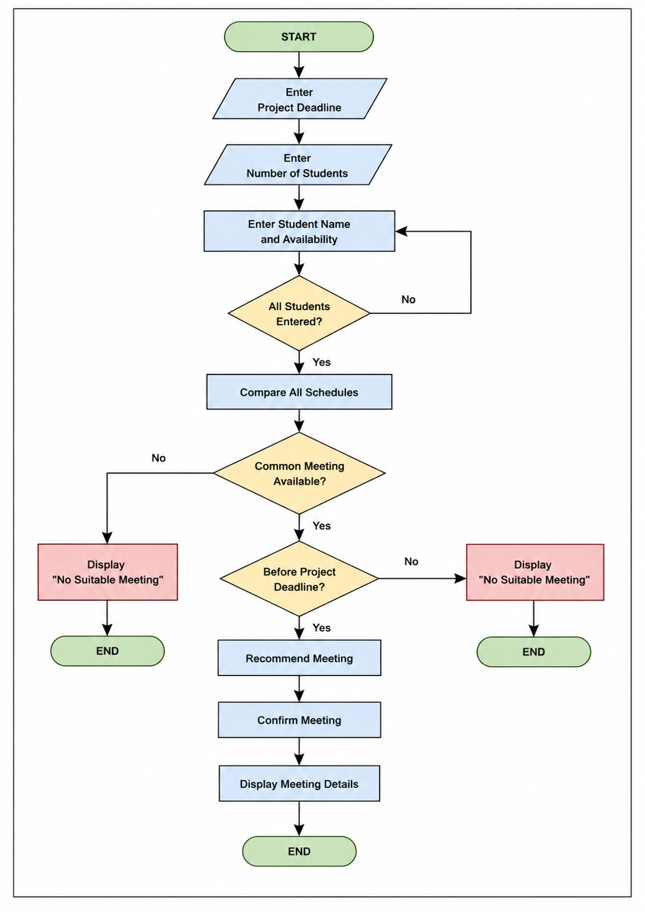
Figure 1. Proposed system flowchart for scheduling a group meeting before the project deadline.

Design Justification
The design was kept deliberately simple so that each stage could be followed clearly. Flowcharts are useful in software design because they provide a visual representation of the order in which processes and decisions take place [4]. In this case, the flowchart shows how the system moves from collecting information to comparing schedules and checking whether a proposed meeting meets the deadline.
Availability is checked before the project deadline because there is no reason to test a date if no common free period has been found. This reduces unnecessary processing and keeps the logic efficient. The confirmation stage only takes place once a valid meeting has been identified, ensuring that users are not asked to confirm an unsuitable option.
The decision points also make the system more reliable. A meeting is only recommended when all students are available and the proposed time is before the deadline. This ensures that the outcome is based on the requirements identified during the problem deconstruction rather than on a single condition. Clear decision structures are important because they allow alternative outcomes to be handled in a controlled and predictable way [5].

Assumptions
The proposed solution is based on several assumptions. It is assumed that every student enters complete and accurate availability information and that all dates and times use the same format. It is also assumed that the project deadline is known before the scheduling process begins and that all group members are expected to attend the selected meeting.
A further assumption is that the system is designed for one student group at a time. It does not connect to external calendars, book rooms or create online meeting links, as these features fall outside the scope of the assignment. These boundaries keep the solution manageable and focused on the main scheduling problem.

Explanation of the Proposed Solution
Figure 1 illustrates the logical process followed by the proposed meeting scheduling system. The sequence begins with the user entering the project deadline, ensuring that the system has a fixed time frame within which a meeting must be arranged. Establishing this information at the start prevents unsuitable meeting dates from being recommended later in the process.
The next stage requires the number of students to be entered before recording each student's name and availability. This information is essential because the system cannot compare schedules until data has been collected from every member of the group. A repetition process is used so that availability is entered for each student individually. This approach allows the solution to work with different group sizes rather than being restricted to a fixed number of users.
Once all student information has been entered, the system compares every timetable to identify periods where all members are available. This comparison represents the main processing stage, as it determines whether a suitable meeting can be arranged. If no common availability is identified, the system displays a message informing the user that no suitable meeting is available before ending the process. This prevents unsuitable recommendations from being made and clearly communicates the outcome to the user.
Where a common meeting time is found, the system performs a second validation by checking whether the proposed meeting takes place before the project deadline. Although students may all be available at a particular time, the meeting would have little value if it occurred after the submission date. Including this decision ensures that the recommended meeting supports the overall objective of completing the project on time.
If both decision points are satisfied, the system recommends the meeting, allows it to be confirmed and then displays the meeting details. Confirmation provides an opportunity for the group to accept the suggested meeting before the final details are presented. The process then ends, having successfully identified a meeting that satisfies both the availability and deadline requirements identified during the earlier analysis.
Overall, the proposed solution follows a clear sequence of inputs, processing and decision-making stages. Each step depends on the successful completion of the previous stage, helping to reduce unnecessary processing while ensuring that meeting recommendations are based on accurate information and the objectives defined within the assessment scenario [2], [3].

Reflection and Justification
Designing the proposed meeting scheduling system demonstrated the importance of analysing a problem thoroughly before attempting to produce a solution. Although the task initially appeared straightforward, breaking the scenario into smaller components showed that multiple factors needed to be considered, including student availability, project deadlines and the logical order in which information should be processed. Applying computational thinking helped transform a real-world scheduling problem into a structured sequence of tasks that could be represented clearly through a flowchart [2].
One of the strongest aspects of the proposed solution is its simplicity. The design follows a logical sequence that is easy to understand and ensures that essential information is collected before any decisions are made. By checking both student availability and the project deadline, the system avoids recommending meetings that would not help the group complete the project successfully. Keeping the design straightforward also improves readability, making it easier for future developers or users to understand how the system operates. Sommerville [3] argues that simple and well-structured software designs are generally easier to maintain and less likely to introduce unnecessary errors.
Another strength of the solution is the use of decision points to validate information before progressing through the process. Rather than assuming that a meeting can always be arranged, the system considers situations where no common availability exists or where a meeting would occur after the project deadline. This ensures that unsuitable outcomes are handled appropriately and that recommendations are based on the requirements identified during the problem deconstruction. Including these validation stages also improves the reliability of the overall process.
Despite these strengths, the proposed solution has several limitations. The system assumes that all students enter accurate and up-to-date availability. If incorrect information is provided, the meeting recommendation may not reflect the actual availability of the group. The solution also assumes that every member is expected to attend the same meeting, meaning it cannot currently accommodate situations where only a minimum number of attendees is required. Furthermore, the design does not integrate with online calendars or automatically update schedules if student availability changes after the information has been entered. These limitations were accepted because the assignment focuses on demonstrating computational thinking and logical problem solving rather than developing a fully featured scheduling application.
If the system were developed further, several improvements could be introduced. Automatic synchronisation with online calendar services would reduce manual data entry and improve accuracy. The system could also suggest alternative meeting times when no common availability is found, rather than ending the process immediately. Additional features, such as prioritising the earliest available meeting or allowing students to rank preferred meeting times, could further improve the usability of the system while maintaining the same logical structure.
Overall, completing this task reinforced the value of planning before designing a solution. Breaking the problem into smaller components made it easier to identify the information required, understand the constraints involved and develop a logical process that directly addressed the requirements of the assessment. The experience demonstrated that successful software design depends not only on producing a working solution but also on understanding the problem thoroughly before development begins [2], [3].

Conclusion
This report analysed the problem of scheduling meetings for student groups and demonstrated how computational thinking can be used to develop a structured solution. By deconstructing the scenario, identifying the key requirements, constraints and variables, a clear understanding of the problem was established before any design decisions were made. A logical solution was then proposed using a flowchart to illustrate the sequence of processes and decision points required to recommend suitable meetings before the project deadline.
The proposed design satisfies the objectives of the assignment by providing a structured and easy-to-follow approach to meeting scheduling while recognising the limitations of the simplified system. Although additional functionality could be incorporated in future developments, the solution demonstrates how careful analysis and logical design can be applied to address a practical problem effectively.

References
[1] University of Wales Trinity Saint David, ACCA4019 Component 2 Assignment Brief. Carmarthen: University of Wales Trinity Saint David, 2026.
[2] J. M. Wing, "Computational Thinking," Communications of the ACM, vol. 49, no. 3, pp. 33–35, Mar. 2006.
[3] I. Sommerville, Software Engineering, 10th ed. Harlow, UK: Pearson, 2016.
[4] D. Clegg and R. Barker, Case Method Fast-Track: A RAD Approach. Wokingham, UK: Addison-Wesley, 1994.
[5] R. S. Pressman and B. R. Maxim, Software Engineering: A Practitioner's Approach, 9th ed. New York, NY, USA: McGraw-Hill Education, 2020.
[6] T. H. Cormen, C. E. Leiserson, R. L. Rivest and C. Stein, Introduction to Algorithms, 4th ed. Cambridge, MA, USA: MIT Press, 2022.

