REFLECTIVE REPORT

Student name: Petko Tonev Petkov

Student number: 2125440

Lecturer name: Muhammed Hossain

Module Code: BMSW4001_BIRM

Module tittle: Academic and employability skills

Assignment tittle: Component 3 Reflective report

Introduction: The following reflective report will contain a break down of feelings, experiences and overall learning outcomes of the Academic & Employability skill module. How all the components went, what aspects of it were successful and also alternatively what didn’t go as planned and as well as it could have. All the examination on collaborating with my colleagues to create presentations and present in front of audience went and also what I learned throughout the writing up of the academic report for component 2.

For this reflective report I will be using the Gibbs’ reflective model in order to break down and analyse and evaluate where I went wrong and what I actually did well. This will help me create a checklist of what I have to improve on for future assignments and tasks during my studies in UWTSD.
Gibbs model of reflection contains very important 5 stages of reflection; 1. Description, 2. Feelings, 3. Evaluations, 4. Conclusions and 5. Action. This model of reflection is invented by Gibbs himself and he mentions that people learn from experience, however if they don’t reflect on their experience and situations, they will never learn properly where they went wrong and what they have to improve on.

This figure shows an image of how the reflective model actually works and the sequence of all 5 stages of reflection:
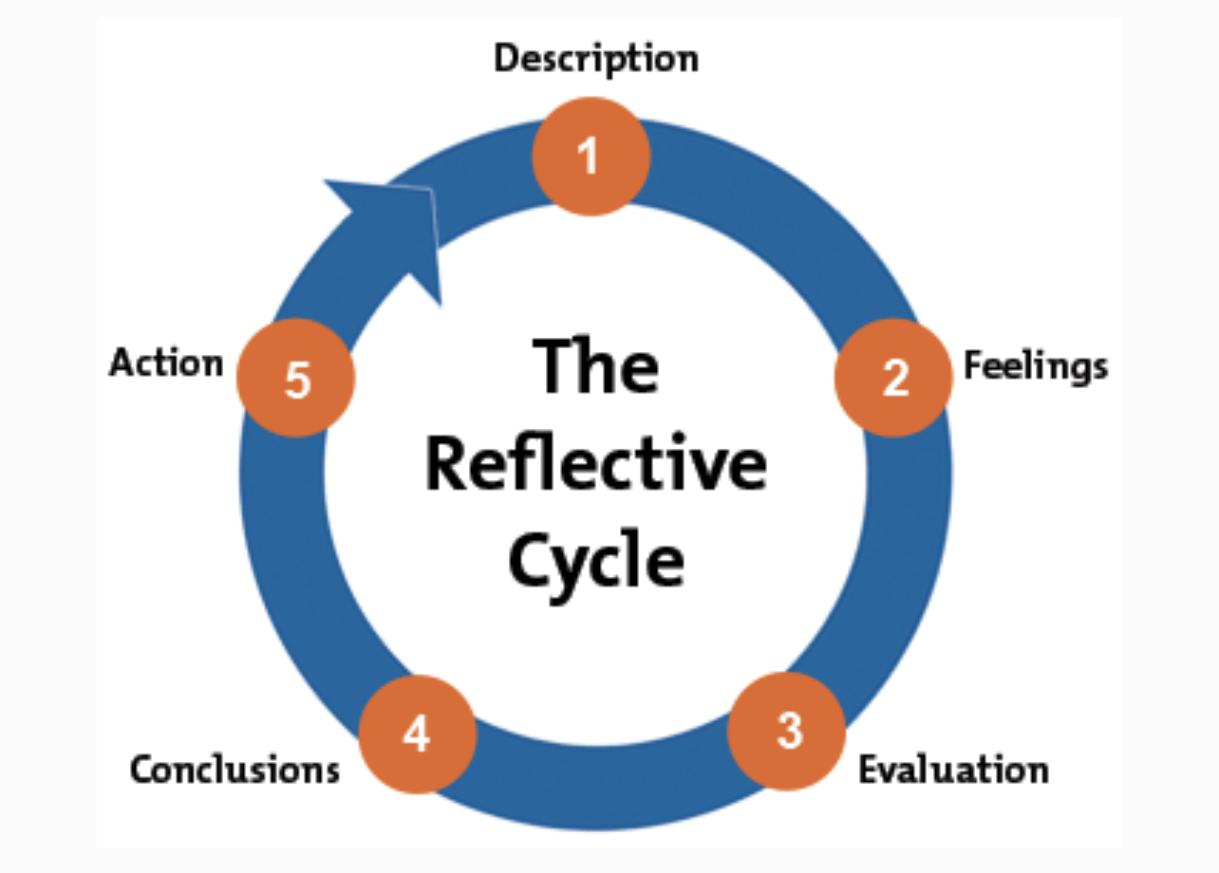
Regarding my personal reflection using Gibbs’ reflective model I have divided it into 5 sections according to each stage of reflection.

To begin with, the previous two tasks in Academic and Employability skill module were; 1. A quiz on the most important information we needed to know about the basics of academic and employability skills. This went well, amazing mark, amazing questions which gave me an understanding of what we have to do when we write up the 2nd task. The 2nd task was to write up an academic report on a theme which was to evaluate some of the most effective ways to motivate staff. This was very productive for me, I did it on time and submitted everything on time, I saw the task, broke it down into sections once again and started writing it up. In addition, we had a class task which was to create a presentation/poster on a job description and advertisement.

My feelings on how I did in the first two tasks mentioned above are very positive to be honest, I had everything planned out, had enough time to study and prepare for both of them. The academic report was slightly more complicated and harder to complete because it had more analysis and the amount that was expected from us to submit was 1000 words on the question given. This really frightened me at first, however when I actually started the task, every bit of information and resources I needed I was able to find so nothing prevented me from completing it on time. Coming up to the presentation we did in class I felt very embarrassed and not ready to present, I had not had enough sleep the night before and also I had very little preparation to present. I did not feel as comfortable on this task as I did on the previous two.

In terms of evaluation, which is the 3rd stage of reflection, it all went well aside from some errors I made. I had fun and enjoyed working in a team with my colleagues, both for the presentation and during the process of making up the poster advert for a job description. We combined the strengths we have as separate individuals and created this amazing poster which explained in depth the job tittle we chose. One problem we had was the preparation and the separation of roles and who does what when we had to present. We had some almost no preparation and we did not discuss anything about how we were going to present and also who was going to say what. A lot of reading off the screen took place. The presentation was chaotic over all. For future group presentations it would be useful to have a certain part which I have to learn on my own to present and would strive to improve my presenting skills and practice more talking in front of audience. This would help in the future with important presentations and auditions at work or elsewhere.

To conclude, the quiz was very useful in memorising information and also evaluating what my basic academic skill are overall. The academic report was really useful in understanding the level of writing I can produce and answers the question if it does fit the academic standards of the university. I have to proceed to improve my writing, it has many imperfections and most importantly to be able to learn how to evaluate properly, in this case which was the most effective way to motivate staff. By creating this academic report I learned that for future I need to plan and structure my theme and topics I want to include into the academic report. I loved helping my colleagues out as well whenever they needed help with working the Microsoft apps such as word and powerpoint. This helped me understand that my level of understanding and applying my knowledge I have to the academic work in UWTSD has helped not only me but other people as well, which I am really proud and glad for. What I also can say as a conclusion is that in a team and in order to create a piece of academic work as a team, we need to have synchronous, this would imply working as an actual team and exchanging ideas with each other on how to complete the task set by the lecturer. Also a team needs to have most importantly a separation of roles and a clear overview of who does what within the team. In this case I can mention the Gibbs reflective model once again, by saying that a person needs to know that experience teaches, however if you don’t work on improving your weaknesses and also elaborating on your strengths you will never learn properly and reflect on yourself and evaluate how you could be better next time in a certain situation.

In Gibbs reflective model there are five stages of reflection however I would like to add another one which would be overview. This stage consolidates the advantages and disadvantages also the strengths and the weaknesses about my academic writing and skills. Still following Gibbs model, however this additional stage of reflection precisely depicts the vital and most important areas of improvement. My personal weaknesses are presenting and working as a team. So my goal from now on would be the following: improve my communication and presenting skills, also deliberately listen to and exchange ideas with my colleagues, because it is team work so it should be done as a team.
Next important point of this reflective report is the PDP (personal development plan). I have created a table, by gathering all the information on how to improve in my studies, based on the experience from the already completed tasks and assignments in the module Academic and Employability Skills.

PDP (weaknesses) | Overview + Gibbs model | Strategies for Improvement
Weakness 1 | The first chosen weakness of mine is speaking in front of audience. I would love to be confident and fearless whenever I present or just speak in front of a group of people. What prevents me from doing that is not having enough preparation and stressing about how it would come across. Also another thing I am worried about is the unconscious fear of boring people out and not being able to entertain them fully and engage their attention towards my presentation. | Improvement strategy would be the preparation methods, record myself whilst presenting would help with my stage fright and would ease my voice and tone to flow consistently and smoothly with my thoughts over the topic of presentation. Also a thorough research on the topic I am presenting about would be very useful because by knowing what you speak about, people engage with you more and want to listen to you more, when they see that the person knows what they are talking about.
Weakness 2 | Fully analysing and evaluating important topics using sources and supporting evidence is very vital. It is an essential part of understanding what you are writing about and process fully the capacity of the compilation of the gathered arguments according to the task and the topic. This is one of my other weaknesses. | By carefully selecting the correct pieces of evidence to support my arguments I will be able to support my viewpoints and ideologies regarding a topic in a more sufficient way. This would be achieved by consolidating the information I have and compiling the according evidence I need go support that piece of information.

The last but not least stage of reflection following Gibbs model would be Action. In terms of action, the best option is to work on your weaknesses, because the strengths are already strengths, so what I want to do is make my weaknesses equivalent to my strengths. How will I achieve this particular task? By managing my own time and studies. Also connecting with the people I work with more, ask for help, ask for advice and also just stay in contact and share ideas to one another would be great and helpful to create a mutual agreeing on a plan which will be followed and every part of our task will be perfectly completed on time and flawlessly delivered to the lecturer and/or the audience.

Reference List:

Adeani, I.S., Febriani, R.B. and Syafryadin, S., 2020. USING GIBBS’REFLECTIVE CYCLE IN MAKING REFLECTIONS OF LITERARY ANALYSIS. Indonesian EFL Journal, 6(2), pp.139-148.

Potter, C., 2015. Leadership development: an applied comparison of Gibbs’ Reflective Cycle and Scharmer’s Theory U. Industrial and Commercial Training.

https://images.app.goo.gl/vnFrKPByTtcYQRMW8

