
By Nikolay Balkanski
Student: 1909874
C#
Section - 1

L4T2 – SOD Assessment 2020

University of Wales Trinity Saint David
BSc Cloud Computing
Lecturer: S. Fernando

Table of content

Introduction………………………………………………………………………………….3
Variables and constant……………………………………………………………………...4
Data types……………………………………………………………………………………4
Primitive and non - Primitive Data types………………………………….……………..5
Implicitly and Explicitly and type conversions…………………………….……………6
Flow charts…………………………………………………………………………………..9
Test the source code from appendix……………………………………………….……15
Explanation of testing source code…………………………………………………..…..16
Exercises whit full screenshots………….………………………………………………..19
Test cases…………………………………………………………………………………....21
Conclusion………………………………………………………………...………………..22
Appendix……………………………………………………………………………….…..22

Introduction

The introduction of the Microsoft .NET framework at the Professional Developers Conference in July 2000 additionally saw Microsoft introduce a brand new programming language called C#.
C# is designed to be simple, current, standard-cause, item-oriented programming language, which is also open source code, borrowing key concept from several other languages – maximum substantially the Java. Consequently, the whole lot in C# is a category “object” whit homes and Methods. C# can be used to create various types of libraries, programs and extensions, it has many SDK (Software Development Kits) for developers to satisfy their needs and achieve their goals faster. And also C# is a case sensitive language that means capital letters “B” and small letters “b” are important. C# is one of the famous programming Language nowadays due to the fact lot of humans locate easy to understand in this digitalize World!

Part A (Understanding)

1.Define variable and constant. State the difference between variable and constant. Why variable is important in programming?

Why variable is so important in programming language, Variable is important because they store a Data, the container that store a Data. Variable in C# are design to store values but this value is changed during the execution. But constant is not change in time of the execution, why we use a constant, reason to use constant is just to create safety on application for example P = 3.14 it’s constant if we change this number in the application everything will blow up. For instance, we create a program that performs some calculations on the values entered as person. The value entered by using one consumer will manifestly be exceptional from the ones entered in by some other consumer. This manner that when creating the program, the programmer does not know what values could be brought as input, and that makes it important to system all feasible values a person may additionally enter. When a consumer enters a brand new.
When a user enters a new value that will be used in the process of calculation, we are able to keep it (temporarily) inside the random get right of entry to memory of our laptop. The value on this a part of reminiscence trade (vary) all through execution
(Kimura, Shunsuke ; Imai, Keigo Imai, Keigo (pacrepositoryorg)org., Apr 3, 2020)
and this has led to their name – variable. Variable is important because they store a Data, it’s like small container store a data a write on the Ram memory.
How we declaring Variable and Constants, I will give you some suitable examples:

Int Number = 5;
Constant float Pi = 3.14f;

<data type> <variable name>;
<data type> <variable name> = <value>;

So how we define what type of date should be stored in which container, we used a date types to define the type of data to be stored in a particular variable. Data types is primarily used in computer programming, in which variables are created to store data. Each variable is assigned a data type that determines what type of data the variable my contain, are often used interchangeably. A types is really necessary because tells a computer what can be done whit data. We can add these two pieces together, we can divide them, we can search them for a name and etc. A types tell us how to display a date, Types help us to find a mistake in our code as well, there is also different strategies whit data types in code. The high level language is design to determines these typing strategies. In C# there is Primitive data type (build-in), and Non primitive data types which is defined by the programmer it’s not support by programming language also we called “reference variable” since they reference a memory location. To store different data we use Basics data types.

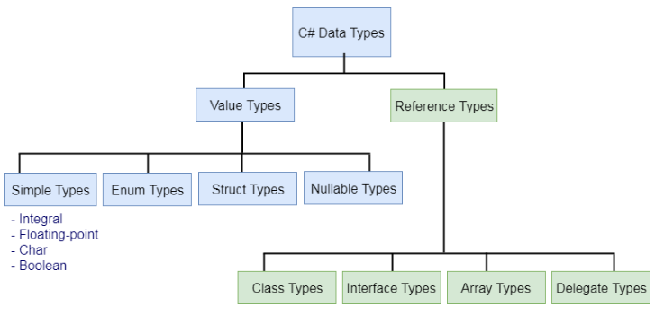
In C# there is too many data types which contains big range of default values:

Primitive date types or (built- in // types//)
Types | Default  Value | Minimum Data  Value | Maximum  Value
sbytes | 0 | -128 | 127
Byte | 0 | 0 | 255
short | 0 | -32768 | 32767
ushort | 0 | 0 | 65535
Int | 0 | -21474833648 | 2147483647
Uint | 0u | 0 | 4294967295
Long | 0L | -9223372036854775808
ulong | 0u | 0 | 18446744073709551615
float | 0.0f | +-1.5x10 -45 | +-3.4x10 38
double | 0.0d | +- 5.0x10 -324 | +-1.7x10 308
decimal | 0.0m | +- 1.0 x10 -28 | +-7.9 x10 28
bool | false | Two possible value true and false
char | ‘\u0000’ | ‘\u0000’ | ‘\uffff’
object | null | none | none
string | null | none | none

That’s all the primitive or build in data types, I will focus briefly and try to explain most usable data types, float, char, string, bool, int.
int - is a short from integer, data type to store a numbers without decimal, when we work whit numbers int is most commonly used data type.
float – is data type to store numbers which contain decimals.
bool – is one of the simplest data type contain only 2 value false or true, bool is important when programmer use logical operators.
String – it is used to storing text, a number of chars. In C# string are immutable that’s mean never changed after they been created.
char – is using to store single char and always use whit single quotation marks.
I would like to give you same examples as well for implicitly and explicitly data types: (Akiki, 2019)

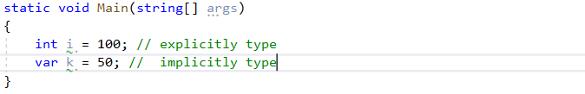

Implicitly – typed must be initialized at the time of declaration, otherwise compiler will give you error:
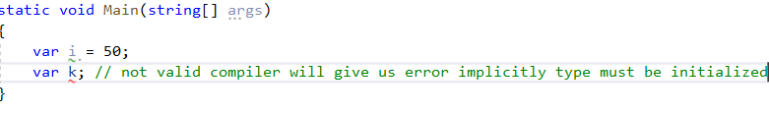
And there is too many examples I can show you but now I am going to focus and try to explain the control structures in C# programming.

And multiple declaration of var in single statement need to be declare in this order
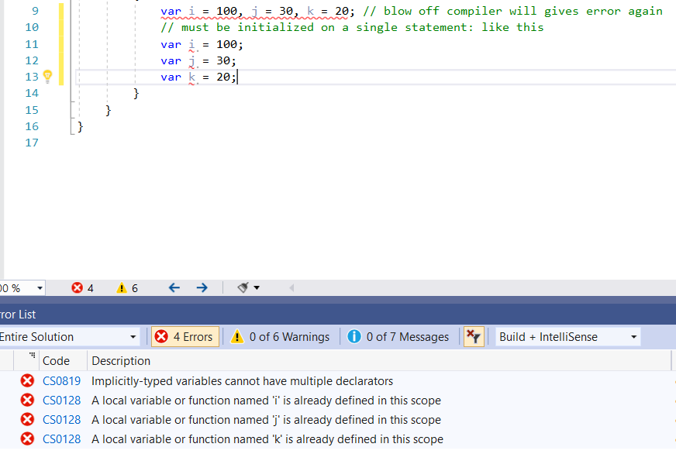
as you can see on the bottom of the picture implicitly typed variables cannot have multiple declarators.
Let me give some more examples for implicitly “var” whit different value
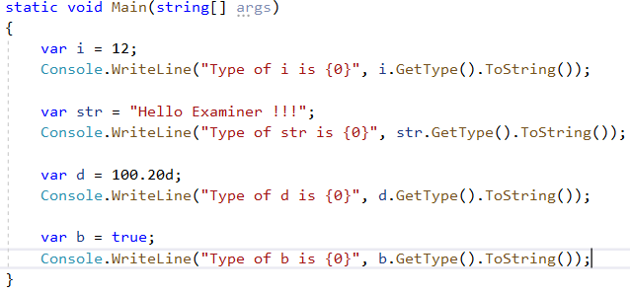

And there is too many examples I can show you, but now I am going to focus and try to explain the control structures in C# programming and how decision making changes the flow of execution.

If I desired to understand pc programs (and discover ways to lead them to) I needed to recognize their building blocks. You see, while a application runs, the code is examine with the aid of the computer line by means of line (from top to bottom, and from left to right), just like you would read a book. At some factor, the program might also reach a situation wherein it needs to decide which includes soar to a different a part of the program or re-run a positive piece again. These choices that affect the glide of the program’s code are known as a Control Structures.
Control Structures may be considered because the building blocks of computer applications. They are commands that allow a program to “take decisions”, following one course or every other. A software is usually no longer restricted to a linear series of commands considering the fact that for the duration of its system it can bifurcate, repeat code or bypass sections. Control Structures are the blocks that examine variables and choose guidelines in which to move based on given.
Basic control structures in C# programming language are: Conditional and Loops.
Condition is use in C# to execute one or more statement if condition is met.
Loops we use in C#, the purpose of loops is to repeat the statement certain times until the condition is (gratify) meet.
Conditionals are at the very core of programming. The idea behind them is that they allow you to control the flow of the code that is executed based on different conditions in the program an input taken from the user, or the internal state of the machine the program is running on. In this article I will try to explore the Conditionals Control Structures of “If statements” and “If Else statement”.

If Statement - If statement execute one or more statement when condition gratify,
If condition is True statement will execute, If False condition is not gratify and will not executed and nothing will happen, as you can see on the graphic:
(Kimura, Shunsuke ; Imai, Keigo Imai, Keigo (pacrepositoryorg)org., Apr 3, 2020) (Akiki, 2019)

start

condition
False
statement
End

If (condition) statement
X < - 2
If (x >= 0)
Print (variable is positive number)

In this example first we assign a value of 2 to variable (x) and used “if statement”
To verify that value equal or greater than zero if this is True will print variable x positive.
Output will be “variable x is positive number”

But for “if statement” simplest executes a statement if the examined situation is TRUE, what might had happened if the variable x become negative, to execute a declaration of tested condition False we need to use “If Else Statement”.

If Else Statement – whit this control structure allow the program to go on alternative way of execution even condition is met or not, so I am going to show you on this figure :

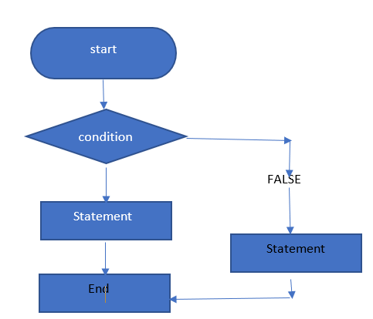

If (condition) statement else statement
The Else statement and will evaluate if the condition test is False.
Following our instance, we growth the preceding conditional “If Statement” by such as the “else component” to test if a the cost of a variable is positive or negative and perform an movement whether or not the take a look at result is TRUE or FALSE.

X < - - 2
If (x >= 0){
(“print variable x is positive number”)
}else{
(“print variable x is positive number”)
}
In this example is nearly the same, just assign – 4 to the variable (x) and use “If statement” to verify if that value is equal or more than 0. If it’s True the program will print variable (x) is positive number. But in case the test consequences False as in this case, the future keeps to alternative expression and the program will print the sentence: “variable (x) is negative number”. As you can see on the flowchart.
I am going now to explain my knowledge about Loops, for Loops, while Loops,
And do while Loops.

Loop statements” are not anything extra than the automation of multi-step tactics by means of organizing sequences of moves, and grouping the elements that want to be repeated. Also a vital part of programming, generation (or Looping) offers computers plenty computer power. They can repeat a sequence of steps as often as necessary, and appropriate repetitions of simple steps can resolve complex problems.
In widespread terms, there are kinds of “Looping techniques”.

For Loop, in this Control Structure, statements are performed one after any other in a consecutive order over a sequence of values that gets evaluated handiest whilst the “For Loop” is initiated (never re-evaluated). In this example, the variety of iterations is fixed and acknowledged earlier. (Akiki, 2019) (Laine, 2018)

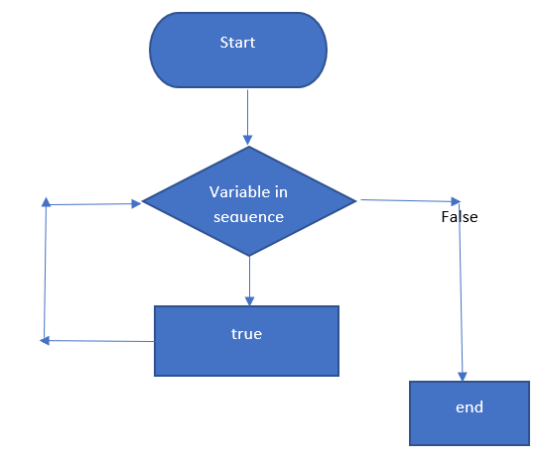

For (variable in sequence) statement

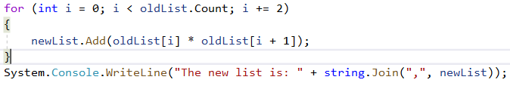

While Loop In “While Loops” a condition is first evaluated, and if the result of checking out that circumstance is TRUE, one or greater statements are again and again achieved till that circumstance turns into FALSE.

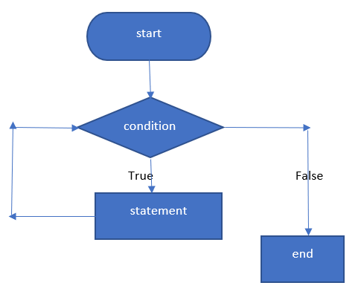 While Loops are iterative statements that execute a few expression time and again until the situation turns into FALSE. If the condition never seems to be FALSE, the “While Loop” will cross on all the time and the program will crash or blow off.

While (condition) statement
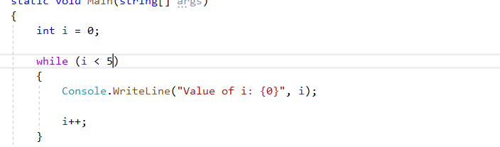

Do While loops, The do-even as loop is similar to the while loop except that within the do-whilst loop, the code block may be finished as a minimum once.
The do-while loop begins with the do key-word followed by means of a code block and a Boolean expression with the while. The do-even as loop exits while expression returns false. (Laine, Computers, 2018)

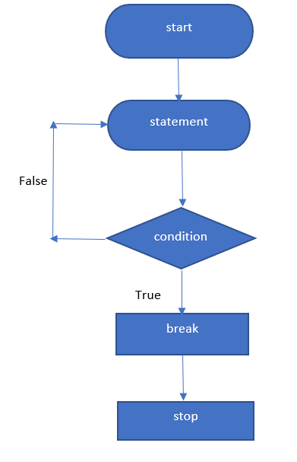
While (condition) statement
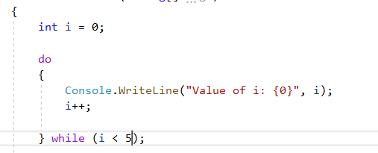
As you can see on this example it’s nearly the same like is while loop but firs is do than while
Boolean.
Boolean operations has a lot big functions in decision making whit the logical operations
PART B (Testing)

- using System;
- using System.Collections.Generic;
- using System.Linq;
- using System.Text;
- using System.Threading.Tasks;
- namespace Assignmen2014_15
- {
- class Program
- {
- const int MAXNUMBERS = 3;
- static void Main(string[] args)
- {
- int[] theNumbers = new
- int[MAXNUMBERS]; int chosenOption = 0;
- bool quit = false;
- InitialiseNumbers(theNumbers);
- while (quit == false)
- {
- DisplayHeader();
- DisplayMenu();
- chosenOption = ReadNumber("Please choose an option: ");
- quit = ProcessMenu(chosenOption, theNumbers);
- Console.Clear();
- }
- }
- static void InitialiseNumbers(int[] numbers)
- {
- for (int index = 0; index < MAXNUMBERS; index++)
- {
- numbers[index] = 0;
- }
- }
- static void DisplayHeader()
- {
- WriteText("*******************************************************************************", 0, 0); // Top left hand corner of
- screen is x = 0, y = 0
- WriteText("* This application is designed to allow you to choose numbers *", 0, 1); // Next line down is x = 0, y = 1, etc
- WriteText("* and finds the biggest and the smallest value *", 0, 2);
- WriteText("*******************************************************************************", 0, 3);
- }
- static void DisplayMenu()
- {
- WriteText("Select an option", 20, 8); // Display menu at at x = 20, y = 8
- WriteText("1. Enter the numbers", 20, 9);
- WriteText("2. Find the smallest", 20, 10);
- WriteText("3. Find the largest", 20, 11);
- WriteText("4. Display all numbers", 20,
- 12); WriteText("5. Quit", 20, 13);
- }
- static void WriteText(string text, int x, int y)
- {
- Console.CursorLeft = x;
- Console.CursorTop =
- y; Console.Write(text);
- }
- static int ReadNumber(string prompt)
- {
- string text;
- int number;
- WriteText(prompt, 20, 14);
- text = Console.ReadLine();
- number = int.Parse(text);
- ClearText(20, 14, prompt.Length + text.Length); // Clear the text at this line
- return number;
- }
- static void ClearText(int x, int y, int length)
- {
- // Write space ' ' characters starting at x, y for 'length' times
- WriteText(new String(' ', length), x, y);
- }
- static bool ProcessMenu(int option, int[] numbers)
- {
- bool quit = false;
- switch (option)
- {
- case 1:
- GetNumbers(numbers);
- break;
- case 2:
- WriteText(string.Format("The smallest value is {0}", FindSmallest(numbers)), 20, 15);
- Console.ReadKey(); // Pause
- break;
- case 3:
- WriteText(string.Format("The largest value is {0}", FindLargest(numbers)), 20, 15);
- Console.ReadKey(); // Pause
- break;
- case 4:
- quit = IsQuitting();
- break;
- case 5:
- quit = IsQuitting();
- break;
- default:
- WriteText("Unknown option value entered", 20, 15);
- Console.ReadKey(); // Pause
- break;
- }
- return quit;
- }
- static void GetNumbers(int[] numbers)
- {
- for(int index = 0; index < MAXNUMBERS; index++)
- {
- numbers[index] = ReadNumber("Enter number: ");
- }
- }
- static int FindSmallest(int[] numbers)
- {
- int smallest = numbers[0];
- for (int index = 0; index < MAXNUMBERS - 1; index++) // <-- subtract 1
- {
- if(numbers[index + 1] < smallest)
- {
- smallest = numbers[index + 1];
- }
- }
- return smallest;
- }
- static int FindLargest(int[] numbers)
- {
- int largest = numbers[0];
- for (int index = 0; index < MAXNUMBERS - 1; index++) // <-- subtract 1
- {
- if (numbers[index + 1] > largest)
- {
- largest = numbers[index + 1];
- }
- }
- return largest;
- }
- static bool IsQuitting()
- {
- string response;
- bool quit = false;
- WriteText("Do you really wish to quit? ", 20,
- 13); response = Console.ReadLine();
- if (response == "YES")
- {
- quit = true;
- }
- return quit;
- }
- }
- }

That it sort code already from appendix - line 35:
And how it should be to start
- }
- }
- static void DisplayHeader()
- {
- WriteText("*******************************************************************************", 0, 0); // Top left hand corner of

- WriteText("* This application is designed to allow you to choose numbers *", 0, 1);
- // Next line down is x = 0, y = 1, etc
- WriteText("* and finds the biggest and the smallest value *", 0, 2);
- WriteText("*******************************************************************************", 0, 3);
- }
- static void DisplayMenu()
Run the code and describe how the application works creating step by step instructions.
Us you can see explained line by line how the application is work according whit my knowledge:
- using System;//
- using System.Collections.Generic;
- using System.Linq;
- using System.Text;
- using System.Threading.Tasks;

- namespace Assignmen2014_15 // name space
- {
- class Program// class
- {
- const int MAXNUMBERS = 3;// Enter users a numbers only 3
- static void Main(string[] args)// Main method
- {
- int[] theNumbers = new int[MAXNUMBERS];// Declairin array
- int chosenOption = 0;//declare variable of array list
- bool quit = false;//
- InitialiseNumbers(theNumbers);//
- while (quit == false)// while loop boolean operator, expresion to false - so will do the job until == false
- {
- DisplayHeader();//Method dispaly header// block of data
- DisplayMenu();//Method display menu
- chosenOption = ReadNumber("Please choose an option: ");// dislay on console options
- quit = ProcessMenu(chosenOption, theNumbers);// if quit chose from options menu
- Console.Clear();//method to clear the screen and cursor going to the top left corner
- }
- }
- static void InitialiseNumbers(int[] numbers)// Method
- {
- for (int index = 0; index < MAXNUMBERS; index++)// for each loop, integer, index< MAXNUMBERS is smaller increment by 1;
- {
- numbers[index] = 0;//index return array of value// assigne index 0
- }
- }
- static void DisplayHeader()//Method
- {
- WriteText("*******************************************************************************", 0, 0); // Top left hand corner of
- WriteText("* This application is designed to allow you to choose numbers *", 0, 1); // Next line down is x = 0, y = 1, etc
- WriteText("* and finds the biggest and the smallest value *", 0, 2);
- WriteText("*******************************************************************************", 0, 3);
- }
- static void DisplayMenu()// Method
- {
- WriteText("Select an option", 20, 8); // Display menu at at x = 20, y = 8
- WriteText("1. Enter the numbers", 20, 9);// Display options x = 20, y = 9
- WriteText("2. Find the smallest", 20, 10);// Display options x = 20, y = 10
- WriteText("3. Find the largest", 20, 11);// Display menu x = 20, y = 11
- WriteText("4. Display all numbers", 20,12); // same again
- WriteText("5. Quit", 20, 13);// same again
- }
- static void WriteText(string text, int x, int y)// Method
- {
- Console.CursorLeft = x;// position by x
- Console.CursorTop = y;// position by y
- Console.Write(text);// to be writen on console
- }
- static int ReadNumber(string prompt)// Method
- {
- string text;//
- int number;// whit this block code convert string to integer, to be displayed x20,y14
- WriteText(prompt, 20, 14);//
- text = Console.ReadLine();//read from console
- number = int.Parse(text);//conversion
- ClearText(20, 14, prompt.Length + text.Length); // Clear the text at this line//
- return number;// exit of method whit out exit of program
- }
- static void ClearText(int x, int y, int length)//Method
- {
- // Write space ' ' characters starting at x, y for 'length' times
- WriteText(new String(' ', length), x, y);
- }
- static void DisplayNumbers(int[] theNumbers)//Method
- {
- Console.Write("ALL your numbers are: ");// Write on console all numbers
- for (int i = 0; i < MAXNUMBERS; i++)// loop, loop variable i, for every time that 'i' is smaller then MAXNUMBERS, after each iteration of the loop increment by 1//
- {
- Console.WriteLine(theNumbers[i]);// display numbers
- }

- }
- static bool ProcessMenu(int option, int[] numbers)//Defined Method
- {
- bool quit = false;// boolean operator
- switch (option)// switch statement - option
- {
- case 1:// Input numbers
- GetNumbers(numbers);
- break;// braek statement terminate loop
- case 2:
- WriteText(string.Format("The smallest value is {0}", FindSmallest(numbers)), 20, 15);// dislay on console x20, y15 The smallest value
- Console.ReadKey(); // Pause
- break;// braek statement terminate loop
- case 3:
- WriteText(string.Format("The largest value is {0}", FindLargest(numbers)), 20, 15);// display on console again x20, y15 largest value
- Console.ReadKey(); // Pause
- break;// braek statement terminate loop
- case 4:

- WriteText(" ", 20,16);// display on console where exactly
- DisplayNumbers(numbers);// display numbers
- Console.ReadKey();// Pause
- break;// braek statement terminate loop
- case 5:
- quit = IsQuitting();// Option 5 if you want to quit
- break;// braek statement terminate loop
- default:
- WriteText("Unknown option value entered", 20, 17);// wrong option input from user dif. then numbers
- Console.ReadKey(); // Pause
- break;// braek statement terminate loop
- }
- return quit;// exit of loop whit out exit of main program
- }
- static void GetNumbers(int[] numbers)//Method
- {
- for (int index = 0; index < MAXNUMBERS; index++)// loop again variable index of array 0, until index is smaller than MAXNUMBER increments each cycle by 1/
- {
- numbers[index] = ReadNumber("Enter number: ");//
- }
- }
- static int FindSmallest(int[] numbers)// Main Method find smallest
- {
- int smallest = numbers[0];// integer smallest = number 0 of arrays list position
- for (int index = 0; index < MAXNUMBERS - 1; index++) // <-- subtract 1// for each loop index 0 smaller than MAXNUMBER
- { // Int smallest is the first element of the numbers array, passed from outside when call the Method - function.
- if (numbers[index + 1] < smallest)// The first element in array is always the smallest until you find smaller element, then loop the numbers
- { // array this MAXNUMBERS is equal to the lenth of the number array and loop the array from the second element
- smallest = numbers[index + 1]; // index + 1 to the last element numbers lenght - 1;
- }
- }
- return smallest;// exit from the Method not from the program
- }
- static int FindLargest(int[] numbers)// Defined a Method find largest
- {
- int largest = numbers[0];
- for (int index = 0; index < MAXNUMBERS - 1; index++) // <-- subtract 1
- {
- if (numbers[index + 1] > largest)// same from smaller numbers
- {
- largest = numbers[index + 1];// same
- }
- }
- return largest;//
- }
- static bool IsQuitting()// Method quit
- {
- string response;// user responce will be stored variable responce
- bool quit = false;// boolean operator
- WriteText("Do you really wish to quit? ", 20,13); // option to wish to quit
- response = Console.ReadLine();// read from console
- if (response == "YES")// if user responce = "YES" do quit yes allways capital letters
- {
- quit = true;// bollean operator return true so quit
- }
- return quit;// exit only from the method
- }
- }
- }

Part of requirements flow chart
Switch conditional expression
start
Switch statement

Case condition 1
Statement brake;

False
Case condition 2
Statement brake;

False
Statement brake;
Case condition 3

False
Case condition 4
Statement brake;

False
Case condition 5
Statement brake;

False
Default
Default statement

Statement below switch case

Switch statement Flow chart figure 1:
Exit

Exercise 1:
- using System;
- using System.Collections.Generic;
- using System.Linq;
- using System.Text;

- namespace Task_1_assigment_1
- {
- class Program
- {
- static void Main(string[] args)
- {
- Console.Write("\n\n");
- // name of the customer
- Console.WriteLine("Input the Name of the customer: ");
- string customerName = Console.ReadLine();
- // product price
- Console.WriteLine("Input product price £; ");
- float Price = float.Parse(Console.ReadLine());
- // product quantity
- Console.WriteLine("Input quantity of the product: ");
- float Quantity = float.Parse(Console.ReadLine());
- // order price
- float Amount = Price * Quantity;
- // show order price
- Console.WriteLine("Show total price of order", customerName, Amount);
- Console.WriteLine("Product : {0}.", Price);
- Console.WriteLine("Price: {0:0.00}.", Price);
- Console.WriteLine("Quantity : {0}.", Quantity);
- Console.Write("\n\n");
- Console.WriteLine("Total Cost: Php {0:0.00£}.", Amount);
- Console.Write("\n\n");

- }
- }
- }

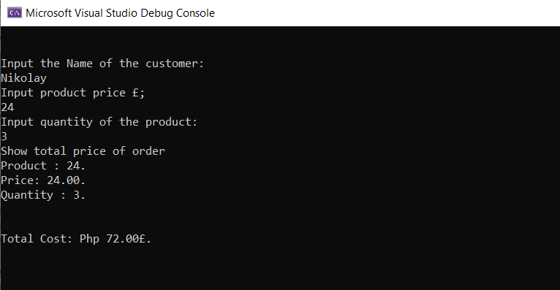
Output for Exercise 1.
Test cases | Expect result | Actual result | Any discrepancies | Test result as screen shot
Input required values to the program | User is required to input customer name, price and Qty and the program should calculate and display the cost | As expected | No
Input Inappropriate values | In case user enter number instead of string value to customer name, the system should generate an error message | Appropriate error handling code has not been used to handle errors. | Yes

Exercise 2:
- using System;

- namespace task_2_assigment_1
- {
- class Program
- {
- static void Main(string[] args)
- {
- Console.WriteLine("Find Shaded region of octangle");
- Console.WriteLine("Only Numbers");
- // calculate shaded area on rectangle: divided this fig on two part and and get shaded area off
- Console.Write("Enter X: ");
- decimal x = decimal.Parse(Console.ReadLine());
- Console.Write("Enter Y: ");
- decimal y = decimal.Parse(Console.ReadLine());
- // now we can do calculation by the formula for octagonal
- decimal surface = ((x - 7) * 3) + ((y - 3) * (x - 7)) + 21 - (2) * (2);
- Console.WriteLine("The face of the octangle is X * Y - Shaded Area ", surface);
- Console.WriteLine("The face of the octangle is {0}", surface);
- Console.WriteLine("If you want to continue Press Enter and F5");
- }
- }
- }

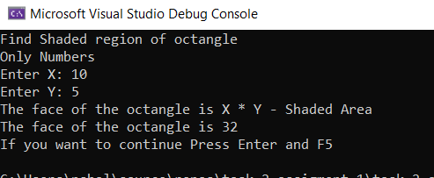
Output for Exercise 2. ”/n X =10, Y = 5;

Test cases | Expect result | Actual result | Any discrepancies | Test result as screen shot
Input required value to the program | User is required to put x and y and to calculate face on a shaded area | As expected | no
Input inappropriate values | In case user enter a string instead of numbers, string value to x and y , the system should generate an error message | Appropriate error handling code has not been used to handle errors | yes

Exercise 3: First solution
- using System;
- using System.Collections.Generic;
- using System.Text;

- namespace ConsoleApplication1
- {
- class Program
- {
- static void Main(string[] args)
- {
- System.Random generator = new Random(DateTime.Now.Millisecond);
- float a, b, c, player = 0, count = 0;

- Console.WriteLine("Fruit Machine");
- Console.WriteLine("One player?");

- if (player == 1)
- goto oneplayer;
- float score;
- oneplayer:
- for (score = 0; score <= 10; count++)
- {
- a = generator.Next(10);
- Console.Write(a + "\n");
- b = generator.Next(10);
- Console.Write(b + "\n");
- c = generator.Next(10);
- Console.Write(c + "\n");

- if (a == b && a == c && a == 9)
- {
- Console.WriteLine("Jackpot!");
- Console.WriteLine("Win !!!.\n Congatulation You win 2000 points");
- }
- else if ((a == b && a == 9) || (b == c && b == 9) || (a == c && c == 9))
- {
- Console.WriteLine("Win !!! . \n Congratulation You win 200 points");
- }
- else if ((a == b && a == c) || (a == b && a == c) || (b == c && c == a))
- {
- Console.WriteLine("Win !!!.\n Congtulations You win 15 points");
- }
- else if (a == b || b == c || a == c)
- {
- Console.WriteLine("Win !!!.\n Cogratulation You win 5 points");
- }

- score = 0;

- Console.ReadKey();
- Console.WriteLine("Press Enter if You Want To Continue!: ");

- }
- }
- }
- }

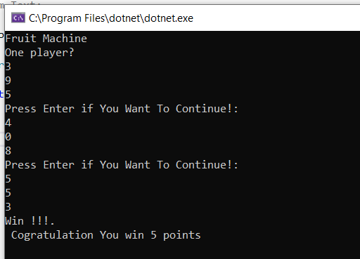
Output for Exercise 3.”/n 5 points any set of two same numbers.
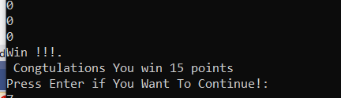
Output for Exercise 3. “/n 15 points any set of three same numbers.
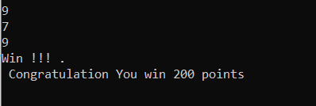
Output for Exercise 3. “/n 200 points any set two nines.
Output for Exercise 3.”/n “Jackpot” 2000 points.

Exercise 3: Second Solution to display total points on User. I gave you first solution by my mistake and later on I’ve decided to leave as evident of test case where been struggling but believe me until sorted out I was getting nuts and in the test case provided down below will explain my accreditation.
- using System;
- using System.Collections.Generic;
- using System.Text;

- namespace ConsoleApplication1
- {
- class Program
- {
- static void Main(string[] args)
- {
- Random generator = new Random();

- float a, b, c;
- int score = 0;

- Console.WriteLine("Do you wat to play Fruit Machine");
- Console.WriteLine();

- while (true)
- {
- a = generator.Next(10);
- Console.Write(a + "\t");
- b = generator.Next(10);
- Console.Write(b + "\t");
- c = generator.Next(10);
- Console.Write(c + "\t");

- string player = Console.ReadLine();
- player.ToLower();

- if (player == "quit")
- {
- break;
- }

- if (a == b && a == c && a == 9)
- {
- Console.WriteLine("JACKPOT!");
- Console.WriteLine("WIN !!!.\n Congatulation You win 2000 points", generator.Next(10));
- Console.WriteLine("Your new score is {0}", score += 2000);
- score += 2000;

- }
- else if ((a == b && a == 9) || (b == c && b == 9) || (a == c && c == 9))
- {
- Console.WriteLine("WIN !!! . \n Congratulation You win 200 points", generator.Next(10));
- Console.WriteLine("Your new score is {0}", score += 200);
- score += 200;

- }
- else if ((a == b && a == c) || (a == b && a == c) || (b == c && c == a))
- {
- Console.WriteLine("WIN !!!.\n Congtulations You win 15 points", generator.Next(10));
- Console.WriteLine("Your new score is {0}", score += 15);
- score += 15;

- }
- else if (a == b || b == c || a == c)
- {
- Console.WriteLine("WIN !!!.\n Cogratulation You win 5 points", generator.Next(10));
- Console.WriteLine("Your new score is {0}", score += 5);

- }
- else
- {
- Console.WriteLine("You lost");

- }
- }
- }
- }
- }
Output for exercise 3 solution 2
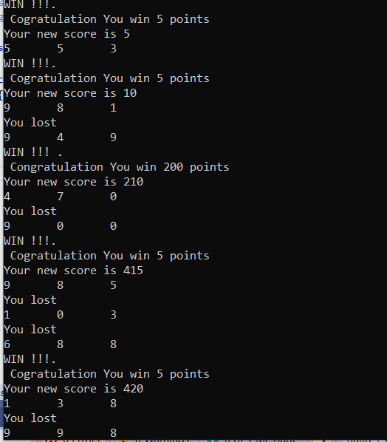

Test cases | Expect result | Actual result | Any discrepancies | Test result as screen shot
Input required value to the program | User is required to put 3 variables a,b,c, and create random number generator. As equals pairs or triple combination winning points as 5, 15 , 200 and big winning 2000 points | Yes as expected | no | Yes
Input inappropriate values | No just press enter, yes if you press space | Appropriate error handling space has not been used to handle errors | yes

Exercise 4:

- using System;

- namespace assigment_1_task_4
- {
- class Program
- {
- public static void Main(string[] args)
- {
- int player = 1;

- while (player < 36)
- {

- Console.Write("Roll the dice? ");
- string userInput = Console.ReadLine();
- Random rnd = new Random();
- int dice = rnd.Next(1, 7);
- Console.WriteLine("You rolled {0}, dice");
- player += dice;

- switch (player)
- {
- case 2:
- player = 15;
- Console.WriteLine("You landed on a Ladder\n Your new possition is {0}", player);
- break;
- case 5:
- player = 7;
- Console.WriteLine("You landed on a Ladder \n Your new possition is {0}", player);
- break;
- case 9:
- player = 27;
- Console.WriteLine("You landed on a Ladder \n Your new possition is {0}", player);
- break;
- case 18:
- player = 29;
- Console.WriteLine("You landed on a Ladder \n Yor new possition is {0}", player);
- break;
- case 25:
- player = 35;
- Console.WriteLine("You landed on a Ladder \n Your new possition is {0}", player);
- break;
- case 32:
- player = 30;
- Console.WriteLine("You landed on a Ladder \n Your new posstition is {0}", player);
- break;
- case 34:
- player = 12;
- Console.WriteLine("You landed on a Ladder \n Your new posstition is {0}", player);
- break;
- case 24:
- player = 16;
- Console.WriteLine("You landed on a Ladder \n Your new posstition is {0}", player);
- break;
- case 17:
- player = 4;
- Console.WriteLine("You landed on a Ladder \n Your new posstition is {0}", player);
- break;
- case 20:
- player = 6;
- Console.WriteLine("You landed on a Ladder \n Your new posstition is {0}", player);
- break;
- }

- Console.WriteLine(" You win,");
- Console.WriteLine(" Do you want to play another game");

- }

- }
- }
- }

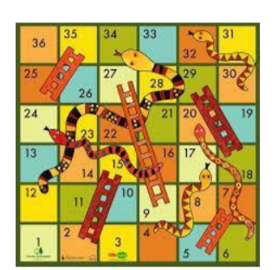

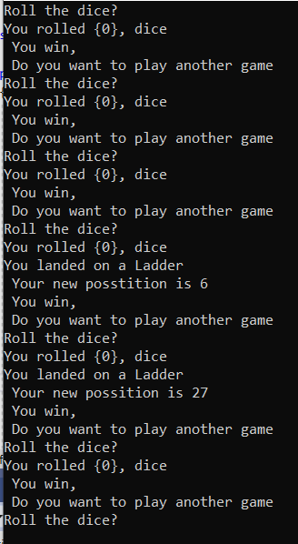
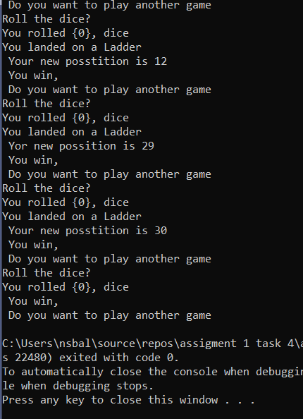
Output for Exercise 4.
Test cases | Expect result | Actual result | Any discrepancies | Test result as screen shot
Input required value to the program | As Expected | yes | no
Input inappropriate values | Specifies the message text of the expected exception | Code is run whit as it should

References

(Kimura, Shunsuke ; Imai, Keigo Imai, Keigo (pacrepositoryorg)org., Apr 3, 2020),
(Akiki, 2019),
(Laine, Computers, 2018),

Appendix

Explained line by line code from appendix according by my knowledge:
- using System;//
- using System.Collections.Generic;
- using System.Linq;
- using System.Text;
- using System.Threading.Tasks;

- namespace Assignmen2014_15 // name space
- {
- class Program// class
- {
- const int MAXNUMBERS = 3;// Enter users a numbers only 3
- static void Main(string[] args)// Main method
- {
- int[] theNumbers = new int[MAXNUMBERS];// Declairin array
- int chosenOption = 0;//declare variable of array list
- bool quit = false;//
- InitialiseNumbers(theNumbers);//
- while (quit == false)// while loop boolean operator, expresion to false - so will do the job until == false
- {
- DisplayHeader();//Method dispaly header// block of data
- DisplayMenu();//Method display menu
- chosenOption = ReadNumber("Please choose an option: ");// dislay on console options
- quit = ProcessMenu(chosenOption, theNumbers);// if quit chose from options menu
- Console.Clear();//method to clear the screen and cursor going to the top left corner
- }
- }
- static void InitialiseNumbers(int[] numbers)// Method
- {
- for (int index = 0; index < MAXNUMBERS; index++)// for each loop, integer, index< MAXNUMBERS is smaller increment by 1;
- {
- numbers[index] = 0;//index return array of value// assigne index 0
- }
- }
- static void DisplayHeader()//Method
- {
- WriteText("*******************************************************************************", 0, 0); // Top left hand corner of
- WriteText("* This application is designed to allow you to choose numbers *", 0, 1); // Next line down is x = 0, y = 1, etc
- WriteText("* and finds the biggest and the smallest value *", 0, 2);
- WriteText("*******************************************************************************", 0, 3);
- }
- static void DisplayMenu()// Method
- {
- WriteText("Select an option", 20, 8); // Display menu at at x = 20, y = 8
- WriteText("1. Enter the numbers", 20, 9);// Display options x = 20, y = 9
- WriteText("2. Find the smallest", 20, 10);// Display options x = 20, y = 10
- WriteText("3. Find the largest", 20, 11);// Display menu x = 20, y = 11
- WriteText("4. Display all numbers", 20,12); // same again
- WriteText("5. Quit", 20, 13);// same again
- }
- static void WriteText(string text, int x, int y)// Method
- {
- Console.CursorLeft = x;// position by x
- Console.CursorTop = y;// position by y
- Console.Write(text);// to be writen on console
- }
- static int ReadNumber(string prompt)// Method
- {
- string text;//
- int number;// whit this block code convert string to integer, to be displayed x20,y14
- WriteText(prompt, 20, 14);//
- text = Console.ReadLine();//read from console
- number = int.Parse(text);//conversion
- ClearText(20, 14, prompt.Length + text.Length); // Clear the text at this line//
- return number;// exit of method whit out exit of program
- }
- static void ClearText(int x, int y, int length)//Method
- {
- // Write space ' ' characters starting at x, y for 'length' times
- WriteText(new String(' ', length), x, y);
- }
- static void DisplayNumbers(int[] theNumbers)//Method
- {
- Console.Write("ALL your numbers are: ");// Write on console all numbers
- for (int i = 0; i < MAXNUMBERS; i++)// loop, loop variable i, for every time that 'i' is smaller then MAXNUMBERS, after each iteration of the loop increment by 1//
- {
- Console.WriteLine(theNumbers[i]);// display numbers
- }

- }
- static bool ProcessMenu(int option, int[] numbers)//Defined Method
- {
- bool quit = false;// boolean operator
- switch (option)// switch statement - option
- {
- case 1:// Input numbers
- GetNumbers(numbers);
- break;// braek statement terminate loop
- case 2:
- WriteText(string.Format("The smallest value is {0}", FindSmallest(numbers)), 20, 15);// dislay on console x20, y15 The smallest value
- Console.ReadKey(); // Pause
- break;// braek statement terminate loop
- case 3:
- WriteText(string.Format("The largest value is {0}", FindLargest(numbers)), 20, 15);// display on console again x20, y15 largest value
- Console.ReadKey(); // Pause
- break;// braek statement terminate loop
- case 4:

- WriteText(" ", 20,16);// display on console where exactly
- DisplayNumbers(numbers);// display numbers
- Console.ReadKey();// Pause
- break;// braek statement terminate loop
- case 5:
- quit = IsQuitting();// Option 5 if you want to quit
- break;// braek statement terminate loop
- default:
- WriteText("Unknown option value entered", 20, 17);// wrong option input from user dif. then numbers
- Console.ReadKey(); // Pause
- break;// braek statement terminate loop
- }
- return quit;// exit of loop whit out exit of main program
- }
- static void GetNumbers(int[] numbers)//Method
- {
- for (int index = 0; index < MAXNUMBERS; index++)// loop again variable index of array 0, until index is smaller than MAXNUMBER increments each cycle by 1/
- {
- numbers[index] = ReadNumber("Enter number: ");//
- }
- }
- static int FindSmallest(int[] numbers)// Main Method find smallest
- {
- int smallest = numbers[0];// integer smallest = number 0 of arrays list position
- for (int index = 0; index < MAXNUMBERS - 1; index++) // <-- subtract 1// for each loop index 0 smaller than MAXNUMBER
- { // Int smallest is the first element of the numbers array, passed from outside when call the Method - function.
- if (numbers[index + 1] < smallest)// The first element in array is always the smallest until you find smaller element, then loop the numbers
- { // array this MAXNUMBERS is equal to the lenth of the number array and loop the array from the second element
- smallest = numbers[index + 1]; // index + 1 to the last element numbers lenght - 1;
- }
- }
- return smallest;// exit from the Method not from the program
- }
- static int FindLargest(int[] numbers)// Defined a Method find largest
- {
- int largest = numbers[0];
- for (int index = 0; index < MAXNUMBERS - 1; index++) // <-- subtract 1
- {
- if (numbers[index + 1] > largest)// same from smaller numbers
- {
- largest = numbers[index + 1];// same
- }
- }
- return largest;//
- }
- static bool IsQuitting()// Method quit
- {
- string response;// user responce will be stored variable responce
- bool quit = false;// boolean operator
- WriteText("Do you really wish to quit? ", 20,13); // option to wish to quit
- response = Console.ReadLine();// read from console
- if (response == "YES")// if user responce = "YES" do quit yes allways capital letters
- {
- quit = true;// bollean operator return true so quit
- }
- return quit;// exit only from the method
- }
- }
- }

Thank you for your time to check my work.

