Individual Project
Engineering Design for New Relief System


HNC Mechanical Engineering
Matthew Evans

HNC Mechanical Engineering
Individual Project
SGDM5024
Matthew Evans
ME204775
J Williams
30-4-20

- Summary
The project is to redesign the relief system on the Alky Acid settler as the vessel is being replaced to increase capacity and being run as a separate project. During the engineering of this project there will be a number of activities to keep track of along with progress, cost control, engineering deliverables, procurement and planning.
This project will start by setting out its project team and aligning all with their duties. Some of the first step will be to set out the project brief and create a project plan execution plan. Once with these small steps complete it is then possible to complete the process design before moving onto the detailed design.
The design started well with all modeling being completed and the first set of 0.1 drawings issued. As this design progressed there were some unforeseen changes that added some delay and addition re-design works. This also occurred extra cost.
Although engineering as not yet complete at the time of writing this report it has and will meet the project brief but slightly over on cost due to changes and design productivity.
As with all projects there is always learnings. Some learning from this project would be to include construction as early as possible to avoid any constructability issues that could occur during engineering design. This simple step could save cost in the long turn of a project with the avoidance of engineering reworks.
- Contents
1. Summary 2
2. Contents 3
3. Table of figures 5
4. Acknowledgements 6
5. Introduction 7
5.1. Background Information 7
5.2. Roles and Responsibilities 8
6. Literature Review and Background Research 9
7. Project Specification and Testing Plan 11
8. Project Planning & Cost Control 12
8.1. Project Planning 12
8.2. Cost Control and Farecasting. 13
8.3. Incorporating Change. 14
9. Project Solutions 15
10. Design and Implementation 16
10.1. Initial Design 16
10.2. Design Problems 17
10.3. Re design Solution one. 18
10.4. Re design Solution Two. 18
11. Analysis, Results and Evaluation 19
12. Conclusion 20
13. Recommendations 21
14. Bibliography 22
15. References 23
16. Appendices 24
16.1. Project Proposal 24
16.2. Project Team Roles and Responsibilities 24
16.3. Basis of Design (BOD) 24
16.4. Deliverables list 24
16.5. Project Execution Plan (PEP) 24
16.6. Project Plan and Reports 24
16.7. Project Solution Advantages and Disadvantages. 24
16.8. Relief Mitigation Review Process and Reviewers. 24
16.9. CTEMS Fittings 24
16.10. Engineering Standard List 24
16.11. Final Engineering Deliverables 24
16.12. Project Analysis. 24

- Table of figures
Figure 1: Project Overlaps 7
Figure 2: Project Org Chart 8
Figure 4:PSV cross section (Parisher, 2002) 10
Figure 5: PSV piping layout model 17
Figure 6: Rev 0.1 ISO Tie in location 18
Figure 7: Site Header Tie in Pic 18
Figure 8: Re Design first proposed Solution 19
Figure 9: Final Design configuration 19

Table 1:Criteria Analysis 16

- Acknowledgements
Simon Law: Valero Project Manager.
I would like to thank my Simon Law, my boss, who has supported me through this project and through my HNC. He has given good guidance on what and how to report out to management.
Jeremy Fisher; Valero Project Engineering.
I would like to thank Jeremy fisher lead senior project engineer who has led this project. He has given me a good look into project management along with enhancing some new skill with how to document project issues or concerns.
Dominic Jones; Valero Lead Design Engineer.
I would like to thank Dom Jones for his design knowledge and reasoning behind all the choices that have happened during the design phase of this project.
Gary Nevil; Valero Project Development lead Process Engineer.
I would like to thank Gary Nevil for his explanation on how and why it is important to have all relief system accurate and correct. Gary has a lot of knowledge for process designs and has explained the reasoning behind this project.
Sabrina Evans; My Wife.
Finally, I would like to give a very big thanks to my wife. Without my wife I would not have been able to compete this project or have the time to do my HNC with family life.

- Introduction

Background Information
At Pembroke refinery there is always projects under development from concept to construction and completion. There are also many different categories of project type, they are:
- Safety project,
- Compliance project,
- Improvement projects,
- Major investment project,
This project is a small section of a larger project that is reviewing and replacing relief systems across all process units the overall project being developed within this report falls under 2 categorise, Safety and Compliance. This element of the overall safety relief systems is an improvement of a safety system on a new vessel replacement for a major turnaround that will be carried out in 2021. The new vessel is replacing an old vessel that is being improved for future proofing the performance and safety of the vessel at the refinery. This project is looking at a specific area of the safety relief system from a larger project on the new vessel that needs to be improved due to the increase in capacity. The overlap in these projects can be seen in (Figure 1). There is a requirement to complete all engineering deliverables for this project by the end of 2019 to meet a key milestone for the 2021 Turnaround. This time scale for engineering is in place to be able to give time for ordering all required materials and to complete any pre-TAR fabrication and any pre-TAR on site installation if required.
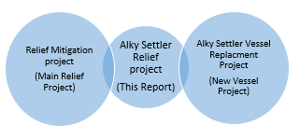

Figure 1: Project Overlaps
During this project there will be a number of studies carried out along with a list of design deliverables that will apply for the completion of this project. These deliverables will then aid the design and construction for this project.
Along the way there will be a design contractor assigned to carry out all the detail design for the project along with cost estimate, detailed construction drawing and any specification for any new equipment that needs to be purchased.

Roles and Responsibilities
There will be a project management team set up to carry out different responsibilities and tasks. These roles will be set out as Valero Project Manager (PM), Project Planner, Cost controller, Engineering, Procurement Company Project engineer (EPC) (PE), Cost controller And EPC Discipline design leads.
Figure 2: Project Org Chart
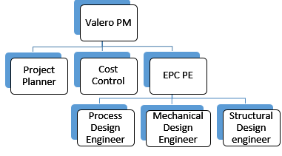

It is a key part to organise your management team and structure as early as the project allows. By setting up the team early they then can get a full understanding of the project and scope as it gets developed. “An important aspect of establishing early clarity is figuring out who needs to be involved with the project, what they will be responsible for, and how they will participate.” (Martinelli, 2016, p. 60).
With any project, and the project management team each person will have their own role to carry out. When all roles are carried out correctly this will help and aid the success of the project.
All the project team and Roles and Responsibilities can be seen under Appendix 2

- Literature Review and Background Research
At Pembroke refinery, there is a requirement to have a relief system on all pressurized systems and vessels. This project is specifically looking at and improving the relief system associated with the new Alky settler vessel replacement. The standard to follow and project requirements can be found in the “Basis of Design” BOD (Appendix 3) and “Basic Engineering Design Document” BEDD section 7.5 Relief systems. (Chesmer, 2018).
A relief valve has a different purpose to your standard valve in that it is set at a designed pressure to mechanically open if over pressured. Not only is it to protect against over pressuring a piping system and protect equipment, it is also to protect personnel injury if a failure was to happen. “They are designed to release excessive pressure that builds up in equipment and piping systems. To prevent major damage to equipment, and more importantly, injury to workers, relief valves can release elevated pressures before they become extreme.” (Parisher, 2002, p. 78).
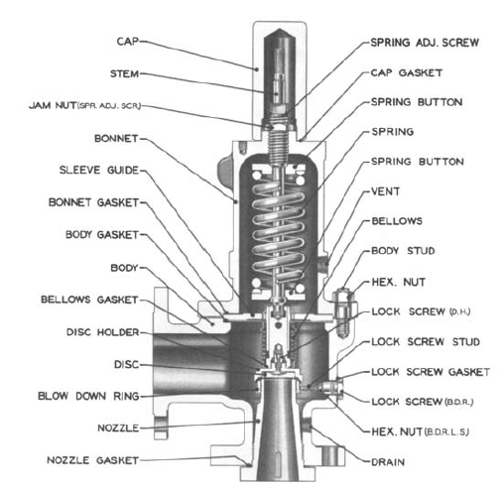

Once the design pressure has been calculating in relation with the design and prosses condition the relief valve can be pre-set to mechanically open to relieve the pressure and once the pressure has dropped it will close. The Relief valve is held close by a set pressure on a spring. (Figure 4).
Another type of relief valve is known as a pressure safety valve or PSV. Although very similar in design and appearance, they both work slightly differently. A relief valve will predominantly be in a liquid service that will open proportionally to the amount of pressure. I.e. the higher the pressure the greater the opening. A pressure relief valve will predominately be in a higher-pressure service such as steam and gas. The pressure relief valve is designed to fully open regardless of the pressure that need to be realised. As with the relief valve once the pressure has dropped the valve will close. (Parisher, 2002, p. 79).
Figure 4:PSV cross section (Parisher, 2002)
- Project Specification and Testing Plan
At Pembroke refinery there is an early project development phase. At this early phase it is required to define the project and create what is known as the BOD or project specification. The BOD will have all the project requirement from why it is to be carried out to the project specific requirements. There will also be a high level of work scope for each design discipline to the requirements of any new equipment. This project BOD is as per (Appendix 3).
During this early design development phase there is also a requirement to issue a variety of design deliverables, this will always be a project by project requirement due to how complex a project can be. This list of deliverables for this project is as per the list (Appendix 4).
This early development phase is a critical point of any project as it will set out the requirements and the budget that the project is required to meet. If this early development is not completed in-depth there runs a risk of not having a detailed BOD, and not having the required deliverables. This can then lead into a potential big impact on the project later on in the life cycle. This impact can be redesign works to poor construction drawing and over running on cost.
From a study by PMI in 2014 it was concluded that, “The major finding was that the more time spent on requirements definition and understanding up front, the more predictable project costs become, the higher the probability for achieving successful solutions from the customer’s and user’s perspectives, and the greater the chance for achieving the financial and business objectives for the project. Requirements are the foundation on which systems are built.” (Martinelli, 2016, p. 84).
- Project Planning & Cost Control

Project Planning
At Pembroke refinery project planning is a key element to day to day working. Having a good detail plan can be used for many different reasons. Some Key elements of having a good project plan are as:
- For mapping out the duration and end date of the project.
- To show what is the critical path for the project.
- Recourses required to deliver the project on time.
- Cost forecasting.
- Progress reporting.
- Requirements for forward planning when issues arise.
- Ensuring long lead equipment is delivered it time to meet the construction needs and requirements
During the conception of a project it is a requirement to start off with a high-level schedule to show a proposed duration of the project to the stakeholders and managers. This can be a simple excel plan. As the project develops it is at this point when the Project execution plan (PEP) (Appendix 5) will be developed. This will outline the plan to complete this project.
Once the PEP has been approved it is then possible to create a project schedule for this element of the overall project. To be able to create the schedule there will be some information that will be required as a feed into the schedule. The information that will be required will be;
- Man-hour estimates from the EPC.
- PDEP check list of deliverables.
- PEP.
- Background information understanding of the project.
Once all this information has been received it is then possible to create a detailed schedule for the detailed Engineering for this project.
To create a detailed schedule the first step will be to create a project then the work breakdown structure (WBS). This allows the project to be easily broken into work areas and more manageable. “A project work breakdown structure is an outcome-oriented grouping of project elements that organizes and defines the total scope of the project” (Martinelli, 2016, p. 126). With the WBS complete it is then possible to add all the required activities, hours for these activates and then the resources that will be required to complete this these tasks. With these activates scheduled it will create the critical path along with the KPI milestone that will be targeted to meet during engineering. “Major milestones include completion of certain tasks or deliverables by a specified date and are typically requested by those issuing the charter.” (Martinelli, 2016, p. 72).
Finally, once the project schedule has been completed and approved by the project team it will be required to set a baseline. As the project progresses it will be updated and tracked against the baseline for progress and to monitor the critical path and for any slippages.
All project plans and progress report are as (Appendix 6).

Cost Control and Farecasting.
For this particular part of the overall relief project £100,000 has be set as the budget to compete the engineering for the redesign of the relief system on the acid settler. Along with project planning, coast control is another important element of project control. As the project plan has recourses with hourly rate assigned to each activity it is possible to easily have a cost forecast from the schedule. One of the benefits of using this method is that as the project plan is updated the cost forecast will always be in alignment with the planned work. “Cost planning is the process by which organizational goals are translated into a plan that specifies the allocated resources, the selected estimation methods, and the desired schedule for achieving the goals of the project.” (Martinelli, 2016, p. 182).

Incorporating Change.
During the engineering and design phase of any project there is a high risk that there will be change. This change can happen in a number of different ways. The EPC has found a problem within the original scope and need to make changes, the client has changed direction in what they would like as a finished project and finally the constructability of the project. This can have an impact on the cost and duration of a project.
All changes need to be verified and approved before the EPC can continue with this work as there is a chance that the client will not except this change and there could be an accrued cost that was not required. “So change will happen! Unmanaged and poorly managed changes to requirements lead to mistakes, unnecessary features, and expensive rework.” (Martinelli, 2016, p. 103).

- Project Solutions
As with any project it is important to understand the different approaches that could be achieved to meet the requirement of the proposed project. There are many different factors that can be considers at this early stage of the project.
The three solution that were considered for this project are as bellow;
- Review the relief situation for the new vessel and run the unit at risk.
- Replace the PSV’s for larger oversized PSV’s.
- Replace the PSV’s with correctly calculated sizing and correctly sized pipework.
Table 1:Criteria Analysis
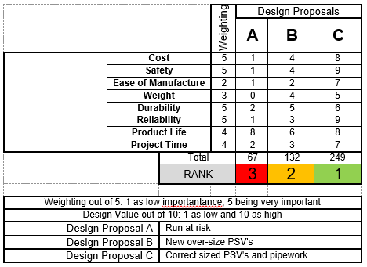

For the overall project there is three solution that can be considered. As above (Table 1). For the disadvantages and advantages of each proposal see (Appendix 7). For this particular element of the grater project it will be required to follow proposal C. This is due the resizing of the new vessel and the increase in the required relief system. It is important at Pembroke refinery that all process units are within operational limits and are safe to work within these limits. Therefore, despite the higher cost and time proposal 3 will be followed for this particular element.
- Design and Implementation

Initial Design
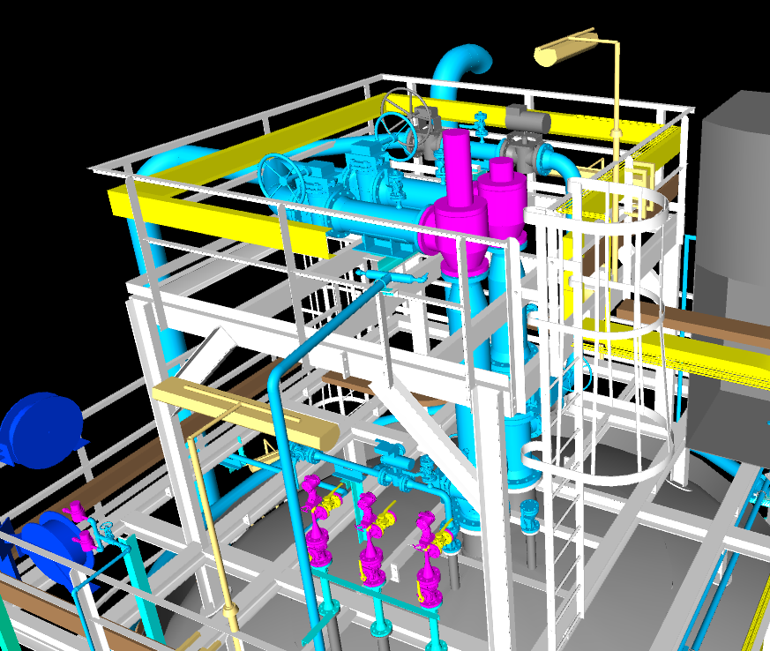
Due to the process specification and calculations there are many different things to consider in the design stages and piping layouts. Once all the early process and engineering work is complete it is then possible to start on any design works. The first stages of the design will be for the EPC to create a 3D model to the proposed design and considering all the prosses requirements. As the design is developed it will include a number of different disciplines to carry out work at different stages. Some of this work will be stress calculation as the piping layouts are designed. With the stress calculation it is then possible to design the locations and types of pipe supports that will be required.
Figure 5: PSV piping layout model
There are some grate benefits for creating a 3D model, it will aid with a visual of what the design will be and to the suitability of any future maintenance and operation. Once this is complete it is then required to carry out a model review at various stages with all the stakeholders. For this particular Review there will be reviewers from a number of departments. (Appendix 8).
Once the model design and layouts have been approved in the final model review it is then possible to get into the detail fabrication drawing for the pipe work and the new platform. At Valero a three-step approach is used before the fabrications ISO’s are approve for fabrication (Appendix 8). During the drafting phase it is important to understand all the piping specifications as this will have a design impact on the piping materials and fittings. Fitting design under CTEMS (Appendix 9).

Design Problems
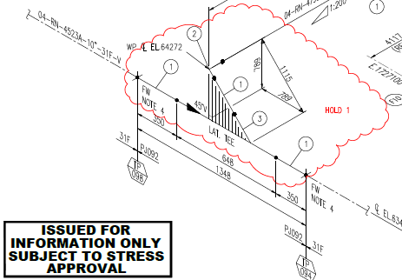
During the first review of the drafted ISO’s against the model and in the field by the construction team an issue was discovered at TP 098 and TP 094 (Figure 6) and the accessibility of being able to the weld onto and around the relief header.
Figure 6: Rev 0.1 ISO Tie in location

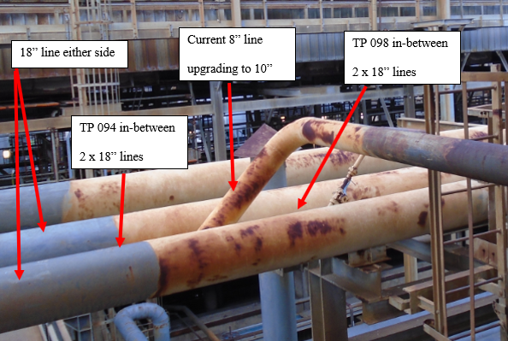
Figure 7: Site Header Tie in Pic
Although the design complies with all standards it will still need to have redesign work carried out. Due to the design specification and the allowed fittings (CTEM’s Drawing Appendix 9) and Standards list (Appendix 10) it was required to carry out some additional engineering and design work and come up with a solution to still be able to comply with the process requirement for the relief system. The current line is 8” and is required to upsize to 10” as per the Process calculation to be able to obtain the required relief and back pressure on the PSV’s. The redesign needed to take some considerations into account. These considerations needed to include the knock-on effect of the new vessel that is being fabricated as there is a link between the two projects. As part of this project, information is required to the location of the support brackets that will be installed and fabricated onto the new vessel.

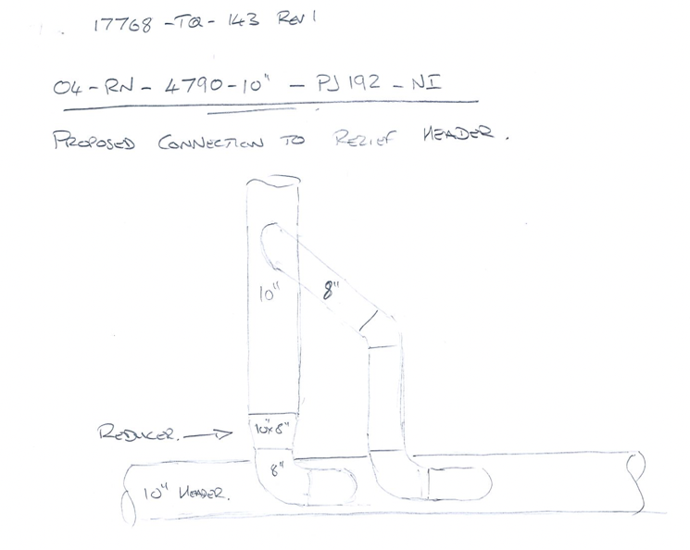
Re design Solution one.
Figure 8: Re Design first proposed Solution
Solution one was to split the new 10” line into 2, 8” tie-ins into the header. This solution requires an additional 8” lateral-let to be welded into the header (Figure 8) as one is already existing. Whilst this solution complies with the maximum size of welding fitting allowed within the spec and will still have the design capacity that is required for relief.
During further analysis of this design idea it was discovered that there would need to be a significant amount of stress calculations and a possibility of additional pipe supports. Due the timing of this change and the amount of re-engineering and design works in the project a simpler solution was required to meet the required date for completion of the design, as this could affect the fabrication of the new vessel.

Re design Solution Two.
Solution two was to further increase the size of the line to 12”. By carrying out some further process calculations it was acceptable to increase the line size and to maintain the relief requirements as per the relief requirements. As this design further developed there was a strict requirement to keep the line in its original position. This was to avoid any further knock on of re-design works around the platforms supports and clip position that are getting welded onto the new vessel. The first step would be to re-model the piping configuration, getting approval and then to create the construction ISO’s. This was the solution that we chose to continue with. Final design can be seen under (Appendix 11 Construction ISO’s).
Figure 9: Final Design configuration
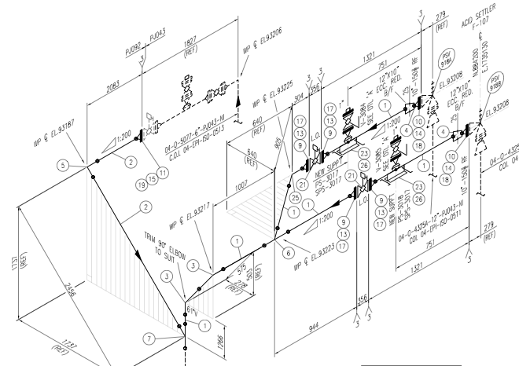

- Analysis, Results and Evaluation
Project analysis assesses the result of the project and how successful it was or can be. To be able to analyse your project for its performances there is a number of areas to review:
These can be;
- Budgetary performance.
  - This looks at how the project has performed against the original budget. Did the project come in on time of over run?
- The schedule performance.
  - This will look at how the project has performed against the baseline schedule and to deliver on time. Did the project complete on time or over run?
- Personnel Performance.
  - Did the personnel doing each task complete on time?
- Risk Analysis.
  - What risks appeared during the engineering of this project and how were they closed out or reduced.
- Client Requirements.
  - Was the client requirement meet and understood?
- Final design solution.
  - Did the final design meet the requirement?

Project Analysis can be seen in Appendix 12

- Conclusion
Whilst the engineering is still not complete it will meet the final design requirement set out within the BOD and proposed solutions, but the cost of engineering this project along with the schedule did not. The final cost for the engineering is currently farecasting to over ran by 10% providing no more issues or reworks, but this is also within an expectable limit. The project also has over ran on schedule and missed the completion date. This was due to some design issue that occurred during drawing and construability reviews and resulted with engineering and redesigning the pipework layout due to the constructability of the proposed design.
On reviewing the project analysis other factor that become apparent was that the personnel working on this project. There was a large amount of time lost with the SME’s and decision making due to their workloads within the refinery. With all these factors it can quickly add up in time pushing out the end date with the individuals not seeing the importance of the completion dates.
- Recommendations
Base on my learnings from being heavily involved with this project would be to spend more time at the earlier phase of engineering. Primarily the earlier phases of a project are more focused around process engineering and only as the project further develops the inputs from other disciplines and construction are then considered. My belief would be to include all discipline as early as possible to get a fully defined theoretical scope of work to engineer. By including the likes of construction earlier within engineering it is possible to have the constructability reviews of any proposed design ideas. This would then reduce the risk of rework later in the detailed engineering phase when the budget and schedule has been finalised. By understanding the full concept and proposed design you are more likely to have a more accurate budget and schedule with a more predictable project.

- Bibliography

Bai, Y., 2001. Pipeline And Risers. 3rd ed. Netherlands: EJSEVIER SCIENCE Ltd.
Becht, C., 2002. Process Piping. New York: s.n.
Chesmer, D., 2018. Basic Engineering Design Document. Pembroke: Valero.
Hessler, P. G., 2015. Power Plant Construction Managments. 2nd ed. Oklahoma: Pennwell.
Kerzner, H. r., 2013. Project Managment. 4th ed. New Jersey: Wiley.
Martinelli, R. J., 2016. Project Managment ToolBox. 2nd ed. New Jersey: John Wiley & Sons .
Parikh, N., 2019. smarttask. [Online]
Available at: https://www.smarttask.io/blog/project-analysis
[Accessed 17th April 2020].
Parisher, R. A., 2002. Pipe Drafting and Design. 2nd ed. Oxford: Gulf Professional Publishing.
Silowash, B., 2010. Piping Systems Manual. 1st ed. New York: McGraw Hill.

- References

Chesmer, D., 2018. Basic Engineering Design Document. Pembroke: Valero.
Martinelli, R. J., 2016. Project Managment ToolBox. 2nd ed. New Jersey: John Wiley & Sons .
Parisher, R. A., 2002. Pipe Drafting and Design. 2nd ed. Oxford: Gulf Professional Publishing.

- Appendices

Project Proposal

Project Team Roles and Responsibilities

Basis of Design (BOD)

Deliverables list

Project Execution Plan (PEP)

Project Plan and Reports

Project Solution Advantages and Disadvantages.

Relief Mitigation Review Process and Reviewers.

CTEMS Fittings

Engineering Standard List

Final Engineering Deliverables

Project Analysis.

