

Student name: NAIRAH JADIDAH NAMAKULA
Student ID: 2438044

Module name: Introduction to Health And Social Care.
Module code: LCHS4003
Supervisor’s name: Jolly Nwankwo

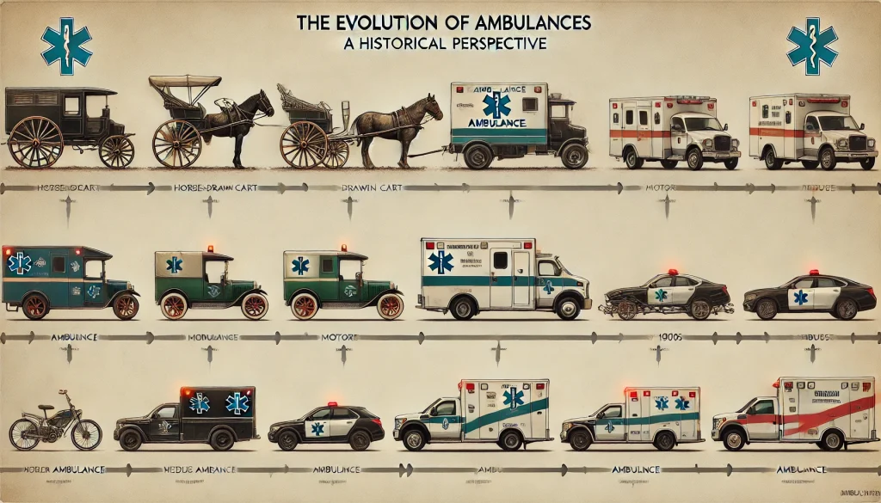 |  | AMBULANCE  This is a vehicle used to transport people who are sick or injured, for example trucks, helicopters, and cargo vans. They are driven by trained emergency medical technicians and paramedics. Ambulance services play a vital role in our communities, responding to people’s most urgent needs and at their most vulnerable times. |  | 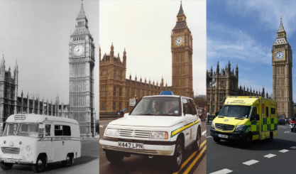
BRIEF HISTORY  This concept started in Europe with the Knights of St. John during the crusade in the 11th Century. This group of people received instructions in first aid treatment from Arab and Greek doctors, which acted as the first emergency workers.  In 1879, the Metropolitan Asylums Board introduced horse-drawn ambulances to transport patients with infectious diseases.  In 1904, St. John Ambulance Brigade was formed, in 1912, Horse drawn ambulances were replaced by motor vehicles.  In 1918, the National Ambulance Service was planned.  In 1925/30, these were spread across the country.  In 1937, 999 telephone numbers were introduced.  In 1948, the NHS Act was introduced gradually.  In 1965, nine existing services formed the unified London Ambulance Service.  In 1970/80, Introduction of modern services, for example Helicopters, Motorbikes.  In 1990’s, Staff with extended training were re-qualified as Paramedics.  (Hutchinson, 2023)  (Strudwick, 2024) |  |  |  | CURRENT STATE  Reduced latency despite the Service facing demands, with service providers getting thousands of calls for more emergency alerts in the existing situation being managed compared to the past and previous demand and action in the system. There are more advanced technology and quick approach to treatments that can be manged on the phone call than for a service user or patient to come to the hospital and delay in queues in the NHS. The services have really focused on getting to sickest patients even faster despite the challenging backdrop of further demand on the NHS. The paramedics use the phone to provide expert assessments and clinical oversight to refer patients to the most appropriate care pathway and avoid people going to busy hospitals when it’s not necessary.  Earlier this year, The King’s Fund called for a complete shift in focus for the health and care system a shift towards care closer to home. Key words are.  - Equality, diversity, and inclusion improvement plan.  - Balance operational performance with people.  - Improve the operational environment, line management and undergraduate training.  - Target bullying and harassment, including sexual harassment.  - and organizational development functions  (Jefferies, 2024)  (Londono and Londono, 2025)

CHALLENGES
- Patients are waiting longer to be treated due to long queue for example a city of 500,000 people would have around 200 ambulance service call outs per day.

- Demand and capacity in the ambulance service for example, multiple resources may be sent to a life-threatening incident
(The Health Foundation, 2023)

ORIGIN OF NATIONAL HEALTH SERVICES.
- In 1941, the Liberal politician William Beveridge set out to discover what kind of Britain people wanted to see after the war. His report, published in 1942 it was a key part of the plans to rebuild and improve Britain after the war had ended.
- The Five Giants the governments committee, led by Beveridge, identified five major problems which prevented people from bettering themselves.
- These were known as the Five Giants.
- want (caused by poverty).
- ignorance (caused by a lack of education).
- squalor (caused by poor housing).
- idleness (caused by a lack of jobs, or the ability to gain employment).
- disease (caused by inadequate health care provision).
- In 1944, before victory in Europe had been achieved, a committee within the Ministry had considered how emergency hospital service would be destroyed. Bevan had worked out the details, and the NHS had a command structure, ideology and was heavily dominated by those providing the services. Just before the service started, Aneurin Bevan sent a message to the medical profession. They spoke of the profession’s worries about discouragement of professional freedom and worsening of a doctor’s material livelihood and said if there were problems, they could easily be put right. The NHS was launched in 1948. It has been argued that the model for the NHS was inspired by Bevan’s knowledge of the Tredegar Workmen’s Medical Aid Society, where free health and dental care was available to its members for the payment of a penny a week. In January 1948, Bevan, then Minister for Health and Housing, announced that on 5 July the National Health Service would launch. In those six months, the introduction of the NHS was resisted in parliament and by health practitioners, dental surgeons and physicians who feared a loss of independence. However, the Socialist Medical Association actively campaigned in its favor. As the implementation date grew closer, community doctors began to advertise for patients and with just five weeks to go, the British Medical Association finally ended its resistance. In 1952, charges were introduced for prescriptions, spectacles and dental services, health improved, infant mortality reduced, and life expectancy increased. In 1958 the first mass vaccination program arrived. Throughout the 1960s – despite long waiting lists, the service continued to have widespread support. In April 1974, the service was re-organized with the aim of providing a fully integrated local health service.
- Since then, the NHS has seen many changes, improvements, updates and modernisation processes.
- This service was developed as a tax-funded, universal health care system.
- Initially, all the services provided by the NHS were free of charge.
- Before the 50s, most care for people with mental health problems was provided in asylums and psychiatric institutions.
- The mental health act of 1952 helped to enable deinstitutionalisation in England. Restructuring of the service, and they were responsible for managing all health services in their area, including hospital services, general practice and community health services.
- Governing boards and chief executives became a more common sight in the NHS.
- Advanced use of technology in the system changed in provision of care.
- Modernisation of Hospitals
- Implementation of legislation has also changed the face of NHS

REFERENCES
Hutchinson, S. (2023). History of UK ambulance services | EMSUK LEARNING. [online] Emsuklearning.co.uk. Available at: https://www.emsuklearning.co.uk/history-of-uk-ambulance-services/.
Jefferies, D. (2024). Ambulances Are Bringing Care Closer To Home | The King’s Fund. [online] The King’s Fund. Available at: https://www.kingsfund.org.uk/insight-and-analysis/blogs/ambulances-bringing-care-closer-home.
Londono, A. and Londono, A. (2025). London Ambulances Service reaches serious emergencies faster than last year - London Ambulance Service NHS Trust. [online] London Ambulance Service NHS Trust - accidents, traffic accidents, car, vehicle. Available at: https://www.londonambulance.nhs.uk/2025/08/14/london-ambulances-service-reaches-serious-emergencies-faster-than-last-year/.
Royal College of Nursing (2023). NHS 75: the history of our National Health Service | RCN Magazine | Royal College of Nursing. [online] The Royal College of Nursing. Available at: https://www.rcn.org.uk/magazines/History/2023/July/NHS-75-anniversary-history-of-the-National-Health-Service.
Strudwick, C. (2024). The Evolution of the London Ambulance Service. [online] BM Ambulance Group. Available at: https://www.bm-ambulance-service.co.uk/999-family/london-ambulance-service-history/.
The Health Foundation (2023). Why Have Ambulance Waiting Times Been Getting worse? [online] The Health Foundation. Available at: https://www.health.org.uk/reports-and-analysis/analysis/why-have-ambulance-waiting-times-been-getting-worse.

