THE GLOBAL BUSINESS ENVIRONMENT

MODULE CODE: LCBB4005

ASSESSMENT 2

Environmental Analysis of an industry

Student name: Damian Florentina
Student ID: 2020306
Lecturer name: John Malagila

Executive Summary
The report includes focuses on global business environment that helps the business to expand their market reach and extend geographical reach. This report includes factors changing global business environment and changes in customer demands and preferences. There are various theories applied to understand and identify international trade and its features that impact the business of a company.

Table of Contents
Introduction 4
Recognise the major forces shaping the global business environment, and gain an understanding of the changing global business environment 5
Apply relevant business models (Porter’s Diamond, Value Network, Five Forces, etc.) within the context of an international environmental analysis 6
Identify, and critically evaluate, the reasons why organisations engage in international trade 10
Assess markets in action, understanding their micro-economic and macro-economic foundations, different market structures and their influence on firm strategy, long-run and short-run changes, and major features of the current international economy. 16
Conclusion 17
References 18

Introduction
Global business environment needs to be analysed effectively for expanding the business internationally and maintaining the business position in international markets. There are various factors that affect the internationalisation of business that can be identified by applying various theories and analysing regional trading features. The company needs to analyse current trends of global trade and business and identify competitive advantages of the business globalisation. Fashion industry is considered most polluting industry where external factors affecting can be identified by using PESTEL analysis whereas internal analysis is conducted by using Porter’s generic strategy. The company needs to analyse market structure and influences caused on the business strategy to revise their strategies as per market conditions and customer requirements.
Marks and Spencer is a retail multinational company with headquarters is London, England and was founded in 1884 by Michael Marks and Thomas Spencer (corporate.marksandspencer.com, 2021). The company’s revenue is around 1,018 crores GBP and has 75,505 employees worldwide (statista.com, 2021).

Recognize the major forces shaping the global business environment, and gain an understanding of the changing global business environment
Fashion industry causing pollution
Fashion industry is considered as most polluting industry as it produces huge amount of carbon emission and also microplastics that pollutes the oceans. The production and distribution of the crops, fibers and the garments create more air pollution and water pollution as well. The fibers used are more of polyester which has 2 to 3 times more carbon emission. Pollution is caused due to overproduction of fashion materials and use of synthetic and polyester fibers. Fast fashion production is one of the major reasons to harm the environment and human as well. This is due to use of harsh chemicals in cloth production which may cause skin problems, and lung diseases due to poor ventilation. Fashion cycle is actually slower but customer always demands for new trends with good quality and cheaper costs. To fulfill all these demands the quality is at risks and the production mechanism creates negative impacts on the environment.
Changes happening in the industry and its impact on business
Fashion industry in rapidly growing and adapting trending technologies which will creates huge difference to industry in the coming years (forbes.com, 2021). Marks and Spencer is developing their strategies to adapt these changes and grow business potential. The expected changes in fashion industry are:
- Data Driven: Customer’s choice differs from person to person and fashion is the industry where the diversity is expanded to greater extend. Data is used to analyse the customer preferences and demands to find the designs as expected from the brand.
- Sustainable: Environment friendly fashion is now trending and mostly preferred. Customers are focusing on eco-friendly products and fashion materials to avoid environmental hazards.
- Digital: Digital platforms are preferred by introducing online sales and e-commerce websites to publish the products. This helps the business to expand their reach and grow business worldwide.
- Simplified: Covid-19 pandemic has impacted the fashion industry and its production. Every year around eight collections were launched by the industry whereas now only two or three collections are launched.

Apply relevant business models (Porter’s Diamond, Value Network, Five Forces, etc.) within the context of an international environmental analysis
PESTEL analysis
PESTEL analysis is an approach used to examine the external factors that are affecting the business of a company. The analysis evaluates several factors that may create its influence on the business in both positive as well as negative way.
Elements | Factors | Influence
Political | BREXIT | BREXIT has impacted the workforce of M&S by creating scarcity of human resources. Also, the company revised their policies for employees.
Economical | Increased rate of inflation by 0.9% (ons.gov.uk, 2021) | The inflation rate has increased marketing and production cost which also affected the product price. This might lead to decrease the customer base of M&S.
Social | Changes in the consumer preferences | M&S conducts market research to identify the customer’s preferences and current market trends. This helps to develop designs that will fulfill customers’ needs and ensure customer satisfaction.
Technological | Technical advancements | User experience is developed by implementing Augmented Reality in stores. Also use of Artificial Intelligence in marketing helps to attract the customers towards M&S.
Environmental | Environmental Protection Act 1990 (legislation.gov.uk, 2021) | Waste reduction is achieved by M&S by implementing environment protection act. This ultimately helps the company to increase profit margin by reducing waste production.
Legal | Equality Act 2010 (legislation.gov.uk, 2021) | Equality act is strictly followed by Marks and Spencer whether it is for customers or for the employees. This develops the productivity of the employee and maintains motivation.
(Table 1: PESTEL Analysis for Marks & Spencer)
(Source: Created by Learner)
Every factor has its impact on the business and the work culture of the company. Analysing these factors helps the company to identify the loopholes in the process and redesign their business strategies for business improvement and sustainability.

Changes made by company in their business model
Marks & Spencer closely identified the changes in business environment and their existing business strategies to adapt trending changes and development in fashion market. Business model of Marks and Spencer was revised to cope up with the changes and maintain business performance (corporate.marksandspencer.com, 2021). M&S follows three step transformations:
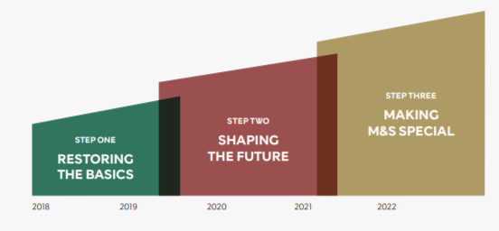
(Figure 1: Business Model)
(Source: corporate.marksandspencer.com, 2021)
Some of these changes are:
- Changing international business model.
- Management of excess clothing and home stock.
- Examining recent trade performance of the company.
- Plan actions against covid-19 impacts.
- Reengineering of clothing and home.
- Plan actions to maintain stability in cash flow above £500m.
Marks and Spencer ensured to increase their business profitability by revising their business model and strategies.
Benefits of the changes made
The company is benefited by these changes made in their model as it helped them to create a trusted brand in clothing and to manage customer needs and profit for the company. The business model of M&S works on over 78,000 colleagues across all the operational stores. The changes in their business model considering their stock management and trading performance have helped the company to generate more revenue and increase the productivity. Also, regularly updating the business model as per the changes in fashion industry will help the company to avoid loss and maintain their customer base.
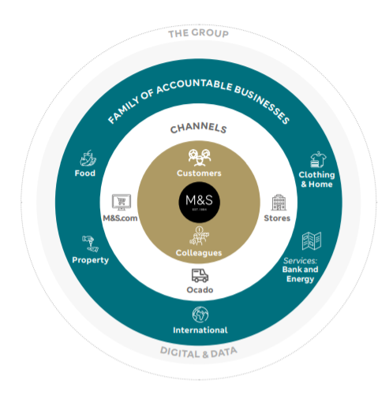
(Figure 2: Changes to Business Model)
(Source: corporate.marksandspencer.com, 2021)
Internal analysis by using tools Porter’s generic strategy
Porter’s generic strategy is used to classify company behavior and gain competitive advantages (Islamiet al., 2020). Generic Strategies can be applied for any product or service in all industries where large scale as well as small scale organisations can implement Porter’s generic strategy. This strategy focuses on:
- Cost Leadership: The businesses focus on reducing cost and deliver the product to customers where the company earns more profits and adds value to shareholders as well. This helps the company to invest their capital in other parts of the business and reinvesting the profits of business. Marks and Spencer focuses on preserving the market leadership position by managing the value chain. Also, this strategy allows the company to expand their market share.
- Differentiation: This strategy helps to differentiate the product or service from other brands and gain competitive advantage over others. Marks and Spencer differentiate their products by introducing unique features, designs, and quality. This strategy is implemented by identifying current trends and demands from the customers.
- Focus: This strategy helps the company to concentrate their resources on expanding the targeted segments and create competitive advantage on niche markets. Marks and Spencer apply this strategy to provide low cost as well as best value products. This helps the company to focus on current products and trending demands and requirements of the customers.
The company has adapted different cost leadership, differentiation, and focus strategies to maintain their competitive position in the market and achieve the company’s objectives and goals. The business strategies and plans are clearly analysed to identify the advantages and make required changes to the strategies to improve market growth.

Identify, and critically evaluate, the reasons why organisations engage in international trade;
International trades help the business to expand their brand presence globally and engage in foreign markets for business growth and target different customer segments (Tolstoyet al., 2021). To invest into foreign markets and enter into international markets the company needs to analyse the international trades and their business potential along with the advantages and disadvantages of the internationalisation of business.

Features of regional trading groups: NAFTA
The North American Free Trade Agreement is a treaty between Canada, Mexico, and the United States that eliminates the tariffs between these countries (inc.com, 2021). The features of NAFTA that benefits the businesses to engage in international trades are:
- Tariff reduction for auto parts and automobile rules.
- Expansion in telecommunication trades.
- Reduction in Textile and apparel barriers.
- Increased investment opportunities.
- Increased protection of intellectual property rights.
- Elimination of non-tariff barriers.
Features of regional trading groups: European Union
Europe is the world’s largest exporter of goods and services with biggest export market for around 80 countries (europarl.europa.eu, 2021).
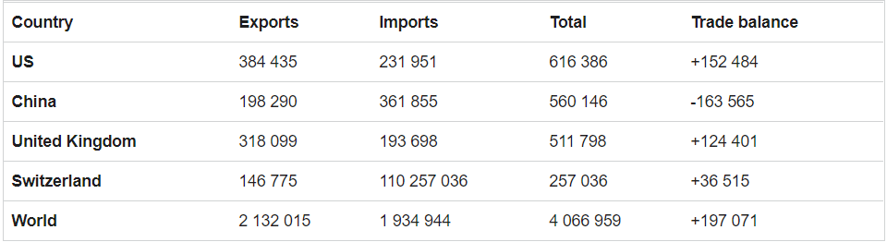
(Figure 3: International Trades)
(Source: europarl.europa.eu, 2021)
This provides various benefits to the businesses and helps them to engage in international trade. The EU helps companies to easily import and export raw materials and products within the countries of EU and also the concerned countries. It helps to remove trade barriers with enabling fair access to other markets and exporters. The EU also works with World Trade Organisation to set global trade rules and eliminate the obstacles faced to trade between WTO members. Sustainable development, clauses on human rights, tariff reductions, and intellectual property rules are included in the agreements and are unique for every business. The EU also gets support from public, business, and non-governmental bodies while negotiating with trade agreements and rules. This helps to include the preferences and view of the companies while investing into international trade.
Internationalisation of business helps to expand the business geographically where Marks and Spencer works to expand their brand globally and invest in foreign markets to improve market reach. This also contributes in increasing profitability for the company by investing into foreign economy and attracting investors and shareholders from different countries.
Current levels and trends of global trade and business
UK is leading in foreign exchange and has 64% of its GDP, it is also ranked as fifth largest importer and eleventh largest exporter of goods in the world. Covid-19 Pandemic has impacted the import and export markets of the UK where businesses had to suffer from increased costs and availability of the material (santandertrade.com, 2021). Government imposed rules and regulations on import/exports, transportation, and travelling which dropped the trading rate and also brands like Marks and Spencer faced issues with their supply chain strategies and business performance (corporate.marksandspencer.com, 2021). The following figures will helps to understand impact of covid-19 pandemic on foreign trade values.
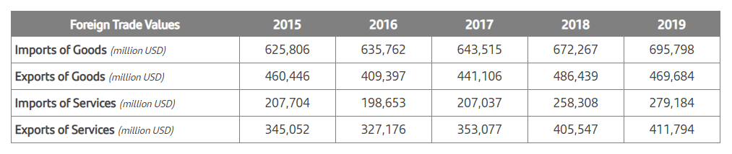
(Figure 4: Foreign Trade values)
(Source: santandertrade.com, 2021)
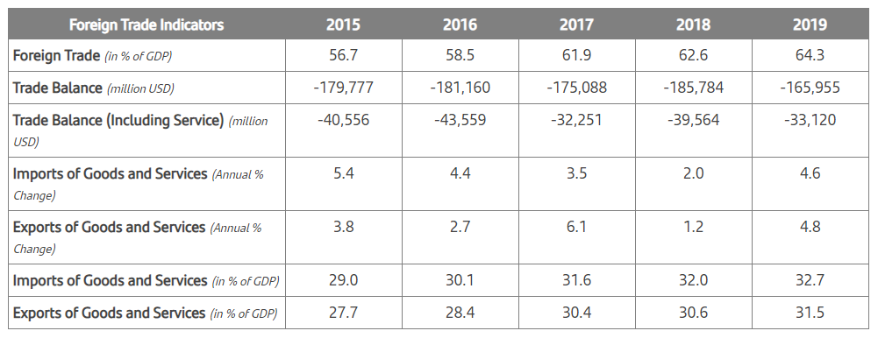
(Figure 5: Foreign Trade indicators)
(Source: santandertrade.com, 2021)
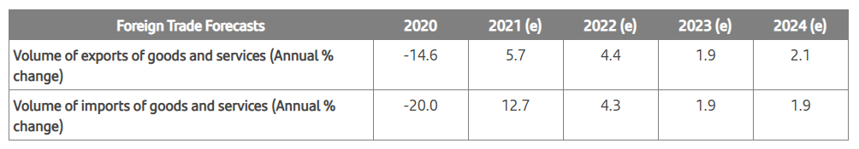
(Figure 6: Foreign Trade forecast)
(Source: santandertrade.com, 2021)
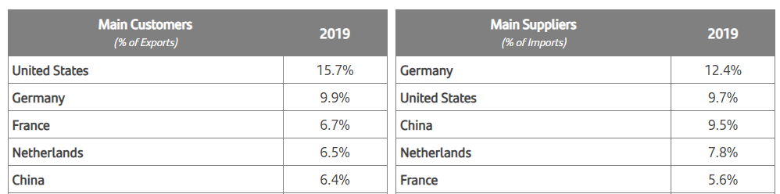
(Figure 7: Main Customers and Suppliers)
(Source: santandertrade.com, 2021)
The decreased rates in foreign trades have impacted Marks and Spencer economically by affecting their employment and worker’s rights. To overcome these challenges the company works on employee engagement by listening to their issues and understanding their concerns. Shareholders and investors are affected due to reduced profits where the company needs to manage their expectations by effectively dealing with the investors and planning business strategies to overcome these challenges. Limited import and export facility has impacted the business by reduction is productivity and supply of products to the customers overseas. Customers’ expectations are lacking to be fulfilled hence customer dissatisfaction is increasing due to unavailability of the products that are in demand. There are customers from different segments where the company needs to focus by implementing their innovation strategies and redesigning the existing designs. This is restricted due to limited supply of raw material and products required along with the restrictions imposed for functional operations of the company.
International trade Advantages and Disadvantages
International trade is the exchange of goods and services between different countries where trading globally allows consumers and countries to access the services from other countries that are not available in their country (Gani, 2017). There are various types of international trade that are: Export trade, Import trade, and Entrepot trade. The international trades of UK are helping its businesses to expand international markets by import/exports and marking global presence of the brand.
Export Trade: This refers to the manufacturing of products in one country that are used by customers from other country. The product or services developed domestically and traded in foreign country and international markets are called as export.
Import Trade: This refers to the goods and services that are purchased from other countries to develop the products these can be considered as raw materials for the product. Importing goods helps to speed the industrialization by accessing the material required for product development.
Entrepot Trade: This is combination of import and export trade where the goods are imported from one country and exported to another. This supports supplies of goods and services from one country to another.
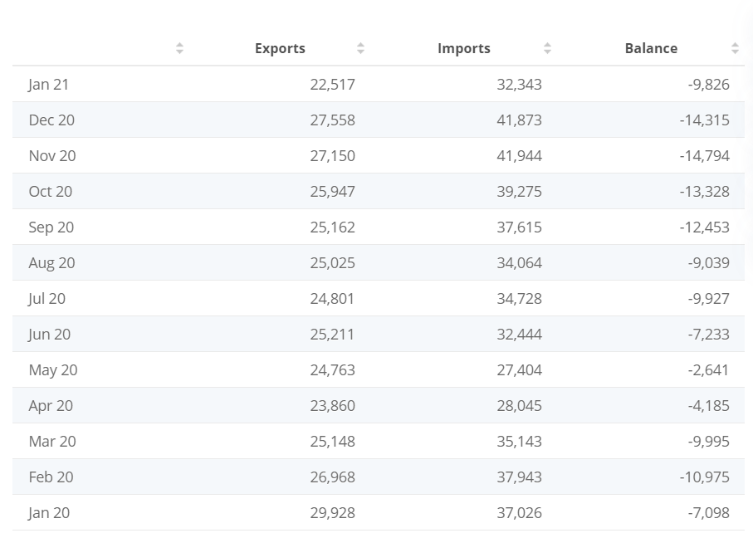
(Figure 8: UK Trade Value)
(Source: statista.com, 2021)
There are various advantages of international trades to the business but also there are some disadvantages that should be considered by the company to avoid risks and manage their business strategies effectively.
Some of the advantages of international trade are:
- Optimum allocation of resources.
- Specialisation and expertise gaining.
- Enhanced wealth with high trading.
- Cultural values and cross culture adaption.
- Better international politics.
- Larger output.
- Competitive advantages.
- Expansion of markets.
Some of the disadvantages of international trade:
- Resource exhaustion.
- Affect developing infant industries.
- Diversification of savings.
- Decreasing domestic employment.
- Over interdependence to businesses.

Assess markets in action, understanding their micro-economic and macro-economic foundations, different market structures and their influence on firm strategy, long-run and short-run changes, and major features of the current international economy.
Market structures and the customer demands affect business strategy and marketing strategy of the company. There are different market structures in fashion industry that are segregated based on cultural preferences, gender, ages, sizes, and fashion sense of the people (Nagyet al., 2018). This helps the company to focus on targeted market segment and apply their strategy accordingly. The Supply chain of company is sustained by focusing on each segment. Marks and Spencer has variety of clothing and accessories option for each market segment and that helps the company in customer engagement and satisfaction. These structures influence the strategy to redesign the existing clothing options or develop new designs as per customer requirement and preferences from each segment. Marks and Spencer consider their international markets for long run strategies whereas focuses on each segment of the market to accomplish short term targets and business objectives. Economical conditions of the country as well as revenue generation of the company impacts the marketing strategy of the company and supports business development. The company needs to analyse economical aspects before initiating new product launch to benefit the business and revenue of the company. Supply chain management can be maintained by focusing on these factors to ensure profitable business for company as well as for the investors and shareholders. Marks and Spencer strategies to maintain their supply chain involves stakeholder satisfaction that includes employee satisfaction, customer satisfaction, and shareholder profitability.
Conclusion
Global expansion for the business is a key factor for business development that helps the business to expand their international reach and adapt foreign markets to improve business profitability and revenue generation rate. The company needs to expand their reach by reducing the pollution caused as the fashion industry is most polluting industry. This includes identifying the key factors of external forces that influences the marketing strategy of the business. Also, the report focuses on international trading by identifying current trends of foreign markets and trades. This includes features of regional trading along with the advantages and disadvantages of international trading which supports business expansion in foreign markets. Market structures and customer preferences also influences the marketing strategies and business development plans which are discussed to identify the practices that helps to improve business performance of the company in foreign markets.

References

corporate.marksandspencer.com 2021 About Us [Online] Available At: https://corporate.marksandspencer.com/aboutus[Accessed At: 24th April 2021]
corporate.marksandspencer.com 2021 Marks and Spencer Annual Report [Online] Available At: https://corporate.marksandspencer.com/documents/msar2020/m-and-s_ar20_strategic-report.pdf [Accessed At: 24th April 2021]
corporate.marksandspencer.com 2021 Marks and Spencer response to covid-19 workers in supply chain [Online] Available At: https://corporate.marksandspencer.com/documents/plan-a/m-and-s-response-to-covid19-workers-in-supply-chains [Accessed At: 24th April 2021]
europa.eu 2021 European Union [Online] Available At: https://europa.eu/european-union/topics/trade_en [Accessed At: 24th April 2021]
europarl.europa.eu 2021 The European Union and its trade partners [Online] Available At: https://www.europarl.europa.eu/factsheets/en/sheet/160/the-european-union-and-its-trade-partners [Accessed At: 24th April 2021]
forbes.com 2021 The fashion industry is ready for a makeover [Online] Available At: https://www.forbes.com/sites/blakemorgan/2020/12/03/the-fashion-industry-is-ready-for-a-makeover-4-changes-well-see-in-the-future/?sh=4e7bade2914a [Accessed At: 24th April 2021]
Gani, A., 2017. The logistics performance effect in international trade. The Asian Journal of Shipping and Logistics, 33(4), pp.279-288.
inc.com 2021 North American free trade agreement [Online] Available At: https://www.inc.com/encyclopedia/north-american-free-trade-agreement-nafta.html [Accessed At: 24th April 2021]
Islami, X., Mustafa, N. and Latkovikj, M.T., 2020. Linking Porter’s generic strategies to firm performance. Future Business Journal, 6(1), pp.1-15.
Nagy, J., Oláh, J., Erdei, E., Máté, D. and Popp, J., 2018. The role and impact of Industry 4.0 and the internet of things on the business strategy of the value chain—the case of Hungary. Sustainability, 10(10), p.3491.
santandertrade.com 2021 United Kingdom Foreign trades [Online] Available At: https://santandertrade.com/en/portal/analyse-markets/united-kingdom/foreign-trade-in-figures [Accessed At: 24th April 2021]
statista.com 2021 Number of employees of Marks & Spencer worldwide 2014-2020 [Online] Available At: https://www.statista.com/statistics/872828/marks-and-spencer-number-of-employees-worldwide-uk/ [Accessed At: 24th April 2021]
statista.com 2021 UK trade in goods [Online] Available At: https://www.statista.com/statistics/284738/uk-trade-in-goods/#:~:text=The%20value%20of%20goods%20exported,by%20over%209%20billion%20pounds. [Accessed At: 24th April 2021]
Tolstoy, D., Nordman, E.R., Hånell, S.M. and Özbek, N., 2021. The development of international e-commerce in retail SMEs: An effectuation perspective. Journal of World Business, 56(3), p.101165.

