Title: Applied Professional Skills
Name: Kyle Stuart
Student Number: 1811687
Word Count: 2818

Table of Contents
Introduction 3
Activity 1 4
Activity 2 6
Activity 3 9
Activity 4 13
Conclusion 15
List of evidence/appendix 17
Professional Marketing Standards 17
Belbin 18
Tuckman’s model 18
Bruce Tuckman’s - model of team development 19
Gantt Chart 19
Brainstorming 20
Fishbone diagram 20
De Bono - 6 thinking hats 21
Thomas-Kilmann – conflict mode questionnaire 22
Thomas-Kilmann - conflict resolution model 27
27
CPD cycle 27
Development Plan 28
Reference list 30

Introduction

In this professional development report, four sections are evaluated and assessed. The corresponding electronic portfolio of evidence for each section is provided which corresponds to four activities. The first activity evaluates what being a professional entails with specific reference to the marketing profession, as well as the professional standards a marketeer must adhere to in order to be certified. The elements of group dynamics are described in activity two and examples of different methods to resolve conflict within an organisation are given. Activity three provides examples of project management and problem-solving techniques being used in a recent project I completed. Further examples are given to show how I successfully influenced, convinced and discussed problems and solutions with my fellow team members. The last activity conducted was a self-assessment which recognised my professional development needs within marketing and provided solutions for these development needs. Justification of these solutions were set out in a professional development plan (PDP).

Activity 1

A professional is a person who makes proficient use of specialist knowledge, exercises autonomous thought and judgement, and makes a voluntary commitment to a set of principles (Lester, 2010). In order to become a chartered marketer, one must be either a member (MCIM) or a fellow (FCIM) membership grade. A minimum of four reflective statements should be completed in a continuing professional development (CPD) within a year for a minimum of two years consecutively, which align with the professional marketing competencies framework (Charted Institute of Marketing, 2020). One should then complete the online chartered marketer assessment. Once these three steps are completed, individuals will be awarded Chartered Marketer status. According to CIM (2020) marketing professionals need to be able to demonstrate ten behaviours in order to ensure they do their jobs efficiently and effectively. These ten behaviours marketers should possess are that they must be innovative, inspiring, financially literate, responsible, collaborative, influencing, creative, commercially aware, entrepreneurial and challenging. Marketers should be able to solve problems by using existing ideas or have the ability to formulate their own new ideas. One should encourage and motivate others to achieve a common vision or goal. Marketers should have the ability to present financial calculations in order to justify investment and expenditure. The impact decisions would have on people, companies and the environment around them should also be considered by marketers. Marketers should have the ability to collaborate with others to achieve the businesses objectives and goals. One should be able to promote ideas and initiatives internally and externally. The ability to use one’s imagination and be creative, as well as use the knowledge one has gained from everyday work experience to assist them in business are all vital skills a marketer should have. One should be able to hone in on opportunities and maximise them, as well as be able to challenge the status quo and drive change. There are technical competencies that one should have depending on the area of marketing they specialize in (CIM, 2020).

Activity 2

According to Kurt Lewin “people often take on distinct roles and behaviours when they work in a group”. He further goes on to state that the term ‘group dynamics’ “describes the effects of these roles and behaviours on other group members and on the group as a whole” (Mindtools, n.d.). Group dynamics can be affected by a weak leader, excessive defence to authority, lack of communication, blocking, which involves team members behaving in a way that disrupts the group, and free riding which results in other group members picking up the slack for another member in the group. When breaking down group dynamics, we look at Bruce Tuckman’s 5 step theory which can be seen in the appendices on page 19 . The first step is ‘forming’. The group is formed, and group members are allocated roles. During this step group members are highly dependent on the leader for guidance and direction. Time is spent planning, collecting information and bonding. The second step is ‘storming’. The team will address the task at hand and start suggesting ideas. It is vital that each team members ideas are heard and managed to ensure that there is no conflict that occurs between team members. This could in turn result in a prolonged period in the storming phase. The third step is ‘norming’. Team members start trusting members of the team and the vital contribution each member makes. If all is running smoothly, this is the opportunity for the leader to take a step back which allows individual members to take greater responsibility. The risk during this stage is that members become complacent and lose their creative edge. The fourth step is ‘performing’. The team knows its goals and objectives and it is able to function without the inference of the leader. Performing teams are identified by their high levels of independence, motivation, knowledge and competence. The fifth step is ‘adjourning’. This happens once the project is completed and members of that team split up and go their own ways or move onto another project (Businessballs, 2019).

Belbin believed that having a mixture of nine different behaviours would create a high performing team (Belbin Associates, 2020). The 9 team roles that Belbin mentions, which can be seen in the appendix (page 18), are an implementer, motivator, team worker, specialist, completer, shaper, resource investigator, plant and a co-ordinator. A team member can be assigned or slot into a variety of roles as not all of them are performed at the same time. Belbin gives team members a greater understanding of their strengths, which in turn, would result in better communication between team members. Teamwork is extremally important for professionals as it motivates unity in the workplace, promotes workplace synergy, provides learning opportunities, offers improved efficiency and productivity, and offers differing perspectives and feedback (Wehbe, 2017).

According to the Cambridge dictionary (2020) conflict is an active disagreement between people with opposing opinions or principles. In a workplace conflict is inevitable, but not all conflict is necessarily bad as it presents opportunities for improvement. One could use Thomas Kilmann’s model which illustrates five options available when dealing with conflict resolution. These options are avoiding, competing, compromising, collaborating and accommodating (The Participation Company, 2019). Compromising is vital if conflict needs to be resolved quickly. The thinking behind this technique is that prolonged conflict distracts people from their work and causes bad feelings. Therefore, this solution is not the best solution, but it is the quickest way of resolving conflict. Accommodating is where one party gives into the wishes and demands of the other. This resolution is less helpful as it accommodates another party merely to preserve harmony or avoid disruption. This resolution, like avoidance, can result in unsolved issues. Another conflict resolution strategy one could use is the iPEACE model, which uses 5 steps, namely identifying conflict, picking the right strategy to deal with the conflict, enabling voices to be heard, attacking the problems and not the people, creating options and evaluating.

Activity 3

During our last project we were assigned to groups and did not get to choose who we would like to work with, just like you would not be able to choose your team in industry. In fact, we had to get to know one another and figure out what each one of our strength and weaknesses were. We went through the Tuckman’s 5 steps and had to resolve conflict between group members along the way. We used five specific project management steps to assist us in our project. The first being initiation, which is the first phase of the project life cycle. One would use two evaluation tools to decide whether or not to go ahead with the project. The first being a business case document which looks at the need for the project, and includes an estimate of the potential financial benefits. The second being an evaluation of goals for the project, a timeline and the cost the project would incur, which would then determine whether or not the project should proceed. The second phase would be project planning. Once the project receives the green light it needs a solid project plan. This plan helps foresee obstacles the team could face along the way, as well as helps them understand the cost and timeframe of the project. Project execution is the next phase of the project and this phase relies heavily on the planning phase. The team leader is vital during this stage as they allocate resources and keep team members focused on the task at hand. Project monitoring and control is the fourth phase of the project, and this is when teams execute their own project plan and must ensure they are constantly monitoring their own progress. This can be done by using key performance indictors to track differences from the allocated cost and time. The last phase is completion. Once the project is presented and completed, an evaluation of the project is done in order to learn from any mistakes made and build on the successes achieved (Villanova University, 2019). During our project the use Gantt charts assisted us with staying on track. It provided deadlines of when certain tasks needed to be completed. An example of the Gantt chart in the appendix (page 19).

The main problem-solving techniques we used when doing our project was brainstorming and listing pros and cons of our project. There are various other problem-solving techniques, namely De Bono’s 6 thinking hats, which is a model used for discovering different perspectives towards a complex challenge or situation. It stimulates thinking by focusing and thinking on one thing at a time. It also allows us to engineer a switch in thinking without offending others (Sicinski, 2018). Another problem-solving technique we could have used was the fishbone diagram, which is also known as the cause and effect diagram. This model can assist one in identifying possible causes of a problem, and sorting these ideas into categories. The problem or effect is displayed at the head of the fish. This is a visual way of brainstorming (Simon, 2019). Both the De Bono’s 6 thinking hats model, and the fishbone diagram can be seen in the appendix on page 21.

As a group we where assigned to open a lifestyle business. We decided the best way to decide what business we were going to open was to decide what we were all interested in and brainstorm. Each of us wrote down all of the things we were individually interested in and all came up with the common interest in travel. I persuaded my group to listen to my idea and supplied pros and cons of it. In such a competitive market we had to set ourselves apart from our competition and offer something that was different. After listening to my idea and doing research on their own ideas, we came to the conclusion there was a gap in the market and we would pursue this idea. Eventually with the help of my team, we decided we would offer food holidays where people could experience the true culture of that country through food. We decided we would start with four countries we knew well, and each of us would plan a holiday incorporating all the best food festivals that country had to offer. We negotiated which countries we should choose, and decided that it would be the countries we had first-hand knowledge on. I am from South Africa so there is no one better to plan a food holiday to South Africa than a local. Lucy is from Ireland, so she focused on Ireland. Fiona had family in Germany, so I suggested that with her family’s knowledge, they could suggest the best places to go to experience all Germany has to offer. The last member of our team was Matthew, he had travelled many times to the United States so he decided he would focus on designing a food holiday that incorporates local food from the United states. As the group leader I was able to bring a positive influence on our group even when faced with conflict. I ensured that I was there to help everyone if they needed, even though I had to plan my own food holiday to South Africa. By doing this it encouraged others to lend a hand to their fellow team members as well. By the end of the project we were not just individuals that came together to complete a project, but we were actually a proper team that worked together to achieve our goal successfully.

Activity 4

To ensure one continues to be competent in one’s profession, one should complete their Continuing Professional Development (CPD). It is a process that one should keep up throughout their professional career. It enables one to stay up to date and further one’s career and potentially increasing one’s income (The CPD Certification Service, 2016). There are 7 stages of CPD which can be seen in the appendix on page 27. The first stage is to identify where one is and where one wants to be. The second stage is to plan by setting goals and objectives of how one would get to where they want to be. The third stage is to act upon one’s plan and to be open to new learning experiences. The fourth stage is reflecting regularly on your day to day learning experiences. Applying what one has learnt and putting it into practice is the fifth stage. The sixth stage is sharing one’s learning in one’s community of practise, in order to generate greater insights and benefits from the support of the community. Measuring the overall impact of one’s learning on the work one does is completed in the seventh stage. When compiling my development plan, I focused on four aspects of learning I think would improve my knowledge and skills. The first would be gaining experience in the marketing industry. I plan on accomplishing this by sourcing either an internship or an entry level marketing job to gain experience first-hand. The second area I would like to gain knowledge on is digital marketing. Advertising today is mostly digital, and I believe that there is a gap in the market for digital marketeers. This is why getting certified as a specialist in digital marketing would be extremely important. The third area of learning is gaining a better understanding on brand marketing, as it is so broad, and I have only just scratched the surface learning about it. The fourth aspect would be networking. LinkedIn is a business platform for professionals, by developing my profile I could connect with those in industry. Having an established network takes time but if I can develop it now, once I have graduated I could use it to either freelance or obtain a job. To gain a better understanding of how I would achieve these goals I have set, and the resources or support I would need, as well how I will determine my success can be seen in my development plan in the appendices on page 28.

Conclusion

In conclusion, a marketing professional would need to undergo certain criteria in accordance with the professional marketing competencies framework in order to obtain their charted marketer status. Marketers need to possess certain behaviours and skills to ensure that they perform their jobs efficiently and effectively. When individuals work together in a group, they often assume certain roles and behaviours which is termed group dynamics. These dynamics effect the way in which the group runs and can be affected by a variety of factors. Bruce Tuckman’s 5 step theory summarises the stages of team development activity. There are 9 different behaviours, that according to Belbin, make up a successful team. By using these two models we can develop a high performing successful team. It is inevitable that conflict will arise in the workplace, however, it is not always a bad thing and can at times bring about opportunities for improvement. There are two models that can help deal with conflict. The Thomas Kilmann’s and the iPEACE model. Thomas Kilmann’s model provides different options for conflict resolution, whereas the iPEACE model lists a 5 step process. In a recent project, myself and my group carried out the specific project management steps, and made use of Gantt charts to help us stay on track and stick to our original project plan. As a group we used brainstorming and a pros and cons list to problem solve. There are however various other problem-solving techniques that we could have used. As the leader of the group I had to influence, persuade and negotiate with my team members. To keep up in the developing working environment of one’s profession, CPD is a vital process that should be carried out. I carried out a PDP that focused on four aspects of learning I would like to improve. My development plan sets out how I can achieve these four objectives.

List of evidence/appendix

Professional Marketing Standards
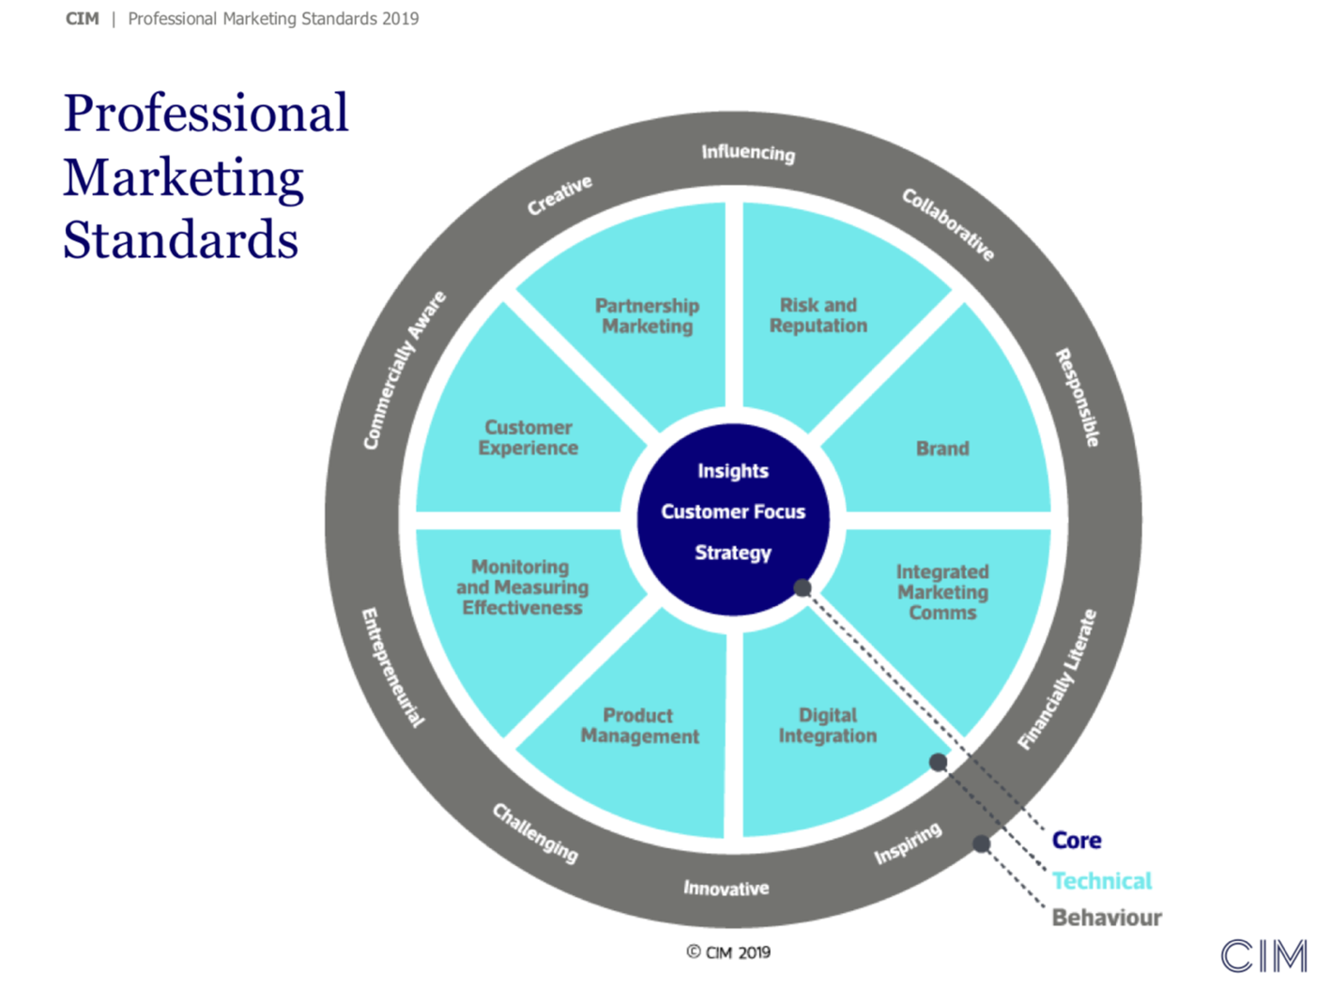

Belbin

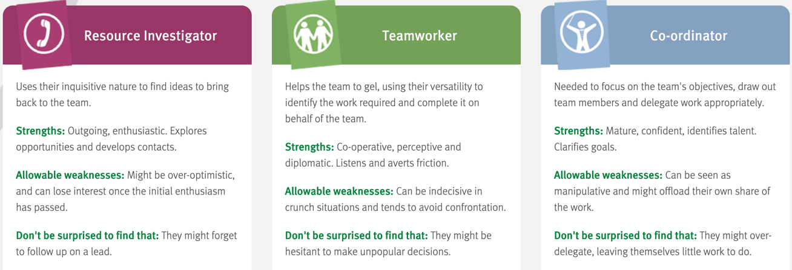

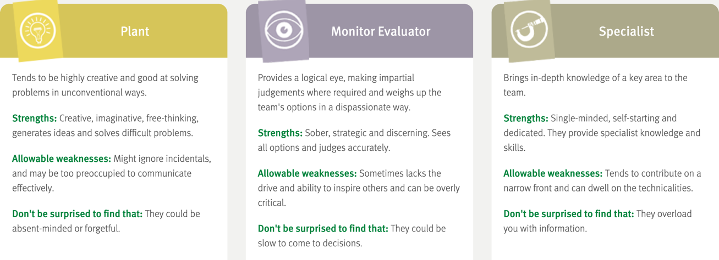

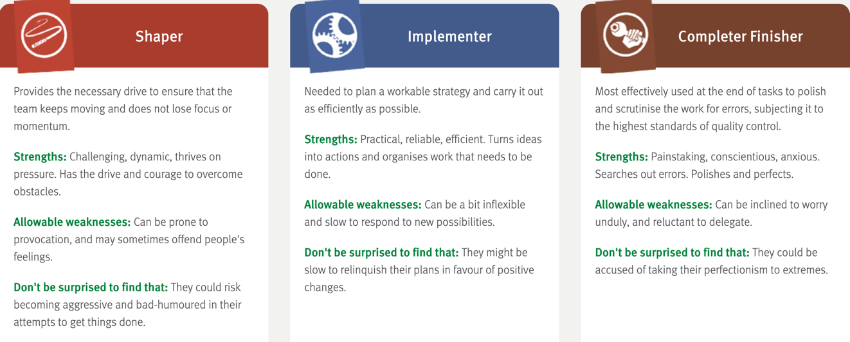

Tuckman’s model

Bruce Tuckman’s - model of team development
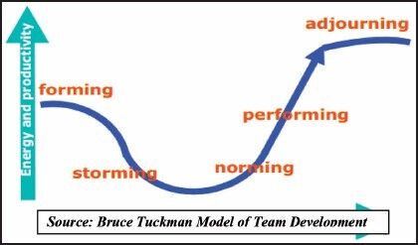

Gantt Chart
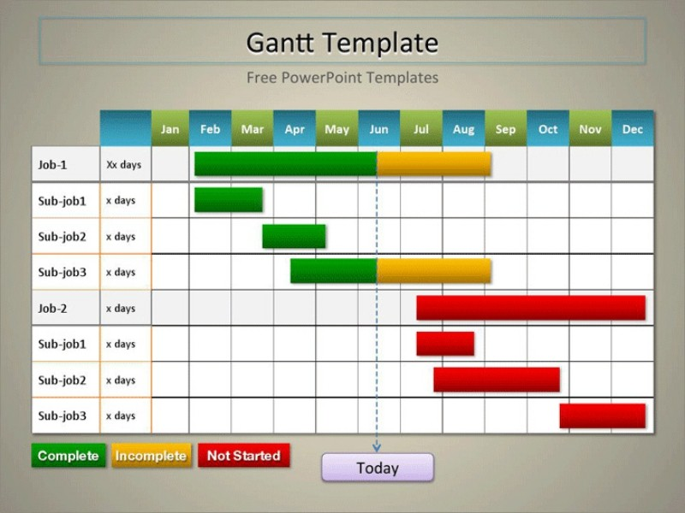

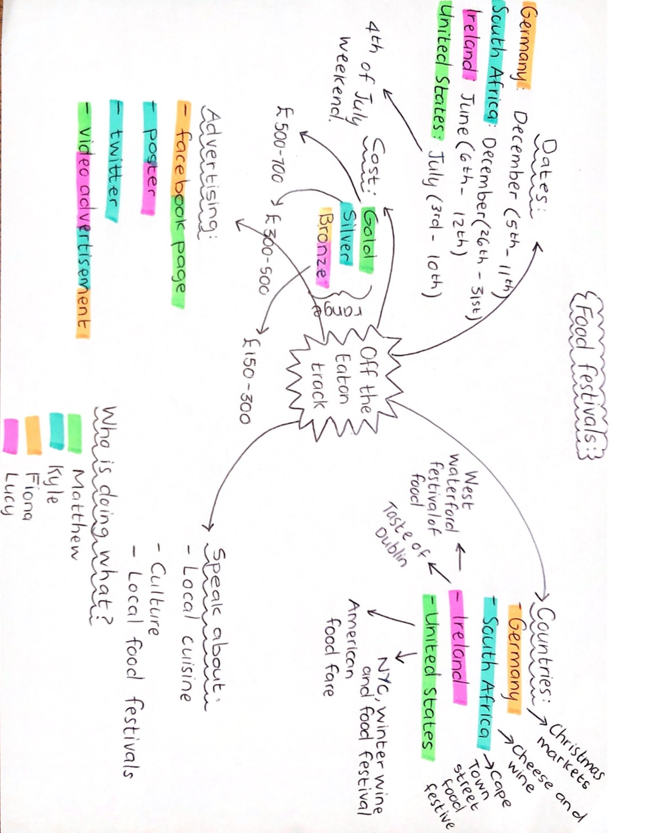
Brainstorming

Fishbone diagram
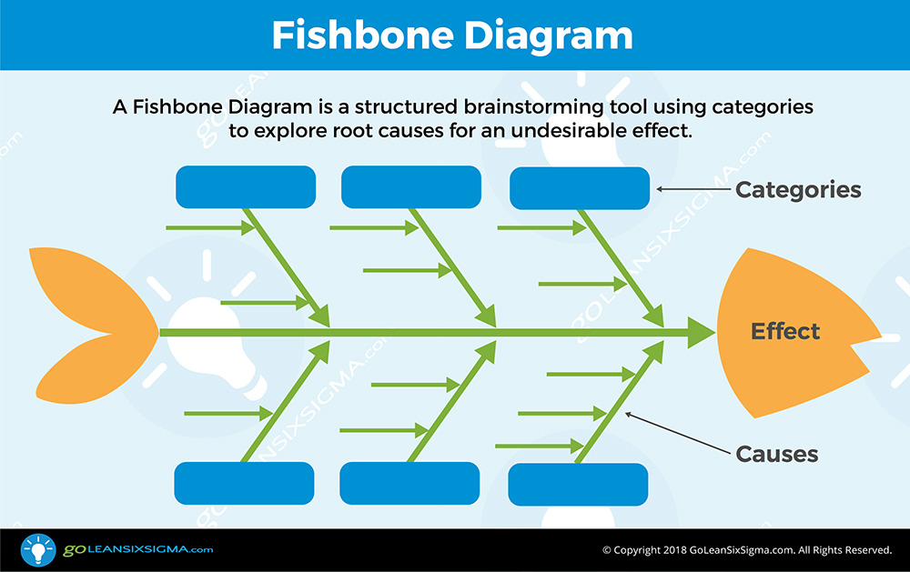

De Bono - 6 thinking hats

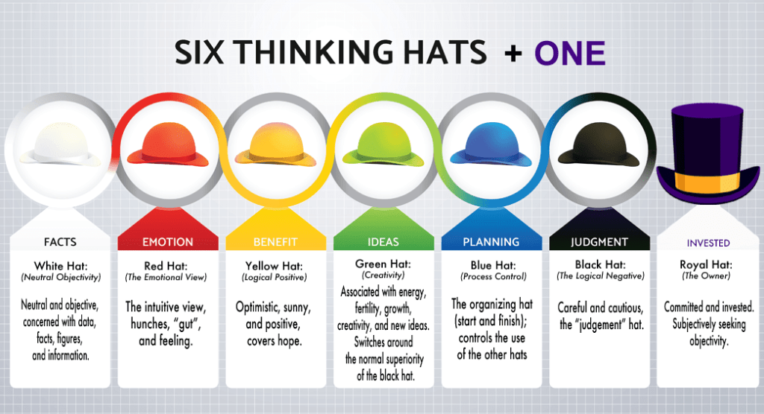

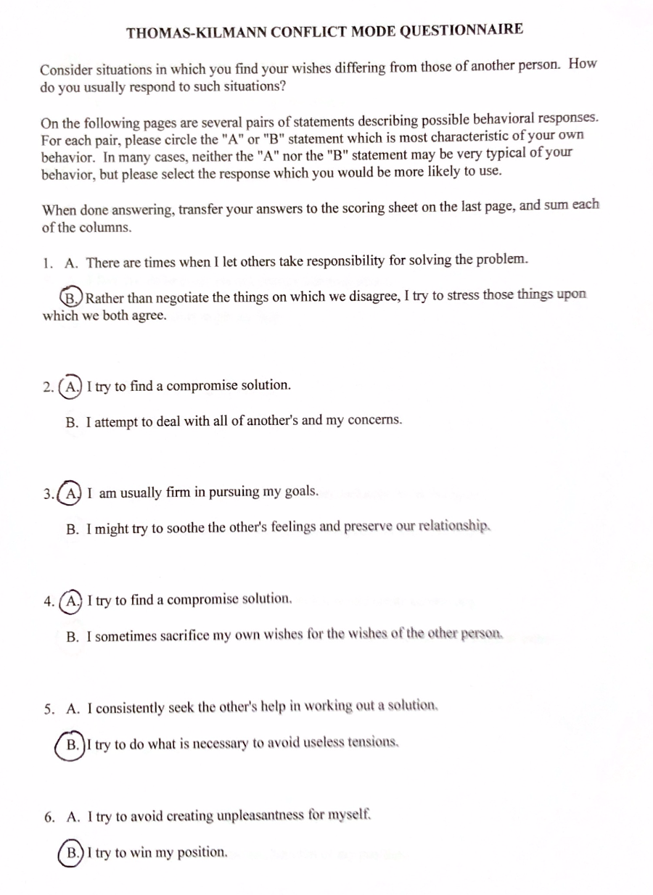
Thomas-Kilmann – conflict mode questionnaire

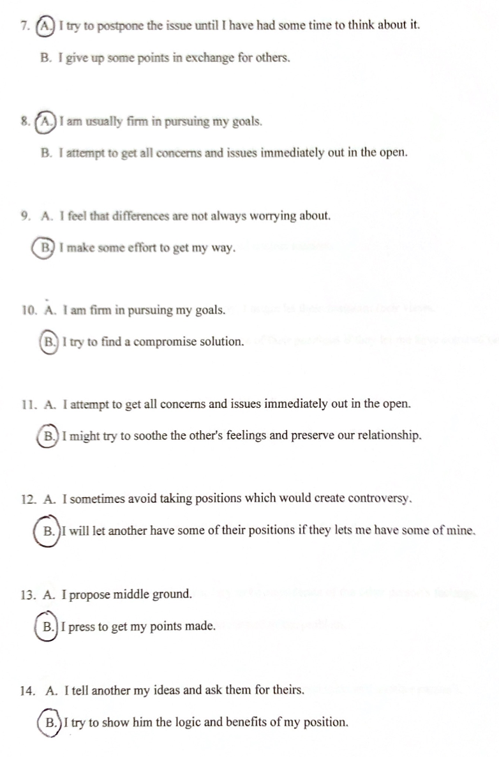

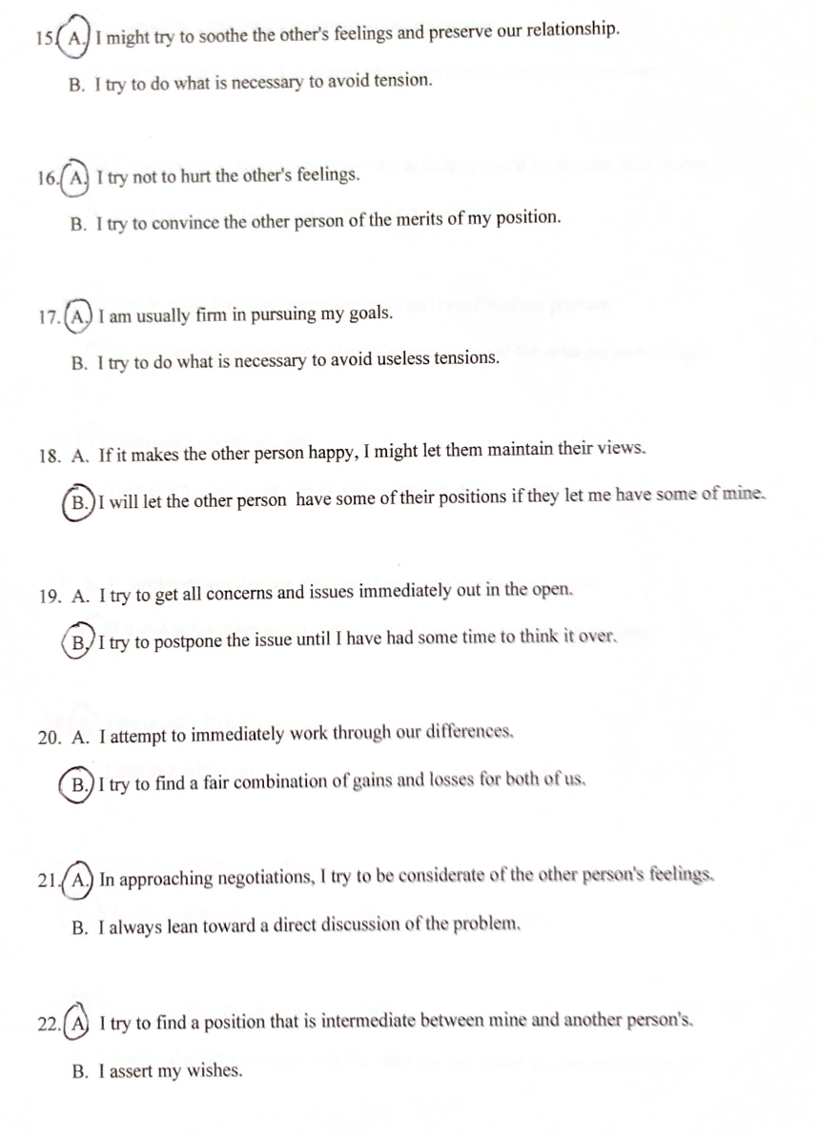

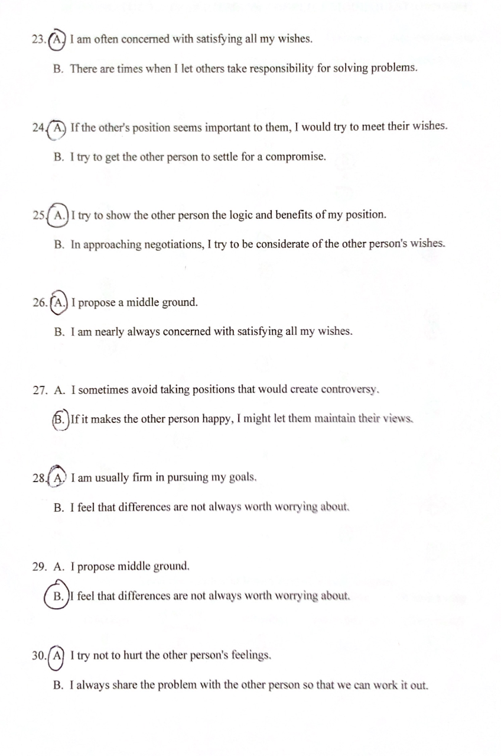

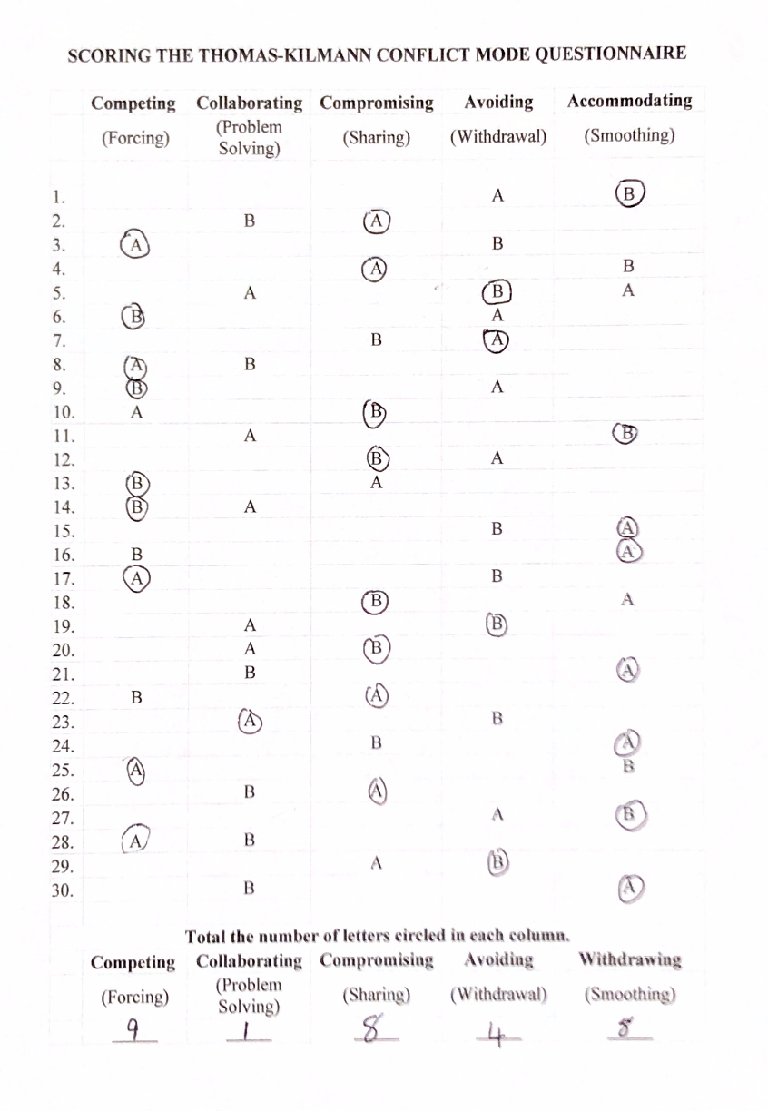

Thomas-Kilmann - conflict resolution model
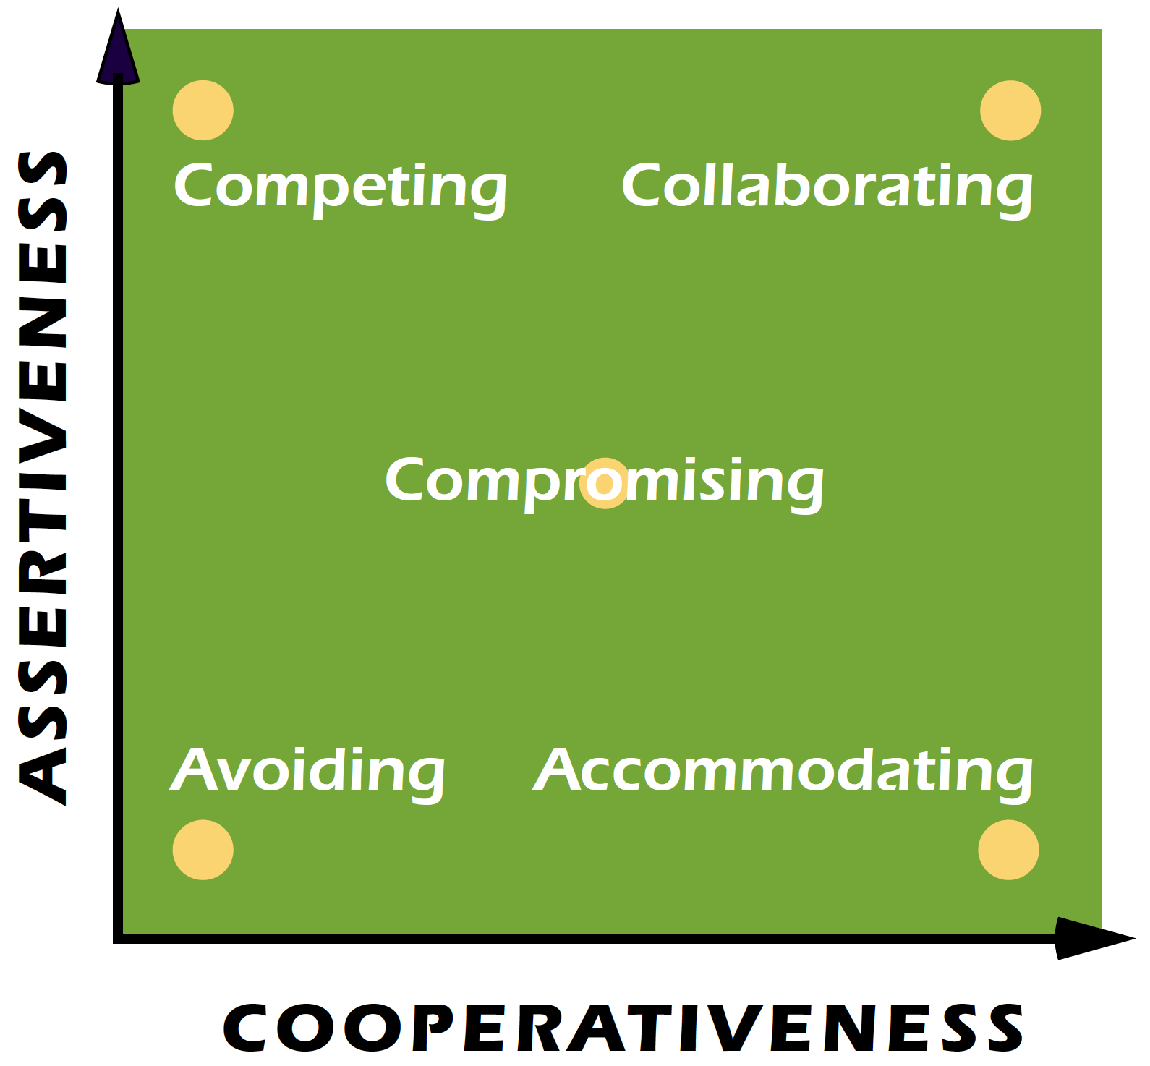

CPD cycle
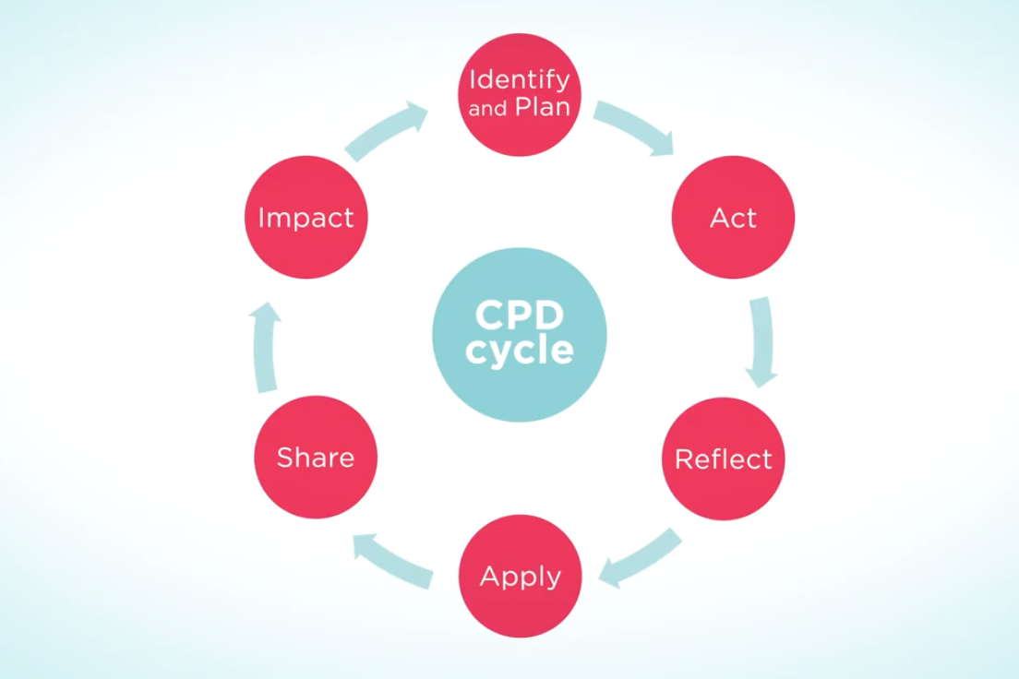

Development Plan
NAME: | Kyle Stuart
COVERING THE PERIOD FROM: | December 2019 to December 2020
What do I want/need to learn? | What will I do to achieve this? | What resources or support will I need? | What will my success criteria be? | Target dates for review and completion
Gain experience in the industry | Find an entry level marketing job, network and see what’s available. | An Updated CV, Speak to recruitment agencies. | Getting a entry level marketing job where I can gain vital experience first-hand and learn how to apply my trade. | August
Gain further knowledge on digital marketing as there is more and more need for it. | There free online courses that can take to learn more. I can eventually get certified. | I will need a laptop and access to the internet. | Getting certified as digital marketer | December
Gain a better understanding of brand marketing | Investigate all the different sorts of brand marketing and understand what they entail | Internet pages such as: marketing.org, study.com, lumenlearning.org.  Get books out of the UWTSD library. | Understanding the different sorts of brand marketing and what they require. Being able to compile a list of types of brand marketing I would be interested in. | June
Start Networking and creating a Portfolio | Set up a LinkedIn account and network with industry professionals | A LinkedIn account | Developing my profile and start connecting with people in industry. | March

Reference list

- 20+ Free Gantt Chart Templates that are Ready for Your Use | Excel, PPT, Word →. 2020. 20+ Free Gantt Chart Templates that are Ready for Your Use | Excel, PPT, Word →. [ONLINE] Available at: https://www.superside.com/blog/gantt-charts. (Accessed 04 January 2020).

- Anon, (2020). [pdf] Available at:https://www.teaching2inspire.co.uk/teachingtips/Thomas%20Kilmann%20Conflict%20Mode%20Instrument.pdf (Accessed 5 Jan. 2020).

- Belbin Team Roles | Belbin. 2020. Belbin Team Roles | Belbin. [ONLINE] Available at: https://www.belbin.com/about/belbin-team-roles/. (Accessed 05 January 2020).

- Belbin Team Roles | Belbin. 2020. Belbin Team Roles | Belbin. [ONLINE] Available at: https://www.belbin.com/about/belbin-team-roles/. (Accessed 01 January 2020).

- CPD. 2020. The Importance of Continuing Professional Development (CPD) - News | The CPD Certification Service. [ONLINE] Available at: https://cpduk.co.uk/news-articles/view/importance-of-cpd. (Accessed 03 January 2020).

- de bonos 6 thinking hats - Yahoo Video Search results. 2020. de bonos 6 thinking hats - Yahoo Video Search results. [ONLINE] Available at: https://uk.video.search.yahoo.com/search/video;_ylt=AwrJ7Y7JjdJdRp8A4h5NBQx.?p=de+bonos+6+thinking+hats&fr=mcasa&fr2=p%3As%2Cv%3Ai%2Cm%3Apivot#id=2&vid=ede03b38ed7b1142114325b318ec6e8f&action=view. (Accessed 05 January 2020).

- Essential skills for marketing | Graduate Jobs, Internships & Careers Advice - Inside Careers. 2020. Essential skills for marketing | Graduate Jobs, Internships & Careers Advice - Inside Careers. [ONLINE] Available at: https://www.insidecareers.co.uk/career-advice/essential-skills-for-marketing/. (Accessed 02 January 2020).

- Forming, Storming, Norming, and Performing - From MindTools.com. 2020. Forming, Storming, Norming, and Performing - From MindTools.com. [ONLINE] Available at: https://www.mindtools.com/pages/article/newLDR_86.htm. (Accessed 02 January 2020).

- GoLeanSixSigma.com. 2020. Fishbone Diagram (aka Cause & Effect Diagram) - Template & Example. [ONLINE] Available at: https://goleansixsigma.com/cause-and-effect-diagram/. (Accessed 04 January 2020).

- Improving Group Dynamics - Team Management Skills From MindTools.com. 2020. Improving Group Dynamics - Team Management Skills From MindTools.com. [ONLINE] Available at: https://www.mindtools.com/pages/article/improving-group-dynamics.htm. (Accessed 01 January 2020).

- Improving Group Dynamics - Team Management Skills From MindTools.com. 2020. Improving Group Dynamics - Team Management Skills From MindTools.com. [ONLINE] Available at: https://www.mindtools.com/pages/article/improving-group-dynamics.htm. (Accessed 27 December 2019).

- Kilmann Diagnostics. 2020. An Overview of the Thomas-Kilmann Conflict Mode Instrument (TKI) A long-term collaboration by Dr. Kenneth W. Thomas and Dr. Ralph H. Kilmann - Kilmann Diagnostics. [ONLINE] Available at: https://kilmanndiagnostics.com/overview-thomas-kilmann-conflict-mode-instrument-tki/. (Accessed 02 January 2020).

- MG RUSH Facilitation Best Practices Blog. 2020. Edward de Bono: Six Thinking Hats Provide Strong Stimulus for Ideation. [ONLINE] Available at: https://mgrush.com/blog/debono-six-thinking-hats/. (Accessed 04 January 2020).

- More on Forming Storming Norming Performing. 2020. More on Forming Storming Norming Performing. [ONLINE] Available at: https://www.teambuilding.co.uk/theory/more-forming-storming-norming-performing.html. (Accessed 01 January 2020).

- Professional Marketing Competencies | CIM. 2020. Professional Marketing Competencies | CIM. [ONLINE] Available at: https://www.cim.co.uk/membership/professional-marketing-competencies/. (Accessed 01 January 2020).

- The Online Learning Platform. 2020. 5 Important Reasons Why Teamwork Matters - Potential.com. [ONLINE] Available at: https://www.potential.com/articles/5-important-reasons-why-teamwork-matters/. (Accessed 03 January 2020).

- The Online Learning Platform. 2020. 5 Important Reasons Why Teamwork Matters - Potential.com. [ONLINE] Available at: https://www.potential.com/articles/5-important-reasons-why-teamwork-matters/. (Accessed 28 December 2019).

- TPC -. 2020. TPC – 5 Conflict Resolution Strategies We All Use. [ONLINE] Available at: https://theparticipationcompany.com/2016/06/5-conflict-resolution-strategies/. (Accessed 04 January 2020).

- TPC -. 2020. TPC – 5 Conflict Resolution Strategies We All Use. [ONLINE] Available at: https://theparticipationcompany.com/2016/06/5-conflict-resolution-strategies/. (Accessed 02 January 2020).

- TPC -. 2020. TPC – 5 Conflict Resolution Strategies We All Use. [ONLINE] Available at: https://theparticipationcompany.com/2016/06/5-conflict-resolution-strategies/. (Accessed 04 January 2020).

- Tuckman: Forming, Storming, Norming and Performing - BusinessBalls.com. 2020. Tuckman: Forming, Storming, Norming and Performing - BusinessBalls.com. [ONLINE] Available at: https://www.businessballs.com/team-management/tuckman-forming-storming-norming-performing-model/. (Accessed 02 January 2020).

- Why is 'Team Role' theory important for the team building process?. 2020. Why is 'Team Role' theory important for the team building process?. [ONLINE] Available at: https://www.linkedin.com/pulse/why-team-role-theory-important-building-process-talan-miller. (Accessed 04 January 2020).

- www.ncbi.nlm.nih.gov. 2020. No page title. [ONLINE] Available at: https://www.ncbi.nlm.nih.gov/pmc/articles/PMC4215500/. (Accessed 04 January 2020).

- www.ncbi.nlm.nih.gov. 2020. No page title. [ONLINE] Available at: https://www.ncbi.nlm.nih.gov/pmc/articles/PMC4215500/. (Accessed 28 December 2019).

- YouTube. 2020. Cause And Effect Analysis - YouTube. [ONLINE] Available at: https://www.youtube.com/watch?v=Fwfgx0dOYvE#action=share. (Accessed 01 January 2020).

- YouTube. 2020. Your guide to professional development - YouTube. [ONLINE] Available at: https://www.youtube.com/watch?v=dm4JwBJmGiI&feature=emb_rel_pause. (Accessed 04 January 2020).

