

Student Name: | Winta Omer
Student Number: | 2238482
Module Code: | BMSK4012
Module Title: | Enterprise and Intrapreneurship

Statement of Confirmation of Authenticity
By the act of making this submission, the student declares that this is the work of the student named above. The work has not, in whole or in part, been knowingly presented elsewhere for assessment, or where assessment has been built on a previous assessment, this has been identified. Where materials have been used from other sources it has been properly acknowledged. If this statement is untrue, the student acknowledges that an assessment offence has been committed.
Attention is drawn to the plagiarism and unfair practice policies of the University.

EmaMe Event Décor
Business Plan
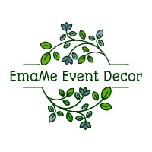

Winta Omer – Manager
Table of content
Contents
1. Executive Summary 4
2. Introduction 5
Vision 5
Mission 5
Value 5
Log and website 6
Email: 6
3. Financial Information 6
4. Marketing 7
Unique Selling Point (USP) 8
PEST Analysis 9
SWOT Analysis 10
Competitor Analysis 10
Marketing Segment 10
Market targeting 11
Marketing objectives: 11
5. Revenue and pricing strategy 11
Income Stream 12
From each income stream 13
6. Operations 13
6.1 Location: 13
6.2 Premises: 13
6.3 Equipments: 13
6.3.1 Equipment to Rent. 14
6.4 Production and distribution processes 14
6.5 Staff 14
6.6 Peoples 15
6.7 Suppliers 15
6.8 Systems and processes 15
6.9 Health and safety, legal compliance 15
7. Conclusion 16
8. Reference 17
9. Appendices 18
9.1 EmaMe Event Decoration Monthly cashflow projection 18
9.2 EmaMe Event Decoration profit and loss 19
9.3 Number of active social media users in the United Kingdom 20
9.4 Curriculum Vita 21
9.5 EmaMe Event Decoration Services Price List 22

- Executive Summary
Emame Event Decoration is an established business that aims to offer event decoration services to clients in our local area. Our team comprises creative individuals passionate about turning ordinary spaces into extraordinary experiences. Our main objective is to create moments for our clients by bringing their visions to life through innovative designs.
Our business strategy is to provide various event decoration services, including weddings, corporate events, birthdays, and other special occasions. We fully understand the importance of creating a memorable atmosphere for each event. We are committed to surpassing our client's expectations.
In Addition, we have emphasised utilising platforms to increase brand visibility while building connections with local event planners to expand our reach. Our SMART marketing objectives drive our efforts to achieve a 20% increase website traffic and social media engagement within the first six months. With our talented team and innovative approach, we are confident in our ability to succeed in this competitive industry.

- Introduction
EmaMe Event Decor is an event decoration company based in Swansea. The company is led by the visionary entrepreneur Winta Omer, who has a passion for creativity and design. The primary goal of EmaMe is to turn venues into extraordinary and unforgettable spaces. Although the company still needs to be registered, Winta Omer and her dedicated management team are fully committed to delivering services. EmaMe offers various event decoration services, including designs, stunning floral arrangements, elegant lighting setups, exquisite table settings and meticulous attention to every decor detail. This introduction gives a sneak peek into EmaMes' enchanting approach to event decoration. The team works closely with clients to create memorable experiences for their special occasions.

Vision
We aim to establish ourselves as the leading event decoration company in the UK, renowned for designs, flawless execution, and unforgettable customer experiences. We aim to create events that surpass our client's expectations and leave a lasting impression on everyone involved.

Mission
Our mission at EmaMe Event Décor is to transform venues into extraordinary moments. Our dedication lies in delivering top-notch event decoration services crafting captivating designs, and paying attention to every detail with passion and expertise. By working with our clients, understanding their unique vision, and bringing it to life through creativity and unwavering commitment, we strive to ensure each event is an outstanding success while making a significant impact in the event industry.

Value
We have a true passion for creating visually stunning and one-of-a-kind events. Our client's satisfaction is our utmost concern, and we make it a point to listen to their desires actively. We take great pride in delivering exceptional work, carefully attending to every detail.

Log and website

https://WWW.emameeventdecor.co.uk

Email:
emamedecor@gmail.uk.com
It would be started as the sole proprietorship creating enchanting decorations for weddings and events. The owner and their assistant would go personally visit events places to deliver magical and personalised services, ensuring every celebration is truly memorable.

- Financial Information
The financial projections are based on market research and empirical examination of the event decorating industry. For the next year, we project revenue of approximately £165,400. The estimated expense costs will be £109,170. We estimate a net profit of £57,630 without taxation. (see appendices)
The company start-up costs will be £20,000, which will be received from friends and family. The company allocates funds for various expenses, including decorations, workspace setup, licenses, and marketing efforts.
Invested capital will be used as follows:
- Decorations Procurement: £8,000
- Workspace Setup: £5,000
- Licensing and Legal Requirements: £2,000
- Marketing and Branding: £3,000
- Website Development: £2,500
- Initial Inventory: £3,500
Using the average revenue per event and the assumed growth rates, EmaMe forecasts their monthly turnover to be -£2,635.00 (Month 1). As the growth rate varies throughout the year, the company expects its revenue to increase steadily, reaching £59,630 by the end of the 12-month period. EmaMe sets a target profit of £3,975 per month after covering all expenses to maintain a sustainable profit margin and ensure business viability. This profit margin allows the company to reinvest in the business, enhance service quality, and support potential expansion plans. However, for a comfortable living, EmaMe expects at least 10 events per a month to cover overheads.
Cash Flow Management and Adjustments: Effective cash flow management is crucial for EmaMe Event Decor to meet financial obligations and seize growth opportunities. The company shall diligently track inflows and outflows to ensure sufficient funds for daily operations. It shall also regularly review projections against actual performance and market conditions as the year progresses. Moreover, it shall adjust stated assumptions and financial plan to adapt to the changing circumstances for optimising profitability.

Assumptions
The financial projections rely on assumptions derived from thorough research and the management's anticipation of potential sales and costs. EmaME assumptions are:
- 18 events monthly, with an average revenue of £1,000. (see appendices)
- Start with eight events per month. In the first eight months, events will increase by approximately 10% each month. But, in the last quarter (10th to 12th month), events will drop by about 5% per month. (see appendices)
- The initial advertising budget will be £1,000 per month, but it projected to increase by approximately 5% per year. (see appendices)
- Some clients will pay 30% deposit upfront for booking, 50% upon stating the event and the remaining 20% balance shall be paid after the completion of the work.

- Marketing
As per Statista (2023), nearly 74% (50.6 million) of the UK population accessed social media in January 2023. The most popular social media platforms in the UK as of the third quarter of 2022 were WhatsApp, Facebook, Instagram, Facebook Messenger and Twitter, with usage reach ranging from 73.4% to 42.8% (see appendices). For an effective marketing and competitive strategy, EmaME shall primarily take a faceted approach: The internet or online marketing via social media. The target of this plan shall be the middle-class citizen in the UK.
Establishing an online presence shall be through creating a user-friendly website to showcase our work and services. Search engines and optimisation techniques shall be pursued, which will ensure a higher appearance of our website in search engines.
Use of social media platforms like Facebook, Instagram, YouTube, TikTok, and WhatsApp shall be pursued to promote our decoration events. Regularly posting high-quality images and videos from events to engage with our followers and using hashtags shall help us reach more clients. Consequently, EmaME’s visibility shall increase, thus increasing the number of customers.
In addition, networking within the industry is also essential. Attending trade shows, conferences and joining associations allows to connect with event professionals who might refer clients or collaborate on projects.
Moreover, offering promotions or discounts to first-time customers will incentivise them to choose EmaME over other competitors. By providing customer service and exceeding their expectations, we can encourage word-of-mouth referrals from clients.

Unique Selling Point (USP)
Our USP lies in our unwavering dedication to crafting experiences through innovative and customised designs. EmaME takes pride in its ability to comprehend and cater to each client's needs and preferences. Through effective listening and communicating, we ensure that every aspect of the event is tailored to the client's vision. Additionally, our team of designers are creative with unwavering attention to detail. We consistently keep updated with the latest techniques in event decoration, enabling us to offer innovative designs that captivate guests' attention.
In addition, we prioritise sustainability in all aspects of our business operations. With growing concerns, clients appreciate our commitment to utilising eco materials and implementing sustainable practices whenever feasible.
By blending service, creative excellence and a solid commitment to sustainability, our event decorating company shall establish itself as a trailblazer in the industry. Our USP guarantees that clients receive experiences surpassing their expectations while contributing to a brighter future of the company.

PEST Analysis

Politics affects the event decoration industry. Regulations on health and safety standards, licensing requirements and taxation policies can impact how these companies operate. Moreover, changes in government policies regarding events or public gatherings like Covid-19 lockdown can also affect the demand for event decoration services.
Economic factors can influence the decoration industry. During economic recessions, consumers’ spending on events decreases. Additionally, fluctuations in exchange rates can affect the cost of importing items from countries.
Socially, trends and preferences can shape the types of decorations sought after. For example, an increasing emphasis on sustainability may drive up the demand for eco decorations.
Lastly, technological advancements have brought about a revolution in how events are planned and executed. Event decorating companies need to stay abreast with technologies like the internet 3D modelling and printing.

SWOT Analysis
Strengths:  - Committed & experienced staff.  - Creative team of designers  - Affordable services | Weaknesses  - Limited resources  - Lack of office spaces  - Lack of brand recognition
Opportunities  - Increasing demand  - Urbanisation and population growth | Threats  - Competition from established companies  - Economic crises  - Pandemics

Competitor Analysis
According to Czepiel, J. A. (2020) Analysing competitors has helped the company gain insights into its strengths and weaknesses and those of the industry. In the startup stage, the entrepreneur is focused on self-awareness. Various factors are being observed to assess competitors, which helps the company establish goals and operational strategies, including pricing strategies.
In Swansea, there are several event decoration companies, such as Eden Events Décor and Styling (EEDS) and Simple Elegant Wedding and Events Decorators (SEWD). These companies offer similar services and target similar customer segments.
EEDS Events has an extensive portfolio of successful events and a strong reputation for creativity and attention to detail. On the other hand, SEWD has a larger team with more resources available for handling multiple events simultaneously.
While EEDS Events offers premium services at higher prices, SEWD focuses on affordability without compromising quality. This information helps me determine where my business fits within the market and how to differentiate myself from these competitors. While we can position our business more effectively in the market by identifying areas where we can differentiate ourselves, such as pricing strategy or digital marketing efforts.

Marketing Segment
The Company focuses on the middle-class market segment in Swansea, which makes up around 70% of our client base. Although we also serve from upper class (20%) and lower class (10%) segments, our primary strategic priority is to gain a significant market share within the middle-class segment by offering competitive pricing and quality products. Recent statistics from the (Office for National Statistics, 2021) reveal that the middle class represents 60% of the population in this area.

Market targeting
The Event Decoration company focuses on catering to the middle-class residents of Swansea, which comprise 70% of our target audience. Based on the census data from the (Office for National Statistics, 2021), Swansea has a population of around 246,500 individuals.
However, our target is the middle-income population since they have income for events and celebrations. Recent statistics indicate that 40% of Swansea's population falls into this category, according to the (Office for National Statistics, 2021). This particular segment of the population will likely prioritise high-quality decorations that can enhance the ambience of their events without straining their budget.
Moreover, it is worth noting that young adults and middle-aged individuals in Swansea show interest in events such as weddings, birthdays, corporate events, parties, and other special occasions. Individuals between the ages of 20 and 44 account for 40% of Swansea's population, based on data from the (Office for National Statistics, 2021). This demographic represents a pool of customers who may be interested in our event decoration services.

Marketing objectives:
Specific; Increase brand awareness among middle-class clients in Swansea's event decoration market.
Measurable: Achieve a 20% increase in website traffic and social media engagement in six months.
Achievable: Secure partnerships with three local event planners to expand the client base.
Relevant: Establish EmaMe Event Decoration as a reputable and high-quality brand in the local market.
Time-bound: Increase booked events by 10% within the first year, aiming for at least 30 successful events.
- Revenue and pricing strategy
Dutta, S. al. (2003) highlight the importance of having a defined pricing strategy for the success of any business, such as event decoration services. As the owner of an event decoration company in Swansea, it is crucial to determine the pricing strategy through market research and evaluating competitors. By adopting a market-based approach to pricing, the company ensures that its prices align with customer expectations and industry standards, thus effectively meeting demand.
In order to establish the pricing strategy, the owner conducted extensive market research to gain insights into the supply and demand dynamics within Swansea's event decoration industry. This involved analysing competitors' pricing structures and considering customer preferences and prevailing industry trends. This research process acquired valuable information on market rates, enabling informed pricing decisions that align with local market conditions.
After researching competitors such as Eden Events Décor and Styling and Simple Elegant Wedding and Events Decorators, we found that they charged an average of £1000 for decorating a medium-sized wedding venue. To remain competitive while ensuring profitability, the company set the price at £900 for a similar service.
Additionally, we considered factors such as overhead costs, labour expenses, and material costs when determining my pricing strategy. By carefully calculating these costs and factoring them into my price calculations, we ensured they covered all expenses while generating a reasonable profit margin.

Income Stream
The company aims to attract customers by offering various packages and themes tailored to their needs (Smithson, J. al. 2019). However, our first source of revenue will come from providing event decoration services for occasions like weddings, birthdays, corporate events, and other special events.
In addition to its event decoration services, we plan to generate revenue through services. This entails renting items such as centrepieces, table linens, chair covers and lighting equipment. Many customers prefer the flexibility of handling their decorations but often need more items. By offering affordable rental options, we can tap into this market segment. Meet the demands of DIY enthusiasts.
Moreover, the company is exploring partnerships with local businesses such as florists or photographers. Through these collaborations, they can refer clients to these businesses. Receive commissions for successful referrals made. This beneficial arrangement allows the company to generate additional income while supporting local entrepreneurs.

From each income stream
From decoration service: This requires collaborating with clients to grasp their vision and specific needs for their events and then offering them tailor-made decoration options. The cost of these services may differ based on the size and intricacy of the event. This particular source of income contributes to around 40% of the revenue.
From renting service: Clients can create the desired atmosphere without buying these items themselves. Rental services make up 30% of the total revenue.

- Operations

Location:
The company operates from home in Swansea. This location advantage helps keep our costs low, enabling us to offer prices without compromising the quality of our services. Being home-based also offers the flexibility to serve clients in Swansea and the surrounding areas.

Premises:
The company workspace is located in the owner's home. This space is creatively designed as a central hub for planning and creating decorations. Moreover, efficient storage facilities are in place to accommodate a variety of decorative items ensuring convenient access and timely delivery for clients' events.

Equipments:
- Crafting Tools: Scissors, glue guns, cutting mats, and other craft supplies for assembling decorations.
- Laptop and Printer: For administrative tasks, contracts, and client communication.
- Camera and Photography Equipment: To capture images of completed decorations for portfolio and marketing purposes.
- Ladders and Step Stools: Essential for setting up decorations at various heights.
- Floral Supplies: Floral foam, flower wire and different artificial flowers for arranging floral decorations.
- Table Setting Essentials: Tablecloths, napkins, plates, and cutlery for elegant table setups.
- Different colours and sizes of balloons.
- Sewing Machine: For creating fabric-based decorations like tablecloths and drapery.
- Staple Gun and Nails: To secure backdrops, banners, and other elements.
- Lighting Equipment: String lights, fairy lights, and LED spotlights to create an ambience.
- Decorative Props: Various decorative items such as vases, candle holders, and figurines.
- Backdrops and Fabrics: Assorted backdrops and fabrics in various colours and textures.
- Signage and Easels: For displaying signs, seating charts, and welcome boards.
- Storage Solutions: Shelving units and storage containers for organising and maintaining inventory.
- Display Stands: For showcasing sample decorations at events or trade shows.
- Safety Equipment: Fire extinguishers, first aid kits, and safety cones for event setup.
- Cleaning Supplies: Cleaning tools and materials to maintain the workspace and equipment.

Equipment to Rent.
- Dance floor
- Event furniture
- Van for transportation

Production and distribution processes
Producing and distributing processes are a part of any business plan Smithson, J. al. (2019). To begin, the company must understand the client's requirements and preferences for event decoration. This may involve meetings or consultations to grasp their vision and theme for the occasion. Once all requirements are gathered, EmaMes's team of designers will create a plan and proposal for the decoration.
After finalising the design, EmaMe will proceed with obtaining all materials and resources for the event decor, which might include purchasing or renting them.
Once all materials are gathered, the company team will start implementing the decoration plan at the venue. This entails setting up elements like stage backdrops, table centrepieces, lighting arrangements and other decorative installations.
Regarding distribution, the company focuses on delivering completed decorations to clients' venues. The company ensures that all decorations are transported safely and securely to prevent any damage during transit.

Staff
The company has a team of three employees, including the owner. Each team member plays a role in providing services to clients. Specifically, the owner takes charge of overseeing all operations and guaranteeing functioning. They handle staff management, collaborate with suppliers and nurture client connections.

Peoples
Clients: Individuals, families, corporations, and event organisers.
Event Planners and Coordinators: Referral sources for decoration services.
Event Partners: Collaboration for cross-promotional opportunities.

Suppliers
The company depends on suppliers like Amazon and Alibaba to acquire top-notch materials at competitive prices.

Systems and processes
The company plans to implement a customer relationship management (CRM) system. This system will allow the company to keep track of client details, preferences, and past interactions. By maintaining a database of clients, the company can personalise their services. Offer customised recommendations based on previous engagements. Additionally, it is crucial to manage inventory by monitoring stock movement and ensuring restocking of supplies Smithson-Jones, A al. (2019).
Furthermore, establishing communication channels within and with stakeholders is essential. Internally conducting team meetings to discuss events, assign tasks, and address employee concerns or challenges is recommended. Similarly, maintaining communication with clients throughout the event planning process – from consultations to post-event feedback sessions – is imperative.

Health and safety, legal compliance
- Regular safety training for staff and provision of protective gear.
- Venue inspections before event setup for hazard identification.
- Obtaining necessary permits and licenses for legal compliance.
- Contractual agreements with clients for transparency and protection.
Health & Safety Executive (n.d.)

- Conclusion

In conclusion, our business plan for the EmaMe Event Decoration Company presents a focused strategy to establish a strong presence in the event decoration market of Swansea. Our target audience will be the middle-class segment. We will prioritise delivering personalised decorations of high quality. Our goal is to make EmaMe a known and highly sought-after brand. Also, the market analysis conducted in the business plan highlights the growth potential within the event decoration industry.
The marketing strategy outlined in our business plan is both innovative and targeted. By utilising social media platforms collaborating with vendors, and actively participating in industry events, EmaMe aims to raise awareness of its brand and attract clients. The financial projections indicate that the company can achieve profitability with cost management and revenue generation strategies within one year.
The competitive analysis also reveals opportunities for EmaMe to thrive by offering price and exceptional customer service.
This business plan is a foundation for successfully launching EmaMe Event Decoration. It combines research with strategic planning to create a roadmap for success. With its offerings and unwavering commitment to customer satisfaction, EmaMe has great potential to become a leader in the event decoration industry.

- Reference
Czepiel, J. A. (2020). Competitor analysis. In The Routledge Companion to Strategic Marketing (pp. 125-140). Routledge.
Dutta, S., Zbaracki, M. J., & Bergen, M. (2003). Pricing process as a capability: A resource‐based perspective. Strategic management journal, 24(7), 615-630.
Gottlieb, M., Promes, S. B., & Coates, W. C. (2021). A guide to creating a high‐quality curriculum vitae. AEM Education and Training, 5(4).
Health & Safety Executive. (n.d.). Risk assessment: A brief guide to controlling risks in the workplace [Brochure]. Retrieved from https://www.hse.gov.uk/pubns/indg163.pdf.
McKeever, M. P. (2018). How to write a business plan. Nolo.
Office for National Statistics. (2021). Population estimates by marital status and living arrangements: England and Wales [Data set]. Retrieved from https://www.ons.gov.uk/peoplepopulationandcommunity/populationandmigration/populationestimates/datasets/populationestimatesbymaritalstatusandlivingarrangementsenglandandwales.
Smithson, J., & Markham-Jones, R. (2019). Event Management: A Practical Guide (5th ed.). Routledge.
Smithson-Jones, A., & Brown, T. S. (2019). The Business of Event Planning: Behind-the-Scenes Secrets of Successful Special Events. Wiley.
Smithson-Jones, A., & Johnson-Williams, K. (2019). The Complete Guide to Event Management: For Corporate Events, Fundraising Galas, Weddings, and Social Events. Atlantic Publishing Group Inc.
Statista. (2022). Most popular social media platforms in the United Kingdom as of Q3 2022, by usage reach [Graph]. Retrieved from https://www.statista.com/statistics/271781/social-network-penetration-in-the-united-kingdom-uk/
Statista. (2023). Number of active social media users in the United Kingdom from January 2023 [Graph]. Retrieved from https://www.statista.com/statistics/278942/number-of-social-network-users-in-the-united-kingdom-uk/
- Appendices
  - EmaMe Event Decoration Monthly cashflow projection
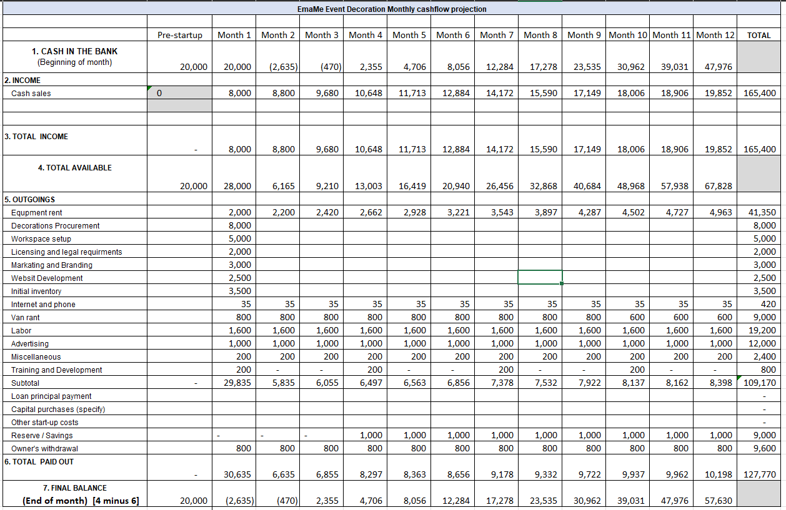

  - EmaMe Event Decoration profit and loss
EmaMe Event Decoration Profit and loss
Profit and loss account for EmaMe company for the year ended 31/03/2024
 | Sales | 165,400.00
 | Cost of sales | 109,170.00
 | Gross profit | 56,230.00
Expenses
Equpment rent | 41,350.00
Decorations Procurement | 8,000.00
Workspace setup | 5,000.00
Licensing and legal requirments | 2,000.00
Markating and Branding | 3,000.00
Websit Development | 2,500.00
Initial inventory | 3,500.00
Internet and phone | 420.00
Van rant | 9,000.00
Labor | 19,200.00
Advertising | 12,000.00
Miscellaneous | 2,400.00
Training and Development | 800.00
 | Total expenses | 109,170.00
 | Net profit | 56,230.00

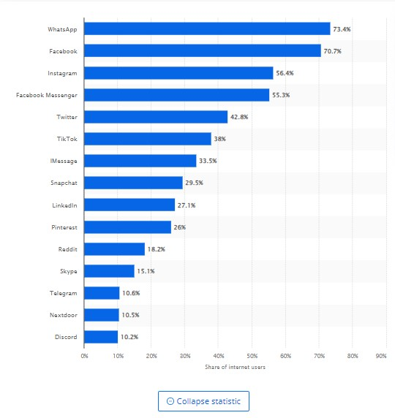
  - Number of active social media users in the United Kingdom

  - Curriculum Vita
Full Name: Winta Omer
Address: 83 Goronwy Road
Contact Number: 09475065083
Email: winta678@gmail.com
Profile: I am a highly imaginative and meticulous person with a deep love for decorating events. I can come up with unique ideas and bring them to life, creating captivating decorations for special occasions. My main goal is to ensure every customer has an extraordinary experience while working with EmaMe Event Decoration Company, ultimately contributing to the company's overall success.
Education:
- Diploma in Secretarial sciences and office management graduated from Addis Ababa University in Ethiopia in 2000.
- Diploma in information technology graduated from Weliso University in Ethiopia in 2004.
- Certificate ESOL from Gower College Swansea in 2022
- CertHE Leadership and Management in the Workplace standing at UWSTD
Work Experience:
Amazon: Customer Returns and Packer 2018-2020
- Unpack returned merchandise, inspect package condition and assess paperwork sent in with return instructions for proper return procedures. Inspect returned merchandise, checking for quality and condition of the product to determine return category. Distribute returned items to their proper location Input clear customer account notes in internal computer systems, communicating return reasons, customer feedback and instructions to ensure accurate processing Measure and weigh the packed container and put information on the packing. Manually record the package information, then enter it into the database and its status. Seal packed containers using glue, nails and other fasteners ready for transporting.
Walsh refuge council: Support worker 2022-2023
- Helping refuge states clients with Applications for Discretionary Assistance Fund (Emergency and Individual Assistance Payments). Helping to make Applications for EMA (Education maintenance allowance) and Welsh Government Learning Grant Further Education application. Helping to make applications for newborn BRP cards. Helping to make BRP replacement applications once lost or stolen. Assisting with Free School Meal Applications

Interests:
- Passionate about exploring diverse decoration styles and trends.
- Enjoys experimenting with new materials and techniques to create unique decorations.
- Excited to collaborate with clients to understand their vision and bring it to life through decorations.
Skills:
- Creative Design and Conceptualization
- Crafting and Decoration Execution
- Customer Service and Communication
- Attention to Detail
- Time Management and Organization
  - EmaMe Event Decoration Services Price List


