How Operation Management Theories Impact on Indian Automotive Industry

SID : 1805534
Module code : LCDB7006
Word count : 7345 ( excluding, cover page, executive summary, table of content and refrence )

Executive Summary
To cope up with the challenging demands of the market and economy there emerge several skills required by the managers at several functional areas such as finance, accounting, marketing, HR and other related areas. Several management theories got emerged to tackle the challenges of the on-going business. Contemporary challenges push firms to innovate something new to go ahead with the changing track. From the analysis of bureaucratic management, it has been observed that several rules and principles go against the modern needs of the firms.
There is an urgent need to satisfy the objectives of the firms not only for the current but also for the future. Continuing development in business helps achieve the mission, vision, and goals by the firms in the long run. Organisations are developed a lot over the past decades through continuous development in business. Innovation in the management styles, leadership changes, focusing on tasks, goals, strategy improvement all leads to sustainable development for the firms.
Six Sigma, Japanese Kaizen, Triple bottom line, lean manufacturing process help organisations become successful in several operational areas. Several industries especially manufacturing industries are dependent on the proper application of the services of operation management theories. The automobile industry of India has been using several techniques of operation management theories and the application of those theories help earn operational excellences not only in India rather in several other locations of the world evidenced by winning of several prizes.

Table of Contents

Executive Summary 2
1.0: Introduction 4
2.0: Evaluation of management theories 4
2.1: Classical management approach 5
2.2: Behavioural management approach 7
3.0: Management theories on operation management 10
3.1 Total Quality Management 10
3.2 Lean Management 11
3.3 Six Sigma 15
3.4 Triple bottom line 17
3.5: Japanese Kaizen: 18
4.0: Role of operation management on Indian automotive industry: 19
5.0: Recommendation on the base of the above literature review: 24
6.0: Conclusion: 26
7.0: References: 27

1.0: Introduction
The aim of this analysis is to underpin several contemporary issues faced by the firms and the evaluation of management theories in order to keep pace with those challenges. Several management theories such as behavioural approach of management, neoclassical, classical and modern management approach would be analysed in this report. How management theories and functions help motivate employees to work better and enhance the productivity in several key areas such as matching the functions of employees to the set aims and objectives of the firms, increasing profit potential, boosting the organisational culture, codes of ethics etc. Over the years, contemporary issues put pressure on management to tackle those effectively. Since the 19th century, several approaches to management have been emerging and firms are coping with the contemporary challenges with the application of those in the given contexts. The objective of the report is to analyse how the managers to cope with the challenges use these theories. Organisations nowadays are focusing more on learning and development that is a greater concern of the management. Objectives by the firms are to learn and develop continuously which have been aided by the management functions properly. These all will be synthesised in this report properly.

2.0: Evaluation of management theories
Starting from the nineteenth centuries there has been the emergence of several important management theories by several authors (Saloner et.al 2018). Theories and their applications over the years have been contributing to the enhancement of productivity by the organisations. Mostly there are three classes of management theories being evaluated since the last two centuries. This segment analyses these three management approaches along with attribution of those management approaches in today’s business organization such as-
Behavioural management theories impact a greater contribution to all the available industries. On the other hand, scientific and focus group theories impact slightly impact on key industrial areas. In today’s world, most of the industries are focusing on the forward-lookingapproaches to become successful at operational areas.

2.1: Classical management approach
Armstrong and Armstrong (2014)statedthat the classical management approach is based on the premise that employee’s only need to satisfy economic and physical needs. According to this management approach there is little evidence that employees require job satisfaction, motivation, social needs etc. (Palmer, 2017). However, this management approach stresses the need for skilled labour, and centralised decision-making system, and profit maximisation etc. It has been observed that there are four guiding principles shaping the concept and evaluation of this management approach as follows
Firstly, there would be the development of science, which furthermore induces the rules of motion, standardized workforce, proper work implementations, ensuring better working conditions (Palmer, 2017).
Secondly, this approach believes that if there is the selection of the right candidate to the right job work performance and productivity enhance (Saloner et.al 2018).
Thirdly, there is the requirement for training and development by the employees to augment the performance.
Finally, there is the importance of the planning of activities by the employees so that everything can be done against a better benchmark (Armstrong and Armstrong, 2014).
Figure: Classical management approaches

Scientific management :
Frederic Taylor first introduced the scientific concept to increase the performance by the employees at the workforce. According to Taylor, rather being forced, making the works easier so that all can understand and accomplish are the prime factors to become successful at the organisational contexts.
According to Taylor money is the main motivator for the employees to keep themselves satisfied and he introduced “fair day’s wages for a fair day’s work” concept that got much popularity and started to become working within very short period of time.
Administrative Principles:
Scalar Chain: It is important to have strong maintenance of communication within the top to bottom levels of management at workforce to ensure the channelling of key ideas, work conditions, performance etc. ((Saloner et.al 2018).
Unity of command: There would be the work specification at each level and each is supposed to work less than one boss only to maintain the unity of command.
Unity of direction: To avoid hassle, one person shall be entitled to one specific objective only.
Bureaucratic organisation
According to Carpenterand Sanders (2014), bureaucratic organisation ensures a strongly rational and efficient form of organisation. Several logics need to be presented before taking any decision. Each activity would be monitored and supervised under legal authority.
There are several features of the bureaucratic organisation as follows
There would be the ensuring of formal rules and each at the organisation must maintain regulations. Strong division of labour ensures work productivity. Employees would be promoted to the next level based on merit and super performance. A clear hierarchy of authority would ensure the bureaucratic system being active at the organisational premises etc. (Bhaskar, A.U. & Mishra 2017).

Disadvantages of the bureaucratic management system
According to Armstrong and Armstrong (2014), an association of high costs due to the use of paper documents whereas organisations prefer soft copies for the documents. On the other hand, efficiency is also lower due to the use of paper documents as it passes several chronological orders whereas soft copies can be sent to several users at a time. The bureaucratic management system is slower in nature whereas other approaches such behavioural management approach is faster and easy to execute. One of the key problems associated with the bureaucratic management approach is that this approach is in the opposite direction of changes being happened at several times despite the modern workforce require changes. Due to the changes in technology and other devices jobs get done using software and online tools in several cases. Senior persons never allow changes being happened. Due to this organisation cannot cope with the changing needs at this global era of technology.
From the analysis of bureaucratic management, it has been observed that several rules and principles go against the modern needs of the firms. To earn efficiency, it is important to have several drawbacks of the theory being renovated such as slowness to change, use of hard copies, important files to have checked and signed at several stages etc. (Bondaroukueël and Looise 2015). However, behavioural and other management approaches have become capable to overcome the problems associated with this management approach.

2.2: Behavioural management approach
According to the behavioural management approach, the behaviour by the employees can be conditioned, nurtured and adapted in several situations through providing right training and development activities to them. Organisational behaviour that is one of the major parts of management deals with nature and attitude of the human at the organisations and tries to generate possible solutions faced how productivity can be increased (Anthony et.al 2017). According to several researchers of OB, there is not necessarily one to be meritorious to become a leader rather the arrangements that may lead one to be visionary in nature. The behavioural approach of management got into action back in one century in the business organisations and half a century in the areas of psychology. In this section there will be the analysis of the behavioural approach of management and how the functions, beliefs of this management approach help organisational successes over the decades

Source: Bondaroukueël andLooise , 2015
The relationship between groups and organisations
Bondaroukueuël and Looise (2015) argued that nowadays organisations have shifted to group tasks. Groups are given tasks of several projects. Several talents are pooled under a group and better results are produced compared to individuals. The managers assign jobs to subordinates who constitute a group. Managers are held as responsible to cooperate and support others. Thus, the community build upon between managers and employees help achieve organisational excellence
Forward-looking management approach
Anthony et.al (2017) argued that there is an on-going need to assess periodically what customers expect and what has been proving to them. Customers’ assessment provides a guideline to go ahead with a clear mission and vision. Customer metrics analysis is a useful tool to assess whether organisations are satisfying the needs to them. Several issues such as customer relationship management, customers’ portfolio management are crucial to successful analysis to consumers by the firms. The forward-looking approach talks to emerge visionary approach by the managers. Managers are required to forecast the needs and demands of the target market and are supposed to provide services to them. This helps organisations keep in touch with the consumers and sustain in the long run.

Social setting and human relations
Taylor (2015) argued that the employees at workforce address social setting to lessen psychological factors to the performance. According to Mayo and his colleague, it has been found that relationships among the employees play a greater factor to the improvement of the performances. Thus, according to the social setting approach factors other the direct jobs play a crucial role to the improvement of the performances.
Employee attitudes and group processes
Researchers found that several factors impact differently on the job performances of several employees. Not all the employees are satisfied with the same factors. Employees are required to comply with the laws and regulations of the groups to have a common goal being achieved at the organisational premises. According to Hawthorne studies, except for psychological factors social and several other human factors impact largely on the performance at the end of the day. Exactly day by day workforce is changing. There are several management appraisal techniques to assess the performance and suggest measures to attain the objective within the given time period such as-
Attributes | Industry | Behavioural |  | Scientific | Administrative | Bureaucratic | Forward looking | Focus Group
Hierarchy | Pharmaceutical |  | ✓ | ✗ | ✓ | ✗ | ✓ | ✗
Goal oriented | Retail |  | ✓ | ✓ | ✗ | ✓ | ✓ | ✗
Individual role | Film making |  | ✓ | ✗ | ✓ | ✗ | ✗ | ✗
Employee wellbeing | Online platform |  | ✗ | ✓ | ✗ | ✗ | ✓ | ✓
Task oriented | NHS |  | ✗ | ✗ | ✓ | ✓ | ✓ | ✗
Social refection | Technology |  | ✓ | ✗ | ✓ | ✗ | ✓ | ✓

According to above table evaluation, the forward looking management style is most popular as it focuses on future and goals of any organistaiton accurately, For example, a organisation needs to accomplish a big earning target such as twenty percent higher income in the next five years then forward looking management style is best as it is visionary and focuses on the goals accurately.Several management theories have several impacts on several industries. Almost all the management theories focus on the task-oriented activities, achievement of the goals, employee wellbeing programs and several other key areas.Research has found that there is a closer link between managing quality and competitive advantage. Ensuring quality helps differentiate goods and services to others. The automotive industry is continuously changing its way of working and its development of the products. New technologies are taking the place of previous technologies. In this situation, forward-looking approach is the perfect management style for this industry. The forward-looking approach takes customers demand into account and act according to it. For example, the automotive giant Toyota introduced a new car named Toyota Yaris Sedan in 2019. Before introducing it, Toyota surveyed the Asian market and found that there is demand for low price quality cars and they have motivated the employees and driven the employees according to the need of the customers and that’s why Toyota is the most successful company for its forward-looking approach management style (Business Intelligence, 2018).

3.0: Management theories on operation management
Farmer et.al (2013) stated that quality management is an art which ensures that all activities, tasks, events are linked up in operations. There are four parts of quality management process such as quality planning, quality assurance, quality control and quality improvement. These all are not only linked up with the products only rather with several other processes to produce a desired level of output at the organisational context. There are several approaches to manage the quality of the organisational context. Among those some popular theories have been discussed here

3.1 Total Quality Management
Total Quality Management has based on the premise that everyone in the organisations is ready to produce quality in each area. Employees are supposed to learn continuously with several circumstances. Continuous quality improvement stresses on the production of quality products and services and on-demand creates an appeal for the products and services offered by the firms (Drucker, 2013). Along with with the production of other departments such as accounting, finance, marketing, HR and other functional areas. According to this approach, there are several areas such as funding, training, staffing, and goal setting help to train and lead efficient employees at the workforce. Quality control is the key dimension for this management approach.TQM started to gain popularity back in the 1980s and soon after 1990. ISO 900, Lean manufacturing process and Six Sigma lead the total quality management process to peak its success.
Total quality management is important because the primary focus of quality management is to ensure customer satisfaction and ultimately serving the company with goodwill and profit. It serves the management by identifying problems, building commitment among the employees and helps to promote a better quality environment in the company. For example, a large private automobile company holds a transparent bowl near its canteen alongside a tray of red and green balls. Red indicates issues with food, green indicates well. Employees are required to pick their opt ball and put on the transparent bowl. After lunchtime, it can easily identify the food quality of that day. This is an example of TQM.
This approach helps to control costs and earn superior profits. ISO certification guarantees the quality of the production process in the international market. Six Sigma is popularly known as the best quality measure at the organisational context which is useful to make the level of defeats at zero level and near best quality products are produced with the use of this approach (Drucker, 2013). Several big companies such as Toyota, Cadbury, and Tesco etc. are using this approach to earn efficiency in terms of quality ensuring process.
From this analysis, it has been found that over the years several management approaches have emerged to solve several contemporary challenges such as quality ensuring, earning efficiency through operational; excellences etc. Aiding to these areas management contributes a lot to the modern organisational workforce.

3.2 Lean Management
Lean management is one of the most talked operational management techniques in the manufacturing industry all over the world. This management process creates value to the customers by optimising resources. Its main purpose is to reduce three types of problems in manufacturing by eliminating non-value adding work,overburden from the production process and ensuring that the value-creating process are occurring in correct order and sequence (Kanbanchi.com, 2015).An example of lean management is given in the below paragraph. To improve the quality of work in a continuous way, lean management is used. Work processes, purposes and people are the three dominant variables need to be improved continuously according to the lean management technique.
Shared responsibility and shared leadership are the two main drivers of this management technique. That’s why respect for people and continuous improvement are always encouraged in the lean management technique.
The basic proponent of this technique is that a good idea or initiative can be born at the level of management hierarchy and people who are well aware of how a job should be done well are always respected and trusted. The origination of lean management technique has a history of back in 70 years when Toyota Production System launched in a new environment. At the very beginning when Toyota first introduced the manufacturing process in work, it tried to lessen the steps that were not making any value to the system. Through this happening, Toyota was capable to reduce costs, earn efficiency and reduce cycle time in operational areas.Not necessarily, lean management was evolved in a moment rather it took a gradual approach to make it happen in the workforce. There were several observations and desire by the people for continuous improvement in this manufacturing system.
There are five key principles of lean management system as follows
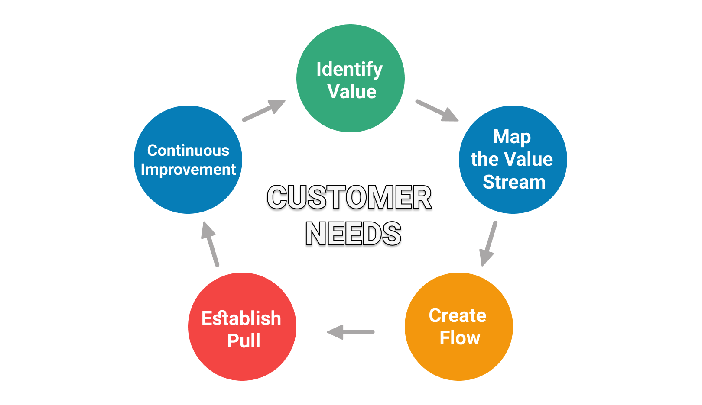
Figure: Principles of lean management
Identify value: Every organisation is striving for serving target consumers with products and services they desire to have. Companies need to add value to serve the target consumers. Specifically, value lies in the problems associated with the satisfaction to the consumers. Lean management excludes the tracks that do not create any value. After value added is identified next steps come into action
Value stream mapping
Mapping the workflow of activities is identified in this step. Literally all the people and actions of various areas are included in this step. Incorporating these all help identify the actions not necessary to the organisations. Application of this process let us know which processes are useful to generate values along with the proportion to the process and which do not thus elimination of the unnecessary steps has become easy in this step. This step tells organisations on what actions are needed to complete by which persons and thus identification of the persons to measure, evaluate and monitor the respective system in the lean management process.
Creating a continuous workflow:
Once the value stream mapping is completed it is important to know that the work process is continuing smoothly. It is common that developing a product requires several cross-functional teams in action where there is the emergence of several interruptions and bottlenecks at any time. It is possible to visualize and remove roadblocks by breaking down the steps in the process.
Creating a pull system
Once there is a guarantee that workflow will continue relentlessly there is the possibility that work will be done smoothly with fewer efforts. However, to make sure the stable workflow there is the requirement for creating a pull system.
In such kind of system, there is the creation of smoother workflow only when there is the demand for such. Thus, this system is helpful in order to optimise the resources and creation of workflow only when it is required.
An example is worthy in this respect. While one goes to a restaurant to have a pizza the baker starts to produce the same only when the order to prepare is made. Not necessary, the restaurant owner prepares lots of pizzas before they are produced. This helps reduce waste and makes the best utilization of the resources. Just like the example, pull system helps minimize the waste and maximise the resources.

Continuous improvement:
After getting all the previous steps, lean management system is in action. This is the final step of the management process that is most probably the most important compared to all the previous four. Problems may encounter at any of the previous steps and requiring continuous improvement by the people of all layers to tackle those successfully. Several techniques are used in order to improve continuously. For example, there can be the arrangement of the daily meeting regarding what has been done previously and what needs to be done since today. Also, it includes obstacles. This is an easy way to daily improvement.
Benefits of lean production method:
The main benefits from the manufacturing method have stemmed from the facts that it focuses on each action in the process as well as the level of the hierarchy. Managers can attain several benefits from the lean production method as follows
Focus: Through the reduction of waste activities, managers can focus on the core activities adding value need to be completed.
Improving productivity and efficiency: Because employees are concentrated only on the actions creating value, they become more productive and efficient in nature.
Smarter process: Through incorporating pull system, only the demanded activities are delivered unless otherwise dictated. This leads to proceed to the next value-added steps.
Better uses of resources: As only the demand accelerates the production, there is no waste of resources for unnecessary actions.
Though the lean production system taking into action employees become faster and accurate to the roles and responsibilities. Thus, lean production management aids to stable operation along with better performance.

3.3 Six Sigma
Six Sigma is a technique that provides tools to organisations to improve the capacity of those organisations. The use of this helps increase the profits and decrease the variation in the process which leads to several other benefits such as reduction of defeats, increased profits, higher employee morale and finally the quality of the products and services to the target consumers.
Six Sigma is a well-controlled technique where ±3s is the process limit from the central line and ±6s is the tolerance limit from the central line.There are several propositions regarding six sigma to be workable in action
- The teams employed in several well-defined projects must have impact on the bottom line of the organisations.
- There is the provision for training on statistical packages to all people where the key people are required to be trained with several advanced statistical packages. The key people are termed as Black Belts.
- DMAIC which define, measure, analyse, improve, and control is used to solve the problems in several areas.
- The need for management support that accelerates all the said functions in organisational contexts.
The difference between the six-sigma and lean management method is quite blurred. The former one is focusing on the process variation as well as the controlling of the said variation. Six Sigma can be beneficial to a company by reducing waste in strategic processes. After detecting the defects by using six sigma, a company can adopt seven waste reduction strategy named reject, transportation, over production, waiting, over processing, movement and inventory (GreyCampus, 2017).
A popular example of using six sigma is Southland C.N.C. which provides machine components to the car manufacturer. Their decision to start new production was based on six sigma and they achieve their desired success by using it precisely (Sixsigmadaily.com, 2013). On the other hand, lean management method is concerned on out of activities those are not adding any value to the organisational contexts. Thus, it can be said that lean management method is more concerned to the work standardisation and smoother flow of the works at the workforce. A sig sigma practitioner must be well aware regarding the both to achieve advantage from those (Armstrong and Armstrong2014).
Lean six sigma is based on data and factors which values most on the prevention of defects over the defects. This approach of quality management focuses more on the satisfaction of the customers that reduces cycle time, waste and variation from the benchmark. On the other hand, it promotes work standardisation and flows thus creating a competitive advantage to the production method. It applies in the cases where both variation and waste are in existence and there is the provision for employment of everyone in the production process.
Integrating six sigma and lean management process:
Anthony et.al (2017) argued that the interaction between these management systems provides several attributes such as quality, cost, delivery, and a newer attribute, nimbleness. Though there is the overlapping between these two activities several shared goals are achieved through the application of these techniques. The difference between these two techniques is as follows
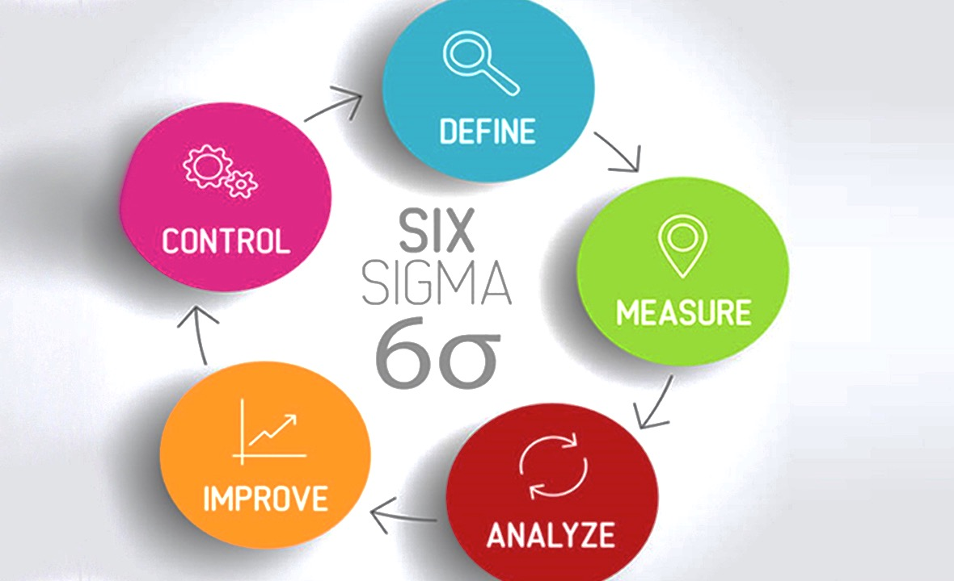
Source: www.escatec.com
Lean is focused on waste reduction whereas six sigma focuses on variation reduction. Whereas lean uses only Kaizen to control the quality process, six sigma focuses on several statistical techniques, design of packages and hypothesis tests etc.

3.4 Triple bottom line
Also known, as TBL or 3BL is an accounting measure that is based on three schools of fields such as social, environmental and financial. Some organisations use this approach as a measure of evaluation to the broader aspects. This management approach believes that firms should focus on social and environmental setting. Instead of one bottom line, TBL focuses on three aspects such as profit, people and planet.A popular example of the company which has adopted a triple bottom line approach is DHL. DHL is a shipping company which consume oil and gasoline to keep their transportation at work. They are now shipping their products through bicycles in European countries such as Germany and Netherlands as part of their social responsibility to keep the environment safe (Earth911.com, 2018).
TBL stresses the need to expenditure on corporate social responsibilities and the impact of the organisations on the societies. John Elkington first used the term in the year 1994 when he first tried to measure the performance in corporate America. He first introduced the idea that we can not only earn profit but also do something better for the planet.
Understanding the triple bottom line requires knowing the full costs of doing business. Not necessarily, the costs of doing business include the costs of production and other overhead rather the full cost structure encompasses the impact of doing businesses on society. Thus, there is the initiation of a sustainable management approach through creating value on the operations. According to this approach, only knowing the financial aspects does not let to know on the full cost structure by the firms (Anthony et.al 2017). Thus, a significant cost structure is not mentioned while only financial aspects are considered.
The three key dimensions of TBL are discussed here that also called “3p”
Profit: It is composed of natural profit earned by the corporations also the losses.
People: It measures the extent to which corporations engage in social activities.
Planet: It measures the extent to which corporations are engaged in environmental activities.

3.5: Japanese Kaizen:
A Sino-Japanese word Kaizen stands for improvement. Kaizen is a popular technology which helps a company increasing productivity and improving inventory management and delivery system as well. It follows the pattern called PDCA meaning plan, Does, check and act (Corporate Finance Institute, 2015). It stresses the need to involve from CEO to line managers (Gilmoreand Williams2017). The main proposition of the approach is that small and on-going positive change can create a large impact in the future. Cooperation and commitment are the two main drivers for the process. Japanese Kaizen is used to attain the biggest goals and sweeping lifestyle changes with the guarantee of improving 1% every day (Hersey et.al 2017).Kaizen model is used by Ford and Toyota. Toyota is using the Kaizen method from the beginning of its operation to improve its activity. Ford started using it since 2006 to make their processes more efficient.
The basic premise of lean Kaizen argues to identify waste and then reduce it gradually. Thus there is the opportunity creation to improve in several areas such as personal life, home life, social life and corporate life etc. The 5 S Kaizen also argues for continuous improvement that basically focuses on visual order, organisation, cleanliness and standardisation. Several key benefits from implementing 5 S programs are improvement in profitability, service and safety and efficiency etc.
There are five steps necessary in order to institutionalise Kaizen both in personal life and business organisations as follows
- Taking small steps forward is the first step of Japanese Kaizen. This basic premise of Kaizen lies in incremental improvements over time.
- Specific programs are identified and they are preceded to actions
- Wastes are identified and they are planned to eliminate from the process
- Appropriate actions are taken to happen the process workably
Mental resources are used to map activities and action plans.

4.0: Role of operation management on Indian automotive industry:
According to Saloner et.al (2018), in order to earn operational excellence and to make the business more profitable players in the automotive sector always like to earn operational excellence through several ways such as cutting costs, improving customer services, achieving operational excellence etc. Supply chain management plays a pivotal role to earn operational excellences and the automotive industry is too much dependent on this department while serving in the market places.
The automotive industry in India plays a major role in the development of the economy and has been considered as one of the key sectors to the development process. Lean production method, six sigma, just in time inventory management system is widely used to increase the performance in the industry (King and Lawley 2013). The application of different operation management techniques in the Indian automotive industry has been discussed here
Maruti Suzuki, the largest Indian passenger car manufacturer has been using Total Quality Management, 6 standard deviations, Poka Yoke in order to earn better operational excellence. Since the inception of the organisation, Maruti Centre for Excellence (MACE) was formed along with the other 21 vendors to offer better quality and productivity. Furthermore, to solve the issues of recalling and defectiveness that other competitors were facing, MACE is helpful since the inception of the operation. In order to reduce resource wastage and improve productivity, the organisation deploys lean production method to the suppliers. Training, audit, implementation and up gradation are the four main activities of the lean production method by the suppliers. These suppliers also follow the same procedure to another tier 1 supplies thus quality is maintained to all the layers of the organisation.
Maruti Suzuki offers training program to both white and blue collared employees in the offices of vendors. The audit comes in the next steps whether the quality is maintained in each stage as prescribed previously. Based on the Suzuki Japan and Total Quality Management, Maruti Suzuki starts the implementation system thus the ways to the reduction of waste, improvement of the productivity and performance. The organisation using the lean management process has been successful in 720 different projects. It has been observed that Maruti Suzuki has been working with 146 vendors with tier 1 companies the significant achievement from the lean manufacturing process is that there is the reduction of rejections from 10993 to 1180 only per month.
Furthermore,the defect has been reduced to 146 from 432. Thus, it can be said that using the lean manufacturing process integrated with six sigma, Maruti Suzuki has achieved a lot of operational improvements as discussed above.
Tata engineering ltd has organised a six-sigma organisation coupled with an extensive audit in each stage of operations. There is the employing of several team members to the accomplishments of the projects. At Tata engineering ltd, there is one at the top of the management level and there are others employed in several operational areas such as at Jamshedpur, Pune and Lucknow. There is the ensuring of filtering processes to identify and remove errors from the process. The filtering process is used in the aggregate level of operation such as an engine, gearbox, body, parts, axe etc.
After the filtering process, three types of audits are completed such as product audit, process audit and finally implementation audit. These all are done in line with the needs of the consumers. Six Sigma operations are conducted in several key areas such as at process level, manufacturing level, plant support services etc (King and Lawley 2013).
Components and supplier level issues come in next of six sigma principles (King and Lawley 2013). There are several strategies followed in the improvement process such as skill enhancement, mapping of the process, cause and effect analysis, failure mode and effect analysis which is helpful in order to identify future problems and thus corrective actions are suggested at this level.
Honda Cars India Limited is a subsidiary of Honda Japan limited and the company is mainly responsible for the disbursement, selling and exporting of automobiles in India started its operation in the year 1995. At first, the operation started in the form of a joint venture between Honda Motor Company and Usha International of Siddharth Shriram Group. Honda Cars India Limited has 121 outlets in India with 21 major cities and 3 union territories. The company started the operation of lean manufacturing process in the year 1996 when the concept was very new to the industry.
In 2002, the head of the operation of Honda came to India from Japan and lean manufacturing started to operate in the full swing under one team with all the members. During the very early stage of lean manufacturing program, the project-based operation was used. At that time, several tools and techniques of lean manufacturing program were used to solve the small-scale problems at the organisation.
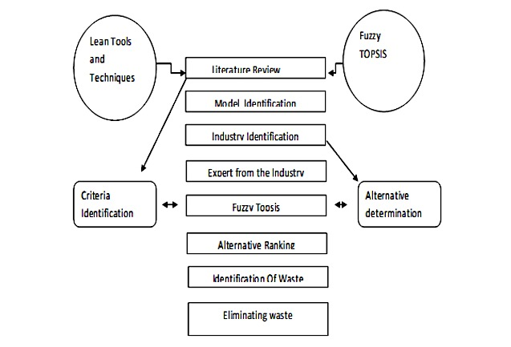
Figure: Effectiveness of the lean manufacturing program at the Indian automotive industry
Five full-time members were first given training from the people of headquarter, Greater Noida. They shared their knowledge, skills and expertise with the others working at the organisation. Lean manufacturing process started to operate in the other production and manufacturing areas. At second, FUZZY Topsis was applied so that proper prioritisation could be applied in the lean manufacturing process. Waste, cost, maintenance and productivity were the main characteristics for the selection of the model line in the industry. At the final edge, it was observed that due to the incorporation of project-based operation and application of the lean manufacturing process, inventory level to be kept at each time was reduced and it reduced the costs of operations.
This lean manufacturing process identified several types of waste at the organisation such as waste of inventory, waste of transportation, waiting times, waste of unnecessary processing, waste of unnecessary motion, defeated products and services etc. The organisation uses the continuous improvement process until there is the selection of proper order of rank. Since the level of inventory started to reduce several other types of wastes started to decline also.
In order to the implementation of lean manufacturing level, there is the full level of support from the top authority as the process is cost effective and conducive to the increased performance of the organisation. Due to better incorporation of the lean manufacturing at the organisation, Honda India limited was awarded the engine of the year in the year 2014-Honda Eco Technology-Sedan of the year. Now the organisation has been used extensively as a role model for the use of lean manufacturing process. Mahindra and Mohammed were established in 1945 and later named as Mahindra and Mahindra in the year 1948.
Having headquartered in Mumbai, Mahindra and Mahindra is one of the largest manufactures of the automobile in India with the employees more than 150000 and ranked as 19th among all existing companies according to fortune 500. One of the critical issues faced by the firm is not maintaining the total quality fully though the quality is good enough. The tractor is the main product while there is a higher rate of rejection. Total Quality Management started to operate at M&M in three phrases such as introduction phase among 1990 to 1994, promotion phase 1995 to 1994 and development phase since 2000 to onwards. During the introduction phase focus made on improving manufacturing through process control, developing the products bought out at the process and finally increasing productivity and reducing the cost of poor quality (Juse.or.jp, 2016).
In promotion phases several tremendous achievements were obtained such as standardisation of the operation according to international standards, improved operational excellence, ISO 9000 certification, up gradation of the manufacturing facilities, obtaining of QS 2000 standards in the quality maintenance process, proper initiation of Deming Prize Guidelines etc. During development phases, there were also several outstanding achievements at the organisation such as the development of the core processes to introduce new products and services in the market, sales operation improvement, customer-supplier management, obtaining of the environmental management system standard ISO 14001. Since then there was the pressure on the employees to the continuous development and it belongs to the 100 percent of the employees.
The adoption of TQM benefits the organisation through several ways such as reduced rejection rates, higher employee involvement to the continuous development process, and innovation of several market-required models such as 15 models within 3 years. As a result of the quality operation, the organisation secured the first Deming award in the year 2003 globally. In the era of the 21st century, TQM is the only path to become successful in the manufacturing industry. Though it is painful to operate with the full installation of TQM there is the no proper alternative of this (Claver and Tarí, 2008).

At Ashok Leyland, there is the strongest ecosystem followed between employees and processes at the organisation. The organisation is fully using TQM manufacturing process and there is no comprise on the quality goods and services to the target customers. The use of state-of-the-art commercial products and young employees in the manufacturing process led the company to earn the Deming Prize award in the year 2016 which is the only organisation outside of Japan in the manufacturing industry. The incorporation of multi-phased implementation system, robust system to solve the problems, employees’ supplier's relationships, proper training and development have made a better quality operation at the organisation. Improved quality gate, advanced automation and robotics, processes to improved mistake proofing make the manufacturing process attractive at the organisation. To Ashok Leyland, just winning awards and earning benchmark operational strategies are not the core concepts rather the satisfaction of the consumers that make the operation more attractive and time friendly.
At Hyundai India that is a subsidiary of South Korea based Hyundai motor ltd has been operating successfully since 1996 in India. Total Quality Management process is one of the integral parts of operation at the organisation. TQM is ensured at several key areas at the operation process of Hyundai India Ltd as discussed below
Customer-related process: The organisation is careful regarding the services to the customers during sales and after-sales services and post-delivery arrangements, provisions for dispute settlements, post-sales problems mitigation etc (Taylor, 2015).
Design and development: At this stage process design and planning for the products are done. Validation, verification and rearrangements of the activities provide a greater scope of serving excellences to the consumers (Saloner et.al 2018).
Design and development inputs:At this phase, the organisation does several activities such as requirement for the key materials for the development of the products, compliance with the laws and regulations, extra elements if required, ideas and processes generation from the several previous designs etc.
Design and development outputs: This stage is concerned with whether the key inputs are used in the process properly, the specification of the products and services whether they met the criteria that are essential to the product. This stage provides appropriate information regarding selling, distribution, and promotion and after sales services etc.
Design and development review: At this stage whether the performances of the products are satisfactory are measured. Several other activities include the meeting of requirements checking by the products, identification of any problems and providing suggestion to solve the problems etc.
Validation of the products and services:Finally, the products are services are validated through using several arrangements such as establishing criteria for reviewing, approval of equipment’s, the use of specific methods and procedures, revalidation etc (Taylor, 2015).
At Hyundai, India limited these stages are followed strongly so that the quality is up to the mark to the target consumers. Following the stages make the quality process effective and supportive to the market.

5.0: Recommendation on the base of the above literature review:
Saloner et.al (2018) argued that the more the days are advancing, the more the operations are becoming challenging in the industry where manufacturing is one of the cores to operate. It is important to all the firms that both the management and operation management theories are understood first and then are applied in several situations so that proper quality in the operational areas can be met. First, the applications of management theories are discussed and secondly the operation management theories. From the Maslow’s hierarchy of needs theory, it has been gleaned that employees require several kinds of needs and they are to be fulfilled at hierarchy order being maintained. Human capital is the most important capital in organisational contexts. They need to be kept satisfied and active to achieve the performances of the organisations. The fulfilment of the needs of the employees shall keep themselves satisfied and it will motivate them to do something innovative and better at the organisational context. Organisations following the theory have been doing better over the others in several industries.
Apart from the Maslow theory, there are other management approaches need to be maintained so that progresses can be done in other functional and operational areas. Organisations need to practise a strong chain of command in operational contexts. Decisions are to be made on the basis of democratic principles. There shall the scope to everyone in the decision-making process. This will enhance both the performance and productivity of the operational contexts. Employees will be more motivated and satisfied if they are given the opportunity to participate in the decision-making process. There are several factors impacting negatively on the working conditions and these are to be discharged from the organisational contexts. On the other hand, several other factors termed as Y factors impacting positively on the performance and these are to be promoted so that more performance can be achieved from all layers of management at the organisational contexts.
In the era of modern technology and quality assurance process, operation management theories play a greater role in the achievement of successes and milestones at several key areas (Jeffs, 2015). Given the higher competitiveness and needs of consumers, operation management theories provide the path as to how firms can be successful. Including the automotive industry, all the manufacturing organisations need to operate through innovative and successful ways so that competitive advantages can be achieved over the other rivals.
SixSigma, Lean-manufacturing process, Japanese Kaizen, Triple bottom line are needed to be understood and applied properly by the firms and industries in several areas. Advanced technologies and automation services make services more advanced and more competitive. There is continuous pressure on the firms to increase the quality of products and services so that both profits can be earned and long-term sustainability can be maintained by the organisations.
Increase in productivity is ongoing pressure on the firms in several industries (Saloner et.al 2018). Operation management theories are helpful in order to augment the productivity and performance of the firms.Thus, it is important to apply several operation management techniques to boost the level best performance by the organisations. Planning, organising, controlling, monitoring and evaluation are several integral parts of performance improvement. In these areas’ management need to be careful and tactic to go further by the organisation. Thus, incorporation of better strategies in these areas requires several attractions and these need to be properly done.
It is important to increase productivity by the firms for all the time being. Productivity is measured by the input-output ratio. Operation management techniques always work to make the best uses of resources so the optimum productivity can be achieved in the organisational contexts. Thus, it is necessary to go ahead with all the key operation management techniques for better performance in several key areas.
For all the organisations, the first target is to meet the requirements of the customers and if the customers are satisfied properly, the organisation is said to be successful. Operation management techniques are integrated with the approaches to meet the needs of the customers. Thus, it is suggested to implement the techniques of operation management to keep the requirements of the customers.
Profit is the key to long-term sustainable management (Palmer, 2017). To earn a profit, it is important to make the best use of several resources and materials available in the organisational contexts. Several techniques of operation management help earn industry average even higher than the normal rates. Thus, understanding and application of the operation management techniques are required to earn profit and sustain in the long term. These issues are to be properly understood by all layers of management and applied as when required.
It is estimated that in the long run only the successful players will sustain and those who would not be capable of meeting the needs of eras will be out of the market. So, forecasting on the activities and arrangements of activities would lead the success in industries of several kinds. Players need to be aware of the operation management techniques and research on the activities that would lead to success in the industries.

6.0: Conclusion:
Management has advanced a lot over the years. There are several evaluations of theories, practices and approaches in the operation management practices. To increase productivity and keeping pace with the changing environment, operation management has been playing a vital role. In this century there is the requirement for changes and evaluations in several management practices. Modern workplaces are not as simple and manual as in the past. To cope with the modern workplace challenges and other contemporary issues, management stresses the need to collaborate with the other departments such as human resource to augment the performance of the employees. Emphasis on training and development helps increased performance by the employees. Several needs and demands are required to analyse and there is the need to satisfy them to keep employees satisfied and motivated at the workplace. It can be assured that if all the functions and activities of operation management theories can be applied properly, organisations would be capable of sustaining in the long run.

7.0: References:
Anthony, R.N., Govindarajan, V. and Dearden, J., 2017. Management control systems (Vol. 9). Boston, MA: Irwin McGraw-Hill.
Armstrong, M. and Armstrong, M. (2014). Armstrong's handbook of strategic human resource management. London: Kogan Page.
Arvinen-Muondo, R. and Perkins, S. (2013). Organizational behaviour. London: Kogan Page.
Bondarouk T, Ruël H and Looise J, Electronic HRM In Theory And Practice (Emerald 2015)
Bhaskar, A.U. & Mishra, B., 2017. Exploring relationship between learning organizations dimensions and organizational performance. International Journal of Emerging Markets, 12(3), pp.593–609.
Business Intelligence. (2018). Top Automotive Companies in the World - 2018 | Automotive Industry. [online] Available at: https://www.infinitiresearch.com/thoughts/top-automotive-companies-world-2018 [Accessed 12 May 2019].
Candyindustry.com (2017).Technology[online] Available at: https://www.candyindustry.com/topics/2667-technology [Accessed 11 Oct. 2017].
Carpenter, M. and Sanders, G. (2014). Strategic Management. Harlow: Pearson Education Limited.
Chanda A and Shen J, HRM Strategic Integration And Organizational Performance (Response Books 2018)
Chen, C. (2018). Strategic human resource practices and innovation performance: the mediating role of knowledge management capacity. Strategic Direction, 25(6).
Claver, E. and Tarí, J. (2008). The individual effects of total quality management on customers, people and society results and quality performance in SMEs. Quality and Reliability Engineering International, 24(2), pp.199-211.
Drucker, P. and Maciariello, J. (2017).Management. London: Collins.
Drucker, P., 2013. Management. Routledge.
Easterby-Smith, M., Thorpe, R. and Jackson, P.R., 2013. Management research. Sage.
Editorial Board. (2014). Human Resource Management Review, 24(3), p.IFC.
Farmer, M., Yellowley, W. and Smith, P. (2013).Organizational Behaviour. London: Taylor & Francis Ltd.
Gilmore, S. and Williams, S. (2017). Human resource management. Oxford: Oxford University Press.
Hayter, C. (2017). Overview of the UK population - Office for National Statistics. [online] Ons.gov.uk. Available at: https://www.ons.gov.uk/peoplepopulationandcommunity/populationandmigration/populationestimates/articles/overviewoftheukpopulation/mar2017 [Accessed 14 Oct. 2017].
Hersey, P., Blanchard, K.H. and Johnson, D.E., 2017. Management of organizational behavior (Vol. 9). Upper Saddle River, NJ: Prentice hall.
Ibisworld.co.uk. (2017).Chocolate& Confectionery Production in the UK Market Research | IBISWorld. [online] Available at: https://www.ibisworld.co.uk/industry-trends/market-research-reports/manufacturing/manufacture-of-food-products/chocolate-confectionery-production.html [Accessed 12 Oct. 2017].
Jeffs, C. (2015). Strategic management. Los Angeles: SAGE.
Jones R, HRM Fundamentals (Pearson Education 2019)
Juse.or.jp. (2016). [online] Available at: https://www.juse.or.jp/english/information/pdf/TopInterview_M&MFS2013_05.pdf [Accessed 12 May 2019].
King, D. and Lawley, S. (2013). Organisational behaviour. Oxford: Oxford University Press.
Likert, R., 2018. New patterns of management.
Likert, R., 2017. The human organisation: its management and values.
Martin, J. (2014). Human resource management. Los Angeles: SAGE.
Palmer, G. (2017). UK firms 'failing to prepare' for regulation changes after Brexit. [online] The Telegraph. Available at: http://www.telegraph.co.uk/business/2017/06/29/uk-firms-failing-prepare-regulation-changes-brexit/ [Accessed 14 Oct. 2017].
Saloner, G., Shepard, A. and Podolny, J. (2018).Strategic management. New York, N.Y.: Wiley.
SHRM 2012-2013 Health Care Benchmarking (Society for Human Resource Management 2012)
SHRM 2015-2016 Human Capital Benchmarking
Sinha, J. (2013). Culture and organisational behaviour. New Delhi: SAGE.
Statista. (2017). UK: number of social network users 2015-2022 | Forecast. [online] Available at: https://www.statista.com/statistics/553530/predicted-number-of-social-network-users-in-the-united-kingdom-uk/ [Accessed 11 Oct. 2017].
Taylor, F.W., 2015. Scientific management.Routledge.
The SHRM Learning System (Society for Human Resource Management 2017)
Tsui A and Lai K, Professional Practices Of Human Resource Management In Hong Kong(Hong Kong University Press 2013)

