
Skills for the Workplace
Module Assignment Submission
Student Name: | Sara Griffiths
Student Number: | 1302902
Module No: | BMSK4003
Module Title: | Digital Skills and Research Methods

Statement of Confirmation of Authenticity
By the act of making this submission, the student declares that this is the work of the student named above. The work has not, in whole or in part, been knowingly presented elsewhere for assessment, or where assessment has been built on a previous assessment, this has been identified. Where materials have been used from other sources it has been properly acknowledged. If this statement is untrue, the student acknowledges that an assessment offence has been committed.
Attention is drawn to the plagiarism and unfair practice policies of both the University and of ILM.
Permission for ILM to use this script
ILM uses learners’ submissions – on an anonymous basis – for assessment standardisation. By submitting, both the centre and the learner agree that ILM may use this script on condition that identifying information is removed. However, if you are unwilling to allow ILM use this script, please refuse by ticking the box: □

Table of Contents
What has been the impact of 21st Century Technologies on the modern workplace? 3
Part 1 3
An Overview of the 21st Century Workplace 3
An in-depth look at technologies used in own workplace 3
Part 2 4
An exploration of the use of social media in the workplace generally 4
An in-depth look at the use of social media in own workplace 4
The use of social media to enhance networking and career prospects 4
LinkedIn Profile 4
Conclusion 5
References 6
Appendix 1 7
Appendix 2 8

What has been the impact of 21st Century Technologies on the modern workplace?

Part 1

An Overview of the 21st Century Workplace

Technology keeps changing through time and now in the 21st century it is changing workers how they work in their jobs. Technology has improved working conditions. Changing tedious working conditions & time-consuming wasteful procedures. Now increasing productivity and saving money in the new way of working with technology. We can send emails, text, video chat, video conference with colleagues or directors through social networking apps like WhatsApp, Skype, LinkedIn, Facebook, Instagram, Dropbox, Cloud, Evernote, websites etc. If we need to search for something we can use google or another search engine. Everything has become available globally through WIFI! There is an app almost for anything or everything.
Computer programmes built and designed for small companies and large organisations. Management programmes to flag up risks in business projects and to ensure employees are up to date with compulsory training e.g. space management programme. Technology is globally increasing manufactures and businesses to work across the world to different countries in trade and banking. The communications to world business trade are bigger and easily merged together through digital technology. Previously business deals would take months due to sending letters through the post. Now in the 21st century decisions can be discussed through skype in group chats. Emails can be sent in minutes and payment transactions can be paid immediately. The speed of communication has increased in the workplace. Thus, saving money for the employer. There is a familiar quote many have used in business “time equals money”!
Through technology it enables us to work closely & work remotely. Colleagues don’t need to be physically in the same place. Groups and teams can hold video – conferencing technology & work on shared documents on cloud-based file sharing. Tools like google drive. Shared open offices now offer a no designated desk. Staff can now hot desk and work remotely with several devices such as a smart mobile phone, laptop and iPad. No longer do you need to be located where your job is due to being able to work from home. Styles of work has changed such as freelancer known as gig economy. Having a flexible hour of work and powered by a plethora of apps that apply for -x- business model across multiple industries. Gigging enables the employer to take on several freelance jobs at once. Bringing other contractors in when needed and able to pay on many platforms such as gusto. Many apps have given the public opportunities that weren’t able to be reached before technology. Work was harder to find jobs. People would find contractors before the 21st century on the news paper or the yellow paper. Whereas today for example they could download an app for my builder and hire or advertise that your looking for work or need to hire a contractor in to complete works to be done.
Technology has given us new techniques such as word processing programs making work productive and efficient. Word processing is a quick and convenient method for writing reports, letters and so forth. Long gone are the hardy typewriters in the office which gave a lot of health problems to clerical administrator’s wrists. The delays in sending letters etc via mail. Where today we can store files into an electronic filing system on computers and laptops. Word processed documents can be stored on many programs on systems. Easily attached to emails and saving time and money at one given time. Cloud technology has made it easier to view and edit files a remote server available from any approved device. Excel is a programme used in nearly every organisation. A simplistic way of keeping data of calls, people’s names, addresses, payments, financial expenditure etc. Excel can perform many tasks by making a spread sheet with different formulas to keep accurate data and saving time.
We have an up to date method of keeping invoices and accounts by using different apps such as quick books. This too saving money and accurate accounts of invoices, inventory, record payments, sales, pay bills and payroll. Previously this would have been an accountant’s role, but self-employed business can keep control of what their expenditure and monitor invoices and payments. Most accountants recommend that self employed business’s uses this type of programme as it is easier for them to access online their invoices by sharing passwords for the app. Previously the accountants office would be covered by boxes of files filled with invoices and a state of fear held by the self employed Ltd company director of the business as they would find that the end of the financial year would be a dread. In the 21st century technology makes the workplace life far easier and less complex in the business world.
Business productivity software is relied on because it provides many tools to help with the challenges, they face on a day to day basis. Managers can track progress of different phases and completion. This can help the manager monitor the performance and offer coaching to keep performances up to standard and raising productivity.
Technology has got good and bad aspects in the workplace. The negative impact is that employees are supposed to be online all the time, this affects they’re work & life balance. They are reachable online via email, WhatsApp, smart phones and social media. However, the good outweigh the bad by using technology in the workplace for productivity, communications mean everyone is easily accessed quickly. All businesses are trying to keep up with technology. Technology gives choices in the workplace. It has changed incredibly within the last 20 years in the workplace. Privacy rights must be protected for the employees and that technology shouldn’t be abused by contacting staff out of working hours.

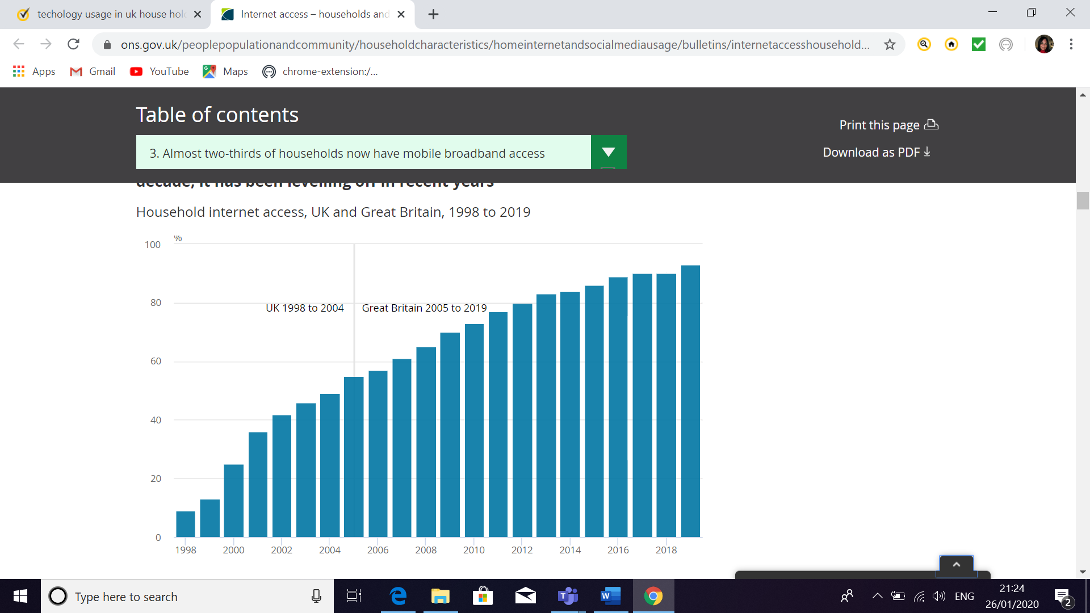
https://www.ons.gov.uk/peoplepopulationandcommunity/householdcharacteristics/homeinternetandsocialmediausage/bulletins/internetaccesshouseholdsandindividuals/2019



An in-depth look at technologies used in own workplace

Working for Pobl within the umbrella of care & support sits Carmarthenshire Bond Scheme. Carmarthenshire Bond Scheme provide bonds for homeless or potentially homeless in the Carmarthenshire area. Over the recent years has formed changes for Gwalia as they merged with Seren Living, Charter Housing now forming one of the largest family housing associations in Wales. Carmarthenshire Bond scheme was whilst before with Gwalia based in an office hot desking but due to technology and new devices the scheme despite being managed by Pobl were moved to Carmarthenshire County Council offices. Working in partnership with the council, shelter and environmental health. The scheme is micromanaged by Pobl from Newport. Technology is the most important aspect in having the communication within Pobls organisation for the trust and productivity to be satisfactory.

Technology is used daily ranging from the computer desktop and tower in the office.
WiFi is used to connect onto the Citrix system that all employees use at Pobl.

The computer holds documents saved in files in word processing. Excel is used for important data of tenants, estate agents collaborating stats for monthly reports and savings. Financially we can monitor if someone has saved for their bond within twelve months or is in arrears. We monitor bond claims for damages and rent arrears. With out the use of Excel we would not be able to efficiently monitor everything, and work would not be done quickly or accurately as it is done now.

Using Microsoft office, Word processing, emails, PowerPoint daily. Word is quick to use, precise and have many benefits such as tools that can alert the employee if there is a spelling mistake or can change the colour or type of font to suit the letter, poster or report. Long gone are the days where typists would be using shorthand and reals of paper with typing corrections.

The office is council owned and we share with all other employees three printers. The WIFI connects to the printer and is sent to the printer. It is easy to use and quick We can scan documents from the printer to our emails.

Pobl has a computer programme on their Citrix called INVU. INVU stores all documents for Pobl.

We have been provided with a smart phone. On the smart phone we have several apps as to be able to work remotely. The apps are WhatsApp, Microsoft office, emails, calendars. A safe app to ensure we are safe whilst working remotely and if in danger we can send an alert to managers and the police.
To adapt to remote working we have laptops with the same log in details and can equally access the same files, excel, INVU, Microsoft office as we would if we were working in the office. We have ipads to use if we are in tenants’ houses. Thus, making us able to work from other locations not only just in the office. We work from job centres and food banks and can contact other organisations on the same systems via laptops and smart phones. Our productivity is high whilst remotely working in all locations.

Managers from Pobl which is a large organisation can monitor online activity by the employer by seeing length of time they are logged into the company system. The manager would receive flags of up to date online training for them to notify the staff to complete risk assessments or online training to be completed adhering to their policy.

We in Pobl use the below spread sheets to store data, stats to understand how the bond scheme is delivering a service. The excel sheet stores data that is individually inserted to record monthly, quarterly measurements of bonds, homelessness and causes of potentially homeless individual, couples and families. The examples of excel spread sheets are seen below.

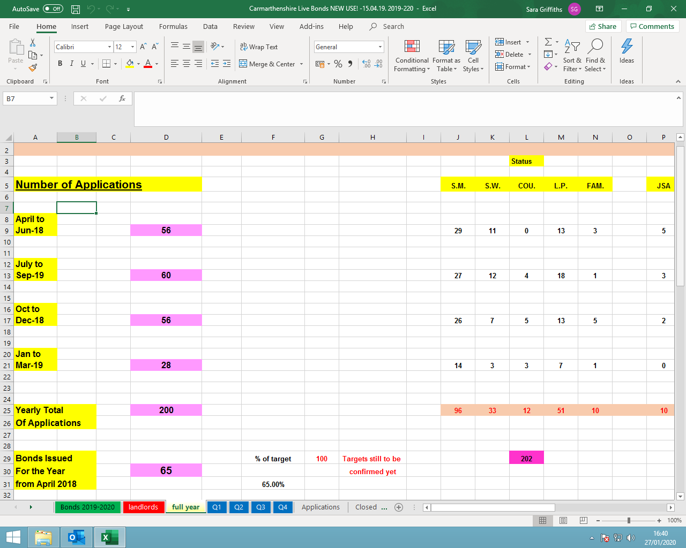

Part 2

An exploration of the use of social media in the workplace generally

Social media is the workplace is accessed via smart phones, computers, tablets to keep up with new updates, news, keeping in touch with people and enable to pass messages or reviews etc.
Social media can affect communications among managers & their employees. The public can be influenced by reviews and how the organisation promotes their business. Social media can influence how you judge another colleague or treat them. I believe it can form a bad opinion of someone simply by what you see and read about someone, an organisation or business. Contacting colleagues after working hours can blur the lines.
Google estimates reports that misuse of the internet and social media by workers costs Britain's economy billions of pounds every year. It is said that many employers are already grappling with issues like time theft, defamation, cyber bullying, freedom of speech and the invasion of privacy.
There are certain policies against the following:
The Human Rights Act 1998 Article 8 gives a 'right to respect for private and family life, home and correspondence'. Case law suggests that employees have a reasonable expectation of privacy in the workplace.
The Data Protection Act 1988 covers how information about employees and job applicants can be collected, handled and used. The Information Commissioner's Office has published an employment practices code - Information Commissioner's Office: Quick guide to the employment practices code [PDF, 168kb] - to help employers comply with the law.
The Regulation of Investigatory Powers Act 2000 covers the extent to which organisations can use covert surveillance.
Most Employees should regularly check the privacy settings on their social networking sites such as Facebook nor other social networks at the same time considering whether they want or need co-workers to see their profiles.
It has been found that creativity and morale were boosted by social media use at work that indicated that employees who engaged more frequently in social media activity were more likely to leave their organization soon. The authors of this study attribute this behaviour to their ability to grow their professional network through these channels, as well as to search directly for new jobs on sites like LinkedIn.
Blocking social media totally on company computers both tends to produce negative results in terms of morale and is generally negative. Employees will still access these channels on their own personal devices, and they may be more inclined to discuss your organization in a negative light on them as a result.
A policy outlining appropriate behaviours is the most effective strategy for managing the use of social media in the organisation whilst safeguarding & managing risk and protection their reputation. Social media is too powerful and potentially beneficial to prohibit entirely, so savvy companies will strive to utilize it to their benefit and flourish.
we are experiencing a blurring of the distinction between labour and leisure time in multiple settings. To many employees have become addicted to smart phones whilst in the workplace. Looking through facebook, Whatsapp, Twitter during work time. How can a company monitor productivity whilst there is nothing to monitor unless it is on the company’s smart phone or digital devises? How do we keep boundaries under order of use age whilst maintaining a good trusting relationship with employees rather than a threat to the established order? Good management and polices ensure that everyone who is employed realises lines cannot be blurred or crossed.
Use of social media in the workplace provides numerous opportunities for businesses and individuals to connect and improve status. The use of social media also raises concerns about privacy and how personal information of either an employee or employer will be handled and disclosed. An employer may breach an employee’s privacy by disclosing personal information, via social media, of that employee to other staff members in the workplace. There is limited recognition of privacy protection under common law, it is necessary to consider privacy legislation
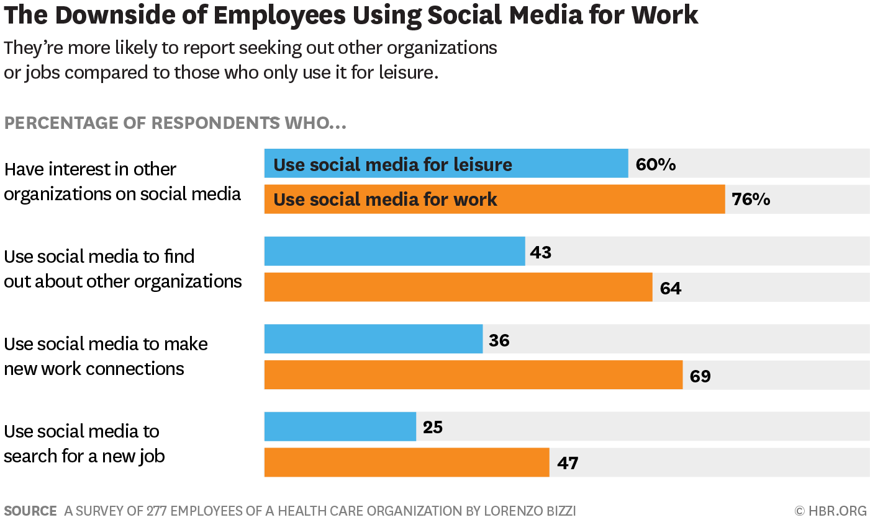

An in-depth look at the use of social media in own workplace

Pobl Group whom I work for has a policy and procedure for Social Media and Networking. This gives guidelines that the employees must adhere to whilst Networking and Social Media.
Pobl Group uses social media to market and advertise what they do and to be open transparent to the public to see the growth and productivity. Pobl is the largest housing association in South Wales. Pobl has merged Gwalia, Seren and Charter living into one huge group now named Pobl.

The company uses their own website to advertise jobs called Pobl Point. Also has a facebook page, Twitter and Linkedin.
Having theyre own webpage is an advantage to the public wanting to possibly research the company before possibly applying for a job with the company. It is easy to use, quick and not time consuming.
The public can like posts and message the organisation. However, there is a negative impact to social media. Please see screen shots that I have included into this assignment of reviews for Pobl on Indeed. Some of the reviews are very negative and would make members of the public re consider applying for work within the company. Could this have been avoided if there wasn’t in the 21st Century social media and digital exclusion? Yes 100% this wouldn’t have happened about 10 years ago. Pobls procedure can discipline and in serious cases dismiss staff for posting negative comments about their business. The policy stipulates what the staff can say or cannot say about the company, its clients or users, or other people within their organisation. This is critical that the staff understand that these restrictions apply using their own phone, tablet in their own time, as it should not be used out side of working hours.
Without a social media policy, employers will find it more difficult to dismiss or even to discipline staff for posting inappropriate comments. To start with you will need to find out how much damage or potential damage has been caused to your business reputation – something you may prefer not to do, as it runs the risk of highlighting to a client, something that they may not be even aware of. Even if you can show that your client might have read the blog etc, you should not take a disproportionate view of the damage that has or could have been incurred.
The question of who owns contact lists and other information put on an individual’s LinkedIn profile is starting to cause concern for a number of businesses – particularly those who rely on close connections and developing good contacts.

The starting point is that if a contact list is developed and used for business purposes by the employee in the course of his employment, the employer is regarded as the maker of the list (unless the parties have agreed otherwise).

About online profiles there is a distinction between ownership of the account and of the information contained within it. The employee will own his profile but what about information about clients, products or other business information? We do not have any decided cases on this point, but a number of cases are being brought both in the UK and abroad which hopefully will provide some clarity.

The best way to address potential problems and ownership of contact lists is to have a coherent policy which makes it clear that the business owns its confidential information, intellectual property and clients and business contacts. Well drafted restrictive covenants will also assist employers to protect this type of information.
Accessing a candidate’s social media profile is a legitimate recruitment tool. It can be a quick and cheap way to obtain insight into a candidate’s real character and their potential suitability for the job. Employers must not use this information to reach decisions that are discriminatory. I recommend that you conduct social media investigations in a uniform way, by for example, searching the same sites for all the applicants for a position. Information obtained from social networking sites could be screened by someone outside the recruitment process to ensure that any information relating to an applicant’s disabilities, sexual orientation or other protected characteristics are removed from the profile.

Vetting of job applicants via social media will involve processing personal data (when the employer either uses or records the information obtained), so you must ensure that your enquiries comply with the Data Protection Act.
Vetting should be used to confirm specific points rather than for general intelligence gathering;
Information should only be sought from sources where it is likely that relevant information will be revealed; Employers must avoid placing reliance on potentially unreliable sources.
You may find that in obtaining social media profiles, you have more information about some candidates than others, particularly those without electronic footprints. There is nothing wrong with this – it is usual for employers to have varying degrees of knowledge about candidates. Careful interview questioning will enable all candidates to expand on their suitability for the role.
Anything done by an employee in the course of their employment is treated as having also been done by the employer regardless of whether the employee's acts were done with your knowledge or approval.

Business’s will only be liable for your employees' discriminatory actions if these are done "in the course of employment", a term which is given a wide meaning. It will include conduct that takes place off the premises and out of normal working hours such as at social gatherings or parties organised or attended by the employer.
Companies should ensure that your employees understand that they should not post discriminatory comments about other members of staff, or customers on social networks – even on forums that they consider to be private as they have no control over whether their comments are forwarded or posted to other sites.

Staff who feel that they have been bullied by their colleagues in this way, will expect you to act to prevent further harassment. You should investigate their complaints and if substantiated, take appropriate action against the perpetrator.

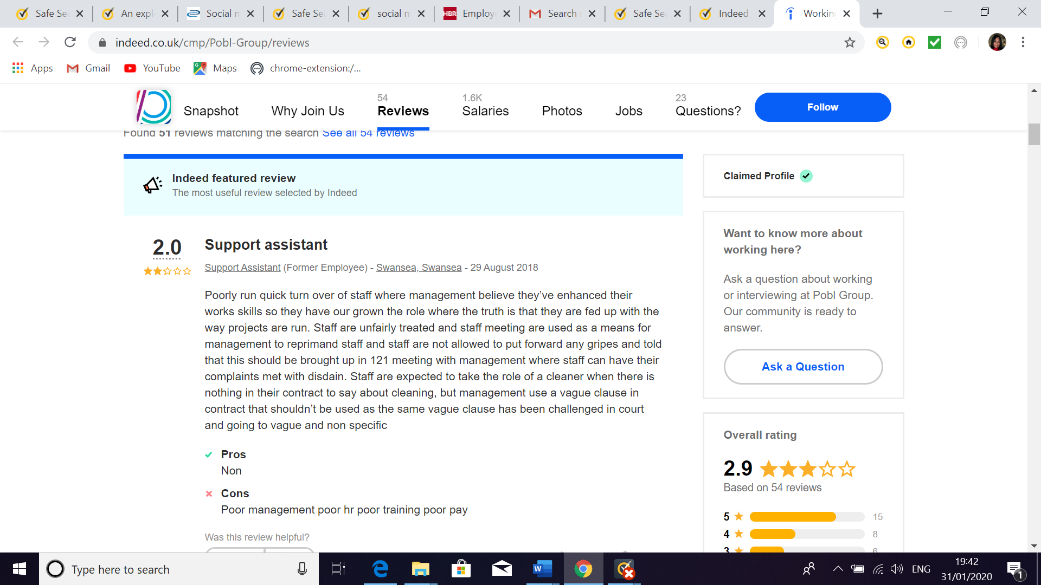
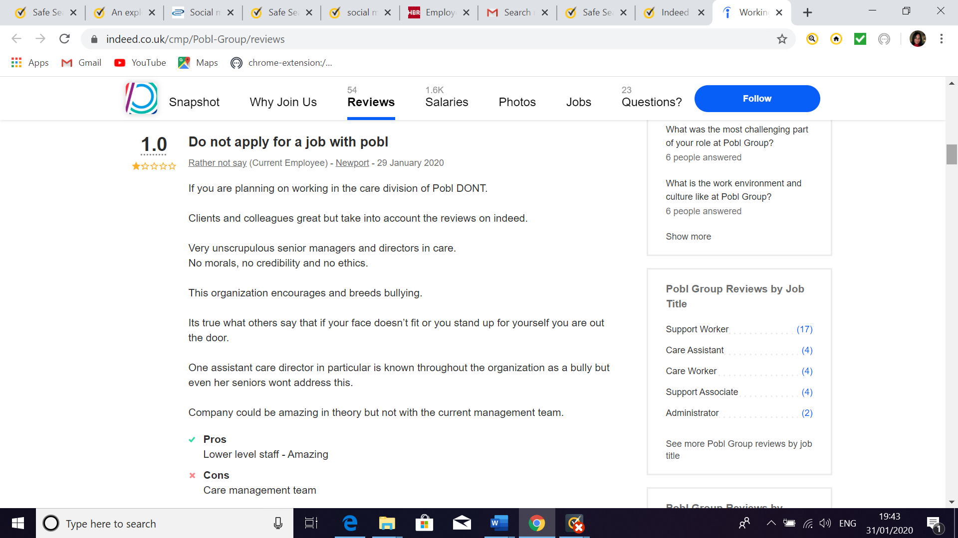

The use of social media to enhance networking and career prospects

Social media has greatly transformed the business landscape for the organisation called Pobl. This organisation uses many platforms as It is one of the most important aspects of digital marketing, which provides incredible benefits that help reach millions of customers, partners, stakeholders and contractors.
Linkedin profiles is a way you can show who your employer is and what your previous employers have been. This is an open way to show off your successful career and away of networking with other employees or from other organisations. Many career hungry employers search for suitable candidates to successfully fill their job vacancies. They can look who your connections are, who has endorsed you and if you have the skills that mirror what they are looking to employ.
LinkedIn has jobs that are advertised on their website. You can see what employees are also on LinkedIn and if brave enough you could tip your toe in the water so to speak and approach the employer to enquire and show interest in the job vacancy. Making yourself known and they could look at your LinkedIn profile.
I have a LinkedIn profile. I have included the profile within the appendix. I personally find LinkedIn useful as to job search and to network.
However, LinkedIn has negative effects too! Some could use it to negatively comment to a company.
You can advertise your C.V on Indeed, job search engines where this is a way to allow employers look at your C.V and contact you.
On incidents I do feel that applying online for a job vacancy can be fair in some respects as they do not know anything about you and cannot discriminate. On the other hand, sometimes if there is a lot of applications you could be overlooked, and you are the ideal candidate. There are pro’s and cons for online job opportunities.
I feel that Facebook can bring negativity to a prospective employee as an employer could search your profile and could take the first impression wrong. Especially judging the person who has applied for the job if they were seen to ‘partying the night away with empty cans of alcohol looking drunk or maybe someone looking very conservative and boring. First impressions could cost you not ending up with the desired job and really that one night of showing on Facebook cost them a hefty price of being unsuitably employed by most employers. Employers legally shouldn’t look due to privacy at prospective employers but unfortunately, they sneakily do.
The way you present yourself on Facebook, Twitter, Instagram and LinkedIn are all completely different and the way you show yourself is equally important. I have included in the appendix a photo from Facebook of Catherine Zeta Jones photographed profiles of each social media page and I thought it explained excellently the answer to this question.

Linkedin Profile
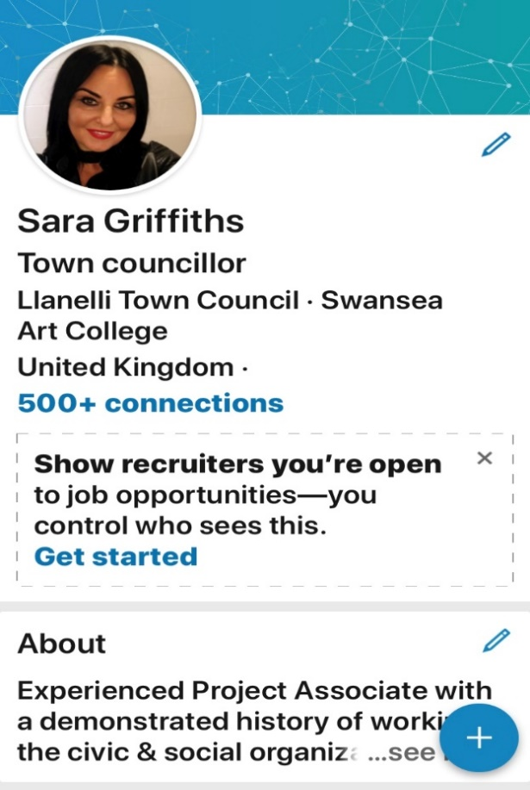
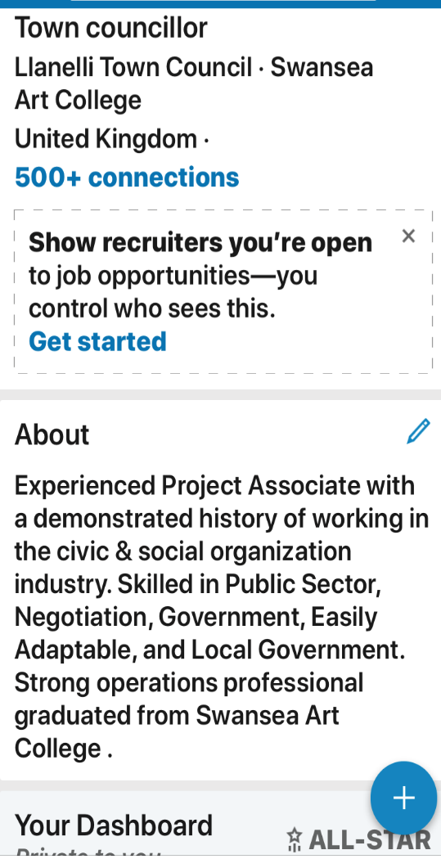

Conclusion

Social media has helped create connections, gain knowledge and information. Most people have one account on a social networking website. Everyone suddenly is known to everyone. No need for the yellow page directory to find a contact number. These days you can instantly contact someone directly by searching social media. You have to protect yourself on social media. Maintain that your privacy is on the correct settings and be vigilant protecting your family and their accounts.
Everyone joins a social media due to not being stero typed as not to be left behind. Whereas it should not be peer pressure it is a matter of choice and if you feel you would benefit it emotionally and career wise.
Websites such as Facebook claim that people communicate and manoeuvre in these networks rather than be lonely and they sense of belonging to friends and communities. Hence making you less lonely.
I argue that conclusion by Facebook and I feel that it causes more people to become lonelier and more depressed due to social media. More youths today are on PlayStation and making virtual reality friends which causes isolation. Virtual reality is not face to face and causes a make-believe world. Social media is abused and misused. Fake Facebook profiles causing people distress and harassment with bullying. I feel the negative effects on social media out way the good. There has been a huge number of teenagers bullied severely through facebook and other social media networks. There should be policies to protect people from bullying and discrimination on these sites. Some thing will cause the same hurt and pain unless people are protected. It is dangerous and bullying goes unnoticed. Also, as a parent I worry over my daughters and even though they are married I still worry about stalkers. My eldest daughter plays rugby for Wales and is on most social media.
My conclusion is that we all should address the problems of social media. How many banks are hacked on a regular basis. Social media stops interpersonal growth. The digital technology can cause international problems by the growth of narcissim in so many internet users.
If the user is not psychologically affected by social media, they are still in danger. Nobody is immune to the harmful side effects social media including identity stalkers, theft or hackers. Social networking is permitting hoaxes and false information to cause widespread chaos. “The dark side of social media is that, within seconds, anything can be blown out of proportion and taken out of context. It is very difficult not to get swept up in it all” (Formichetti.) If there are no regulations or limitations on social media, the repercussions will accumulate. People need to change the destructive patterns of social media use before it destroys society. The fast, easy access to information that is supposed to be beneficial to society is detrimental to society.

References
https://smallbusiness.chron.com/technology-affect-work-environment-today-27299.html

How Does Technology Affect the Work Environment Today?
by Grant; Reviewed by Michelle Seidel, B.Sc., LL.B., MBA; Updated March 16, 2019
4Robert Spence, Social Media for Business just got Interesting (7 May 2013)
104Anthony Forsyth and Andrew Stewart (eds), Fair Work: The New Workplace Law and the Work Choices Legacy (The Federation Press, 2009).
81See, eg, Janneke Hoek, Paula O'Kane and Martin McCracken, ‘Publishing Personal Information Online: How Employers’ Access, Observe and Utilise Social Networking Sites within Selection Procedures’ (2016) 45 Personnel Review 67.
A survey of 277 employers of care and health organization by Lorenxo Bizzi

Appendix 1
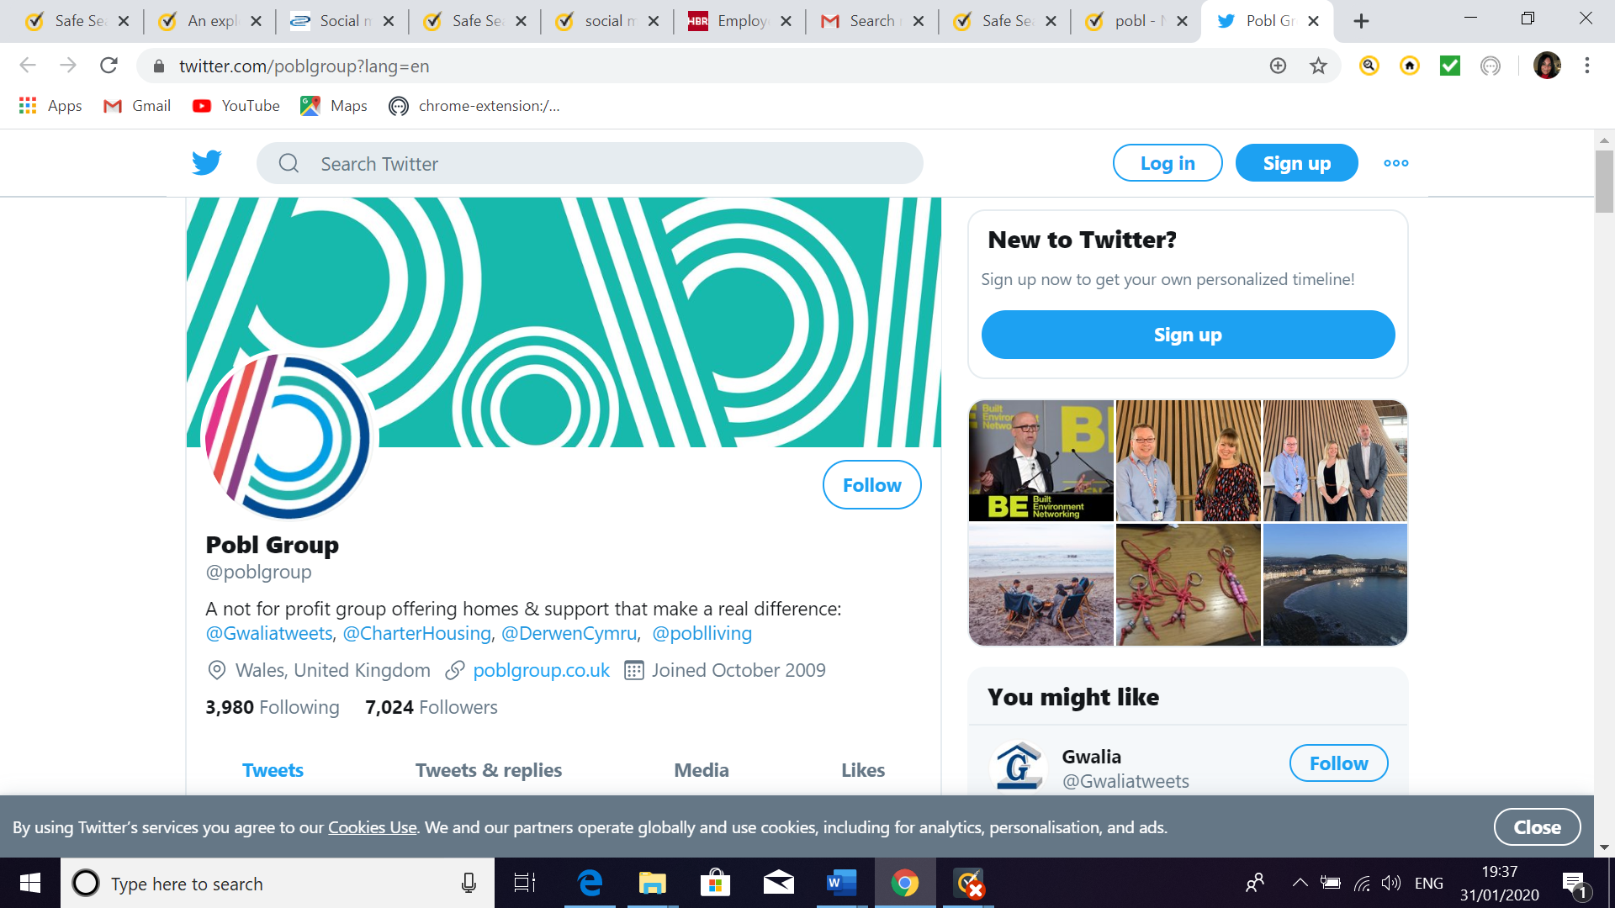
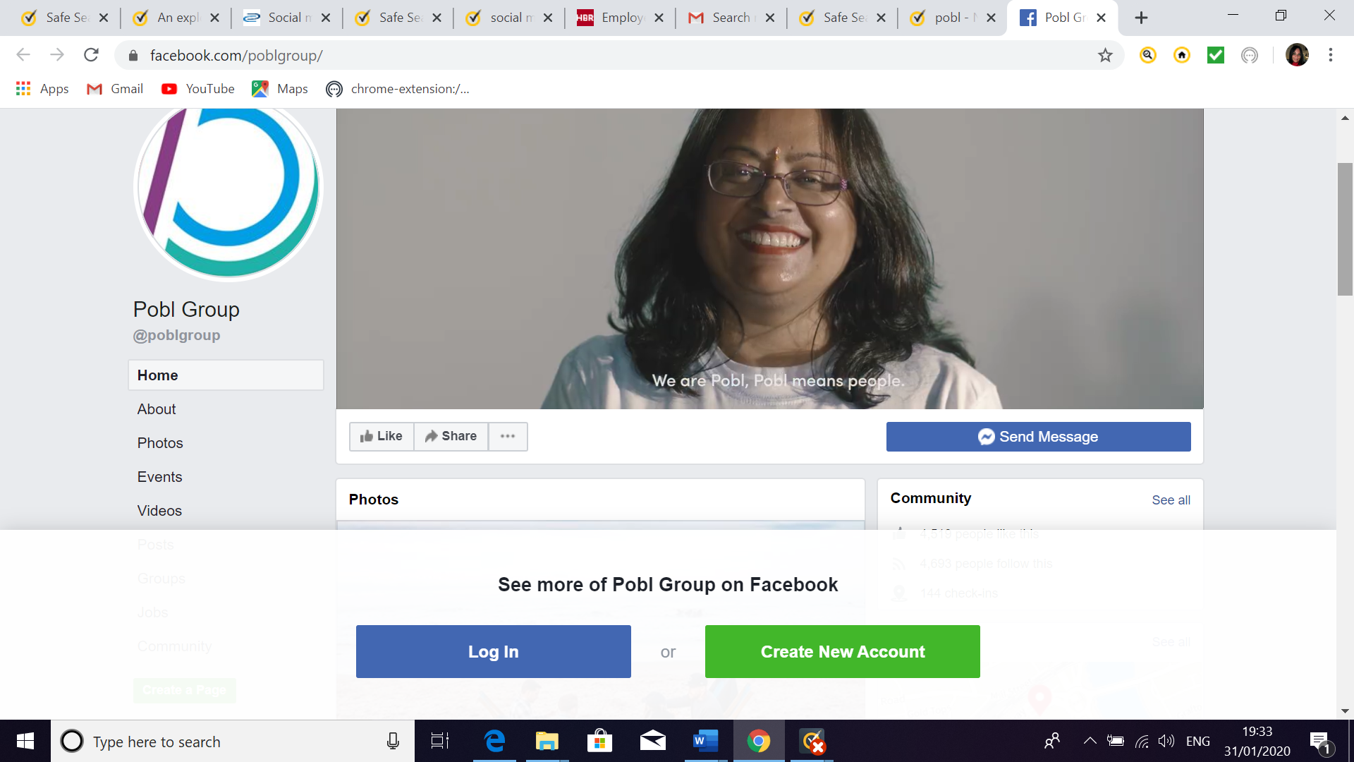
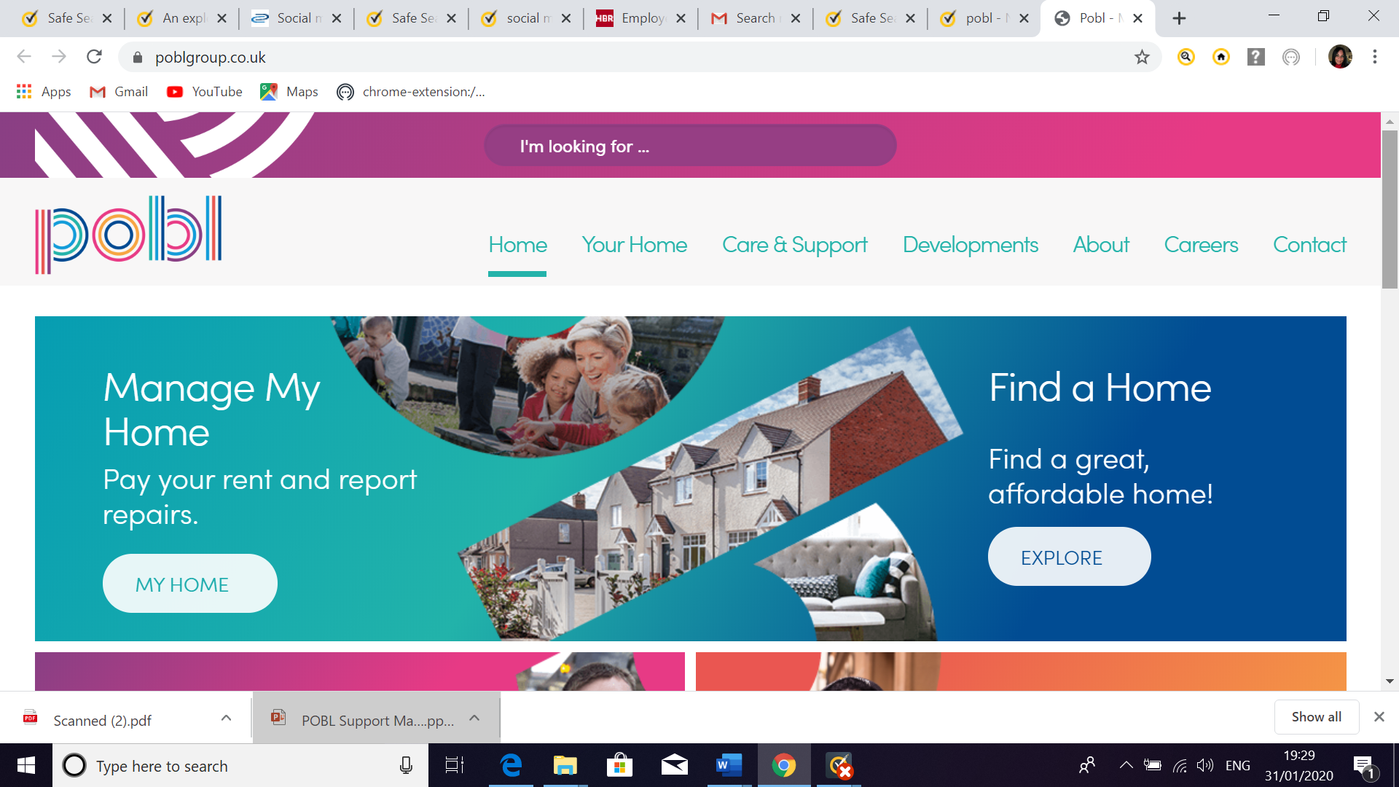
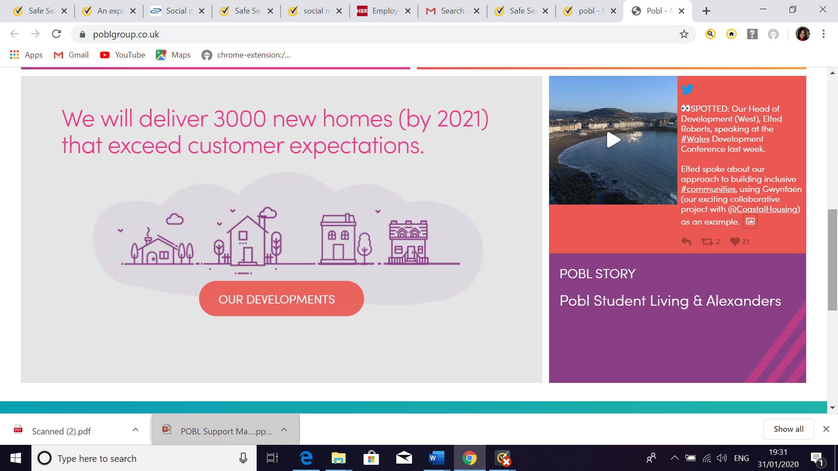

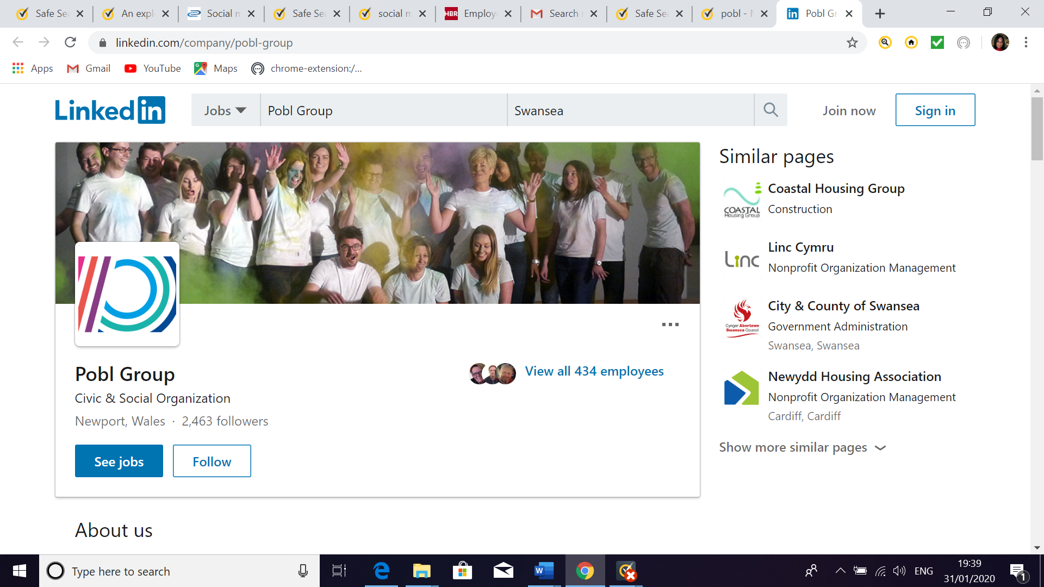

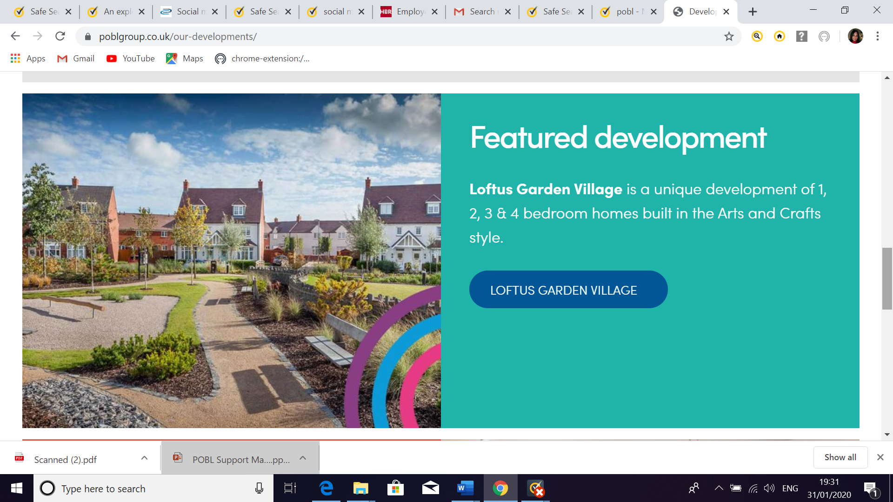

Appendix 2
Indeed Pobl reviews working for the company


