

BABA ROOM CAFÉ



Programme: BA Business Management
Module: Entrepreneurship
Module code: LCBB 5001
Lecturer: Riaz Bhatti
Assignment title: Assessment 1
Essay – 2110 words
Student name: Vasilica Gherasim
Student ID: 2110943
Strategy for doing business.

Baba Room Café

1. Company description

Even a busy coffee shop is easier to run with the right tools. In 2020, people in the UK spent more than £4 billion on coffee at more than 25,000 shops all over the country. Even with the lockdown and the pandemic, the coffee shop market is growing quickly, and British customers seem to like a good cup of coffee no matter what. As owners of a coffee shop, it can be easy to focus on the day-to-day operations instead of the company. Because of this, I wanted to make some great tools to help the new cafe run a successful business.
The main purpose of this business plan is to get private equity funds, and the total amount of cash needed is £45,000. A deciding factor was that this system was easy to use. Baba Room Café it will be a new private business. The effort is planned to start on July 4, 2023. This business plan describes the specific plans and steps that will be done to start the business.

2. Goals and plans of action

On Chichester's main street, the Baba Room Café will show a new way of looking at things. The food will be the best, the service will be great, the menu will change often, and the bathrooms will be clean. The Baba Room Cafe's goals will be greatly affected by three important success factors and actions.
In line with the business deal, the Baba Room Cafe will make a conscious decision to be different and unique in how it treats customers. Baba Room Café will give the impression that it serves healthy, whole foods in a beautiful, well-organized space. Curtains and floors will be black and white. I will have white tables, and pieces by local artists it will hanging on the walls. One sign will be made to promote the business, and I want to be big enough which can be read from the street.
Each table will have a comment card, which will be collected at the register. Feedback on the service and ideas for new or better meals would also be appreciated.

3. Supplies and Equipment.

Finding the right tools and materials can be difficult at first. But if I've listened to the right tips and done my research, I know what equipment to buy and which suppliers to buy from.
Here are some great resources that will help me find the right machines for my coffee shop:

a) CoffeeGeek has a passion for coffee.
CoffeeGeek is one of the most famous and useful websites for coffee drinkers and people who own coffee shops. They have important tips like how to buy an espresso machine, milk frothier, and reviews of coffee equipment from customers.

b) Nisbets
Nisbets is one of many caterers where you and I can buy all of our coffee goods at once. Everything is included, like groceries, coffee makers, dishes, and clothes. You can easily make a buy from the cafe, and the delivery service makes it even easier.

c) Bidfood
Bidfood UK provides bars with food and drinks. You will get coffee beans, special tools, and every kind of soft drink you can imagine. It also helps cafe owners who need it handle their menus, get information about their customers, and even support Covid-19.

d) Online shopping system
An online ordering system is a great way to give customers the best possible experience in a useful and easy way. Customers can use this method to buy coffee and pay from their phones without needing to download an extra app or pay in person. It's a great way to stand out from the competition and meet the legal requirements for accepting credit card payments through an app.

e) Paying with QR codes
It's a way to accept payments quickly, easily, and in a handy way using QR codes. They are especially helpful for coffee shops that want shorter lines and happier customers.

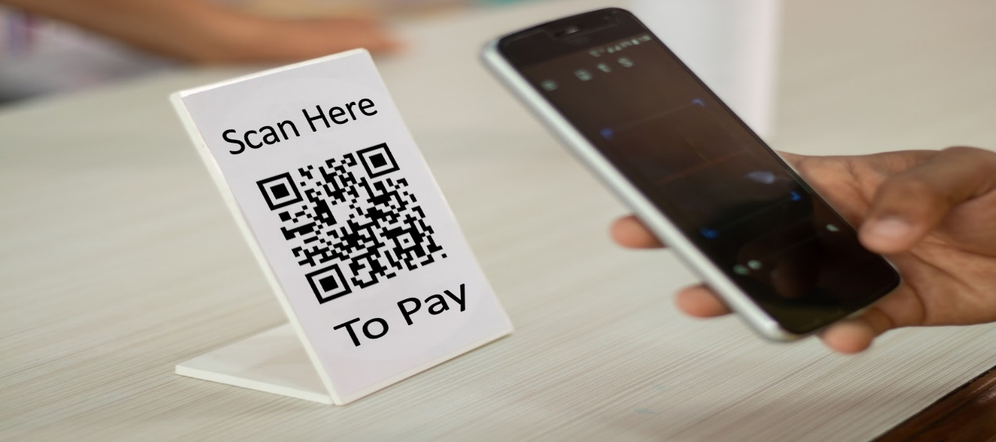

4. How a business works

At the Baba Room Café, which will be at 22 South Street in Chichester, West Sussex, there will be room for 20 people. The rent is £1,663 per month for a five-year lease choice. The building has a kitchen that is fifteen by fifteen, a living room that is twenty by twenty, two bathrooms, and a storage room in the back. Before this display case can be used as a restaurant, it needs to be wired and set up right. Also, the floors, countertops, and walls need to be redone. The renovation will cost £5,000, which includes discounted materials and free work.
There will be a commercial range cooker, a fridge freezer, a fridge, an oven, a microwave, and a small commercial dishwasher in the kitchen. The price will be £20,000 if you use cheap but good tools. Start-up costs will also include dishes, furniture, food stock, a rent fee, and advertising.
Baba Room Café will serve breakfast and lunch in a simple English way, with a focus on healthy and tasty food. When possible, low-fat recipes will be used, but the food will still look and taste good. Prices for breakfast items range from £4 to £6.50. Items on the lunch menu cost between £5 and £8.59 each. There will be a soup of the day every day. Details can be found in the related menu. The store will be open from 6:30 p.m. to 11:00 p.m., six days a week, and from 8:00 a.m. to 3:00 p.m., on Sunday.

5. Marketing by Sector

During the week, about 2,000 people work in Chichester, which is a target market for business owners and employees. Baba Room Café will open at 6:30, since most people start their days early. This group includes managers, factory workers, retail workers, professionals, artisans, laborers, and others who work in the food service business. Since many of them will come back, they will make up the majority of buyers. A number of sellers promised to go to the cafe every day. Since these customers often only have a short amount of time for a quick breakfast, they will be served on time.
When business is slow, can be make a deal coupon and offered "2-for-1". Menus will be sent to local companies, and takeout orders will come in pretty boxes, and table service will get the same kind of care.
Hotel guests will be enticed to visit the cafe by meals sent to nearby hotels. There will be ads and listings in state and local publications and tourist guides. Menus will also be put in tourist spots and other places with a lot of people. Chichester College is a nearby college. Students are most likely to go to The Baba Room Café on the weekends, especially on nice days, and during school breaks. During these times, there will be flyers all over campus that offer students a deal on certain meals at certain times.

6. SWOT analysis

Most of the time, a SWOT analysis for my shop is an important part of your business plan. In fact, if I fully understand how the SWOT factors affect my coffee project, I'll be able to figure out how to make the most of my strengths, work around my weaknesses, and push growth while minimising risks.
Let's look at my cafe's most important SWOT factors:

- Good things (Strengths)

If I want my coffee shop to do well, I need to sell high quality coffee, tea, and other drinks, as well as a range of tasty, freshly cooked food. I'm able to do this by getting my ingredients from a carefully chosen group of local sellers and keeping my inventory low to make sure the food is as fresh as possible.
Great service to customers can do a lot to bring people to my shop and keep them coming back. Strong customer service comes from a place that makes people feel welcome, has knowledgeable and helpful staff, and serves people quickly and well.
I will build a strong brand name and do good marketing. In today's market, it can be very effective to draw and keep customers by using social media, customer reviews, and word of mouth.
Managing money well is important for the success of any business, including my coffee shop. This means making correct plans and budgets and keeping a tight grip on costs. By keeping up with the latest market trends and putting out new coffee goods and services regularly, can keep customers coming back and open new ways to make money.

- Weaknesses

The desire for coffee and other drinks can be affected by things like the weather, the state of the business, and other things. For example, warmer weather might make more people want coffee and other hot drinks, while a recession might make less people want them because they have less money to spend. Because of this, it can be harder to predict and plan for future demand, which could hurt the business's ability to make money.
Some of the expensive costs that coffee shops have to pay are rent, utilities, marketing funds, and labour. These costs can sometimes be hard to handle, and if sales are lower than expected, they can hurt the business's ability to make money.
There may be fewer ways to make money because so many coffee shops are open in the morning and early afternoon. This can be especially hard if the business is not in a place where a lot of people walk by.

- Opportunities

By focusing on a niche market, my shop can stand out from the rest and attract customers who will stick with it. For example, my coffee shop might appeal to a certain group of coffee fans if it focuses on sustainable sourcing, uses organic coffee beans, and offers different ways to make coffee.
Take advantage of online ordering, by letting people buy and have food delivered online, my cafe can reach more people and make more money. Customers who cannot come to the store or who would rather place their orders from the safety of their own home or office may find this especially helpful.
Partnerships with other local businesses can help the coffee shop bring in more people and make more money. They can do this by teaming up with other food and drink vendors or local companies in the area. For instance, I'd like to work with a local bakery to sell baked goods or with a local event space to host their events.
Unique activities and events, like live music shows, stand-up comedy shows, or neighbourhood get-togethers, can help bring more people to my cafe and make it feel more special. By holding these events, my shop can feel more like a neighbourhood spot and become a popular place to hang out.
How about putting in more than one item? By adding new foods and drinks, like smoothies, pastries, or even sandwiches, they can reach a bigger range of customers and increase sales. This can be especially helpful if my cafe is in a place where there aren't many other places to eat and drink.
I should think about growing my coffee shop business in the future by opening more shops in new places or even starting a franchise programme. This can be especially important after I've opened my first site, gained loyal customers, and made a good name for myself.

-Threats

With so many established, well-known competitors in the area, it becomes difficult for a new coffee shop to stick in and draw customers. Consumer patterns are constantly changing and evolving in our fast-paced world. The types of products and services that people desire, such as the type of coffee they want to drink, can change as a result of changes in consumer behaviour. For instance, my cafe might need to alter its menu to satisfy a new demand if there is a trend towards healthier, natural choices.
A coffee shop may find it difficult to operate efficiently and continue earning money if there are delivery delays or shortages of certain coffee ingredients or equipment. If my cafe relies on a limited number of suppliers, this may be particularly challenging. Health and safety issues, such as food-borne illnesses or workplace mishaps, might exist in my cafe. By ensuring that my website complies with health and safety regulations and has the necessary quality assurance measures and licenses, I can minimise these dangers.

7. Conclusion

In conclusion in a café shop, there are usually two or three items on the receipt for one customer, which is make me to believe during the first year, it is anticipated that there will be a daily flow of 100 customers and become 3000 clients each month. The company will then increase by 25% yearly, reaching 125 customers during the second year and 150 customers during the third year.
The monthly revenue for the first month is £18,240 and £218,880 in the first year,
and the second rise of 25% which it will become 273,600 annually, and also in third year
representing a 25% rise I will have over £342,000. In this situation whit this amount of money I can secure my investment in the less 10 months.

8. References:

https://www.lawdepot.co.uk/contracts/business-plan/?loc=GB&pid=msnppc-1230353683278693-76897270267165

https://www.pomelopay.com/blog/resources-coffee-shop

https://fastercapital.com/content/An-Example-of-a-Business-Plan--A-Case-Study-of-a-Coffee-Shop.html
https://businessandplans.com/coffee-shop-swot-analysis-strengths-weaknesses-opportunities-and-threats/

