A comparison of the marketing methods of two multinational hotel brands

Marriott & Premier Inn

Syeda Shabna Begum

2126655

BA International Hotel Management

Marketing Essentials: BMIH4005

Chris Wilkin

In this essay there will be the comparison of marketing methods used between two multinational hotels and discussing the ways in which these organisations market their products and services. The first chosen hotel is the renowned Marriott hotel which is an expensive and lavish up market/resort known worldwide (Marriott, 2022). This will be compared to the Premier Inn, which is a more budget friendly hotel, being UK’s largest hotel brand (Premier inn, 2022). Reason of chose being both hotels are well known within the public sector and have similarities within their marketing strategies.
The Marriott Hotel was founded in 1957 by the founder J. Willard Marriott. It is the largest hotel chain in the world and are the largest hotel operators who have established themselves across 138 countries and territories with over 7800 properties, giving people more diversified ways to connect and experience the services they have to offer. Marriott has 30 brands offering the most powerful portfolio in the hospitality industry (Marriott,2022). They have a core value of putting people first, their marketing strategy is to create content that entertains, informs and provides value to people, building a community/ relationship with their customers. (Founder & Growth Story: Marriot International 2022). Marriott’s use of twitter and social media enables to gather data and be able to target customers. In comparison Premier inn is a British limited hotel chain founded in 1987 by Whitbread. It is the UK’s largest hotel brand, being located nationwide across the UK and currently has 800 hotels and more than 72,000 rooms. They also have many brands including their food and beverage brands (Premier Inn, 2022). Premier Inn understands service is important but wanted a model for assessing the effectiveness towards customers. By undergoing research project, it has improved the level of return visits. With social insights and trip advisor reviews they were able to identify the needs and develop value for target customers (Reporters, 2019).

The primary aim in marketing is identifying its target market and how to satisfy these customers. The focus is understanding, creating, communicating and developing value for your customers. To be successful in marketing an organisation must understand the customers’ requirements and satisfy the needs of their targeted customers (Dibbs,2012). In marketing, segmentation targeting is the process of dividing a broad consumer or business market into 4 groups. Segmentation variables are geographic, demographic, psychographic and behavioural all these segments are important in marketing as this allows to divide market to distinct groups of consumers and their needs (Hooley et al., 2020, page171-198). The ways in which Marriott and Premier Inn market their product and services are through using target segmentation. Both hotels use segmentation targeting approach to position where they are today. Marriott demographically targets all ages, their brands focus more on businesspeople/business travellers, geographically-as they are based worldwide, they are targeting many diverse consumers, psychographics-the lifestyle and interests the individual is accustomed to, behavioural-Marriott offers a reward program to appeal to its loyal customers (Marriott,2022). Premier Inn target businesses, families looking for budget accommodation, they offer discounts to families with children when booking on their website (About Us 2022).
By using target segmentations, companies can collect data about customer needs. Marketing also involves in providing the right marketing mix (Dibbs,2010). Marketing Mix is the combination of marketing elements used by businesses to meet the needs of customers; elements of the mix should work together in order to be successful. In their marketing strategies both hotels use the 7 p’s marketing mix, McCarthy’s 4 p’s strategy of product, price, place, promotion and Boom & Bitner, 1981 3p’s strategy of people, process, physical evidence to market their products and services. The mix allows both hotels to use methods, strategies and tools to reach out to their target customers (tutor2u, 2017). Both hotels provide quality products and services within their hotels, Marriott provides more luxury products, amenities and services in their hotels, Premier Inn does not offer as much as Marriott meaning their services costing less. Service and product are based on price e.g., spa, gym access, swimming pool. Both hotels invest a lot of money in advertising their products through many channels, digital marketing, websites, social media. Marriott’s loyalty programme, Marriott bonvoy offers many benefits, promotions and discounts (Marriott, 2022). Premier Inn also promote many offers, discounts to families with children (Premier Inn, 2022).

Currently positioned Premier Inn is one of the UK’s leading hotel chains it has begun to expand into international markets (Lock, 2022). Marriott is currently the largest hotel chain globally holding no.1 in the largest hotel companies by market cap, Marriott International, Inc. MAR is committed to strengthening its position in the hospitality industry through expansion. Future of Marriott expect to debut more than 30 luxury hotels (Zacks, 2021).

Communication and interaction in the world of marketing has transformed drastically due to the internet and internet-enabled platforms. Social media platforms have become integral in human life, users are using a substantial amount of time on these platforms. Social media has become a part of digital marketing, businesses are using a variety of digital technologies and digital media to connect to the audience. The RACE framework is very popular and aids marketers to manage digital marketing (Rautela, 2021). In 2010 Dr. Dave Chaffey developed the RACE marketing planning framework as research showed that many businesses were using digital marketing without a strategic approach, the idea behind this framework would create a simple structure to help companies create and manage digital strategies. This also allows to develop an omnichannel communications plan to reach and engage with online audiences to prompt conversation with online and offline sales. The model below shows goals structured around classic marketing.
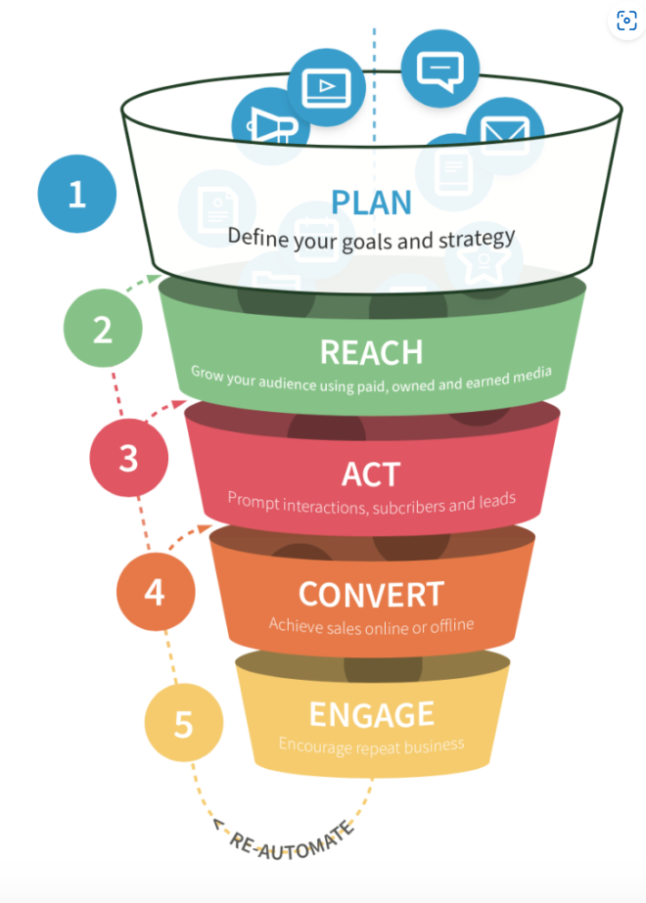(Chaffey, 2022).

Both hotels are using the RACE framework in their marketing startegies. For Marriott, promotion and advertising strategy are focused on digital promotions. This means they focus on promoting their hotels through their websites and social media. They have online web pages, bought prime time ads to broadcast on major cable networks, they are using social media platform and using snapchat influencers to advertise their products this works very well as this reaches out from snapchat to youtube, Facebook sharing, and other channels, this allows of capturing the attention of other demographics (Softinn, 2022). Marriott bonvoy app allows members to book and provides a lot more advantages through their app also giving members discounts and promotions, this is an advantage of gaining return customers (Marriott 2002). Similarly, Premier Inn also use digital marketing to advertise and attract their targeted customers, they advertise on TV, as well as covering outdoor, radio, print, digital and using social media platforms. Premier inn is broadening their digital reach by enabling their customers to book through their new website. “Whitbread’s focus on marketing comes as part of its “investing to win” strategy” (Jefferson, 2021).

Marriott’s Serve360 sustainability program is their commitment to create a positive and sustainable impact wherever they do business, there are ways Marriot is working on reducing their environmental impact, in sustainably managing their water and energy use they are minimizing their environmental footprint and reducing their waste and carbon emissions whilst also increasing their use of renewable energy. They are working on to build and operate sustainable hotels, by constructing and operating sustainable hotels they are reducing the environmental impact of and risk to their businesses. Marriot’s goals by 2025, 100% of hotels to be certified to a recognised sustainability standard. Sourcing their products are also very important to making sure their products are sourced responsibly (Sustain - CSR 2019). Premier Inn is making an industry-leading sustainability commitment, their aim is by 2025 cutting down on carbon emissions by 50% and by 2050 as much 88%. Whitbread’s award-winning environmental strategy has been used throughout Premier Inn hotels they have already made significant efforts to cut down on carbon wherever possible. They have already invested in LED lights and their operating sites use 100% renewable electricity. 113 of their hotels are using solar panels to generate electricity on their sites (World Earth Day 2018). Both hotels have made changes to their marketing strategies they both have sustainability programmes in place, and both have aims to be more sustainable for the future.

Covid 19 had a huge impact on the hospitality industry. Since covid 19 the safety of guests and team members became priority for both hotels. Both hotels had similar approach to how they introduced new measures after covid 19. Premier Inn implemented extra precautions in their hotels after Covid 19 they introduced “Premier Inn Clean Protect” their enhanced hotel cleaning promise, to ensure all Premier Inn hotels are safe, clean and adhere to government guidelines. They also encourage wearing of face masks while in the restaurants as they are more confined spaces (Premier Inn,2022). Marriott have also implemented new protocols and practices in place due to the covid 19 pandemic, Marriott International’s high standards commitment to clean by increasing the frequency of cleaning and disinfection, particularly in areas most used e.g., restrooms. They have social distancing measures and contactless experience, Marriott Bonvoy app offers mobile check in/out, key and service request delivered right to the door. After covid Marriott continue to follow the 3 principles of hygiene, ventilation and sanitization within their marketing (Marriott Cleanliness Council: Marriott Bonvoy 2022).

In conclusion both hotels use similar marketing strategies in which they advertise their products and services. The difference is the target segmentation, Marriott targeting the more affluent and business class people as it provides more luxury, Premier Inn is targeting families and middle-class people as it is a more affordable budget accommodation.

Reference list

About Us (2022) Whitbread PLC. Available at: https://www.whitbread.co.uk/about-us/ (Accessed: 28 October 2022).

Chaffey, D. (2022) Race Marketing Model Definition - what is? - digital marketing glossary, Dr Dave Chaffey: Digital Insights. Available at: https://www.davechaffey.com/digital-marketing-glossary/race-marketing-planning-model/ (Accessed: 25 October 2022).

Dibb, S. et al. (2012) Marketing: concepts & strategies. European edition, 6th edition. Andover, U.K: Cengage Learning.

FAQs (2022) Premier Inn. Available at: https://www.premierinn.com/gb/en/faq.html (Accessed: 28 October 2022).

Hooley, G.J. et al. (2020) Marketing strategy and competitive positioning. Seventh edition. Harlow, England; Pearson, p 171-198.

Jefferson, M, (2021) Premier Inn pins recovery hopes on marketing with ‘invest to win’ strategy. Available at: https://www.marketingweek.com/premier-inn-recovery-marketing/ (Accessed: 16 October 2022).

Lock, S (2022) Available at: Premier Inn hotel numbers 2022 | Statista (Accessed: 27 October 2022).

Marriott (2022). Available at: https://news.marriott.com/ (Accessed 14 October 2022).

Marriott Cleanliness Council: Marriott Bonvoy (2022) Marriott Cleanliness Council | Marriott Bonvoy. Available at: https://clean.marriott.com/ (Accessed: October 28 2022).

Marriott International Newscenter (US). 2022. Hotel Industry News | Marriott News Center. [online] Available at: <https://news.marriott.com/> (Accessed 17 October 2022).

Page.mysoftinn.com. 2022. How Hotels Can Learn From Marriott Marketing Strategy. [online] Available at: <https://page.mysoftinn.com/en/how-hotels-can-learn-from-marriott-marketing-strategy> [Accessed 16 October 2022].

Premier Inn (2022). Available at: https://www.premierinn.com/gb/en/faq.html (Accessed 15 October 2022).

Premier Inn (2022) Premier Inn Rest Easy. Available at: Coronavirus (COVID-19) information | Premier Inn (Accessed: 27 October 2022).

Rautela, S. (2021) “International Journal of Interactive Mobile Technologies,” Social Media for New Product Launch: A Study of Social Media Platforms Across the RACE Planning Framework., 15(5), pp. 187–204.

Sustain - CSR (2019) marriott. Available at: https://serve360.marriott.com/sustain/ (Accessed: 25 October 2022).

Tutor2u. (2017) Extended Marketing Mix (7P’S) Explained Marketing [video]. Available at: (1) Extended Marketing Mix (7P's) Explained | Marketing - YouTube (Accessed: 27 October 2022).

World Earth Day (2018) Cutting our carbon emissions 50% by 2025. Available at: https://www.premierinn.com/gb/en/news/2018/world-earth-day.html (Accessed: 25 October 2022).

Zacks (2021) Mar stock | news | marriott stock price today | analyst opinions | markets insider, Business Insider. Business Insider. Available at: https://markets.businessinsider.com/stocks/mar-stock (Accessed: 27 October 2022).

