

Student Name: Tahmina Aktar
Student ID: 2508483

Module Name: Marketing Management
Module Code: LCMB7024

Lecturer’s Name: Dr Laila Maazouz

Work Count: 2697

Term 1

Table of Contents
1. Introduction 3
2. Task 1: Critical Analysis of the Macro Marketing Environment 4
2.1 Macro Marketing Environment 4
2.2 Analysis of Macro Factor 1: Technological Factors 5
2.2.1 Impact on the Pioneer Organisation (Apple Inc.) 5
2.2.2 Impact on the Follower Organisation (Xiaomi Corporation) 5
2.3 Analysis of Macro Factor 2: Economic Factors 6
2.3.1 Impact on the Pioneer Organisation (Apple Inc.) 6
2.3.2 Impact on the Follower Organisation (Xiaomi Corporation) 7
3. Task 2: Strategic Responses of Pioneering and Follower Organisations 9
3.1 Pioneering Organisation’s Strategic Responses (Apple Inc.) 9
3.2 Follower Organisation’s Strategic Responses (Xiaomi Corporation) 10
4. Conclusion 12
References 14

Table 1: Macro Factors - Impact on Pioneer (Apple) vs Follower (Xiaomi) 8
Table 2: Strategic Responses: Pioneer vs Follower 12

Figure 1: PESTLE Framework - Key Macro-Environmental Factors Influencing the Smartphone Industry 4
Figure 2: Market Growth Trend Line - Apple vs Xiaomi 8
Figure 3: Application of Ansoff Growth Matrix - Apple vs Xiaomi 9

Introduction
This report is a critical study of strategic marketing management in the smartphone industry in the globe and how the external macro-environment factors affect the organisational strategy. It is aimed at comparing the reaction of a pioneer organisation, Apple Inc., and a follower organisation, Xiaomi Corporation, to environmental opportunities and threats to remain competitive (Johnson, Scholes and Whittington, 2017; Kotler, Keller and Chernev, 2021).
The smartphone market is quite dynamic, which is typified by a high rate of technological innovation, the low life cycle of products produced and intense market competition amongst the players around the world. The growing market share of smartphones, the evolution of technologies, including the use of 5G and AI, and the growing popularity of differentiated features among consumers ensure the growth of the market (Deloitte, 2022; Statista, 2026). The organisations in this sector have to strike the balance between innovation, cost efficiency and responsiveness to the market in order to have a competitive advantage (Porter, 1985).
A macro marketing environment analysis is critical in strategic decision-making. The PESTLE framework is an organizational method of evaluating each of the aforementioned forces (including political, economic, social, technological, legal, and environmental) to enable firms to determine their opportunities and threats and make qualified strategic decisions (Johnson, Scholes and Whittington, 2017; Kotler, Keller and Chernev, 2021).
The report has been divided into three parts. Task 1 is the critical analysis of the macro marketing environment and the effects it has on Apple and Xiaomi. Task 2 studies their strategic reactions with the help of the Growth Matrix by Ansoff (1957). The report brings the end by synthesizing the major findings and implications of the strategic marketing management.

Task 1: Critical Analysis of the Macro Marketing Environment
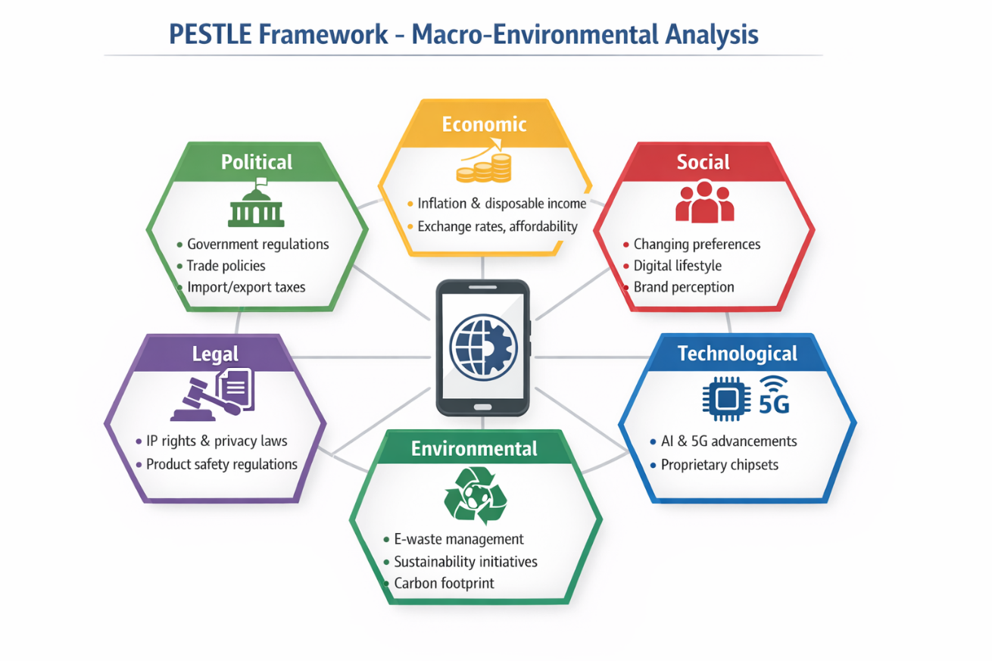

Figure 1: PESTLE Framework - Key Macro-Environmental Factors Influencing the Smartphone Industry
2.1 Macro Marketing Environment
The macro marketing environment refers to the external forces which are broad and widely beyond the control of the managers and only influence the organisation strategy. The most common framework used to study these forces is the PESTLE model that measures Political, Economic, Social, Technological, Legal, and Environmental factors (Kotler, Keller and Chernev, 2021). Such a framework can be especially useful in strategic marketing because it allows companies to determine the external opportunities and threats and, thus, base long-term choices on them (Johnson, Scholes and Whittington, 2017).
This report specifically concentrates on the technological and economic factors in the smartphone industry of the world. These two dimensions are selected due to their strong focus on the industry development as well as firm-level competitiveness. Innovation, product differentiation, and creation of value are some of the key drivers of success that require technological aspects in the smartphone market (Deloitte, 2022). Simultaneously, consumer purchasing power, demand trends, and pricing strategies in various segments of the market directly rely on economic conditions (Statista, 2026).
They are strategic factors because the industry requires fast innovation opportunities and is considerably sensitive to world economic changes. The next technological shock and the fact that product life cycle is short means that firms have to constantly innovate and macroeconomic instability impacts desired upgrades by consumers. As a result, the evaluation of these elements will be important to understand the functioning of organisations like Apple Inc. and Xiaomi Corporation in terms of maintaining and transforming their competitiveness.

2.2 Analysis of Macro Factor 1: Technological Factors

2.2.1 Impact on the Pioneer Organisation (Apple Inc.)
Technological progress is one of the key opportunities and strategic necessities of Apple Inc. Being an innovative organisation, Apple uses the power of constant innovation to maintain the competitive edge. The firm has a huge investment on research and development, especially in the realms of proprietary chip design, artificial intelligence, and integration in an ecosystem (Apple Inc, 2023).
According to the industry data, more evolutions in the global smartphone living have been prompted by the technologies related to the 5G connection and AI-driven functionalities and enhanced user interfaces (Statista, 2026). This differentiated user experience is formed by Apple combining hardware, software, and services with services in a one-unit ecosystem which strengthens the brand loyalty and allows the company to command a high price (Deloitte, 2022).
But there is also the threat of a sudden technological change that would require a long-term investment and places the firm on the risk of becoming obsolete. Nevertheless, the high financial capability of Apple, as well as the power of innovation, helps such risks to be minimized. It is an implication of the competitive advantage, that through technological leadership, Apple can continue with a differentiation approach that will reinforce its dominance in the market and profitability.

2.2.2 Impact on the Follower Organisation (Xiaomi Corporation)
In the case of Xiaomi Corporation, technology provides opportunities and limitations in a follower strategy. Xiaomi is a fast-follower company that quickly incorporates current innovations into its products at competitive prices (McKinsey & Company, 2022).
The availability of mature and cost-effective technologies made available through technological advancements can also help Xiaomi to sell high in specification smartphones at comparatively cheaper prices. This increases its competitiveness especially in the developing markets which are very sensitive to prices (Statista, 2026). Consequently, Xiaomi has gained the right to increase its market share in the global market in the last few years.
However, Xiaomi is more vulnerable than Apple because of the dependency on other suppliers and the weak own technological ecosystem. Contrary to Apple, Xiaomi is a company that does not have a significant vertical integration, and this limits its capacity to generate sustainable differentiation (Deloitte, 2022).
The market position meaning is that Xiaomi can compete on cost effectiveness and value, instead of leading with innovation. Although the strategy can be used to generate faster growth and market penetration, its impact on long-term competitive advantage in the segments of premium markets might be restricted.

2.3 Analysis of Macro Factor 2: Economic Factors

2.3.1 Impact on the Pioneer Organisation (Apple Inc.)
Economic forces play a much larger role in influencing the performance of Apple Inc. especially as it has a high pricing policy. The high opportunity exists during the economic growth, when the level of disposable income increases and people are ready to spend money on the devices with high quality (Statista, 2024).
In contrast, economic crises, inflation and currency fluctuation are also significant threats. Studies show that shipments of smartphones in the world will generally decrease in moments of economic insecurity, as well, customers non-renew their purchases, switching to cheaper options (IDC, 2026). This trend can also have adverse effects on the sales of Apple especially in developing markets.
In spite of all these problems, Apple has been resilient as it has a good brand equity and customer loyalty. The effect of its ecosystem lock-in makes it less prone to switching behaviour among customers even in unfavoursome economic times (Johnson, Scholes and Whittington, 2017). The competitive advantage implication is that when Apple growth is low due to recessions, it can still hold on to its comparatively stable, and profitable market.

2.3.2 Impact on the Follower Organisation (Xiaomi Corporation)
The economic realities pose a big opportunity to the Xiaomi Corporation particularly in times of financial limitation. Being a cost-oriented brand, Xiaomi also enjoys a price sensitivity tendency of consumers. Economic recessions tend to change the demand to less expensive smartphones to high-end ones and this enhances the market of Xiaomi (Statista, 2026).
As one example, there has been rising inflation and tightened disposable income, world-wide, which has motivated the purchasers to find cheaper options, thus leading to increased sales of Xiaomi. This puts Xiaomi at a strong position in the emerging markets, whereby economic factors have one of the most significant roles in consumer decisions.
Nevertheless, Xiaomi also has threats, such as unstable cost of production, supply chain and low profit margins. Its margin is also slimmer than that of Apple, which means that it is more vulnerable to cost and economic shocks (McKinsey & Company, 2022).
Flexibility wise, Xiaomi shows more flexible pricing and products in its offering, which makes it to be fast in adjusting to new economic conditions. The market position implication is that Xiaomi will be able to increase its market share when the economy is in a decline though profitability might also be limited.

Market Growth Trend Line - Apple vs Xiaomi
Figure 2: Market Growth Trend Line - Apple vs Xiaomi
(For Chart Data collected from Data and Statistics, 2025)

Macro Factors - Impact on Pioneer (Apple) vs Follower (Xiaomi)
Macro Factor | Apple (Pioneer) – Opportunity/Threat | Xiaomi (Follower) – Opportunity/Threat | Strategic Implication
Technological | Opportunity: Proprietary chipsets; AI integration; strengthens differentiation | Opportunity/Threat: Fast-follower strategy; quickly adapts existing technology | Apple maintains premium positioning; Xiaomi enhances cost competitiveness
Economic | Threat: Premium pricing may limit growth in price-sensitive markets | Opportunity: Low-cost devices attract price-sensitive consumer segments | Apple relies on brand loyalty and ecosystem; Xiaomi increases market share in emerging markets
Table 1: Macro Factors - Impact on Pioneer (Apple) vs Follower (Xiaomi)

3. Task 2: Strategic Responses of Pioneering and Follower Organisations

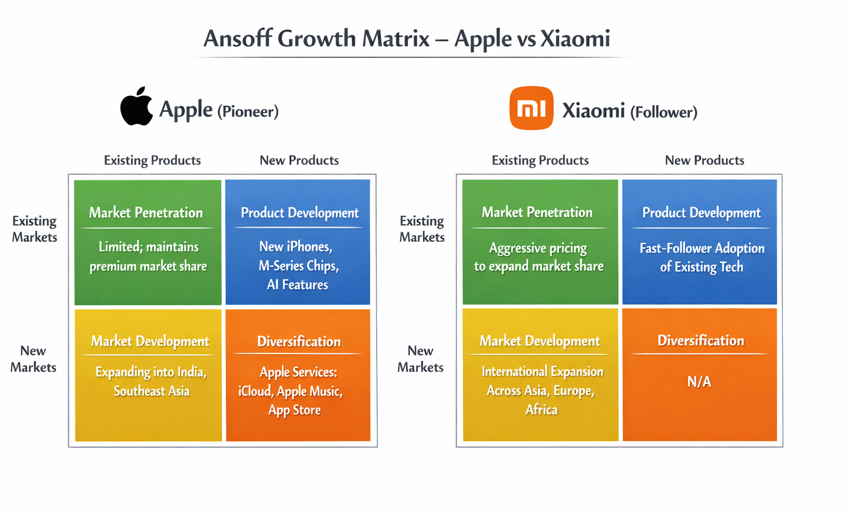
3.1 Pioneering Organisation’s Strategic Responses (Apple Inc.)
Figure 3: Application of Ansoff Growth Matrix - Apple vs Xiaomi
Apple Inc., the pioneering organisation, exhibits a very structural and innovation-based strategic response to the external environmental challenges and opportunities. Based on the Growth Matrix by Ansoff, we can explain the strategic orientation of the firm in terms of four growth strategies namely; market penetration, product development, market development and diversification (Ansoff, 1957; Johnson, Scholes and Whittington, 2017). This model allows the critical review of how Apple responds to the macro factors that are technological and economic.
Apple focuses largely on product development, and constantly launches new products and services in the existing markets. Apple has a massive investment in research and development due to the rapid change in technology, which is manifested in proprietary technologies (particularly, the M-series processors, a high level of artificial intelligence integration, and improved camera systems) (Deloitte, 2022; Apple Inc, 2023). These innovations reinforce differentiation, customer experience, and remain premium, which is consistent with the differentiation principle proposed by Porter (1985).
Apple is actively involved in market development in economic factors, such as entering new markets, such as India and Southeast Asia, where the increasing disposable incomes and penetration of smartphones provide growth potential (Statista, 2024). Yet, it has a premium pricing policy that limits the access to segments that are sensitive to prices and limits the full extent of market usage (Johnson, Scholes and Whittington, 2017). Apple manages this limitation so that it adds value through ecosystem services, a variety of services such as iCloud, Apple Music, and the App Store, which effectively create recurring revenue streams and makes hardware sales less dependent on hardware (Kotler, Keller and Chernev, 2021).
Another related diversification Apple practises is to use services in differentiating hardware products in order to reinforce customer lock-in and risks in economic uncertainty (IDC, 2026). This strategy will provide a competitive advantage against competition threats and promote profitability in the long term, but price rigidity might lower agility during worse economic times.
More importantly, the strategic reactions of Apple represent the leadership of innovation, ecosystem integration, and differentiation of premiums. Although they are extremely useful to make the company remain competitive, its approaches lack flexibility in coping with the sudden changes in the economic environment, which, perhaps, is an issue when it comes to highly volatile markets (Johnson, Scholes and Whittington, 2017; Deloitte, 2022; Apple Inc, 2023)

3.2 Follower Organisation’s Strategic Responses (Xiaomi Corporation)
Xiaomi Corporation being a follower organisation is more flexible and cost oriented. It is also possible to review its reaction through the Growth Matrix suggested by Ansoff, but its strategy and choices are not similar to those of Apple (Ansoff, 1957; McKinsey & Company, 2022). Xiaomi mainly employs market penetration, intending to maximize market share in the current markets by offering competitive pricing and intensive distribution channels. With its low prices and high specification smartphones, Xiaomi successfully draws in price applicants within the emerging economies, especially during the period of economic recessions (Statista, 2026). The approach helps the company to capitalize on the opportunity presented by the declining consumer buying ability and increasing demand of inexpensive devices (Kotler, Keller and Chernev, 2021).
Besides that, Xiaomi uses product development through a fast-follower strategy. Xiaomi adapts the advanced technologies, including 5G connectivity, high megapixels cameras, long-lasting batteries, among other technologies, in a very short time, as soon as the rivals, including Apple, launch them (Deloitte, 2022). The strategy can help Xiaomi to stay technologically abreast with minimal R&D spending, and this strategy aligns with the resource-based limitations that follower firms usually have (Johnson, Scholes and Whittington, 2017).
Another way in which Xiaomi promotes market development is through an international expansion into Asia, Europe, and Africa, which increases its level of competition and makes it less dependent on a particular market (McKinsey & Company, 2022). The efficiency of its operations through online sales and direct-to-consumer model offers the firm efficiency in its operations, cost-saving, and scalability, which contributes to its cost leadership stance (Kotler, Keller and Chernev, 2021).
Nonetheless, the strategies of Xiaomi are not problematic. It heavily depends on cost leadership, which causes it to have low profit margins and thus makes the firm susceptible to the increase in cost of components and instead of supply chain disruptions (Deloitte, 2022). In addition, poor brand differentiation makes it less competitive in the higher-level segments where brand perception and system integration are of greater concern (Porter, 1985).
Importantly, Xiaomi is more flexible than Apple, in particular, to the changes of the economy. Highly adaptable price and diversification of its products enable it to quickly adapt to the market conditions to remain competitive even in times of worldwide economic uncertainty (McKinsey & Company, 2022; Statista, 2026). Such short-term flexibility, however, might not be able to differentiate and enhance brand loyalty in the long term.
Altogether, the strategic responses provided by Xiaomi, based on the Growth Matrix by Ansoff, can be characterized as market penetration and fast-follower growth strategy, as it can help to achieve rapid growth and cost-competitiveness but limits the ability to sustain differentiation in the long term (Johnson, Scholes and Whittington, 2017; Deloitte, 2022).

Strategic Responses: Pioneer vs Follower
Strategic Dimension | Apple (Pioneer) | Xiaomi (Follower) | Outcome/Impact
Core Strategy | Differentiation, innovation leadership | Cost leadership, fast-follower approach | Apple maintains premium positioning; Xiaomi grows market share in price-sensitive segments
R&D Approach | Heavy investment, proprietary tech | Moderate investment, rapid imitation | Apple leads tech; Xiaomi remains competitive at lower cost
Market Focus | Premium consumers, emerging markets | Price-sensitive segments, global expansion | Balanced revenue streams vs fast penetration
Revenue Diversification | Hardware + Services ecosystem | Primarily hardware | Apple reduces risk, Xiaomi relies on volume sales
Table 2: Strategic Responses: Pioneer vs Follower

4. Conclusion
Drawing a conclusion, this report has critically discussed strategic responses in a pioneer organisation compared to a follower organisation in the smartphone industry in the global market. The macro marketing environment has been analyzed indicating that technology and the economy play a major role in the dynamics of industries. In the case of the groundbreaking organisation, Apple, technological innovation and high premium positioning have helped it stay ahead of competition and act proactively when external opportunities and challenges arise. Unremitting development of products and their diversification into ecosystem has strengthened brand loyalty and guaranteed long-term sustainability, but monitored impact of pricing flexibility restraint its expansion in price-sensitive markets.
On the other hand, the follower organisation, Xiaomi, has used the adaptability and cost-saving approach to take advantage of openings in the market and especially in the price-sensitive markets and in the developing economies. Following a fast-follower strategy towards technology and rapid market penetration, Xiaomi has been capable of increasing its market quickly and be competitive even with its smaller profit margins.
In general, the results include the strategic importance of the environmental scanning process and the need to adopt adaptive marketing strategies. As it is shown in both organisations, the alignment of the internal capabilities with the external macro-environmental forces is the key to maintaining the competitiveness. Though Apple is more about differentiation and innovation, Xiaomi is more flexible and affordable, which demonstrates how the companies can use opposite strategies to attain their strategic goals within the same sector.

References
Ansoff, H.I. (1957) ‘Strategies for diversification’, Harvard Business Review, 35(5), pp. 113–124. Available at: https://doi.org/10.1016/0024-6301(72)90048-9.
Apple Inc (2023) ‘Apple Inc Annual Report 2023’. Available at: https://investor.apple.com/investor-relations/default.aspx.
Data and Statistics (2025) Global Smartphone Market share in 2024 - FactoData, FactoData. Available at: https://factodata.com/global-mobile-phone-market-share/ (Accessed: 21 March 2026).
Deloitte (2022) Deloitte TMT 2023 Predictions, Deloitte. Available at: https://www.deloitte.com/global/en/about/press-room/deloitte-tmt-2023-predictions.html (Accessed: 20 March 2026).
IDC (2026) IDC - Smartphone Market Insights, IDC. Available at: https://www.idc.com/promo/smartphone-market-share/market-share/ (Accessed: 20 March 2026).
Johnson, G., Scholes, K. and Whittington, R. (2017) Exploring Corporate Strategy: Text & Cases. Pearson.
Kotler, P., Keller, K.L. and Chernev, A. (2021) Marketing Management. Pearson Education. Available at: https://books.google.com.bd/books?id=zXpfzgEACAAJ.
McKinsey & Company (2022) McKinsey Technology Trends Outlook 2022, McKinsey. Available at: https://www.mckinsey.com/capabilities/tech-and-ai/our-insights/the-top-trends-in-tech-2022#/.
Porter, M.E. (1985) ‘Competitive Advantage: Creating and Sustaining Superior Performance’. Available at: https://books.google.com.bd/books?id=9C-5AAAAIAAJ.
Statista (2026) Smartphone market share by vendor quarterly 2025| Statista, Statista. Available at: https://www.statista.com/statistics/271496/global-market-share-held-by-smartphone-vendors-since-4th-quarter-2009/ (Accessed: 20 March 2026).

