

Student name:Daberechi Onyinye Eze
Student ID:2232114
Module name: Student Independent Project
Module code: BMHP6020
Supervisor’s name: Dr. Jolly Nwankwo

 |  |  | Project Title  The Impact of Staff Training and Development on the Quality of Care Provided to Older Adults in UK Care Homes  Research Aim  To critically examine how staff training and development influence the quality of care provided to older adults in UK care homes.  Research Objective  - To critically examine the relationship between staff training and development and the quality of care provided to older adults in UK care homes.  - Improve organizational and workforce factors that facilitate or constrain the effectiveness of staff training and development in UK care homes.  - To evaluate strategies through which staff training and development can contribute to sustained improvements in care quality for older adults. |  | 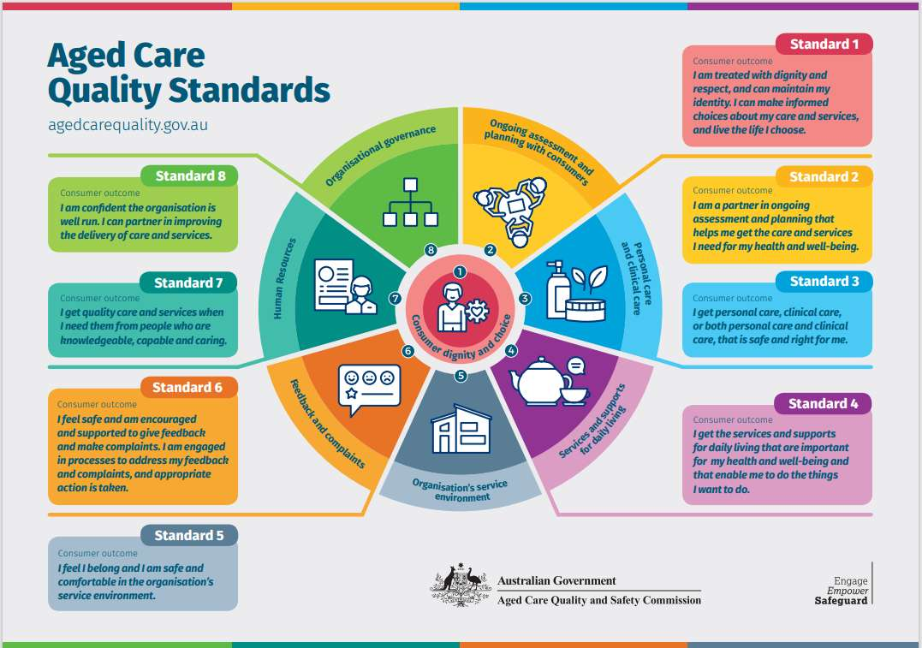
Methodology  This study will adopt a secondary qualitative research approach. Data will be collected from peer-reviewed journal articles, government reports, and publications from organizations such as the Care Quality Commission (CQC), Skills for Care, NHS England, and the Department  of Health and Social Care. A methodical literature review and thematic analysis will be used to establish patterns and themes relating to staff training as well as quality of care. Secondary data are suitable because they provide access to extensive evidence while reducing time and resource requirements. |  |  |  |  | Data Analysis method  The data collected from 10 selected studies were analyses using thematic analysis, following the approach outlined by (Braun et al;2021). The analysis involved six stages: Familiarization with the data, coding, generating initial themes, reviewing themes, defining and naming themes, and producing the final report. This process resulted in the identification of four key themes across the included studies. The ENTREQ framework (Tong et al.,2021) was used to promote transparent and comprehensive reporting throughout the analysis.  Ethical Considerations  As a secondary qualitative study using only published literature, no primary data were collected and no participants were recruited. Ethical approval was obtained from UWSTD.  Overall, the study posed minimal ethical risk because it did not involve direct contact with vulnerable individuals or the collection of sensitive primary data. Nevertheless, ethical principles such as honesty, respect for intellectual property, transparency, and responsible interpretation of evidence were upheld throughout the research process.
= Data Collection method
This study will adopt a secondary qualitative data collection approach, using existing published literature rather than collecting new information directly from participants. Secondary data are information that have already been gathered and analysed by other researchers and can be reused to address a new research question (Taherdoost, 2021). The main resources required will include access to online academic databases such as Google Scholar, ScienceDirect, Emerald Insight, Sage Journals, and ProQuest.
A structured search strategy will be used to identify relevant and credible sources. Key terms and phrases related to the research topic will be entered into the selected databases, and Boolean operators such as ‘AND’, ‘OR’, and ‘NOT’ may be used to broaden or narrow the search results (Wakefield, 2014). The search process will be documented, including the databases used, keywords applied, filters selected, and the number of results identified (University of Texas Libraries, 2020).

References
Aveyard, H. (2023) Doing a literature review in health and social care: a practical guide. 5th edn. London: Open University Press.
Department of Health and Social Care (2025) Adult social care workforce survey 2023–2024. London: DHSC.
Taherdoost, H. (2021) ‘Data collection methods and tools for research: a step-by-step guide’, HAL Archives Ouvertes. Available at: https://hal.science/hal-03741847/document (Accessed: 12 October 2026).
University of Texas Libraries (2020) Steps in the literature review process. Available at: https://guides.lib.utexas.edu/c.php?g=1060589&p=7710319 (Accessed: 12 October 2026).
Wakefield, A. (2014) ‘Searching and critiquing the research literature’, Nursing Standard, 29(8), pp. 48–55.

