

University of Wales Trinity Saint David
School of Engineering

BEng Advanced Manufacturing and Operations

Applying Lean Techniques

Taperloc Stems Process Improvement Proposal

Amy Evans
1909135
Module Code: ACMA6002

Contents
1. Introduction 4
1.1. Taperloc Stem Cost 4
2. Process Improvement Using Lean Methodology 5
3. Taperloc Manufacturing Process Analysis 5
3.1. Value Stream Mapping 5
3.2. Data Collection 5
4. Results 6
4.1. Value Added – 40% 6
4.2. Non-Value-Added Business Requires – 34% 7
4.3. Non-Value-Added (Wastes) – 26% 7
4.3.1. Transportation 7
4.3.2. Inventory 7
4.3.3. Motion 8
4.3.4. Waiting 8
4.3.5. Over Processing 8
4.3.6. Over Production 8
4.3.7. Defects 9
4.3.8. Skills 9
5. Process Improvement Proposal 9
5.1. Taperloc Stems Takt Time 10
5.2. Taperloc Stems Line Balancing 10
5.3. Cell Manufacturing & Batch Size 10
5.4. Potential Improvements 13
6. Implementation Concerns 14
6.1. Cost & Resource 14
6.2. Culture 14
7. Conclusion 15
8. Works Cited 16
9. Appendices 17
9.1. Appendix 1 – Taperloc Stems Current Value Stream Map 17
9.2. Appendix 2 – Taperloc Stems Line Balancing Graph 18

Table Of Figures
Figure 1 - Taperloc Hip Stem 3
Figure 2 - Taperloc Cost Breakdown Chart 4
Figure 3 - Taperloc Stems Current State Value Stream Map 6
Figure 4 - Taperloc Stems Value Stream Map Results Summary 6
Figure 5 - Inventory (WIP) Locations 7
Figure 6 - Spaghetti Charts (Steps) 8
Figure 7 - Over Produced Inventory 9
Figure 8 - Takt Time Calculation 9
Figure 9 - Taperloc Stem Cell Flow 11
Figure 10 - Example Machining Cell Layout 11
Figure 11 - Example Post Porous Layout 12

Introduction
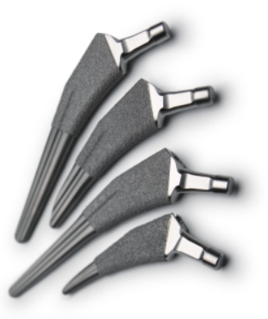
The Taperloc Hip Stem developed in 1982 is the longest running product produced by Zimmer Biomet. The Taperloc Hip Stem accounts for roughly half of what is produced in Bridgend; despite having upgraded nearly all of our equipment or processes, Bridgend continues to use the same legacy process flow. There are too many small individual operations, resulting in excessive waste, longer lead times, and higher costs. The objective report will investigate the possibility of improving the process by combining it into a single documented operations that does not jeopardise line clearance, traceability, or product quality.
Figure 1 - Taperloc Hip Stem

Taperloc Stem Cost
Profit margins determine how much money you make and represent the company's overall financial health. Net profit margin accounts for all expenses and income from other sources (Treece, 2022). This is calculated by ‘Price – Cost ÷ Price’. A Taperloc stem costs £130 to the health care provider and £113 in fixed costs to manufacture, resulting in a 13% net profit margin. Rates, utility bills, taxes, equipment costs, cross charges, direct/indirect salaries, and insurance are all part of the fixed cost Figure 2. With the rising cost of living, such as gas, electricity, consumables, and taxes, what happens if the customer refuses to pay? Zimmer Biomet Bridgend must reduce fixed costs and improve the manufacturing process in order to continue producing the Taperloc Stem.

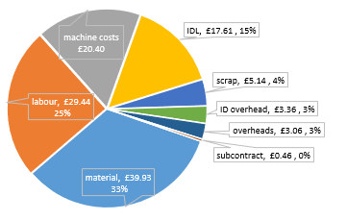
Figure 2 - Taperloc Cost Breakdown Chart

Process Improvement Using Lean Methodology
Lean management is one of the most popular process improvement programs. Toyota pioneered the lean methodology, which has since been adopted by many major corporations around the world. Lean focuses on reducing waste, which includes all non-value-added activities that customers will not pay for. This will improve flow while decreasing costs ( (Maleyeff & Amheiter, 2005). Lean principles are mainly focused on customer value and are used widely over a range of different manufacturing and distribution companies. According to (Womack, Jones, & Roos, 1990), there are five key lean principles:

- Value – Identify what the customer perceives as value.
- Value Stream – Analyse processes to identify value and non-value-added tasks.
- Flow – Focus on improving continuous flow through production or supply chain
- Pull – Product to be produced by customer demand and ‘Just in Time’.
- Perfection – Continuously improving and making lean principles part of the corporate culture.

Taperloc Manufacturing Process Analysis
The Taperloc process consists of a total of 29 steps from ‘Raw Material’ to ‘booked to stock’ and produced in batches of 12. Only the Stems manufacturing processes (18 steps) will be reviewed for this assessment; all end-of-line (EOL) processes such as final clean, packaging, and sterilisation will be completed at a later stage.

Value Stream Mapping
Value-stream mapping (VSM) analyses every process step involved in bringing a product from order to delivery to identify and eliminate waste. This is done by identifying the value and non-value-added activities within the process. There are three types of activities within a value stream (Tapping & Shuker, 2003):
- Value added (VA) – Adds value to the product
- Necessary / Business Non-Value Added (NNVA / BNVA) - Not adding value to the customer, but necessary from a business standpoint and therefore necessary to include in your processes.
- Non-value added (NVA) – Creates no value to the customer

Data Collection
In order to capture all the process data required a cross-functional team was formed to create a current state map that captured the actual state of the Taperloc value stream. The team was split into pairs to go onto the shop floor and review each process step and measure the cycle time and steps that it takes the operator to go through all of the work elements before starting a new batch.

Results
The completed Taperloc Stems value stream map Figure 3 can be found in Appendix 1.
The overall lead time start to finish was 19 days but the actual processing time (spent actually working on product) was 9 hours and 30 minutes, see results summary below Figure 4.

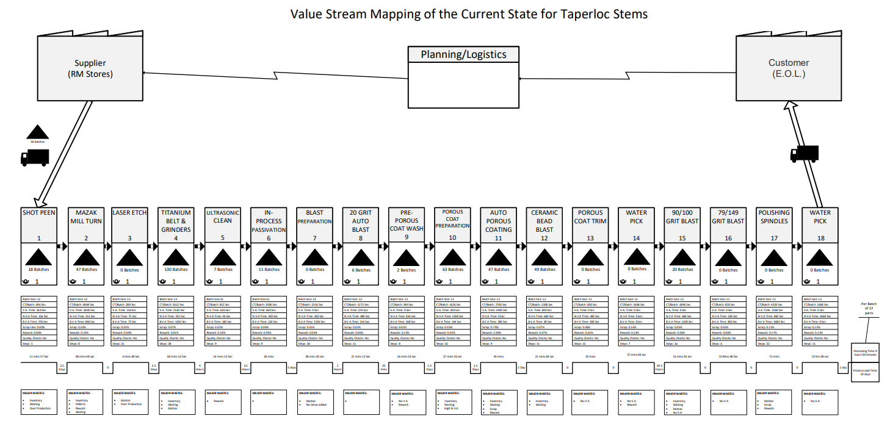
Figure 3 - Taperloc Stems Current State Value Stream Map

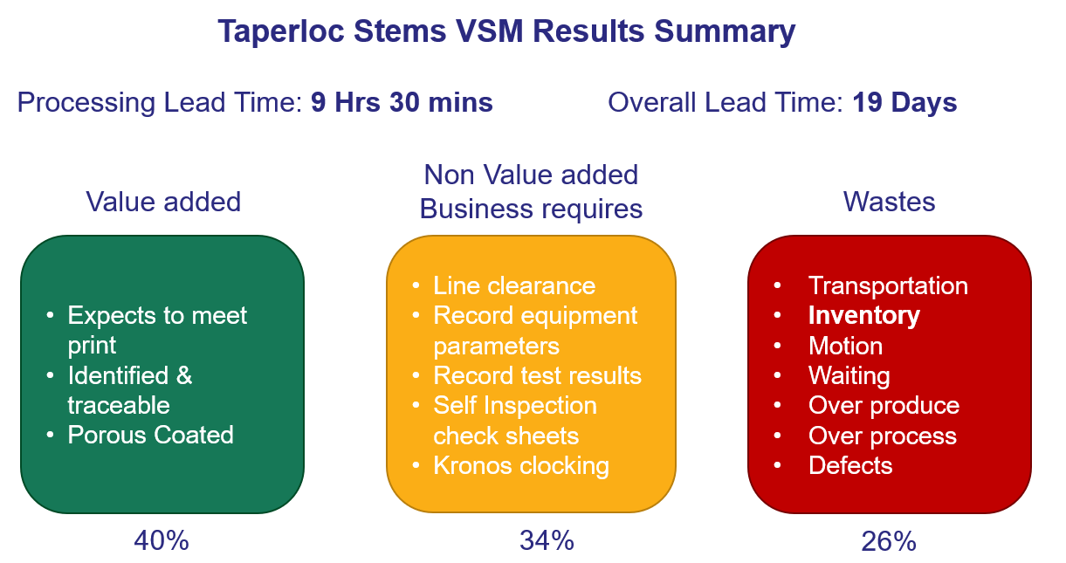
Figure 4 - Taperloc Stems Value Stream Map Results Summary

Value Added – 40%
What the customer is willing to pay for is value added activities that adds value to the product. The stem is transformed from a raw material to a finished product through value-added activities. Assuring that it is made in accordance with the drawing, specifications, and customer requirements. The customer patient/surgeon pays for the stem to be dimensionally correct and to meet the drawing. To avoid infection, it must also be clean and sterile packed. They also pay for coatings that promotes bone growth.

Non-Value-Added Business Requires – 34%
As the stem is a medical device there are standards that must be followed for the business to produce and sell products. The BNVA activities do not add value to the product but must be completed to be compliant. At the start and end of each operation line clearance and self-inspection must be performed; this can also include part measurement tooling or measuring equipment referencing.

Non-Value-Added (Wastes) – 26%
The lean theory 'TIMWOOD' was used to identify wastes in the Taperloc value stream. transportation, inventory, moving, waiting, over processing, over production, and defects are instances of waste. 'TIMWOOD' is a mnemonic for remembering all of the wastes. There is an eighth waste that is not included, and that is the waste of skills (Skhmot, 2022). All these wastes are deemed as non-value-added activities.

Transportation
Unnecessary product movement is referred to as transportation waste. This was a waste found within the Taperloc value stream, from the very first operation, 'Shot Peen,' all batches are issued from stores, which is located on the opposite side of the factory from where the process starts. The batches were then moved to different locations as the process progressed.

Inventory
Inventory (WIP) was discovered across most operations Figure 5, with the highest WIP found in operation 4 with 130 batches accounting for nearly £15K of stock. Inventory waste is defined as waste caused by the storage of unnecessary stock, whether raw materials, work-in-process, or finished goods, which increases the cost of the goods (Dennis, 2015). The WIP has an impact on continuous flow, takes up space, and increases the lead time to customers, and the ability to produce by customer demand 'Just in Time'.

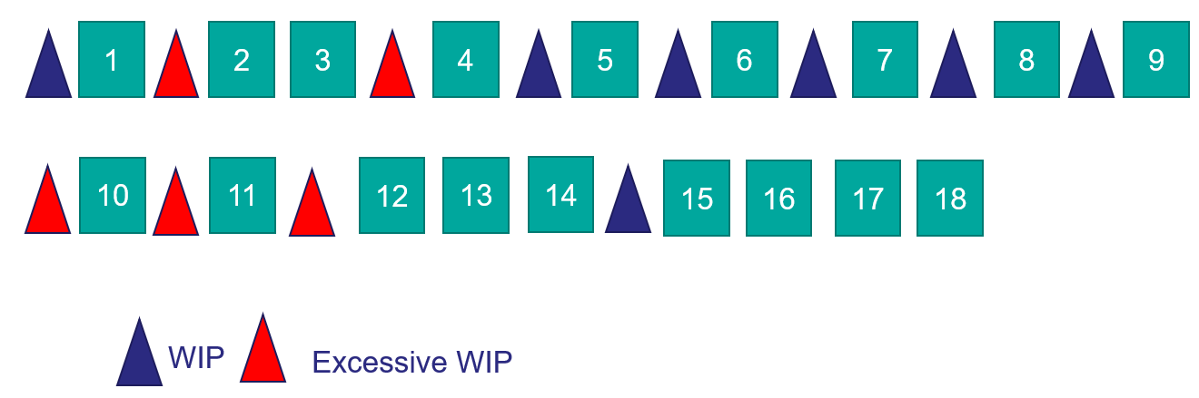
Figure 5 - Inventory (WIP) Locations

Motion
Unnecessary motion is waste that is more related to operator motion and layout. The operator steps were counted during the time study and later mapped onto the shop floor layout Figure 6. Equipment and workstations appear to be placed where there is space rather than strategically to improve flow. The operator took 32 steps during the polishing operation step 17.
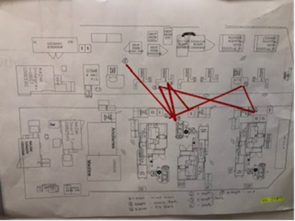
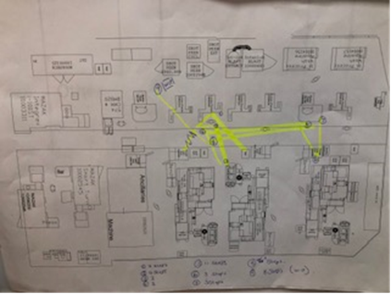
Figure 6 - Spaghetti Charts (Steps)

Waiting
Waiting is one of the most noticeable wastes, and it can occur at any stage of a process. It's typically found when a step in the process has finished but has to wait for something else to be completed before the next step can start (Womack, Jones, & Roos, 1990).
When looking at the stems process, this was discovered at many stages as some workstations and equipment are shared by two operators, for example, the polishing spindles are used by two different work streams, so the stem operator must wait for the shells operator to finish the batch before they can start.

Over Processing
Overprocessing exhausts resources and is frequently the result of adding something extra to the product that the customer is not paying for or doing more work than is required or necessary to complete a task (Skhmot, 2022). Batch assignment, line clearance and quality checks were identified as over processing. Before and after each process step the operator has to repeat the same checks as the previous operator. Some operators were progressing to the next step but had to repeat the checks they had just completed.

Over Production
Over production occurs when parts of a process are finished before the next step in the process. It also refers to when too much product is produced when there is no customer demand (Trent, 2008). The inventory levels clearly shows that over production is an issue across the value stream Figure 7.
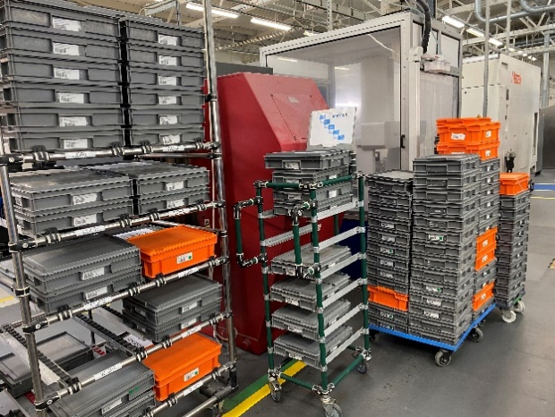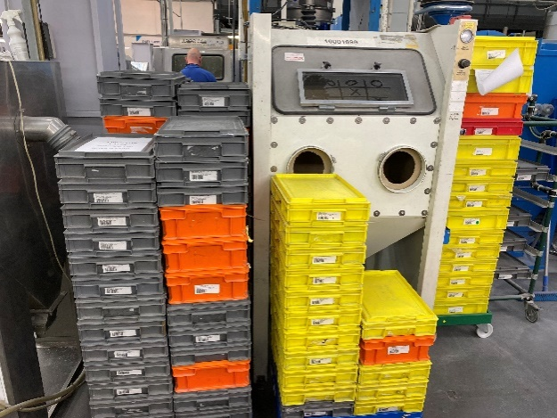
Figure 7 - Over Produced Inventory

Defects
Defects and rework are examples of defective products that do not meet customer requirements; it costs money and consumes time, materials, and energy. Defective parts have a significant impact on the entire process, depending on where they occur. Rework requires the operator to repeat work, which doubles the cost. Step 11 Auto Porous Coating has the most rework (2.9%), with over spraying of porous coating accounting for the majority of the rework. These parts are sent to a third party to be water jetted in order to remove the coating; this process takes 3-5 weeks and costs £116K per year.

Skills
Skills is the eighth waste and refers to used skills of employees. Toyota is a good example of valuing its team members; the company invests in its leaders and expects them to grow by utilising the members' skills, knowledge, and ideas ( Liker, 2004). This could be improved at ZB because during the information gathering for the VSM, operators shared ideas and skills that could improve the process but felt there was nowhere to voice and present these ideas until the kaizen event was initiated.

Process Improvement Proposal
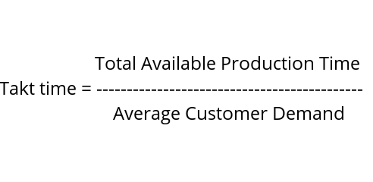
According to (Allen, et al., 2002), techniques such as line balancing is a production strategy that involves balancing operator and machine time to match the production rate to the takt time. Takt time refers to the rate at which parts or products must be manufactured to meet customer demand and is calculated by the available production time divide by customer demand Figure 8. If the cycle time is equal to the takt time, the process is perfectly balanced. To remove bottlenecks, rebalancing the resource or equipment assigned to each operation can achieve the best possible output rate.
Figure 8 - Takt Time Calculation

Taperloc Stems Takt Time
The calculated takt time for stems was calculated as follows:
Available time (week) = 8620 mins
Weekly demand = 4300 parts
Takt time per part: 8620 ÷ 4300 = 2.02 Mins / 122 Sec

Taperloc Stems Line Balancing
To level the workload across all processes in the value stream, all operations and timings were input into a line balancing Graph 1 that details the overall time broken down into non-value added, value added, and business non-value added. It indicates whether the overall cycle for each operation meets the takt time requirement. For example, Step 2 'CNC Machining' on a single machine one piece takes 404 secs exceeding the takt time of 122 secs. In order to meet the takt time we will need 3 - 4 machines. (404 ÷ 122 = 3.3).
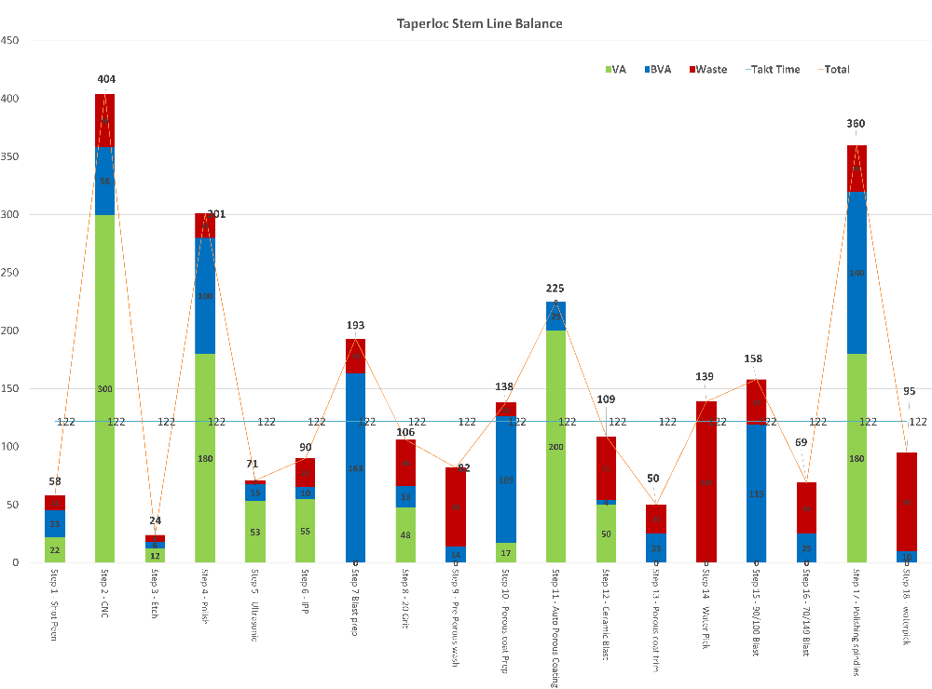
Graph 1 - Taperloc Stems Line Balancing Graph (Appendix 2)

Cell Manufacturing & Batch Size
To improve the stems manufacturing process, the proposal is to introduce cell manufacturing. Combining manual and machine operations into a more efficient combination maximising value-added while decreasing waste, resulting in a more balanced process (Totally Aligned Organization, 2022).
The batch size will increase due to the porous coating chamber being a process constraint processing 72 pieces per cycle. Increasing batch size will significantly reduce NVA activities such as batch assignment, line clearance, and quality checks but enable one piece flow within dedicated manufacturing cells. The Stems value stream will consist of 5 cells Figure 9, Figure 10 and Figure 11.

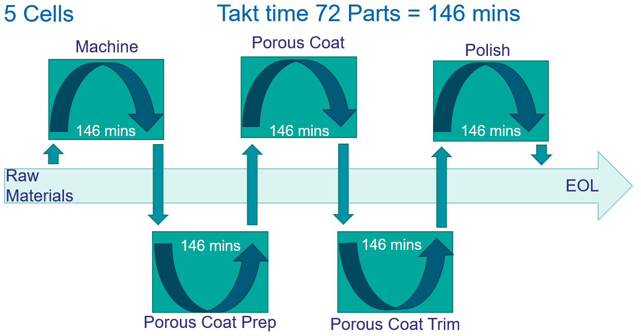
Figure 9 - Taperloc Stem Cell Flow
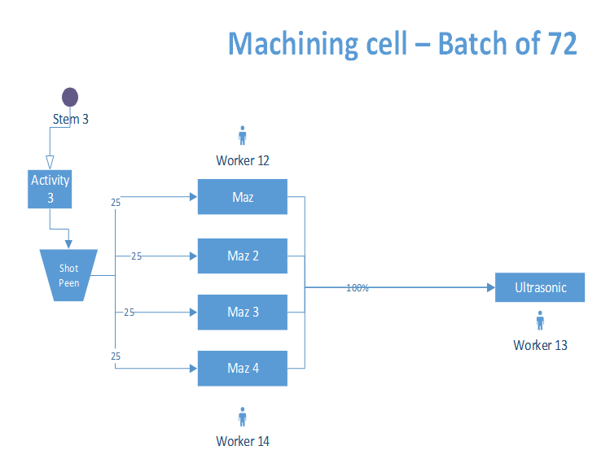
Figure 10 - Example Machining Cell Layout
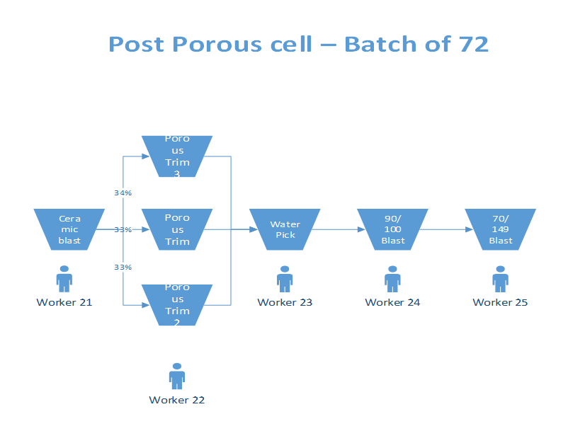
Figure 11 - Example Post Porous Layout

Potential Improvements
Cellular manufacturing will not only reduced production costs, but it will also improve lead times and quality. Communication between cell team member will also be improved. One of the bigger benefits is waste these are summarised in the Table 1 - Cell Manufacturing Waste Improvements.

Table 1 - Cell Manufacturing Waste Improvements
Waste | Improvement
Transportation | - The introduction of cells will reduce part transportation because of the layout and close proximity of the cell's equipment and resources.  - Cell 1 will be closer to raw material stores.
Inventory | - Balancing the work will stop operators exceeding what the next operator can handle stopping WIP Inventory  - New layout will not have room to store excess inventory.
Motion | - Equipment and work benches will be conveniently located so that the operators have all resources needed to do their jobs within the cell.
Waiting | - Cells will reduce waiting time and improve flow due to resources being close together.  - Allows for flexibility by allowing workers to assist others in order to reduce waiting time.
Over Processing | - Larger batch size and fewer operations means less paperwork for batch assignment, line clearance, and quality checks. This will only be required once per cell.  - Cells will make it easier to identify the processes that are not adding value to the product.
Over Production | - Inventory will be reduced (see inventory) making it easier to produce only what is needed.  - Balancing the steps in the production process is simplified which will result in shorter lead times between order placement and delivery.
Defects | - Easier implementation of zero-defect strategies  - Greater quality control means faster identification of defects due to the lack of "buffered" upstream production.  - Complete water jetting rework operation in-house.

Implementation Concerns

Cost & Resource
Financial resources are required to introduce cellular manufacturing, and there is currently insufficient money for any investment. It will be necessary to relocate equipment and utilities in order to create cells. This will necessitate the use of outside contractors, particularly for Mazak CNC machining equipment. There may also be an impact on production and planned downtime to allow for the moves. Another consideration is planning and documentation, such as machine validation and risk assessment, which all require resources.
Even though the business must consider capital expenditures for the changes they should also consider the positive returns even though this may take some time. To mitigate some of the costs, a structured implementation plan is required to ensure resource allocation, changes, communication, and objectives are set and met. It may also allow for gradual implementation of improvements by identifying which operations can be changed with minimal or intensive resource allocation. Downtime for layout changes can be avoided by completing work during holiday periods, such as Christmas, to minimise disruption while also forming a team to support that would normally be working on day-to-day tasks to solely dedicate time.

Culture
To implement and sustain lean changes, a company's leadership and employees' behaviour, culture, and attitudes must undergo significant change. Senior managements commitment and involvement are required to change workplace behaviour. According to a survey conducted by (Bhasin, 2012), organisations believe that the responsibilities of lean cause a struggle because of the time required to implement lean, and they also do not focus on the long-term outcome.
Big changes in the workplace can evoke resistance, with employees displaying a critical attitude and fearful of changing the way they have been completing work for years or fear of losing their job. Some of these concerns stem from a misunderstanding of lean. Clear communication about the purpose and priorities of lean can help to avoid resistance by involving everyone in the implementation process from the start. Monitoring and communicating progress and results, as well as recognising accomplishments, will keep the team motivated while preventing a relapse into old habits. Senior management should also commit time and be actively involved in any lean or kaizen events, as well as provide investment; however, they must also allow time for middle management and operators to participate.

Conclusion
With rising production costs, the primary goal of this project was to look at how the Taperloc Stem could be made cheaper by making the process leaner. The time study to create the value stream map, as well as further analysis and trials, provided an excellent opportunity for operators, team leaders, and engineers to identify constraints and engage in ways to improve and lean the process. The senior management team is eager to move forward with the changes and will review over the next few project meetings in order to create a project charter and further invest in lean training.

Works Cited
Liker, J. K. (2004). The Toyota Way: 14 Management Principles from the World's Greatest Manufacturer (Reissue edition) . McGraw-Hill Education.
Allen, T., Murman, E., Bozdogan, K., Cutcher-Gershenfeld, J., McManus, H., & Nightingale, D. (2002). Lean enterprise value : insights from MIT's Lean Aerospace Initiative. New York: Palgrave.
Bhasin, S. (2012). Prominent obstacles to lean. International Journal of Productivity and Performance , 403-425.
Dennis, P. (2015). Lean Production Simplified (3rd ed.). New York: CRC Press, Taylor & Francis Group.
Maleyeff, J., & Amheiter, E. (2005). The integration of lean management and six sigma. The TQM Magazine, Vol. 17, 5-18.
Skhmot, N. (2022, July 13). The 8 Wastes of Lean 2017. Retrieved from The Lean Way: https://theleanway.net/The-8-Wastes-of-Lean
Tapping , D., & Shuker, t. (2003). Value Stream Management for the Lean Office. Value Stream Management for the Lean Office: Productivity Press.
Totally Aligned Organization. (2022, July 17). Lean (Flow & Cellular Manufacturing). Retrieved from Totally Aligned Organization: https://totallyalignedorganization.in/models/lean
Treece, D. (2022, JUne 29). What Should Your Profit Margins Be? Retrieved from Business News Daily: https://www.businessnewsdaily.com/11096-determining-profit-margins.html
Trent, R. J. (2008). End-to-End Lean Management: A Guide to Complete Supply Chain Improvement. J. Ross Publishing.
Womack, J. P., Jones, D. T., & Roos, D. (1990). The Machine That Changed the world. New York: According to Womack and Jones, there are five key lean principles: value, value stream, flow, pull, and perfection.

Appendices

Appendix 1 – Taperloc Stems Current Value Stream Map
(For larger scale appendix 1 has been sent via email)

Appendix 2 – Taperloc Stems Line Balancing Graph
(For larger scale appendix 2 has been sent via email)


