International Entrepreneurship.

This essay will look after the international entrepreneurship and thoses complexity. It will treated of international entrepreneurship all around the world and all the differences that we can found between country of differents areas of the world. First of all it’s important to know what is Entrepreneurship. Today it is difficult to give an exact definition of the words entrepreneur and entrepreneurship. Some economist we try to give a definition to these terms but we can observe that their definitions are not necessarily the same. Anytime we will be interested in some of them. Prof. Howard Stevenson defined entrepreneurship as "Entrepreneurship is the pursuit of opportunity without looking at resources currently controlled" (https://hbr.org/2013/01/what-is-entrepreneurship). This definition is interesting and allows us to better understand the term entrepreneurship. In the case of entrepreneur Chris Oakley said, "An entrepreneur has an opportunity to make a difference in the performance of an existing business. In this definition, he explains to us that an entrepreneur is someone who is in some way ahead of the others and that it can invest in areas where other people who do not have the entrepreneurial fiber would not invest. Now that we know what entrepreneurship and entrepreneurs are, we can be interested in the difference between entrepreneurship and international entrepreneurship. Now that we know what entrepreneurship and entrepreneurs are, we can be interested in the difference between entrepreneurship and international entrepreneurship. International entrepreneurship is the process of an entrepreneur conducting business activities across national boundaries. The activities necessary for ascertaining and satisfying the needs and wants of people in the country. "(Chris Thomas Lecture, 2018) in this definition we are told that international entrepreneurship is in a way the result of a good functioning of entrepreneurship. International entrepreneurship is presented here as a kind of extension of national entrepreneurship. In this essay it will be question of what are the ways of doing international entrepreneurship in five different countries. We will focus on these countries according to certain theories of entrepreneurship such as the economic approach for example. The five countries we are going to be interested in are: Germany, Australia, Ethiopia, Canada and Argentina

This first part will deal with one of the most important countries in Europe, Germany. This country is one of the most economically strong in Europe and is one of the largest economic rains in the world. It is a country that has many advantages for entrepreneurs, especially in terms of infrastructure. We will therefore observe the different characteristics that this country presents for entrepreneurship.

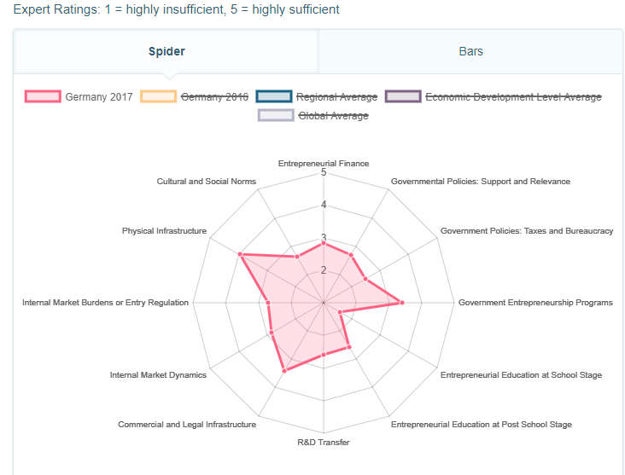
(http://www.gemconsortium.org/country-profile/64)
As previously announced we can realize that Germany has many infrastructure and that they are well anchored in the German economic landscape, any time we can notice that the spirit of entrepreneurship is not very pronounced in the culture In Germany, this country has low average scores in areas such as entrepreneurial finance and entrepreneurship learning. These features may interest foreign entrepreneurs, indeed if the Germans do not have the entrepreneurial fiber that can leave a place for foreigners. "Germans are known for their hard work and efficiency, but not especially for their entrepreneurial flair. They create fewer new businesses than the Americans, the Swedes, and even the French, "says the British magazine The Economist. A third of the entrepreneurs settled in Germany were born abroad, and in 2015, 44% of the companies in Germany were created by foreigners, compared to only 13% in 2003. The recent wave of immigration partly explains the fact that this phenomenon continues to grow. Starting your own business is not easy. Germany was ranked 114th by the World Bank for the ease of starting a business. In question: bureaucracy and rules that are sometimes difficult to grasp.
(https://www.courrierinternational.com/article/entreprendre-lallemagne-compte-sur-les-etrangers)
We can therefore ask ourselves the question: what is the best place to start a start-up in Germany? Everything suggests that all the innovation and the birth of start-ups is focused on the city of Berlin, but to take a closer look, we notice that many cities are emerging in Germany such as Munich, Hamburg or Cologne. These different cities are home to many start-ups but also events concerning entrepreneurship that is why it develops and allows Germany to expand its panel of start-ups. Berlin is still the most important city for entrepreneurs at present Berlin has more than 2000 start-ups, there is a business creation every 20 minutes, 100,000 jobs will be created by 2020 and on the last two years more than 2 billion euros have been invested. Anyway, as in all the big cities that brings together many start-ups, the competition is fierce and is a negative point according to the different entrepreneurs practicing it.
(http://www.face-entrepreneurship.eu/fr/blog/articulos/l-ecosysteme-des-start-up-en-allemagne)
The German state despite its weak participation in the evolution of entrepreneurship on territory is still trying to take measures that favors the creation of business. The state has set up different types of business creation. In Germany, the Gesellschaft mit beschränkter Haftung (GmbH) and the Unternehmergesellschaft (UG) are forms of limited liability companies. This means that the partners can not be held personally responsible for the debts contracted by the entity: the responsibility is limited to the contributions. In this sense, they are comparable to French SARLs. The UG has been introduced by the German legislator with less demanding formalities.

The main characteristic of the UG is the possibility of creating a company with a minimum capital of 1 euro. This creation proved to be a great success for the German legislator who wanted for several years to increase the entrepreneurship on its territory. Indeed, the UG has become extremely popular in Germany although internationally it is confined to the national territory and has not been much sought by foreign entrepreneurs.
(http://spiegeler.com/les-differentes-etapes-pratiques-et-legales-pour-la-creation-dune-gmbh-ou-dune-ug-en-allemagne/)
To sum up, Germany is a country with some important and interesting characteristics for entrepreneurs such as infrastructure and competitiveness clusters like Berlin, but this country still has many obstacles to entrepreneurship, such as the fierce competition that exists there. reign or the fact that business creation is not so easy because of the different administrative constraints it presents.

This second part will focus on one of the most important countries in the Asia Oceania region, Australia. It is one of the largest countries in the world and counts among the world's largest economic powerhouses. This country long to consider as a kind of eldorado for the entrepreneurs to him all the qualities required to attract the entrepreneurs? We will look at Australia's possibilities for entrepreneurship.
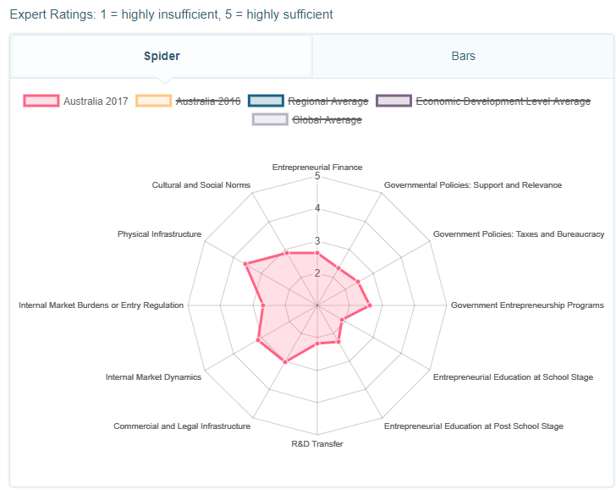
(http://www.gemconsortium.org/country-profile/37)
Australia in its GEM model can be likened to the German model, this country offers strong and well established infrastructure in its territory and also offers a dynamic internal walk, which can make it possible to find partners quite easily, all the time. Australian culture is not very focused on entrepreneurship, we can observe that there is not much education on entrepreneurship, so that the Australian system is not primarily aimed at training entrepreneurs. The Australian government, for its part, does not propose many reforms in favor of entrepreneurship, which may mean that the implatation aids are not numerous and therefore that a substantial contribution and liquidity are needed to be able to launch. business in this country, this can be seen as a brake by the various entrepreneurs suceptible what this throw in the Australian adventure. When we observe the behavior of Australians with respect to entrepreneurship, we can notice that they are very motivated, their score shows that they are people determined to launch them into entrepreneurship, they also perceive the different opportunities. , which is one of the essential capacity of entrepreneurs, any time we notice that there is a brake on their motivation, it is the fear of failure, it is indeed very pronounced in this country, it can be due to the fact that it does not have a lot of help from the state and so can insurance when their business does not work.
We can look at the different strengths and drawbacks that this Australian system offers.
Main assets:
  - Political, institutional and social stability
  - Stable, transparent, rational and predictable economic environment
  - Strong and attractive financial market
  - Low public debt
  - Near Asia
  - High standard of living
Weaknesses:
- Population (22.7 million inhabitants)
- General distances and their consequences
- Lack of skilled labor

Opportunities:
- Open and transparent market
- Large scale projects (mining, infrastructure)
- Riches in raw materials and agricultural products
Risks:
- Slowdown in the commodity boom
- High exposure to natural hazards
- High level of household debt
(http://www.facci.com.au/recruitment/reussir-en-australie/entreprendre-en-australie)
The Australian government has been aware for some years that it is important to develop entrepreneurship in its territory and also to change attitudes of its citizens on the issue of entrepreneurship. For that, the Australian government has launched a major program on innovation and entrepreneurship. According to Australian Government « Australia, since 2015, has extremely strengthened its policy agenda of science and technology for entrepreneurship and innovation.Since 2015, the National Innovation and Science Agenda (NISA - http: // www.innovation.gov.au/) is aimed at stimulating value creation from research results Set up in 2016, the independent Innovation and Science Australia (ISA) office advises the government on the Australian transition to an economy of innovation based on a greater appreciation of the scientific capabilities of the country The ISA published a review of the Australian system of research and innovation in February 2017 and submitted for public consultation the stakes of the 2030 strategic plan for research and innovation between March and June 2017. The Bureau is today publishing its strategic plan, entitled "Prosperity Through Innovation" to advise the government Australia with the aim of strengthening the country's ability to convert its ideas and scientific results into valuable products or services in the economic market. »

This strategic plan is developed along 5 axes: education, industry, government, R & D and culture and ambition. (https://www.diplomatie.gouv.fr/fr/politique-etrangere-de-la-france/diplomatie-scientifique/veille-scientifique-et-technologique/australie/article/innovation-and-science-australia-remet-au-gouvernement-federal-son-plan)
The goal of this Australian government initiative is to develop entrepreneurship and innovation on its territory so that natives of Australia can develop it because today there is a high rate of foreign entrepreneur and it does not seem normal in the eyes of the government that the native of australia does not develop like the strangers.
In summary, Australia is a country with a strong potential for entrepreneurship but it is currently constrained by difficulties such as distance or the lack of development of investment aid.

This third part goes on to deal with the case of Ethiopia. It is an African country in full development but still anchored in a certain poverty, it has become today the new workshop of the world as could be China. Its cheap manpower and labor legislation make Ethiopia an interesting country for big entrepreneurs who want to develop it on the continent of Africa.
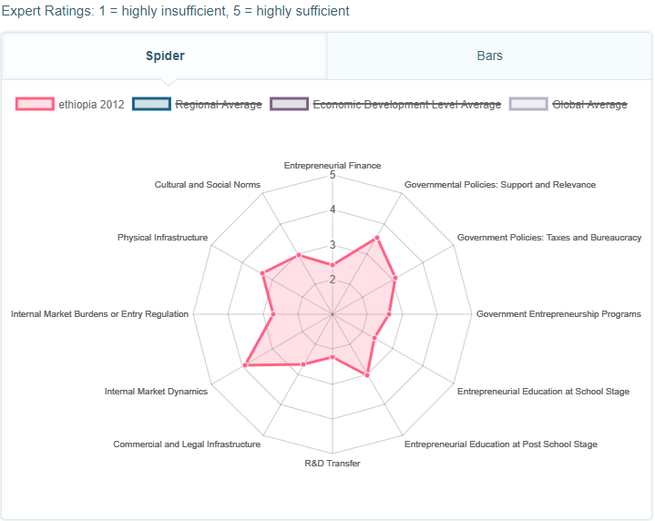
(http://www.gemconsortium.org/country-profile/129)

According to the GEM presentation of Ethiopia, we can notice that this country has different quality, in fact Ethiopia has a very active and dynamic internal market, many state aids to entrepreneurs, a strong education around entrepreneurship especially in post-school and also strong infrastructure, any time we note that Ethiopia has a major gap in research & development, and the level of financing of entrepreneurs by the state. We can notice that the entrepreneur is a profession very aprécier and recognized in this country, but in spite of that we can not see huge progress at the level of entrepreneurship on new innovative products, this is due to the fact that There is not a lot of research & development, but also because of the desire of the Ethiopian to start entrepreneurship.

Unemployment is one of the factors that has exacerbated the 2016 protests in Ethiopia. Today, the threat of an uprising still hangs over the country. To curb the threat and fight against unemployment, the Ethiopian government is banking on SMEs by encouraging young graduates to take up jobs. To encourage entrepreneurs, Ethiopia annually rewards its best companies, among other incentives.
In Ethiopia, the youth unemployment rate was 8.1%, according to the Mo Ibrahim Foundation. If the unemployment rate is low compared to other countries on the continent, the number of young graduates who arrive each year on the labor market continues to grow. They are estimated at 200,000 applicants. (https://afrique.latribune.fr/entreprises/2017-06-13/ethiopie-les-jeunes-chomeurs-appeles-a-s-orienter-vers-les-pme-738362.html)
Since 2000, the Ethiopian government has been focusing on programs aimed at developing SMEs, with the aim of creating better jobs, indeed the unemployment issue is recurrent in Ethiopia and the government has decided to counter this problem by putting the focus on youth and women with SMEs. This program has multiple objectives.
- expand and consolidate SMEs in Ethiopia
- improve the business environment and infrastructure in Ethiopia
- provide policy makers with the tools and knowledge to design strategies for young entrepreneurs
- strengthen the capacities of young researchers and leaders
- publish articles and policy briefs
- establish a database to track the growth of SMEs over time
The government has also instituted a system of meritocracy, that is to say, it rewards the best entrepreneurs of the year, this is also part of the government's plan to boost entrepreneurship.
(https://www.idrc.ca/fr/project/developpement-de-lentrepreneuriat-et-des-petites-entreprises-en-ethiopie)
We must recognize that the government has made a huge leap forward. Ethiopia has real strengths, including a promising market and an exceptional environment. Socio-economic indicators confirm remarkable progress over the last decade. Megaprojects of development were supposed to pull the economy. They are in place: Ethiopia has built railroad tracks, a tramway. An enormous hydroelectric network is being built. But we have to see if these projects will be completed. The country lacks funds from Ethiopia and abroad: the infrastructure is visible, but investments must now follow.
Ethiopia lacks liquidity and is highly dependent on agricultural exports, which accounted for half of its exports in 2015. This makes it vulnerable to fluctuations in international prices. The scenario of the worst would probably be a sharp drop in commodity prices, such as coffee, combined with a sharp rise in the price of oil. We can also mention the upward recovery of inflation which could again exceed 10% for 2016. Finally, the political dimension of the model implemented is problematic: the government's desire to control everything is in contradiction with its desire yet displayed to encourage entrepreneurial initiative. (http://www.lemonde.fr/afrique/article/2016/09/27/ethiopie-privilegier-la-stabilite-economique-a-l-ouverture-politique-a-cree-une-situation-explosive_5004314_3212.html)
In summary Ethiopia is a country that offers a lot of advantages on different levels. Any time it faces an important unemployment and has an economic model which is not based on very stable bases and it could thus collapse quite easily which could cause a departure of the various investors.

This fourth part will deal with the case of Canada. This country is the 10th largest economy in the world and has many attractive cities for young companies. Traditionally business friendly, Canada is more open than ever to foreign investment. Favorable market conditions, attractive public policies: the country and its various provinces are attractive to many foreign companies and project carriers.
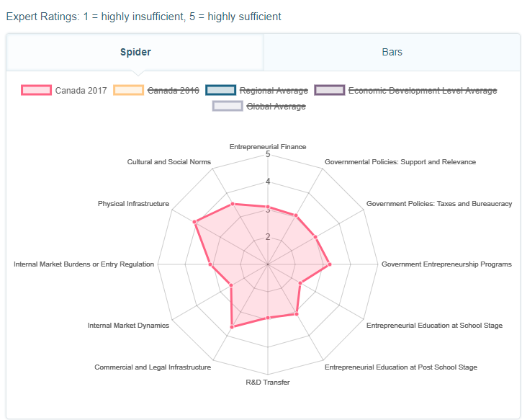
(http://www.gemconsortium.org/country-profile/49)

GEM's analysis of Canada shows us that this country is very attractive to entrepreneurs. Firstly we observe that the infrastructure is very strong, it is one of the countries that has the best infrastructure for business, but also legal. It is also observed that the job of entrepreneur is very well regarded in this country, when one is a successful entrepreneur in this country, one can be considered as having a strong social status. The perception of opportunity is also a strong point in this country. Nevertheless, there are some small problems in the functioning of this country for entrepreneurship. Canada does not have a very dynamic internal market. The culture of entrepreneurship is also not very anchored, and as in most countries there is a strong fear of failure.
Canada offers fertile ground for business creation through, among other things, its culture, a favorable fiscal and regulatory environment, and efforts to stimulate research and innovation. However, financing remains the main concern of a large majority of entrepreneurs.
This is revealed by a new survey published by Ernst & Young (EY). EY's 2013 G20 Entrepreneurship Barometer survey of 1,500 entrepreneurs places Canada among the top five countries in the business environment. Among the positive elements, the EY survey notes that the costs to start a business in Canada are among the lowest in the G20. Labor costs are also lower than in most other countries, while Canadian entrepreneurs spend less time on tax issues than other advanced countries.
That said, securing funding remains a challenge for 73% of Canadian entrepreneurs, which is above the average for all G20 countries. The ratio of private equity activities to GDP in Canada is now higher than in any other G20 country except Australia. Private equity and venture capital are improving, but bank financing remains a challenge. (https://www.lesaffaires.com/strategie-d-entreprise/entreprendre/entrepreneuriat-le-canada-parmi-les-meilleurs-sauf-pour-le-financement/560887)
This funding problem can cool candidates for entrepreneurship in Canada that's why the Canadian government has set up a system of easy enough for foreign companies, it is relatively easy to obtain a visa to create a business in Canada. This program is the result of the fact that the costs are rising to open its business but also because the Canadians are not big enterpreneurs, with this program the Canadian government hopes to attract many investors who will create jobs for Canadians . The government has therefore listed the various benefits to evolve in Canada, and these benefits are:
- a strong economy;
- low taxes;
- low operating costs;
- excellence in research and innovation;
- an excellent quality of life;
- canada is a gateway to investing in the american territory.
(https://www.canada.ca/fr/immigration-refugies-citoyennete/services/immigrer-canada/visa-demarrage.html)

The last part of this essay will focus on Argentina. Argentina is one of the most emerging countries in South America, with a 10% GDP growth ranking as the world's 21st largest economy. This country had fallen behind economically as a result of the various policies exerted in the passing of the dictatorships. Since the 2000s and the arrival of the Kirchner couple, the country has been doing better, even though a strike in the agricultural field appeared at the beginning of Mrs Kirchner's term.
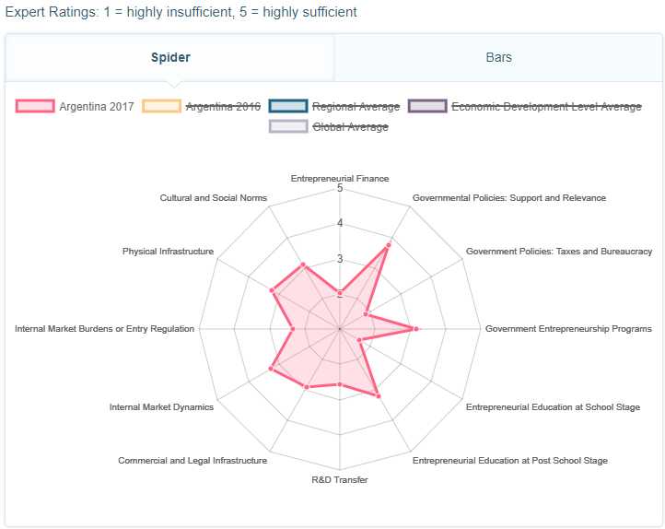
(http://www.gemconsortium.org/country-profile/36)
Argentina's GEM analysis reveals several aspects of this country for entrepreneurship. First we can see that the help of the government is very important, it is the most important that we could see in this essay. The government has also reformed education in order to steer it more towards entrepreneurship, we also note that the momentum is strong within the country's internal market. These different elements show that Argentina has a good base to welcome entrepreneurs, however there are some obstacles to the development of entrepreneurs. Indeed, if the state sets up a big program to help the entrepreneurship to develop, it does not put so much funding, it is perhaps one of the biggest negative point of this analysis. We can also see that the status of entrepreneur is not necessarily considered as very important in the Argentine population. The fear of the failure is also to pronounce in this country, this is due to the fact that the financing is different and therefore it is necessary to leave a lot of personal money to develop its project. Moreover, innovation is not one of the main characteristics of the Argentine market, which can close the door to several types of entrepreneurs.
For most foreigners, working in Argentina means above all: undertaking. Indeed, it is difficult for everyone to find work in the country, and most positions are obtained through a network of relations. The level of wages in Argentina is very low compared to Europe. This discourages many foreigners seeking to settle in Buenos Aires. The minimum wage is 1,200 pesos a month, and the average wage is 3,600 pesos! That is 240 euros per month, and 720 euros per month, respectively. In addition, a large number of unskilled jobs involve "black" jobs, paid below the minimum wage. Undertaking in Argentina is perfectly feasible for foreigners, and allows to obtain a visa: the brand new company hires its manager and asks for a visa for him, as an employee of an Argentine company. All that is required is that one of the company's associates is already resident. The necessary capital is not considerable: one can create a S.R.L. (the equivalent of the SARL in France) with 12,000 pesos (about 2,400 euros) of capital. So we can very well settle in Buenos Aires with a little know-how, a low capital, and create his own job. (https://lepetitjournal.com/buenos-aires/emploi/travailler-en-argentine-loption-de-lentreprenariat-71168)
If we summarize the situation in Argentina we could observe that the country has many assets for entrepreneurship and it may be easier for a foreigner to settle there than for a local because wages are enough low and the cost of an implatation is not very high, moreover the fact that the innovation is not very develop that can allow a foreign investor who with the technical knowledge to bring novelty on the Argentine market .

To conclude this essay we can say thanks to all the observations made that all countries do not belong to the same theories of entrepreneurship. Countries such as Germany, Canada or Australia belong more to Kirzner's theory ie that an entrepreneur is a person who perceives the opportunities well and that no matter what rank in society this can come from anyone and from anywhere. In less economically developed or poorer countries, we can see that the theory that stands out most is that of Schumpeter who says that entrepreneurs are special people who have special ideas and that this is not to give to everyone, in a country like argentina even if it takes little personal contribution to create his own business, the Argentineans living on a basic salary will find it hard to launch because the financial contribution remains very high compared to their wages, moreover the Argentine state does not help much financially entrepreneurs. In spite of this we can see that the current world evolves more towards the theories like that of Kirzner where everybody can be an entrepreneur, it is noticeable in Ethiopia where we reward the best entrepreneurs that insists the people to invest even if the personal contribution must be high.

References :

- http://www.gemconsortium.org/country-profile/49
- http://www.gemconsortium.org/country-profile/129
- http://www.gemconsortium.org/country-profile/64
- http://www.gemconsortium.org/country-profile/37
- http://www.gemconsortium.org/country-profile/36
- Mr Chris Thomas lectures (2018)
- https://hbr.org/2013/01/what-is-entrepreneurship
- http://spiegeler.com/les-differentes-etapes-pratiques-et-legales-pour-la-creation-dune-gmbh-ou-dune-ug-en-allemagne/
- https://www.courrierinternational.com/article/entreprendre-lallemagne-compte-sur-les-etrangers
- http://www.face-entrepreneurship.eu/fr/blog/articulos/l-ecosysteme-des-start-up-en-allemagne
- http://www.facci.com.au/recruitment/reussir-en-australie/entreprendre-en-australie
- https://www.australia.gov.au/information-and-services/business-and-industry
- https://www.diplomatie.gouv.fr/fr/politique-etrangere-de-la-france/diplomatie-scientifique/veille-scientifique-et-technologique/australie/article/innovation-and-science-australia-remet-au-gouvernement-federal-son-plan
- http://www.lemonde.fr/afrique/article/2016/09/27/ethiopie-privilegier-la-stabilite-economique-a-l-ouverture-politique-a-cree-une-situation-explosive_5004314_3212.html
- https://www.idrc.ca/en/project/entrepreneurship-and-small-business-development-ethiopia
- https://www.afdb.org/fr/news-and-events/africas-future-lies-in-entrepreneurship-and-industrialization-2017-african-economic-outlook-17021/
- https://afrique.latribune.fr/entreprises/2017-06-13/ethiopie-les-jeunes-chomeurs-appeles-a-s-orienter-vers-les-pme-738362.html
- file:///C:/Users/HP/Downloads/Ethiopie_FR_2017.pdf
- https://business.lesechos.fr/entrepreneurs/internationaliser-exporter/0301460031449-le-canada-terre-d-entrepreneuriat-ouverte-aux-investisseurs-320040.php
- https://www.lesaffaires.com/strategie-d-entreprise/entreprendre/entrepreneuriat-le-canada-parmi-les-meilleurs-sauf-pour-le-financement/560887
- file:///C:/Users/HP/Downloads/gem-university-of-calgary-report-2015-2016-1492374307.pdf
- http://library.uniteddiversity.coop/Cooperatives/CoopAFRICA/Cooperating_out_of_poverty-The_renaissance_of_the_African_cooperative_movement.pdf
- https://www.argentina.gob.ar/tema/emprender/soy-emprendedor
- http://cjf.qc.ca/revue-relations/publication/article/le-developpement-industriel-de-largentine/
- https://lepetitjournal.com/buenos-aires/emploi/travailler-en-argentine-loption-de-lentreprenariat-71168
- https://www.canada.ca/fr/immigration-refugies-citoyennete/services/immigrer-canada/visa-demarrage.html

