HTML & CSS Web Development
Gabor Jonas
Student Number: 1705136
Course: Web Development HND
Modul Name: Introduction to Web Development ACCA4003
Date: 2018/01/10

Table of Contents
1. Title Page
2. Table of Contents
3. Introduction 2
4. Requirements 3
4.1 Introduction 3
4.2 Site Map 3
4.3 Wireframe diagram 4
5. Implementation 4
5.1 HTML Validation 4
5.2 CSS Validation 5
7. Evaulation 5
References 5

3. Introduction
This document is a report of Web Development 1 module assignment.

4. Requirements

4.1 Introduction
GJ Motors is a fictional vehicle servicing company. The website is made for advertise it’s services to car owners. Target audience is every car owner.

4.2 Site Map
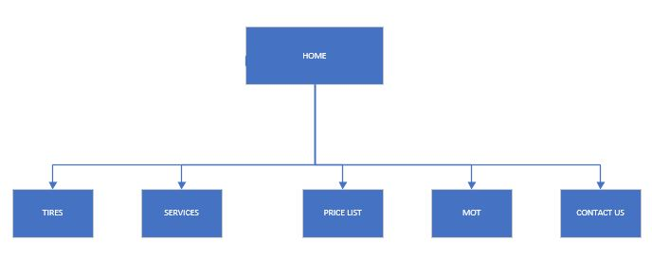

4.3 Wireframe diagram

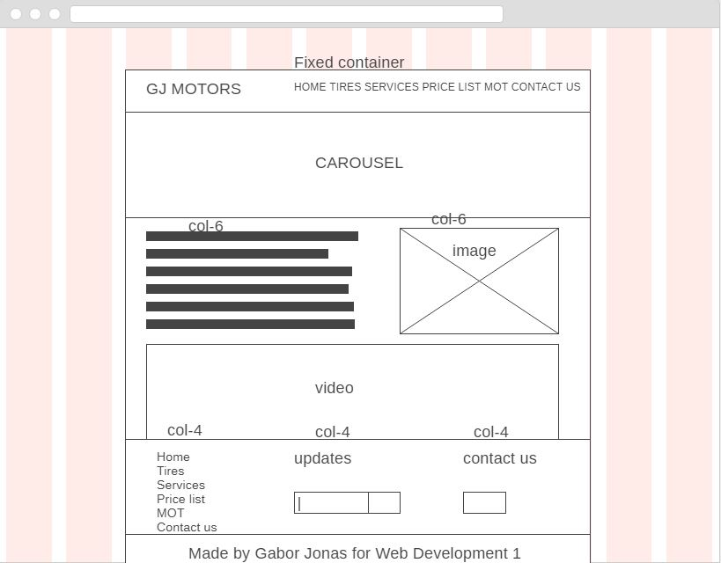

5. Implementation

5.1 HTML Validation
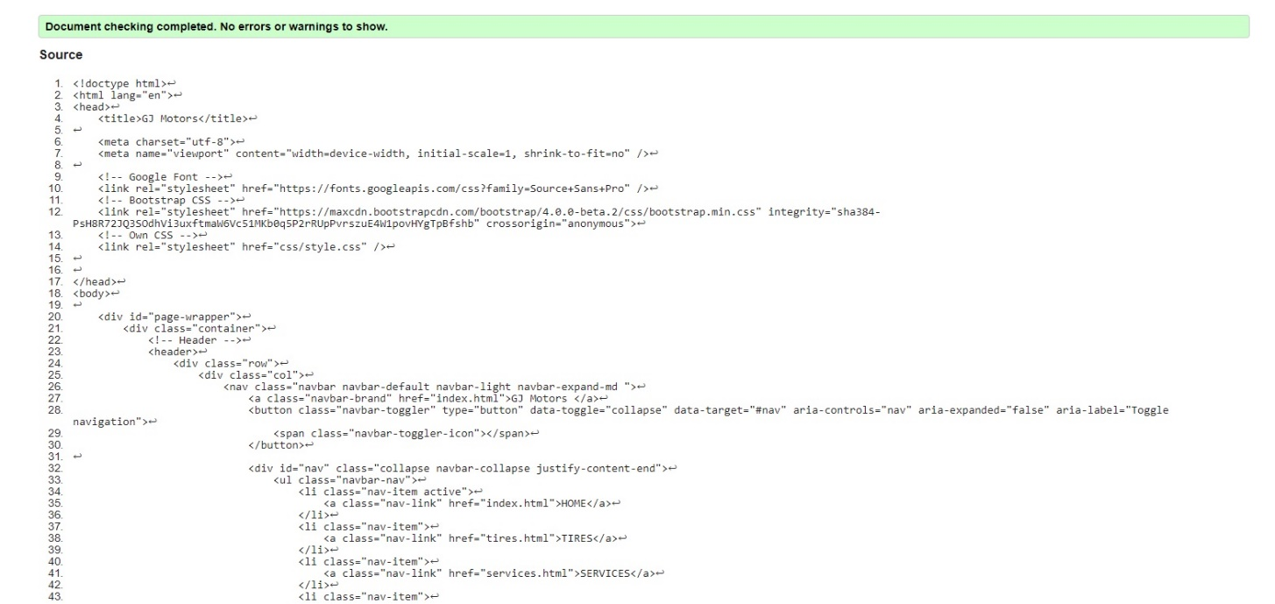

5.2 CSS Validation
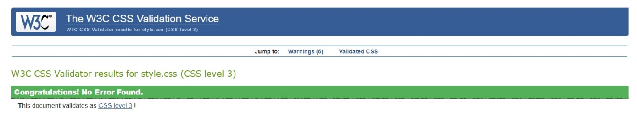

5 warnings for vendor-specific prefixes
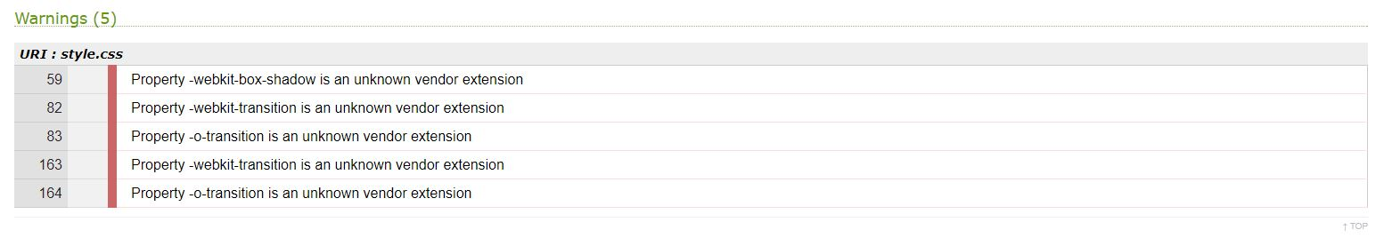

7. Evaulation

7.1 Accessibility Evaluation
- All headings are marked up
- Every image has alt with alternative text.
- Contrast ratio: high
- Text zoom available: All text gets larger, doesn’t desappera or get cut off, text, images, other content do not overleap. All buttons forms ar visible
- All forms have labels

7.2 Recomended impovements
- Bug fixing
- Better design
- More content
- Back end for booking system

References
1. w3schools. [Online] https://www.w3schools.com.
2. MDN web docs. [Online] https://developer.mozilla.org/.
3. WEBAim. [Online] https://webaim.org/.
4. Solo Learn. [Online] https://www.sololearn.com/.
5. Bootstrap. [Online] https://getbootstrap.com/.
6. Code Academy. [Online] https://www.codecademy.com/.
7. HTML5 & CSS3 For Beginners: Your Guide To Easily Learn HTML5 & CSS3 Programming in 7 Days. hely nélk. : Independently published, 2017. ISBN-10: 1521359229 ISBN-13: 978-1521359228.
8. Web Accessibility intitiative. [Online] https://www.w3.org/WAI/.

