

BEng, HND & HNC Automotive, Motorcycle & Motorsport Engineering
BEng Engineering Programmes
Tensile Test
Module: Engineering Science
Module Code: ACHA4002 & ACMA4028
Student Name: William Davies
Student Code: 2400569
Lecturer Name: Abi Penny
Submission Date: 08.12.2024

Contents
1
BEng, HND & HNC Automotive, Motorcycle & Motorsport Engineering 1
1.0 Introduction 3
2.0 Experimental Procedure 4
2.1 Experimental Images 4
3.0 Results – Raw Data 5
3.1 Steel 5
3.2 Aluminium 6
3.3 Duralumin 7
3.4 PVC 8
4.0 Analysis 9
4.1 Stress & Strain 9
4.2 Calculated Values 10
4.3 Graphs 12
4.3.1 Steel 12
4.3.2 Aluminium 13
4.3.3 Duralumin 14
4.3.4 Plastic 15
5.0 Conclusion 16
5.1 Tensile Strength & Yield Stress 16
5.1.1 Tensile Strength 16
5.1.2 Yield Stress 16
5.2 Young Modulus 16
6.0 Evaluation 18
7.0 Further Work 19
8.0 Bibliography 19

1.0 Introduction
This assignment presents a tensile strength experiment on various materials. The report includes results, explanations, images, and research to support the accuracy of the findings. Tensile testing is a destructive method that applies increasing axial load while measuring elongation, allowing for the determination of key mechanical properties: yield strength, ultimate tensile strength (UTS), Young’s modulus, and elongation. These values are essential in engineering for selecting materials and designing components. UTS identifies materials suitable for high-load applications, yield strength shows the limit before permanent deformation, Young’s modulus measures stiffness in the elastic range, and elongation helps assess flexibility for forming or flexible-use applications.

2.0 Experimental Procedure
The experiment was carried out using a tensile tester kit, which included two chucks to hold the specimen and a load nut to apply force. Turning the nut raised the top chuck by 1 mm per full revolution, pulling the specimen upward. A dial indicator measured spring deflection at the bottom chuck, with force calculated based on Hooke’s Law. The load nut and vertical scale helped track turns precisely. Four materials—steel, aluminium, alloy, and plastic—were tested. Each specimen's original dimensions were measured for strain calculations. After securing the specimen and applying a small preload, the dial was zeroed. Measurements were recorded every 0.2 mm of rotation up to 5 mm, then at 1 mm intervals until fracture.

2.1 Experimental Images
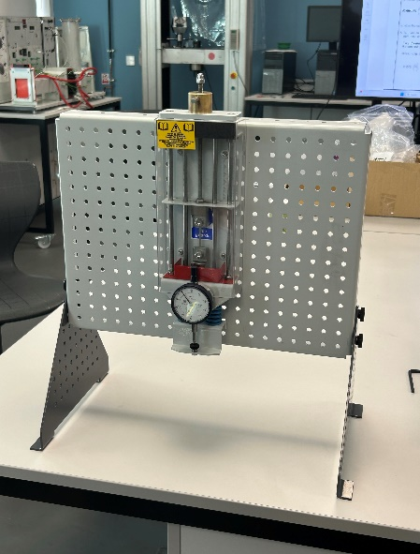
Tensile Board
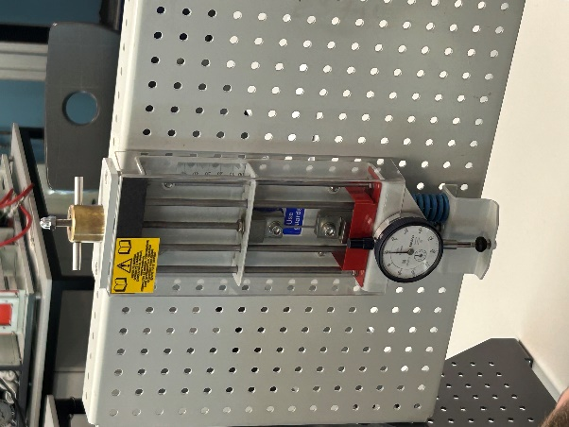
Specimen

Nut which applies load

Dial
Figure 2.2: ‘Aluminium Specimen’
In figure 2, the Aluminium specimen is set up in the tensile tester and has a slight load applied to it. As the load is applied the elongation increases and the length of the specimen is also increased.
Figure 2.1: ‘Steel Specimens’ This figure shows the specimen of steel being set in the tensile tester and is set to zero before a load is applied.

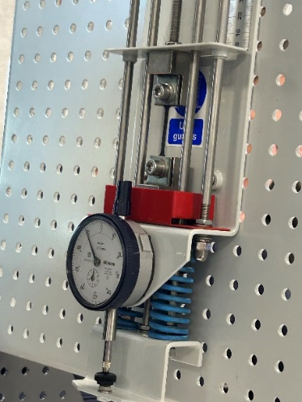
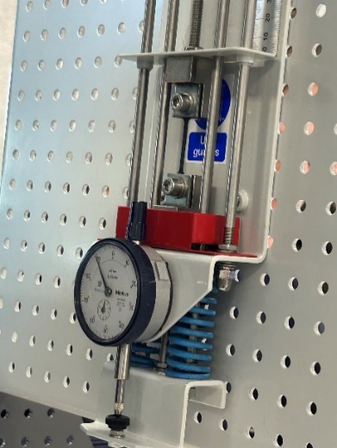
Figure 2. 3: ‘Alloy Specimen’
Figure 3 is the alloy specimen being set to zero in the tensile tester. This is before a load is applied.

Figure 2.4: ‘Plastic Specimen’
Figure 4 is showing the plastic specimen being set into place in the tensile tester and being set to zero.

3.0 Results – Raw Data

3.1 Steel
Table 3.1: Steel Raw Data
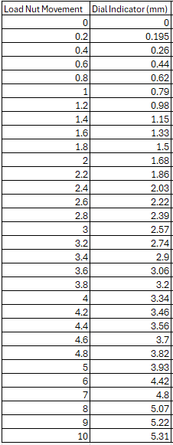

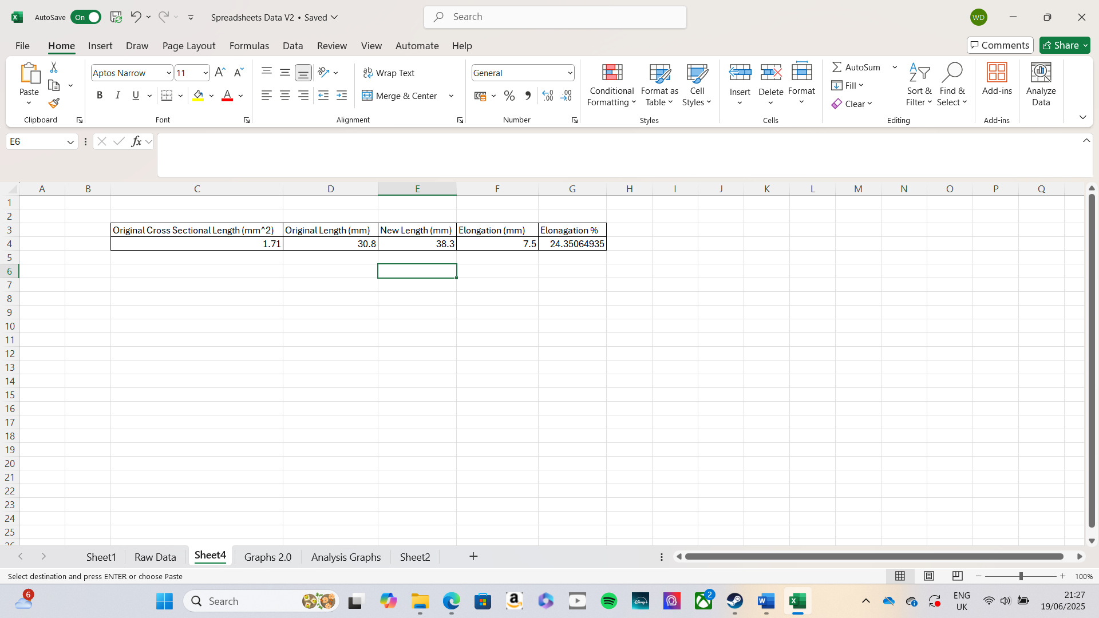
Table 3.2: Measured value of steel

3.2 Aluminium
Table 3.3: Aluminium Raw Data
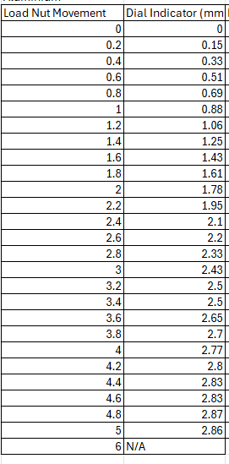

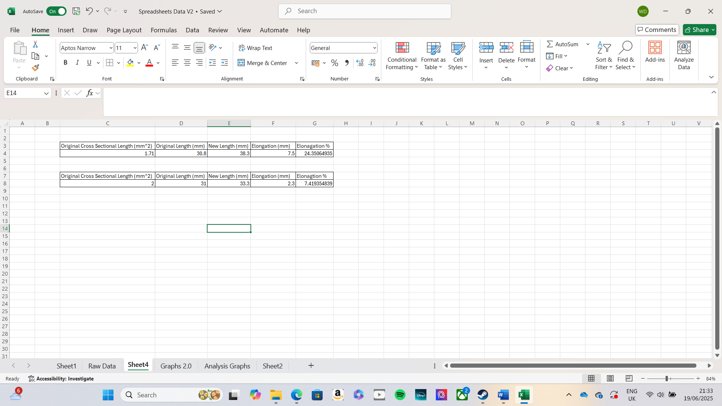

Table 3.4: Measured values of Aluminium

3.3 Duralumin
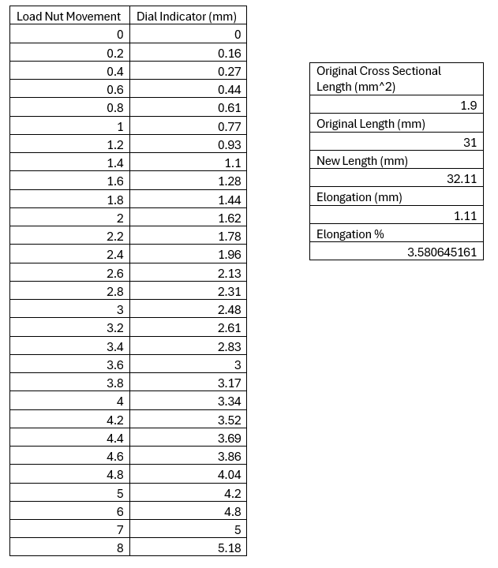
Table 3.5: Raw Data of Duralumin
Table 3.6: Measured Values of Duralumin

3.4 PVC
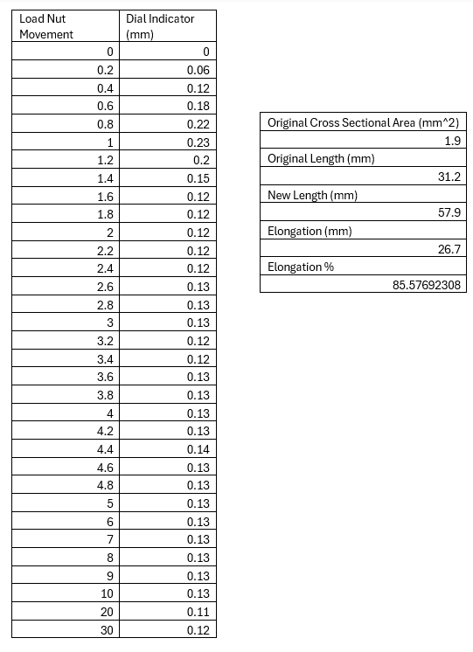
Table 3.7: Raw Data of PVC
Table 3.8: Measured Values of PVC

4.0 Analysis

4.1 Stress & Strain
To evaluate the stiffness of each specimen, Young Modulus must be the first to be determined using a stress-strain graph. This process begins by calculating the extension and the applied force of each specimen:
Extension (mm) = Load Nut Movement (mm) – Dial Indicator Reading (mm)
Force (N) = Dial Indicator Reading (m) x 100
Next, stress (σ) is calculated by the formula:
σ (N/mm^2) = Force (N)/ Area acted on by force (mm^2)
Although stress is typically measured in N/m^2 or Pascals (Pa), using N/mm^2 or (MPa) results in more manageable numbers.
1Mpa = 1 N/mm^2
Similarly, strain (ε) is calculated using the formula:
Ε = Change in Length / Original Length

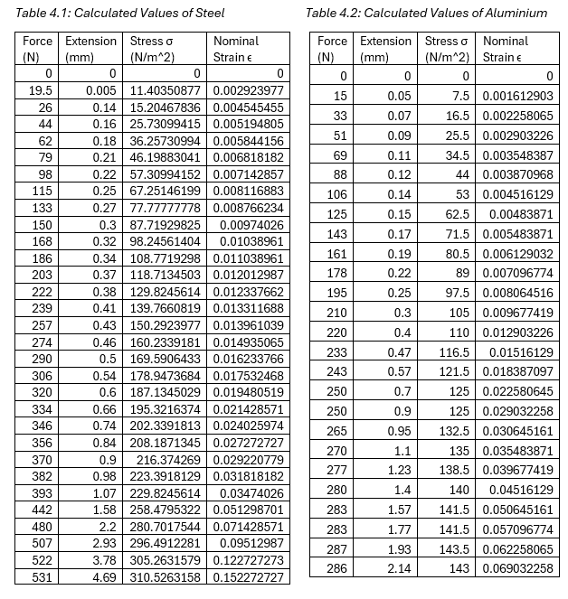
4.2 Calculated Values

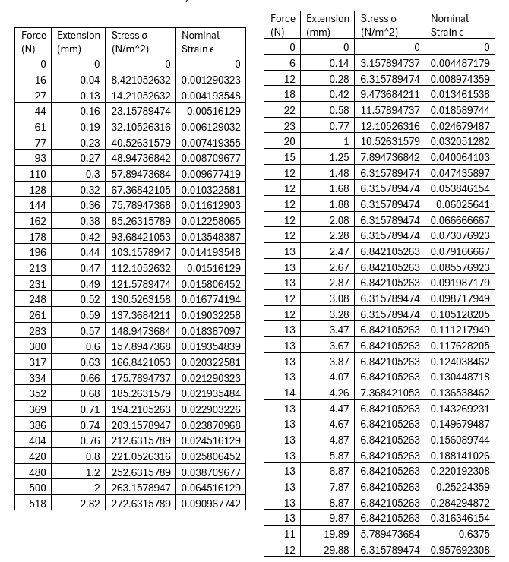
Table 4.3: Calculated Values of Duralumin Table 4.4: Calculated Values of Plastic

4.3 Graphs
With all the necessary values calculated, the values can now be inputted into a graph to create a stress v strain graph. All the stress values are inputted onto the Y axis and the Strain on the X axis. This type of graph is known as a Young’s Modulus graph. This creates the Young’s Modulus graphs which can be seen down below in figures 4.1 to 4.4.

4.3.1 Steel

Figure 4.1: Stress & Strain Graph of Steel

Figure 4.2: Stress & Strain Graph of Steel Elastic Region

4.3.2 Aluminium
Figure 4.3: Stress & Strain Graph of Aluminium

Figure 4.4: Stress & Strain Graph of Aluminium Elastic Region

4.3.3 Duralumin
Figure 4.5: Strain & Stress Graph of Duralumin

Figure 4.6: Strain & Stress Graph of Alloy Elastic Region

4.3.4 Plastic
Figure 4.7: Strain & Stress Graph of Plastic

Figure 4.8: Strain & Stress Graph of Plastic Elastic Region

5.0 Conclusion

5.1 Tensile Strength & Yield Stress

5.1.1 Tensile Strength
The highest recorded tensile stress for steel was 310 MPa (Table 4.1), below the average maximum tensile strength of 400–550 MPa. At 20mm dial movement, the specimen snapped due to stress exceeding its limit.
For Duralumin, the maximum tensile stress applied was 143 MPa, within the average range of 90–690 MPa. After 30mm load nut movement (Table 3.7), the specimen broke from further stress.
The alloy specimen reached a maximum tensile stress of 272 MPa, lower than its typical range of 420–500 MPa, indicating it broke under less load than expected.
The plastic specimen reached 12 MPa, surpassing the average maximum tensile stress of ~10 MPa. Unlike the metals, it elongated under stress, making the applied stress less effective.

5.1.2 Yield Stress
Yield stress is noted to show where the specimen’s elastic region starts. This will happen at a certain value of stress for each specimen assessed. The steel yield stress entered around the 135Mpa mark, however compared to other sources the yield point for steel is around 160MPa.
For the aluminium specimen, the yield point is at 110MPa. This type of specimen has varied in specifications, but the yield point is around 90MPa.
For the alloy specimen the yield point is around 221MPa regarding this to be expected with the higher yield points if this material and resulting this to be an accurate result.
The plastic specimen has a low yield point of 12MPa, this is the lowest yield point of all four materials. However, for this type of plastic it is expected to have a yield point of around 10-25MPa, leading to the fact that this is a positive result.

5.2 Young Modulus
Young’s Modulus is denoted by the symbol E and can be calculated by formula:
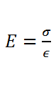

Young’s Modulus can be calculated with the stress v strain graph as the gradient of elastic region can be seen in the graphs of figures 4.2, 4.4, 4.6, 4.8. This is where the gradient will be y = mx + c.
For Steel the gradient is y = 9603.1x
For Aluminium the gradient is y = 8558.7x
For Duralumin the gradient is y = 5195.7
For PVC the gradient is y = 576.11x

Steel is the stiffest material among the four, while PVC has the lowest stiffness, as expected. Steel also shows the highest elongation among metals at 24.35%, making it more ductile than aluminium (7.42%) and duralumin (3.58%), both of which are brittle. PVC has the highest elongation at 85.58%, indicating it deforms rather than resists stiffness.
Figure 4.7 shows PVC’s stress rate is inconsistent, with each load nut movement nearly resetting the applied stress. Room temperature influenced these results, affecting the specimens’ mechanical properties by making PVC more fragile but increasing its tensile strength and stiffness.

6.0 Evaluation
To reduce errors, I ensured the specimen was securely and symmetrically gripped to prevent slipping and uneven force distribution. The specimen was aligned with the pulling axis to eliminate lateral forces and bending. I also pre-loaded the specimen to avoid initial stress skewing results and maintained environmental control, as humidity and temperature affect elasticity during loading.
In analysing the data, figure 4.1 shows an outlier at the start, indicating no tension on the specimen at that point. Figure 4.5 also contains a clear outlier, which could adversely affect the results.

7.0 Further Work
If I were to redo this experiment with unlimited resources and time, I would use a high-precision servo machine for more consistent loading and record data at ultra-high frequencies to capture detailed material behaviour. I would invest in custom testing equipment for better environmental control and upscale the specimens and equipment to compare results on stronger samples of the same material. Additionally, I would thoroughly review my data and discuss results with peers to verify accuracy, as I noticed some discrepancies while analysing my initial data.

8.0 Bibliography
UWTSD logo image – page 1. https://i0.wp.com/theoneplanetlife.com/wp-content/uploads/2019/06/UWTSD-logo.jpg. Accessed on 25/11/2024.
TecQuipment – Page 4 - Using Engineering Science Kits to make the Motorcycle… | TecQuipment. Accessed on 26/11/2024.
Monroe Engineering – Page 17 - https://monroeengineering.com/info-general-guide-tensile-strength.php. Accessed on 26/11/2024.
AZO materials – page 17 - https://www.azom.com/article.aspx?ArticleID=2863#:~:text=The%20tensile%20strength%20of%20pure,properties%20of%20selected%20aluminium%20alloys. Accessed on 26/11/2024.
Engineering Toolbox – Page 17 - Young’s Modulus of Elasticity – Values for Common Materials. Accessed on 26/11/2024. Author – Engineering Toolbox
Material Modelling of PVC for change in tensile properties – page 17 - IRJET- International Research Journal of Engineering and Technology. Accessed on 26/11/2024. Author - IRJET
Young’s Modulus Equation – Page 17 - https://th.bing.com/th/id/R.8dff008b2ae7cf1add1f3b7c649d27b7?rik=JNIHS1ZhzJr15A&pid=ImgRaw&r=0. Accessed on 26/11/2024.
Temperature effecting materials – Page 18 - The Impact of Specimen's Temperature on Tensile Testing Results. Accessed on 26/11/2024. Author Tensile Mill CNC Inc
Youngs Modulus – page 18 - 12.4: Stress, Strain, and Elastic Modulus (Part 1) - Physics LibreTexts. Accessed on 26/11/2024. Author LibreText – NICE CXone Expert

