Name: Mohammad Samir Shaikh
Student ID: 2535799
Professor name: Muhammad Khan
COMMUNITY CARE AND MANAGEMENT OF LONGER-TERM CONDITIONS

LCHS7003

Component 1
Information Booklet of Long-term Condition Management
Chronic Kidney Disease

Table of Contents

1. Explanation and Evaluation of Chronic Kidney Disease 3
1.1 Definition of Chronic Kidney Disease 3
1.2 Burden and Prevalence 3
1.3 Risk Factors and Aetiology 4
1.4 Signs and Symptoms 5
1.5 Importance of Kidney Function 5
2. Critical Evaluation of the Impact of CKD and Evidence-Based Treatments Available Through the NHS 6
2.1 Physical Impact 6
2.2 Psychological Impact 7
2.3 Social Impact 8
2.4 Wider Implications for Families 8
2.5 Evidence-Based Treatments Available 8
3. Review Theoretical Perspectives by Using Models 9
3.1 Application of the UK Model 9
3.2 Application of the International Model 9
3.3 Critical Comparison of the Models 10
4. Evaluation of National and Local Political Health and Social Care Agendas 11
4.1 National Agenda 11
4.2 Local Agenda 11
4.3 Critical Evaluation 11
5. Recommendations for Improvement 12
5.1 Person-Centred Care 12
5.2 Self-Management 12
5.3 End-of-Life Care 12
References 13

1. Explanation and Evaluation of Chronic Kidney Disease

1.1 Definition of Chronic Kidney Disease
Chronic Kidney Disease (CKD) is a long-term condition in which the kidneys become impaired in their ability to effectively filter the blood of waste products, excess fluid, and toxins over time. The condition is divided into five stages, which are based on the estimated glomerular filtration rate (eGFR), where Stage 5 is the kidney failure stage, where renal replacement therapy is required. CKD is identified as a tremendous public health issue as it is a silent disease, and typically progresses to the point of overt kidney damage by the time it is diagnosed. Kidney diseases affect about 850 million people globally and are one of the most common non-communicable diseases (NCDs) (Wijewickrama and Kalyesubula, 2025). Type 2 diabetes and hypertension are the most common causes of kidney damage, and are strongly related to CKD in the United Kingdom.
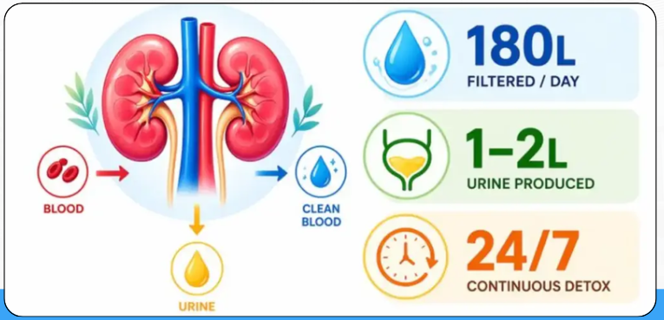
Figure 1: Normal functioning of kidneys
(Source: Romagnani et al., 2025)
In other words, it is a condition marked by decreasing kidney function over time that affects a person's kidney's ability to remove waste and maintain water, electrolyte and acid-base balance and essential body functions. Kidney problems are diagnosed only when the kidney problems last for three months or more, and there are five stages from mild impairment to kidney failure (Romagnani et al., 2025). Ferro et al. (2025) emphasized how CKD is difficult to diagnose and can have many complications if not treated in the early phases of the disease.

1.2 Burden and Prevalence
The prevalence of CKD is increasing globally. It represents an expanding public health problem, meaning that there is a need for policy measures which are oriented towards prevention and prompt diagnosis. The main risk factors are diabetes, hypertension, obesity, smoking and cardiovascular disease and old age. Dasgupta et al. (2025) reported that around 40% of individuals with type 2 diabetes develop CKD during their lifetime, highlighting the importance of integrated management strategies to slow disease progression. Arriola-Montenegro et al. (2025) found a significant increase in the number of online searches and public engagement with information about CKD and dialysis over the last 20 years. Continuous monitoring for early detection and management of risk factors is still key to slowing the progression and enhancing prognosis.
United Kingdom
CKD is a major public health challenge in the UK. An estimated 3.25 million adults with diagnosed CKD and many more with undiagnosed CKD exist (KC, 2025). Diabetes, hypertension, obesity, smoking, cardiovascular disease and age are among the major risk factors. Prevention and early detection take the first place, with the NHS taking steps to encourage people to get more active, promote education and learning about health and disease, and employ integrated care pathways to minimize progression of the disease and complications.
Worldwide
CKD has become a worldwide health problem that is increasingly present in people not only in developed countries, but also in developing ones. CKD is one of the fastest-increasing non-communicable diseases in the world, which is a Public Health Challenge. It occurs in people of all ages, but is much more common among people with other chronic health problems and the elderly. Globally, the prevalence of any type of CKD is estimated to be around 13.4% of the adult population (Bucci et al. 2025). Diabetes, hypertension, poor nutrition, lack of physical exercise and inadequate healthcare are some of the risk factors. According to Mark et al. (2025), there were about 673 million adults with CKD in 2023 in the world. Bucci et al. (2025) reported that the co-occurrence of cardiovascular disease and CKD is common and associated with greater rates of hospitalisation and poor clinical outcomes.

1.3 Risk Factors and Aetiology
CKD occurs when kidneys become damaged, and over a long period of time they lose their ability to perform important functions. The most frequent cause of the condition is chronic health issues that continually put strain on the tissues and blood vessels of the kidneys. Diabetes and high blood pressure are known causes of CKD and are a significant part of all cases of CKD globally. The National Kidney Foundation estimates that diabetes and hypertension rank as the top two risk factors for developing kidney disease and that around one in every 10 people worldwide is currently at risk for the disease (NKF, 2025). High blood sugar can injure the kidneys' filtration units, and high blood pressure will slowly decrease filtration efficiency and over time, weaken the renal blood vessels. Impairment of renal (kidney) function can also occur as a result of lifestyle risk factors like a bad diet, little physical exercise, and obesity. Additionally, socioeconomic factors and co-existing chronic conditions impact the progression of CKD and health outcomes in people (Tasnim et al. 2025).

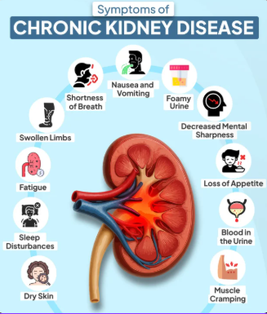
1.4 Signs and Symptoms
CKD signs and symptoms may not be noticed until the disease is in its early stages. Blum et al. (2025) explained that early CKD often produces no symptoms in patients, a factor that can help delay the diagnosis and propel progression of the disease. Symptoms of worsening kidney function include swelling of the feet and ankles, not being able to think as well as normal, feeling tired all the time, feeling shaky or muscle cramping and changes in the amount or pattern of urination. The patient also loses their appetite, and changes in weight may occur.
Figure 2: Symptoms of CKD
(Source: Chen et al. 2025)
Breathlessness, chest pain, and fatigue during physical activity can be present because of the strong correlation between kidney and heart health (Chen et al. 2025). The known association between heart and blood vessel disease and CKD across the world shows the need to recognise warning signs promptly. The prevalence of CKD in different community settings in India varied from around 9% to 13%, suggesting that a significant number of people may be living with undiagnosed CKD (Talukdar et al. 2025). Early symptom recognition and prompt medical evaluation can, therefore, help to optimise outcomes of treatment and delay the progress of the disease.

1.5 Importance of Kidney Function
There are two bean-shaped organs called kidneys, which have critical functions in maintaining the body's balance. They always filter blood, remove toxins, control the amount of water in the body and adjust the level of electrolytes for normal bodily function. The healthy kidneys get rid of about 180 litres of fluid every day, but they reabsorb the nutrients and water that the body requires (KC, 2025). Iatridi et al. (2025) reasoned that the kidneys regulate blood pressure through the renin–angiotensin–aldosterone system, acid–base balance, and mineral metabolism. They also secrete erythropoietin, a substance that stimulates the production of red blood cells, and activate vitamin D, which is essential for the absorption of calcium and the growth of bones. The reduced kidney function has a negative impact on numerous systems. Stage 3 of CKD was present, but not diagnosed, in 8,832 patients, which highlights the need for it to be identified and monitored sooner (Nie et al. 2025).
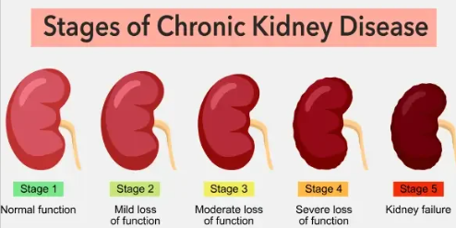
Figure 3: Stages of CKD
(Source: Nie et al. 2025)

2. Critical Evaluation of the Impact of CKD and Evidence-Based Treatments Available Through the NHS

2.1 Physical Impact
CKD has many first-order consequences of physical ill health, as the kidney functions play an important role in fluid balance, BP control, blood waste removal and production of hormones. As the kidneys' ability to function decreases, more damaging toxins build up in the body, which can lead to a variety of health issues and an overall poor quality of life. Mailani et al. (2022) stated that people with CKD are often tired, there is muscle wasting, a person feels weak and has poor work tolerance, along with swelling of his or her legs and ankles. Additionally, due to the decreased production of erythropoietin, the condition can cause anaemia, a decrease in red blood cells (RBCs) and a lower oxygen delivery to body tissues.
One of the recent reports of Think Kidneys national programmes stated that around 10% of adults have some form of CKD, and many suffer from physical complications to a greater or lesser extent as kidney function decreases (TK, 2025). CKD patients are especially susceptible to cardiovascular disease since the poor functioning of the kidneys puts an extra burden on the heart and blood vessels. The far-reaching implications for the overall health care system are also significant. Kidney disease is thought to afflict over 7 million people in the UK and it is hypothesized to be putting increasing pressure on services in the NHS if prevention and early intervention in kidney disease is not enhanced (NHE, 2025).

2.2 Psychological Impact
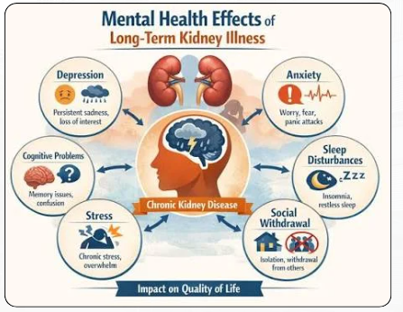
Figure 4: Impact of CKD on mental health
(Source: Inspired by Mailani et al. 2022)
Living with CKD can lead to profound emotional changes because of needing life-long treatment, to making lifestyle changes and to worrying about the disease progression. One feels disturbed sleep. There can be feelings of anxiety, stress, sadness and a loss of confidence, especially when trying to prepare for having dialysis or a decreasing quality of life. Grams and Melamed (2025) reported that CKD is often accompanied by other chronic diseases, which contributes to a higher emotional load and a decrease in wellbeing. Global burden of CKD has gone up between 1990 and 2021 and points to a need for increased psychosocial support (Guo et al., 2025). Moreover, Catapan et al. (2025) identified that communication and trust on healthcare services can gauge the patients' confidence and self-management.

2.3 Social Impact
The management of CKD involves integrated care from a general practitioner, physician or nurse specialist, dietitian, pharmacist, social worker as well as the community health care team. This multidisciplinary approach can meet the physical, psychological and social needs of patients and can provide continuity of care. Grams and Melamed (2025) highlighted the need for regular monitoring, risk assessment and timely interventions to enhance outcomes. Birn et al. (2025) emphasised the importance of cohesive care for monitoring and optimisation of treatment. Moreover, Catapan et al. (2025) revealed that DHTs can boost patient engagement and self-management. Arriola-Montenegro et al. (2025) further noted a rise in public awareness of CKD information within the last two decades, highlighting the significance of accessible healthcare information and patient education.

2.4 Wider Implications for Families
CKD not only affects the person with the disease, but also all the family members who emotionally, physically and practically support the sick person. As the condition progresses, patients may require help making appointments, managing medications, dietary needs and other daily activities, which increases the burden on both the caregiver and family life. Cui et al. (2025) added that that family function is closely related to self-management in individuals with early-stage CKD. Support can make it easier to follow treatment plans and manage the disease, and burden can hurt the patient's well-being. Family members might also be emotionally stressed, worrying about how the disease is progressing and what future needs are. The long-term nature of CKD can cause financial burden due to costs of CKD therapy, needs of caring for provenances and lost employment opportunities. Metsärinne et al. (2025) found a significant burden of disease among persons with Stage 3–4 CKD, not only for the patient, but also for their caregivers. But families may have to make many lifestyles, personnel and social changes to suit continued treatment needs. Coping strategies can be facilitated, the quality of life can be increased, and positive health can be achieved through strong support networks.

2.5 Evidence-Based Treatments Available
The goals of treatment for CKD include slowing disease progression, preventing or reducing complications, reducing symptoms and improving quality of life. According to Madero et al. (2025), provide evidence for the following CKD management strategies, frequent kidney function monitoring, blood pressure management, glucose management, lifestyle management, and using kidney-friendly medications. Marx-Schütt et al. (2025) highlighted the strong relationship between CKD and cardiovascular disease, emphasising the importance of integrated management approaches. Solid follow-up with a set plan and prompt referral to specialists are part of the successful treatment pathways in the primary care context (Birn et al. 2025). Renal replacement therapies, including haemodialysis, peritoneal dialysis and kidney transplantation may be needed with advanced disease. The management of end-stage kidney disease (ESKD) is constantly improving with improvements in dialysis services, transplantation programmes and patient-centred approaches (Chen et al. 2025). Ferro et al. (2025) advocated the need for swift action in Europe to promote detection of CKD and easier access to effective treatment in order to achieve better outcomes in patients with long-term CKD.

3. Review Theoretical Perspectives by Using Models

3.1 Application of the UK Model
Collaborative partnerships between patients and healthcare professionals supports person-centred care and the UK House of Care Model promotes this. A key focus of the model is on informed patients, personalised care planning, co-ordinated services and professional support. This strategy fosters collaboration, empowerment, and personalized care, thereby optimising health and enhancing quality of life for people with CKD (Dasgupta et al., 2025).

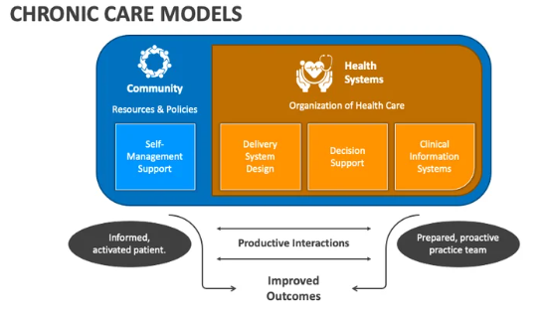
3.2 Application of the International Model
Figure 5: Framework of the Chronic Care Model
(Source: Cui et al. 2025)
Chronic Care Model (CCM) is an internationally validated model that aims to: Enhance the way people with chronic diseases are managed through proactive healthcare systems, support for self-management, community resources, and multi-disciplinary team working. As inspired by the ideas of Cui et al. (2025), this model aims to engage patients in active management of their care, encourage regular monitoring and interventions, and prevent disease progression and complications based on evidence. Effective management of CKD requires patient engagement, coordinated care and long-term monitoring both models can help achieve this. The House of Care Model has a focus on personalised care planning while the Chronic Care Model has a focus on system-wide support and multidisciplinary collaboration.

3.3 Critical Comparison of the Models
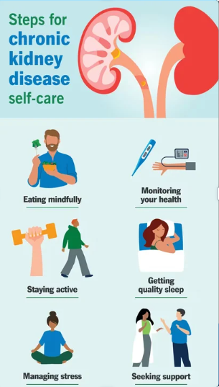
The UK House of Care Model and the Chronic Care Model (CCM) are both designed to enhance the care of people with long-term conditions, such as CKD. It is stated by Dasgupta et al. (2025) that person-centred care, shared decision-making and personalised care planning between patients and healthcare professionals is at the core of the House of Care Model. Instead, the CCM is a more holistic disease management system that brings together health-care systems, community-based resources, and interdisciplinary collaboration to enable proactive management of chronic conditions when needed (Cui et al., 2025). The House of Care Model emphasizes individual patient empowerment while the CCM emphasises the organization of healthcare systems and the preparation of future care coordination. When combined they offer complementary approaches to effective management of CKD.
Figure 6: Self-care to deal with CKD
(Source: Cui et al. 2025)

4. Evaluation of National and Local Political Health and Social Care Agendas

4.1 National Agenda
Healthcare policies and guidelines at national level are formulated as a framework to define consistent and evidence-based CKD management. Iatridi et al. (2025) emphasised that the KDIGO 2024 guidelines focus on the risk-based assessment, early diagnosis, follow-up, and patient-centred care for people with CKD. These national strategies provide healthcare providers with standardised, integrated care pathways to prevent disease progression, complications and to enhance long-term health outcomes.

4.2 Local Agenda
Integrated Care Systems (ICSs), community healthcare providers, and local authorities, have a significant part to play in helping individuals with CKD at the local level. The local UK agenda for CKD is emphasised on shifting to community care. The largest charity dedicated to kidney research in the UK, Kidney Research UK, has estimated saving 10,000 lives in between 2023 and 2033 by means of effective interventions (Kidney Research UK, 2024). This starts with early diagnosis and improved management. Local schemes work to enhance access to kidney health checks, help to narrow health gaps, and ensure better integration of primary, secondary and social care. If these agendas are implemented well, they could also help achieve efficacy of care and, ultimately, better care outcomes.

4.3 Critical Evaluation
Adoption of national and local political health and social care agendas has played an important role in delivering progress in the management of CKD by enabling earlier access to care; structured monitoring systems; and access to multidisciplinary CKD provision. Guidance specific to each child's kidney disease is outlined in national documents. This includes clear guidance for prevention, treatment and patient-centred care, such as the NHS Extended long-term plan and KDIGO. Integrated Care Systems (ICSs) of Kidney Research UK provide assistance at a local level for coordinated delivery of health services and enhanced continuity of care. However, policy implementation gaps have been identified between policy goals and clinical practices, which has led to some inconsistencies in the quality of services and patient outcomes. Disparities in access to screening, nephrology services, and digital health services, also impact access to care, especially in disadvantaged communities. Also, some people are not diagnosed early because they do not experience any symptoms, which are early signs of CKD. Thus, more investment, training and services are required for uniformity and effective care in all regions.

5. Recommendations for Improvement

5.1 Person-Centred Care
As per Barnard-Kelly et al. (2025), person-centred care approaches are required to make outcomes and life better for people with CKD. This strategy is rooted in acknowledging patients' needs, values, preferences, and treatment goals, and in engaging patients in decision-making. Treatment adherence and self-management can be improved by personalised care plans, shared decision-making process, and good communication. Multidisciplinary teams of nephrologists, nurses, dietitians, social workers, and others also aid in the provision of holistic care. Digital health tools and frequent monitoring can also be effective for enhancing the engagement and continuity of care (Madero et al., 2025).

5.2 Self-Management
The key to slow down the progression of kidney disease and enhance quality of life is self-management. These include keeping blood pressure and blood glucose levels under control, maintaining a healthy weight, and following a heart-healthy, kidney-friendly diet, avoiding smoking and excessive alcohol intake and physical activity. Kidney Care UK says that people can manage CKD effectively by making lifestyle changes, taking tests and taking medication prescribed by their doctors (KC, 2025). Increase in public awareness of information about CKD over 20 years (Arriola-Montenegro et al. 2025). In the UK, there are around 7.2 million people with CKD, clearly showing the need for prevention and self-care (KC, 2025).

5.3 End-of-Life Care
One of the important elements of care with advanced CKD is End of Life Care, for those who are not appropriate for dialysis or transplant with onset of further kidney disease. Advance care planning helps patients, families and healthcare professionals to consider their care preferences, future care needs and aspects of end-of-life care in a timely fashion. This is to ensure that care is in line with the patient's values and wishes, and is dignifying and comfortable. As per Arooj et al. (2025) and Elias et al. (2025), nurse-led care is an essential factor in the patients' quality of life at an advanced stage of CKD, which supports care planning, good communication, symptom control, and improved care support.

References
Arooj, H., Aman, M., Hashmi, M.U., Nasir, Z., Zahid, M., Abbas, J., Amjad, N., Maryam, S. and Farhan, K. (2025). The impact of nurse-led care in chronic kidney disease management: a systematic review and meta-analysis. BMC nursing, 24(1), p.188. https://link.springer.com/article/10.1186/s12912-025-02829-z
Arriola-Montenegro, J., Cheungpasitporn, W., Thongprayoon, C., Craici, I.M. and Miao, J. (2025). Public interest in chronic kidney disease and dialysis: a 20-year data analysis. Renal Failure, 47(1), p.2462253. https://www.tandfonline.com/doi/abs/10.1080/0886022X.2025.2462253
Barnard-Kelly, K., Battelino, T., Brosius, F.C., Ceriello, A., Cosentino, F., Gavin III, J.R., Giorgino, F., Green, J., Ji, L., Kellerer, M. and Koob, S. (2025). Defining patient-reported outcomes in diabetes, obesity, cardiovascular disease, and chronic kidney disease for clinical practice guidelines-perspectives of the taskforce of the Guideline Workshop. Cardiovascular Diabetology, 24(1), p.68. https://link.springer.com/article/10.1186/s12933-024-02550-2
Birn, H., Nelveg-Kristensen, K.E., Frederiksen, L.E., Christensen, S., Mehtälä, J., Smith, S., Bruun, M. and Bodholdt, U. (2025). The management of chronic kidney disease in primary care in Denmark: patient characteristics, treatment, follow-up, progression and referral. Clinical kidney journal, 18(2), p.sfae393. https://academic.oup.com/ckj/article-abstract/18/2/sfae393/7914329
Blum, M.F., Neuen, B.L. and Grams, M.E. (2025). Risk-directed management of chronic kidney disease. Nature Reviews Nephrology, 21(5), pp.287-298. https://www.nature.com/articles/s41581-025-00931-8
Bucci, T., Nabradalik, K., Irlik, K., Shantsila, A., Romiti, G.F., Proietti, M., Teo, W.S., Park, H.W., Shimizu, W., Tse, H.F. and Chao, T.F. (2025). Adherence to the ABC (atrial fibrillation better care) pathway and risk of adverse outcomes in patients with chronic kidney disease: a report from the prospective APHRS-AF registry. The Lancet Regional Health–Western Pacific, 58. https://www.thelancet.com/journals/lanwpc/article/PIIS2666-6065(25)00107-5/fulltext
Catapan, S.D.C., Taylor, M.L., Scuffham, P., Smith, A.C. and Kelly, J.T. (2025). Improving consumer trust in digital health: A mixed methods study involving people living with chronic kidney disease. Digital Health, 11, p.20552076241312440. https://journals.sagepub.com/doi/abs/10.1177/20552076241312440
Chen, B., Wang, X., Pan, D. and Wang, J. (2025). Global trends and hotspots in the association between chronic kidney disease and cardiovascular diseases: a bibliometric analysis from 2010 to 2023. Cardiorenal Medicine, 15(1), pp.1-20. https://karger.com/crm/article-abstract/doi/10.1159/000542441/916532
Chen, T., Sun, X., Tsuei, S., Yang, R., Yip, W. and Fu, H. (2025). Care for end-stage kidney disease in China: progress, challenges, and recommendations. The Lancet Regional Health–Western Pacific, 54. https://www.thelancet.com/journals/lanwpc/article/PIIS2666-6065(24)00262-1/fulltext
Cui, Y., Liu, N., Guo, Z., Liu, Q., Zhang, M., Li, J., Mu, H., Zhang, Y. and Chen, X. (2025). Family function and self-management of patients with early chronic kidney disease: The mediating roles of self-perceived burden and ego depletion. Patient preference and adherence, pp.161-172. https://www.tandfonline.com/doi/abs/10.2147/PPA.S494483
Dasgupta, I., Zac‐Varghese, S., Chaudhry, K., McCafferty, K., Winocour, P., Chowdhury, T.A., Bellary, S., Goldet, G., Wahba, M., De, P. and Frankel, A.H. (2025). Current management of chronic kidney disease in type‐2 diabetes—A tiered approach: An overview of the joint Association of British Clinical Diabetologists and UK Kidney Association (ABCD‐UKKA) guidelines. Diabetic Medicine, 42(2), p.e15450. https://onlinelibrary.wiley.com/doi/abs/10.1111/dme.15450
Elias, M.A., Van Damme, W., Ku, G.M.V., Kadammanavar, M. and Wouters, E. (2025). Lived experiences of people with chronic kidney disease on maintenance dialysis: a systematic review and thematic synthesis of qualitative studies. BMC nephrology, 26(1), p.22. https://link.springer.com/article/10.1186/s12882-025-03952-4
Ferro, C.J., Wanner, C., Luyckx, V., Fontana, M., Gallego, D., Vanholder, R., Torra, R. and Ortiz, A. (2025). A call for urgent action on chronic kidney disease across Europe. The Lancet Regional Health–Europe, 54. https://www.thelancet.com/journals/lanepe/article/PIIS2666-7762(25)00139-5/fulltext
Ferro, C.J., Wanner, C., Luyckx, V., Stevens, K., Cerqueira, S., Darwish, R., Fernandez, B.F., Fiel, D., Filev, R., Grieger, M. and Lopez, A. (2025). ABCDE to identify and prevent chronic kidney disease: a call to action. Nephrology Dialysis Transplantation, 40(9), pp.1786-1798. https://academic.oup.com/ndt/article-abstract/40/9/1786/8087355
Grams, M.E. and Melamed, M.L. (2025). Chronic kidney disease. Annals of internal medicine, 178(9), pp.ITC129-ITC144. https://www.acpjournals.org/doi/abs/10.7326/ANNALS-25-02684
Guo, J., Jiao, W., Xia, S., Xiang, X., Zhang, Y., Ge, X. and Sun, Q. (2025). The global, regional, and national patterns of change in the burden of chronic kidney disease from 1990 to 2021. BMC nephrology, 26(1), p.136. https://link.springer.com/article/10.1186/s12882-025-04028-z
Iatridi, F., Carrero, J.J., Cornec-Le Gall, E., Kanbay, M., Luyckx, V., Shroff, R. and Ferro, C.J. (2025). KDIGO 2024 clinical practice guideline for the evaluation and management of chronic kidney disease in children and adults: a commentary from the European Renal Best Practice (ERBP). Nephrology Dialysis Transplantation, 40(2), pp.273-282. https://academic.oup.com/ndt/article-abstract/40/2/273/7762204
KC. (2025). Chronic kidney disease (CKD). Available at: https://kidneycareuk.org/kidney-disease-information/kidney-conditions/patient-info-ckd-chronic-kidney-disease/ [Accessed: 04 July 2026]
Kidney Research UK, (2024). Chronic kidney disease and prevention: Harnessing the potential of early intervention and disease management. Available at: www.kidneyresearchuk.org/wp-content/uploads/2023/03/Kidney-Research-report-on-prevention-and-early-detection.pdf [Accessed: 09 July 2026]
Madero, M., Levin, A., Ahmed, S.B., Carrero, J.J., Foster, B., Francis, A., Hall, R.K., Herrington, W.G., Hill, G., Inker, L.A. and Kazancıoğlu, R. (2025). Evaluation and management of chronic kidney disease: synopsis of the kidney disease: improving global outcomes 2024 clinical practice guideline. Annals of internal medicine, 178(5), pp.705-713. https://www.acpjournals.org/doi/abs/10.7326/annals-24-01926
Mailani, F., Herien, Y., Muthia, R., Tumanggor, R.D. and Huriani, E., (2022). The Experiences of Patients with Chronic Kidney Disease Undergoing Dialysis in Managing the Symptoms. Malaysian Journal of Medicine & Health Sciences, 18. https://medic.upm.edu.my/upload/dokumen/202212142235248_1614.pdf
Mark, P.B., Stafford, L.K., Grams, M.E., Aalruz, H., Abd ElHafeez, S., Abdelgalil, A.A., Abdulkader, R.S., Abeywickrama, H.M., Abiodun, O.O., Abramov, D. and Abrar, M.M. (2025). Global, regional, and national burden of chronic kidney disease in adults, 1990–2023, and its attributable risk factors: a systematic analysis for the Global Burden of Disease Study 2023. The Lancet, 406(10518), pp.2461-2482. https://www.thelancet.com/journals/lancet/article/PIIS0140-6736(25)01853-7/fulltext
Marx-Schütt, K., Cherney, D.Z., Jankowski, J., Matsushita, K., Nardone, M. and Marx, N. (2025). Cardiovascular disease in chronic kidney disease. European heart journal, 46(23), pp.2148-2160. https://academic.oup.com/eurheartj/article-abstract/46/23/2148/8107983
Metsärinne, K., Bodegård, J., Toppila, I., Uusi-Rauva, K., Frederiksen, L.E. and Brinkmann, S. (2025). Characteristics, treatment and disease burden among stage 3–4 chronic kidney disease patients with and without type 2 diabetes in Finland during 2016–2022. Nephrology Dialysis Transplantation, 40(6), pp.1115-1123. https://academic.oup.com/ndt/article-abstract/40/6/1115/7885362
NHE. (2025). Kidney disease could overwhelm the NHS if left unchecked, report finds. Available at: https://www.nationalhealthexecutive.com/articles/kidney-disease-could-overwhelm-nhs-if-left-unchecked-report-finds [Accessed: 04 July 2026]
Nie, S., Zhou, S., Cabrera, C., Chen, S., Jia, M., Zhang, S., Su, L., Gao, Q., Tangri, N. and Hou, F.F. (2025). Characteristics of patients with undiagnosed stage 3 chronic kidney disease: results from an observational study (REVEAL-CKD) in China. The Lancet Regional Health–Western Pacific, 54. https://www.thelancet.com/journals/lanwpc/article/PIIS2666-6065(24)00269-4/fulltext
NKF. (2025). Global Facts: About Kidney Disease. Available at: https://www.kidney.org/global-facts-about-kidney-disease [Accessed: 07 July 2026]
Romagnani, P., Agarwal, R., Chan, J.C., Levin, A., Kalyesubula, R., Karam, S., Nangaku, M., Rodríguez-Iturbe, B. and Anders, H.J., (2025). Chronic kidney disease. Nature reviews Disease primers, 11(1), p.8. https://scholar.google.com/scholar?output=instlink&q=info:5xQslrdRz7wJ:scholar.google.com/&hl=en&as_sdt=0,5&as_ylo=2022&scillfp=13769115107245091267&oi=lle
Talukdar, R., Ajayan, R., Gupta, S., Biswas, S., Parveen, M., Sadhukhan, D., Sinha, A.P. and Parameswaran, S. (2025). Chronic Kidney Disease Prevalence in India: A Systematic Review and Meta‐Analysis From Community‐Based Representative Evidence Between 2011 to 2023. Nephrology, 30(1), p.e14420. https://onlinelibrary.wiley.com/doi/abs/10.1111/nep.14420
Tasnim, T., Karim, K.M.R., Rahman, T. and Rashid, H.U. (2025). Health-related quality of life and its predictors among chronic kidney disease patients: A hospital-based cross-sectional study. PLoS One, 20(2), p.e0319100. https://journals.plos.org/plosone/article?id=10.1371/journal.pone.0319100
TK. (2025). Information for the public. Available at: https://www.thinkkidneys.nhs.uk/ckd/information-for-the-public/ [Accessed: 04 July 2026]
Wijewickrama, E. and Kalyesubula, R. (2025). World kidney day: detecting kidney disease in low-and middle-income countries. Kidney International Reports, 10(3), pp.637-640. https://www.kireports.org/article/S2468-0249(25)00040-3/fulltext
Xu, L., Chen, F., Huang, Y., You, B., Zhang, X. and Sun, B. (2025). Social determinants of health and all-cause or cardiovascular mortality in chronic kidney disease: insights from 1999-2018 US National Health and Nutrition Examination Survey. Renal Failure, 47(1), p.2506811. https://www.tandfonline.com/doi/abs/10.1080/0886022X.2025.2506811

