Critical Analysis of Decision Support: BMDS7003
Word Count: 5098
Background
For many years, the integrated sexual health (ISH) clinic within Swansea Bay University Health Board (SBUHB) operated on a walk-in basis, allowing patients to attend without appointments and wait to be seen by a clinician. This provided open access for people with a wide range of sexual health needs including symptoms suggestive of sexually transmitted infections (STIs), contraception, emergency contraception and HIV care. Although accessible, the walk-in approach placed pressure on patients and staff due to long waiting times and unpredictable clinic capacity.
The COVID-19 pandemic in 2020 caused significant changes to healthcare delivery. Patients were discouraged from attending hospital sites unless necessary and services were required to prioritise those with urgent clinical needs. In response, the ISH service introduced a telephone triage system, supported by national guidance from the British Association for Sexual Health and HIV (BASHH) and the Faculty of Sexual and Reproductive Healthcare (FSRH) (BASHH & FSRH 2020). Under this system, a clinician contacts patients by telephone to assess symptoms and risks. Appointments were then allocated according to clinical need and directed to the most appropriate healthcare professional.
During the pandemic, triage was essential to safeguard patients and staff. Individuals with urgent presentations, such as genital ulceration, were prioritised for face-to-face appointments. Where appropriate, patients were instead directed to alternative pathways, including the ‘test and post’ service provided by Public Health Wales (PHW) or clinician-led appointments. This reduced unnecessary face-to-face contact, shortened waiting times, and helped manage clinician workload while ensuring timely care for those most in need.
Following the reopening of services, SBUHB did not return to the walk-in model as triage had shown clear benefits. Triage is now a core component of the service. Initial patient contact is managed by clerical staff via telephone or online referral forms, with patients added to a digital list. A nurse then completes a telephone clinical assessment using checklists alongside professional judgement (see Figure 1). While effective, this system could be further enhanced through the development of a digital triage (DT) decision-support tool.
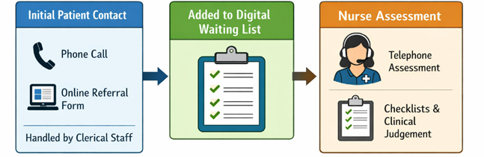
Figure 1. Current patient pathway (OpenAI 2026)

The proposed digital tool is a triage decision-support system designed to sit at the point of first contact with ISH. It will guide patients through a structured online assessment using clear questions to collect information on symptoms, sexual risk, pregnancy possibility, HIV exposure and safeguarding concerns. Based on this information, the tool will suggest an appropriate next step, such as referral to the PHW “test and post” service, routine clinician appointments, or urgent face-to-face review. The tool is intended to support, not replace, nurse-led triage by collecting standardised information before clinician contact. This allows clinicians to focus on clinical interpretation, safeguarding and decision-making rather than routine data collection. Higher-risk or complex cases will continue to require nurse telephone assessment. The tool will be used before nurse triage, replacing/enhancing the current online referral form. Telephone access will remain available to ensure equal access.
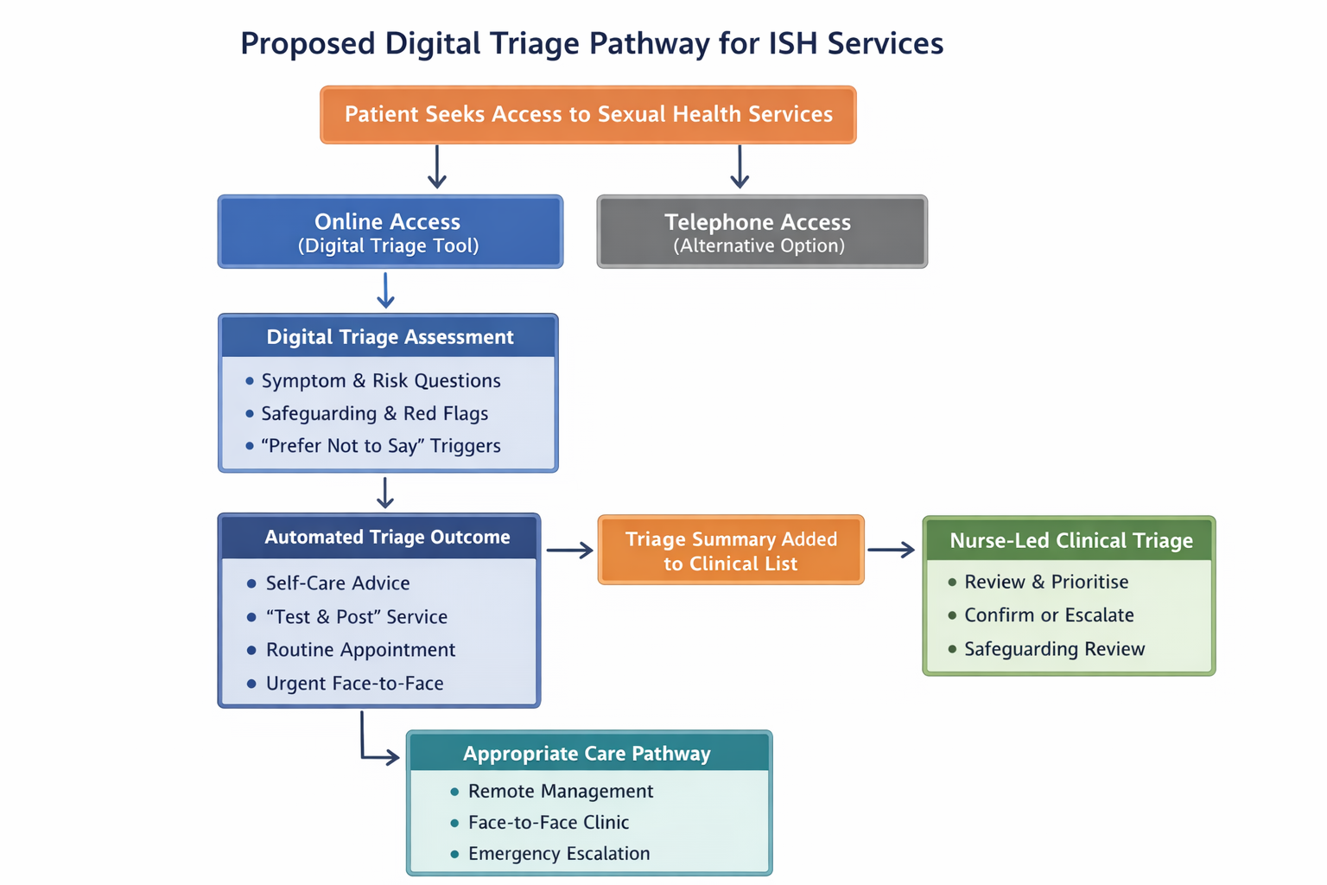
Figure 2.Proposed Digital Pathway for ISH Services (OpenAI 2026)

Digital Decision-Making
Digital technology is now a central feature of healthcare delivery across the NHS, driven by strategies focused on digital transformation. The NHS ‘Long-Term Plan’ (2019), the World Health Organisation’s (WHO) global digital health strategy (2021), and the Welsh Government’s ‘Digital Strategy for Wales’ (2021) all promote online access, remote consultations and data-driven tools to manage rising demand and workforce pressures.
Advances in technology have created new opportunities for healthcare delivery (Wadham 2019). In Wales, 66% of people use the internet to support their health (Song, Sharp & Davies 2020). However, despite increasing utilisation of digital decision-making and triage tools, there is still a lack of evidence around safety, effectiveness and equity. Internet use declines with increasing age and socioeconomic deprivation, raising concerns about digital exclusion (Song, Sharp & Davies 2020). Individuals with limited digital literacy, language barriers, disabilities, or restricted access to technology may be disadvantaged. This can lead to widening health inequalities.
Concerns have also been raised regarding clinical risk and accuracy. Algorithm-based tools may rely on incomplete or self-reported information which can lead to inappropriate advice or incorrect appointment allocation. Clinicians have reported uncertainty around accountability, governance and regulation, particularly where automated recommendations influence decision-making (Esmaeilzadeh 2020; Scott, Carter & Coiera 2021). Issues of data privacy, consent and transparency further complicate implementation, especially where artificial intelligence (AI) is involved (Murdoch 2021). These concerns are particularly significant in sexual health services, where confidentiality and sensitivity are paramount.
DT aims to support, rather than replace clinical judgement by standardising assessments and prioritising need (Illicki 2022; Semigran et al 2015). Given both its potential benefits and identified risks, a critical review of the literature is required.
Literature Review
With the reliance on a triage-based model within ISH services, it is important to examine the existing evidence supporting digital decision-making tools. By exploring the current literature, an insight into the effectiveness, safety and acceptability of triage approaches in sexual health and wider healthcare settings can be established. It also enables identification of best practice, potential risks and gaps in knowledge. The following literature review explores current research and national guidance relating to AI/machine-learning digital decision-making tools for triage.
A systematic approach was used to identify relevant literature to ensure a comprehensive understanding of digital decision support tools.
Grey Literature Methodology
All grey literature was identified by a search of organisation websites (e.g. BASHH) or Google search. The searches included unpublished reports, published standards and guidelines, news articles, policy documents and blog posts, specifically related to digital/remote working.
E-database Methodology
A search across the ‘PubMed’ e-database was conducted. Boolean operators (AND, OR) were used to refine the search. During the search, Mendeley Reference Manager was utilised to export articles into a reference list where duplicates were removed.

The search terms used to find relevant articles, reports and studies were as Table 1 below:

Search 1:
("digital support system*"[Title/Abstract]) OR ("digital system*"[Title/Abstract])) OR ("digital tool*"[Title/Abstract])) OR ("symptom checker*"[Title/Abstract])) OR ("online support"[Title/Abstract])) OR ("online system"[Title/Abstract])) OR (“remote”) OR (algorithm[Title/Abstract])) OR (digital technology[MeSH Terms])) OR (digital health[MeSH terms])) AND ((triage[Title/Abstract]) OR (triage[MeSH Terms])
Search 2:
("sexual health"[Title/Abstract]) OR ("genito-urinary medicine"[Title/Abstract])) OR ("genitourinary medicine"[Title/Abstract])) OR (sexual health[MeSH Terms])) AND ((triage[Title/Abstract]) OR (triage[MeSH Terms])
Table 1.
The following criteria was applied to ensure relevant, methodically sound studies were considered as shown in Table 2:

Inclusion | Exclusion
Full text available | Opinion sources
Peer reviewed | Non-English Publication
English language publication | Non Full Text
Published in the last 10 years | Decision aids not related to triage
Settings analogous to sexual health e.g. emergency department | Non-healthcare contexts
Table 2.

Results
Literature was initially screened based on title and abstract relevance. Full text articles were then reviewed to ensure they met the search criteria. This approach then informed the later discussion of the literature.
Figure 3 utilises the PRISMA model (Page et al 2020) to outline the systematic selection of literature.

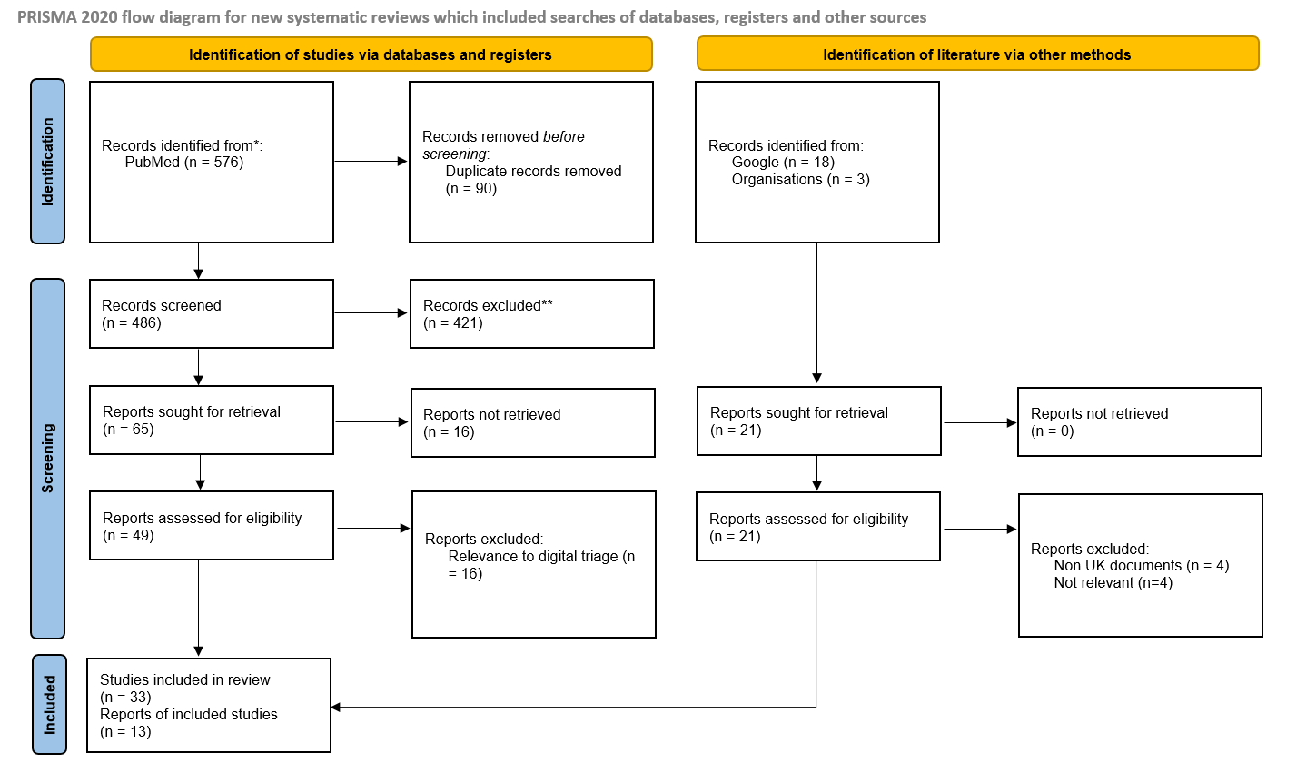
Figure 3. Prisma Diagram

Findings
A search of grey literature and academic databases identified different types of evidence. The grey literature, published within the past six years, was produced in response to the COVID-19 pandemic and the rapid acceleration of remote working. In these sources, DT is described not only as a technical tool but as part of wider discussions about access to care. The focus is on practice and policy during periods of restricted face-to-face contact, and themes included service continuity, safeguarding adaptations, governance frameworks and the expansion of digital pathways. However, much of this literature is context-dependent. It reflects emergency conditions, workforce shortages and rapid implementation, which may limit how it applies to routine, post-pandemic sexual health services. As a result, professional guidance developed during this period may prioritise what was immediately achievable and sustainable rather than focusing on longer-term goals.
In contrast, the peer-reviewed literature approaches digital triage differently, examining its use in settings such as emergency departments and primary care. These studies focus on technical performance, agreement with clinician decision-making, service utilisation and user satisfaction (Paule et al 2025; Ziebarte et al 2023). Importantly, none of the identified studies were specific to sexual health services, and few addressed safeguarding, stigma, or the complex social issues central to sexual health services. Many studies were conducted outside the UK, which limits their applicability to the NHS. In the NHS, care pathways, professional roles, legal duties and safeguarding responsibilities differ from those in international health systems.
Safety and Accuracy
Systematic reviews of digital telephone triage, such as that by Sexton et al (2025), demonstrates that digital support systems can be helpful when making service utilisation or ‘routing’ decisions, but concludes that evidence on clinical outcomes and safety is limited.
These reviews highlight the risk of ‘over-triage’ (for example, sending a person for urgent care when it is not needed), or ‘under-triage’ (failing to recognise when a person requires urgent care). For example, Levine et al (2024) showed that an AI system sometimes failed to recognise urgent cases, even though it appeared efficient at identifying diagnoses. Similarly, Liu et al (2024) found that ‘ChatGPT’ (an AI tool) often gave the same triage advice as clinicians, but the study did not examine whether this advice was safe or whether important contextual risks were missed. In addition, some AI studies are produced in collaboration with technology developers, which may lead to bias. Positive outcomes may be exaggerated or the scrutiny of possible harm/poorer outcomes may be limited.
A major limitation of these reviews is that they fail to examine the complexities associated with the social context of a person, and instead see the patient as a list of symptoms. In sexual health settings this is an important aspect of triage. If a young person (<18 years old) completes an online tool with the symptoms of ‘abdominal pain and irregular bleeding’, the tool may classify this as a non-urgent appointment. However, this person may be experiencing abuse or pregnancy risk that a clinician would likely explore. Most of the DT studies reviewed do not assess whether these tools can reliably detect or respond to contextual risk.
Lindner and Ravioli (2025) show that an AI-based triage system can both over and under-triage when compared with the ‘Manchester Triage System (MTS)’. This highlights that even ‘gold standards’ are subjective and depend on context. This is important for sexual health, where generic triage scales are unlikely to be sufficient and where assessment needs to be consistent with existing standards such as HIV PEP (post-exposure prophylaxis) eligibility, pregnancy risk and safeguarding guidelines. In contrast, the prediction modelling approach described by Li et al (2025), although focused on acute abdominal pain, shows the value of using structured, prospectively collected variables and models that can be validated and calibrated. This may offer a safer alternative to fully automated AI systems. For sexual health settings this would mean capturing important information such as menstrual history, pregnancy risk, timing of exposure, HIV risk windows, assault disclosure and red-flag symptoms, while allowing options that still protect patient safety.
While grey literature reflects the lived realities, regulatory concerns and ethical issues of implementing digital triage in healthcare, the academic literature has mainly evaluated DT in areas where risk is more easily standardised. This reveals a gap in the evidence. The absence of sexual health specific studies in the database literature limits the transferability of its findings and highlights the need for research that examines the unique clinical, ethical and safeguarding challenges of DT in sexual health settings. This gap also raises the question of whether DT offers adequate benefit over alternatives, such as enhanced nurse-led triage, improved appointment scheduling, or hybrid models that combine digital technology with clinician contact.
The literature from UK professional bodies consistently emphasises the complexity of safeguarding in triage. The BASHH/FSRH ‘Standards for online and remote SRH providers’ (2020) stress that triage systems must address safeguarding, consent and confidentiality. Similarly, the Office for Health Improvement and Disparities (OHID) ‘Integrated Sexual Health Service Specification’ (2023) describes digital access to be part of a wider system that must maintain equity, safety and continuity of care. However, as professional guidance may reflect shared opinions rather than evidence, it should be considered alongside independent research.
The academic literature on DT tends to focus on measures such as agreement with clinician decision-making, adherence to triage advice or patterns of service utilisation (Sexton et al 2022; Paule et al 2025). In sexual health settings, these measures are insufficient, as agreement between an algorithm and a clinician does not ensure that safeguarding concerns have been identified or that indicators of abuse have been recognised. This limitation is reinforced by evidence that triage performance is often poorer than diagnostic performance and that evaluation methods rely on simulated cases (vignettes) rather than real interactions (Riboli-Sasco et al 2023; El-Osta et al 2022). Additionally, evidence from AI-based triage research demonstrates that even advanced systems can fail to appropriately prioritise urgent cases, highlighting the risks of relying on automated assessments in contexts where safeguarding is critical (Levine et al 2024).

Systematic and scoping reviews of online symptom checkers and self-triage tools show mixed and inconsistent results. Many studies use different methods and rely heavily on vignettes rather than real patient use. Riboli-Sasco et al (2023) found that all studies they reviewed had a high risk of bias and that symptom checkers were generally worse at giving safe triage advice than at suggesting diagnoses. Additionally, Ziebart et al (2023) reported that although self-triage tools were rolled out quickly during the pandemic, there was little strong evidence that they reduced pressure on services or improved patient outcomes. Overall, this suggests that DT tools have often been developed and implemented faster than they have been properly evaluated for safety.
Studies using simulated patient cases, such as that by Levine et al (2023), highlight important weaknesses in the current evidence base. In this paper, a large language model (LLM) was studied. An LLM is a type of AI designed to understand and generate human-like text (Naveed et al 2025). Although LLM’s performed reasonably well at suggesting diagnoses, they were less accurate at deciding how urgent a case was and sometimes failed to identify emergencies. Their performance also worsened as cases became more serious. This is particularly worrying for sexual health services, where missing rare but serious conditions such as ectopic pregnancy, testicular torsion or sexual assault can have serious consequences.
The issue is not just that these studies have limitations, but that they are carried out in clinical settings where risk is mainly based on physical symptoms. In sexual health, risk is often shaped by personal, social and safeguarding factors, meaning that urgency cannot always be judged by symptoms alone.
One of the most important contributions of the academic literature is not clear evidence that digital triage works well, but evidence that current evaluation methods are limited. A study by El-Osta et al (2022) showed that when symptom checkers are tested using vignettes, the results can change depending on who enters the same information. Agreement on triage advice was only moderate and was weakest for urgent cases, leading the authors to conclude that vignette-based studies are not suitable for assessing triage safety. This is important because many studies rely on vignettes to judge whether DT systems are safe or accurate.
This limitation is particularly relevant for sexual health. Sexual health information is often sensitive to wording, cultural understanding and personal circumstances. Some individuals may understate symptoms to avoid face-to-face care, safeguarding questions, or judgement, while others may overstate symptoms to gain reassurance (Minchiello et al 2013). The variation seen in vignette studies is therefore likely to be even greater in sexual health settings, meaning that reliance on simulation-based validation may give a misleading impression of safety.
Studies using real patients provide more realistic insights but also have weaknesses. Prospective evaluations of symptom checkers in emergency department settings suggest low levels of potentially harmful under-triage, but these studies are usually limited to single sites, exclude many eligible patients and rely on expert opinion rather than direct evidence of harm (Sexton et al 2022). In addition, emergency department populations differ from sexual health service users, who may access care repeatedly, use multiple services at the same time and have issues linked to privacy and stigma.
Evidence from usage data further highlights these challenges. Accorsi et al (2025) found that many users restart or explore multiple triage pathways, particularly when advised to attend emergency care. This behaviour, sometimes described as “triage shopping,” is rarely considered in safety evaluations. In sexual health services, where users may actively seek the least stigmatising or most private option, this behaviour is likely to be common. DT systems that assume users will follow a single direct pathway may then fail to identify those who need urgent care.

Digital Literacy
Across the grey literature, digital literacy is discussed through repeated concerns about access, equity, safeguarding and service design. National guidance and commissioning documents from NHS England, OHID, and NICE consistently recognise that not all service users have the skills, confidence, language or access required to use digital systems (NHS England 2025; OHID 2023; NICE 2019). Rather than blaming the individuals for the deficits in literacy, these sources place it as a responsibility of health services. They emphasise the need for multiple access routes and clear, accessible information. They recommend non-digital alternatives (such as telephone access) so that online triage does not become a barrier to care. Safeguarding-focused grey literature reinforces this. The Royal College of Paediatric and Child Health (RCPCH) guidance for under-18s accessing abortion services highlights how limited understanding, shared device use or inability to use digital systems safely can correlate with vulnerabilities. This increases the risk of harm if DT is relied on without human escalation pathways (RCPCH 2022). Professional standards also stress that services must account for varying levels of user capacity when designing digital pathways (BASHH/FSRH 2020).
In the academic literature, digital literacy is more clearly visible as a factor shaping how triage systems perform in practice. Studies of symptom checkers and online triage demonstrate that outputs are highly sensitive to how information is entered, with small differences in wording leading to different urgency recommendations (El-Osta et al 2022). This has implications for users with lower health or digital literacy who may struggle to interpret questions. Reviews of digital and telephone triage also show that user behaviour, adherence and service use are inconsistent, suggesting that understanding and confidence in using digital systems influences whether advice is followed (Sexton et al 2022; Paule et al 2025). Evidence on AI and LLM-based triage reinforces these concerns, as vignette studies show that triage accuracy can deteriorate when information is incomplete or complex (Levine et al 2024; Liu et al 2024).
Although few sources actually define or quantify digital literacy, many assume that uneven digital skills, comprehension and confidence will affect navigation, trust and safety within digital triage systems. Both bodies of literature imply that DT must be designed to cope with variations in digital literacy through clear language, flexible options, strong safety-netting and easy escalation to human support (BASHH/FSRH 2020; NHS England 2025).
Governance
Interest in AI driven DT has increased concerns about safety, governance and ethics. Small studies assessing tools such as ChatGPT in outpatient triage settings have reported high levels of agreement between AI generated advice and clinician decisions, but these findings are based on very small samples and do not examine patient outcomes (Liu et al 2024). In these studies, if the digital tool’s answer matches a clinician’s answer, it is assumed that the system must be safe.
However, matching a clinician’s decision does not guarantee that the decision itself was safe or appropriate, especially for urgent or high-risk situations. Both the clinician and the system could miss the same warning signs, or the system might match clinicians on routine cases but fail on rare, serious ones. Other studies show that this is a real risk (Levine et al 2024; Sexton et al 2025; Knitza et al 2024). For example, the research has found that AI systems can appear accurate overall, yet still fail to recognise emergencies or assign them sufficient urgency. This means a system can have high agreement with clinicians in general, while still making dangerous mistakes in the cases where getting triage right matters most. Mani and Albagawi (2024) identified clinician education as a challenge in the use of AI tools. Their review, plus a systematic review by Yi, Baik and Baek (2024) highlighted the need for nurses to receive appropriate training on how to use these systems, as well as to understand their capabilities and limitations. The reviews reinforced that AI cannot replace the nuances of human interaction and that clinical judgement is essential.
A scoping review by Daneshjou et al (2021) found that many clinical AI studies do not clearly report who their systems are trained or tested on, making it difficult to judge whether the results are biased or apply to different populations. Although this study is not specific to sexual health, it is highly relevant because sexual health services often support marginalised groups, including young people, LGBTQ+ communities, migrants, and people facing social or economic disadvantage (McDermott, Nelson and Weeks 2021; Adley, O’Donnell and Scott 2025). The same conclusion was drawn by Siira et al (2025), who stated that AI tools must integrate with patient needs and voices to be inclusive. If AI systems are developed or evaluated using data that do not reflect these populations, there is a risk that existing inequalities are made worse.
Professional guidance takes a more cautious approach than much of the academic literature. In the document ‘Digitally Enabled Triage’ by NHS England (2025), DT is described as a tool to support clinical decision-making, not to replace professional judgement, and stresses the need for clear oversight, governance, and accountability. In a similar way, Welsh Government standards, including the ‘Quality Statement for Women and Girls Health’ (2022), place strong emphasis on equity, safety and access when using digital health systems. Together, these frameworks make clear that DT should not operate on its own, but as part of a wider, well-governed health system that prioritises person-centred care. Brownie et al (2025) carried out a scoping review of the available clinical guidelines for virtual health assessment and care, and found that standardised guidelines are not well documented, despite them being critical to safety and quality.
Professional bodies in sexual health also stress governance and audit. The BASHH position statement on digital testing platforms and antimicrobial stewardship (2021) emphasise clinical oversight and audit mechanisms, while joint standards from BASHH and FSRH (2020) highlight governance arrangements, escalation pathways and workforce accountability. These views differ from many academic studies, which often look at triage tools as standalone technologies rather than as parts of regulated healthcare systems.
Ethical and legal issues are not consistently addressed in DT research. Informed consent is rarely discussed and DT is often presented as a simple access tool rather than a clinical intervention that can influence risk and decision-making. Responsibility for triage decisions is also often unclear, especially when automated recommendations are used and accountability is shared between clinicians, healthcare organisations and technology providers (Paule et al 2025). Although bias in algorithms is increasingly recognised in AI research, it is difficult to assess in practice because studies often lack transparency and do not clearly report who systems are trained or tested on (Daneshjou et al 2021).

System Integration and Organisational Oversight
System integration and oversight are central to the safe and ethical use of DT, yet they are weakly addressed in much of the academic literature. Studies of online and DT in primary and urgent care show that these systems are often poorly integrated with existing clinical records and workflows, leading to duplication of work and increased administrative burden (Paule et al 2025). When triage tools operate alongside, instead of within clinical systems, responsibility for decisions becomes less clear, raising concerns about accountability and governance.
Reviews of telephone and digitally supported triage further highlight how oversight is distributed between non-clinical staff, clinicians and decision-support systems (Sexton et al 2022; 2025). While these models are intended to support decision-making, they also make it difficult to identify who is responsible when triage decisions are incorrect. This is particularly relevant in sexual health services, where DT must connect with safeguarding processes, laboratory testing and legally regulated care pathways, all of which require clear escalation and audit mechanisms.
Evidence on user behaviour reinforces these concerns. In sexual health contexts, where users may access services repeatedly and anonymously, fragmented data can hide patterns of risk and undermine safeguarding (Accorsi et al 2025).
Despite the importance of these issues, most studies of digital and AI-supported triage focus on technical performance or agreement with clinicians, rather than on how systems are governed in practice (Liu et al 2024; Levine et al 2024; Mani and Albagawi 2024). This reflects the wider ethical gap identified in the literature. While policy and professional guidance emphasise oversight, accountability and safety, practical evaluations rarely test whether DT systems are capable of managing risk in services such as sexual health.

Implementation Issues
Introducing a DT tool into sexual health services raises implementation challenges that include technical performance, workflow, governance and accountability. Academic evidence on digital and telephone triage suggests that instead of reducing workload, these systems often change how work is organised and distributed. Reviews of DT and online consultation systems determine that digital tools can add extra steps by creating parallel access routes. This can lead to duplicated work when digital and non-digital pathways operate side by side (Paule et al 2025; Sexton et al 2022). This is particularly relevant in sexual health services, which manage high volumes of routine, low-risk patients alongside a small number of more urgent, high-risk presentations. Redesigning workflows at the point of implementation would lessen this risk. Making clear decisions about which presentations are appropriate for digital entry, how digital and non-digital routes interact and how duplication will be avoided is key. Grey literature also reflects this concern through its emphasis on clinical governance, escalation pathways and accountability, suggesting that implementation risks are organisational in nature rather than technical (BASHH & FSRH 2020; NHS England 2025).
Clinical safety, professional trust and accountability also present further implementation challenges. Academic studies highlight that clinicians have concerns about where responsibility lies when algorithm-based or AI-supported triage makes care decisions (Esmaeilzadeh 2020; Scott, Carter & Coiera 2021). Reviews of AI use in triage identify that clinician education is a recurring barrier. It is noted that staff require training not only in system use but in understanding the system limitations and the continued necessity of human clinical judgement (Mani & Albagawi 2024; Siira et al 2025; Illicki 2022; Semigran et al 2015). Providing structured and ongoing training for all staff involved in triage would mitigate this. Training should provide clear guidance on clinical accountability for triage and escalation decisions including when digital recommendations should be accepted, questioned or overridden. These concerns are echoed within the grey literature in sexual and reproductive health, which consistently states that DT is a decision-support tool rather than a replacement for professional judgement, and stresses the need for clear lines of responsibility (BASHH & FSRH 2020; RCOG 2022).
Other issues for implementation include equity, digital literacy, data quality and safeguarding. Both academic and grey literature note that there are large disparities in the population regarding digital access and capability. Lower internet use is associated with older age, socioeconomic deprivation, language barriers, disability and lack of access to devices (Song, Sharp & Davies 2020; OHID 2023). In sexual health, these factors interact with stigma, confidentiality concerns and safeguarding risks meaning some users may be unable or unwilling to engage with digital triage, or may provide incomplete or ambiguous information. To overcome this, triage tools should use structured, plain-language questions in keeping with sexual health guidelines. The importance of maintain other channels to access services and clear routes to human support is emphasised in professional guidelines and standards (BASHH & FSRH 2020; NHS England 2025). Strong governance arrangements are also required, including named clinical ownership of the triage system, routine audit of triage decisions and clear escalation and incident-reporting processes to identify safety concerns. Overall, the literature suggests that introducing DT without addressing workflow integration, clinician training, accountability and equity may increase risks rather than providing improvements in access to services.

Evaluation and Recommendations
Evaluation is essential for any new service initiative to assess quality, impact, and whether intended outcomes are achieved. Applying a structured evaluation methodology enables a determination of the value of the DT tool within ISH services and supports refinement or wider implementation.
The implementation of the digital triage tool could be evaluated using the ‘Model for Improvement’, a widely used healthcare quality improvement framework (Improvement Cymru 2023). This model is well suited to digital triage as it combines clear evaluative questions with testing through Plan–Do–Study–Act (PDSA) cycles. Evidence suggests that PDSA-based approaches can lead to meaningful improvements in healthcare outcomes (Varkey et al. 2007).
The three guiding questions provide a structured approach to assessing whether the tool enhances access, safety, efficiency and user experience within ISH:
- what are we trying to accomplish?
- how will we know a change is an improvement?
- what changes will result in improvement?

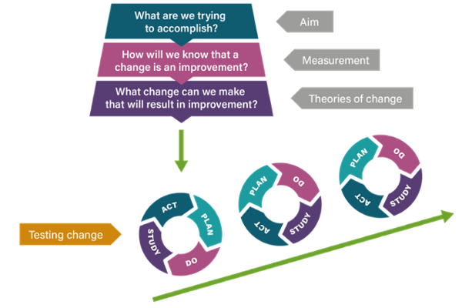
Figure 4: Illustration of the Model for Improvement (Improvement Cymru 2023)

Early PDSA cycles should prioritise real-patient audit rather than vignette-based testing and data should be collected both before and after implementation to assess change over time. Indicators should include safeguarding detection and escalation rates, alongside patient and staff experience, system efficiency and health outcomes. Evaluation must extend beyond technical performance to consider equity of access and integration with existing clinical workflows due to the complexity of ISH services. This should include analysis by age, deprivation and access route to identify patterns of digital exclusion or unintended barriers to care. Ongoing telephone and face-to-face access should be monitored to ensure that digital triage compliments, rather than replaces inclusive service provision.
A mixed-methods approach should be used to support a thorough evaluation of the DT tool. Quantitative measures may include accuracy of appointment allocation, rates of under-triage in high-risk presentations, time to clinician escalation, service throughput and rates of onward referral to appropriate care pathways. Statistical analysis could enable identification of changes associated with implementation. Continuous variables (such as time saved per patient or user satisfaction scores) may be assessed using t-tests or analysis of variance (ANOVA) (Vandever 2020).
Qualitative data could provide insights into the lived experiences of patients and staff using the DT tool. Semi-structured interviews or focus groups could explore usability, clarity of questions, confidentiality, digital literacy and impact on clinical workflows. These methods are particularly important in ISH services, where stigma, privacy and trust influences engagement with care.
Combining quantitative and qualitative findings allows for triangulation and strengthens the evaluation. This combined analysis will determine whether the DT tool meets its objectives of improving efficiency, data quality, safeguarding and user experience, and will inform decisions regarding further refinement.
Governance arrangements should form part of the evaluation framework. The DT tool should sit under named clinical ownership, with clear accountability for triage decisions, routine audit of outcomes and established escalation/ incident-reporting processes. Findings from evaluation cycles should inform refinement of the tool, staff training and workflow redesign, or withdrawal of the intervention if safety or equity concerns emerge.

Conclusion
By introducing DT, there are potential benefits for managing demand and standardising information within ISH services. However, the literature provides limited evidence of safety, effectiveness and equity, particularly in sexual health contexts. This highlights that triage accuracy alone is insufficient and that safeguarding, digital literacy and governance must be central to implementation and evaluation. A hybrid model, where digital tools support rather than replace clinician judgement is essential to ensure that DT enhances care without increasing health disparities.

References
Accorsi, T.A.D. et al. (2025) “Patient Navigation Behavior in a Symptom-Based Self-Triage Mobile App for Direct-to-Consumer Urgent Care: Retrospective Observational Study,” Journal of Medical Internet Research, 27. Available at: https://doi.org/10.2196/63816.

Adley, M., O’Donnell, A. and Scott, S. (2025) “How LGBTQ + adults’ experiences of multiple disadvantage impact upon their health and social care service pathways in the UK &amp; Ireland: a scoping review,” BMC Health Services Research, 25(1), p. 244. Available at: https://doi.org/10.1186/s12913-025-12232-8.

BASHH & FSRH (2020) ‘Telemedicine for Sexual & Reproductive Healthcare Services in Response to Covid 19’. Available at: 1.-Triage-Integration-Considerations-Methods-to-Prioritise-Vulnerable-Groups.pdf accessed on 14.1.26
BASHH & FSRH (2020) ‘Standards for Online & Remote Providers of Sexual & Reproductive Health Services: BASHH/FSRH Joint Standard.’ Available at: standards-for-online-and-remote-providers-2020.pdf accessed on: 8.2.26
BASHH (2021) ‘BASHH position statement on the use of multiplex testing platforms and suboptimal antibiotic treatment regimens for bacterial sexually transmitted infections’ Available at: BASHH position statement on the inappropriate use of multiplex testing platforms, and suboptimal antibiotic treatment regimens for bacterial sexually transmitted infections | BASHH accessed on: 8.2.26
Beck, J. et al. (2025) “Teledermatological services at a Swiss university hospital - evaluation of patient benefits and economic impact ,” Journal of Dermatological Treatment, 36(1). Available at: https://doi.org/10.1080/09546634.2025.2555189.

Brownie, S. et al. (2025) “Clinical Guidelines for Virtual Health Assessment and Care: A Scoping Review,” Journal of Advanced Nursing [Preprint]. Available at: https://doi.org/10.1111/JAN.16952.

Care Quality Commission (2022) ‘Digital Triage in Health Services’ Available at: Digital triage in health services - Care Quality Commission accessed on 8.2.26

Da’Costa, A. et al. (2025) “AI-driven triage in emergency departments: A review of benefits, challenges, and future directions,” International Journal of Medical Informatics, 197. Available at: https://doi.org/10.1016/J.IJMEDINF.2025.105838.

Daneshjou, R. et al. (2021) “Lack of Transparency and Potential Bias in Artificial Intelligence Data Sets and Algorithms: A Scoping Review,” JAMA Dermatology, 157(11), pp. 1362–1369. Available at: https://doi.org/10.1001/JAMADERMATOL.2021.3129.

El-Osta, A. et al. (2022) “What is the suitability of clinical vignettes in benchmarking the performance of online symptom checkers? An audit study,” BMJ Open, 12(4). Available at: https://doi.org/10.1136/BMJOPEN-2021-053566.

Esmaeilzadeh, P. (2020) “Use of AI-based tools for healthcare purposes: a survey study from consumers’ perspectives,” BMC Medical Informatics and Decision Making, 20(1), p. 170. Available at: https://doi.org/10.1186/s12911-020-01191-1.

Ilicki, J. (2022) “Challenges in evaluating the accuracy of AI-containing digital triage systems: A systematic review,” PLOS ONE, 17(12), p. e0279636. Available at: https://doi.org/10.1371/JOURNAL.PONE.0279636.

Improvement Cymru (2023) ‘Model for Improvement’. Improvement Cymru Academy Toolkit Guide. Available at: performanceandimprovement.nhs.wales/functions/quality-safety-and-improvement/improvement/improvement-cymru-academy/resource-library/academy-toolkit-guides/model-for-improvement-toolkit-guide/ accessed on 5.2.26
Knitza, J. et al. (2024) “Comparison of Two Symptom Checkers (Ada and Symptoma) in the Emergency Department: Randomized, Crossover, Head-to-Head, Double-Blinded Study,” Journal of Medical Internet Research, 26. Available at: https://doi.org/10.2196/56514.

Levine, D.M. et al. (2024) “The diagnostic and triage accuracy of the GPT-3 artificial intelligence model: an observational study,” The Lancet Digital Health, 6(8), pp. e555–e561. Available at: https://doi.org/10.1016/S2589-7500(24)00097-9.

Li, R. et al. (2025) “Development and validation of risk prediction models for high-risk patients with non-traumatic acute abdominal pain: a prospective observational study,” Frontiers in Public Health, 13. Available at: https://doi.org/10.3389/FPUBH.2025.1701050.

Lindner, G. and Ravioli, S. (2025) “Performance of the artificial intelligence-based Swiss medical assessment system versus Manchester triage system in the emergency department: A retrospective analysis,” American Journal of Emergency Medicine, 94, pp. 46–49. Available at: https://doi.org/10.1016/J.AJEM.2025.04.023.

Liu, X. et al. (2024) “Assessing the utility of artificial intelligence throughout the triage outpatients: a prospective randomized controlled clinical study,” Frontiers in Public Health, 12. Available at: https://doi.org/10.3389/FPUBH.2024.1391906.

Mani, Z. and Albagawi, B. (2024) “AI frontiers in emergency care: the next evolution of nursing interventions,” Frontiers in Public Health, 12. Available at: https://doi.org/10.3389/FPUBH.2024.1439412.

McDermott, E., Nelson, R. and Weeks, H. (2021) “The Politics of LGBT+ Health Inequality: Conclusions from a UK Scoping Review,” International Journal of Environmental Research and Public Health, 18(2), p. 826. Available at: https://doi.org/10.3390/ijerph18020826.

Minichiello, V. et al. (2013) “E-health: potential benefits and challenges in providing and accessing sexual health services,” BMC Public Health, 13(1), p. 790. Available at: https://doi.org/10.1186/1471-2458-13-790.

Murdoch, B. (2021) “Privacy and artificial intelligence: challenges for protecting health information in a new era,” BMC Medical Ethics 2021 22:1, 22(1), pp. 122-. Available at: https://doi.org/10.1186/S12910-021-00687-3.

Naveed, H. et al. (2025) “A Comprehensive Overview of Large Language Models,” ACM Transactions on Intelligent Systems and Technology, 16(5), pp. 1–72. Available at: https://doi.org/10.1145/3744746.

NHS (2019) ‘The NHS Long-term Plan’. Available at: NHS Long Term Plan v1.2 August 2019 accessed on: 15.1.26
NHS England (2025) ‘Digitally Enabled Triage’ Available at: NHS England » Digitally enabled triage accessed on: 8.2.26
National Institute for Health & Care Excellence (NICE) (2019) ‘Abortion Care Guideline NG140’ Available at: Overview | Abortion care | Guidance | NICE accessed on 8.2.26
Office for Health Improvement & Disparities (OHID) (2023) ‘Integrated Sexual Health Service Spcification’ Available at: Integrated sexual health service specification accessed on 8.2.26
OpenAI (2026) Figure 1- ChatGPT response to: ‘make me a flowchart of this process: Initial patient contact is managed by clerical staff via telephone or online referral forms, with patients added to a digital list. A nurse then completes a telephone clinical assessment using checklists alongside professional judgement.’ Accessed on 5.2.26
OpenAI (2026) Figure 2- ChatGPT response to: ‘make a flowchart image of the proposed digital triage pathway for ISH services’ accessed 5.2.26
Page, M.J. et al. (2021) “The PRISMA 2020 statement: an updated guideline for reporting systematic reviews,” BMJ, p. n71. Available at: https://doi.org/10.1136/bmj.n71.

Paule, A. et al. (2025) “Patient-facing online triage tools and clinician decision-making: a systematic review,” BMJ Open , 15(5). Available at: https://doi.org/10.1136/BMJOPEN-2024-094068.

Pope, C., Ziebland, S. and Mays, N. (2000) “Analysing qualitative data,” BMJ : British Medical Journal, 320(7227), p. 114. Available at: https://doi.org/10.1136/BMJ.320.7227.114.

QuestionPro (2025) “10 Quantitative Data Analysis Software for Data Scientists” Available at: 10 Quantitative Data Analysis Software for Data Scientists Accessed on: 9.11.25
Riboli-Sasco, E. et al. (2023) “Triage and Diagnostic Accuracy of Online Symptom Checkers: Systematic Review,” Journal of Medical Internet Research, 25. Available at: https://doi.org/10.2196/43803.

Scott, I.A., Carter, S.M. and Coiera, E. (2021) “Exploring stakeholder attitudes towards AI in clinical practice,” BMJ Health & Care Informatics, 28(1), p. e100450. Available at: https://doi.org/10.1136/BMJHCI-2021-100450.

Semigran, H.L. et al. (2015) “Evaluation of symptom checkers for self diagnosis and triage: audit study,” BMJ, 351. Available at: https://doi.org/10.1136/BMJ.H3480.

Sexton, V. et al. (2022) “Service use, clinical outcomes and user experience associated with urgent care services that use telephone-based digital triage: A systematic review,” BMJ Open, 12(1). Available at: https://doi.org/10.1136/BMJOPEN-2021-051569.

Sexton, V. et al. (2025) “Safety and accuracy of digitally supported primary and secondary urgent care telephone triage in England: an observational study using routine data,” BMC Medical Informatics and Decision Making, 25(1). Available at: https://doi.org/10.1186/S12911-025-02888-X.

Siira, E., Johansson, H. and Nygren, J. (2025) “Mapping and Summarizing the Research on AI Systems for Automating Medical History Taking and Triage: Scoping Review,” Journal of Medical Internet Research, 27. Available at: https://doi.org/10.2196/53741.

Software World (2025) “Best Qualitative Data Analysis Software” Available at: List of Top Qualitative Data Analysis Software - Nov 2025 Reviews | SoftwareWorld Accessed on: 6.2.26

Song, J; Sharp, CL; Davies, AR (2020) ‘Population health in a digital age: Patterns in the use of social media in Wales’. Public Health Wales & Bangor University. Available at: phw.nhs.wales/topics/digital-technology-and-health/population-health-in-a-digital-age1/ accessed on: 17.1.26
The King’s Fund (2025) ‘Digital Triage in GP: enhancing access to care or increasing inequalities?’ Available at: Digital Triage In GP: Enhancing Access To Care Or Increasing Inequalities? | The King's Fund accessed on: 8.2.26
The Royal College of Paediatric & Child Health (RCPCH) (2022) ‘Safeguarding Guidance for Children & Young People Under 18 Accessing Early Medical Abortion Services’ Available at: Safeguarding guidance for children and young people under 18 accessing early medical abortion services - RCPCH Child Protection Portal accessed on 8.2.26
Vandever, C. (2020) “Introduction to Research Statistical Analysis: An Overview of the Basics,” HCA Healthcare Journal of Medicine, 1(2). Available at: https://doi.org/10.36518/2689-0216.1062.

Varkey, P., Reller, M.K. and Resar, R.K. (2007) “Basics of Quality Improvement in Health Care,” Mayo Clinic Proceedings, 82(6), pp. 735–739. Available at: https://doi.org/10.4065/82.6.735.

Wadham, E. et al. (2019) “New digital media interventions for sexual health promotion among young people: a systematic review,” Sexual Health, 16(2), pp. 101–123. Available at: https://doi.org/10.1071/SH18127.

Welsh Assembly Government (WAG) (2021) ‘Digital Strategy for Wales’. Available at: Digital strategy for Wales | GOV.WALES accessed on 15.1.26
Welsh Assembly Government (WAG) (2022) ‘Quality Statement for Women & Girls Health’ Available at: Quality statement for women and girls’ health [HTML] | GOV.WALES accessed on 8.2.26
World Health Organisation (WHO) (2021) ‘Global Strategy on Digital Health 2020-2025’ Available at: content accessed on 8.2.26
Yi, N., Baik, D. and Baek, G. (2025) “The effects of applying artificial intelligence to triage in the emergency department: A systematic review of prospective studies,” Journal of Nursing Scholarship, 57(1), pp. 105–118. Available at: https://doi.org/10.1111/JNU.13024.

Ziebart, C. et al. (2023) “A Digital-First Health Care Approach to Managing Pandemics: Scoping Review of Pandemic Self-triage Tools,” Journal of Medical Internet Research, 25. Available at: https://doi.org/10.2196/40983.

