

Module Title: Academic and Employability Skills
Student Name: Roxana-Ioana Ciubotariu
Student ID: 2115139
Module code: BMSW4001

INTRODUCTION
The academic report aims to focus on the different aspects that have been covered in the academic module of the session. In this report, a brief explanation of the four topics that have been covered in the report will also be discussed thoroughly. The broad view of time management, referencing, and summarising will be discussed thoroughly. Further, the broad part of the report will also involve the description of the public speaking and the presentation's features in a broad manner.
The major aim of the report is to elaborate on the topics briefly in the reflective form. All the learning gathered in this report will be abed on the learning from the academic module. The reflective learning will be showcased with the help of the appropriate reflective model. The reflective model will be based on the aspects of Kolbe’s learning cycle.

KOLBE’S LEARNING CYCLE

Kolbe’s reflective cycle is based on the aspects and the features of the four stages for the effective explanation of the learning in a reflective manner (Watson et al., 2019). The stages like the concrete experience, reflective observation, abstract conceptualization, and active experimentation involve in the model for the explanation of the reflection in an effective manner. The foundation of this model is based on the aspects and the features of the own experience that has been gathered in the gathering of any type of learning.
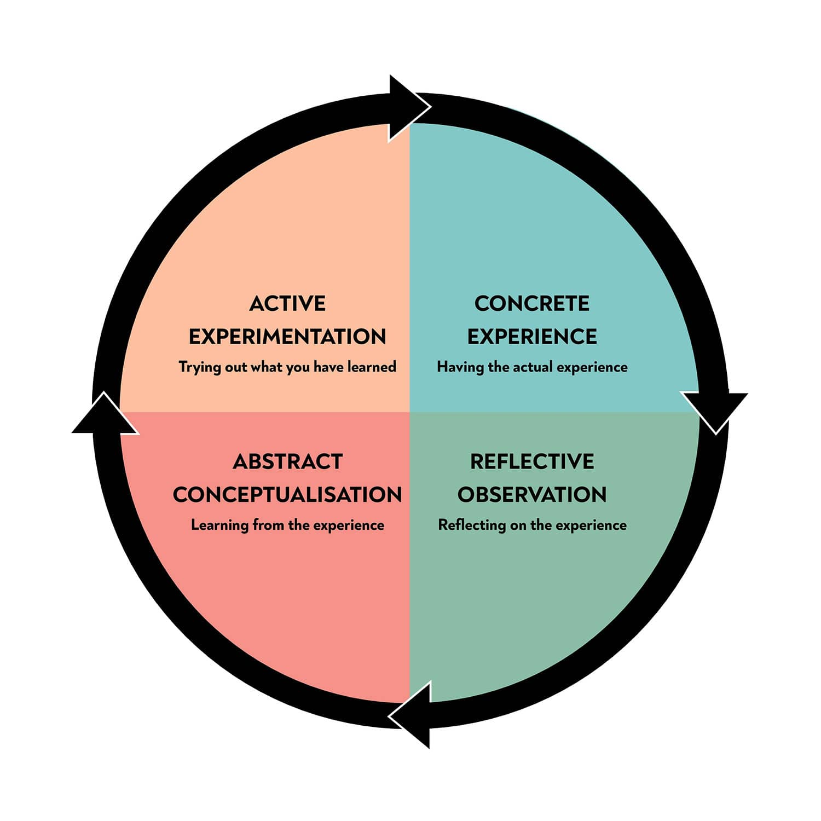
Figure 1 Kolbe's learning cycle
Source: (Watson et al., 2019).

Concrete experience:
This stage will be based on the foundational aspects of the learning of the specific situation and the basic description of the feeling, and the thinking gathered in the experience will be elaborated in this stage.
Reflective observation:
This stage will elaborate on the experience in the form of an effective understanding of the experiences (Watson et al., 2019).
Abstract conceptualization:
Under this stage, the effective conceptualization of the learning or the experience will be done effectively.
Active experimentation:
During this stage, the newly acquired knowledge will be discussed thoroughly (Watson et al., 2019). Own thoughts and reflections regarding the improvement will be one in this stage.

TIME MANAGEMENT
Time management can be referred to as the process in which different tasks will be organized effectively by the individuals in a productive manner. The module “Academic And Employability Skills” has helped me effectively in gathering the basic tenants of time management.
Concrete experience:
Attending the module learning has helped me a lot in the attainment of the basic understanding of time management in the student’s life. Before, learning from this module I was ignorant of the basic aspects of time management. Furthermore, with the help of this module, I have come to know about the aspects of time management. Basic tenants of the time management principles, daily time management aspects, review of effective time management, daily to-do lists, and the weekly to-do list are some of the aspects that I have come to know effectively. Furthermore, the aspects like the setting of the SMART goals, alignment of the clock, review of the time management, the process of time management, and the creation of the log are some of the major aspects, I have gained through this module (Mindtools, 2019). I felt much more effective and confident with the help of this module. The learning attained from this module has helped me in the better development of a broad base for time management in academic life.
Reflective observation:
Under the time management aspects, I have come to know the aspects of the effective allocation of time to the different important tasks. I have found that the scheduled sessions, work, family, eating, and sleeping are some of the major tasks that consume more time than the other ones. I have gathered that the allocation of the most important task should be prioritized by the individuals for effective time allocation. Review, plan, and estimation of the time requirement have been gathered by me in this module. The module has taught me that for effective time management, the aspects like diaries, action logs, tidy workplaces, and organized paper works are some of the effective tools used for time management (Mindtools, 2019). SMART goals, to-do lists, and the Eisenhower are some of the important tools I have gathered from the module. The module has helped me effectively in reviewing the time slots for the different work. At the end of the module, I come to know about the creation of logs for the better management of time.
Abstract conceptualization:
I have concluded in the module, that the effective management of time has helped me in the better management of difficult tasks. Before, the attainment of the learning from the module I was ignorant of the concepts of the Eisenhower and the learning logs (Mindtools, 2019). This module has helped me in the effective drawing of the conceptual understanding of time management tools.
Active experimentation:
I have found that the different type of review tasks and activities has been provided in the report. With the help of these tasks, I have implemented the learning in a better manner. Under activity one of the time management modules, I have prepared the to-do lists for myself. In this to-do list, I have better managed the aspects of learning the time management tools. My teacher told me that I need to work on the implementation of the Eisenhower matrix in the development of the timetable for academic life. Activity 2 of the module has helped me in the formulation of the setting of the goals for me in an effective manner (Mindtools, 2019). Time management review is the third stage that I have on in the activity third of the report. With the help of activity four, I have come to implement the understanding of the time log effectively.

SUMMARISING
This is the second topic that has been chosen in the report for a better analysis of the summarising of the different aspects of the summarising in aspects of academic life (Read, 2018). Summarising can be elaborated as the aspect by which the key points from the texts or the books can be elucidated effectively.
Concrete experience:
This module has helped me in the effective understanding of the art of summarising. I have come to know the aspects of the analysis and the evaluation for a better understanding of summarising in academic life. This module has helped me in the effective understanding of using the art of summarising effectively. I have experienced better production methods for the elucidation of the different texts in an effective manner (Read, 2018). Reading, writing, checking, revising, and references are some of the aspects I came to know with the help of this module.
Reflective observation:
Before, reading this module, I was ignorant about the art of summarising and its importance in academic life. This module has helped me in the productive representation of the texts of diverse books. I have come to know the broader aspects of reading, writing, checking, revising, and the references in the summarising of complex texts (Read, 2018). I have found that the art of summarising will save my time and I can better allocate my time to the different tasks by summarising the complex texts involve in the different books.
Abstract conceptualization:
I have outlined that the module has helped me in providing the details of the different tasks involving the focus on the summarising tool. I have effectively made the differentiation between the paraphrase and the summarising tool in effective manner. The example presented in the module has helped me in the effective understanding of the summarising tool in understanding complex tasks.
Active experimentation:
I have found that the numerous activities associated with the art of summarising have been presented in the module. All the activities presented in the report have helped me in implementing the learning effectively. From activity one, I have effectively summarised the main ideas. Under activity two of the module, I have better focused on the aspects of summarising the complex paragraphs (Read, 2018). As per my teacher's feedback, I have better managed the summary exercises given in the module and I need to work on the complex type of the texts for the effective summarising of the different subjects.

REFERENCING
Referencing is a crucial skill involved in academic writing. Referencing can be defined as the process in which the writer of the texts acknowledges the work of the other writers that have been used in the report in an effective manner (Marsh and Campion, 2018). With the help of the appropriate referencing the aspects of plagiarism which is an academic offense can be restricted.
Concrete experience:
The module has helped me in a better understanding of the importance of referencing in the life of the students. I have come to know the aspects of plagiarism and referenced in this module more deeply. Before, reading this module I was ignorant of the aspect of referencing and the importance of referencing I am dealing with plagiarism. However, after the appropriate learning from this module, I have better managed the aspects of the references in my learning (Marsh and Campion, 2018).
Reflective observation:
I have come to know the severe implication that can be faced by individuals for failing to appropriately reference the different aspects. I have found from this module that poor paraphrasing by individuals indicates the offense of plagiarism (Marsh and Campion, 2018). I have come to know the aspects of the different types of offensive issues that can be created due to the lack of references in academic works (Bottomley et al., 2018). This module has helped me in the effective understanding of the reviewing technique with which I can effectively reduce the chances of plagiarism in my written texts.
Abstract conceptualization:
I have found that the module has helped me in the effective conceptualization of the art of referencing in my work. Different activities provided in the module have increased and improved my understanding of referencing art. I have come to know the aspects of self-plagiarism, collusion, and paraphrasing with the help of this module.
Active experimentation:
Under this aspect, I have acquainted myself with the different activities provided in the module for a better understanding of the referencing tool. I have found that through the help of activity one I have inculcated the university referencing guide effectively. I have found the guidance for referencing the work in an effective manner such that the publisher and the author whose work has been sued in the academic work can get appropriate authorization. Under activity two, I have better represented the reference list such that the mistakes can be negated in academic writing (Bottomley et al., 2018). My teacher has provided me with moderate feedback and tells me to work on an effective understanding of the online referencing aspects.

PUBLIC SPEAKING AND GIVING PRESENTATIONS
Public speaking and giving presentations play a crucial role in showcasing the mettle of the individuals within the corporate world (Yulianti and Sulistyawati, 2021). This module has helped me in developing a better understanding of public speaking and the presentation-giving aspects. I have found that with the help of this module public speaking helps in the development of learning communication and effective values in the workplace (Lee and Kleinsmith, 2019). Furthermore, I came to know the importance of presentation-giving skills in the workplace and academic life.
Concrete experience:
The module has provided me with an effective understanding of the pre-talk preparations, handout preparation, and the importance of body language for a better oratory of the presentation. I have found that asking questions during the presentations, using the appropriate body language and the length of the presentation plays a crucial role in effective presentation (Lee and Kleinsmith, 2019).
Reflective observation:
Before, the learning attained from this module I was ignorant of the different aspects involved in a better presentation, however, after this module I have better managed the aspects of the presentation-giving traits. Arriving a few minutes earlier, using the handout only when it is required, opening statements, speaking at the natural pace, using body language with the natural gesture, appropriate behaviour, and the use of concussions are the effective learning I have attained from this module (Lee and Kleinsmith, 2019).
Abstract conceptualization:
This module has provided me with an effective understanding of the broad type of presentation-giving aspects. I have come to know the diverse types of concepts involve in the presentation-giving aspects.
Active experimentation:
The activities present in the module have provided me with a practical view of an effective presentation. With the practical sessions on the different types of presentation-giving exercises, I have better managed the attributes of the learning gathered to form the module. My teacher has provided me the positive feedback for the practical session on presentation-giving exercises.

CONCLUSIONS
The report has been based on the learning attained from studying the module on academic and employability skills. The reflective learning has been showcased with the help of the appropriate reflective model of Kolbe’s learning cycle. Time management, referencing, summarising, and presentation giving are the major aspects discussed in this report.

REFERENCES
Bottomley, J., Pryjmachuk, S. and Cartney, P. (2018). Academic Writing and Referencing for Your Social Work Degree. Critical Publishing.
Lee, H. and Kleinsmith, A. (2019), May. Public speaking anxiety in a real classroom: Towards developing a reflection system. In Extended Abstracts of the 2019 CHI Conference on Human Factors in Computing Systems (pp. 1-6).
Marsh, J.D. and Campion, J. (2018). Academic integrity and referencing: Whose responsibility is it?. Journal of Academic Language and Learning, 12(1), pp.A213-A226.
Mindtools (2019). ‘ What is Time management?’ Online available at: https://www.mindtools.com/pages/article/newHTE_00.htm [Last accessed on: 27 July 2022]
Read, S.H. (2018). Academic writing skills for International students. Bloomsbury Publishing.
Watson, M.K., Pelkey, J., Noyes, C. and Rodgers, M.O. (2019). Using Kolb’s learning cycle to improve student sustainability knowledge. Sustainability, 11(17), p.4602.
Yulianti, T. and Sulistyawati, A. (2021). Enhancing public speaking ability through focus group discussion. JURNAL PAJAR (Pendidikan Dan Pengajaran), 5(2), pp.287-295.

