Case Study
An in-depth Analysis on the GSK Carbon Neutral Laboratory for Sustainable Chemistry

Prepared by
Kieran John Bowen

Table of Contents

- Abstract
- Main Body
  - Research Context and Analysis
  - Excavation Process and Calculations
  - Materials Used in the Construction Build
- Conclusion
- Bibliography
- Annexes

Abstract
This case study will involve me having a deep in-depth analysis on the GSK Carbon neutral Laboratory in Nottingham which the construction phase of the project started in 2015 with it being complete and open in February 2017. (The Carbon Neutral Laboratory - the University of Nottingham, 2017). I will be analysing the structure and design of the building with also looking at the choice of materials used for the project. I will also be looking at the foundation requirements needed to use on this project in order to make it feasible, stable, and sustainable. This project is very unique due to the methods used to construct it such as its “built from natural materials and energy required to run the laboratory is met by renewable sources such as solar power and sustainable biomass. Excess energy created by the building provides enough carbon credits over 25 years to pay back the carbon used in its construction”. (The Carbon Neutral Laboratory - the University of Nottingham, 2017). This project is evolutional due to the materials and technology used to design and build the project, with this case study highlighting the various different methods that allowed it to become such a eco-friendly, structural stable, aesthetically pleasing building.

Main Body
Research Context
I’ve vigorously analysed the various different foundation requirements needed in order for a building of this structure. Firstly, I’ve looked at the previous history of the site in order to help identify the materials used, load bearing on the site as this will allow us to plan and prepare in to which foundation would be most suitable for the site to prevent any unexpected structural surprises when building/complete. Through conducting primary research, this allowed me to find out that the site is a brownfield site, a brownfield site “refers to previously developed land, which is or was occupied by a permanent structure”. (What Are Brownfield Sites and Could They Be Better Used to Support New Homes? | Strutt & Parker, 2019). Therefore, due to the fact that the site “was formerly the site of bicycle makers Raleigh”. (Walter2017-03-08T08:44:00+00:00, n.d.). This will help allow me to determine what foundation requirements need to be met for this brownfield site and also determine which foundation would be the most suitable for this site. In order to also identify the foundation requirements for the site I needed to look at the design of the building in order to allow me to understand the structure, materials, and size of the building, this will then allow me to analyse the different foundations that can be used for the load of the building and draw reliable conclusions as to which would be the most suited and tailored for this construction project. As you can see from figure 1 it’s an architectural detailed drawing showing the long section of the building, as you can see the building is a long span structure with large ventilation towers on the roof.
In order to determine what type of land they wanted to construct the building on, they needed to inspect the land through bore holes being dug, which would allow specialist contractors to pile drive down between roughly 60-200m to inspect the underlying rock types and soil types. Through this, they were able to determine that the land was sitting on a bed of “sandstone, which is pinkish red or buff-grey, medium to coarse grained, pebbly, cross-bedded, friable; subordinate lenticular beds or reddish-brown mudstone”. (British Geological Survey (c) UKRI mailto:www-bgs@bgs.ac.uk, n.d). Due to the site being a brownfield site, the ground needed to be inspected for any contamination to the land, this therefore, led us to find the following findings “Some contaminated land was identified by a specialist, who recommended a remediation strategy, including: a clean capping layer for asbestos contamination, restriction of infiltration through contaminated source areas, and ground gas protection measures. This land would have otherwise remained contaminated and undeveloped” (bregroup.com, 2022).

Analysis
Through this information we have now gathered we can now have a look at three main types of foundations which are strip/wide strip, raft and piled. I can now analyse the three different foundations and given the current ground conditions of the existing site I can now look at the advantages and disadvantages of each foundation type for this building and help drawn an assumption as to which foundation type I would recommend for this build.

The first foundation type I’ve decided to analyse is the Strip foundation, this is arguably the cheapest foundation type used within the construction industry, this involves the removal of a strip of land to a set depth and width, which concrete is then poured into the strip and tamped/balanced level. These types of foundations can only be used on firm/solid, good bearing of ground and to a depth of no more than 1.5-2m in order to be economical. This foundation type would be well suited for this build due to it being fairly inexpensive and also due to it being a quick and fast process of implementing the foundation, the downsides of this foundation which means it doesn’t meet the foundation requirements is due to the ground being contaminated and also the soil within the ground is weak which means with this foundation type being used it can lead to “serious consequences, potentially leading to structural integrity issues or even collapse”. (www.reinforcementproductsonline.co.uk, n.d.)

The second foundation type I’ve decided to analyse is the Raft foundation, this foundation type involves a reinforced concrete slab under the whole of the building floating on the ground for e.g. a raft floating on water, this type of foundation spreads the load of the building on a larger area which will help to lower the pressure on the ground. The process involves excavating soil, stabilise the soil using hardcore soil, then pour the reinforced concrete into the raft then construct the walls. This foundation would meet the requirement as to the area and size of the structural building that was designed in figure 1, which shows the design covers a larger area which would be suited to a raft foundation as this foundation covers a larger area, this foundation type will also save time for the build as the excavation process is quicker.

The third foundation type I’ve decided to analyse is the Pile foundation, this is arguably the most expensive foundation type of the three. This foundation process involves a “series of columns constructed or inserted into the ground to transmit loads to a lower level of subsoil. A pile is a long cylinder made up of a strong material, such as concrete. Piles are pushed into the ground to act as a steady support for structures built on top of them. Piles transfer the loads from structures to hard strata, rocks, or soil with high bearing capacity. The piles support the structure by remaining solidly placed in the soil”. (www.schoolofpe.com, n.d.). This foundation type will be suited for this build as it can take a huge load bearing, which the building will be, also the process of completion can be very quick due to factors such as pre-ordering the piles to size and specification. Also, with the piles being pre-made this can lead to less waste so therefore this helps adhere to how they want the build to be which is economical and eco-friendly.

To conclude, I’m going to make an assumption as to what foundation type was used for this build, in which I think a piled foundation was used due to many reasons. I think this foundation type was used due to the underlying ground conditions consisting of loose sandstone which is generally moderately strong and provides good foundation conditions, therefore this means the pile foundation would hold up strong and steady within the ground conditions. Also, with the building not being vastly tall the interior and exterior sub structure of the building is still a heavy load bearing this means the foundation would need to be very strong and able to handle a heavy bearing, this is why the pile foundation is suited due to it being predominately used on heavy load buildings. This type of foundation is also considered eco-friendly and economical which coincides with the whole plan of the build which is to make it sustainable, the helical piles “requires fewer materials and less energy to produce. Because of their size, they are easy to ship to a worksite and arrive ready to be installed”. (Stroyer, 2019). The ground conditions within the area of Nottingham tend to be wet and a high level of water due to “Nottingham being built near a crossing point on the River Trent in the East Midlands of England. Initially, the city developed on a low sandstone hill close to the north bank of the river, which provided a secure, well-drained location”. (Bell et al., 2009). So therefore, due to these conditions a pile foundation would be well suited for this.

Excavation Process
Excavation within construction involves the removal of rocks, soil and any other materials from the ground through extracting it from the ground with various different techniques such as using Power tools, tools such as diggers and explosives. Excavation is predominately done for reasons such as “exploration, environmental restoration, mining, and construction. Among these, construction is one of the most common applications for excavation. Excavation is used in construction to create building foundations, reservoirs, and roads”. (Wollam, 2015).

Excavation Works
In order to work out the excavation works we need to find out the below dimensions of the building. Height x Width x Length
Area of building = 41,995m2 (Calculated by length x width)
Assume Pile Depth = 25m Deep
Assume Diameter of each pile = 1.25m
Assume Piles Dug = 25nr
In order to work out how much soil and rock was excavated per pile I need to work out the below:
To multiply the diameter for each pile by the depth of each pile = 25m x 1.25 = 31.25m2
In order to work out the full excavation I will need to work out the following:
To multiply the excavation per pile (31.25m2) by the Number of piles dug (25nr) = 781.25m2

Materials used within the Sub-Structure
The design and structure of this building is very unique and aesthetically pleasing. The structure of the build consists of a braced glulam timber frame of beams and columns. As you can see from Figure 2 the design of the glulam timber frame is very articulate and shows how detailed and complex the design of the structure was. This type of timber used to build the structure of this building is extremely ideal for this project as Glulam timber is useful for using large section size timbers with a wide span, which is why it’s ideal for this medium sized long spanning building. It’s also very durable, high strength and stability with low maintenance, perform very well in fires due to the due to the timber chars at a known rate do not deform like steel. It’s also very efficient to produce with energy required to produce a glue-laminated beam from the log is only a fraction of the energy required to produce steel or concrete. Glulam has superior earthquake resilience and greater resistance to fire than any other structural construction material. (Techlam, 2018). The design of the build allowed the building to have a pitched roof with large rooflights to draw natural light into the internal spaces, this design method is extremely clever as this helps allow the build to be sustainable, environmentally friendly, and also cost efficient. The building also consisted of a photovoltaic array on the south side and a green roof system on the north side which assisted with rainwater attenuation. In order to control the environment, the roof has deep overhangs as you can see in figure 3 and windows are inset into the façade, with the cladding on the walls a rainscreen of western red cedar boards and single fire rated terracotta panels, as these were chosen due to their low-embodied energy. This whole design of the building shows how much they have taken on board looking at the environmental factors by the choice of materials they have used. Also, with the use of CLT for a wide range of things within the build this shows how the material can be implemented, for example the structural flooring for the build was used from CLT with the CLT being supported by glulam structural frame with CLT panels being used for the roof deck. In order to help improve the building’s sustainability the quantity of steel in the building was reduced by the use of traditional timber. Another sustainable factor for the building is the laboratory is heated by a 125We biofuel combined heat and power system which exports excess heat to adjacent rooms in the building by a 230.9Wp array of photovoltaics on the south pitch of the roof. LED lighting has been fitted throughout the building with an average of 5.4 Watts/sq.m. it’s estimated that the building will save more than 60% of power and will use just 15% of the heat needed for a more traditional building design. Which due to the sustainability of the build the excess energy created by the building will provide enough carbon credits over 25 years to offset the construction phase. As you can see from the below figures the build is extremely aesthetically pleasing with the feature its presents and also with it having a modern look to it. (UKGBC - UK Green Building Council, n.d.).

Conclusion
To conclude, after an in-depth analysis looking at this unique building. It’s clear to see that the new modern design techniques combined with the materials used has allowed this to become an extremely sustainable, stable building with it also being extremely eco-friendly and renewable due to the materials used for the build.

Bibliography
The Carbon Neutral Laboratory - The University of Nottingham. (2017). Nottingham.ac.uk. https://www.nottingham.ac.uk/chemistry/research/centre-for-sustainable-chemistry/the-carbon-neutral-laboratory.aspx

What are brownfield sites and could they be better used to support new homes? | Strutt & Parker. (2019). Www.struttandparker.com. https://www.struttandparker.com/knowledge-and-research/what-are-brownfield-sites-and-could-they-be-better-used-to-support-new-homes

Walter2017-03-08T08:44:00+00:00, P. (n.d.). Nottingham green labs rise from ashes. Chemistry World.https://www.chemistryworld.com/news/nottingham-green-labs-risefromashes/2500511.article

British Geological Survey (c) UKRI mailto:www-bgs@bgs.ac.uk. (n.d.). BGS Linked Data - Nottingham Castle Sandstone Formation [Obsolete Name And Code Use: CHES]. https://data.bgs.ac.uk/id/Lexicon/NamedRockUnit/NTC

bregroup.com. (2022). GlaxoSmithKline’s Carbon Neutral Laboratory for Sustainable Chemistry achieves BREEAM Outstanding - BRE Group. [online] Available at: https://bregroup.com/case-studies/breeam-new-construction/glaxosmithklines-carbon-neutral-laboratory-for-sustainable-chemistry-achieves-breeam-outstanding/.

www.reinforcementproductsonline.co.uk. (n.d.). Strip Foundations: All You Need To Know | RPO. [online] Available at: https://www.reinforcementproductsonline.co.uk/news/strip-foundations/#:~:text=The%20Limitations%20of%20Strip%20Foundations&text=Where%20soil%20conditions%20are%20weak.

www.schoolofpe.com. (n.d.). Basic Principles and Classifications of Pile Foundations. [online] Available at: https://www.schoolofpe.com/blog/2017/06/basic-principles-and-classifications-of-pile-foundations.html#:~:text=A%20pile%20foundation%20is%20defined.

Stroyer, B. (2019). Helical Piles - Environmental Benefits Of Helical Piles. [online] IDEAL Foundation Systems. Available at: https://www.idealfoundationsystems.com/environmental-benefits-of-helical-piles/ [Accessed 2 Jan. 2023].

Bell, F.G., Culshaw, M.G., Forster, A. and Nathanail, C.P. (2009). The engineering geology of the Nottingham area, UK. Geological Society, London, Engineering Geology Special Publications, 22(1), pp.1–24. doi:10.1144/egsp22.1.

Techlam (2018). Advantages & Benefits of Glulam | Techlam. [online] Techlam. Available at: https://techlam.nz/about/advantages-benefits-of-glulam/.

UKGBC - UK Green Building Council. (n.d.). CASE STUDY: GSK Centre for Sustainable Chemistry. [online] Available at: https://www.ukgbc.org/solutions/case-study-gsk-centre-for-sustainable-chemistry/.
‌

Annexes

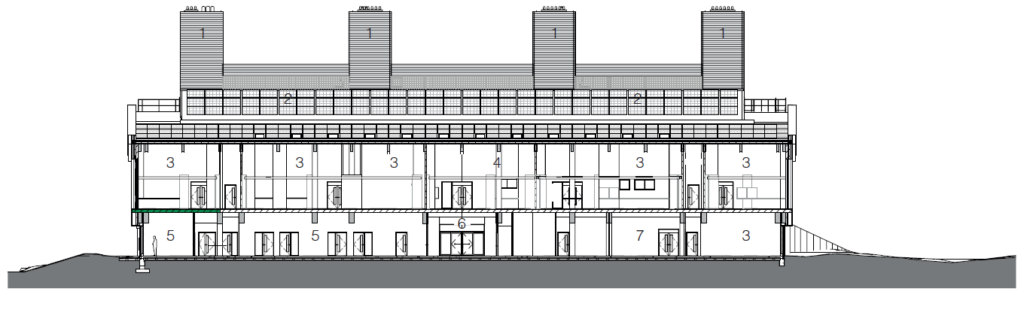
Figure 1

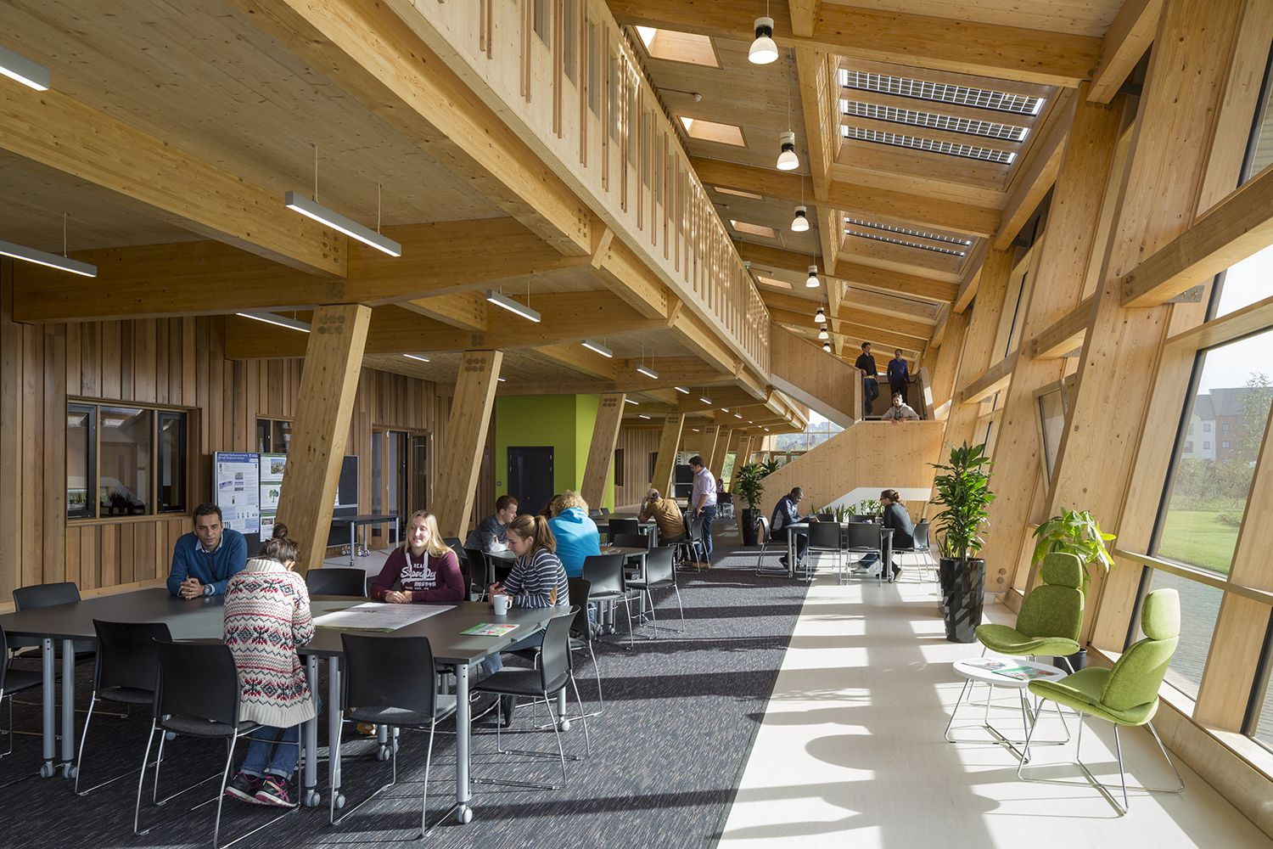
Figure 2

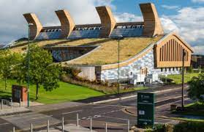
Figure 3

